
UNIVERSITI TUNKU ABDUL RAHMAN

UECS2033 APPLIED MACHINE LEARNING

Pneumonia Detection from Chest X-Ray Images

October 2025

Prepared by:
No. | Name | Student ID
1 | Leong Bao Yee | 2300499
2 | Faith Ee Hui Yi | 2206808
3 | Bernie Lim Hui Ci | 2305684

Introduction
Pneumonia is a critical global public health challenge, particularly among children under five years old and is a leading cause of mortality. According to the World Health Organization (2022), this respiratory infection was responsible for approximately 740,180 deaths in young children in 2019, highlighting the urgent need for improved diagnostic capabilities (WHO, 2022). Chest X-ray imaging (CXR) is the primary diagnostic tool for pneumonia detection in clinical settings, but its effectiveness is heavily constrained by the requirement for specialized radiological expertise. The interpretation process remains inherently subjective, time-consuming, and particularly challenging in resource-limited environments where qualified radiologists are scarce, often resulting in delayed diagnoses that compromise patient outcomes (Togunwa et al., 2025).
The rise of deep learning technologies, especially Convolutional Neural Networks (CNNs), has provided a transformative solution to these diagnostic challenges. CNNs possess the remarkable capability to automatically learn and extract complex hierarchical features from medical images without manual feature engineering, making them exceptionally well-suited for analyzing the subtle pathological patterns indicative of pneumonia in chest X-rays (Kermany et al., 2018). This project’s rationale is structured around the 5W1H framework: What—to developing an automated pneumonia detection system; Why—to address the problems of diagnostic inconsistencies and resource limitations; Who—benefiting patients, clinicians, and healthcare systems; Where—it can be deployable in underserved medical facilities; When—it can be used during initial screening phases; How—through CNN-based feature learning from annotated X-ray images.
This project leverages advanced CNN technology to build an automated computer-aided diagnosis system capable of accurately distinguishing between "normal" and "pneumonia" chest X-ray images, thereby providing support for clinical decision-making. If successfully implemented, such a system has the potential to significantly augment diagnostic capabilities in underserved regions, provide valuable decision support to healthcare practitioners, and ultimately contribute to reduced mortality rates through earlier and more reliable detection of this life-threatening condition.

Data Understanding
This study is based on the publicly available Chest X-Ray Images (Pneumonia) dataset from Kaggle, which originates from the peer-reviewed clinical study by Kermany et al. (2018). The dataset contains a total of 5,856 pediatric chest X-ray images in JPEG format, taken in both anterior-posterior (AP) and posterior-anterior (PA) views. The images are pre-organized into training (5,216 images), testing (624 images), and validation (16 images) subsets. Each image is labeled with a binary classification label of “normal” or “pneumonia” based on rigorous radiological assessment. The quality of the annotations and clinical relevance of this dataset are well-established, as it is widely cited in medical artificial intelligence (AI) research.
A comprehensive exploratory analysis revealed a significant class imbalance in the dataset. The training set contains 1,341 Normal images and 3,875 Pneumonia images, resulting in an imbalanced ratio of approximately 2.9:1 (Pneumonia to Normal). This distribution presents a critical methodological challenge, as deep learning models trained on such skewed data may develop a prediction bias toward the majority class (Pneumonia). To visualize this imbalance and its implications, a class distribution chart is presented in Figure 2.1. To counteract this bias, our methodology incorporates strategic mitigation techniques, including class weighting and extensive data augmentation. These techniques aim to reduce model bias toward the majority class and improve the generalization performance of the trained CNN model.
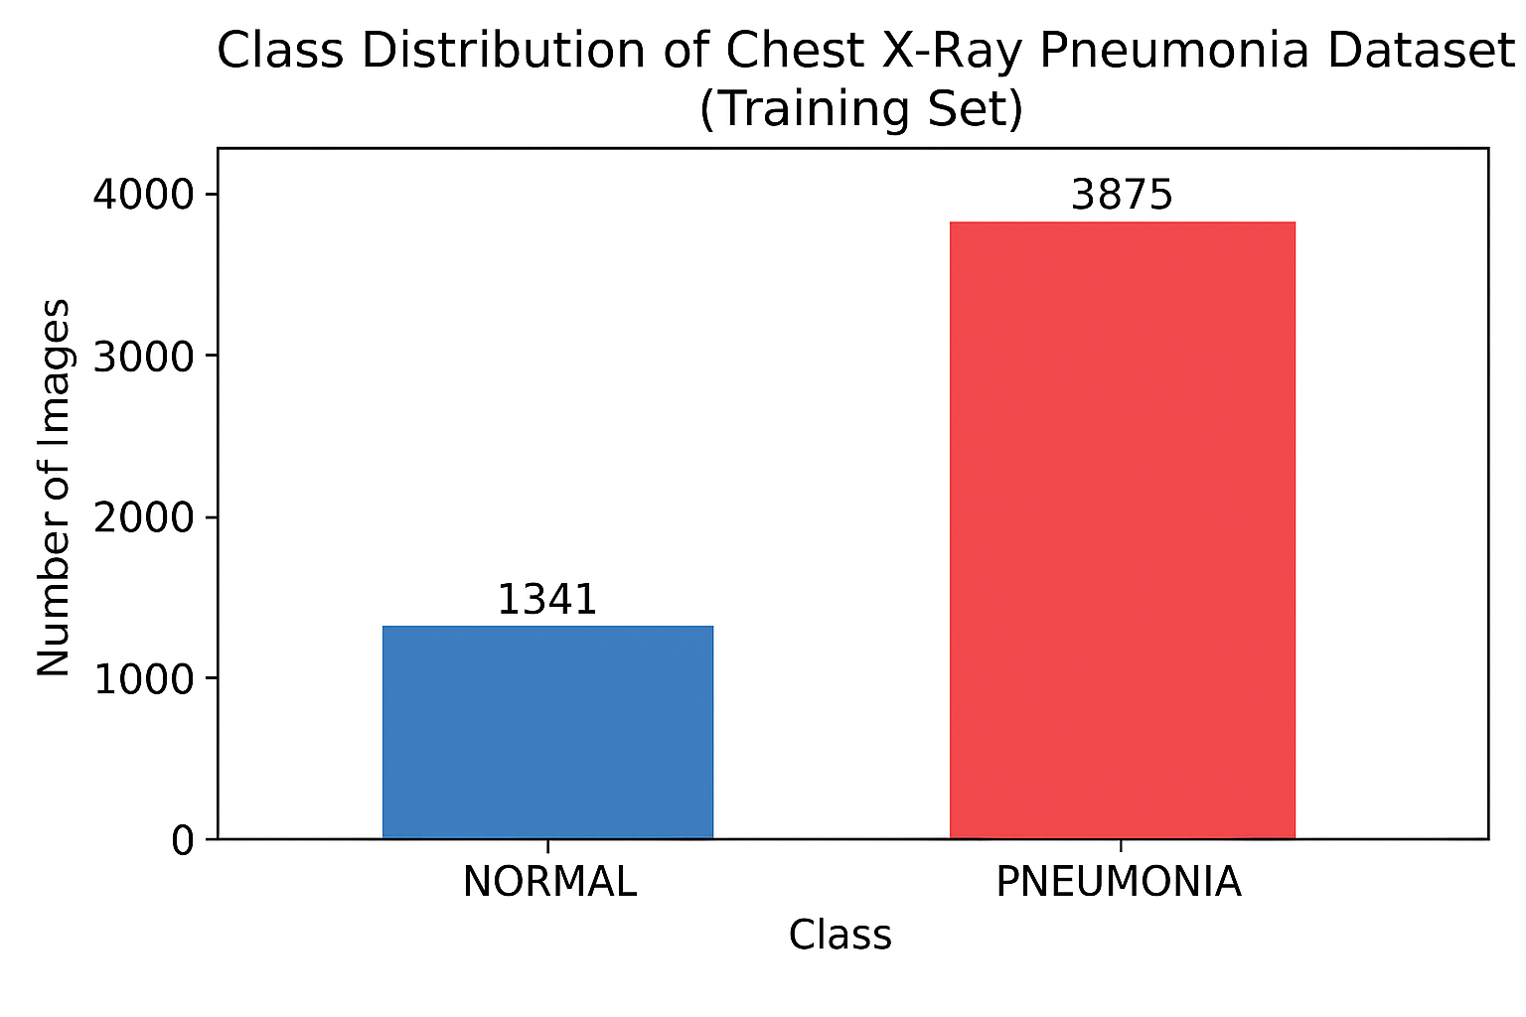
Figure 2.1 Class distribution of the training set, showing a 2.9:1 imbalance between pneumonia and normal cases
Visual inspection of sample images clearly demonstrates the distinctive characteristics that the model must learn to differentiate. As shown in Figure 2.2, normal X-rays display clear lung fields with well-defined anatomical structures and vascular patterns. In contrast, pneumonia-affected X-rays exhibit various pathological patterns, including areas of increased opacity (whitening), consolidation (solidification of lung tissue), and interstitial markings, which are indicative of infection and inflammation. These visual differences highlight the advantages of Convolutional Neural Networks (CNNs), which excel at recognizing spatial and textural patterns, are well-suited for this classification task.
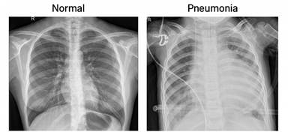
Figure 2.2 Example of a normal chest X-ray and a pneumonia-affected X-ray
Furthermore, image metadata and quality analysis indicate differences in resolution and contrast, consistent with the characteristics of real clinical imaging. These variations necessitate robust preprocessing steps, such as resizing and normalization, to ensure consistent model input. The dataset is large-scale, expert-curated labels, and clinical realism make it highly suited for developing and validating a robust deep learning model for pneumonia detection that can generalize effectively to real-world clinical scenarios. It is noted that the validation set provided in the dataset is relatively small; therefore, model performance evaluation primarily relies on the test set, while the validation data is mainly used for monitoring training behaviour during model training.

Methodology
This chapter will describe the overall machine learning pipeline for detecting pneumonia from chest X-ray images. The method will outline the steps followed, it is starting with loading and preprocessing the data, data augmentation, dataset splitting, model development for the baseline CNN and EfficientNetB0 transfer learning model, and finally the training and evaluation procedures, as shown in Figure 3.1.
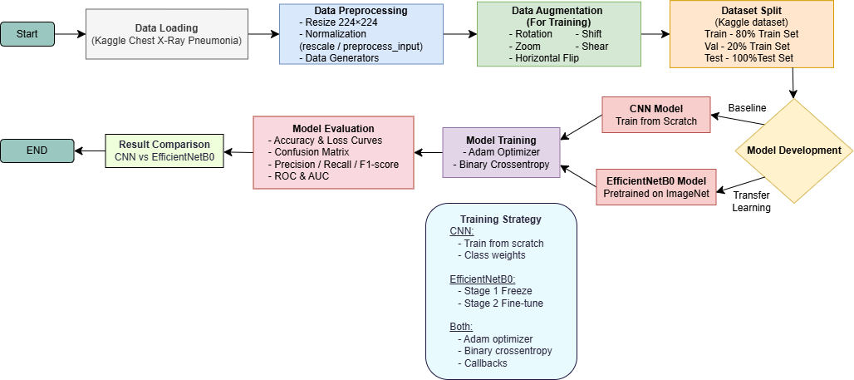
Figure 3.1Overall workflow of the proposed pneumonia detection pipeline

Data Pre-Processing
In this section, because the original chest X-ray images in the Kaggle dataset vary in resolution, brightness, and orientation, we will apply several preprocessing steps to ensure consistent image format suitable for training deep learning models.
- Image Resizing and Normalisation
In this part, all the images were resized to 224 × 224 pixels to match the input requirements of the CNN model and EfficientNetB0 models. For the CNN model, pixel values were normalised to the [0,1] range using a rescaling factor of 1/255, whereas EfficientNetB0 used the ‘preprocess_input’ function for model-specific normalisation. These steps ensure stable training and maintain consistency in the input representation.

Data Augmentation
This part is needed to enhance the model's generalization ability and reduce overfitting, we will performed data augmentation using Keras ImageDataGenerator. When during training, the randomized transformations were performed, including rotation, width and height shifting, zooming, shear transformation, and horizontal flipping. These augmentations simulate natural variations in X-ray imaging conditions while preserving disease-related features.
- Dataset Splitting and Rationale
In this part, because the Kaggle dataset is providing the separate folders for training, validation and testing, the original validation folder only contains 16 images, which is insufficient for a reliable evaluation of model performance. If the validation set is too small, it can lead to unstable validation loss, misleading early stopping behaviour, and unreliable hyperparameter selection. To address this issue, our team decide use 20% of the training set reallocatted as the validation set using ‘validation_split’ parameter in ‘ImageDataGenerator’. This results in more balanced and representative subsets: 80% training, 20% validation and independent test set.
- Data Generators
In this part, all the images were loaded using data generators ‘flow_from_directory’, in which the features are to:
- stream images in batches (memory-efficient)
- automatically apply resizing, normalisation, and augmentation
- ensure consistent preprocessing for both models
This can create a unified and efficient data pipeline across CNN and EfficientNetB0.

Model Development
In this section, our group will implement two different deep learning models (CNN and EfficientNetB0) to compare the performance of benchmark and transfer learning methods.

CNN Architecture
The baseline model is a custom Convolutional Neural Network (CNN) that built is using the Keras Sequential API. The architecture of CNN is consists of four convolutional blocks, each is designed to extract increasingly abstract spatial features from the chest x-ray images.
Component | Explanation
Convolutional Layers (32, 64, 128, 256 filters) | Each of the block will begins with a 3x3 convolution (padding=’same’) to capture the local texture and edge patterns commonly found in pneumonia-infected lungs.
Batch Normalization | The batch normalization will apply after each convolution to stabilize training, to improve gradient flow, and reduce the internal covariate shift.
ReLU Activation | Nonlinearity is introduced to prevent the gradient vanishing problem.
MaxPooling2D (2×2) | The purpose of this component is to downsample the feature map, preserving important spatial features while reducing computational cost.
Flatten Layer | Flatten later feature is to convert 2D feature maps into a 1D vector before entering the fully connected layers.
Fully Connected Layer (Dense 256) | This component is followed by batch normalization, ReLU activation, and Dropout (0.5) to reduce overfitting.
Dropout Layer (0.5) | This component will randomly disable a portion of neurons to reduce overfitting and improve the generalization ability.
Output Layer | Individual neurons are activated using sigmoid to perform binary classification (normal vs pneumonia).

EfficientNetB0 Architecture
Next, the EfficientNetB0 is a modern convolutional neural network that applying transfer learning via pretrained ImageNet weights. Thus, it may benefit from general image features acquired through training on large-scale datasets while quickly adapting the architecture to the chest X-ray classification task. EfficientNetB0 was used as a backbone, and a custom classification head was added on top to impose a two-stage training strategy that will refine the model's performance.
Component | Explanation
EfficientNetB0 Backbone (Pretrained on ImageNet) | The base EfficientNetB0 feature extractor comes loaded with pretrained ImageNet weights. This gives it a robust starting feature representation whereby the model will learn to identify the shapes, edges and textures relevant to medical imaging.
Global Average Pooling (GAP) | A GAP layer transforms the spatial feature maps into a single vector per channel. The purpose is to prevents overfitting by eliminating the need for large dense layers.
Dropout Layer (0.4) | The dropout function can help to reduce overfitting by randomly disabling neurons during training, it can improving the model generalisation.
Output Layer (Sigmoid) | A single-unit sigmoid classifier is used to perform binary classification, such as Normal vs Pneumonia.

Training Strategy
This section is describing the training strategies used for both the CNN and EfficientNetB0 models.

CNN Training Strategy
Strategy | Explanation
CNN is training from Scratch | This means that all weights are randomly initialized, and the CNN will learn all features directly from the chest X-ray dataset without any pre-training knowledge.
Class Weights | Class weights are used to address the imbalanced dataset problem. If misclassifying normal images is penalized more severely, while correctly predicting normal images contributes more to reducing the loss. This weighting method can help to prevents the model from being biased towards to the majority class (pneumonia).

EfficientNetB0 Training Strategy
Strategy | Explanation
Stage 1:  Frozen Backbone | In stage 1, we will freeze the pretrained EfficientNetB0 layers on initially. It only the new classification head was trained to adapt the model to the pneumonia dataset.
Stage 2:  Fine-Tuning | In stage 2, we will unfreeze the selected deeper layers of EfficientNetB0 to refine feature extraction for pneumonia-specific patterns while preserving ImageNet knowledge.
No Class Weights | EfficientNetB0 did not require class weights because transfer learning inherently provides more stable and balanced learning.

Shared Training Strategy
Strategy | Explanation
Batch Size | The batch size of 32 will provides a balance between computational efficiency and stable gradient estimation, to enabling the smoother training.
Optimizer | Both models will use Adam optimizer with a learning rate of 1e−3 due to its adaptive learning rate mechanism, it can helps to achieve faster and more reliable convergence.
Loss Function | Loss Function is suitable for binary classification tasks, this function measures the error between predicted probabilities and actual class labels.
Evaluation Metric | The accuracy was monitored during training to track the proportion of correctly classified images across epochs.
Mini-batch Training | Both models will use mini-batch gradient descent, because it can improve the training stability and reduces the memory usage compared to full-batch.
Callbacks (EarlyStopping, ReduceLROnPlateau, ModelCheckpoint) | The main purpose of this function is to maintain the training process and help the model converge more effectively. For example, EarlyStopping mechanise will stops the training early AND ReduceLROnPlateau will reduces the learning rate when validation loss/accuracy stops improving.

Evaluation Metrics
The following evaluation metrics were used to assess the performance of both models on the validation and test sets.
Metric | Explanation
Accuracy | This metric use to measures the overall proportion of correctly classified images. Used during training to track general performance.
Precision | This metric indicates how many of the images predicted as Pneumonia are actually Pneumonia, it helps to assess reliability of positive predictions.
Recall (Sensitivity) | This metric use to measures the model’s ability to correctly identify Pneumonia cases. It is important in medical diagnosis to minimise the false negatives.
F1-score | Harmonic mean of precision and recall. Provides a balanced evaluation, especially useful for imbalanced datasets.
Confusion Matrix | This metric summarises the true positives, true negatives, false positives, and false negatives, it helps to visualise the types of prediction errors.
ROC Curve & AUC | The ROC curve shows the trade-off between sensitivity and specificity. AUC quantifies overall discriminatory ability; higher values indicate better model performance.

Result and Discussion
This section will present the experimental results for both models trained on the Chest X-Ray Pneumonia dataset. The project will compare a custom CNN model and an EfficientNetB0 transfer learning model to evaluate the model's performance in classifying Normal and Pneumonia images. The results are presented using accuracy and loss curves, confusion matrics, classification metrics, and ROC-AUC scores.

CNN and EfficientNetB0 Performance Summary
The table below are summarizing the performance of CNN and EfficientNetB0 models on the test set.
Table 4.1 CNN vs EfficientNetB0 Performance Comparison
Metric | CNN | EfficientNetB0
Test Accuracy | 0.9071 | 0.9038
AUC | 0.9613 | 0.9673
Precision (Normal) | 0.94 | 0.94
Recall (Normal) | 0.80 | 0.80
Precision (Pneumonia) | 0.89 | 0.89
Recall (Pneumonia) | 0.97 | 0.97
F1-score (Pneumonia) | 0.93 | 0.93

CNN Model Results
4.2.1 CNN Training vs Validation Accuracy Curve  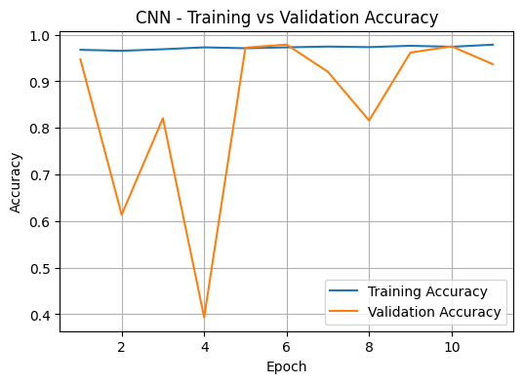  Figure 4.1 CNN Accuracy Curve | From the beginning of training, the training accuracy is somewhat constant high, but the validation accuracy fluctuates at some initial epochs. This is due to the imbalanced nature of the dataset and the model’s early adjustment to class weighting, combined with the relatively small validation set, it makes the performance metrics more sensitive to misclassifications. As training progresses, the validation accuracy gradually stabilises and converges towards the training accuracy. This indicates that the CNN has learned meaningful features and achieved good generalisation by the end of training.

4.2.2 CNN Training vs Validation Loss Curve  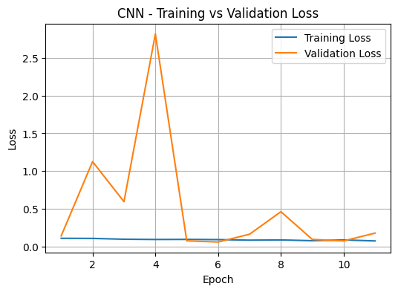  Figure 4.2 CNN Loss Curve | Training loss remains low and stable throughout all epochs, while validation loss shows noticeable fluctuations during the initial stages of training. This behaviour is common when the model is still adapting to the data distribution and refining its decision boundary under class-weighted training, as the introduction of class weights can lead to early instability in validation performance. As training progresses, the validation loss gradually decreases and follows a similar trend to the training loss, indicating that the model becomes more stable over time and does not exhibit clear signs of overfitting.
4.2.3 CNN Confusion Matrix  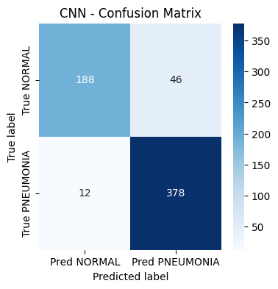  Figure 4.3 CNN Confusion Matrix | The CNN model has correctly classified most cases of pneumonia with only 12 false negatives out of 390 samples, hence indicating a high sensitivity in pneumonia detection. This is very important in medical screening scenarios, because missing a pneumonia case may lead to delayed treatment and serious health consequences. For the NORMAL class, 188 images were correctly predicted, while 46 were misclassified as pneumonia, therefore increasing the false positives. It shows that the model favours pneumonia detection and sacrifices the normal classification. This trade-off is usually acceptable in clinical screening applications where the focus is primarily on sensitivity, and there is very low tolerance for missed cases. A general impression from the confusion matrix is that the model is consistently good across classes, with the most excellent propensity for cases of pneumonia.

4.2.4 CNN Classification Report  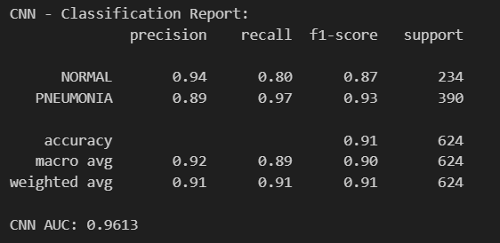  Figure 4.4 CNN Classification Report | The report further confirms the model’s strong performance across both classes. The pneumonia class have achieved a high recall of 0.97 and an F1-score of 0.93, this indicate that the model is highly effective in identifying pneumonia cases while maintaining a good balance between precision and recall. For the NORMAL class, the model records a high precision of 0.94 but a lower recall of 0.80, suggesting that some normal images are incorrectly classified as pneumonia. This behaviour is consistent with the model’s tendency to prioritise sensitivity toward pneumonia detection. The CNN achieves an accuracy of 0.91, supported by balanced macro- and weighted-average metrics, reflecting stable and consistent classification performance.
4.2.5 CNN ROC Curve (AUC)  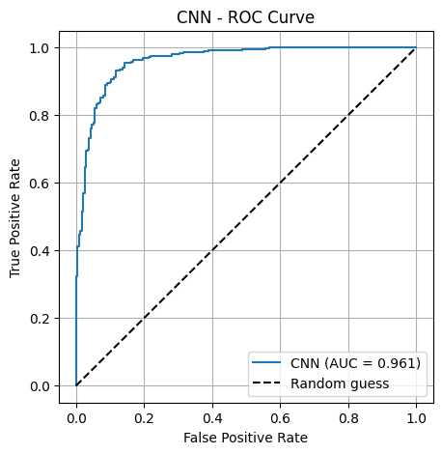  Figure 4.5 CNN ROC Curve | The ROC curve shows that the CNN model has strong discriminative ability, because the curve remains close to the upper-left corner across most threshold values. The AUC score of 0.9613 indicates excellent separation between the PNEUMONIA and NORMAL classes. This result demonstrates that the model performs well across different classification thresholds and is not sensitive to a single decision boundary.

EfficientNetB0 Results
4.3.1 EfficientNetB0 Training vs Validation Accuracy Curve (Stage 1 + Stage 2)  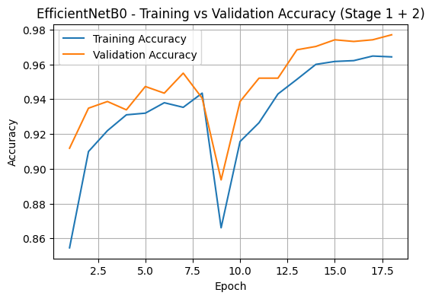  Figure 4.6 EfficientNetB0 Accuracy Curve | The accuracy curves remain stable across both Stages, with training and validation accuracies staying close to each other throughout training. Even though the temporary dip appeared around epoch 9, the validation accuracy quickly recovers and continues to improve, likely due to the transition into the fine-tuning stage where deeper layers begin adapting to the pneumonia dataset. The close alignment between the two curves indicates stable learning behaviour and good generalisation across both training stages.
4.3.2 EfficientNetB0 Training vs Validation Loss Curve  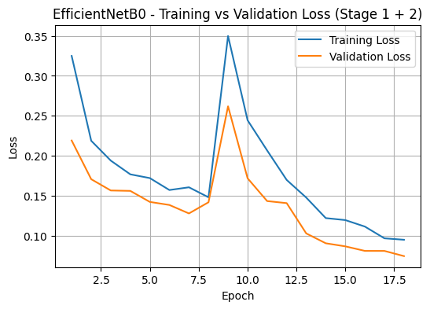  Figure 4.7 EfficientNetB0 Loss Curve | The loss curves are downwardly progressive during training in both stages, and validation loss closely tracks training loss in most epochs. Although both curves exhibit a noticeable spike around epoch 9, the loss quickly stabilizes and continues decreasing afterward. This may indicate model fitting improvement in addition to stable generalization.

4.3.3 EfficientNetB0 Confusion Matrix  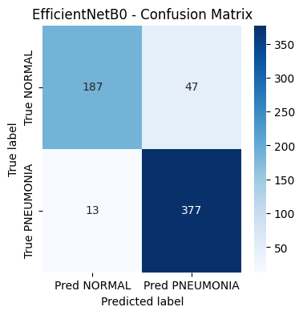  Figure 4.8 EfficientNetB0 Confusion Matrix | The confusion matrix indicates that the model has appropriately classified most cases of pneumonia, with only 13 false negatives out of 390 samples, suggesting high sensitivity in pneumonia detection. For the NORMAL class, have 187 were correctly predicted, while 47 were misclassified as pneumonia, resulting in a slightly higher number of false positives. This pattern indicates that the model prioritizes pneumonia detection over normal classification, consistent with its design as a screening-oriented model. The confusion matrix also demonstrates the model's reliable classification performance, particularly in detecting pneumonia cases.
4.3.4 EfficientNetB0 Classification Report  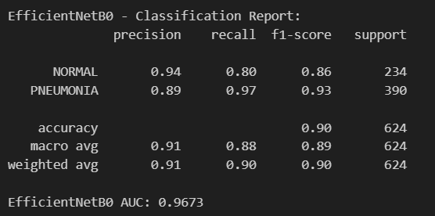  Figure 4.9 EfficientNetB0 Classification Report | The classification report further confirms the strong performance of EfficientNetB0 across both classes. The pneumonia class achieves a high recall of 0.97 and an F1-score of 0.93, it reflects an excellent sensitivity in identifying positive cases. For the NORMAL class, the model records a high precision of 0.94, but a lower recall of 0.80, it is indicating that some normal images are misclassified as pneumonia. This observation aligns with the model’s emphasis on sensitivity over specificity. Overall, the model achieves an accuracy of 0.90, supported by balanced macro and weighted-average metrics, it is indicating stable and consistent classification performance.
4.3.5 EfficientNetB0 ROC Curve (AUC)  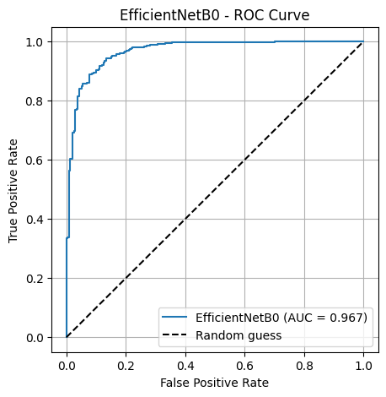  Figure 4.10 EfficientNetB0 ROC Curve | The ROC curve indicates that EfficientNetB0 has a good discriminatory ability, with the curve staying close to the top-left corner. The AUC score of 0.9673 indicates excellent ability to separate NORMAL and PNEUMONIA classes across all decision thresholds. The large distance between the model curve and the random baseline indicates that it has performed well in classification.

Comparison with other Literature Works
The Chest X-Ray Images (Pneumonia) dataset from Kaggle contains chest radiographs retrospectively collected from paediatric patients at the same medical centre and screened for quality before expert labelling. It is designed for academic research and model development, providing a well-structured split for training, validation and testing. It is a controlled setup that allow researchers to train convolutional neural networks while enabling reproducibility. Hence, it is primarily adopted as a benchmark dataset for developing and evaluating pneumonia detection models under consistent experimental conditions. In contrast, the Pneumonia in Children through Chest Radiographs using Artificial Intelligence in a Low-Resource Setting: A Pilot Study dataset from PubMed is used within a clinical research framework (Togunwa et al., 2025). The researchers trained their model using 5,232 open-source paediatric chest X-ray images, which were split into training and internal test sets with both normal and pneumonia labels, then further evaluated the model using 190 prospectively collected Nigerian chest radiographs with expert consensus labels, hence making it more oriented towards evaluating real-world clinical situations.
A key distinction lies in purpose and validation approach. The PubMed dataset usage incorporates both publicly available images and a real clinical data from Nigeria, with the latter serving as an external validation set. This exposed significant challenges in generalisability where the CNN model is applied to new populations with varying imaging conditions and demographics (Togunwa et al., 2025). However, although robust for training and benchmarking models, the Kaggle dataset does not inherently include an independent clinical validation set from other healthcare environments, therefore, models trained on it may demonstrate strong in-sample performance but can struggle when deployed in unfamiliar clinical settings without additional validation.
Another notable distinction is in deployment context and real-world implications. The PubMed dataset usage demonstrated that models trained on curated, open-source data may face substantial performance degradation in real clinical environments due to variations in imaging protocols, equipment and patient demographics (Togunwa et al., 2025). Therefore, it underscores the importance of collecting locally relevant clinical datasets and performing external validation before clinical deployment. Meanwhile, if only controlled environment is utilized, it facilitates reliable model development and comparison but does not guarantee clinical accuracy.
Overall, the two datasets are suited for varying objectives. The primary contribution of the PubMed dataset is the external clinical validation using CNN models, identifying performance degradation of when models trained on public datasets are deployed in the real-world. Together, these datasets illustrate the gap between benchmark performance and clinical applicability, underscoring the significance of external validation.

Conclusion

Summary of Results
This project developed and evaluated an automatic pneumonia detection system using chest X-ray images, then compared a custom Convolutional Neural Network (CNN) trained from scratch and a transfer learning-based EfficientNetB0 model. This study investigated the effectiveness, robustness and clinical relevance of both approaches in tackling a real-world medical imaging problem.
The experimental results showed that both the baseline CNN and the EfficientB0 model performed consistently well using the same dataset. To illustrate, the CNN model achieved a test accuracy of 90.71% and a high ROC-AUC score, which is 0.9613, indicating excellent discriminatory capability between normal and pneumonia cases, which is a critical requirement in medical diagnosis, as false negatives can lead to severe consequences. The EfficientNetB0 model achieved a comparable test accuracy of 90.38%, and a slightly higher ROC-AUC of 0.9673, showing great overall separation between the two categories. This indicates that although the CNN marginally outperformed EfficientNetB0 is terms of raw accuracy, the transfer learning model demonstrated superior overall class separability, reflecting more robust performance across different classification thresholds. This highlights the benefit of transfer learning, where pretrained ImageNet features allow EfficientNetB0 to generalise effectively even with limited medical data. However, the CNN model trained from scratch demonstrated competitive performance as well, therefore, carefully designed architectures combined with data augmentation and class weighting can still achieve strong results without pretrained weights.
Additionally, both models exhibited very high recall for pneumonia cases, that is 0.97, which is a crucial requirement in medical diagnostics. The high recall implies that the models are highly sensitive to pneumonia cases and are unlikely to miss infected patients. This is particularly important in clinical screening scenarios, where false negatives can have serious consequences, including delayed treatment and increased mortality risk. The strong F1-score of 0.93 for pneumonia further confirms that both models maintain a good balance between precision and recall. However, both models showed relatively lower recall for the normal class, that is 0.80, indicating a tendency to misclassify some healthy cases as pneumonia. This behaviour is likely influenced by the class imbalance present in the dataset, where pneumonia images significantly outnumber normal images. Even though this results in a higher number of false positives, such an outcome is often considered more acceptable in medical screening contexts, as it prioritizes patient safety by erring on the side of caution.

Strengths and Limitations
One of the primary strengths of this study lies in its robust data preprocessing structure, which addressed variations in image resolution, intensity and orientation. It required standardizing image size and applying appropriate normalization to ensure stable training and consistent model input. Furthermore, the use of extensive data augmentation significantly improved model generalization by learning fundamental features rather than memorizing specific training examples, thereby reducing overfitting.
Another major strength is the explicit handling of class imbalance, which is a common challenge in medical datasets. The application of class weighting in CNN training helped remove bias towards the majority pneumonia class, while the EfficientNetB0 model benefited from transfer learning, which inherently stabilized learning even without class weights. The study also employed multiple evaluation metrics beyond accuracy, including precision, recall, F1-score, confusion matrices, and ROC-AUC. This comprehensive evaluation is particularly suitable for healthcare applications, where sensitivity and false negative rates are often more critical than overall accuracy.
Furthermore, another strength lies in the comparative analysis between two distinct deep learning approaches. Through benchmarking a CNN trained from scratch against a modern pretrained architecture, the study provides meaningful insight into the trade-offs between model complexity, computational cost, performance and architectural sophistication. The results show that while EfficientNetB0 offers stronger generalization and higher AUC due to pretrained feature extraction, a well-structured baseline CNN can still achieve competitive performance.
Despite these strengths, there are also several limitations to be acknowledged. Firstly, the dataset used consists exclusively of paediatric chest X-ray images from a single publicly available source, which restricts the generalisability of the findings from other populations, such as patients from different healthcare institutions. Furthermore, although data augmentation and class weighting were applied, the dataset remains inherently imbalanced, which is reflected in the lower recall for the normal class, resulting in a value of 0.80. This indicates a tendency for both models to over-predict pneumonia, potentially leading to higher false positive rates. Even though this bias may be acceptable in a screening scenario, it can increase unnecessary follow-up examinations and clinician workload.
Moreover, the validation strategy relied on a reallocated portion of the training data rather than a truly independent validation dataset. Even though the approach improves stability compared to the original small validation set, it can still introduce optimistic bias during model selection and hyperparameter tuning. Lastly, the models operate as black-box classifiers, providing limited interpretability. In clinical environments, the lack of explainability can reduce trust from clinicians and hinder adoption, as the models do not explicitly highlight the radiological features contributing to their predictions.

Future Improvements
To reduce these limitations and further enhance model performance, several improvements can be explored in the near future. Firstly, larger and more diverse datasets should be incorporated, such as multi-center data collected from various hospitals, and multi-age-group data. Such diversity helps the models to absorb more representative features, improves robustness against variations in imaging protocols and patient demographics. Consequently, external clinical validation on existing independent data is significant before real-world deployment, as it provides a more reliable generalisability.
In addition, there should be advanced techniques for handling class imbalance. Even though class weighting and data augmentation were effective to some extent in this study, alternative approaches such as synthetic data generation methods could further improve learning, reduce bias towards the majority class and decrease the number of false-positive predictions, thus enhancing diagnostic reliability.
The inclusion of explainable artificial intelligence (AI) techniques, such as Gradient-Weighted Class Activation Mapping (Grad-CAM), can be proposed to produce visual explanations by using the gradients to identify important image regions (DataScientest, 2024). It extends the categorisation task beyond just binary outcomes, thus enhancing model transparency and clinical decision-making.
Overall, with further refinement, comprehensive validation and the integration of explainable and robust learning strategies, the proposed models would have stronger potential to support radiologists and clinicians, particularly in resource-limited settings, by enabling faster and more reliable early diagnosis.

References
DataScientest. (2024, February 18). What is the Grad CAM method? https://datascientest.com/en/what-is-the-grad-cam-method
Kermany, D., Zhang, K. and Goldbaum, M. (2018) 'Labeled Optical Coherence Tomography (OCT) and Chest X-Ray Images for Classification,' Mendeley Data, 2. https://doi.org/10.17632/rscbjbr9sj.2.
Paul Mooney (2017). Chest X-Ray Images (Pneumonia). https://www.kaggle.com/datasets/paultimothymooney/chest-xray-pneumonia.
Togunwa, et al. (2025). Detection of pneumonia in children through chest radiographs using artificial intelligence in a low-resource setting: A pilot study. https://pmc.ncbi.nlm.nih.gov/articles/PMC12459801/
World Health Organization: WHO (2022) Pneumonia in children. https://www.who.int/news-room/fact-sheets/detail/pneumonia.

