Hillsborough County Parcel Sales Prediction
Bo Fethe

Abstract
This study explores the use of machine learning to predict residential property sale values in Hillsborough County, Florida. Accurate valuation is critical for disaster response and recovery planning, particularly in post-hurricane damage assessments. The project involved extracting and merging parcel and historical sales data, followed by cleaning, feature selection, and exploratory data analysis. A Box-Cox transformation was applied to correct for target variable skewness, and models were trained using a consistent pipeline that handled preprocessing and hyperparameter tuning. Five models were evaluated: linear regression, elastic net, random forest, artificial neural Network (ANN), and light gradient boosting machine (LightGBM). Hyperparameters were optimized using randomized search with cross-validation. Model performance was assessed using root mean squared error (RMSE) in USD on a holdout test set. Ensemble models, particularly random forest and LightGBM, outperformed linear methods, capturing complex, non-linear relationships in the data. The results demonstrate the feasibility of using machine learning for scalable, data-driven property valuation in support of emergency management applications.

Introduction
When a natural disaster, such as hurricanes, impacts a community, government entities rely on metrics from property appraisers to quantify and categorize the damages. For example: Market Value is the value that the land and improvements would sell for in a competitive market at a fair price; Building Value is the value of all structures on a property; and Tax Value is the assessed value minus any taxable exemptions. One issue with these metrics is that they are not standardized in how they are calculated or used, and the Market Value may not accurately represent price a buyer would pay to purchase the property. As a result, estimating total impacts can be challenging, and reimbursement programs may undervalue properties leaving substantial financial burdens on the residents while filing a claim.

Prior research highlights a clear shift from traditional hedonic regression toward more flexible machine learning methods. The University of Colorado at Boulder found artificial neural network and random forest models outperformed traditional models in valuing property sales in Boulder, Colorado (Yazdani, 2021). Mora-Garcia et al. (2022) demonstrated that boosting models like light gradient boosting machine were more robust than bagging and linear methods, especially across structural market changes during COVID‑19 due to the ability to capture non-linear trends (Mora-Garcia, Cespedes-Lopez, & Perez-Sanchez, 2022). Model selection and tuning when applying regression-based methods to housing data has risks of overfitting for smaller sample sizes and it’s beneficial to compare the performance of ensemble models with simple regression models when dealing with property sales (Viktorovich, Aleksandrovich, Leopoldovich, & Vasilevna, 2018).

Our study builds directly on these insights by comparing an expanded set of models, tuning hyperparameters, and adjusting for skewed sales via Box‑Cox, to deliver a more resilient predictive framework for Hillsborough County.

Methodology
Data from the Hillsborough County Property Appraiser’s website containing metrics about the parcels, buildings, and sale values is loaded into an environment and analyzed during the exploratory data analysis (EDA) phase to uncover hidden trends, multicollinearity, outliers, and other statistically significant factors. A cleaned version of the data will be split into training and testing subsets and will use a Box-Cox transformation to transform the data using the optimal $λ$ prior to training. The training subset will undergo multiple rounds of machine learning and deep learning hypertuning using a randomized search with cross-validation to identify the optimal hyperparameters based on the lowest cross-validation error. Once the optimal hyperparameters are determined, the models will be fitted to the testing data subset to measure its performance using the root mean squared error shown in the formula below:

$$\text{RMSE}=\sqrt{\frac{1}{n}\sum_{i=1}^{n}{{\left(y_{i}-\hat{y_{i}}\right)}^{2}}}$$

See Appendix A for a workflow diagram.

Models
This analysis considers 5 models: linear regression, elastic net, random forest, artificial neural network, and light gradient boosting machine.

Linear Regression
A foundational statistical model that fits a straight line to the data by minimizing the sum of squared differences between observed and predicted values. It is ideal for predicting continuous outcomes that exhibit a linear relationship with input features and is valued for its simplicity and interpretability. Linear regression can be described as the following equation:

$$\hat{y}=β_{0}+β_{1}x_{1}+β_{2}x_{2}+…+β_{p}x_{p}$$

- $\hat{y}: Predicted value$
- $β_{0}: Intercept$
- $β_{j}: Coefficient for the jth feature$
- $x_{j}: Input of the jth predictor$
- $p: Number of features$

Elastic Net
A regularized linear regression model that blends the strengths of Lasso (L1) and Ridge (L2) penalties. It connects input features directly to the output through weighted linear combinations, optimizing these weights during training to minimize both prediction error and a combined regularization term. Elastic Net is especially effective for high-dimensional datasets with multicollinearity, offering a balance between feature selection and model stability. Elastic net can be described as the following equation:

$$\text{Loss}=\frac{1}{n}\sum_{i=1}^{n}{{\left(y_{i}-\hat{y_{i}}\right)}^{2}}+λ_{1}\sum_{j=1}^{p}{\left|β_{j}\right|}+λ_{2}\sum_{j=1}^{p}{β_{j}^{2}}$$

- $y_{i}: Observed value for instance i$
- $\hat{y_{i}}: Predicted value for instance i$
- $n: Number of observations$
- $β_{j}: Coefficient for feature j$
- $λ_{1}: L1 regularization strength \left(Lasso\right)$
- $λ_{2}: L2 regularization strength \left(Ridge\right)$
- $p: Number of features$

Random Forest
An bagging ensemble learning method that constructs multiple decision trees using bootstrapped samples and random subsets of features. Each tree contributes to the final prediction through majority voting (classification) or averaging (regression). Random Forests are robust to overfitting and perform well on complex, high-dimensional datasets with nonlinear relationships. There is no single close-formed solution, but random forest can typically be described as the following equation:

$$\hat{y}=\frac{1}{T}\sum_{t=1}^{T}{h_{t}\left(x\right)}$$

- $\hat{y}: Final prediction$
- $h_{t}\left(x\right): Prediction from the t-th decision tree$
- $T: Total number of trees$

Artificial Neural Network (ANN)
A layered computational model composed of input, hidden, and output layers, where each node simulates a neuron. During training, the network adjusts the weights of connections between nodes to minimize prediction error. ANNs are powerful for capturing intricate patterns and nonlinear dependencies, making them suitable for tasks like image recognition, time series forecasting, and natural language processing. For a simple feedforward network with one hidden layer, the ANN can be described as the following equation:

$$\hat{y}=f\left(\sum_{j=1}^{H}{w_{j}^{\left(2\right)}}⋅σ\left(\sum_{i=1}^{p}{w_{ij}^{\left(1\right)}x_{i}}+b_{j}^{\left(1\right)}\right)+b^{\left(2\right)}\right)$$

- $x_{i}: Input feature i$
- $w_{ij}^{(1)}: Weight from input i to hidden node j$
- $w_{j}^{(2)}: Weight from hidden node j to output$
- $b_{j}^{\left(1\right)}: Bias for hidden node j$
- $b^{\left(2\right)}: Bias for output node$
- $σ: Activation function$
- $f: Output activation function$
- $H: Number of hidden units$
- $p: Number of input features$
- $\hat{y}: Predicted output$

Light Gradient Boosting Machine (LightGBM)
A high-performance gradient boosting framework that builds decision trees sequentially, with each new tree correcting the errors of its predecessors. It uses histogram-based algorithms and leaf-wise tree growth to improve speed and accuracy. LightGBM is well-suited for large-scale structured data and excels in both classification and regression tasks, especially when model performance is prioritized over training time. Like random forest, LightGBM also is not a single close-formed equation, but the model is built iteratively as the equation below:

$${\hat{y}}^{t}={\hat{y}}^{t-1}+η⋅h_{t}\left(x\right)$$

- ${\hat{y}}^{\left(t\right)}: Prediction from iteration t$
- ${\hat{y}}^{\left(t-1\right)}: Prediction from previous iteration$
- $h_{t}\left(x\right): New decision tree at iteration t$
- $η: Learning rate$

Exploratory Data Analysis
Raw geographical information systems (GIS) data for property sales and parcel details are read into pandas dataframes and merged based on a primary key (folio) while dropping non-analytical fields. In the event of duplicate fields, values from the sales dataframe are preserved. The schema is listed below.

Table 1: Schema for Finalized Data
Feature | Data Type | Description
FOLIO | object | Folio of parcel. Primary key
SITE_ZIP | category | Postal zip code
tBEDS | float64 | Number of beds
tBATHS | float64 | Number of baths
tSTORIES | float64 | Number of stories
tUNITS | float64 | Number of units
tBLDGS | float64 | Number of buildings
HEAT_AR | float64 | Heating area in ft²
ACREAGE | float64 | Acreage of lot
LU_GRP | category | Generalized land use group
S_YEAR | category | Sale year derived from sale date
S_AMT | float64 | Sale Amount (USD). Response value

Land Use Group
The majority of property sales records occur for residential properties. This analysis focuses on single-family and multi-family properties helps reduce potential bias from the imbalance in property types. The table below shows the distribution by land use group.

Table 2: Land Use Breakdown for Raw Data
Land Use Group | Count | %
SINGLE FAMILY | 1,811,627 | 76.99
MULTI-FAMILY | 241,635 | 10.27
VACANT RESIDENT | 70,837 | 3.01
MOBILE HOMES | 62,889 | 2.67
COMM./OFFICE | 35,423 | 1.51
OTHER: (INVALID CODE, AGRICULTURAL, GOVERNMENT, STORE/SHP CENTE, INSTITUTIONAL, LIGHT INDUS., VACANT COMM., VACANT TOWNHOME, UTILITY, R/W, OFFICE CONDO, SCHOOLS/COLLEGE, VACANT INDUS., HEAVY INDUS., MEDICAL OFFICE CONDO, APT CONDO, COMMERCIAL, INDUSTRAL CONDO, CHURCH PARSONAGES, COOPERATIVE, 1 STY STORE CONDO, VACANT MH/COOP, SFR BLD ARND MH, MINING, MARINAS, CEMETERY, PRIVATE GC, SEMI PRIVATE GC, LANDSCAPE/WALL BUFFER, PARKS, HOA COMMERCIAL, EXEC/PRACTICE GC | 130,731 | 5.56

Time Frame
The Hillsborough County Property Appraiser provides digital records of property sales in dating back to 1901; however, the quantity of records doesn’t start showing a significant amount until the late 1960s. The figure below shows the distribution of sales by year.
Figure 1: Sales Distribution for Raw Data
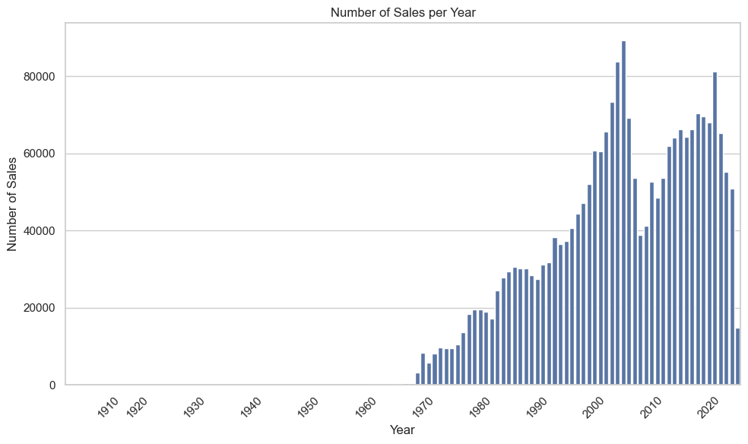
To avoid significant financial events such as the Subprime Mortgage Crisis which started in 2007 and eventually led to a housing market crash in 2008, records from 2014-2024 are used for this analysis.

Outliers
Outliers including sentinel values are systematically removed using an Isolation Forest. This model is an anomaly detection algorithm based on the idea of iteratively isolating observations by randomly selecting features and splitting values until the instance is isolated or the tree reaches a predefined height limit. This uses the concept that anomalies are easier to isolate because they require fewer random splits to be separated from the rest of the data. The scoring for an Isolation Forest can be described as below.

$$s\left(x, n\right)= 2^{-\frac{E(h(x)}{c\left(n\right)}}$$
$$c\left(n\right)= 2H\left(n-1\right)-\frac{2\left(n-1\right)}{n}$$
- $s\left(x,n\right): anomaly score for instance x in dataset of size n$
- $E\left(h\left(x\right)\right): average path length of instance x across all trees$
- $c\left(n\right): average path length of unsuccessful search in binary tree on n samples$
- $H\left(i\right): harmonic number;approximated as\ln\left(i\right)+γ$

The scores can be interpreted as $s(x)≈1$ is likely an anomaly, and $s\left(x\right)<0.5$ is likely normal point. A scikit-learn Isolation Forest with contamination value of 0.025, number of estimators as 250, and max sample size of 256 was fitted to the data by year and the results are shown in the figure below.
Figure 2: Outlier Removal
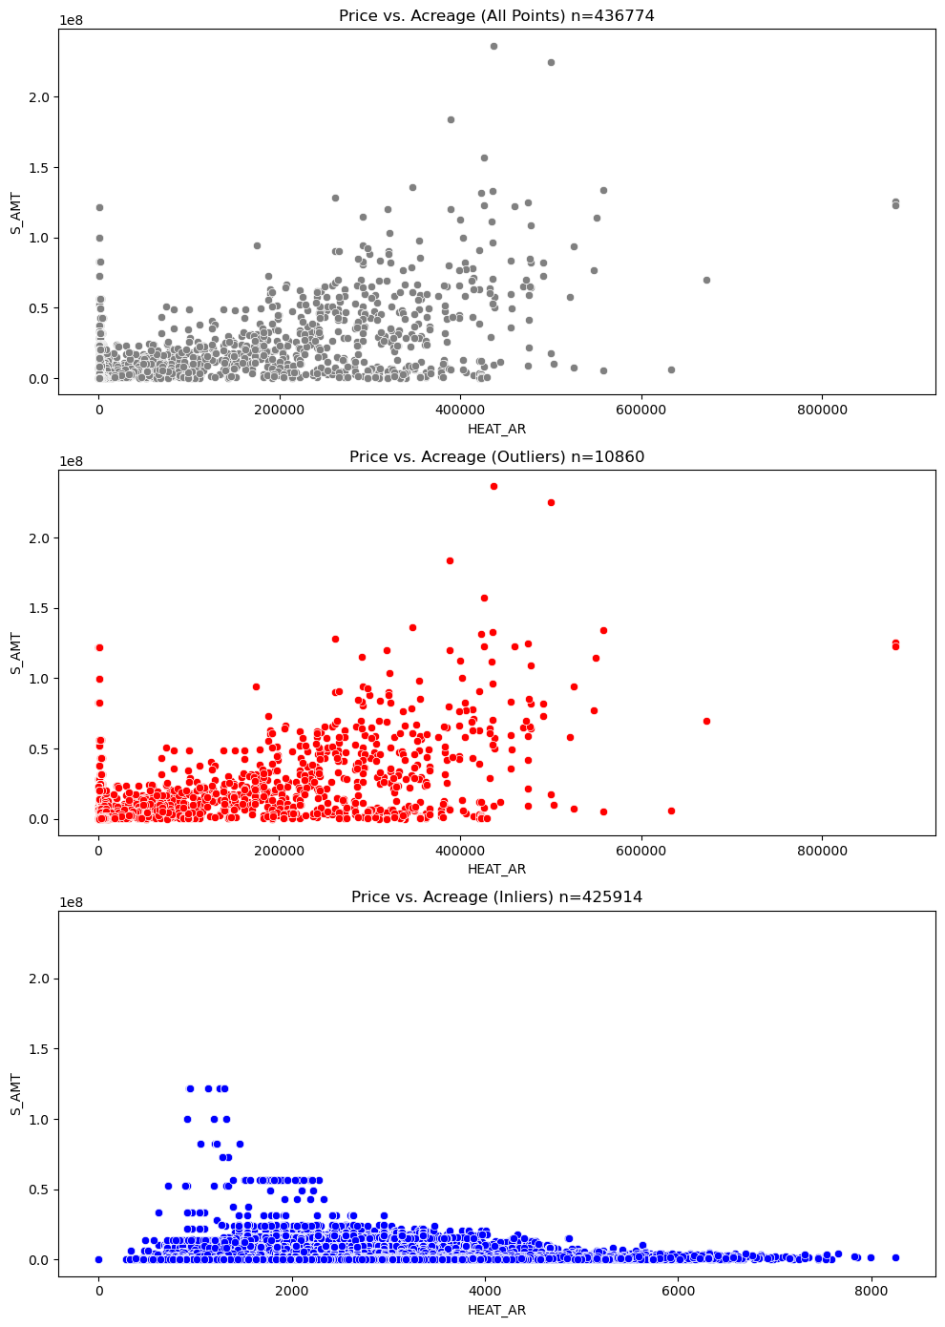
Heating area (ft²) was used for comparison to graphically represent the outlier/inlier relationships and trends from the Isolation Forest. This captured both sentinel values in the lower tail and extreme high-value properties in the upper tail which are absent in the Inliers plot. Approximately 11,000 data points were removed from 2014–2024 on the Outliers and Inliers plots.

Multicollinearity
Before training predictive models, it is important to assess multicollinearity among the input features. Multicollinearity occurs when two or more independent variables are highly correlated, which can distort model coefficients and reduce interpretability. To evaluate this, a correlation heatmap and Variance Inflation Factor (VIF) analysis were conducted to identify and address potential redundancies among predictors.

Figure 3: Correlation Plot
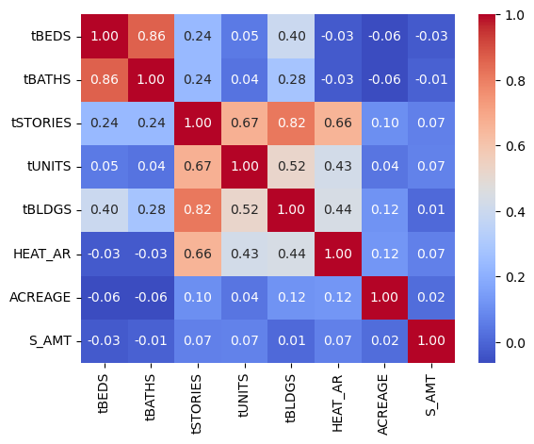
There is a strong correlation between number of beds to number of baths (0.86) and number stories to number of buildings (0.82), and all predictors have a weak correlation to the response sales price.

Table 3: VIF
Feature | VIF
tSTORIES | 6.24
tBEDS | 5.03
tBATHS | 4.59
const | 4.20
tBLDGS | 4.04
HEAT_AR | 1.96
tUNITS | 1.89
ACREAGE | 1.04

No predictors have a high Variance Influence Factor (VIF $≥$10) while the number of stories and number beds have a moderate VIF.

Transformation
One-hot encoding is a method to convert categorical data into numerical format by representing the values as binary vectors. This ensures models treat each category as independent and avoids implicit ordering systems. Zip codes and land use group values were one-hot encoded to allow the algorithms to understand it and use it efficiently.

When analyzing datasets using machine learning, a normal distribution is often assumed. If ignored, the results can lead to biased parameter estimation, inaccurate confidence intervals, and faulty hypothesis testing. For this analysis, sales amounts do not follow a normal distribution and needs to be transformed prior to training. The training data’s sales amount is run through a Box-Cox transformation and the response is transformed using the model’s optimal $λ$ = -0.39828 parameter. The Box-Cox transformation formula equation and the results are shown below.

$$y^{\left(λ\right)}=\frac{y^{λ}-1}{λ}$$
- $y: original data$
- $y^{\left(λ\right)}: transformed data$
- $λ: transformation control$
Figure 4: Box-Cox Transformation
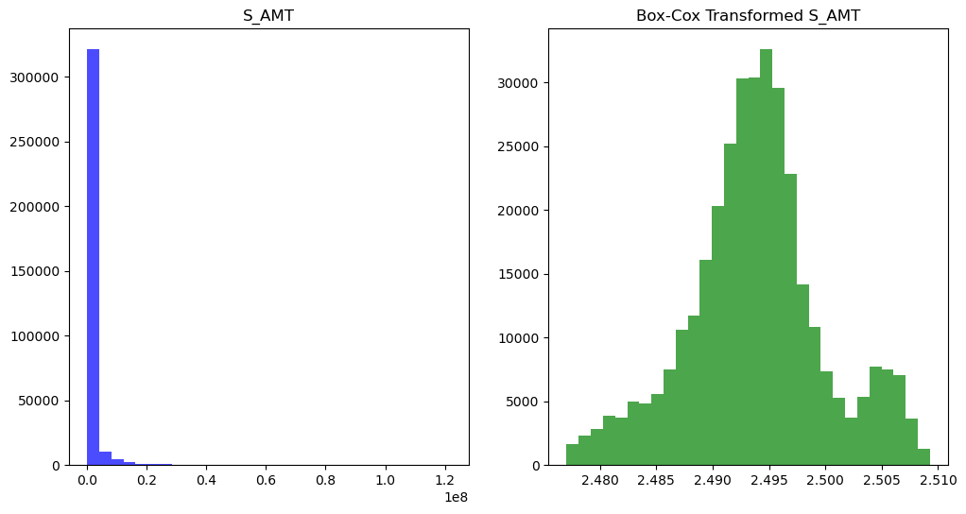

Analysis

Training
The final dataset of 425,914 records is randomly split into training (80%, n = 340,731) and testing (20%, n = 85,183) subsets. To establish a fair and consistent foundation for model comparison, a baseline pipeline was established for each algorithm and included preprocessing steps such as standardization of numerical features and one-hot encoding for categorical features. This ensured all models received the same transformation and avoided data leakage during cross-validation.

Each model’s pipeline was hypertuned using RandomizedSearchCV, which randomly samples from a predefined parameter grid. This approach provides a more computationally efficient approach compared to an exhaustive grid search while still exploring a wide range of hyperparameter options. The tuning process was performed using a 5-fold cross-validation and evaluated based on the RMSE to identify the optimal combination of hyperparameters for each model.

Table 4: Parameter Grid
Model | Hyperparameters
Linear | None; uses default
Elastic Net | $α$, L1 ratio
Random Forest | Number of estimators, max tree depth
LightGBM | Number of estimators, initial learning rate, number leaves, min child samples, subsample fraction, boosting sample fraction, L1 term, L2 term
Artificial Neural Network | Hidden layer size, $α$, initial learning rate, max iterations

Results
To evaluate the models, RMSE was calculated during training on the Box-Cox–transformed target, while predictions on the testing subset were inverse-transformed to compute RMSE on the original sales amount scale (USD). For each model, the hyperparameters that achieved the lowest cross-validation error were used to fit and evaluate the final model on the test data.
Table 5: RMSE
Model | RMSE (training, $λ$ transformed) | RMSE (testing, USD)
Linear | 0.0050849 | 2,419.10
Elastic Net | 0.0051152 | 2,419.77
Random Forest | 0.0044144 | 2,382.29
LightGBM | 0.0045119 | 2,406.30
ANN | 0.0051727 | 2,419.82

Conclusion
This project aimed to develop an accurate model to predict property sale values in Hillsborough County, Florida, with the goal of supporting post-disaster damage assessments. This analysis involved a complete pipeline from extracting and cleaning property appraiser and historical sales data to engineering features, exploring relationships, and applying advanced analytical techniques through machine learning.

A Box-Cox transformation was necessary to normalize the skewed response variable, sales amount, to improve model performance and stability. Multiple machine learning models were trained and evaluated, including linear regression, elastic net, random forest, artificial neural network, and light gradient boosting machine. Each model was processed through a consistent pipeline that handles preprocessing and hyperparameter optimization using randomization with cross-validation.

Among the models, ensemble methods like random forest and light gradient boosting machine outperformed others in terms of RMSE when evaluated on the holdout testing subset. While simpler models such as linear regression provide transparency and interpretability, boosting and bagging models better captured the complex and non-linear relationships in the data.

The final models showed predictive accuracy at levels suitable for offering valuable insights for future valuing properties for emergency response planning and recovery.

References
Fethe, B. (2025). Parcel Sales. (GitHub) Retrieved from https://github.com/bofethe/parcel-sales
Hillsborough County Property Appraiser. (2025). Public Downloads. Retrieved from https://downloads.hcpafl.org/
Mora-Garcia, R., Cespedes-Lopez, M.-F., & Perez-Sanchez, V. (2022). Housing Price Prediction Using Machine Learning Algorithms in COVID-19 Times. Land, 11, 2100.
Viktorovich, P. A., Aleksandrovich, P. V., Leopoldovich, K. I., & Vasilevna, P. i. (2018). Predicting Sales Prices of the Houses Using Regression Methods of Machine Learning. Chelyabinsk: South Ural State University.
Yazdani, M. (2021). Machine Learning, Deep Learning, and Hedonic Methods for Real Estate Price Prediction. Boulder: Department of Economics, Colorado University at Boulder.

Appendix A

