Finite impulse rsponse (FIR) filter design

Output signal of an FIR filter depends only on input signal samples. It’s difference equation is:
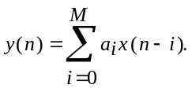

Kaizer FIR filter design method
Initial data for FIR filter design are formulates as it’s magnitude response requirements. Those requirements are specified as shown in the figure below. The following response parameter must be specified:
- Pass band edge(s) frequency(ies) 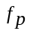 (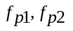);
- Stop band edge(s) frequency(ies) 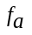 (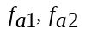);
- Pass band(s) ripple 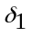;
- Minimum stop band attenuation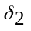;

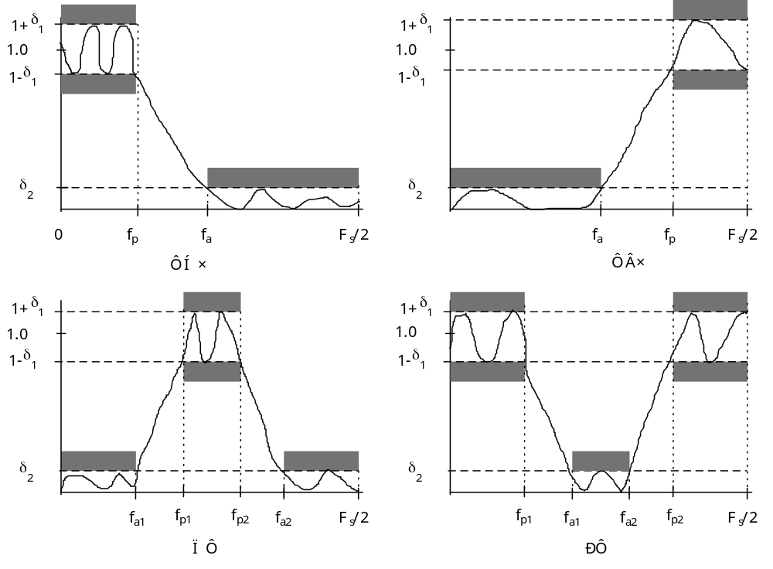

In practice instead of 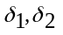, the logarithmic values 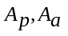 (dB) are specified as follows:
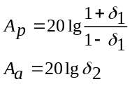
FIR filter is designed in the following sequence:
1) Auxiliary parameters are calculated:
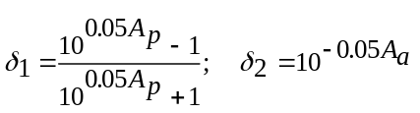
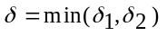
Pararmeters in the table below are calculated in different ways depending on the magnitude response type:

Response type | Calculation formulas
LPF | 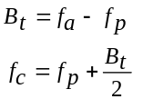
HPF | 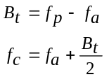
BPF | 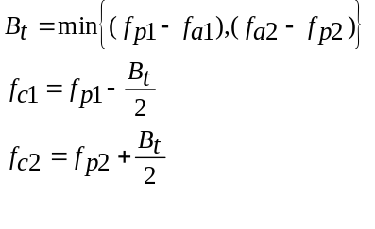
BSF | 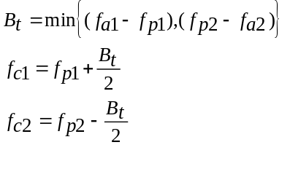

2) Calculate the filter order M and Kaizer window parameter using auxiliary parameters values ca A and D calculated with the empiric formulas:
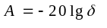
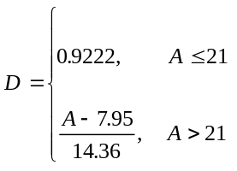
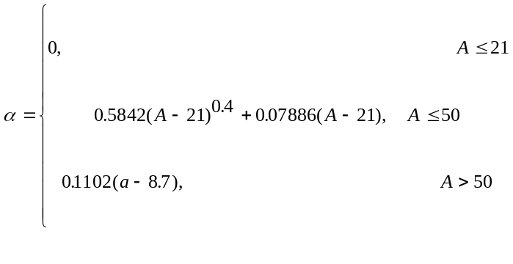
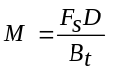
The filter length (tap number) .
3) Calculate Fourier coefficients 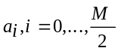 with 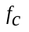 or 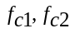 by using formulas in the table below.

Response type | M четное  N=(M+1) нечетное | M нечетное  N=(M+1) четное
LPF | 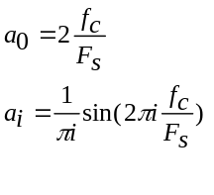 | 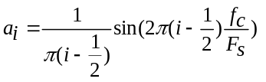
HPF | 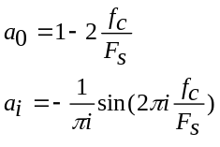 | 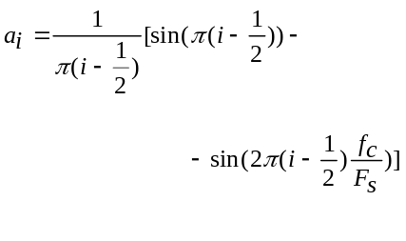
BPF | 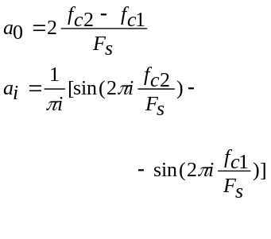 | 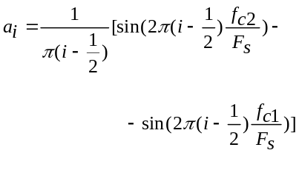
BSF | 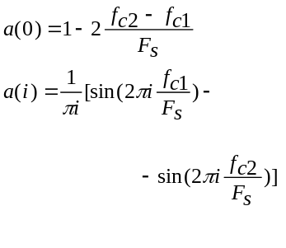 | 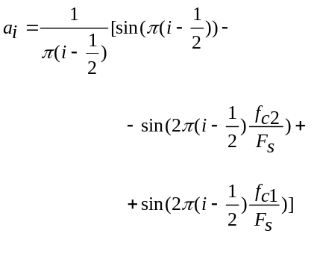
Differentiator | 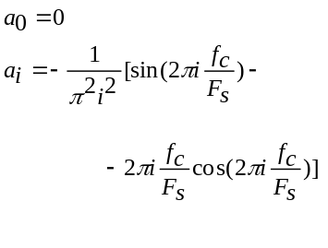 | 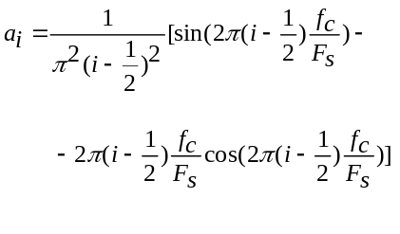
Hilbert  Transformer | 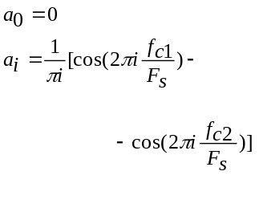 | 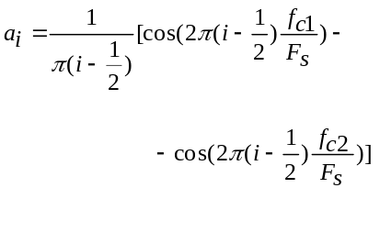

4) Weigh the Fourier coefficdients by the Kaizer window.
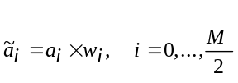
Kaizer window samples are calculated as follows:
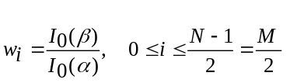
where 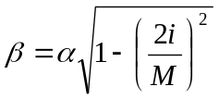, 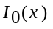 - Bessel function which can be calculated using series expansion:
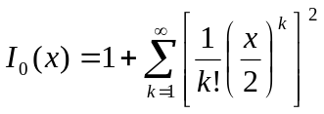.
5) Calculate FIR filter coefficients:
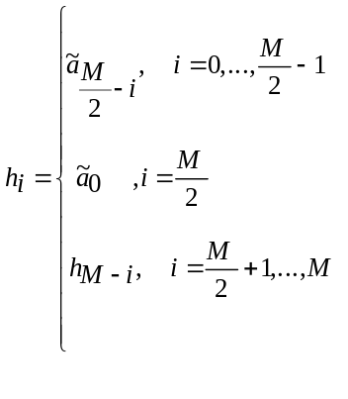
6) Calculate the filter magnitude response and chek it’s correspondance to the specification. Usually the response pass band value is not equal to 1. So normalisation is necessary.
If after normalization response meets the initial requirements are met we obtained the required filter. If they are not met we have to increase filter order and repeat calculation steps 3-6.
Example: design a FIR filter with fp=100Hz, fa=150Hz, fs=1000Hz, Ap=2dB, Aa=30dB.
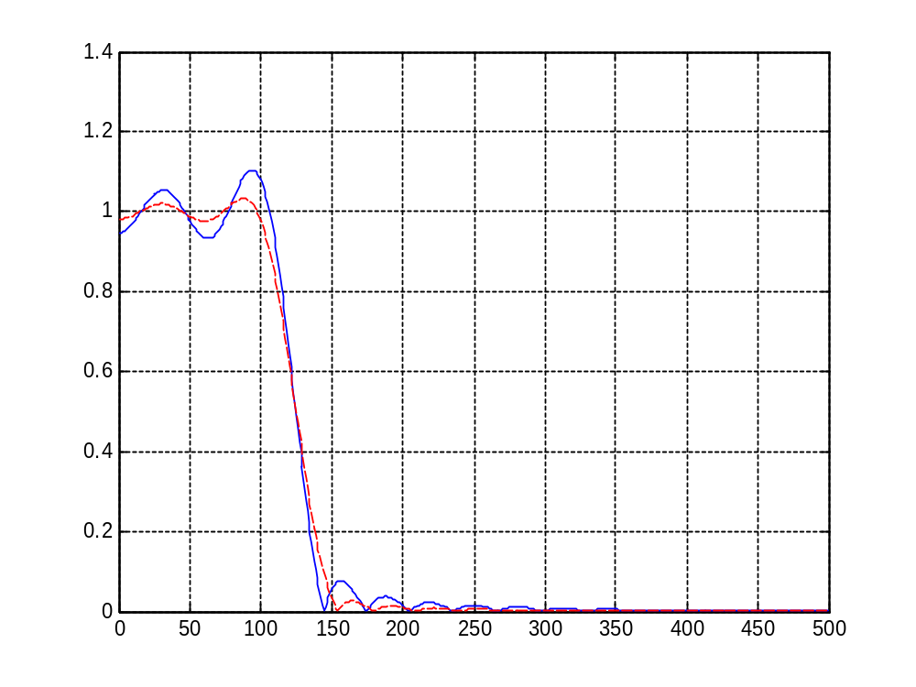
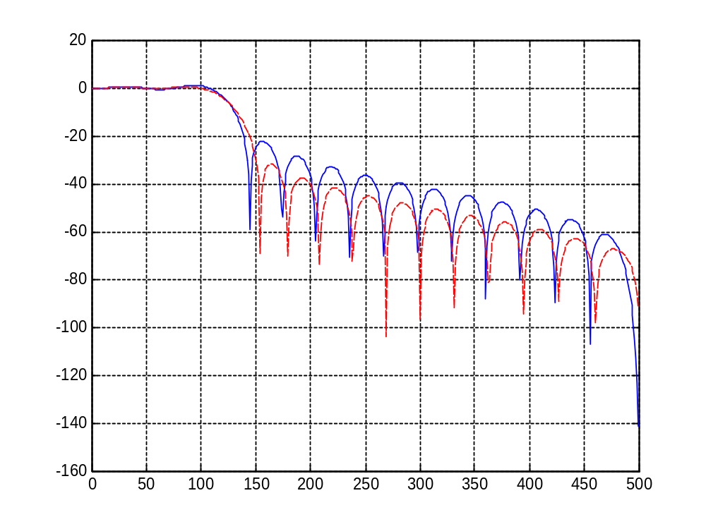
Blue solid line – without window, red dashed line – with Kaizer window.

Parks-McClellan FIR filter design method

Parks-McClellan filter design method produces minimax approximation of frequency response using Remez exchange algorithm.
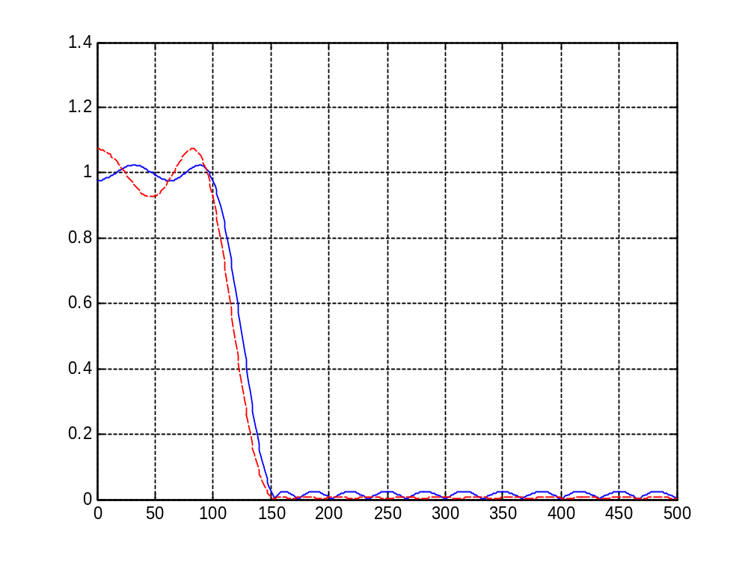
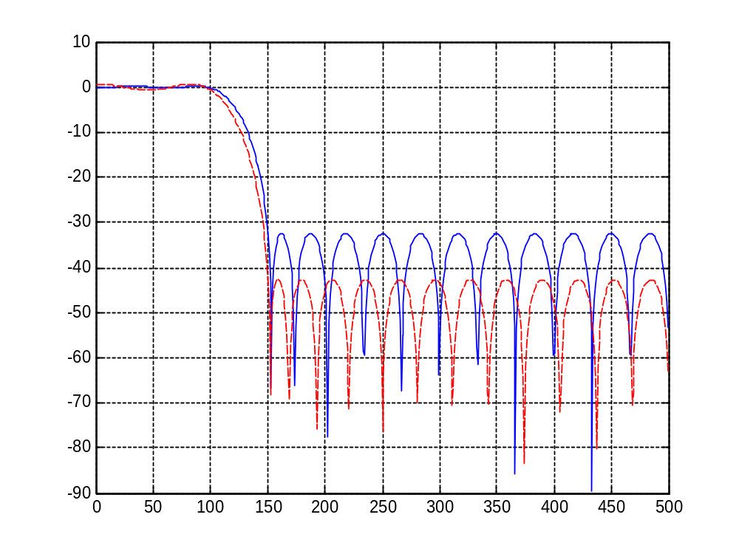
Blue solid line – weight is [1 1], red dashed line – weight is [1 10].

Comparison of IIR and FIR filters

IIR filters
Advantages | Disadvantages
1. Lower order with the same frequency response requirements. | 1. Potential stability problems.
 | 2. Nonlinear phase response.
 | 3. Limit cycle oscillations.
 | 4. In multyrate systems number of operation does not depend on decimation/interpolation factor.

FIR filters
Advantages | Disadvantages
1. Exactly linear phase response can be obtained. | 1. High order.
2. In multyrate systems number of operations is decreasing when decimation/interpolation factor increases.
3. High order filter can be effectively implemented using fast convolution with FFT.

