Problem: websocket is unavailable because port is unresponsive.

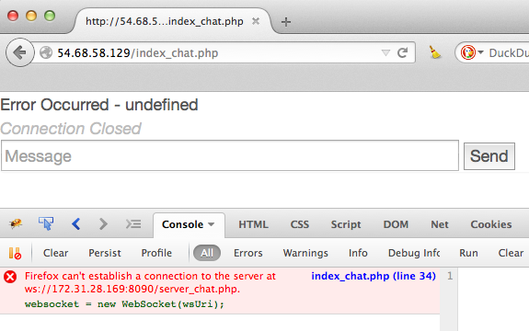

1. Confirm that the port 8000 has the state of ESTABLISHED with another connection that has the state CLOSE_WAIT.

Enter the following command from terminal: netstat -antp

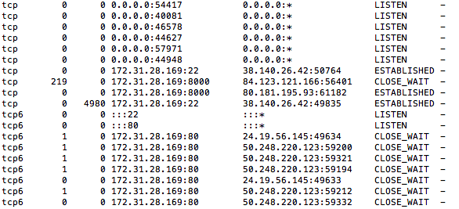

2. find the PID of the process using port 8000

Enter the command: sudo lsof -i :8000

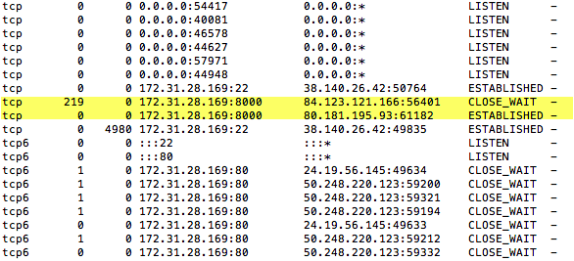

kill the process with the PID

Enter the command: sudo kill -9 30433

confirm that the process has been killed (will probably take several minutes)

Enter the command: netstat -antp