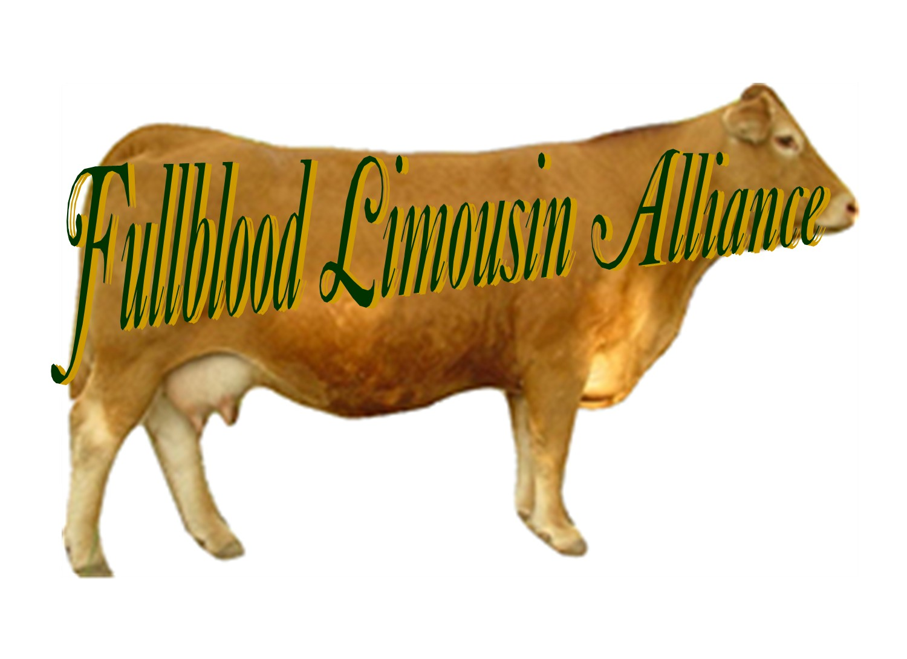

Fullblood Limousin Alliance Junior Membership Application

Membership is free to anyone 21 and under. Must resubmit each year.

Member name: Date of birth:

Address:

City State Zip

Phone #:

Email Address:

Website:

Member of 4-H / FFA

Parent or guardian signature

Check out our web site for more information: www.fullbloodlimousinalliance.org

Send to: Connie Crockett
FLA Secretary
518 SW 20th Lane
Lamar, MO 64759
417 682 2710
DATE:___________________________
mocdjllimousin@yahoo.com

