Game Day Analytics Challenge 2026
A Comprehensive Narrative of Brand Visibility & Engagement
Author: Bogdan Shalimov. MSBA

Executive Summary
The Super Bowl represents a convergence of entertainment, culture, and commercial strategy. While television advertising captures exposure, social media captures reaction. This white paper analyzes Twitter data related to Super Bowl advertisements using keyword frequency, engagement metrics, geographic distribution, and interaction structure to uncover how brands truly performed in the digital space. The analysis demonstrates that digital success is not solely determined by volume of mentions, but by engagement efficiency, conversational amplification, and regional intensity.

Data Preparation & Cleaning
Before analysis, the dataset required structured preprocessing to ensure reliability: • Duplicate tweets were removed using unique identifiers (id). • Columns with 80–100% missing values were eliminated to reduce noise. • Location data was standardized and missing values were labeled 'Unknown'. • A structured State field was extracted for geographic mapping. • created_at was converted to datetime format for time-based aggregation. • Binary variables were engineered: – Has_URL (1 = contains URL, 0 = no URL) – Is_Reply_Or_RT (1 = reply/retweet, 0 = original post) • Advanced performance metrics were created: – Engagement Total = Likes + Retweets + Replies + Quotes – Engagement Rate = Engagement Total ÷ Impression Count These transformations allowed the transition from raw tweet activity to meaningful performance analytics.

Keyword Volume Analysis

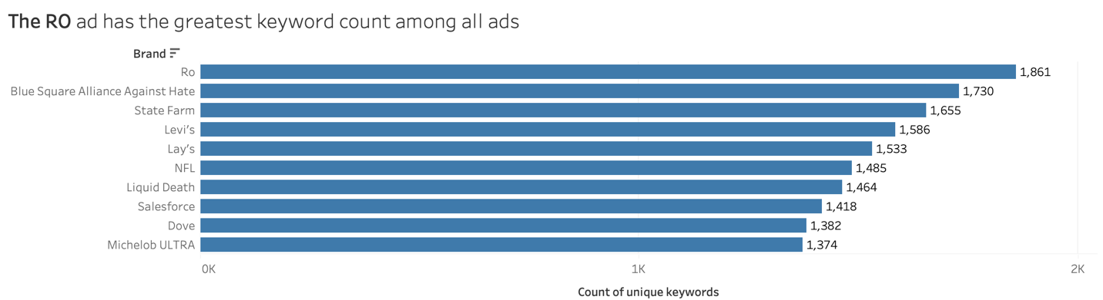
Figure 1: Brands ranked by count of unique keywords.
This diagram ranks brands by the number of unique keywords associated with their advertisements. The chart measures conversation presence rather than performance efficiency. While “Ro” leads in keyword count, this metric reflects visibility and discussion breadth—not necessarily depth of engagement.

Brand Engagement Performance

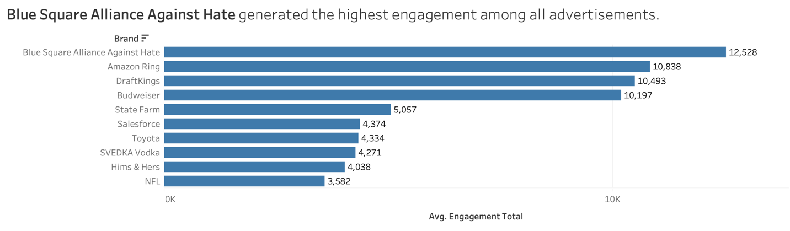
Figure 2: Average engagement generated per brand.
This bar chart compares average engagement totals across brands. Unlike keyword volume, this metric evaluates audience interaction intensity. Blue Square Alliance Against Hate demonstrates the strongest average engagement, indicating higher audience responsiveness per tweet.

Geographic Engagement Distribution
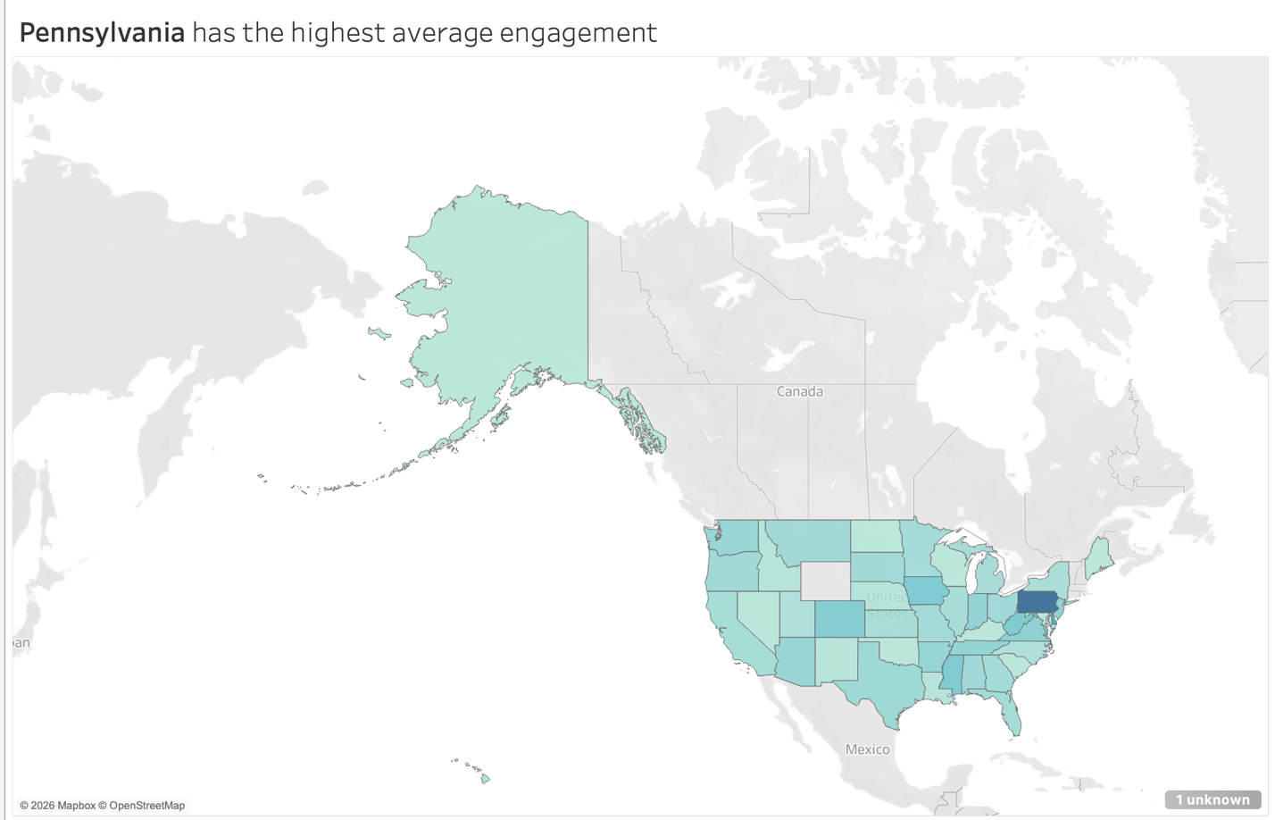
Figure 3: State-level average engagement heat map.
The geographic heat map visualizes average engagement by U.S. state. Pennsylvania shows the highest average engagement, revealing regional concentration in digital amplification. This suggests that national campaigns can still experience localized digital intensity.

URL Impact Analysis

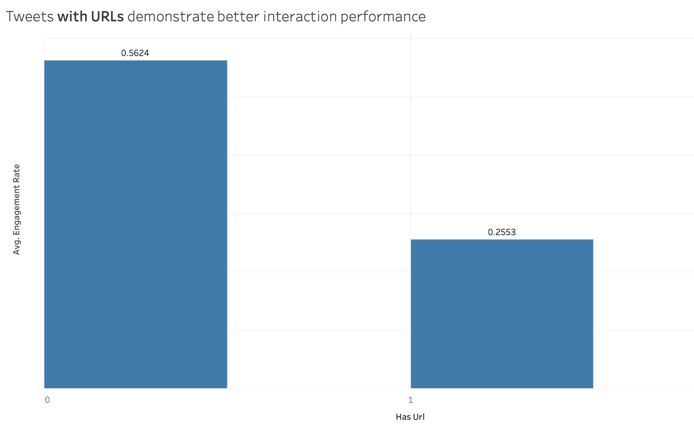
Figure 4: Engagement rate comparison – tweets with vs without URLs.
This chart compares engagement rate between tweets containing URLs and those without. Tweets without URLs demonstrate higher engagement efficiency, suggesting that organic conversation drives stronger interaction than link-based promotional posts.

Conversation Amplification

Figure 5: Engagement rate – original posts vs replies/retweets.
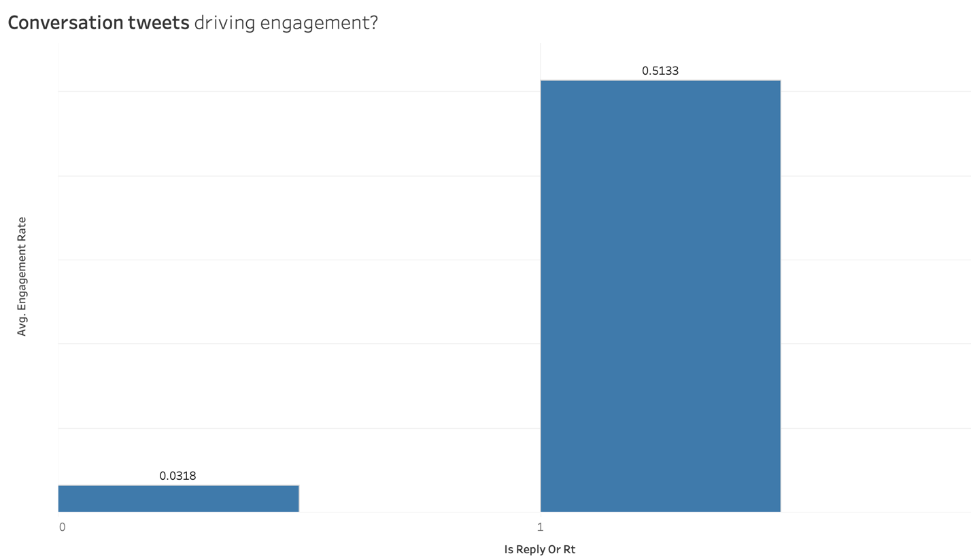
Figure 5: Engagement rate – original posts vs replies/retweets.
This visualization evaluates whether conversation-driven tweets outperform standalone posts. Replies and retweets show significantly higher engagement rates, highlighting the importance of interactive amplification during high-profile live events.

Language Distribution

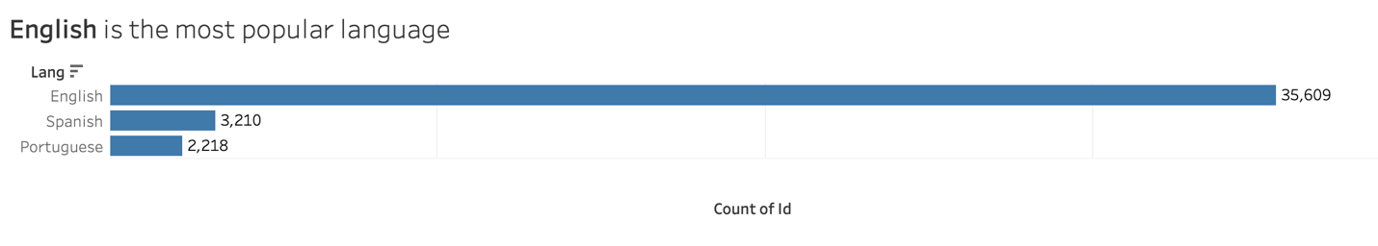
Figure 6: Distribution of tweets by language.
The language distribution chart demonstrates that English dominates Super Bowl-related conversation. However, the presence of Spanish and Portuguese tweets indicates cross-market digital participation.

Most popular tweet

@AccessBadBunny: ALL THE LATIN AMERICAN COUNTRIES BEING MENTIONED BY BAD BUNNY IN THE HALFTIME SHOW. #SuperBowl https://t.co/sYySsOmTE8

6,899,140 interactions !

Unique Findings
1.Keyword dominance does not guarantee engagement leadership. 2. Engagement Rate provides a more stable performance measure than raw interaction counts. 3. Conversation-driven tweets significantly outperform static promotional posts. 4. Geographic concentration reveals uneven digital amplification across states. 5. Organic content without embedded links often generates higher interaction efficiency.

Limitations of Analysis
• Twitter users represent only a subset of the Super Bowl audience. • Location data is self-reported and may not reflect actual tweet origin. • Impression counts may vary depending on account reach and API constraints. • Engagement Rate can be inflated for tweets with low impression counts. • Analysis reflects a specific event timeframe and may not capture long-term brand impact. • Location data was partly missed or improper.

Conclusion
The analysis reveals that effective Super Bowl advertising extends beyond visibility. Digital performance is shaped by interaction structure, conversational momentum, regional amplification, and engagement efficiency. By transforming raw social data into structured analytical insight, this study uncovers the deeper dynamics of brand performance during one of the world’s most visible marketing events.

