template For preparation of articles
Name Surname¹, Name Surname², Name Surname^{1,2}
¹Organization, ²Organization
mail_a@mail.com, mail_b@mail.com
Abstract. Abstract should consist of single paragraph, approximately between 1500-2000 characters with spaces. Bullets and numbering cannot be used in abstract. Abstract text abstract text abstract text abstract text abstract text abstract text abstract text abstract text abstract text abstract text abstract text abstract text abstract text abstract text abstract text abstract text abstract text abstract text abstract text abstract text abstract text abstract text abstract
Keywords: word, word, word.
Introduction
This template should be used in preparation of articles for international scientific conference “Research for rural development 2016”. The advisable structure of the article: title, name, surname of the authors (no more than 4), organisation, e-mail address, abstract, key words, introduction, materials and methods, results and discussion, conclusions, references. The advisable number of pages is 6. Each extra page publication 10 Euro per page.
The article should be prepared in English in MS Word program on A4 format pages with 25 mm top and bottom margins, 30 mm inside and 20 mm outside margin. All text should be written using Unicode Times New Roman, main text with 11 pt font size, single line spacing and 3 pt after-paragraph spacing, 7 mm first line indent and justified.
Title of the article should be in all caps, 11 pt, centered, bold and 6 pt after-paragraph spacing. Names and surnames of authors should be in 10 pt font size, bold and centered. Institution and contact information – 11 pt and centered. Author names can be linked to institutions using numbers in superscript format: the same number after author name and before institution (see example in this document). E-mails should not be linked to authors. Please do not use diacritical marks for names and organizations.
Abstract and key words text – 10 pt with words “abstract” and “keywords” in bold.
Titles can be pointed out using bold style. All variables in the plain text and formulae should be formatted in italic. Position and formatting of table and figure titles are given in the sample article. Tables should be in MS Word or Excel, formulas – MS Equation, diagrams – MS Word or Excel. In order to achieve the best quality of final look of the article it is recommended to supply all figures and chart data electronically in separate files. If the article includes objects prepared in other programs, for instance, Excel diagram, Visio scheme, CorelDraw figure etc., we would like to ask you to send also the file in which this object was prepared. If possible complicated figures and schemes should be prepared in mentioned drawing programs avoiding large grouped objects in MS Word documents.
The template uses the correct page formatting and contains all the necessary styles. The styles are summarized in Table 1. At the same time Table 1 alongside with Table 2 in Materials and methods section show examples of tabular data formatting.
Table 1
Styles used in this template
Style | Usage | Comments
A_article_title | Use to format title of the article | -
A_name | Use to format first names and surnames of the authors | Separate each author’s name and surname using commas
A_organization | Use to format organization and contact information | Do not give address of the organization
A_abstract | Use to format abstract and keywords | Titles “Abstract:” and “Keywords:” leave in bold
A_title | Use to format titles | -
Table 1 (continued)
A_title_num, A_title_num2 | Use to format titles using 2-level numbering | Authors can choose titles with or without numbering but style should be kept consequently throughout he article
A_text | Use to format plain text of the article | -
A_figure | Use to format figures (if “In line with text” laout is used) and titles of the figures | Number of figure and explanations in title should be in regular font, but the title itself in bold
A_table_number | Use to format table number e.g. Table 1 | -
A_table_title | Use to format table title | -
A_table_text | Use to format table text | -
A_formula | Use to format formulae | -
A_formula_variables | Use to format explanations of the variables | Add units of measure to each variable explanation
A_reference | Use to format the reference list | -
A_numbering | Use to format numbered lists | Try to avoid multi-level numbering
A_bullet | Use to format bulleted lists | Try to avoid multi-level bulleting
A_conclusions | Use to format conclusions as numbered list | -
Materials and methods
Figures should be referenced in text as “Figure 1” or “Fig. 1” (without quotes). Explanatory notes in figures can be shown using numbered callouts with comments in title of the figure. The text in figures should be of the same size and font as the main text of the article. Figures can also be used in colors.

1
2
Fig. 1. Title of the figure: 1 – clock; 2 – book
Example of experimental data plot can be found in Fig. 2. Example of graph of a function is given in Fig. 3. Fig. 4 shows an example of a column chart.
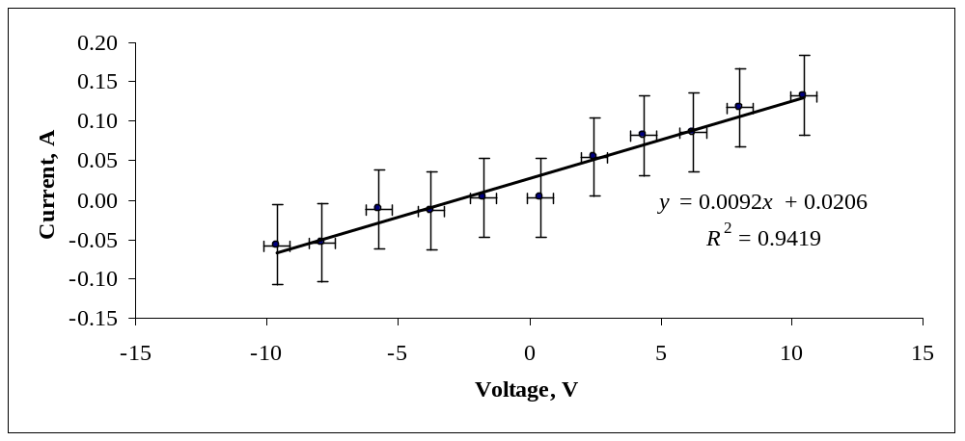
Fig. 2. Experimental U-I curve of 100 Ω resistor
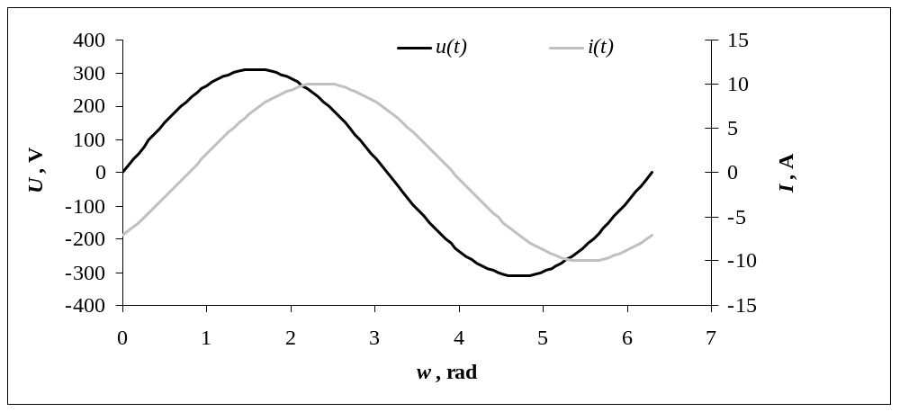
Fig. 3. Phase between voltage and current
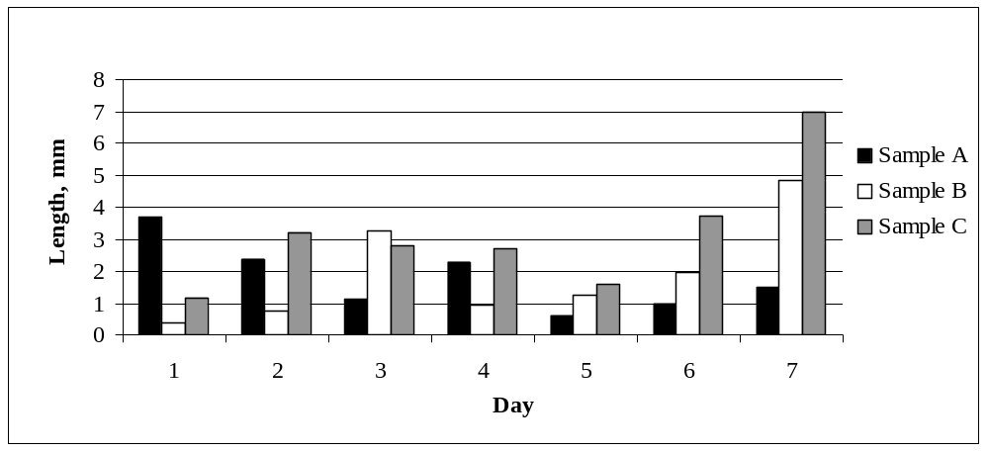
Fig. 4. Sample length by day
In order to achieve the best quality of final look of the article it is recommended to supply all figures electronically in separate files. It is preferable to use the following file formats for illustrative data.
- Photographs, scans and other real-world images: jpg.
- Objects from analytical, modeling, design etc. software (plots, model diagrams, charts): wmf, emf, eps.
- Spreadsheet (e.g. Excel) objects like charts, plots, diagrams: in a separate xls file. If it is possible, please also supply source data for plots and charts.
Each file of figure should be named in accordance to numbering in article, e.g. “Fig1.jpg”.
Try to avoid placing screenshots of charts from various software if fonts on the chart are significantly smaller as main text font of the article.
Tables should be referenced in text as “Table 2” (without quotes). Header row and other key cells can be pointed out using bold or italic font. Tables should consist of at least 3 columns and 4 rows. Try to arrange large tables on a single page. Leave 6pt gap before first paragraph coming after table. Tables should not contain numbering column instead of it rows can be referenced in text, e.g. as it can be seen from Table 2 the green is 99.50 mm and is the longest one, blue is 1.00 mm and is the shortest one.
Width of tables and figures should not exceed the margins of the document.
Table 2
Title of the table
Color | Count | Length, mm
Red | 2 | 3.12
Green | 44 | 99.50
Blue | 10 | 1.00
Formulae and variable explanation should be formatted using appropriate styles. Authors can prepare formulae in any equations editor and insert them as pictures, but MS Equation editor is preferable. Formulae can be numbered throughout the article and referenced in text using these numbers and round brackets (1).
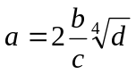 (1)
where a – variable one, units;
b – variable two, units;
c – variable three, units;
d – variable three, units.
Constant numbers are in regular font. Variables in formulae and text should be written in italic e.g. variable a is proportional to b and inversely proportional to c. Equation objects should not be used in plain text. Use only regular symbols if it is necessary to include mathematical expression in text e.g. a + b = c. Units of measurement with fractions should be written using power notation e.g. SI unit of speed is m·s⁻¹. For currencies use ISO 4217 notation e.g. EUR, USD, LVL, currency signs should not be used. Use hard-space (Space+Shift+Ctrl) between value and units of measurement, including degrees and percents, e.g. 5 % and 5 ºC. Leave hard-space also before percent sign. Leave 6pt gap before first paragraph coming after formula variable explanations.
References to other author’s work should be put in text using square brackets [1]. More than one reference can be separated using semicolon for enumeration [2; 3; 5] (only second, third and fifth reference) and dash [4-8] (all references from forth to eighth).
Results and discussion
Text text text text text text text text text text text text text text text text text text text text text text text text text text text text text text text text text text text text text text text text text text text text text text text text text text text text text text text text text text text text text text text text text.
- Numbering;
- Numbering;
- Numbering.
Leave 6pt gap before first paragraph coming after numbered list. Text text text text text text text text text text text text text text text text text text text text text text text text text text text text text text
- Bulleting;
- Bulleting;
- Bulleting.
Leave 6pt gap before first paragraph coming after bulleted list.
Reference examples in this template: book [1], journal article [2], conference proceedings [3], standard [4], reference in other language [5], online source [6] and online source in other language than English [7]. Do not leave hyperlinks formatting. List references in the order as there are cited in the text.
Conclusions
- Conclusions can be represented using plain text or numbered using appropriate style.
- Text text text text text text text text text text text text text text text text text text text text text text.
- Text text text text text text text text text text text text text text text text text text text text text text.
- Text text text text text text text text text text text text text text text text text text text text text text.
- Text text text text text text text text text text text text text text text text text text text text text text.
References
- Kalpakjian S., Schmid S.R. Manufacturing engineering and technology. Sixth edition. New York: Prentice Hall, 2010. 1176 p.
- Kitchen N.R., Drummond S.T., Lund E.D. etc. Soil electrical conductivity and topography related to yield for three contrasting soil-crop systems. Agronomy Journal, vol. 95, 2003, pp. 483-495.
- Kakitis A., Nulle I. Durability of stalk material briquettes. Proceedings of International conference “Scientific achievements for wellbeing and development of society”, March 4-5, 2004, Rēzekne, Latvia, pp. 26-31.
- LVS EN 10002-1 standard “Metals. Tensile test. 1. Part: Test method on surrounded environment temperature”
- Гришкин Ф.В., Лиепинш М.М., Рыбицкий Л.С. Анализ применения модуляции плотности имлулсов в преобразователях частоты асинхронного електропривода (Analysis of impulse density modulation use in frequency converters of asynchronous elektrodrive). Latvian journal of physics and technical sciences: Latvijas Zinātņu akadēmijas vēstis. Fizikas un tehnisko zinātņu sērija, 1991, No 1. (In Russian).
- Deadlines of the international scientific conference “Engineering for rural development 2011”. [online] [31.03.2011]. Available at: http://www.tf.llu.lv/conference/index.php?topicID=4
- Akadēmiskās bakalaura studiju programmas “Lauksaimniecības inženierzinātne” ikgadējie pašnovērtējuma ziņojumi par iepriekšējo akreditācijas periodu, 2002-2008. gads (Annual self-assessment reports for last accreditation period of the academic bachelor study program “Agricultural Engineering”, years 2002-2008). Jelgava: Latvia University of Agriculture, Faculty of Engineering, 2008. 37 p. (In Latvian). [online] [31.03.2012]. Available at: http://www.aiknc.lv/zinojumi/lv/LLULaukInzB08.pdf.

