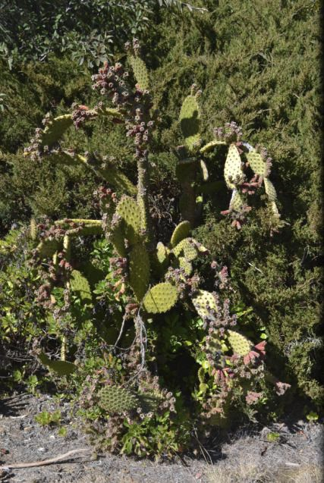

The Group continues to find and remove \*Opuntia plants above

Chapman. We’ve found tall ones - 1 - 2 metres plus. We think our   
horror weed may not be \*O. stricta. It may, however, be a garden   
escape. (It bears a strong resemblance to specimens in properties   
abutting the Reserve.)

Traditional Uses of Prickly Pear

The fruits ("tunas") are eaten raw or turned into candies or jellies. The flat, paddle-shaped stem

segments (cladodes), harvested   
young and tender, are eaten as a   
vegetable (Mexican “Nopales”).   
Plants have also been used for   
barriers on property lines (eg

villages in the Middle East during the First World War).

Family - Cactaceae (from Latin cactus

(káktos, “cardoon”, of pre-Gk. origin).

Genus - Opuntia (Gk. - a   
region - Locris Opuntia - where   
other spiny plants grew)   
Occurrence - throughout the   
Americas. (O. s. came from the   
Caribbean.). Various species   
now naturalised world-wide.