System Programming Lab

COE – 410

By – Divjot Singh

262/CO/12

COE – 1

**Index**

|  |  |  |
| --- | --- | --- |
| **#** | **Experiment** | **Signature** |
| 1 | Write an assembly program that reads a character from the keyboard and writes the character on the screen. |  |
| 2 | Write an assembly program to read a string of characters and print the reverse of this string. |  |
| 3 | Write an assembly program that compares two strings of characters. |  |
| 4 | Write an assembly program that checks whether a string is a palindrome or not. |  |
| 5 | Write an assembly program to find the sum of first n natural numbers. |  |
| 6 | Write an assembly program to add B numbers and print their sum. |  |
| 7 | Write an assembly program that sorts N numbers (Bubble Sort). |  |
| 8 | Write an assembly program makes cursor size bigger |  |
| 9 | Write an assembly program that saves 4 digit hex number input from keyboard to memory location TEMP. |  |
| 10 | Write an assembly program that displays the hex number stored in AX register. |  |

**Assembler Used:** NASM for OS X 10.11 (UNIX based)

**Build Instructions:**

nasm –f macho filename.asm

ld –o programName –e startLabel filename.o

**Execution Instruction:**

./programName

**Experiment 1**

**Code**

*; Assembly program that reads a character from the keyboard and writes the character on the screen.*

global start ; making start visible externally

*; uninitialized data goes to bss section*

section .bss

input resb 2

*; initialized data goes to data section*

section .data

msg db 'Enter a character and press enter after it: '

msgLen equ $ - msg

*; code section*

section .text

start:

call _prompt *; print welcome msg*

*; read (int fileDescriptor, void* buff, size_t count)*

push dword 1 *; 1 character to be read*

push dword input *; input buffer*

push dword 0 *; file descriptor number for STDIN in 0*

sub esp, 4 *; unix requriement of extra space in stack*

mov eax, 3 *; system call number for read is 3*

int 0x80 *; invoke system call*

add esp, 16 *; clearing stack (4 bytes x 3 args + 4 extra space)*

*; appending input with carriage return*

mov dword [input + 1], 0xA

*; write (int fileDescriptor, void* buff, size_t count)*

push dword 2 *; 2 character to be printed*

push dword input *; write the input*

push dword 1 *; file descriptor number for STDOUT is 1*

sub esp, 4 *; unix requirement of extra space in stack*

mov eax, 4 *; system call number for write is 4*

int 0x80 *; invoke system call*

add esp, 16 *; clearing stack (4 bytes x 3 args + 4 extra space)*

*; exit (int statusCode)*

push dword 0 *; exit status code*

sub esp, 4 *; unix requirement of extra space in stack*

mov eax, 1 *; system call number for exit is 1*

int 0x80 *; invoke system call*

*; Prints welcome messsage of the program*

_prompt:

*; write (int fileDescriptor, void* buff, size_t count)*

push dword msgLen *; length of message*

push dword msg *; address of message*

push dword 1 *; STDOUT*

sub esp, 4 *; unix requirement of extra space in stack*

mov eax, 4 *; system call number for write is 4*

int 0x80 *; invoke system call*

add esp, 16 *; clearing stack (4 bytes x 3 args + 4 extra space)*

ret

**Output**



**Macros.asm**

Since printing, reading and exiting system calls are readily used, I’ve created a macros.asm file to use them in a quicker way.

**Code**

; Usage: print <stringPtrName> <length>

%macro print 2

; write (int fileDescriptor, void* buff, size_t count)

push dword %2 ; length of input

push dword %1 ; pointer to the input

push dword 1 ; file descriptor number for STDOUT is 1

sub esp, 4 ; unix requirement of extra space in stack

mov eax, 4 ; system call number for write is 4

int 0x80 ; system call

add esp, 16 ; clearing stack (4 bytes x 3 args + 4 extra space)

%endmacro

; Usage: read <stringPtrName> <length>

%macro read 2

; read (int fileDescriptor, void* buff, size_t count)

push dword %2 ; size of input buffer

push dword %1 ; pointer to input buffer

push dword 0 ; file descriptor number for STDIN in 0

sub esp, 4 ; unix requriement of extra space in stack

mov eax, 3 ; system call number for read is 3

int 0x80 ; system call

%endmacro

; Usage: exit <statusCode>

%macro exit 1

; exit (int statusCode)

push dword %1 ; exit status code

sub esp, 4 ; unix requirement of extra space in stack

mov eax, 1 ; system call number for exit is 1

int 0x80 ; system call

%endmacro

**Experiment 2**

**Code**

%include "../macros.asm" ; contains print, read and exit macros

; Assembly program that reverses given string

global start ; making start visible externally

section .text

start:

; Reading string

print mEnterString, mEnterStringLength

read input, 100

mov dword [inputLength], eax

; Reversing

mov ecx, 0

mov edx, dword [inputLength]

sub edx, 2 ; ignoring 0xA from string and fixing 0 indexing

mov eax, edx ; copy of last index

; Traversing input from behind and saving it to reversedInput in forward directon

loop: mov bl, byte [input + edx] ; copy last of input to bl

mov byte [reversedInput + ecx], bl ; copy bl to first of reversedInput

inc ecx ; increment first of reversedInput

dec edx ; decrement last of input

cmp ecx, eax ; compare first of reversedInput to length of input - 1

jle loop ; if not equal, continue

; Print result

print mReversedString, mReversedStringLength

print reversedInput, dword [inputLength]

print mNewLine, mNewLineLength

exit 0

section .bss

input resb 100

reversedInput resb 100

inputLength resd 1

section .data

mEnterString db 'Enter a string: '

mEnterStringLength equ $ - mEnterString

mReversedString db 'Reversed string: '

mReversedStringLength equ $ - mReversedString

mNewLine db 0xA

mNewLineLength equ $ - mNewLine

**Output**

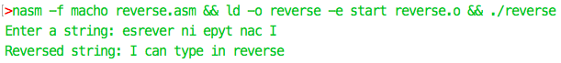

**Experiment 3**

**Code**

%include "../macros.asm"

; Assembly program that compares 2 given strings

global start ; making start visible externally

section .text

start:

; reading first string

print outStr1, outStr1L

read str1, 100d

mov dword [str1L], eax

; reading second string

print outStr2, outStr2L

read str2, 100d

mov dword [str2L], eax

; printing the strings

print outS1, outS1L

print str1, dword [str1L]

print outS2, outS2L

print str2, dword [str2L]

; comparing length

mov eax, dword [str1L]

cmp dword [str2L], eax

jne printLNE

; comparing each character

mov edx, -1

_loop: inc edx

cmp edx, dword [str1L]

jg printE

mov ebx, dword [str1 + edx]

cmp ebx, dword [str2 + edx]

je _loop

jne printNE

end: exit 0

; print that the two strings are not equal in length

printLNE:

print outLNE, outLNEL

jmp end

; print that the two strings are not equal

printNE:

print outNE, outNEL

jmp end

; print that the two strings are equal

printE:

print outE, outEL

jmp end

section .bss

str1 resb 100d

str2 resb 100d

str1L resd 1

str2L resd 1

section .data

outS1 db 'String 1 : '

outS1L equ $ - outS1

outS2 db 'String 2 : '

outS2L equ $ - outS2

outLNE db 'Length of given strings not equal', 0xA

outLNEL equ $ - outLNE

outNE db 'Given strings are not equal', 0xA

outNEL equ $ - outNE

outE db 'Given strings are equal', 0xA

outEL equ $ - outE

outStr1 db 'Enter String 1: '

outStr1L equ $ - outStr1

outStr2 db 'Enter String 2: '

outStr2L equ $ - outStr2

**Output**

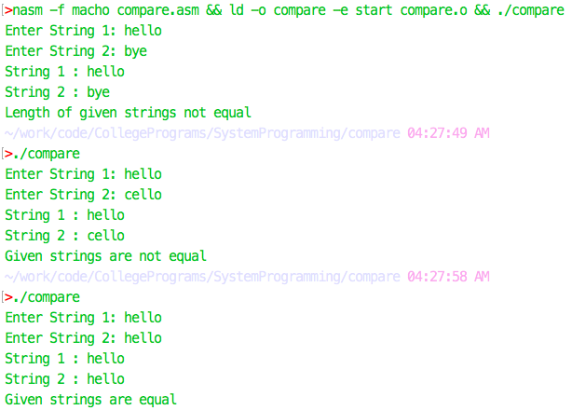

**Experiment 4**

**Code**

%include "../macros.asm" ; macros.asm contains print, read and exit macros

; Assembly program that tells whether given string is a palindrome or not

global start ; making start visible externally

; code section

section .text

start:

; reading string

print mEnterString, mEnterStringLength

read input, 100d

mov dword [inputLength], eax

; printing the string

print mYouEntered, mYouEnteredLength

print input, dword [inputLength]

mov eax, -1 ; -1 index

mov ebx, dword [inputLength]

sub ebx, 1 ; n index

loop: inc eax ; increment start index

dec ebx ; decrement end index

cmp eax, ebx ; compare them

jge printP ; if greater than or equal, string is palindrome

mov dl, byte [input + eax] ; else, save input[eax] to dl

mov dh, byte [input + ebx] ; save input[ebx] to dh

cmp dl, dh ; compare dl and dh

jne printNP ; if not equal, string isn't palindrome

je loop ; else, continue

end: exit 0

; print that the string is not a palindrome

printNP:

print mIsNotPalindrome, mIsNotPalindromeLength

jmp end

; print that the string is a palindrome

printP:

print mIsPalindrome, mIsPalindromeLength

jmp end

section .bss

input resb 100d

inputLength resd 1

section .data

newLine db 0xA

mYouEntered db 'You Entered : '

mYouEnteredLength equ $ - mYouEntered

mIsNotPalindrome db 'Given string is not a palindrome', 0xA

mIsNotPalindromeLength equ $ - mIsNotPalindrome

mIsPalindrome db 'Given string is a palindrome', 0xA

mIsPalindromeLength equ $ - mIsPalindrome

mEnterString db 'Enter a String: '

mEnterStringLength equ $ - mEnterString

**Output**

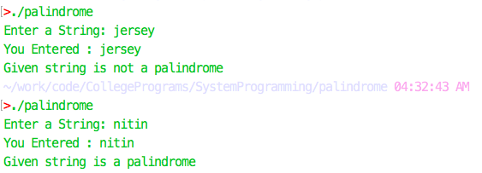

**Experiment 5**

**Code**

%include "../macros.asm"

; Program to print sum of first N natural numbers

global start

section .text

start:

; Taking input

print mEnterN, mEnterNLength

read input, 100

dec eax ; ignoring 0xA from length

mov dword [inputLength], eax

call dec2AX

; Computing sum

mov ebx, eax ; n in BX

inc ebx ; n + 1 in BX

mul ebx ; n*(n + 1) in DX AX

shr eax, 1 ; n*(n + 1)/2 in AX

call AX2dec

; Printing output

print mSum, mSumLength

print input, [inputLength]

print mNewLine, mNewLineLength

exit 0

; Converts ascii decimal number string [input] -> [input + inputLength] to hex number in EAX

dec2AX:

push ebx ; saving BX before overwriting

push ecx ; saving CX before overwriting

push edx ; saving DX before overwriting

mov eax, 0 ; stores final number

mov ebx, 0

mov ecx, 0 ; our index variable

mov edx, dword [inputLength] ; DX =

dec edx ; length - 1

.loop: mul byte [ten] ; AX = AX * 10d

mov bl, byte [input + ecx] ; bl = ascii digit

sub bl, 0x30 ; bl = digit

add eax, ebx ; AX = AX + digit

inc ecx ; set index pointer to next digit

cmp ecx, edx ; if index pointer points to last digit

jle dec2AX.loop ; loop if CX <= DX

pop edx ; restoring DX after using it

pop ecx ; restoring CX after using it

pop ebx ; restoring BX after using it

ret

; Converts EAX hex number to ascii decimal number string in [input] -> [input + inputLength]

AX2dec:

push ebx ; saving BX before overwriting

push ecx ; saving CX before overwriting

mov ebx, 0x0 ; count of digits pushed to stack

mov ecx, 0x0 ; holds the digit before pushing to stack

; converting to ascii

.loop: div byte [ten] ; AL = AX/10, AH = AX%10

mov cl, ah ; CL = AH

add cl, 0x30 ; AX%10 += ascii code for '0'

push ecx ; push the digit

inc bl ; count of digits in stack

mov ah, 0 ; restore dividend

cmp eax, 0x0 ; loop termination condition

jne AX2dec.loop

; overwrite result over input

mov ecx, 0

mov dword [inputLength], ebx

.loop2: pop dword [input + ecx] ; Take first digit from stack

inc ecx ; increment index pointer

cmp ecx, ebx

jl AX2dec.loop2 ; loop termination condition

pop ecx ; restoring CX after using it

pop ebx ; restoring BX after using it

ret

section .bss

inputLength resd 1

input resb 100

section .data

mEnterN db 'Enter a natural number N: '

mEnterNLength equ $ - mEnterN

mSum db 'Sum of first N natural numbers is: '

mSumLength equ $ - mSum

mNewLine db 0xA

mNewLineLength equ $ - mNewLine

ten db 0xA

**Output**

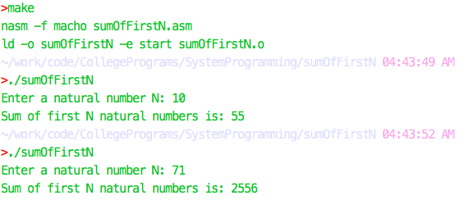

**Experiment 6**

**Code**

%include "../macros.asm"

; Program to print sum of N

global start

section .text

start:

; Taking input N

print mEnterN, mEnterNLength

read input, 100

dec eax ; ignoring 0xA from length

mov dword [inputLength], eax

call dec2AX

mov ecx, eax ; count of numbers to process

mov ebx, 0 ; sum of these numbers

; Inputing N numbers

.loop: print mEnterNext, mEnterNextLength

; Taking ith number

read input, 100

dec eax

mov dword [inputLength], eax

call dec2AX ; Getting ith number in AX

add ebx, eax ; Adding to the sum

dec ecx ; decrementing numbers to be read

jnz start.loop ; loop termination condition

mov eax, ebx ; saving result in AX

call AX2dec ; getting result in input

; Printing result

print mSum, mSumLength

print input, [inputLength]

print mNewLine, mNewLineLength

exit 0

; Converts ascii decimal number string [input] -> [input + inputLength] to hex number in EAX

dec2AX:

push ebx ; saving BX before overwriting

push ecx ; saving CX before overwriting

push edx ; saving DX before overwriting

mov eax, 0 ; stores final number

mov ebx, 0

mov ecx, 0 ; our index variable

mov edx, dword [inputLength] ; DX =

dec edx ; length - 1

.loop: mul byte [ten] ; AX = AX * 10d

mov bl, byte [input + ecx] ; bl = ascii digit

sub bl, 0x30 ; bl = digit

add eax, ebx ; AX = AX + digit

inc ecx ; set index pointer to next digit

cmp ecx, edx ; if index pointer points to last digit

jle dec2AX.loop ; loop if CX <= DX

pop edx ; restoring DX after using it

pop ecx ; restoring CX after using it

pop ebx ; restoring BX after using it

ret

; Converts EAX hex number to ascii decimal number string in [input] -> [input + inputLength]

AX2dec:

push ebx ; saving BX before overwriting

push ecx ; saving CX before overwriting

mov ebx, 0x0 ; count of digits pushed to stack

mov ecx, 0x0 ; holds the digit before pushing to stack

; converting to ascii

.loop: div byte [ten] ; AL = AX/10, AH = AX%10

mov cl, ah ; CL = AH

add cl, 0x30 ; AX%10 += ascii code for '0'

push ecx ; push the digit

inc bl ; count of digits in stack

mov ah, 0 ; restore dividend

cmp eax, 0x0 ; loop termination condition

jne AX2dec.loop

; overwrite result over input

mov ecx, 0

mov dword [inputLength], ebx

.loop2: pop dword [input + ecx] ; Take first digit from stack

inc ecx ; increment index pointer

cmp ecx, ebx

jl AX2dec.loop2 ; loop termination condition

pop ecx ; restoring CX after using it

pop ebx ; restoring BX after using it

ret

section .bss

inputLength resd 1

input resb 100

temp resd 1

section .data

mEnterN db 'Enter a number N: '

mEnterNLength equ $ - mEnterN

mEnterNext db 'Enter next positive number: '

mEnterNextLength equ $ - mEnterNext

mSum db 'Sum of above N numbers is: '

mSumLength equ $ - mSum

mNewLine db 0xA

mNewLineLength equ $ - mNewLine

ten db 0xA

**Output**

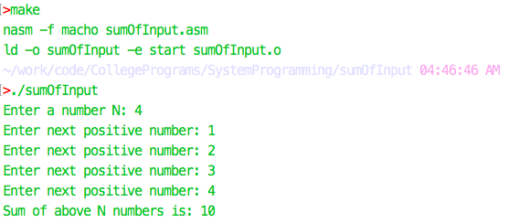

**Experiment 7**

**Code**

%include "../macros.asm"

global start

section .text

start:

print mUnsortedArray, mUnsortedArrayLength

call printArray

call bubbleSort

print mSortedArray, mSortedArrayLength

call printArray

exit 0

bubbleSort:

mov edx, dword [arrayLength] ; DX contains length

; for( i = 0; i < length; i++ )

mov eax, 0 ; AX is i

.outer cmp eax, edx

jge bubbleSort.end

; for ( j = 1; j < length; j++ )

mov ebx, 1 ; BX is j

.inner: cmp ebx, edx

jge bubbleSort.outEnd

mov ch, byte [array + ebx - 1d]

mov cl, byte [array + ebx]

; if array[j - 1] > array[j]

cmp ch, cl

jle bubbleSort.inEnd

; swap a[j - 1] & a[j]

mov byte [array + ebx], ch

mov byte [array + ebx - 1], cl

; end of if

; end of inner loop

.inEnd: inc ebx

jmp bubbleSort.inner

; end of outer loop

.outEnd: inc eax

jmp bubbleSort.outer

.end ret

printArray:

mov eax, 0 ; count of numbers seen yet

mov edx, 0 ; count of numbers seen yet * 2

mov ecx, dword [arrayLength]

.loop: nop

mov bl, byte [array + eax]

add bl, 0x30

mov byte [output + edx], bl

mov byte [output + edx + 1], 32d

add edx, 2

inc eax

cmp eax, ecx

jl printArray.loop

print output, edx

print mNewLine, mNewLineLength

ret

section .bss

output resb 100

section .data

;array db 1, 2, 5, 6, 1, 2, 9, 7

array db 9, 1, 6, 2, 3, 5, 2, 6

;array db 9, 8, 7, 6, 5, 3, 2, 1

arrayLength dd 8d

mNewLine db 0xA

mNewLineLength equ $ - mNewLine

mSortedArray db 'Sorted Array: '

mSortedArrayLength equ $ - mSortedArray

mUnsortedArray db 'Unsorted Array: '

mUnsortedArrayLength equ $ - mUnsortedArray

**Output**

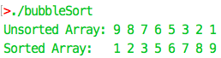

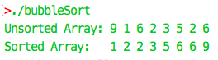

**Experiment 8**

**Code <MASM, DOS>**

.model small

.data

newline db 13, 10, '$'

anykey db "Press [Enter] to exit...$"

.stack 256

.code

start:

mov ax, @data

mov ds, ax

mov es, ax

mov ax, @stack

mov ss, ax

mov ch, 0

mov cl, 7

mov ah, 1

int 10h

call exit_program

print_newline:

lea dx, newline

mov ah, 09h

int 21h

ret

exit_program:

call print_newline

lea dx, anykey

mov ah, 09h

int 21h

mov ah, 01h

int 21h

; exit to operating system.

mov ah, 4ch

int 21h

end start

**Experiment 9**

**Code**

%include "../macros.asm"

global start

; Program to take 4 digit hex input from keyboard and save it in [temp]

section .text

start:

print mInput, mInputLength

read input, 100

dec eax

mov dword [inputLength], eax

call hex2AX

mov dword [temp], eax

mov eax, dword [temp]

call AX2hex

print mTempContents, mTempContentsLength

print input, [inputLength]

print mNewLine, mNewLineLength

exit 0

; Converts ascii hex number string [input] -> [input + inputLength] to hex number in EAX

hex2AX:

push ebx ; saving BX before overwriting

push ecx ; saving CX before overwriting

push edx ; saving DX before overwriting

mov eax, 0x0 ; stores final number

mov ebx, 0x0

mov ecx, 0x0 ; our index variable

mov edx, dword [inputLength] ; DX =

dec edx ; length - 1

.loop: mul byte [sixteen] ; AX = AX * 16d

mov bl, byte [input + ecx] ; bl = ascii digit

cmp bl, 64d ; if bl < 'A'

jge hex2AX.sub55

sub bl, 48d ; bl = digit (0 - 9)

jmp hex2AX.addBX

.sub55 sub bl, 55d ; else bl = digit (10 -15)

.addBX add eax, ebx ; AX = AX + digit

inc ecx ; set index pointer to next digit

cmp ecx, edx ; if index pointer points to last digit

jle hex2AX.loop ; loop if CX <= DX

pop edx ; restoring DX after using it

pop ecx ; restoring CX after using it

pop ebx ; restoring BX after using it

ret

; Converts EAX hex number to ascii hex number string in [input] -> [input + [inputLength]]

AX2hex:

push ebx ; saving BX before overwriting

push ecx ; saving CX before overwriting

mov ebx, 0x0 ; count of digits pushed to stack

mov ecx, 0x0 ; holds the digit before pushing to stack

; converting to ascii

.loop: mov edx, 0x0

div word [sixteen] ; AX = DXAX / 16d, DX = DXAX % 16d

mov cl, dl ; CL = DL

cmp cl, 9d ; if cl < 9

jg AX2hex.addA

add cl, 48d ; AX % 16d += ascii code for '0'

jmp AX2hex.pushCX

.addA: add cl, 55d ; AX % 16d += ascii code for 'A' - 10

.pushCX: push ecx ; push the digit

inc bl ; count of digits in stack

cmp eax, 0x0 ; loop termination condition

jne AX2hex.loop

; overwrite result over input

mov ecx, 0

mov dword [inputLength], ebx

.loop2: pop dword [input + ecx] ; Take first digit from stack

inc ecx ; increment index pointer

cmp ecx, ebx

jl AX2hex.loop2 ; loop termination condition

pop ecx ; restoring CX after using it

pop ebx ; restoring BX after using it

ret

section .bss

temp resd 1

input resb 100

inputLength resd 1

section .data

mInput db 'Enter a 4 digit hex number: 0x'

mInputLength equ $ - mInput

mTempContents db '[temp] = 0x'

mTempContentsLength equ $ - mTempContents

mNewLine db 0xA

mNewLineLength equ $ - mNewLine

sixteen dw 16d

ten dw 10d

**Output**

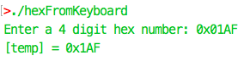

**Experiment 10**

**Code**

%include "../macros.asm"

; Program to print hex value in AX register

global start

section .text

start:

mov eax, 0x0690

call AX2hex

print mAXContents, mAXContentsLength

print input, [inputLength]

print mNewLine, mNewLineLength

exit 0

; Converts EAX hex number to ascii hex number string in [input] -> [input + [inputLength]]

AX2hex:

push ebx ; saving BX before overwriting

push ecx ; saving CX before overwriting

mov ebx, 0x0 ; count of digits pushed to stack

mov ecx, 0x0 ; holds the digit before pushing to stack

; converting to ascii

.loop: mov edx, 0x0

div word [sixteen] ; AX = DXAX / 16d, DX = DXAX % 16d

mov cl, dl ; CL = DL

cmp cl, 9d ; if cl < 9

jg AX2hex.addA

add cl, 48d ; AX % 16d += ascii code for '0'

jmp AX2hex.pushCX

.addA: add cl, 55d ; AX % 16d += ascii code for 'A' - 10

.pushCX: push ecx ; push the digit

inc bl ; count of digits in stack

cmp eax, 0x0 ; loop termination condition

jne AX2hex.loop

; overwrite result over input

mov ecx, 0

mov dword [inputLength], ebx

.loop2: pop dword [input + ecx] ; Take first digit from stack

inc ecx ; increment index pointer

cmp ecx, ebx

jl AX2hex.loop2 ; loop termination condition

pop ecx ; restoring CX after using it

pop ebx ; restoring BX after using it

ret

section .bss

input resb 100

inputLength resd 1

section .data

mAXContents db 'AX = 0x'

mAXContentsLength equ $ - mAXContents

mNewLine db 0xA

mNewLineLength equ $ - mNewLine

sixteen dw 16d

**Output**

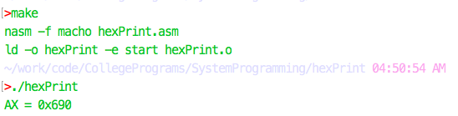**Pics/Hex%20Print.png**