
Ministry of Education and Research of the Republic of Moldova
Technical University of Moldova
Faculty of Computers, Informatics and Microelectronics
Department of Software Engineering and Automation
REPORT
on laboratory work no. 5 and 6
Course: Operating Systems
Topic: The File System with Your Own Hands (Linux) and Inside the xv6 File System
Done by: | st. gr. FAF-242, Bogdan Aramă
Checked by: | Reițman Patricia, university assistant

Chișinău, 2026

CONTENTS
1 Purpose of the work 3
2 Work environment 3
3 Lab 5 – The File System with Your Own Hands (Linux) 4
3.1 Getting started 4
3.2 Part 1. The tree and the file types 4
3.3 Part 2. Inodes and links 5
3.4 Part 3. Permissions 7
3.5 Part 4. Disks and the kernel as files 9
3.6 Stretch tasks 10
4 Lab 6 – Inside the xv6 File System 12
4.1 Part 1. Reading what xv6 shows 12
4.2 Part 2. mystat 13
4.3 Part 3. Measuring the limits 16
4.4 Part 4. find 17
5 Conclusions 22

1 Purpose of the work
This report covers two laboratory works. The purpose of Lab 5 is to check the ideas of the file system lecture on a real Linux system: the directory tree and the file types, inodes as the objects behind file names, hard and symbolic links, permissions and special bits, and the disks and kernel information exposed as files. No programming is involved, only careful observation of what the commands report.
The purpose of Lab 6 is to see the same ideas inside the xv6 file system, which implements inodes, directories as tables of entries, hard links and a log in a few hundred lines. I read what xv6 shows, wrote my own mystat program, measured the limits written in kernel/fs.h, and wrote a recursive find.

2 Work environment
Lab 5 was done directly in Linux:
Item | Value
Machine | VirtualBox virtual machine, 2 vCPU, 3.3 GiB RAM, 25 GB disk
Operating system | Ubuntu 26.04.1 LTS (GNOME, Wayland)
Kernel | Linux 7.0.0-38-generic, x86_64
Shell / terminal | GNU bash, Ptyxis terminal
Compiler | gcc 15.2.0

Lab 6 used the xv6 toolchain:
Item | Value
Host system | Ubuntu 26.04.1 LTS in VirtualBox (2 vCPU, 3.3 GiB RAM)
Cross compiler | riscv64-linux-gnu-gcc 15.2
Emulator | QEMU 10.2 (qemu-system-riscv64, machine virt, 3 harts)
xv6 source | mit-pdos/xv6-riscv, revision 06aad25, branch lab, in ~/xv6-riscv
Prepared with | os2026-setup.sh (check mode reports "All set")

3 Lab 5 – The File System with Your Own Hands (Linux)
All experiments were run as the normal user bogdan (not root, because root ignores most permission checks) in the folder ~/os-lab5.

3.1 Getting started
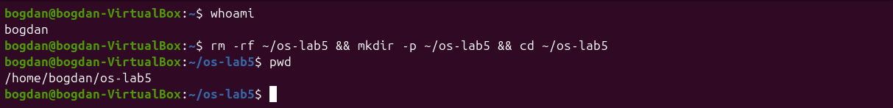
Figure 5.0.1 – Normal user and the working folder

3.2 Part 1. The tree and the file types
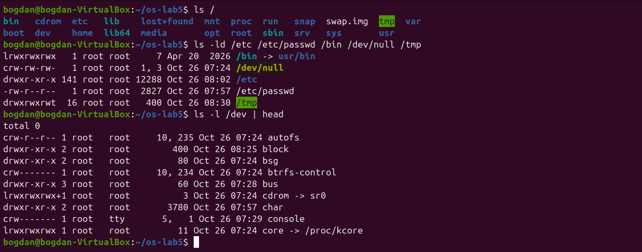
Figure 5.1.1 – The root directory and the file type letters
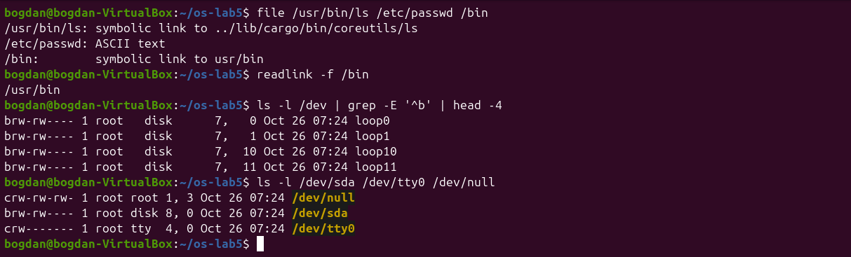
Figure 5.1.2 – file, the /bin link, block and character devices
Figure 5.1.3 – Disk usage of /var/log and /usr
1. For each path in the second line, write its type from the first letter of ls -l.
/etc is d, a directory. /etc/passwd is -, a regular file. /bin is l, a symbolic link. /dev/null is c, a character device (major 1, minor 3). /tmp is d, a directory, with the extra t bit (drwxrwxrwt).
2. What is /bin on your system: a directory or a link, and to where?
A symbolic link: /bin -> usr/bin (file says symbolic link to usr/bin and readlink -f /bin gives /usr/bin). Modern Ubuntu keeps all programs in /usr (the "merged /usr" layout). On this release /usr/bin/ls is itself a link to the Rust coreutils binary ../lib/cargo/bin/coreutils/ls.
3. Find one character device and one block device in /dev.
Character devices: /dev/null (1,3), /dev/tty0 (4,0) and /dev/console. Block devices: /dev/sda (8,0), the whole virtual disk, and /dev/loop0 (7,0), the loop device behind a snap package. Character devices are read as a stream of bytes, while block devices are read in blocks at any position.
4. Which is bigger on your laptop, /var/log or /usr, and by roughly how much?
/usr is much bigger: 5.1 GB against 21 MB for /var/log, about 250 times more. /usr holds all installed programs and libraries, while /var/log holds only the logs of a VM installed today.

3.3 Part 2. Inodes and links
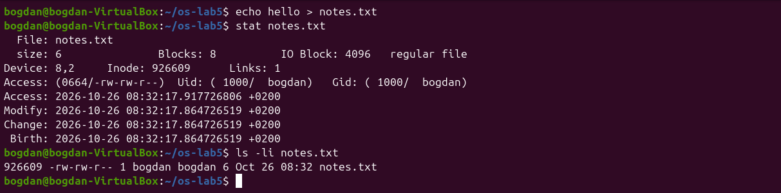
Figure 5.2.1 – stat shows the inode behind notes.txt
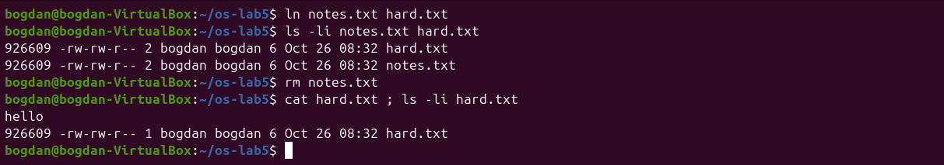
Figure 5.2.2 – A hard link survives the removal of the original name
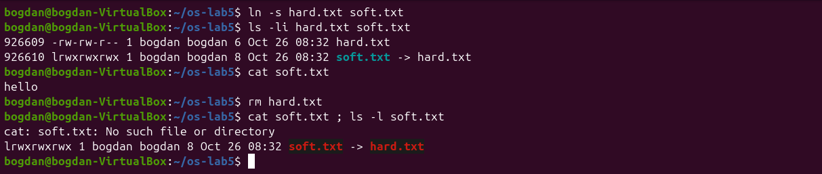
Figure 5.2.3 – A symbolic link breaks when its target is removed
Prediction for the directory: I expected 2 links for a new directory (its name and .), and 4 after creating two subdirectories, because each subdirectory's .. points back to it. Both predictions were correct.
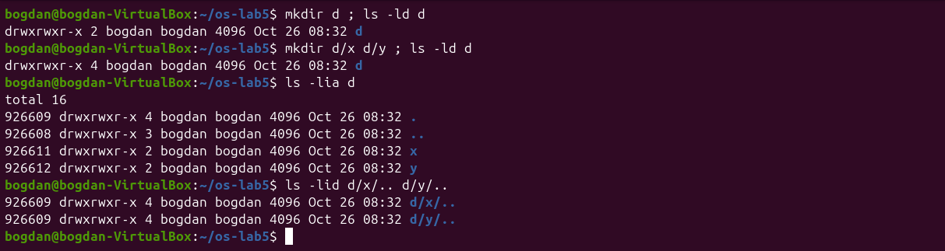
Figure 5.2.4 – Link count of a directory before and after creating subdirectories
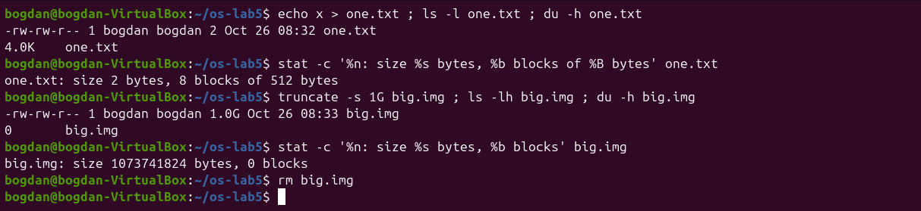
Figure 5.2.5 – Size is not space: a 2-byte file and a 1 GB sparse file
1. Which number in stat is the inode, and which tells how many names the file has?
Inode: 926609 is the inode number (the same number ls -li prints in the first column), and Links: 1 is the link count, the number of directory entries (names) that point to that inode.
2. After rm notes.txt, why could you still read hard.txt? What does rm really remove?
ln created a second name for the same inode 926609, so the link count became 2. rm (the unlink system call) removes only one directory entry and decrements the count to 1. The inode and its data blocks are freed only when the link count reaches 0 and no process has the file open. The content hello was still reachable through the other name.
3. Why did cat soft.txt fail at the end, although soft.txt still exists? How big is soft.txt and why exactly that size?
A symbolic link is a separate small file (its own inode 926610, type l) whose content is just the path hard.txt. After rm hard.txt that path leads nowhere, so opening soft.txt fails with "No such file or directory": the link is dangling. Its size is 8 bytes, exactly the length of the string hard.txt.
4. A new directory has 2 links, and 4 after you create two subdirectories. Explain where each link comes from.
The 2 initial links are the entry d in the parent directory and the entry . inside d itself. Each subdirectory has an entry .. that points back to d, which adds one link per subdirectory: 2 + 2 = 4. ls -lid d/x/.. d/y/.. shows the same inode as d. Here the new directory happened to reuse inode 926609, which had been freed when hard.txt was removed.
5. Why does a 2-byte file use 4.0K, and a 1 GB file use 0?
Disk space is allocated in whole blocks, and ext4 uses 4 KiB blocks, so even 2 bytes take one block (stat shows 8 sectors of 512 bytes). truncate -s 1G only sets the size in the inode without writing any data. Such a sparse file has no allocated blocks (0 blocks in stat), and reading it returns zeros. ls -l shows the size, while du shows the space actually used.

3.4 Part 3. Permissions
Prediction for the box experiment: with only r I expected ls to work and cat box/f to fail, and with only x the opposite. That is what happened.
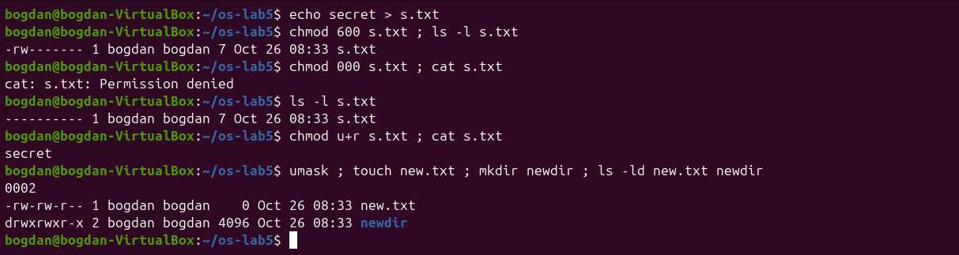
Figure 5.3.1 – Permissions of a file, chmod 000, and the umask
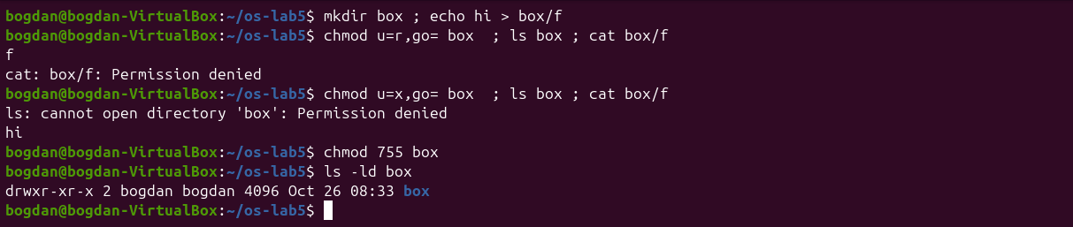
Figure 5.3.2 – The box experiment: r and x on a directory
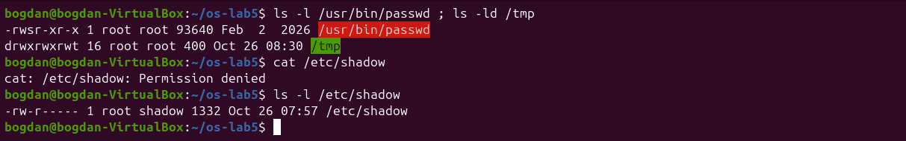
Figure 5.3.3 – The setuid bit of passwd, the sticky bit of /tmp, /etc/shadow
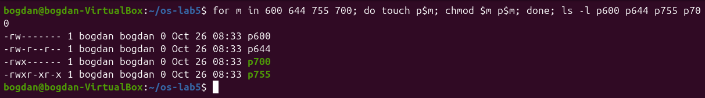
Figure 5.3.4 – The modes 600, 644, 755 and 700 as rwx strings
1. Write 600, 644, 755 and 700 as rwx strings, and give one real use for each.
600 = rw-------, for private files such as an SSH private key (~/.ssh/id_ed25519). 644 = rw-r--r--, for normal documents and configuration files that everybody may read, such as /etc/passwd. 755 = rwxr-xr-x, for programs and public directories (/usr/bin/*, the box directory at the end). 700 = rwx------, for private directories and personal scripts, for example ~/.ssh.
2. With chmod 000 you own the file but cannot read it. Why does ownership not help?
The kernel picks one class of permission bits: the owner bits if I am the owner, otherwise the group bits, otherwise the other bits. As the owner I get only the owner bits, which are ---. Ownership only gives me the right to change the mode with chmod, which is how chmod u+r made the file readable again.
3. What is your umask, and how does it explain the permissions of new.txt and newdir?
The umask is 0002: it removes the write bit for "others". Programs create files with mode 666 and directories with 777, minus the umask: 666 − 002 = 664 = rw-rw-r-- for new.txt, and 777 − 002 = 775 = rwxrwxr-x for newdir.
4. Explain the box experiment: what does r allow on a directory, and what does x allow?
A directory is a table of names. r allows reading that table, so ls box printed f, but without x the names cannot be used to reach the files and cat box/f was denied. x allows passing through the directory to a name you already know, so cat box/f printed hi, but without r the table cannot be listed: ls failed with "Permission denied".
5. What do the s in /usr/bin/passwd and the t in /tmp mean, and why does passwd need the s?
s in the owner execute position (-rwsr-xr-x, owner root) is the setuid bit: the program runs with the rights of its owner, root, not of the user who started it. passwd needs it because it must write the new password hash into /etc/shadow, which belongs to root and is readable only by root and the group shadow (-rw-r-----). My own cat /etc/shadow was denied. t on /tmp (drwxrwxrwt) is the sticky bit: everybody may create files there, but only the owner of a file (or root) may delete or rename it.

3.5 Part 4. Disks and the kernel as files
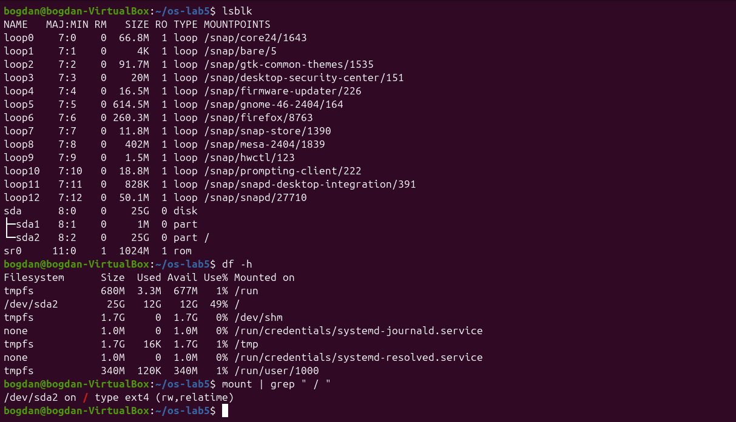
Figure 5.4.1 – Block devices, file systems and the root mount
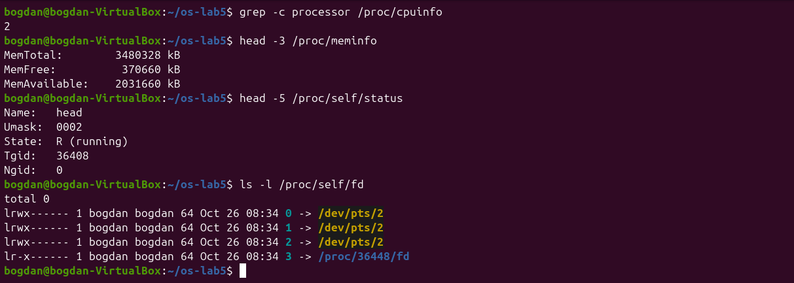
Figure 5.4.2 – CPU, memory and the current process seen through /proc
1. Draw your disk: disk name, partitions, which one is mounted at / and with what file system type.
The structure is shown below. The loop0–loop12 devices are read-only snap images and sr0 is the empty virtual CD drive.
sda (25 GB virtual disk, /dev/sda, 8:0)
├── sda1 1 MB BIOS boot partition (GRUB core), not mounted
└── sda2 25 GB ext4, mounted at / (rw,relatime)
2. How full is your root file system?
df -h shows /dev/sda2 25G 12G 12G 49% /: about half of the disk is used.
3. How many CPU cores and how much RAM does your laptop have, according to /proc?
grep -c processor /proc/cpuinfo gives 2 cores (the 2 vCPUs given to the VM), and MemTotal: 3480328 kB is about 3.3 GiB of RAM.
4. /proc/self/status showed the name of a program. Which one, and why that one?
It showed Name: head. /proc/self is a link that always points to the directory of the process that opens it, and the process reading the file was head itself, not the shell. In the same way ls -l /proc/self/fd showed the descriptors of ls: 0, 1 and 2 on the terminal and 3 on the directory it was reading.

3.6 Stretch tasks
I did three of the optional tasks (a, b and c). Task d needs sudo, so I skipped it.
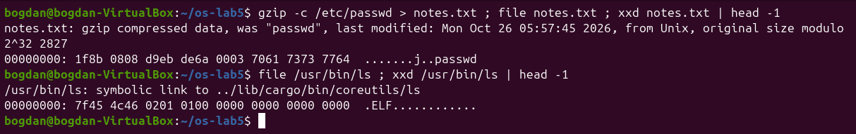
Figure 5.5.1 – (a) Magic numbers of a gzip file and of an ELF program
(a) After gzip -c /etc/passwd > notes.txt, file still recognises the data as gzip compressed data, was "passwd", because it ignores the extension and reads the first bytes. The magic number is 1f 8b, which starts every gzip stream. For comparison, the real ls binary starts with 7f 45 4c 46, that is \x7fELF.
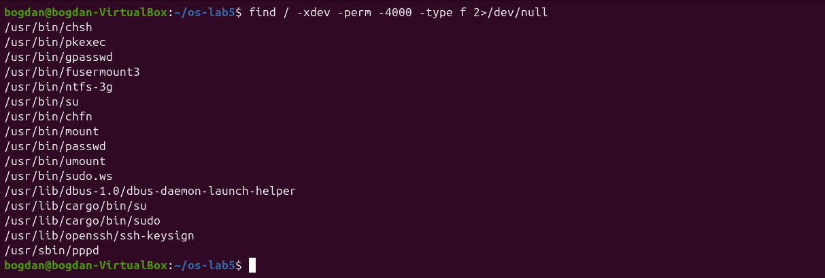
Figure 5.5.2 – (b) setuid programs on the root file system
(b) find / -xdev -perm -4000 -type f lists 16 setuid programs: the classic ones (passwd, su, mount, umount, chsh, chfn, gpasswd, pkexec) and also some less expected ones: /usr/bin/sudo.ws, /usr/lib/cargo/bin/sudo and /usr/lib/cargo/bin/su (Ubuntu 26.04 ships the Rust rewrites sudo-rs and su), ntfs-3g, fusermount3, pppd, ssh-keysign and the D-Bus launch helper.
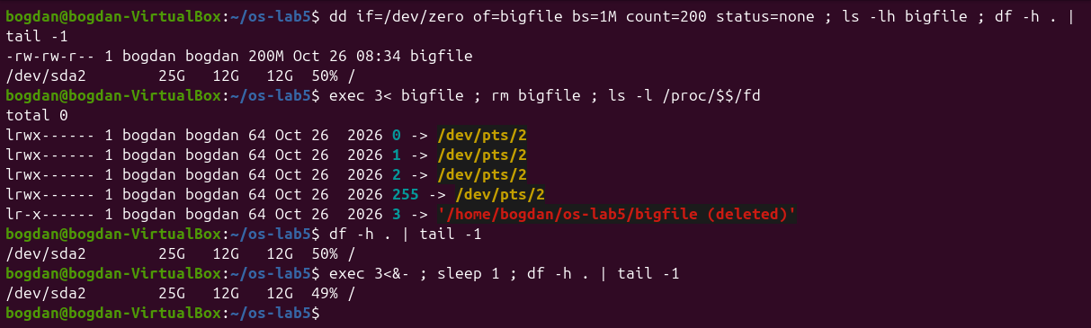
Figure 5.5.3 – (c) Deleting a file that is still open
(c) After opening a 200 MB file on descriptor 3 and deleting it, /proc/$$/fd/3 points to '/home/bogdan/os-lab5/bigfile (deleted)', and df still shows the space as used (50%). Only after exec 3<&- closed the last descriptor did usage drop back to 49%. The kernel frees an inode when both its link count and its open count are zero.

4 Lab 6 – Inside the xv6 File System
All programs were added to ~/xv6-riscv as user/NAME.c with a line $U/_NAME\ in UPROGS. Before Part 1 and Part 4 the tree was cleaned with make clean, so that xv6 started from a fresh disk image.

4.1 Part 1. Reading what xv6 shows
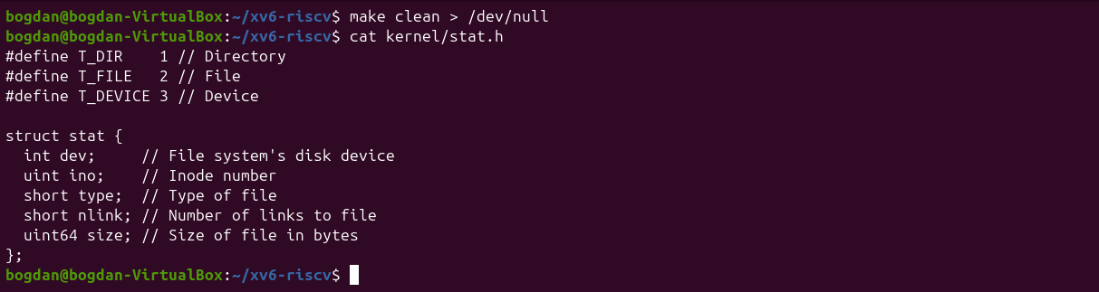
Figure 6.1.1 – kernel/stat.h: the file types and struct stat
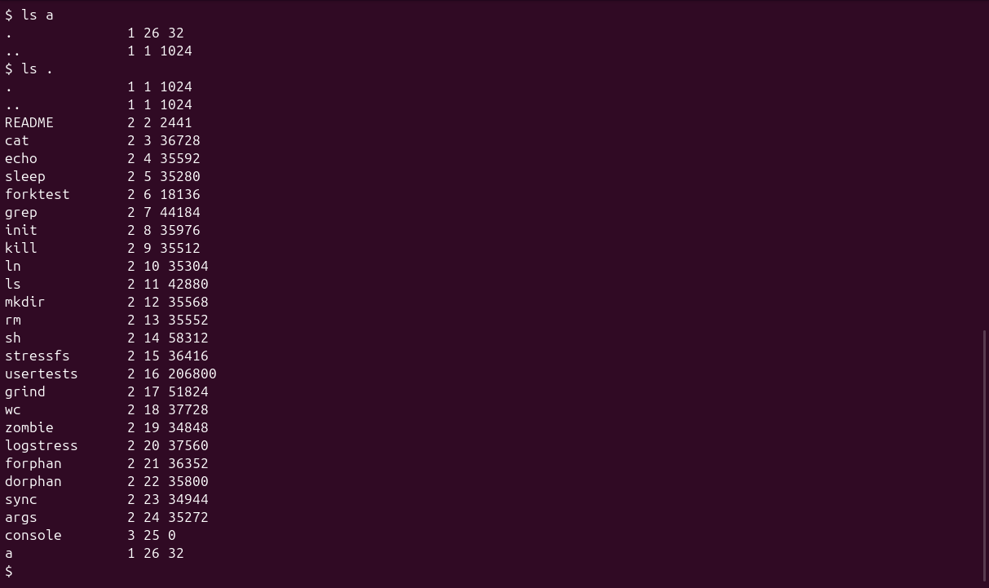
Figure 6.1.2 – ls in xv6, a new directory a and its contents
1. What do types 1, 2 and 3 mean (kernel/stat.h)?
1 is T_DIR (a directory), 2 is T_FILE (a regular file) and 3 is T_DEVICE (a device: the only one is console, which is why its size is 0).
2. Which inode number does the root directory have, and why are . and .. the same there?
The root directory is inode 1 (ROOTINO). Both . and .. in it point to inode 1, because the root has no parent: mkfs creates .. of the root as a link to the root itself, so cd .. from / stays in /.
3. An empty directory a has size 32. How big is one entry, and which two entries does a contain?
A directory entry (struct dirent) is 16 bytes: a 2-byte inode number (ushort inum) and a 14-byte name (DIRSIZ). The empty directory a has two entries, . (inode 26, itself) and .. (inode 1, the root), so 2 × 16 = 32 bytes. The root has size 1024 because its entries fill one whole block.

4.2 Part 2. mystat
typename returns a word for each T_ constant, and main calls stat() for every argument. If stat fails, it prints an error on descriptor 2 and continues with the next name.
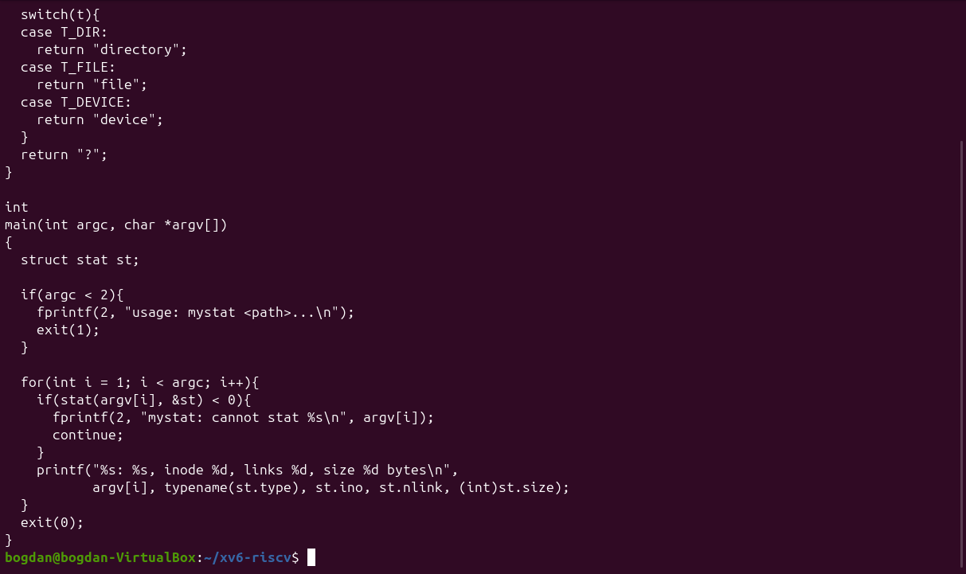
Figure 6.2.1 – The completed user/mystat.c
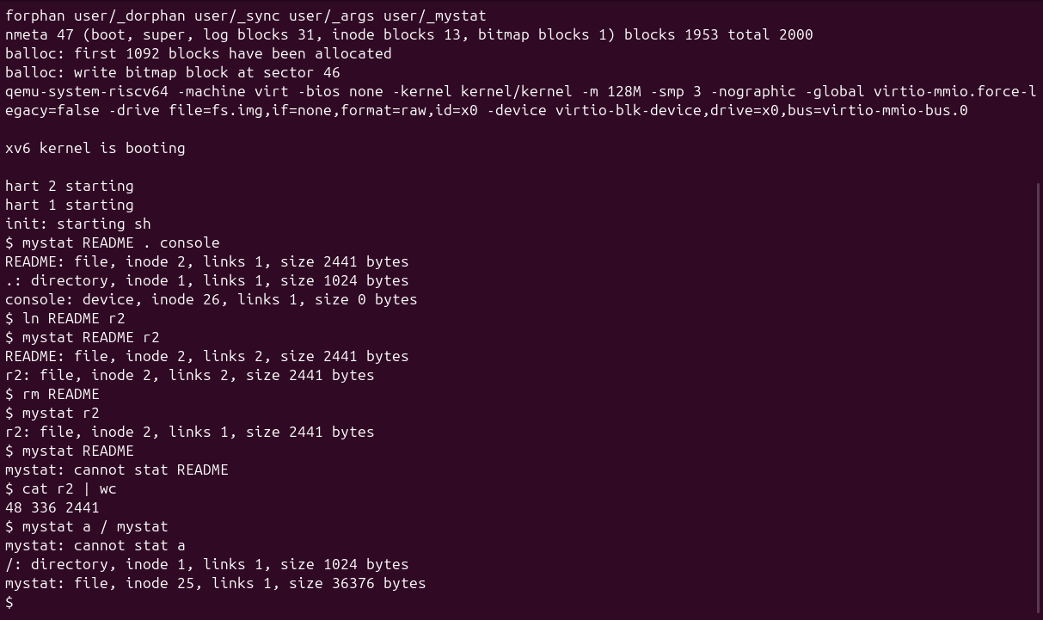
Figure 6.2.2 – mystat watching a hard link being created and removed
1. Paste the outputs after ln and after rm. What changed and what did not?
After ln README r2: README: file, inode 2, links 2, size 2441 bytes and r2: file, inode 2, links 2, size 2441 bytes. After rm README: r2: file, inode 2, links 1, size 2441 bytes, and mystat README fails. Only the link count changed (1 → 2 → 1) and one name disappeared. The inode number, the type, the size and the data stayed the same: cat r2 | wc still gives 48 336 2441, the same as the original README.
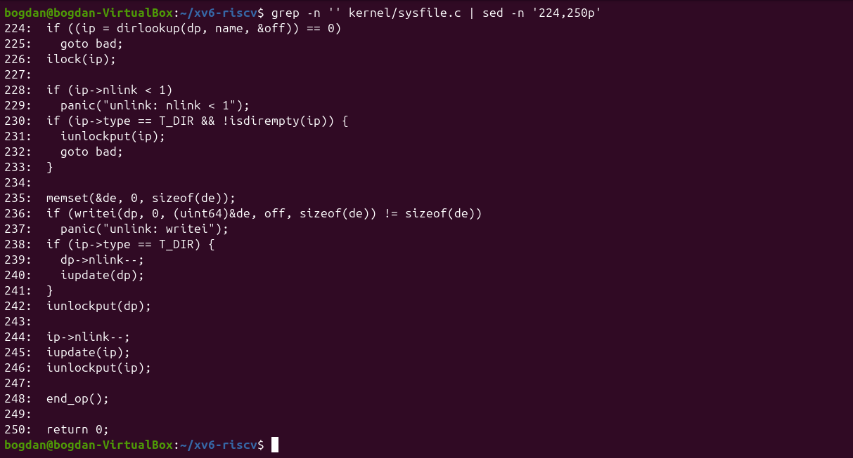
Figure 6.2.3 – sys_unlink in kernel/sysfile.c
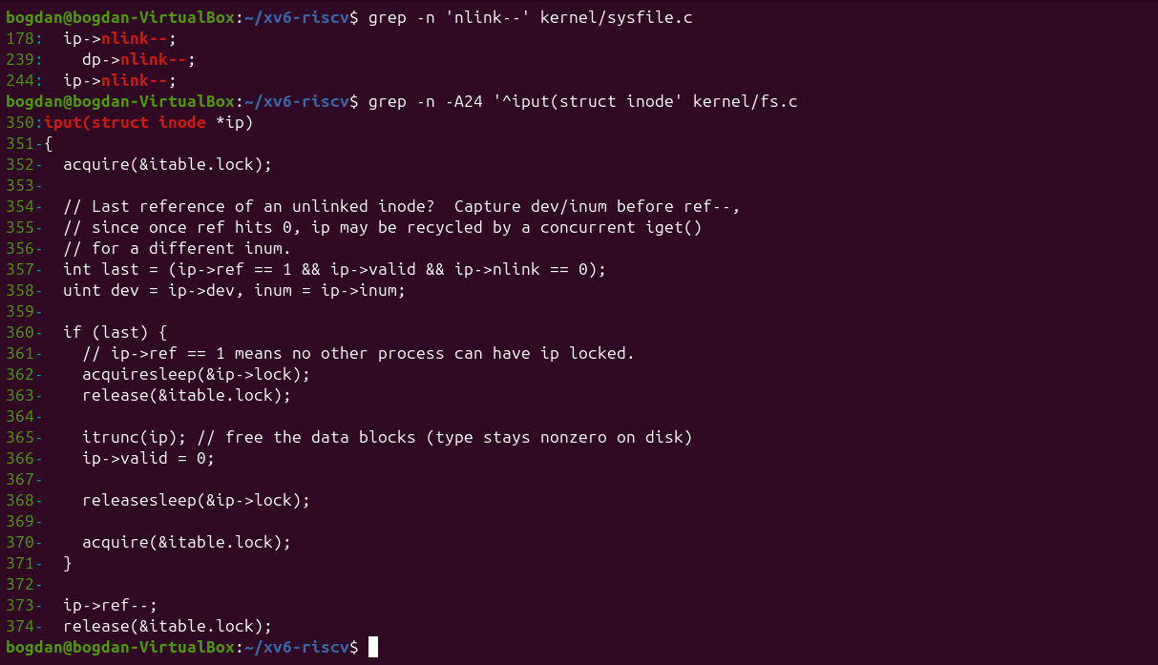
Figure 6.2.4 – The line that decrements nlink and iput(), which frees the blocks
2. Find the line in kernel/sysfile.c (sys_unlink) that decrements the link count. When are the data blocks freed?
Line 244, ip->nlink--;, followed by iupdate(ip), which writes the inode back to disk (line 239 does the same for the parent when a directory is removed). sys_unlink itself does not free any data: it only clears the directory entry and lowers the count. The blocks are freed later, in iput() in kernel/fs.c (lines 357–365). When the last in-memory reference goes away (ref == 1) and the link count is 0, iput calls itrunc(ip), which frees all data blocks. A file that is still open therefore keeps its data until it is closed, just like on Linux.
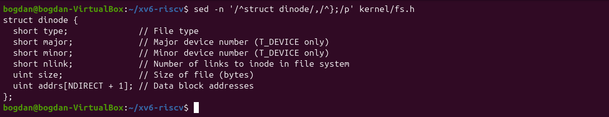
Figure 6.2.5 – struct dinode in kernel/fs.h
3. xv6 has no symbolic links and no permissions. Which fields does an xv6 inode have?
struct dinode has only six fields: type (file, directory or device), major and minor (device numbers), nlink (number of names), size (in bytes) and addrs[NDIRECT + 1] (12 direct block numbers and 1 indirect block). There is no owner, group, mode or timestamp, unlike an ext4 inode, so xv6 cannot check permissions at all.

4.3 Part 3. Measuring the limits
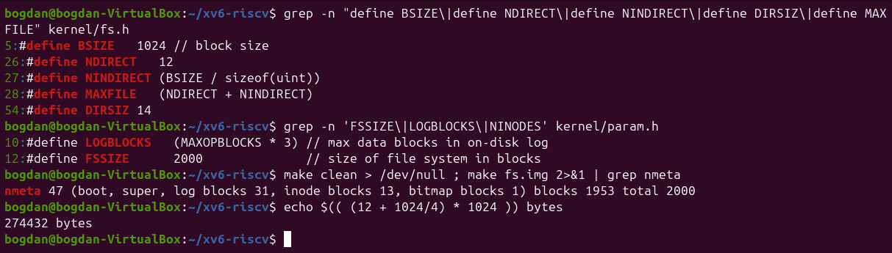
Figure 6.3.1 – BSIZE, NDIRECT, NINDIRECT, DIRSIZ and the disk layout printed by mkfs
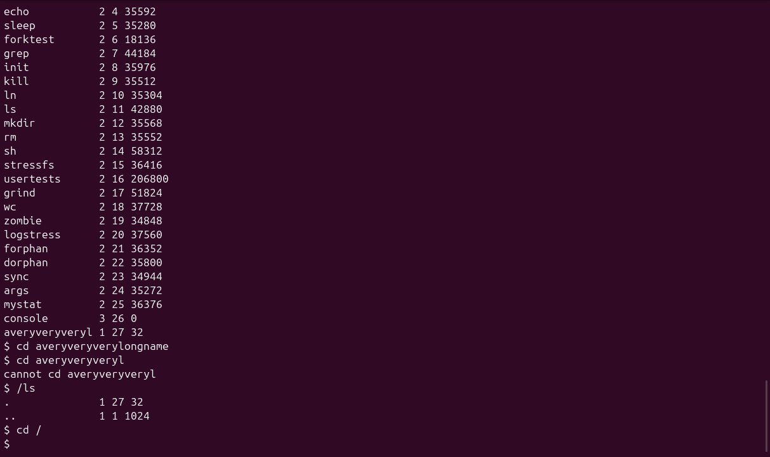
Figure 6.3.2 – A directory name longer than DIRSIZ
1. What does ls show for averyveryverylongname, and which constant explains it?
ls shows averyveryveryl, only the first 14 characters, because DIRSIZ is 14 and the name field of a directory entry has exactly 14 bytes. Lookups also compare only 14 characters, so cd averyveryverylongname still worked: the extra characters are simply ignored. The next cd averyveryveryl failed only because I was already inside that directory.
2. Compute the largest file xv6 can hold.
BSIZE is 1024 bytes, and a block number takes 4 bytes. The largest file is therefore (12 + 256) × 1024 = 274 432 bytes, or 268 KB (MAXFILE = NDIRECT + NINDIRECT = 268 blocks). The shell check echo $(( (12 + 1024/4) * 1024 )) printed the same number.
direct blocks: NDIRECT = 12
indirect blocks: NINDIRECT = 1024 / 4 = 256
max blocks: 12 + 256 = 268
max size: 268 * 1024 = 274432 bytes (268 KB)
3. From the nmeta line: how many blocks does the whole disk have, and how many are for the log, the inodes, and the data?
nmeta 47 (boot, super, log blocks 31, inode blocks 13, bitmap blocks 1) blocks 1953 total 2000. The disk has 2000 blocks of 1 KB (FSSIZE). 47 are metadata: 1 boot block, 1 superblock, 31 log blocks, 13 inode blocks (200 inodes × 64 bytes = 16 inodes per block) and 1 free-block bitmap. The remaining 1953 blocks are for data.

4.4 Part 4. find
My find starts from the structure of ls.c: it opens the directory, reads struct dirent entries one by one, builds the full path in a 512-byte buffer and calls stat on it. It skips free slots (inum == 0) and never descends into . or ... It prints a path when the last component equals the searched name, recurses into every subdirectory, and closes each directory before returning (xv6 allows only 16 open files per process). If the starting path is a file, only its name is compared. The optional -n argument prints the inode number next to the path.
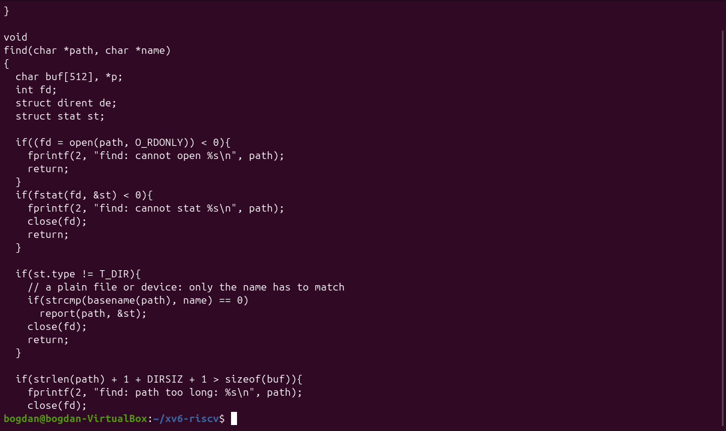
Figure 6.4.1 – user/find.c (first part)
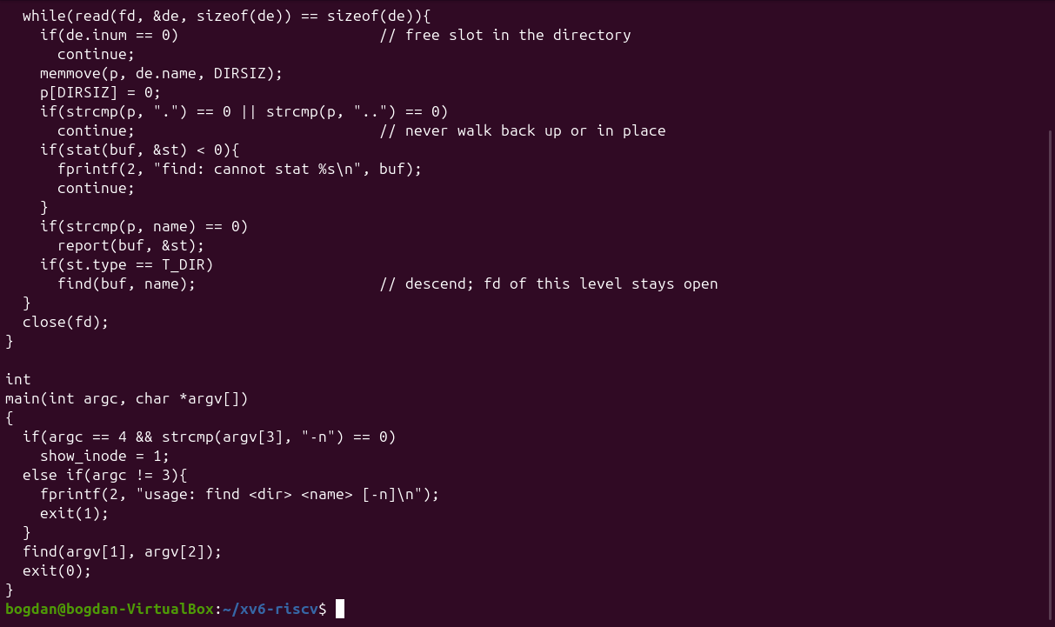
Figure 6.4.2 – user/find.c (second part)
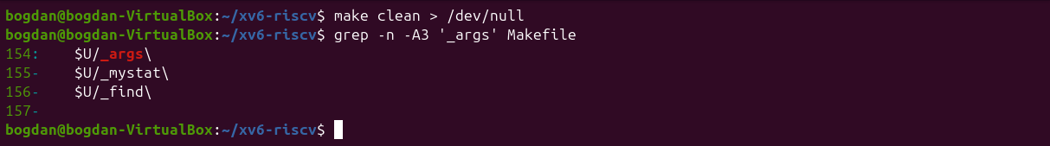
Figure 6.4.3 – The UPROGS lines for args, mystat and find
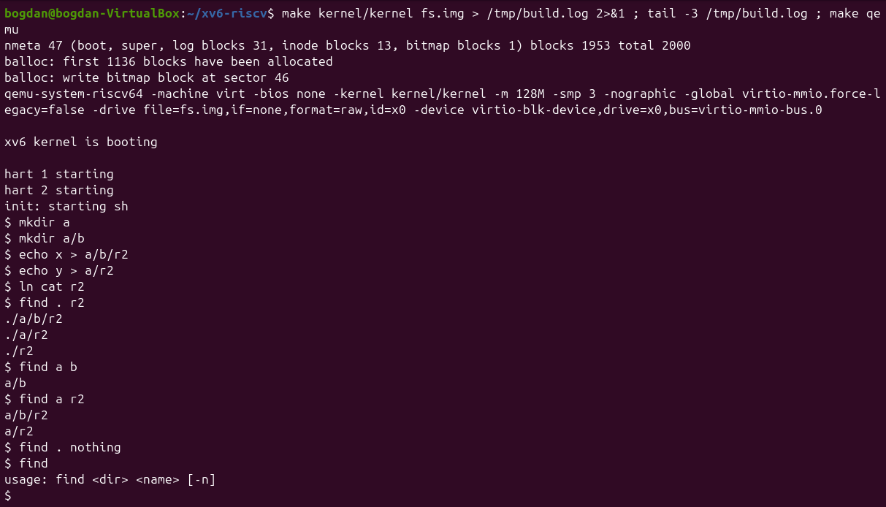
Figure 6.4.4 – find on a fresh disk
On a fresh disk find . r2 prints ./a/b/r2, ./a/r2 and ./r2, and find a b prints a/b. A name that does not exist prints nothing, and calling find without arguments prints the usage line.
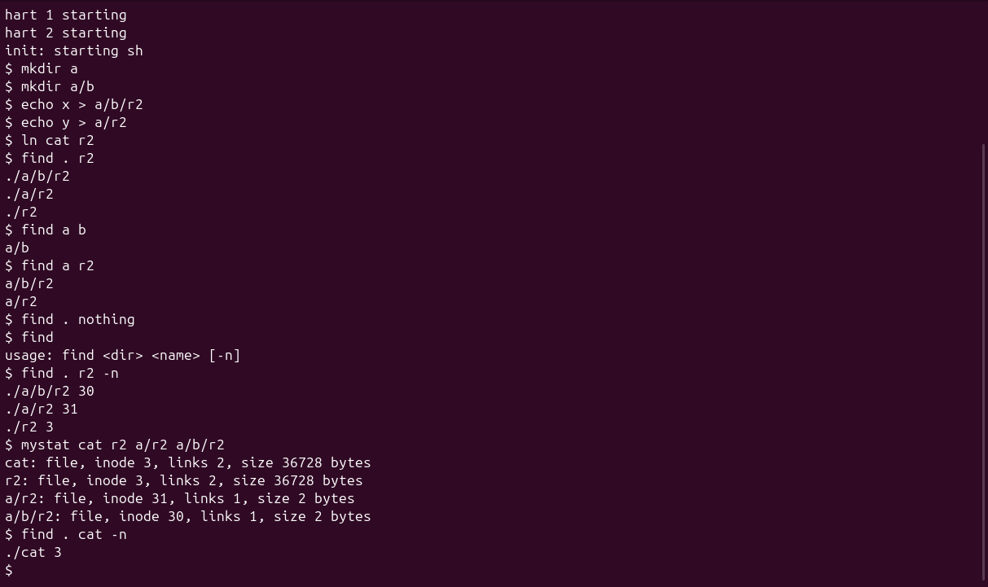
Figure 6.4.5 – Stretch: find with -n and the inodes of the three r2 files
Stretch. find . r2 -n shows ./a/b/r2 30, ./a/r2 31 and ./r2 3, and cat also has inode 3. So only ./r2 is the same file as cat: it was created with ln cat r2, and mystat shows 2 links for both names. The two other r2 files were created with echo, so they are independent 2-byte files with their own inodes.

Source of user/find.c
#include "kernel/types.h"
#include "kernel/stat.h"
#include "user/user.h"
#include "kernel/fs.h"
#include "kernel/fcntl.h"

// find <dir> <name> [-n]
// Print every path under <dir> whose last component is <name>.
// With -n, the inode number is printed next to each path.

int show_inode;

// return a pointer to the last component of path ("a/b/r2" -> "r2")
char *
basename(char *path)
{
char *p = path + strlen(path);
while(p > path && *(p - 1) != '/')
p--;
return p;
}

void
report(char *path, struct stat *st)
{
if(show_inode)
printf("%s %d\n", path, st->ino);
else
printf("%s\n", path);
}

void
find(char *path, char *name)
{
char buf[512], *p;
int fd;
struct dirent de;
struct stat st;

if((fd = open(path, O_RDONLY)) < 0){
fprintf(2, "find: cannot open %s\n", path);
return;
}
if(fstat(fd, &st) < 0){
fprintf(2, "find: cannot stat %s\n", path);
close(fd);
return;
}

if(st.type != T_DIR){
// a plain file or device: only the name has to match
if(strcmp(basename(path), name) == 0)
report(path, &st);
close(fd);
return;
}

if(strlen(path) + 1 + DIRSIZ + 1 > sizeof(buf)){
fprintf(2, "find: path too long: %s\n", path);
close(fd);
return;
}
strcpy(buf, path);
p = buf + strlen(buf);
*p++ = '/';

while(read(fd, &de, sizeof(de)) == sizeof(de)){
if(de.inum == 0) // free slot in the directory
continue;
memmove(p, de.name, DIRSIZ);
p[DIRSIZ] = 0;
if(strcmp(p, ".") == 0 || strcmp(p, "..") == 0)
continue; // never walk back up or in place
if(stat(buf, &st) < 0){
fprintf(2, "find: cannot stat %s\n", buf);
continue;
}
if(strcmp(p, name) == 0)
report(buf, &st);
if(st.type == T_DIR)
find(buf, name); // descend; fd of this level stays open
}
close(fd);
}

int
main(int argc, char *argv[])
{
if(argc == 4 && strcmp(argv[3], "-n") == 0)
show_inode = 1;
else if(argc != 3){
fprintf(2, "usage: find <dir> <name> [-n]\n");
exit(1);
}
find(argv[1], argv[2]);
exit(0);
}

5 Conclusions
Lab 5 showed that a file name is only an entry in a directory that points to an inode. The inode holds the type, permissions, link count and block list. Hard links are just more names for the same inode, rm removes a name and not the data, and a symbolic link is a tiny file that stores a path. Permissions are checked by class (owner, group, others) and mean different things on files and directories. The special bits (setuid, sticky) solve real problems such as changing a password. Size and disk usage are different things, as the sparse file showed, and through /proc the kernel itself appears as files.
Lab 6 showed the same concepts in a file system small enough to read completely. An xv6 inode has only type, device numbers, link count, size and 13 block addresses. A directory is a file of 16-byte entries, which explains both the 32-byte empty directory and the 14-character name limit. The fixed numbers in fs.h and param.h give a maximum file size of 268 KB and a 2000-block disk with 47 metadata blocks. Writing mystat and find with only open, read, fstat/stat and close showed that a recursive tree walk needs nothing more than reading directory entries carefully and closing every directory that was opened.

