
Ministry of Education and Research of the Republic of Moldova
Technical University of Moldova
Faculty of Computers, Informatics and Microelectronics
Department of Software Engineering and Automation
REPORT
on laboratory work no. 1
Course: Operating Systems
Topic: The OS as a Resource Manager
Done by: | st. gr. FAF-242, Bogdan Aramă
Checked by: | Reițman Patricia, university assistant

Chișinău, 2026

CONTENTS
1 Purpose of the work 3
2 Work environment 3
3 Execution of the work 3
3.0 Getting started 3
3.1 Part 1. Files and directories 3
3.2 Part 2. Processes 6
3.3 Part 3. Memory 8
3.4 Part 4. Devices and storage 9
3.5 Extra: system calls of ls 10
4 Conclusions 11

1 Purpose of the work
The aim of this laboratory work is to watch the operating system acting as a resource manager on a real Linux installation. Using only standard command-line tools, I looked at how the OS manages the four big resources of a computer: files, processes, memory and devices, and I wrote down what the system reported instead of only listing the commands.

2 Work environment
Item | Value
Machine | VirtualBox virtual machine, 2 vCPU, 3.3 GiB RAM, 25 GB disk
Operating system | Ubuntu 26.04.1 LTS (GNOME, Wayland)
Kernel | Linux 7.0.0-38-generic, x86_64
Shell / terminal | GNU bash, Ptyxis terminal
Compiler | gcc 15.2.0

All commands were run as the ordinary user bogdan in a working folder ~/os-lab1. Figure 0.1 below shows who I am for the OS, which kernel manages the machine and how long it has been running.

3 Execution of the work

3.0 Getting started
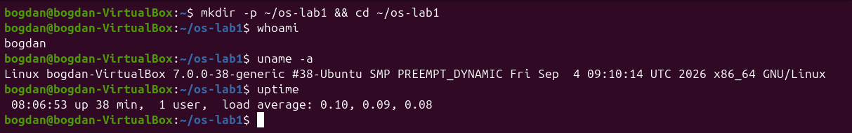
Figure 0.1 – Working folder, user, kernel and uptime
The kernel is Linux 7.0.0-38 for x86_64 and the system had been up for 38 minutes with one user logged in.

3.1 Part 1. Files and directories
First I looked at the top of the directory tree and at my home directory, then created, copied, renamed and removed files and changed their permissions.
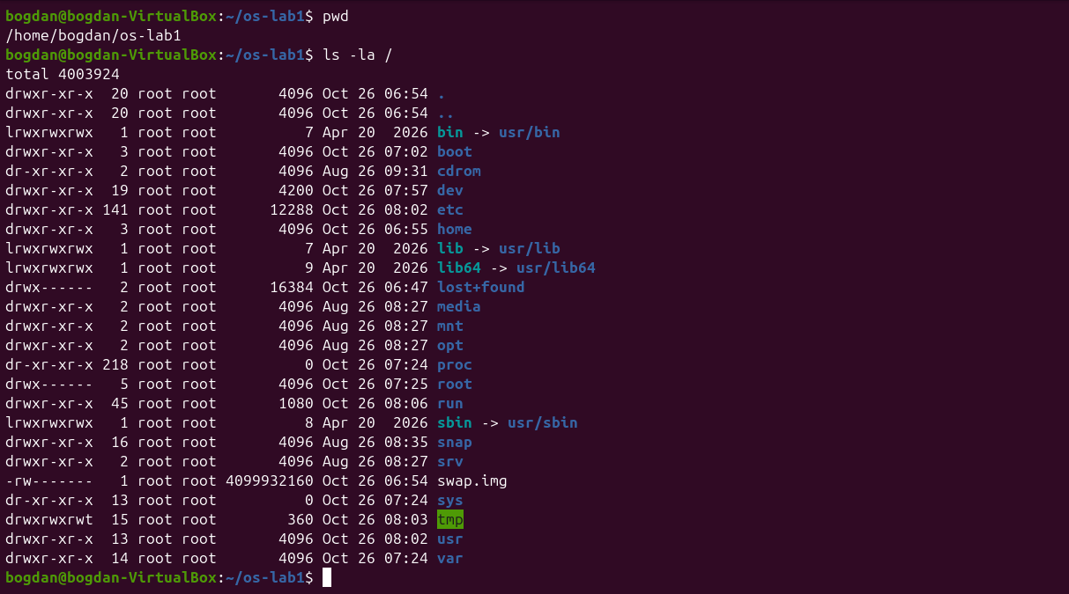
Figure 1.1 – The root of the file tree (ls -la /)
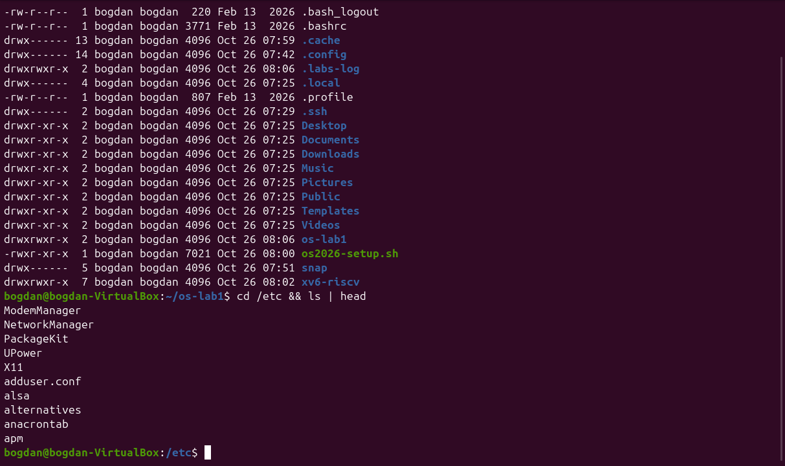
Figure 1.2 – Home directory and the first entries of /etc
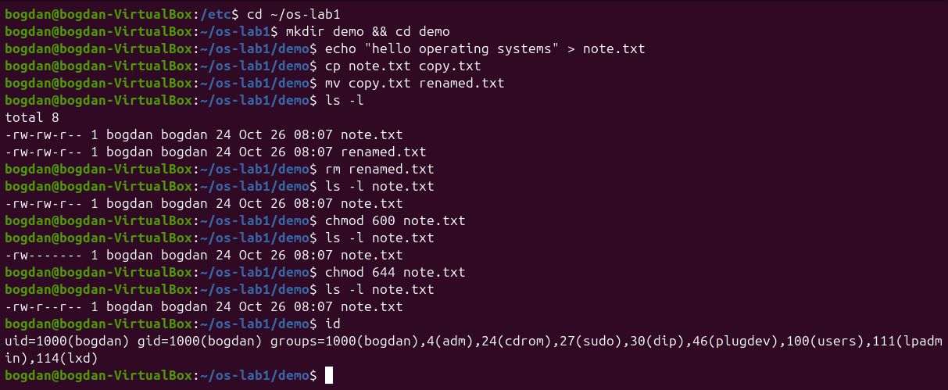
Figure 1.3 – Creating, copying, renaming, removing a file and changing its mode
1. Who owns the files you just created, and which group?
Both note.txt and renamed.txt belong to user bogdan and group bogdan. On Ubuntu every user gets a private primary group with the same name (uid=1000, gid=1000 in the output of id), and new files are created with the owner and primary group of the process that creates them.
2. What do the ten characters at the start of ls -l mean for note.txt after chmod 600?
After chmod 600 the string is -rw-------. The first character - is the file type (a regular file). The next three rw- are the owner's rights (read and write, no execute), and the last two groups --- and --- mean that the group and all other users have no rights at all. Before the change the file was -rw-rw-r--, the default produced by my umask 0002.
3. Name two directories directly under / and say what they hold.
/etc holds the system-wide configuration files (for example passwd, fstab and the NetworkManager settings), and /home holds the personal directories of the users (here only /home/bogdan). It is also interesting that /bin, /sbin and /lib are only symbolic links into /usr, and that /proc and /sys have size 0 because they are generated by the kernel.

3.2 Part 2. Processes
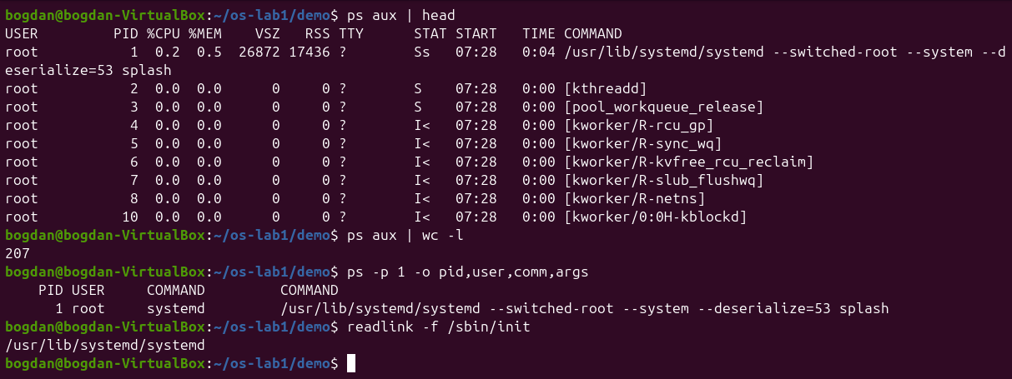
Figure 2.1 – The first processes, their number and process 1
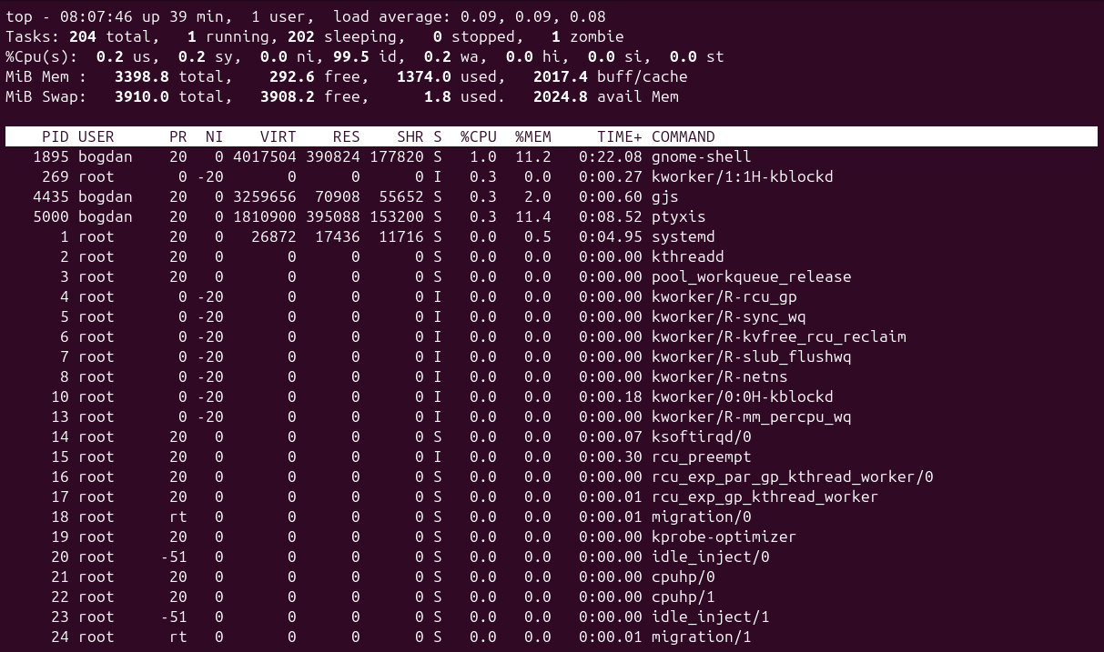
Figure 2.2 – Live view of the process table with top
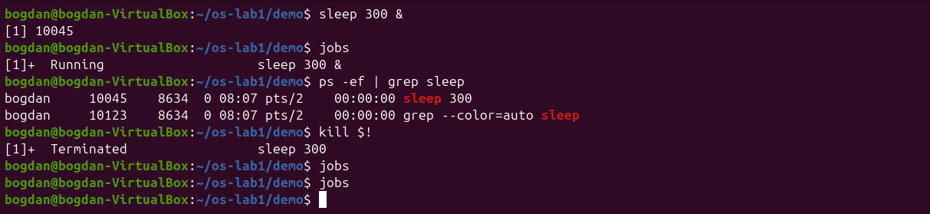
Figure 2.3 – Starting a background sleep, finding it and terminating it
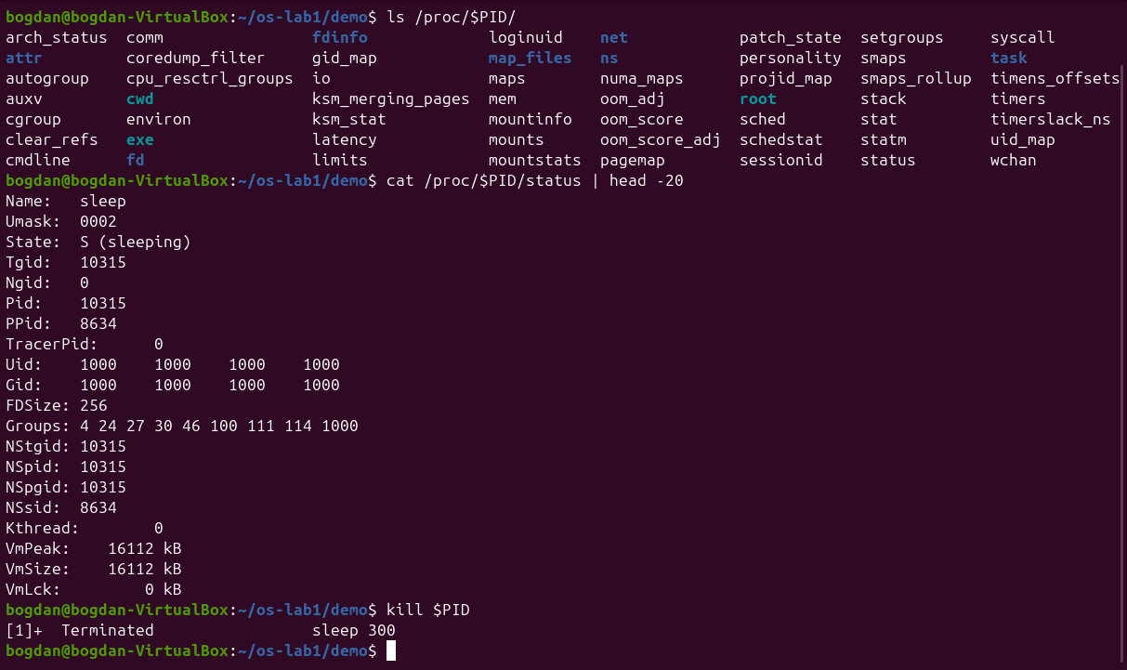
Figure 2.4 – What /proc shows about a running sleep process
1. What is the PID of process number 1, and what is it?
Process 1 is systemd (/usr/lib/systemd/systemd, the target of the /sbin/init link), owned by root. It is the first user-space program started by the kernel at boot. It starts and supervises all the other services and it adopts orphaned processes.
2. Roughly how many processes were running on your idle VM?
ps aux | wc -l printed 207. One of those lines is the header, so there were about 206 processes, and top reported 204 tasks a few seconds later. Most of them are kernel threads (names in square brackets, such as [kworker/...]) and the services of the GNOME desktop. top also showed one zombie process.
3. From /proc/<pid>/status, what does the State: line say for your sleeping process?
It says State: S (sleeping). The process is not using the CPU: it is blocked in the kernel until its timer expires. The same file also shows its PID, its parent (PPid: 8634, my shell) and its memory counters.

3.3 Part 3. Memory
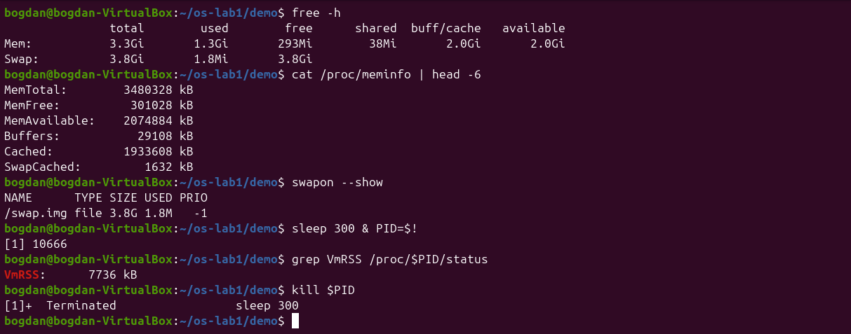
Figure 3.1 – RAM, swap and the resident memory of a sleep process
1. How much total RAM does the VM have, and how much is free?
The VM has 3.3 GiB of RAM (MemTotal: 3480328 kB). Only 293 MiB is reported as completely free, but 2.0 GiB is available, because Linux uses otherwise idle RAM as a page cache (2.0 GiB of buff/cache) and gives it back when programs need it.
2. What is swap, and how much is configured?
Swap is disk space the kernel can use to hold memory pages that do not fit in RAM. Rarely used pages are moved out so that RAM is free for active ones. On this VM swap is the 3.8 GiB file /swap.img, and only 1.8 MiB of it is in use.
3. How much resident memory (VmRSS) does a bare sleep process use, and does that surprise you?
VmRSS was 7736 kB, about 7.5 MB, which is surprisingly large for a program that does nothing. The reason is that RSS also counts the shared libraries and the program code mapped into the process. On Ubuntu 26.04 sleep is part of the Rust coreutils multi-call binary, a single big executable for all the commands, so more code is mapped. Most of these pages are shared with other processes, so the real cost is much smaller.

3.4 Part 4. Devices and storage
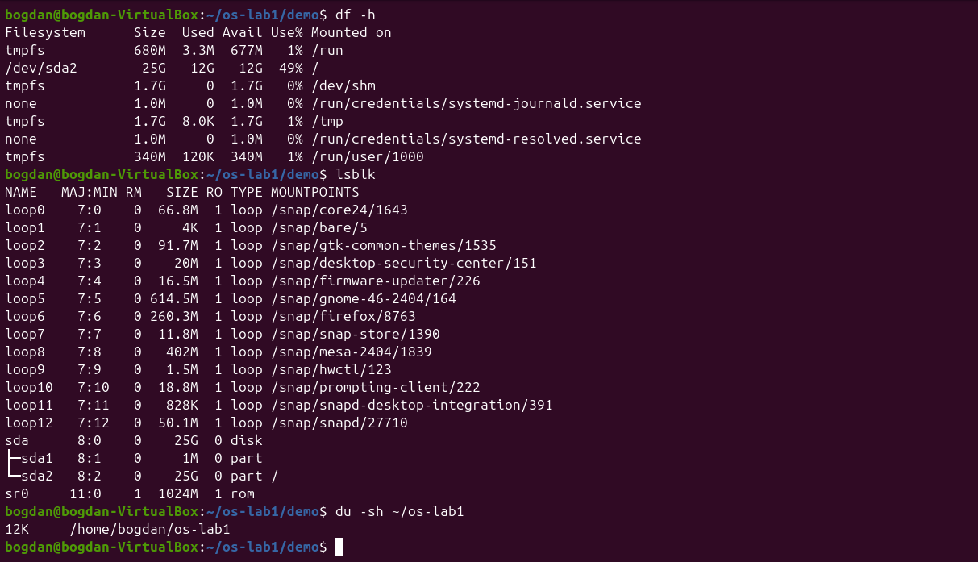
Figure 4.1 – Mounted file systems, block devices and the size of my folder
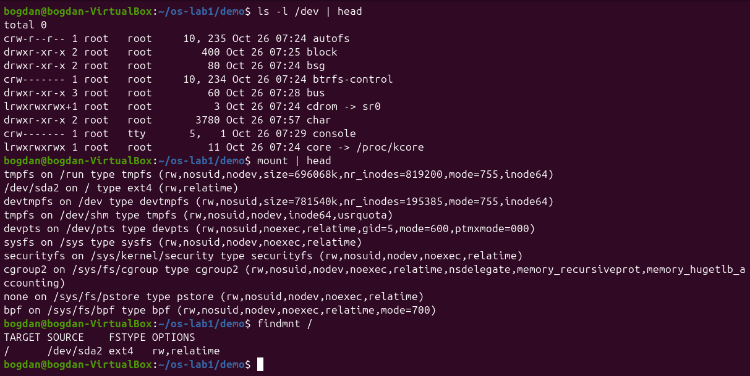
Figure 4.2 – Device files in /dev and the mount table
1. Which device is your root filesystem "/" mounted on?
/ is on /dev/sda2, the second partition of the virtual disk sda. It is formatted as ext4 (findmnt / shows ext4 rw,relatime), has 25 GB and is 49% used. sda1 is a 1 MB partition used by the boot loader, and the many loop devices are snap packages mounted read-only.
2. Give one entry from /dev and say what real thing it stands for.
/dev/sda is a block device (major 8, minor 0) that stands for the whole virtual hard disk. Another example is /dev/cdrom, a link to sr0, the virtual optical drive of the VM. The character device console is the system console.
3. In one sentence: what does "everything is a file" mean, based on what you saw?
Disks, terminals, the CD drive and even kernel information (/proc, /sys) appear as names in the same tree and are used with the same open/read/write operations as ordinary files, so the same tools (ls, cat, redirection) work on all of them.

3.5 Extra: system calls of ls
htop is not installed on this image, so I only did the second optional task: strace -c ls counts the system calls a simple ls makes.
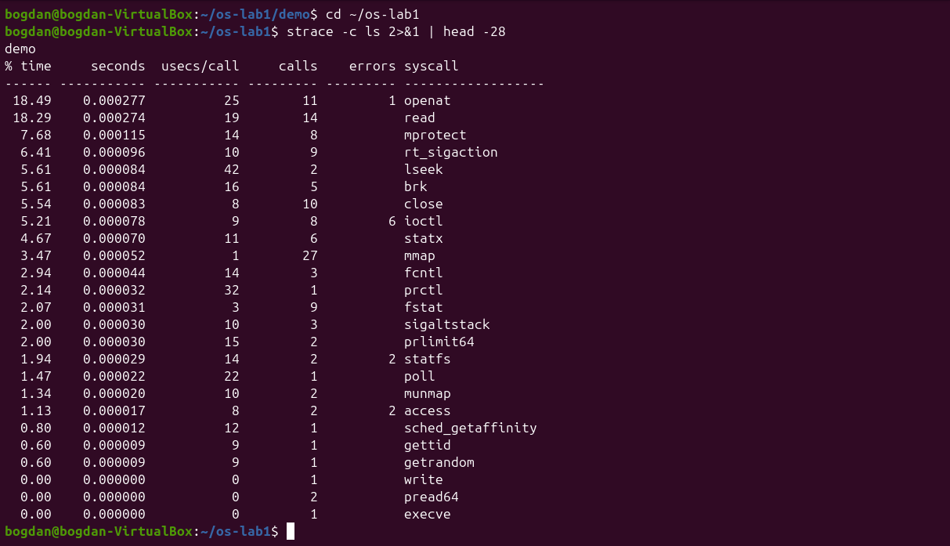
Figure 5.1 – System calls made by ls (strace -c)
Even listing a directory with a single entry needs dozens of requests to the kernel: one execve, 27 mmap (loading the program and libraries into memory), 11 openat, 14 read, statx and ioctl (to find out whether the output is a terminal) and only one write for the actual output.

4 Conclusions
The lab showed that the operating system sits between every program and the hardware and manages four kinds of resources. Files: the OS turns the disk into one tree with owners and permissions, which I saw with ls -l and changed with chmod. Processes: every running program is a process with a PID, a parent and a state, visible with ps aux, top and /proc/<pid>/status. Memory: the OS shares the RAM, uses free memory as cache and has swap as a backup, as shown by free -h and VmRSS. Devices: disks and terminals appear as files in /dev, and df -h, lsblk and mount show how they are attached to the tree.
The most useful idea for me was /proc: the kernel exposes its internal tables as ordinary-looking files, so the same small tools are enough to inspect almost everything the OS does.

