
Ministry of Education and Research of the Republic of Moldova
Technical University of Moldova
Faculty of Computers, Informatics and Microelectronics
Department of Software Engineering and Automation
REPORT
on laboratory work no. 2
Course: Operating Systems
Topic: Meet the OS You Will Build (xv6)
Done by: | st. gr. FAF-242, Bogdan Aramă
Checked by: | Reițman Patricia, university assistant

Chișinău, 2026

CONTENTS
1 Purpose of the work 3
2 Work environment 3
3 Execution of the work 3
3.1 Part 1. Building and booting xv6 3
3.2 Part 2. Using xv6 4
3.3 Part 3. Reading the source 6
3.4 Part 4. My first xv6 program: sleep 8
4 Conclusions 11

1 Purpose of the work
The goal of this laboratory work is to build the teaching operating system xv6 from source, boot it in the QEMU emulator, use it as a small Unix, read its source code to see the boundary between user programs and the kernel, and add a first user program (sleep) that makes a real system call.

2 Work environment
Item | Value
Host system | Ubuntu 26.04.1 LTS in VirtualBox (2 vCPU, 3.3 GiB RAM)
Cross compiler | riscv64-linux-gnu-gcc 15.2
Emulator | QEMU 10.2 (qemu-system-riscv64, machine virt, 3 harts)
xv6 source | mit-pdos/xv6-riscv, revision 06aad25, branch lab, in ~/xv6-riscv
Prepared with | os2026-setup.sh (check mode reports "All set")

3 Execution of the work

3.1 Part 1. Building and booting xv6
The source tree contains the kernel (kernel/), the user programs (user/), the tool that creates the disk image (mkfs/) and the Makefile. After make clean, make qemu compiles every kernel and user file with the RISC-V cross compiler, builds fs.img and starts QEMU.
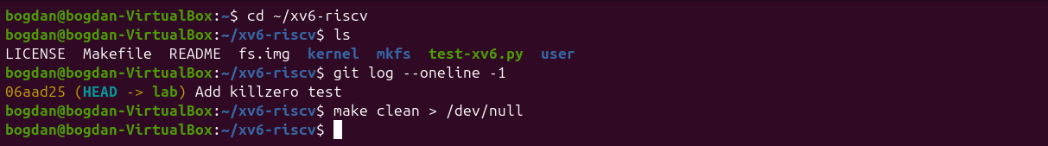
Figure 1.1 – The xv6 source tree and the revision used
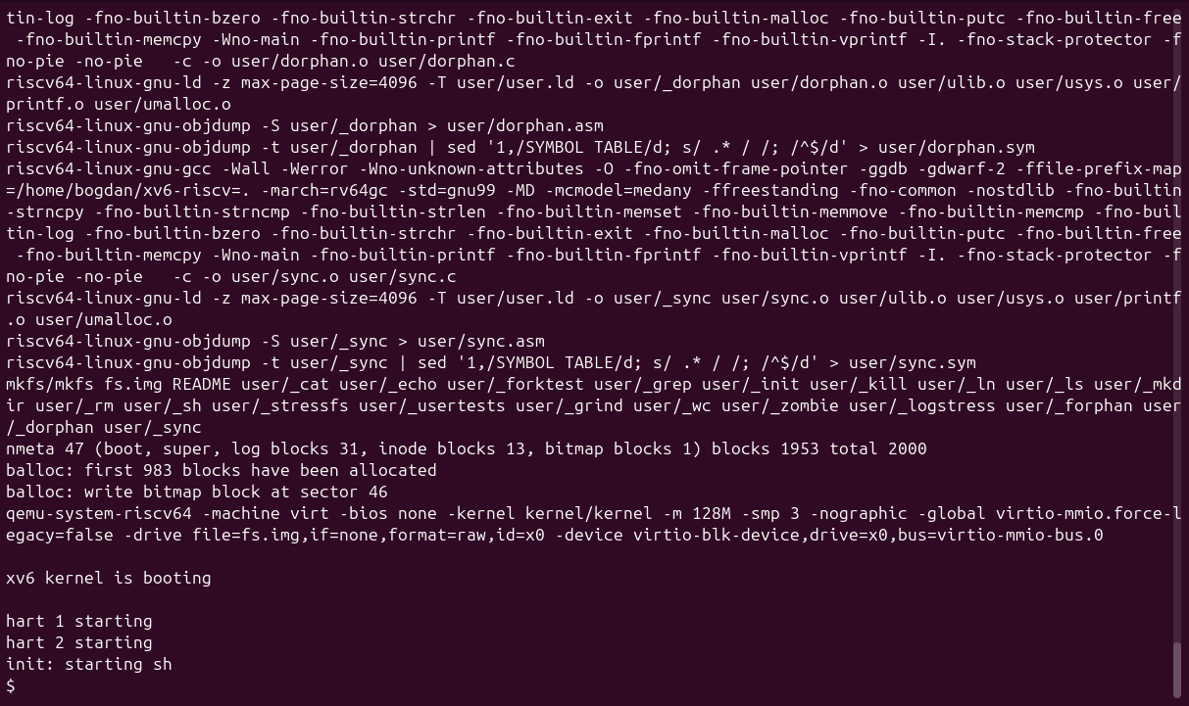
Figure 1.2 – End of the build and the boot of xv6 in QEMU
The build ends with mkfs writing the file system image (2000 blocks, 47 of them metadata). Then the kernel prints xv6 kernel is booting, starts the other two harts (CPU cores) and init starts the shell, which shows the $ prompt. QEMU is left with Ctrl-A followed by X.

3.2 Part 2. Using xv6
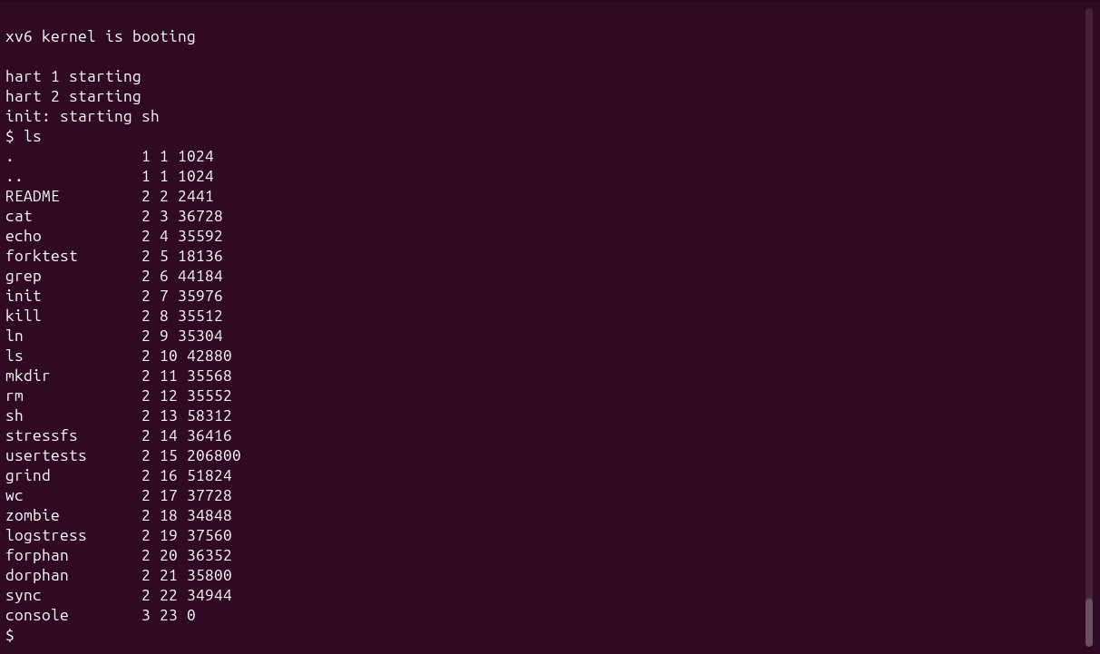
Figure 2.1 – Files of the xv6 root directory
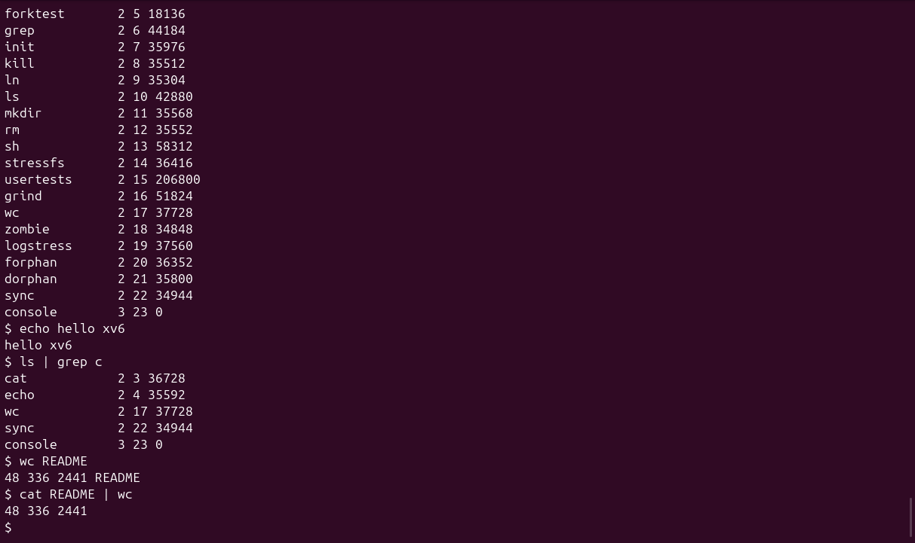
Figure 2.2 – echo, a pipe into grep, and wc inside xv6
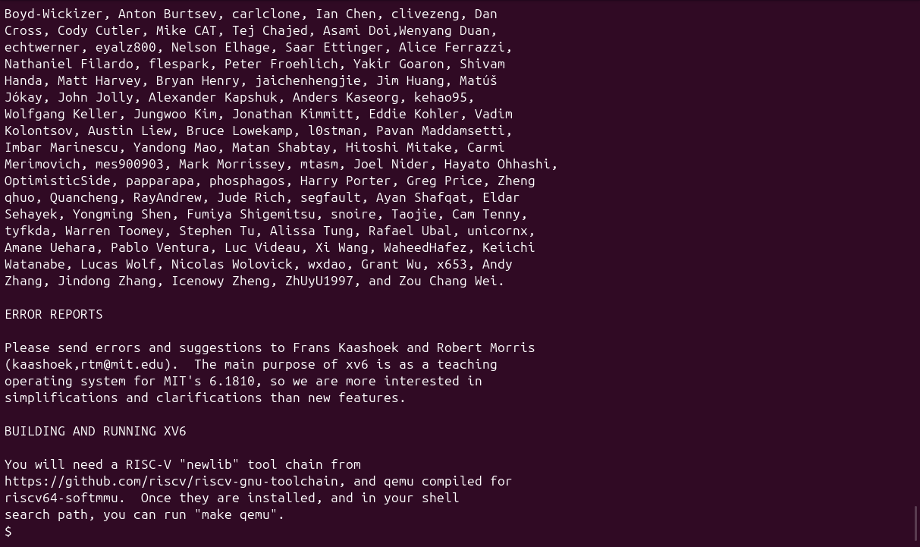
Figure 2.3 – Reading the README file with cat
1. List three programs xv6 ships with.
ls, cat, grep, wc, echo, mkdir, rm, ln, kill and the shell sh, plus test programs such as usertests, forktest and stressfs. In ls, each line shows the name, the type (1 directory, 2 file, 3 device), the inode number and the size.
2. Which two OS features must exist for a pipe to work?
First, process creation: the shell must fork two processes (ls and grep) that run at the same time. Second, inter-process communication with file descriptors: the kernel must provide the pipe object, a buffer with a write end and a read end. The shell connects the write end to the standard output of ls and the read end to the standard input of grep (using close and dup).
3. How does the xv6 shell compare to the Linux shell from Lab 1?
It looks and feels the same for simple commands (pipes, ;, redirection and & all work), but it is much more limited: there is no history, no Tab completion, no variables and no wildcards, and ls prints raw inode information instead of colours and permissions.

3.3 Part 3. Reading the source
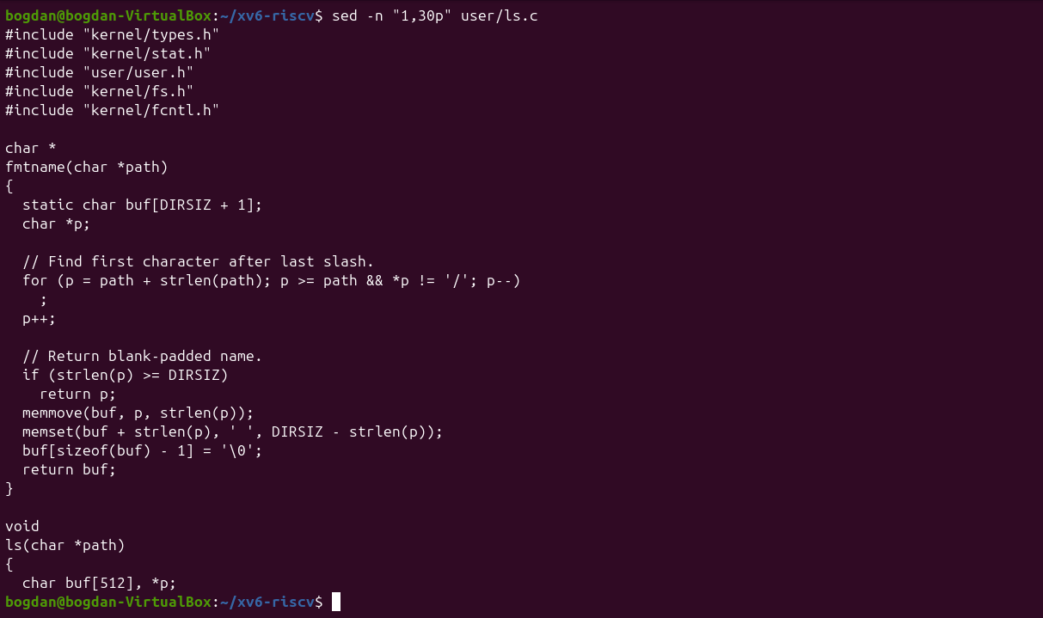
Figure 3.1 – The beginning of user/ls.c
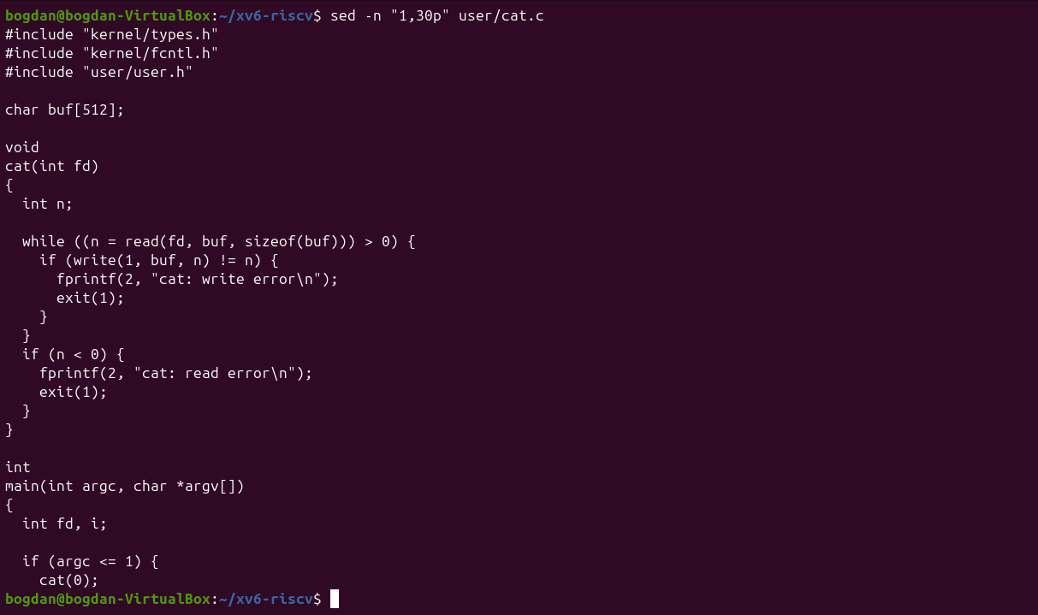
Figure 3.2 – The beginning of user/cat.c
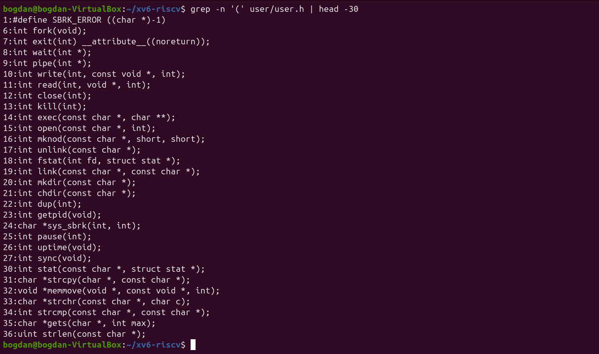
Figure 3.3 – The system calls declared in user/user.h
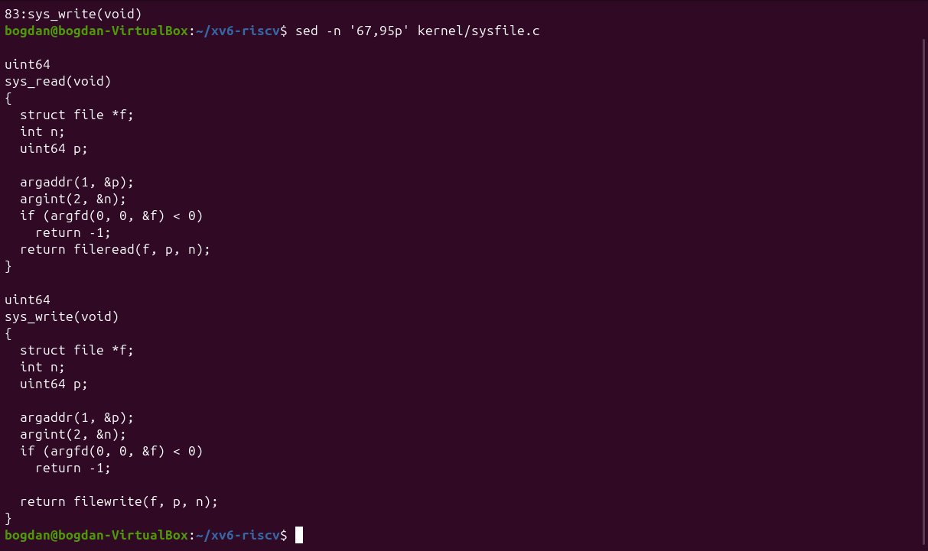
Figure 3.4 – sys_read and sys_write in kernel/sysfile.c
1. Which system calls does user/cat.c use, and what does each one ask the kernel to do?
read(fd, buf, n) asks the kernel to copy up to n bytes from an open file into the buffer. write(1, buf, n) asks it to send bytes to the standard output (and fprintf(2, ...) ends in write on descriptor 2). open(path, O_RDONLY) asks it to find a file by name and return a new file descriptor. close(fd) releases that descriptor, and exit(status) ends the process. When there is no argument, cat reads descriptor 0.
2. In which kernel file, and on which line, is sys_read implemented?
In kernel/sysfile.c: the function name sys_read(void) is on line 69, with its return type uint64 on line 68, and sys_write follows on line 83. sys_read fetches its three arguments from the user registers (argaddr, argint, argfd) and calls fileread.
3. What is the difference between the code in kernel/ and the code in user/?
The code in kernel/ runs in supervisor mode, with access to all memory and to the hardware, and implements the services. The code in user/ runs in user mode, isolated in its own address space, and can only ask for those services through the system calls listed in user/user.h.

3.4 Part 4. My first xv6 program: sleep
I created user/sleep.c exactly as given in the assignment and added $U/_sleep\ to the UPROGS list of the Makefile, right after _echo (TAB at the start, backslash at the end).
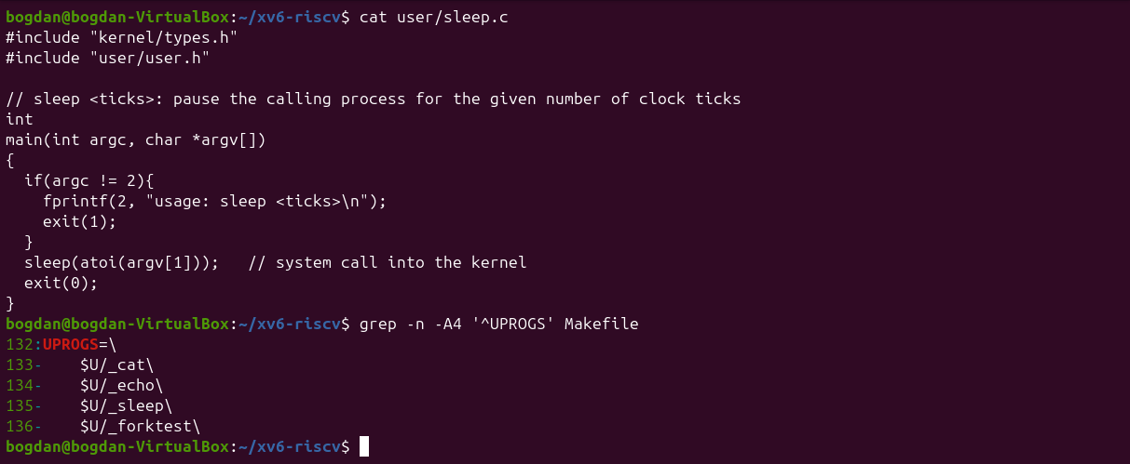
Figure 4.1 – The first version of user/sleep.c and the UPROGS line
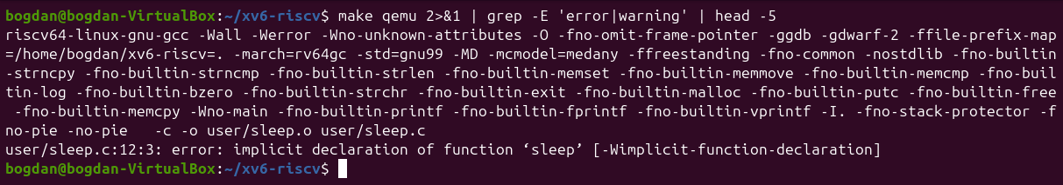
Figure 4.2 – The build fails: sleep() is not declared
The build failed with implicit declaration of function 'sleep'. The reason is that the current xv6 (revision 06aad25) renamed the system call: user/user.h declares int pause(int); and no longer has sleep, and xv6 compiles with -Werror. I changed the call to pause(atoi(argv[1])), which takes the same argument (a number of clock ticks).
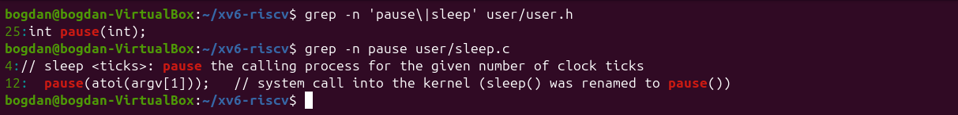
Figure 4.3 – user.h declares pause(); the corrected call in sleep.c
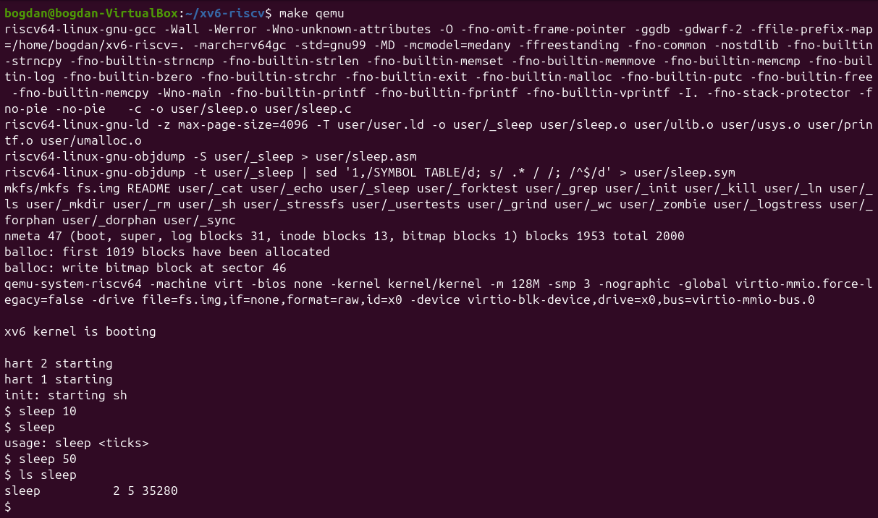
Figure 4.4 – sleep running inside xv6, with and without an argument
After the rebuild, sleep 10 pauses for a moment and returns to the prompt, sleep without an argument prints usage: sleep <ticks>, and ls sleep shows the new program on the xv6 disk (inode 5).
#include "kernel/types.h"
#include "user/user.h"

// sleep <ticks>: pause the calling process for the given number of clock ticks
int
main(int argc, char *argv[])
{
if(argc != 2){
fprintf(2, "usage: sleep <ticks>\n");
exit(1);
}
pause(atoi(argv[1])); // system call into the kernel (sleep() was renamed to pause())
exit(0);
}

4 Conclusions
In this lab I compiled a whole operating system with a cross compiler, booted it on an emulated RISC-V machine and used it like a small Unix. Reading user/cat.c next to kernel/sysfile.c made the user/kernel split concrete: a call such as read() in a user program ends up in sys_read in the kernel.
Writing sleep also showed that system call interfaces change: the program from the assignment no longer compiled because sleep had become pause, and the fix was to read user/user.h, which is the real contract between user programs and the kernel.

