
Ministry of Education and Research of the Republic of Moldova
Technical University of Moldova
Faculty of Computers, Informatics and Microelectronics
Department of Software Engineering and Automation
REPORT
on laboratory work no. 3
Course: Operating Systems
Topic: The Command Line: Shell, Pipes and Text Filters
Done by: | st. gr. FAF-242, Bogdan Aramă
Checked by: | Reițman Patricia, university assistant

Chișinău, 2026

CONTENTS
1 Purpose of the work 3
2 Work environment 3
3 Execution of the work 3
3.0 Preparing the data set 3
3.1 Part 1. Moving fast and finding help 3
3.2 Part 2. What the shell does to the command line 6
3.3 Part 3. Redirection, chaining and jobs 8
3.4 Part 4. Answering questions with one-liners 10
3.5 Part 5. The first script 12
4 Conclusions 15

1 Purpose of the work
The purpose of this work is to become fast and precise in bash: to find help without a browser, to predict what the shell will do to a command line before it runs (expansions and quoting), to redirect standard output and standard error, and to answer questions about a data file with one-line pipelines of small filters. At the end the best one-liners become a first shell script.

2 Work environment
Item | Value
Machine | VirtualBox virtual machine, 2 vCPU, 3.3 GiB RAM, 25 GB disk
Operating system | Ubuntu 26.04.1 LTS (GNOME, Wayland)
Kernel | Linux 7.0.0-38-generic, x86_64
Shell / terminal | GNU bash, Ptyxis terminal
Compiler | gcc 15.2.0

The data set is an artificial web access log generated with the loop from the assignment: 500 lines, each with a date, time, user (user0–user6), result (OK or FAIL) and page (/page0–/page3).

3 Execution of the work

3.0 Preparing the data set
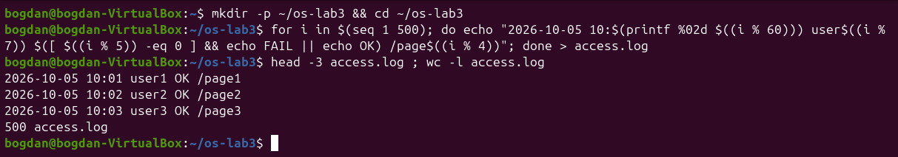
Figure 0.1 – Generating access.log and checking that it has 500 lines

3.1 Part 1. Moving fast and finding help
When the start of a name has several matches, Tab completes nothing and a second Tab lists the candidates (sbin/ share/ src/ for /usr/s). With a unique match, one Tab completes the whole name (/usr/sh becomes /usr/share/, /et becomes /etc/). For a directory with many entries, bash first asks Display all 254 possibilities? (y or n).
Figure 1.1 – Tab completion: list of candidates, then completion to /usr/share/
Figure 1.2 – Tab completes /et to /etc/
Ctrl+R opens a reverse search in the history. After typing da, bash offered the last command containing these letters, date, and Enter ran it again.
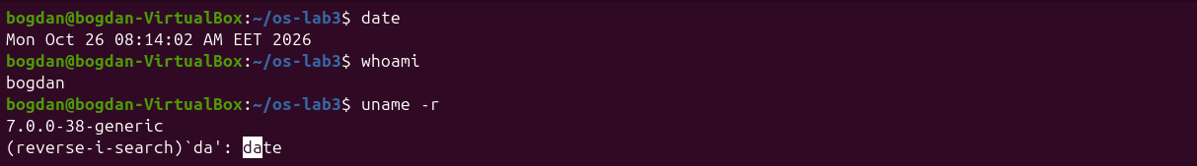
Figure 1.3 – Reverse history search with Ctrl+R
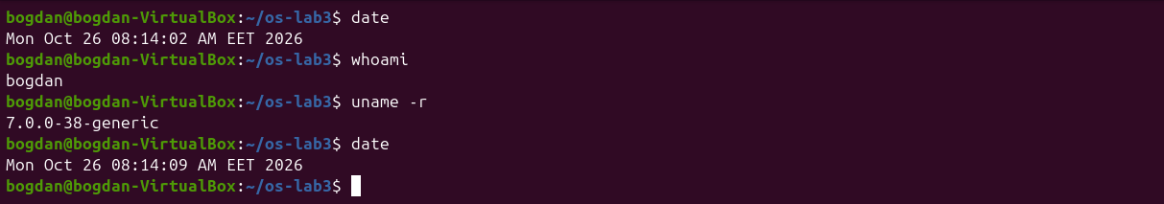
Figure 1.4 – Enter runs the command found by Ctrl+R
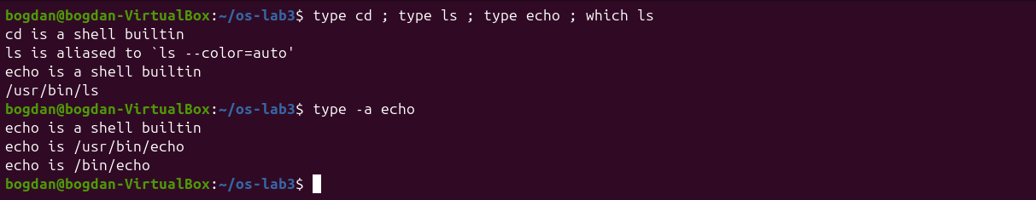
Figure 1.5 – Output of type and which
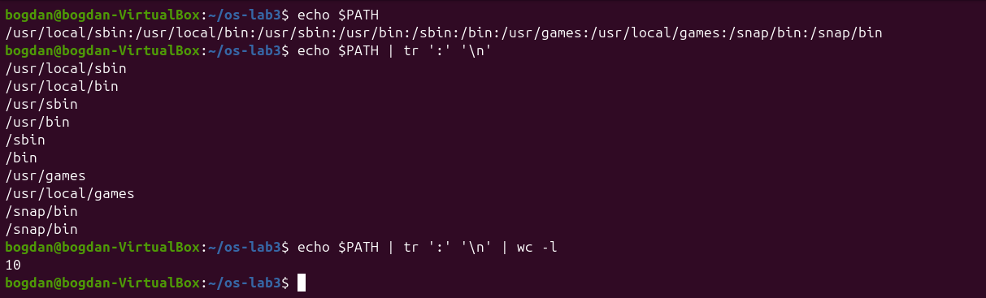
Figure 1.6 – The directories in PATH
Figure 1.7 – Exit code of a missing command
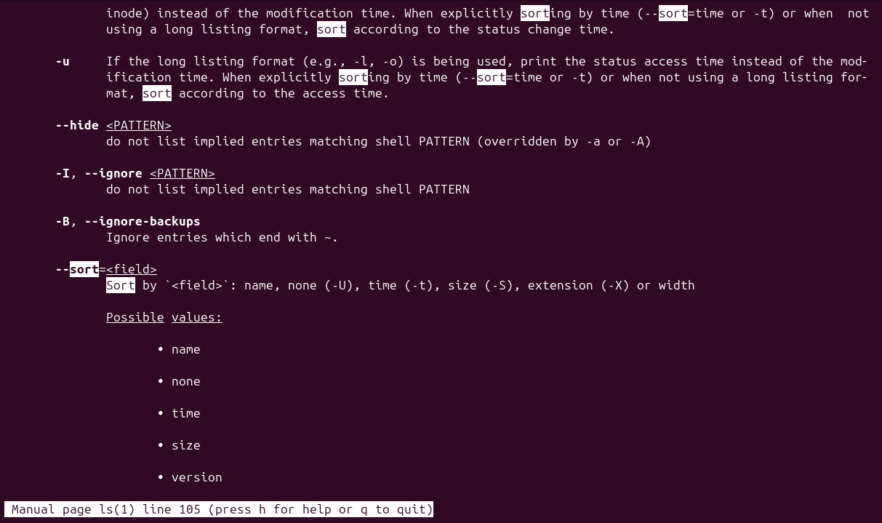
Figure 1.8 – Searching for sort inside man ls
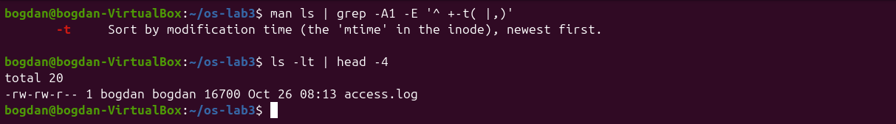
Figure 1.9 – The -t option in the manual and ls -lt
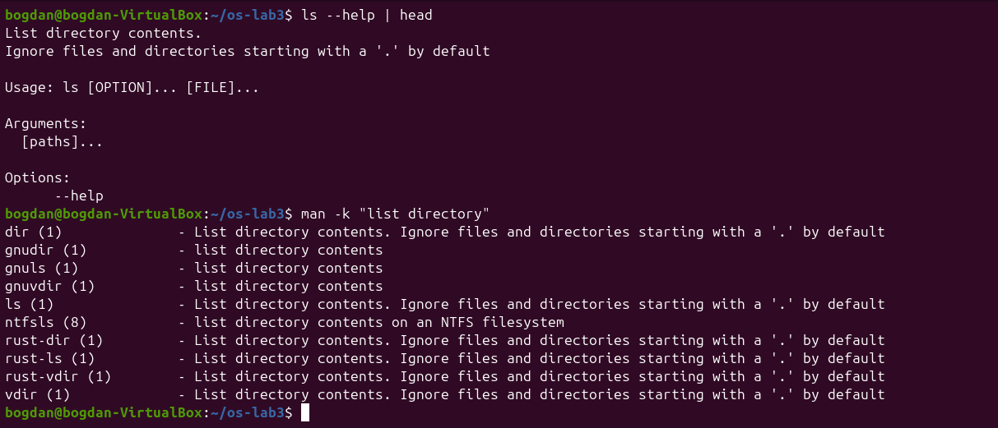
Figure 1.10 – ls --help and man -k "list directory"
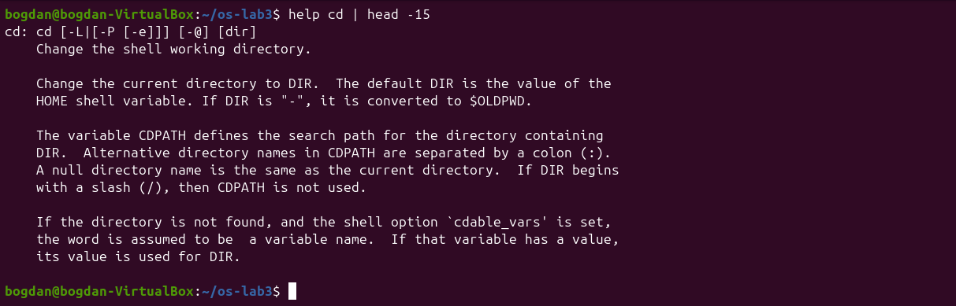
Figure 1.11 – help cd: documentation of a built-in
ls --help and man -k work for external programs, but a built-in such as cd has no separate manual page of its own; bash documents it with help cd. On this system man -k "list directory" also shows that ls, dir and vdir come from the Rust coreutils (rust-ls, rust-dir), while the GNU versions are still available as gnuls and gnudir.
1. Which of cd, ls, echo are built-ins, and why MUST cd be one?
cd and echo are shell built-ins. ls is an external program /usr/bin/ls (in my shell also an alias for ls --color=auto), and type -a echo shows that an external /usr/bin/echo also exists, but the built-in is used first. cd must be a built-in because the current directory is a property of each process: an external cd would run in a child process, change only the child's directory and exit, leaving the shell where it was.
2. How many directories are in your PATH, and in which one is ls?
PATH has 10 entries, with /snap/bin listed twice, so 9 different directories. which ls answers /usr/bin/ls. Because /bin is a link to usr/bin, the same file is also found as /bin/ls.
3. What exit code does a command that is not found return?
127. bash prints nosuchprog: command not found and $? becomes 127.
4. Which option of ls sorts by modification time?
-t, "Sort by modification time, newest first". I found it in man ls by searching with /sort and n.

3.2 Part 2. What the shell does to the command line
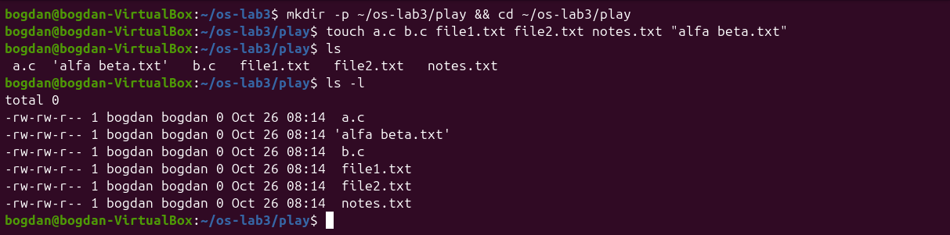
Figure 2.1 – Files created in the play directory
Before running each line I wrote down my prediction. The table compares the predictions with the real output.
Command | My prediction | Real output | Explanation (if different)
echo *.c | a.c b.c | a.c b.c | –
echo file?.txt | file1.txt file2.txt | file1.txt file2.txt | –
echo [a-b]* | a.c b.c | a.c alfa beta.txt b.c | I forgot that alfa beta.txt also starts with a letter in [a-b]; the space inside the name does not matter for globbing.
echo *.xyz | (an empty line) | *.xyz | If a pattern matches nothing, bash leaves the word unchanged (no nullglob).
ls alfa beta.txt | error for two files | cannot access 'alfa' and 'beta.txt' | –
ls "alfa beta.txt" | alfa beta.txt | 'alfa beta.txt' | ls itself adds quotes to names with spaces when it writes to a terminal.
echo '$HOME' "$HOME" \$HOME | $HOME /home/bogdan $HOME | $HOME /home/bogdan $HOME | –
echo {1..5} ; echo $((7 * 6)) | 1 2 3 4 5 / 42 | 1 2 3 4 5 / 42 | –
echo "today is $(date +%A), I am $(whoami)" | today is Monday, I am bogdan | today is Monday, I am bogdan | –
touch log{1..3}.txt && ls log* | log1.txt log2.txt log3.txt | log1.txt log2.txt log3.txt | –

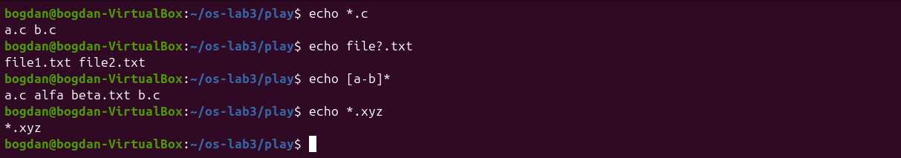
Figure 2.2 – Globbing results
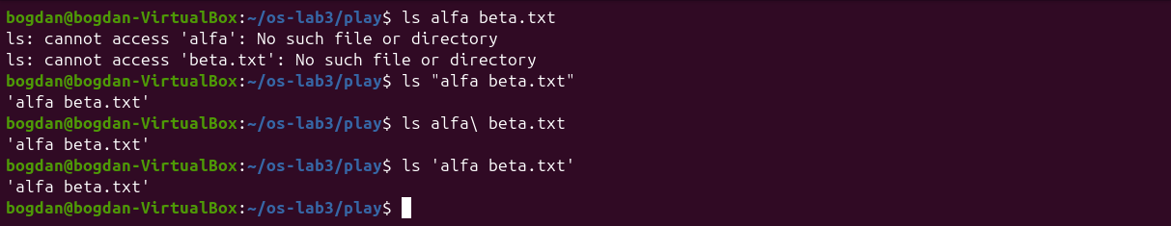
Figure 2.3 – The ls error on a name with a space, and three fixes
Figure 2.4 – Single quotes, double quotes and backslash
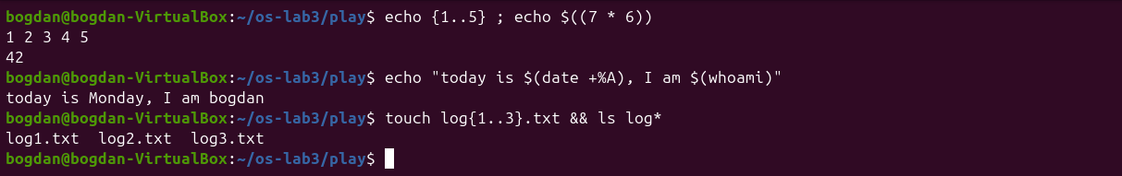
Figure 2.5 – Brace, arithmetic and command substitution
2. echo knows nothing about files, yet echo *.c printed file names. Who produced them?
The shell. Before starting echo, bash performs pathname expansion: it replaces *.c with the sorted list of matching names in the current directory and passes them to echo as separate arguments. echo only prints the arguments it receives.
3. Why did ls alfa beta.txt fail? Give two different ways to fix it.
The shell splits words at spaces, so ls received two arguments, alfa and beta.txt, and neither file exists. Fixes: quote the name (ls "alfa beta.txt" or ls 'alfa beta.txt'), or escape the space with a backslash (ls alfa\ beta.txt). Typing ls alfa and pressing Tab also inserts the escaped name.
4. What is the difference between single and double quotes?
Inside single quotes nothing is special: '$HOME' stays the literal text $HOME. Inside double quotes word splitting and globbing are switched off, but $variables, $(commands), $((arithmetic)) and backslash escapes still work, so "$HOME" becomes /home/bogdan. A backslash outside quotes protects only the next character (\$HOME).
Note on the quotes shown by ls. Since coreutils 8.25, and also in the Rust coreutils on this system, ls prints names that contain spaces or special characters in shell quoting ('alfa beta.txt') when it writes to a terminal. This makes the output unambiguous and lets you copy the name straight into the next command. With ls | cat the quotes disappear.

3.3 Part 3. Redirection, chaining and jobs
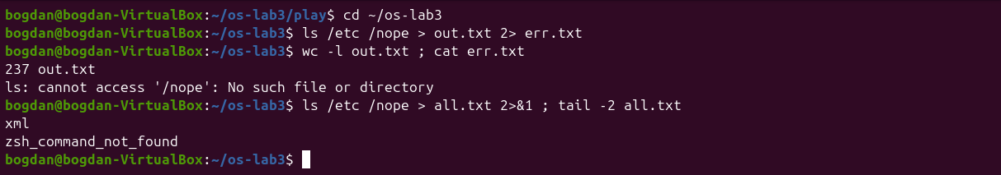
Figure 3.1 – stdout and stderr in separate files
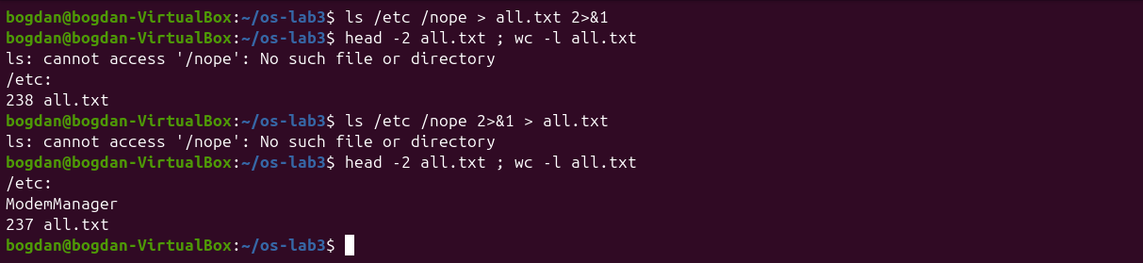
Figure 3.2 – Comparing the order of redirections
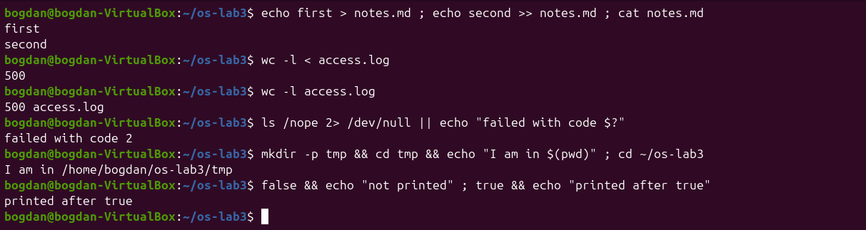
Figure 3.3 – Appending with >>, reading with <, and the ; && || operators
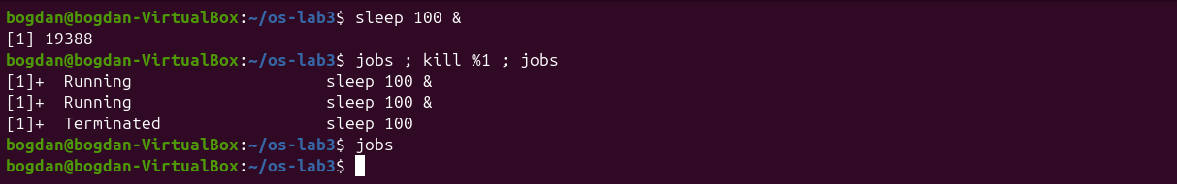
Figure 3.4 – Running a background job and stopping it
1. Which file got the error message, and which got the listing?
err.txt received the error ls: cannot access '/nope': No such file or directory (descriptor 2), and out.txt received the listing of /etc, 237 lines (descriptor 1).
2. What is the difference between > all.txt 2>&1 and 2>&1 > all.txt?
Redirections are processed from left to right, and 2>&1 means "make descriptor 2 point where descriptor 1 points now". In > all.txt 2>&1, stdout first goes to the file and then stderr is copied from it, so both end up in the file (238 lines, with the error on the first line). In 2>&1 > all.txt, stderr is first copied from stdout while stdout is still the terminal, and only then is stdout moved to the file. The error appears on the screen and the file has only the 237 lines of the listing.
3. Why does wc -l < access.log print only a number, while wc -l access.log also prints the file name?
With < the shell opens the file and connects it to descriptor 0 before starting wc. wc reads its standard input and has no idea what the file is called. With wc -l access.log the name is an argument, so wc opens the file itself and reports it next to the count.
4. Explain each operator in one sentence: ; && ||.
; runs the next command after the previous one ends, whatever its result. && runs the next command only if the previous one succeeded (exit code 0), as in mkdir -p tmp && cd tmp. || runs the next command only if the previous one failed, as in ls /nope 2> /dev/null || echo "failed with code $?", which printed failed with code 2.
The job control test shows the life of a background job: sleep 100 & printed the job number and PID, jobs listed it as Running, kill %1 sent it SIGTERM, and the next jobs reported Terminated.

3.4 Part 4. Answering questions with one-liners
Each line of access.log has five fields separated by spaces: date, time, user, result and page. Every question is answered by one line in oneliners.sh.
Figure 4.1 – Number of failed requests
Q1. grep -c FAIL access.log → 100 failed requests.
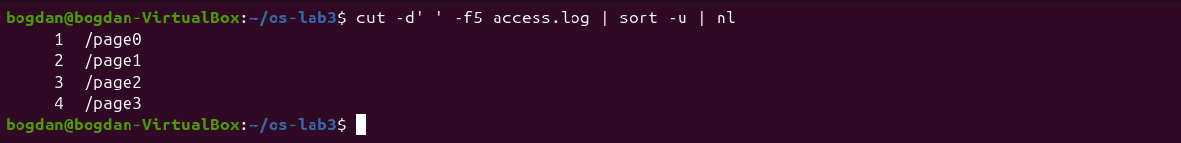
Figure 4.2 – The different pages that were requested
Q2. cut -d' ' -f5 access.log | sort -u | nl → 4 pages: /page0, /page1, /page2, /page3. nl numbers the lines, so the last number is the count.
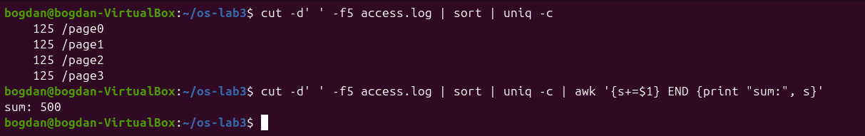
Figure 4.3 – Number of requests per page
Q3. cut -d' ' -f5 access.log | sort | uniq -c → 125 requests for each page. The check with awk confirms that the counts add up to 500.
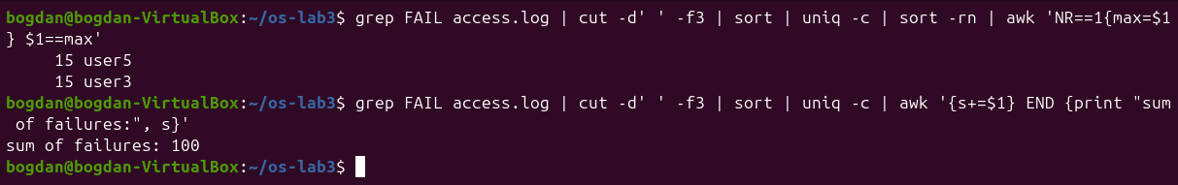
Figure 4.4 – Users with the most failed requests
Q4. grep FAIL access.log | cut -d' ' -f3 | sort | uniq -c | sort -rn | awk 'NR==1{max=$1} $1==max' → user3 and user5, with 15 failures each. I used awk to print every user tied for the maximum, because head -1 would hide the tie. The per-user failures add up to 100, the same as Q1.
Figure 4.5 – Requests and failures of user3
Q5. echo "user3 total: $(grep -cw user3 access.log), failed: $(grep -w user3 access.log | grep -c FAIL)" → user3 made 72 requests and 15 of them failed. -w matches whole words only.
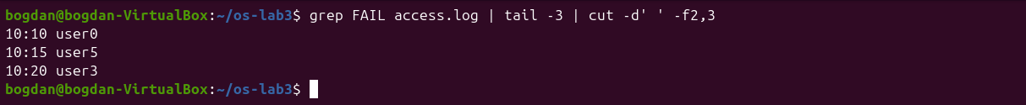
Figure 4.6 – The last three failed requests (time and user)
Q6. grep FAIL access.log | tail -3 | cut -d' ' -f2,3 → 10:10 user0, 10:15 user5, 10:20 user3.
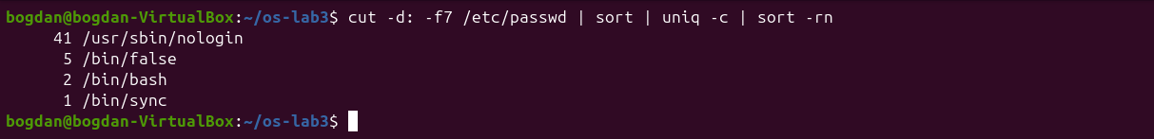
Figure 4.7 – Login shells in /etc/passwd
Q7. cut -d: -f7 /etc/passwd | sort | uniq -c | sort -rn → 41 accounts use /usr/sbin/nologin, 5 use /bin/false, 2 use /bin/bash (root and bogdan) and 1 uses /bin/sync. Only accounts with a real shell can log in interactively; the others are system accounts for services.
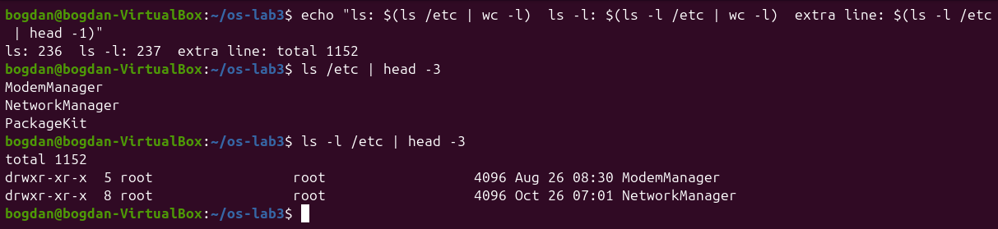
Figure 4.8 – ls versus ls -l on /etc
Q8. My prediction was that ls -l adds a header line. That was right: ls /etc | wc -l gives 236 and ls -l /etc | wc -l gives 237. The extra first line is total 1152, the number of disk blocks used by the listed files. Both commands print one line per file, and only the long format adds this summary.
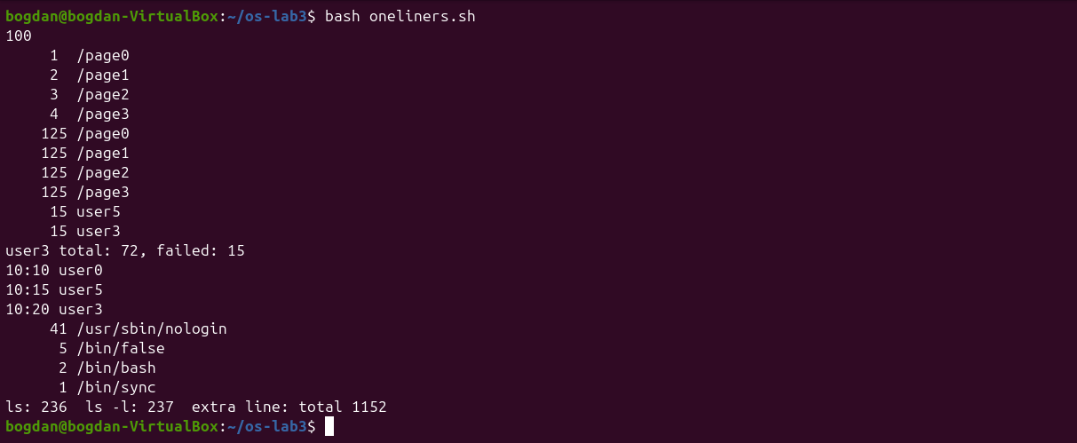
Figure 4.9 – Full run of oneliners.sh
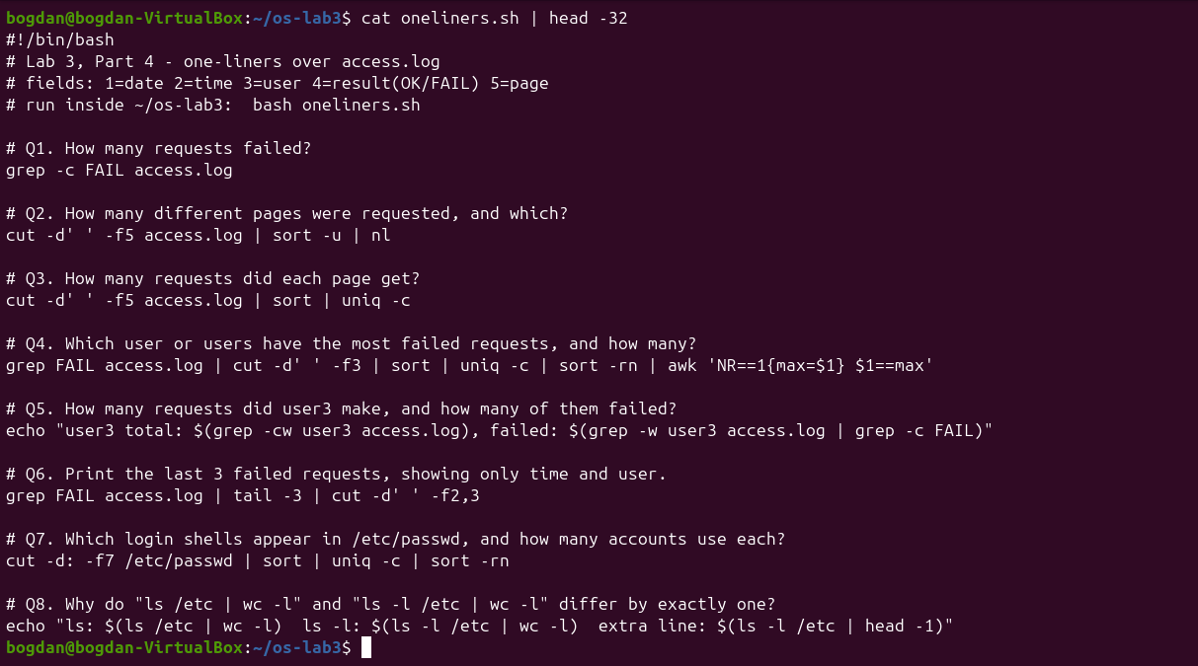
Figure 4.10 – The file oneliners.sh
Bonus. grep -E '^[^ ]+ 10:[0-5]0 [^ ]+ FAIL' access.log | wc -l → 50 lines. The minute ends in 0 exactly when i is a multiple of 10, and every multiple of 10 is also a multiple of 5, so all of these requests failed.

Figure 4.11 – Bonus: failed requests at minutes ending in 0

3.5 Part 5. The first script
I completed the TODO in report.sh with a loop over seq 0 6 that counts the FAIL lines of each user (grep -cw so that user1 cannot match another name).
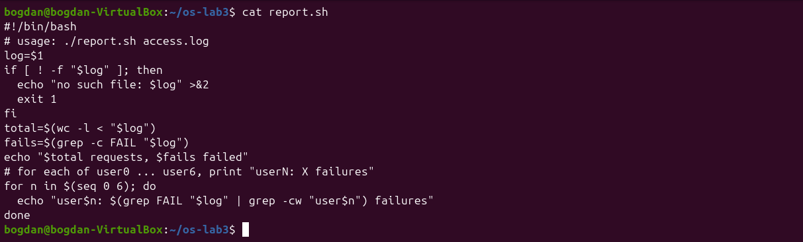
Figure 5.1 – Contents of report.sh
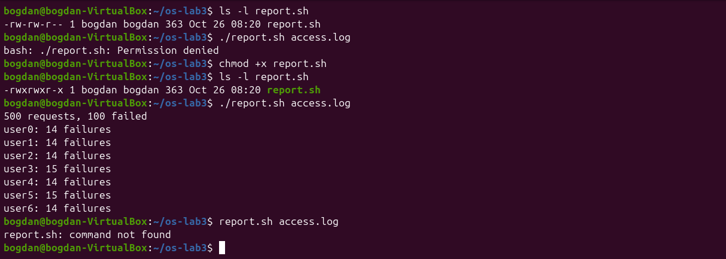
Figure 5.2 – Running the script before and after chmod +x
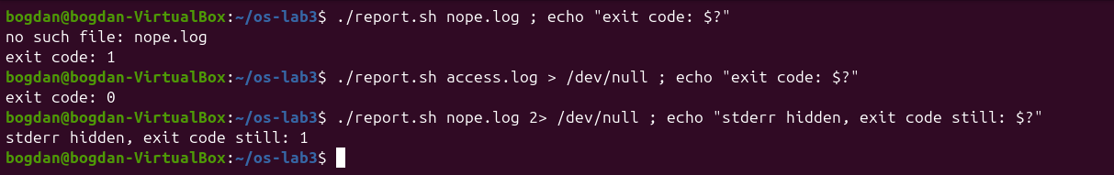
Figure 5.3 – Error handling for a missing file
1. What does the first line #!/bin/bash do, and what happens if you run ./report.sh before chmod +x?
#! (shebang) tells the kernel which interpreter to start when the file is executed directly: execve runs /bin/bash report.sh access.log. Before chmod +x the file has no execute permission (-rw-rw-r--), so the kernel refuses and bash prints Permission denied. It can still be run as bash report.sh.
2. Why must you type ./report.sh and not just report.sh?
A name without a slash is looked up only in the directories of PATH, and the current directory is not in PATH (for safety: otherwise a file named ls in a downloaded folder could be run by mistake). report.sh therefore gives command not found, while ./report.sh is an explicit path.
3. Why does the script write the error with >&2 and end with exit 1?
>&2 sends the message to standard error, so it is not mixed with the data on standard output. It still appears on the screen if stdout is redirected or piped, and it stays hidden when only stderr is redirected. exit 1 returns a non-zero code so that the caller ($?, &&/||, cron, another script) knows the script failed: the run on nope.log returns 1, the normal run returns 0.
Bonus: cron. I added this line to my crontab (with crontab -l piped into crontab -, which has the same effect as editing it in crontab -e):
* * * * * /home/bogdan/os-lab3/report.sh /home/bogdan/os-lab3/access.log >> /home/bogdan/os-lab3/report.log 2>&1
After a little more than two minutes report.log contained two complete reports, one per minute. Then crontab -r removed the crontab.
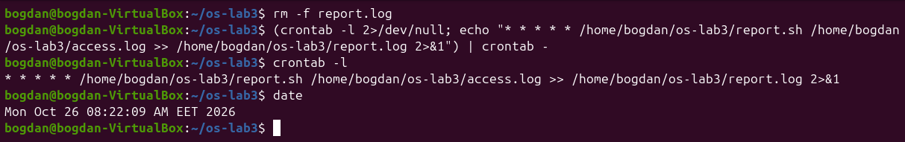
Figure 5.4 – The crontab line
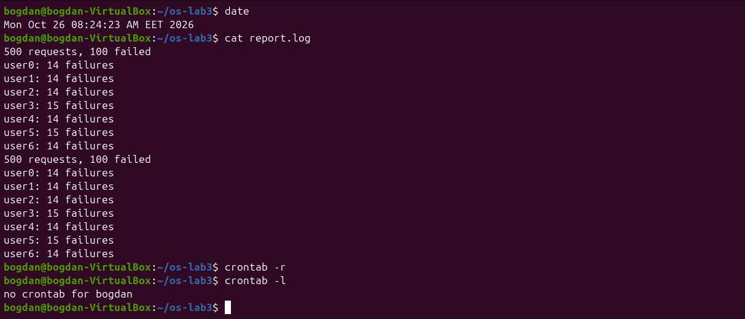
Figure 5.5 – report.log written by cron, then the crontab removed

4 Conclusions
The most important lesson of this lab is that the shell rewrites the command line before any program sees it: globbing, quote removal, variable, brace and command substitution all happen inside bash, and the program only receives the final list of words. Writing a prediction before every command made this visible. My wrong guesses (echo *.xyz and echo [a-b]*) were both about globbing details.
Redirection is also done by the shell, strictly from left to right, which explains why the order of 2>&1 matters. Small filters (grep, cut, sort, uniq, wc) joined by pipes were enough to answer every question about the log, and the cross-checks (500 requests in Q3, 100 failures in Q4) gave me confidence that the pipelines were filtering the right lines. Finally, the same commands became a script with proper error handling, and cron ran it on a schedule.

