
Ministry of Education and Research of the Republic of Moldova
Technical University of Moldova
Faculty of Computers, Informatics and Microelectronics
Department of Software Engineering and Automation
REPORT
on laboratory work no. 4
Course: Operating Systems
Topic: The xv6 Shell from the Outside
Done by: | st. gr. FAF-242, Bogdan Aramă
Checked by: | Reițman Patricia, university assistant

Chișinău, 2026

CONTENTS
1 Purpose of the work 3
2 Work environment 3
3 Execution of the work 3
3.1 Part 1. sleep on the current xv6 3
3.2 Part 2. bash versus the xv6 shell 4
3.3 Part 3. Who expands *? A program that prints its argv 7
3.4 Part 4. Reading the shell 9
4 Conclusions 11

1 Purpose of the work
The aim of this work is to understand what a shell really has to do by comparing bash with the 500-line xv6 shell (user/sh.c) on the same commands. A small program that prints its argv shows who expands * and who removes the quotes. Before that, the sleep program from Lab 2 is checked against the current xv6 tree.

2 Work environment
Item | Value
Host system | Ubuntu 26.04.1 LTS in VirtualBox (2 vCPU, 3.3 GiB RAM)
Cross compiler | riscv64-linux-gnu-gcc 15.2
Emulator | QEMU 10.2 (qemu-system-riscv64, machine virt, 3 harts)
xv6 source | mit-pdos/xv6-riscv, revision 06aad25, branch lab, in ~/xv6-riscv
Prepared with | os2026-setup.sh (check mode reports "All set")

3 Execution of the work

3.1 Part 1. sleep on the current xv6
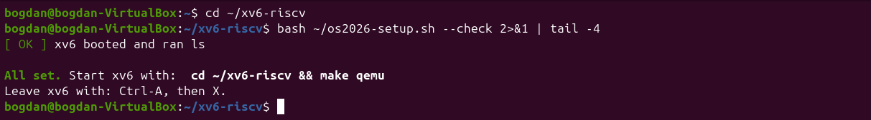
Figure 1.1 – os2026-setup.sh --check confirms that the toolchain and xv6 work
The setup check reports "All set". In this tree user/user.h declares pause and no sleep, so the call in user/sleep.c uses pause() (I already had to make this change in Lab 2). The UPROGS line $U/_sleep\ is on line 135 of the Makefile.
Figure 1.2 – The grep result in user.h
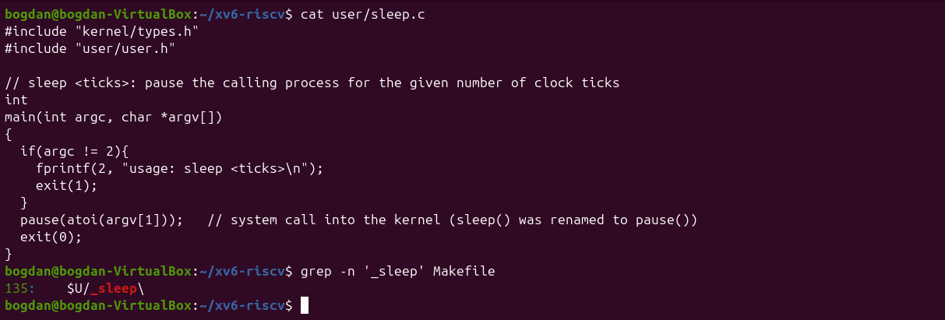
Figure 1.3 – The updated sleep.c
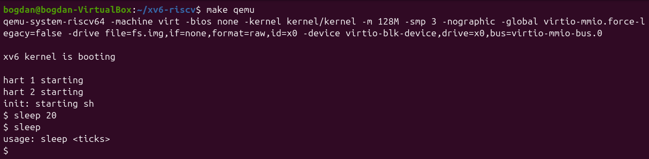
Figure 1.4 – sleep running in xv6, with and without an argument

3.2 Part 2. bash versus the xv6 shell
Every command was run twice: in bash inside ~/shtest (an empty folder with a file named README) and at the xv6 prompt.
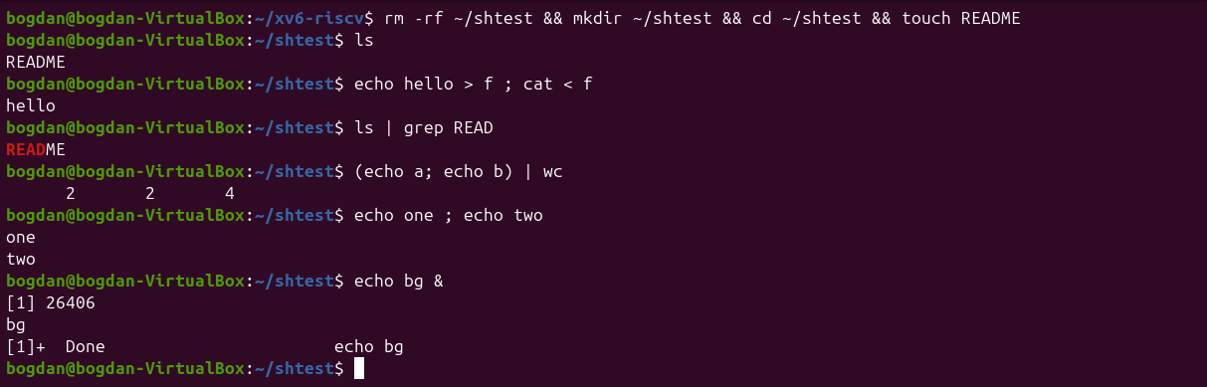
Figure 2.1 – The commands run in bash (1/2)
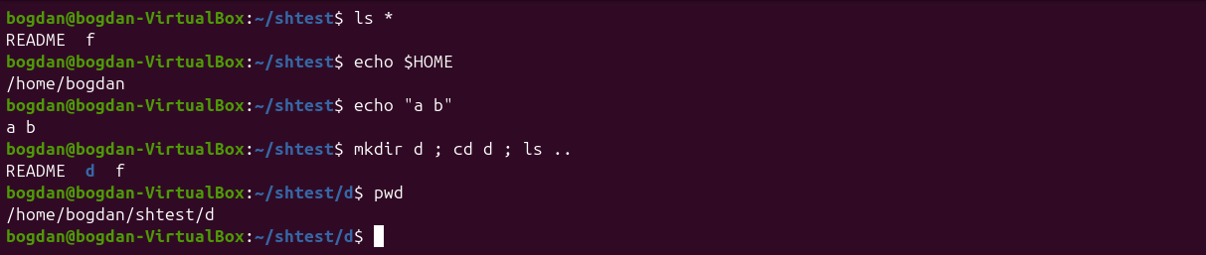
Figure 2.2 – The commands run in bash (2/2)
Figure 2.3 – bash: Tab twice lists the commands starting with ec
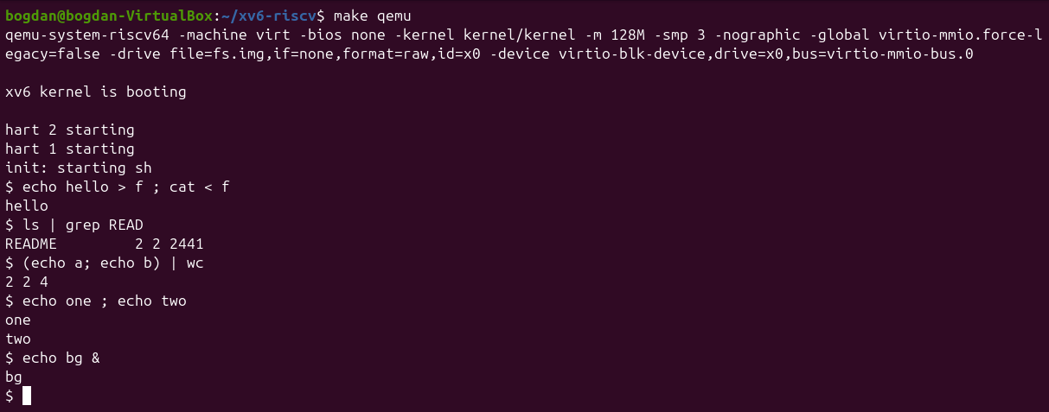
Figure 2.4 – The same commands run in xv6 (1/2)
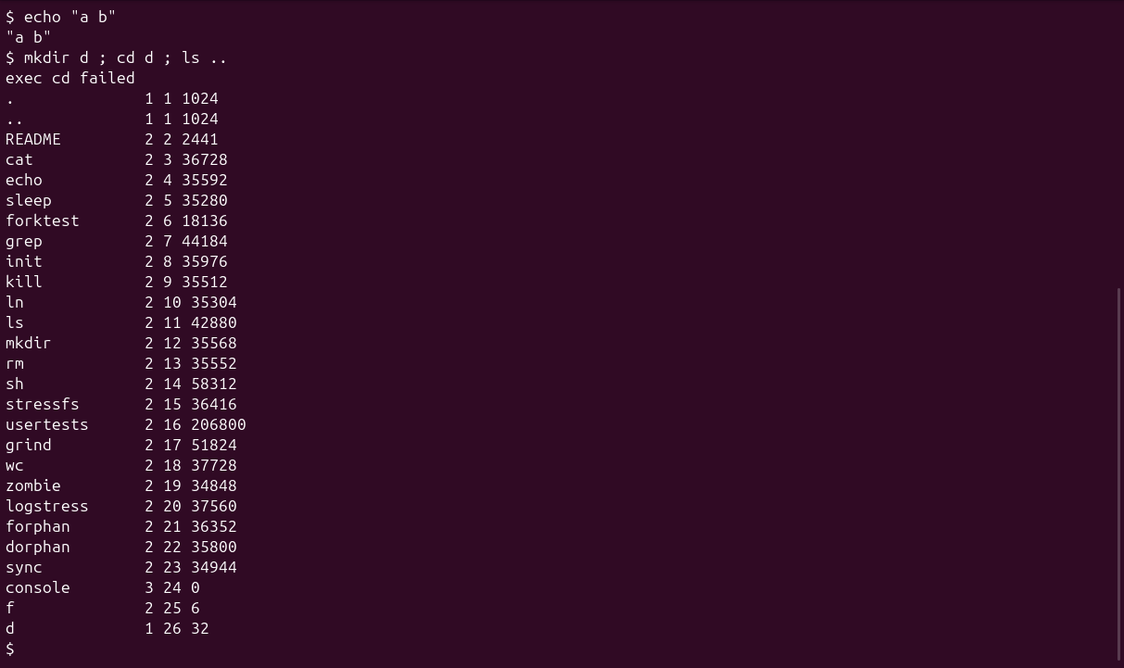
Figure 2.5 – The same commands run in xv6 (2/2)
Command | Tests | bash | xv6
echo hello > f ; cat < f | redirection | hello | hello – works the same
ls | grep READ | pipe | README | README 2 2 2441 – works (xv6 ls also prints type, inode, size)
(echo a; echo b) | wc | grouping, list | 2 2 4 | 2 2 4 – works
echo one ; echo two | sequence | one / two | one / two – works
echo bg & | background | [1] 26406, bg, then [1]+ Done | bg – runs, but no job number or job control
ls * | globbing | README f | ls: cannot open * – no globbing, * is passed as is
echo $HOME | variables | /home/bogdan | $HOME – no variables
echo "a b" | quotes | a b | "a b" – quotes are not removed
mkdir d ; cd d ; ls .. | PATH / cd | README d f (and the prompt is now in d) | exec cd failed, then a listing of / – cd is a built-in only when it starts the line
arrow up, Tab, Ctrl+R | history, completion | previous command recalled, Tab completes or lists names | nothing useful: no history, Tab is just a character (Enter then gives exec failed)

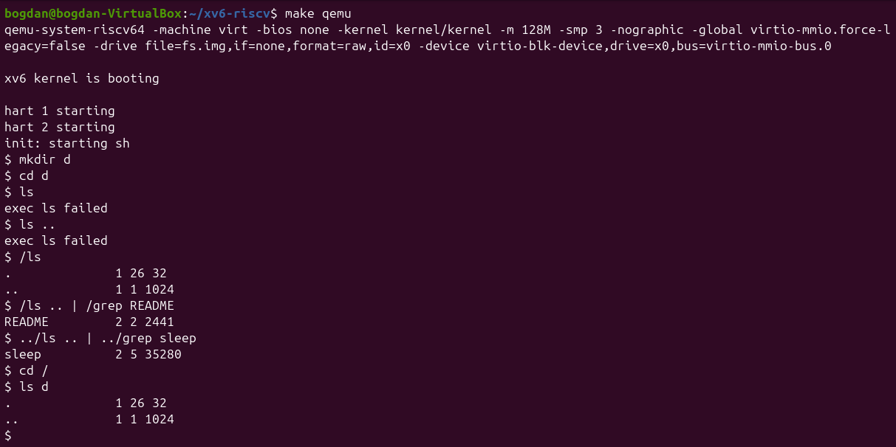
Figure 2.6 – ls failing after cd d, and the working alternative
1. List the features both shells have, and the ones only bash has.
Both shells have running programs with arguments, < and > redirection (and >>), pipes, command lists with ;, grouping with parentheses, background execution with &, and the built-in cd. Only bash has wildcards, variables and $HOME, quote removal, PATH search, job control (jobs, %1, Done messages), && and ||, command and arithmetic substitution, history with arrows and Ctrl+R, and Tab completion.
2. In xv6, ls stops working after cd d. Why? Find a way to run ls from inside d anyway.
The xv6 shell calls exec with the name exactly as typed, and the kernel resolves it relative to the current directory. There is no PATH: all programs live in the root directory /, so inside d the file ls does not exist and the shell prints exec ls failed. A path makes it work: /ls (absolute) or ../ls (relative), for example /ls .. | /grep README.
3. Which missing feature would you miss most in daily work, and which would be easiest to add?
I would miss history with the arrow keys and Tab completion the most, because I use them constantly. The easiest feature to add is a PATH fallback: in runcmd, when exec(argv[0]) fails and the name has no /, try again with "/" in front. That is only a few lines of code. Variables like $HOME would also be simple for one fixed variable, but real globbing needs directory reading and pattern matching.

3.3 Part 3. Who expands *? A program that prints its argv
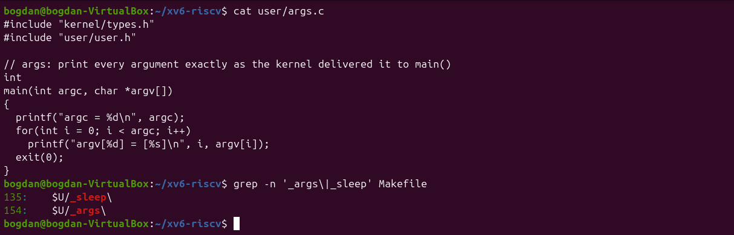
Figure 3.1 – args.c and the UPROGS line
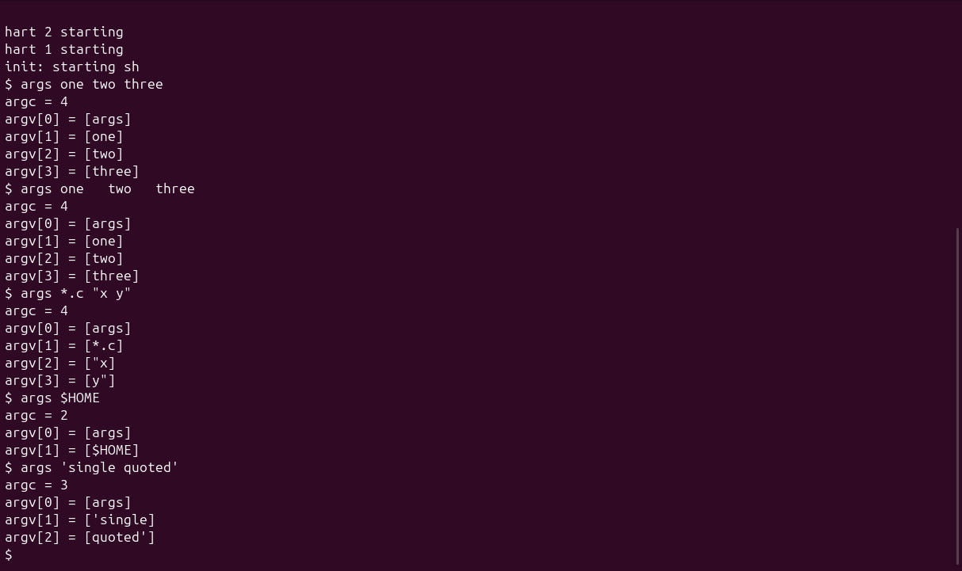
Figure 3.2 – args output in xv6
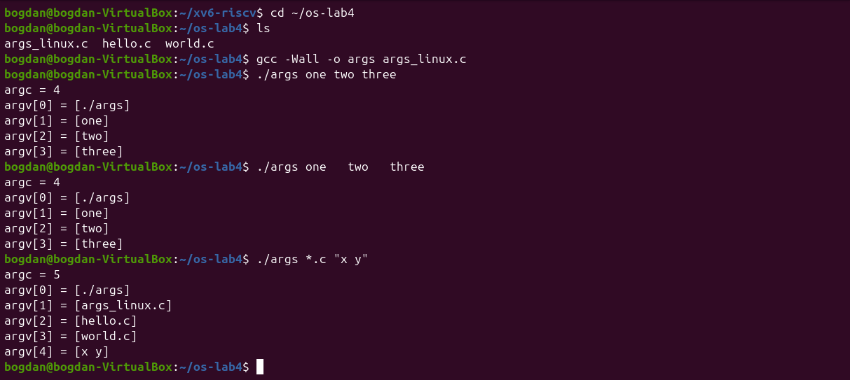
Figure 3.3 – args_linux output in bash
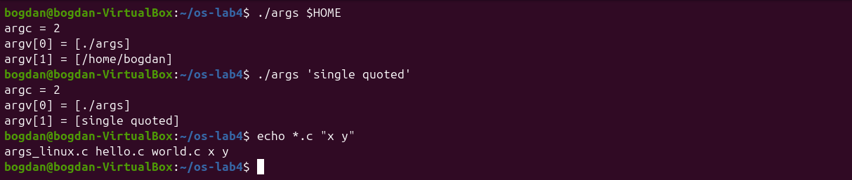
Figure 3.4 – args_linux with $HOME and single quotes
1. Paste both outputs for args *.c "x y". How many arguments did each program receive?
xv6: argc = 4, with argv[1] = [*.c], argv[2] = ["x], argv[3] = [y"]. bash: argc = 5, with [args_linux.c], [hello.c], [world.c] and [x y]. The program code is identical, and only the shell in front of it is different.
2. So who turns *.c into file names and removes the quotes: the program, the kernel, or the shell?
The shell. bash expands *.c into the matching names and removes the quotes, joining x y into one argument, before calling execve. The kernel only copies the final argv array into the new process, and the program just prints what it gets. The xv6 shell does neither, so the raw words reach the program.
3. What happened to the extra spaces in one two three?
They disappeared in both shells: args one two three gives exactly the same four arguments as with single spaces. Spaces and tabs only separate words (in sh.c the whitespace set is skipped by gettoken), so they never become part of an argument unless they are quoted, and in bash only.

3.4 Part 4. Reading the shell
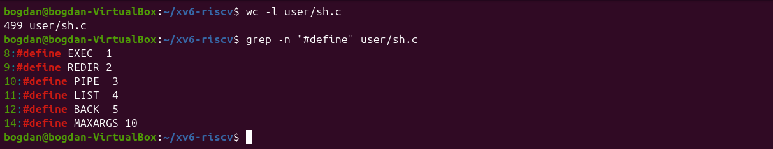
Figure 4.1 – The command kinds defined in sh.c
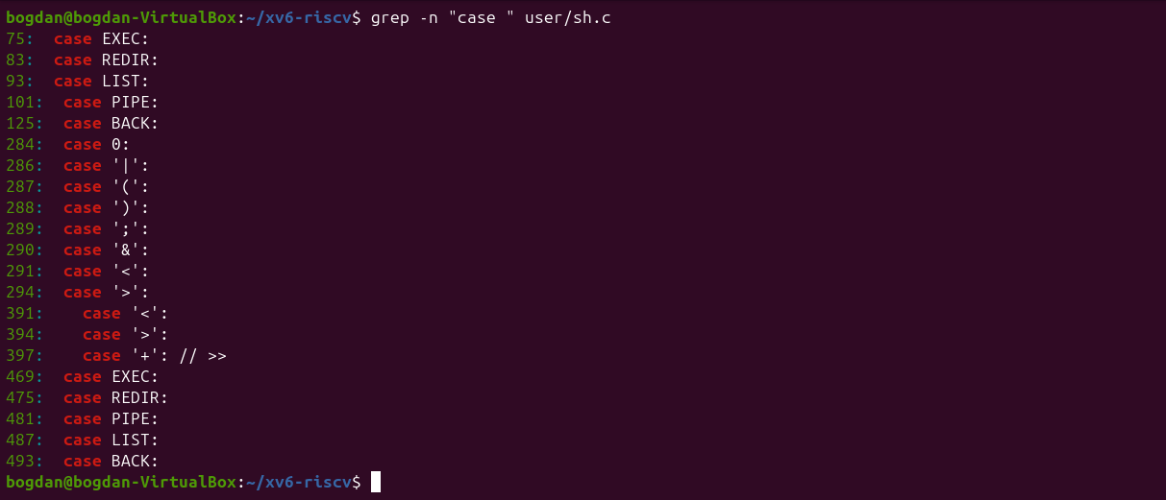
Figure 4.2 – Where each kind is run (case lines)
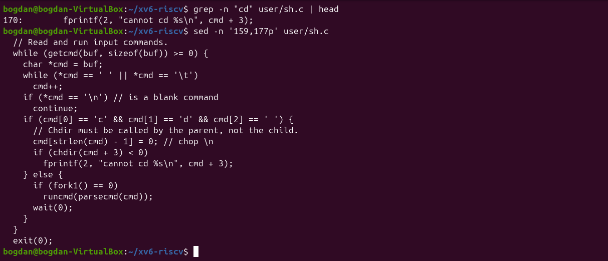
Figure 4.3 – The code that handles cd
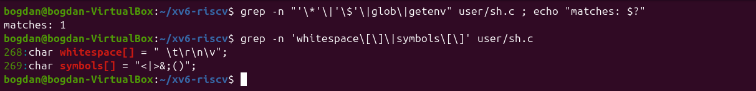
Figure 4.4 – sh.c has no code for * or $
1. Name the five kinds of command the xv6 shell knows and the character that produces each.
EXEC (1), a plain command with arguments, with no special character. REDIR (2), produced by <, > or >>. PIPE (3), produced by |. LIST (4), produced by ;. BACK (5), produced by &. The parentheses ( ) do not create a new kind; parseblock just groups the commands inside. runcmd executes each kind in the switch on lines 75–125.
2. Where is cd handled, and why is it not run as a separate program?
In main(), lines 166–170: if the line starts with cd , the shell itself calls chdir(cmd + 3) instead of forking. The comment says "Chdir must be called by the parent, not the child": the working directory belongs to each process, and a child would change only its own directory and then exit. The check looks only at the beginning of the line, which is why mkdir d ; cd d ; ls .. printed exec cd failed.
3. Search sh.c for any code that handles * or $. What does that explain about Part 2?
There is none: the grep for '*', '$', glob or getenv finds nothing (exit code 1). The only special characters are symbols[] = "<|>&;()", and quotes are not special either. This explains Part 2: ls *, echo $HOME and echo "a b" reached the programs unchanged, because expansion and quote removal are features of the shell, not of the kernel or the programs.

4 Conclusions
Putting the two shells side by side made it clear how little a shell needs in order to be useful. Running programs, fork/exec/wait, redirection, pipes, lists and background jobs fit in the five command types of sh.c. Everything else I am used to in bash (wildcards, variables, quoting, PATH search, history and completion) is extra work done by the shell on the text of the command line.
The args experiment proved this directly: the same C program received 4 arguments under xv6 and 5 under bash for the same line. Reading sh.c also explained the two surprises: cd only works at the start of a line, and nothing works outside the root directory without a path.

