
Ministry of Education and Research of the Republic of Moldova
Technical University of Moldova
Faculty of Computers, Informatics and Microelectronics
Department of Software Engineering and Automation
REPORT
on laboratory work no. 7 and 8
Course: Operating Systems
Topic: Processes, Redirection and Pipes on Linux and inside xv6
Done by: | st. gr. FAF-242, Bogdan Aramă
Checked by: | Reițman Patricia, university assistant

Chișinău, 2026

CONTENTS
1 Purpose of the work 3
2 Work environment 3
3 Lab 7 – Three Small Programs: Processes, Redirection, a Pipe (Linux) 4
3.1 Getting started 4
3.2 Part 1. fork + exec + wait 4
3.3 Part 2. A zombie, on purpose 5
3.4 Part 3. Redirection: ls -l > out.txt 6
3.5 Part 4. A pipe: ls /etc | wc -l 7
3.6 Optional: three stages 8
4 Lab 8 – The Same Calls Inside Your Own OS (xv6) 10
4.1 Part 1. run, inside xv6 10
4.2 Part 2. pingpong 13
4.3 Optional: primes 14
5 Conclusions 16

1 Purpose of the work
This report covers two laboratory works. The purpose of Lab 7 is to run, on Linux, the three answers from the lecture: how a process is born (fork, exec, wait), where printf writes (file descriptors and redirection) and how ls | wc -l works (a pipe and dup). Three short C programs are compiled and run, and each is then changed in one place to see what breaks.
The purpose of Lab 8 is to run the same fork/exec/wait program inside xv6, the operating system built during the semester, to see that the system calls are the same, and then to make two processes talk through pipes with pingpong (and, optionally, a chain of processes with primes).

2 Work environment
Lab 7 was done directly in Linux:
Item | Value
Machine | VirtualBox virtual machine, 2 vCPU, 3.3 GiB RAM, 25 GB disk
Operating system | Ubuntu 26.04.1 LTS (GNOME, Wayland)
Kernel | Linux 7.0.0-38-generic, x86_64
Shell / terminal | GNU bash, Ptyxis terminal
Compiler | gcc 15.2.0

Lab 8 used the xv6 toolchain:
Item | Value
Host system | Ubuntu 26.04.1 LTS in VirtualBox (2 vCPU, 3.3 GiB RAM)
Cross compiler | riscv64-linux-gnu-gcc 15.2
Emulator | QEMU 10.2 (qemu-system-riscv64, machine virt, 3 harts)
xv6 source | mit-pdos/xv6-riscv, revision 06aad25, branch lab, in ~/xv6-riscv
Prepared with | os2026-setup.sh (check mode reports "All set")

3 Lab 7 – Three Small Programs: Processes, Redirection, a Pipe (Linux)
All programs are in ~/os-lab7 and are compiled with gcc -Wall -Wextra (gcc 15.2.0). None of them produced a warning.

3.1 Getting started
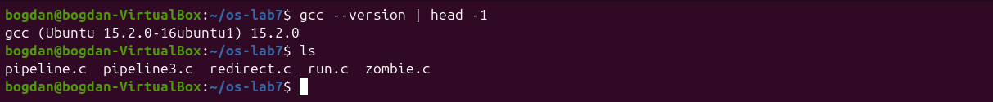
Figure 7.0.1 – Compiler version and the source files

3.2 Part 1. fork + exec + wait
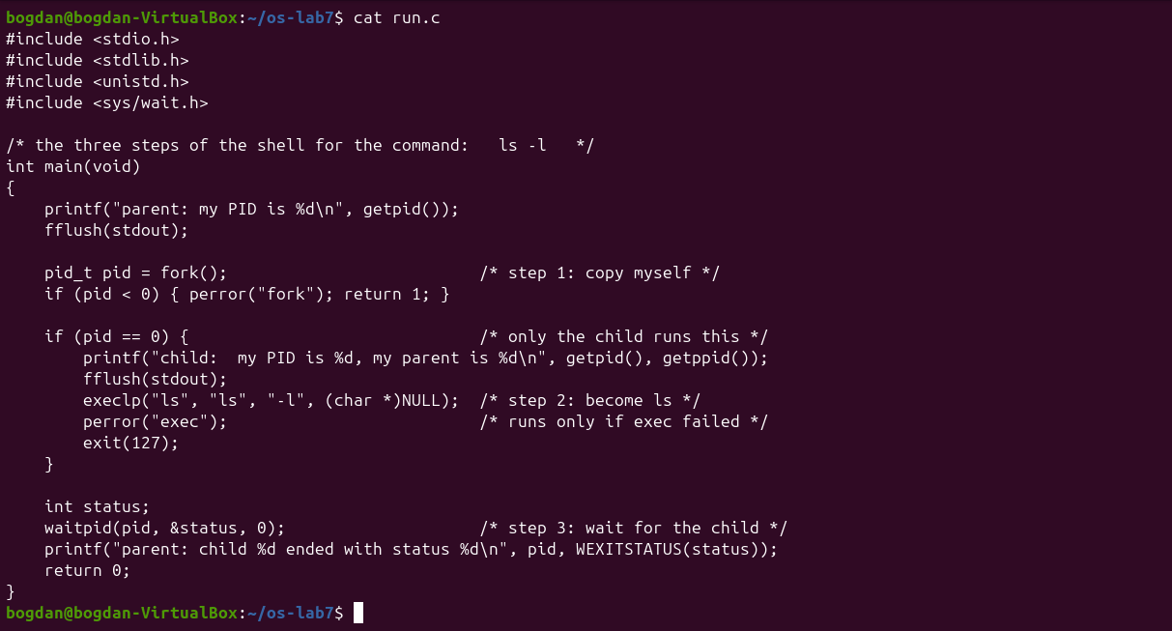
Figure 7.1.1 – run.c
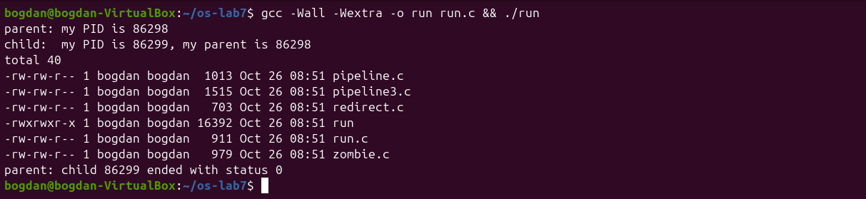
Figure 7.1.2 – run: the child becomes ls -l
The order of the lines matches the expected output: the parent prints its PID, the child prints its own PID and its parent's, then ls -l writes the listing, and finally the parent reports the exit status. Then I changed the execlp line with sed, first to date and then to a program that does not exist.
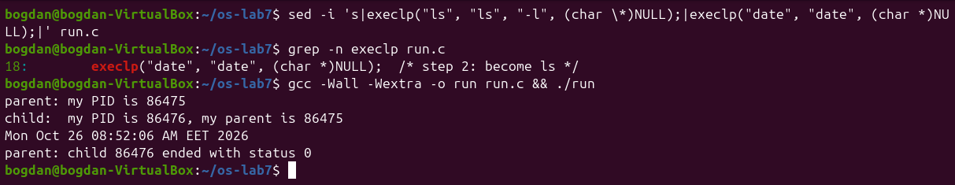
Figure 7.1.3 – The child becomes date
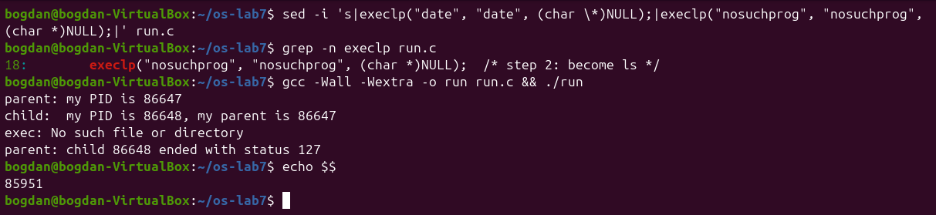
Figure 7.1.4 – exec of a program that does not exist
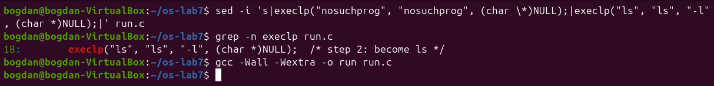
Figure 7.1.5 – run.c restored to the ls version
1. The line perror("exec") is in the child, right after execlp. Why is it printed only with nosuchprog?
A successful execlp never returns: the kernel replaces the whole memory image of the child with the new program (ls or date), so the instructions after the call no longer exist in that process. Only when exec fails (here ENOENT, "No such file or directory", because nosuchprog is in no PATH directory) does the call return -1, and the old code continues with perror and exit(127).
2. Which number does the child print as "my parent", and whose PID is it?
It prints the PID of the run process that called fork. In the first run this was 86298, exactly the number the parent printed as "my PID" (and 86475 and 86647 in the next runs). The parent of run is in turn my shell (PID 85951, shown by echo $$).
3. What status does the parent see with ls, and what status with nosuchprog?
With ls (and date) the status is 0, because the program succeeded. With nosuchprog the status is 127, the value passed to exit(127) after the failed exec. 127 is also the code bash uses for "command not found", as seen in Lab 3. WEXITSTATUS extracts this number from the status word filled in by waitpid.

3.3 Part 2. A zombie, on purpose
zombie.c is run.c with one extra line, sleep(20);, before waitpid (as the diff shows).
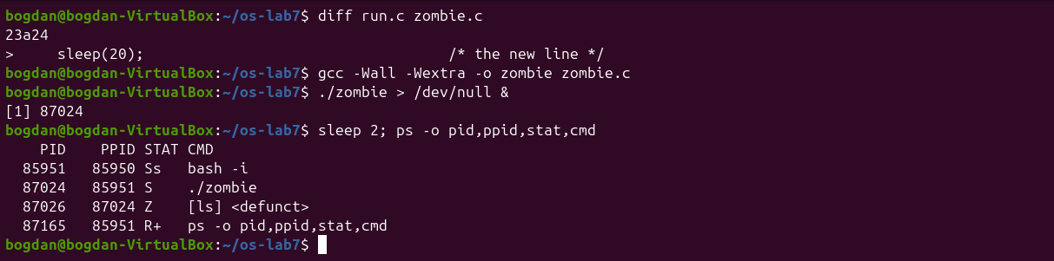
Figure 7.2.1 – ls appears as a zombie while the parent sleeps
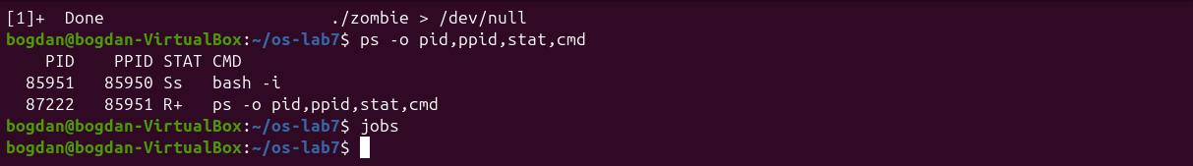
Figure 7.2.2 – After 20 seconds the zombie is gone
1. Which letter does ls have in the STAT column, and what does it mean?
Z, shown as [ls] <defunct> with PPID 87024, the sleeping ./zombie (state S). Z means zombie: the process has finished and released its memory, but its entry in the process table is kept so that the parent can still read its exit status. In the screenshot, bash already prints [1]+ Done for the job under the ps output, at the next prompt.
2. After 20 seconds, is the [ls] <defunct> line still there? Which line of zombie.c made it disappear?
No, it is gone, and so is ./zombie. The line waitpid(pid, &status, 0); removed it: after sleep(20) the parent called waitpid, the kernel gave it the exit status and freed the process table entry (this is called reaping the child). Then the parent itself ended.

3.4 Part 3. Redirection: ls -l > out.txt
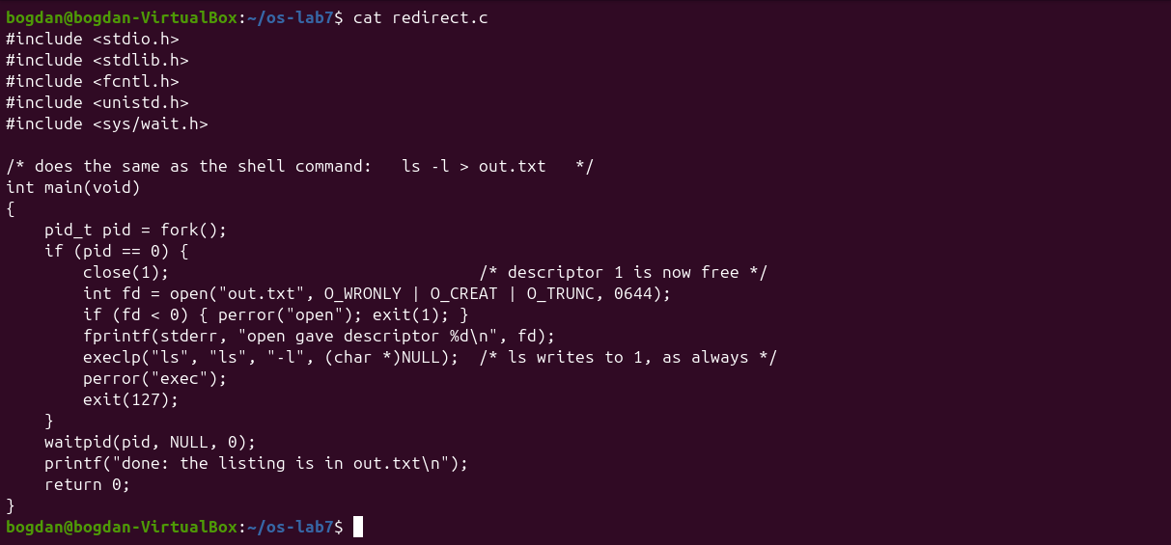
Figure 7.3.1 – redirect.c
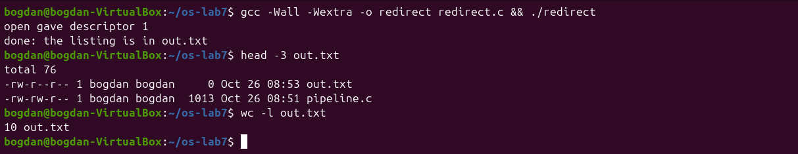
Figure 7.3.2 – redirect: the listing goes into out.txt
1. Which number did open give, and why exactly that one?
open gave descriptor 1. open always returns the lowest free descriptor number. In the child, 0 (stdin) and 2 (stderr) were still open, but 1 had just been closed, so the new file got number 1.
2. ls was not changed at all. Why does its listing not appear on the screen?
Open file descriptors survive exec. ls simply writes to descriptor 1 as always, but in this process descriptor 1 is now out.txt, not the terminal. The program never knows where its output goes, and that is exactly how the shell implements >. out.txt even lists itself with size 0, because it was created before ls ran.
3. To redirect the errors instead (like 2> err.txt), which descriptor would you close before open?
Descriptor 2: close(2) and then open("err.txt", ...) returns 2, so everything the program writes to stderr goes into the file. The fprintf(stderr, ...) message would then also end up in the file.

3.5 Part 4. A pipe: ls /etc | wc -l
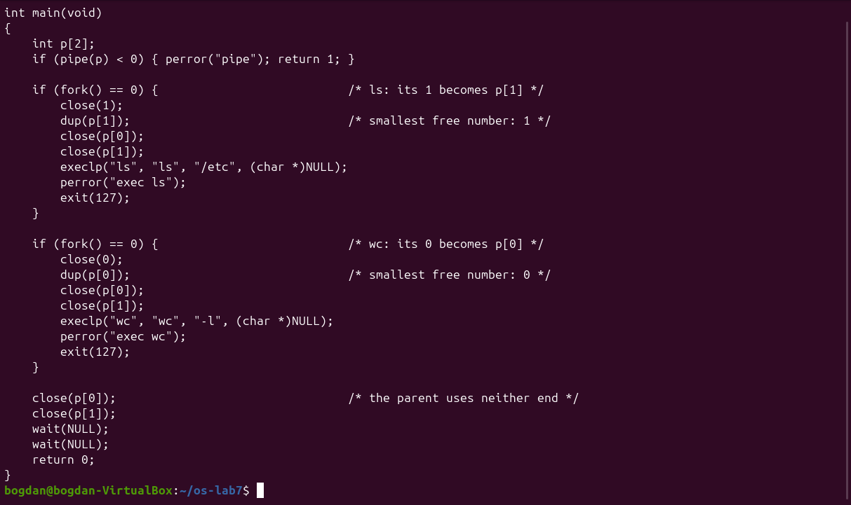
Figure 7.4.1 – pipeline.c
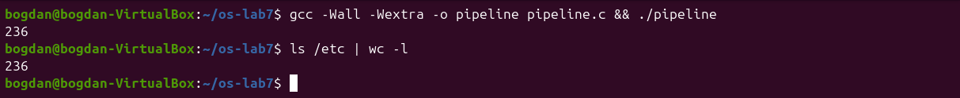
Figure 7.4.2 – pipeline and the real shell give the same number
Then I made a copy with the parent's close(p[1]); commented out (pipeline_broken.c, the diff shows the single changed line). Running it hangs, with no output, until Ctrl-C. Running it in the background lets ps show which process is waiting.
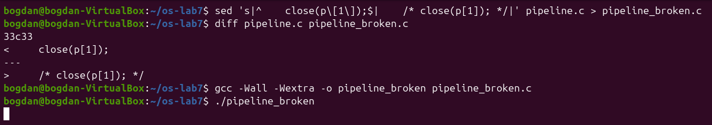
Figure 7.4.3 – Without close(p[1]) in the parent the program never ends
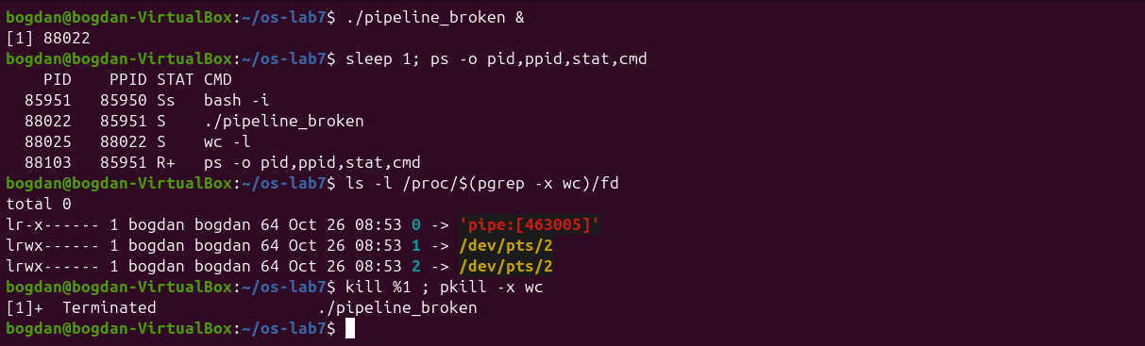
Figure 7.4.4 – ps shows that wc is the child that never ends
1. Did ./pipeline and ls /etc | wc -l give the same number?
Yes, both printed 236.
2. After the change, which of the two children never ends, ls or wc?
wc. ps shows wc -l in state S (sleeping) as a child of ./pipeline_broken, while ls is already gone: it wrote its listing and exited. The descriptor list of wc shows that its stdin (0) is pipe:[463005]. The parent hangs in its second wait.
3. Why, in one sentence: what is wc waiting for?
wc is waiting for end-of-file on the pipe, which comes only when every write end is closed, and the parent still holds an open copy of p[1], so read keeps blocking.

3.6 Optional: three stages
pipeline3.c builds ls /usr/bin | grep x | wc -l with two pipes and three children. A small helper stage(in, out, argv) forks a child, moves the given ends onto descriptors 0 and 1 with close + dup, closes all four pipe ends and calls execvp. The parent also closes all four ends before waiting for the three children.
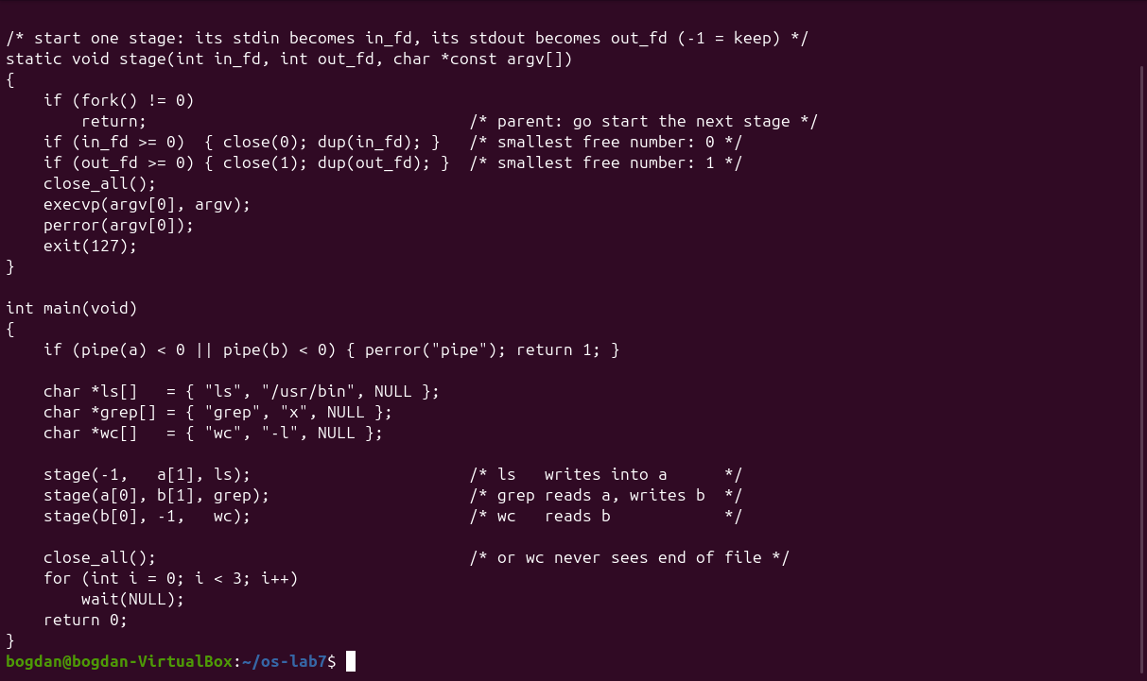
Figure 7.5.1 – pipeline3.c
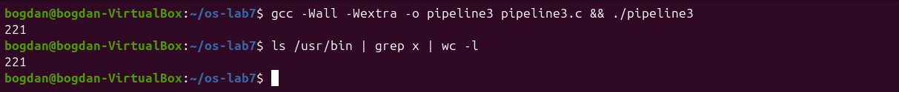
Figure 7.5.2 – pipeline3 and the shell both print 221

4 Lab 8 – The Same Calls Inside Your Own OS (xv6)
The programs run, pingpong and primes were added to ~/xv6-riscv/user/ and to UPROGS. zombie was already in the list. QEMU is left with Ctrl-A X before each rebuild.

4.1 Part 1. run, inside xv6
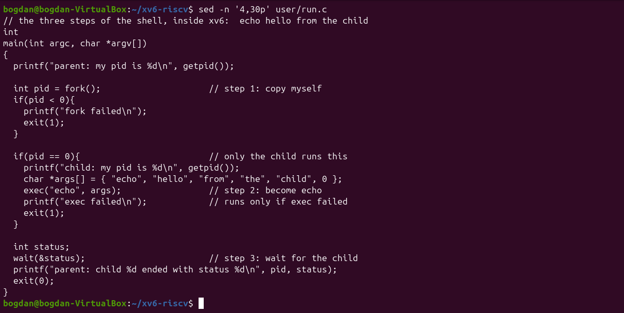
Figure 8.1.1 – user/run.c
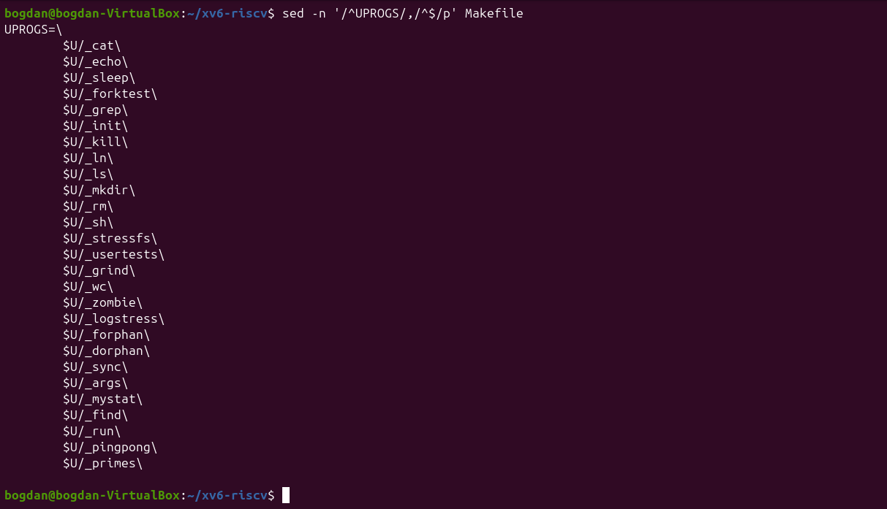
Figure 8.1.2 – The UPROGS list with run, pingpong and primes
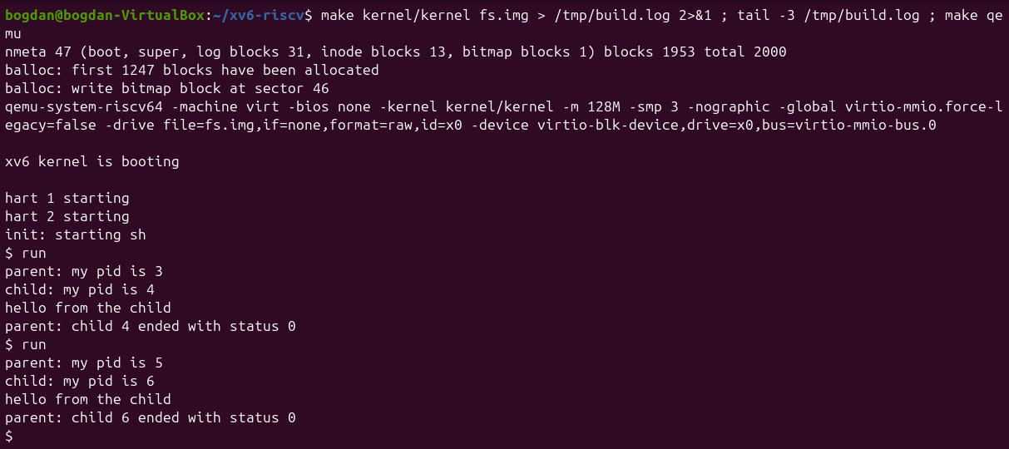
Figure 8.1.3 – run inside xv6: the child becomes echo
The output matches the assignment: parent: my pid is 3, child: my pid is 4, hello from the child, parent: child 4 ended with status 0. A second run gets PIDs 5 and 6, because xv6 never reuses a PID number.
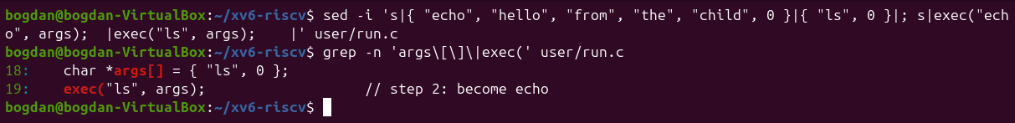
Figure 8.1.4 – Changing the child to run ls
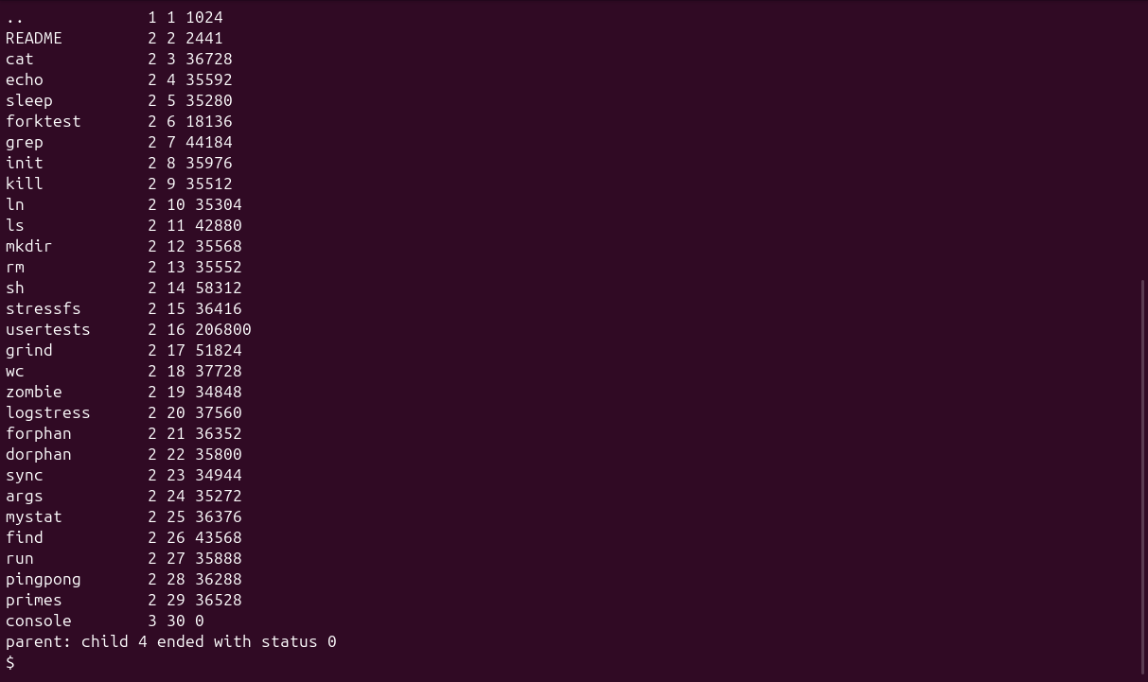
Figure 8.1.5 – run with the child running ls
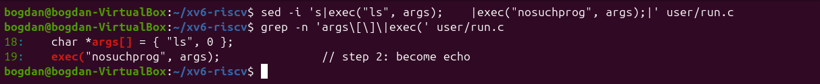
Figure 8.1.6 – Changing the child to exec a missing program
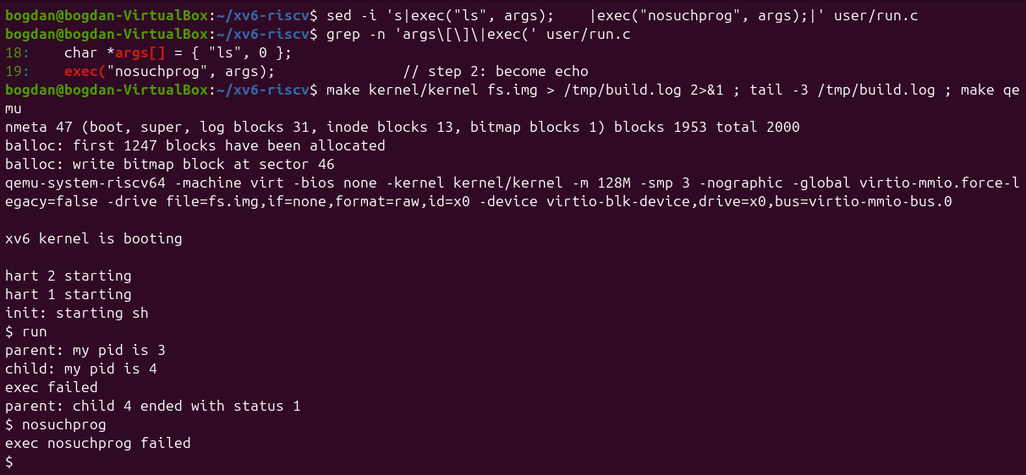
Figure 8.1.7 – exec failed and status 1
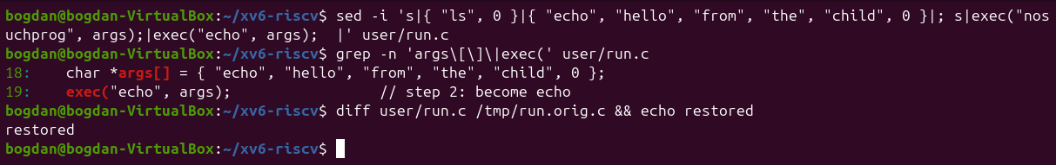
Figure 8.1.8 – user/run.c restored to the echo version
1. Write the three calls that run.c uses in xv6 and the three calls run.c used on Linux in Lab 7. What is the same?
xv6: fork(), exec("echo", args) and wait(&status). Linux: fork(), execlp("ls", "ls", "-l", NULL) and waitpid(pid, &status, 0). The model is identical: copy the process, replace the copy's program, then wait in the parent. Even the structure of the code is the same. The differences are only in the interface: xv6 exec takes a path and an argv array and does no PATH search (it works here because echo is in /), wait waits for any child, and the status is the plain exit value with no WEXITSTATUS decoding.
2. Who prints "hello from the child": the code of run, or echo?
echo does. After a successful exec the child process is no longer running the code of run: its memory now holds echo, which prints its arguments hello from the child. The only lines run itself prints in the child are "child: my pid is ..." (before exec) and, if exec fails, "exec failed".
3. Why is the status 1 here and 127 on Linux?
Because each program chooses the value it passes to exit after a failed exec: the xv6 version calls exit(1) and the Linux version calls exit(127). The kernel only delivers that number to the parent's wait. 127 on Linux is just the shell convention for "command not found". The xv6 shell itself prints exec nosuchprog failed in that case.

4.2 Part 2. pingpong
The four TODO lines become read(p2c[0], &b, 1) and write(c2p[1], &b, 1) in the child, and write(p2c[1], &b, 1) and read(c2p[0], &b, 1) in the parent. I also check that each call really transferred one byte.
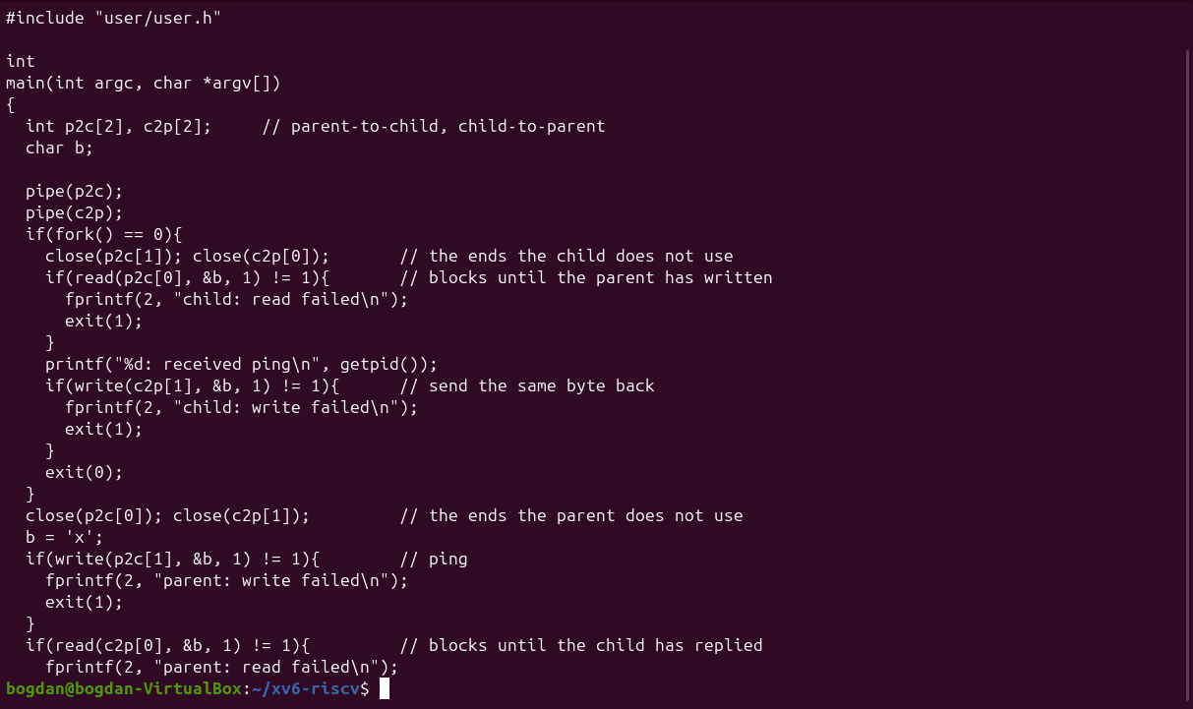
Figure 8.2.1 – user/pingpong.c (first part)
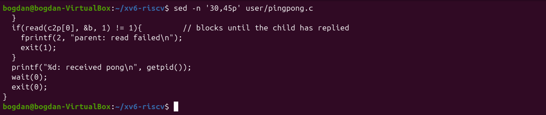
Figure 8.2.2 – user/pingpong.c (end)
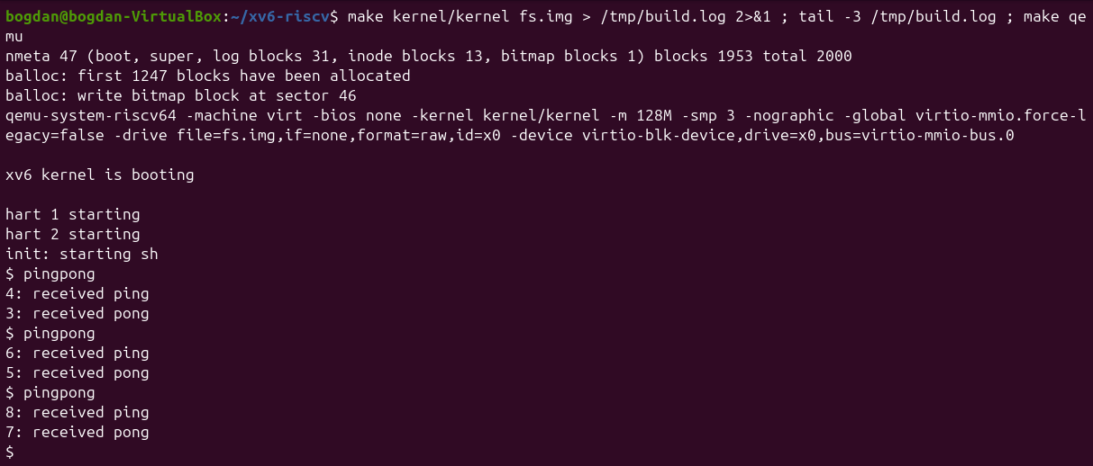
Figure 8.2.3 – pingpong: ping always comes first, from the child
In all three runs "received ping" is printed first by the child (4: received ping) and then "received pong" by the parent (3: received pong).
1. Why do you need TWO pipes, and not one for both directions?
A pipe is one-way: it has one read end and one write end, and its bytes are not addressed to anyone. With a single pipe, the parent's read could take back the byte the parent itself had just written, before the child read it, and nothing would make the reply go to the right process. Two pipes give each direction its own channel: p2c only goes parent to child and c2p only goes child to parent.
2. Nothing in your code says "wait until the child has replied". Which call makes the parent wait?
read(c2p[0], &b, 1). Reading from an empty pipe blocks: the kernel puts the parent to sleep until the child writes its byte into c2p (or until every write end is closed). In the same way the child's read(p2c[0], ...) blocks until the ping arrives, which is why "ping" is always printed before "pong".

4.3 Optional: primes
primes feeds the numbers 2–35 into a pipe. Each stage reads its first number p (always a prime) and prints it, then creates a new pipe and a child and forwards only the numbers that p does not divide. Every stage closes the pipe ends it does not use, so the chain ends cleanly with end-of-file.
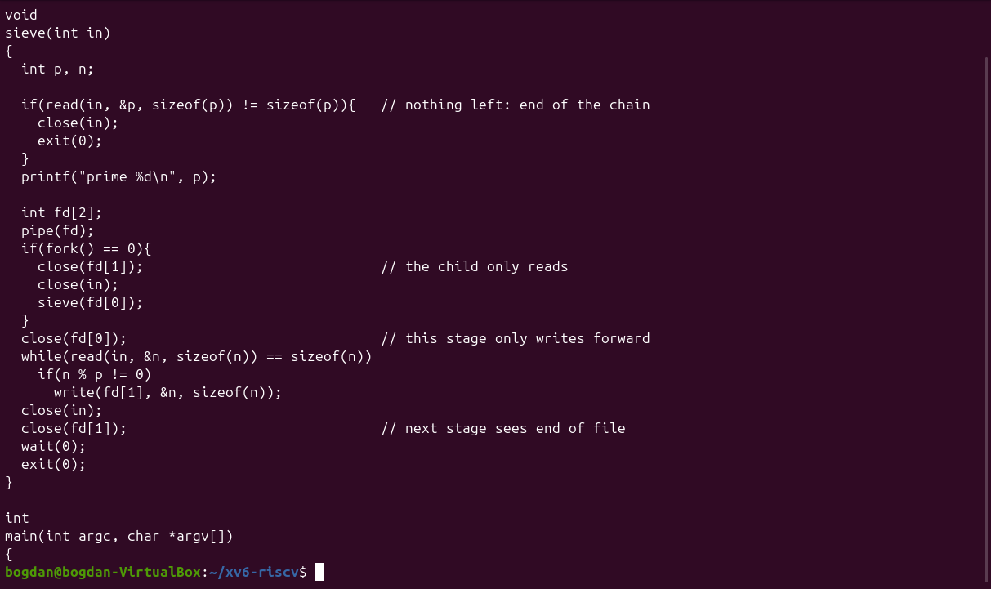
Figure 8.3.1 – user/primes.c
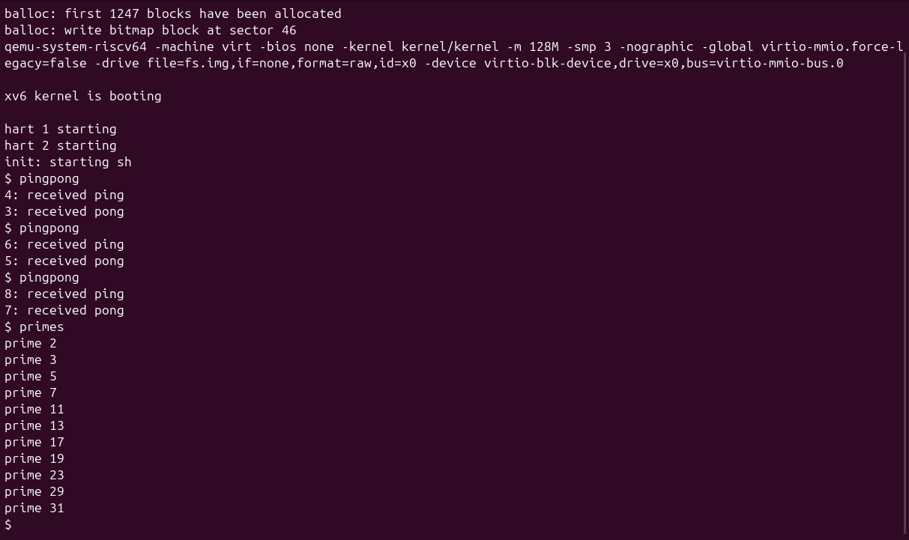
Figure 8.3.2 – primes prints the primes from 2 to 31

5 Conclusions
Lab 7 showed that the three tricks of the shell are built from a handful of system calls. fork + exec + wait start a program and collect its exit status, and forgetting the wait leaves a zombie. Redirection works because open returns the lowest free descriptor and descriptors survive exec. A pipe is just two descriptors placed on 0 and 1 with dup. The broken version showed the most important rule of pipes: every unused write end must be closed, otherwise the reader never sees end-of-file.
Lab 8 showed that xv6 offers the same process model as Linux: the same fork/exec/wait program runs almost unchanged, and only the library conveniences (PATH search, waitpid, status macros) are missing. With pingpong, two processes synchronised only through blocking read calls on two one-way pipes. primes extended the same idea to a whole chain of processes, where closing the unused ends is what lets the chain finish.

