Poetry and Prose Generation

1. Problem Statement
The NLP task addressed in this project is automatic poetry generation in Romanian using a neural language model, specifically RoGPT-2 medium.
- Automatic poetry generation represents a challenging problem in Natural Language Processing due to the creative and non-deterministic nature of poetic language. Unlike standard text generation tasks, poetry does not follow strict syntactic or semantic constraints and relies heavily on metaphor, rhythm, imagery, and stylistic variation.
- The main objective of this project is to generate coherent and stylistically plausible Romanian poetry using a neural language model. The goal is to produce poems that resemble human-written poetry in terms of lexical choice and expressive structure, while remaining original and avoiding direct reproduction of existing poems.

2. Proposed Solution
The proposed solution for this project is based on using a Transformer-based neural language model, specifically RoGPT-2 medium, to generate poetry in Romanian. The model is trained to generate text in an autoregressive way, meaning it predicts each word based on the words generated before it.
The solution includes a poetry generation component and an analysis pipeline that makes it possible to inspect and study the generated poems.

2.1 Theoretical Aspects
The poetry generation task is treated as a language modeling problem. The goal of the model is to estimate the probability of a sequence of words, where each word depends on the previous ones. This can be written as:
$$P(w_{1},w_{2},…,w_{n})=\prod_{i=1}^{n}{P(}w_{i}∣w_{1},…,w_{i-1})$$
RoGPT-2 medium is based on the Transformer architecture, which uses a self-attention mechanism to model relationships between words in a text. This allows the model to consider words that appear far apart from each other, which is important for poetry, where meaning and style often depend on the wider context.
Compared to recurrent neural networks, Transformers can process whole sequences at once during training. This makes them more efficient and better suited for learning complex language patterns, such as those found in poetic texts.
During generation, the model works autoregressively, predicting one token at a time based on the previously generated context. By learning from a corpus of poetry, the model can capture common poetic elements such as imagery, repetition, and stylistic variation, without using explicitly defined rules for rhyme or meter.
The text generation process is controlled using decoding strategies that aim to balance fluency and creativity, allowing the model to generate different poetic outputs instead of always producing the same or repetitive text.

2.2 Dataset Used in the Application (Balacescu Bogdan)
The dataset used in this project consists of Romanian poems written by Nichita Stănescu, collected by scraping an online poetry archive:
https://www.romanianvoice.com/poezii/poeti/stanescu.php
This website provides a curated collection of poems by Nichita Stănescu, organized by poem titles and individual verses. The poems were scraped automatically and later processed to create a structured dataset suitable for language modeling and analysis.

Dataset Structure
After scraping and preprocessing, the dataset was stored in JSON Lines (.jsonl) format, where each line represents a single verse together with relevant metadata. Each entry contains the following fields:
- title – the title of the poem
- verse_index – the position of the verse within the poem
- verse – the text of the verse
This verse-level representation allows the original structure of each poem to be preserved and makes it possible to reconstruct full poems by grouping verses by title and ordering them according to their index.

Preprocessing Steps
Several preprocessing steps were applied to the raw scraped data:
- Web scraping – automated extraction of poem titles and verses from the HTML pages.
- Cleaning – removal of HTML tags, navigation elements, and irrelevant text.
- Normalization – handling Romanian diacritics and text encoding to preserve linguistic correctness.
- Structuring – formatting the cleaned data into a consistent JSON Lines structure.
- Reconstruction – grouping verses by poem title and ordering them by verse index to obtain complete poems when needed.

Dataset Characteristics
The dataset contains rich examples of Romanian poetic language, including metaphorical expressions, abstract imagery, and flexible syntactic structures typical of Nichita Stănescu’s style. The vocabulary is diverse and often abstract, making the dataset particularly suitable for studying and generating poetic text.
Because the poems are written by a single author, the dataset has a consistent stylistic signature, which helps the language model learn coherent poetic patterns and recurring stylistic elements.

Challenges and Limitations
During dataset creation, several challenges were encountered:
- Inconsistent HTML formatting across poems required careful parsing.
- Special characters and diacritics needed to be preserved correctly.

2.3 Model Fine-tuning (Chis Bogdan)

2.4 Application Diagram
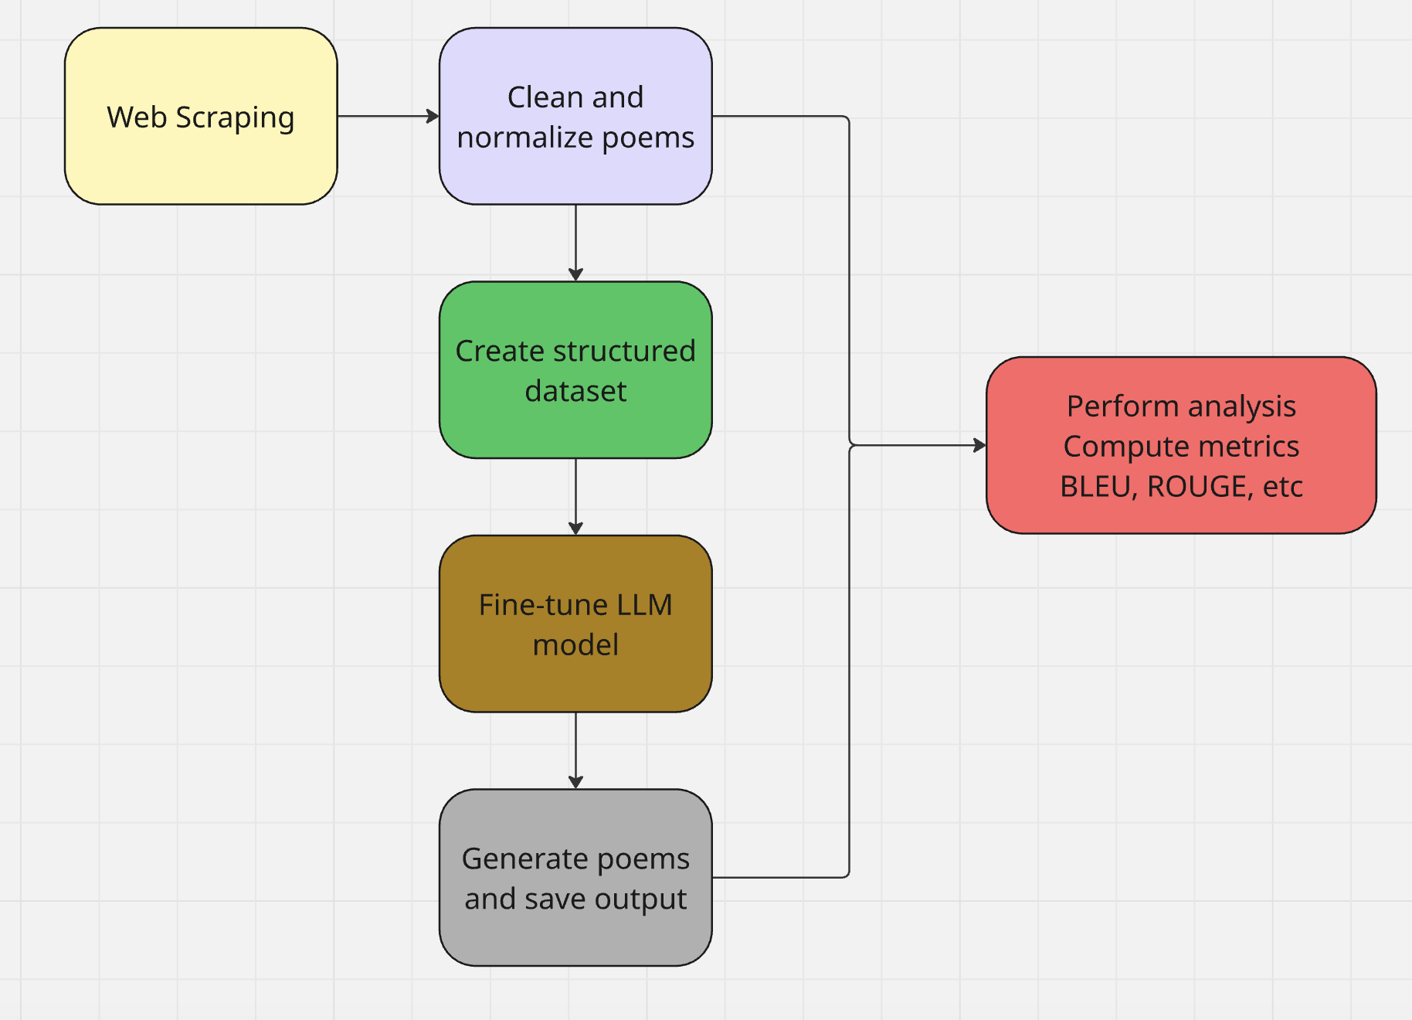

3. Implementation

3.1 Development Environment
The project was implemented using Python and organized into several Jupyter notebooks, each corresponding to a specific stage of the application pipeline. This modular structure improves readability and makes it easier to experiment with different components independently.

The main implementation files are:
- dataset.ipynb
- model-fine-tuning.ipynb
- evaluation.ipynb
- medium_rogpt2_results.txt
- results.jsonl

3.2 Libraries Used
The following libraries were used throughout the project:
- Python standard libraries
  - json – handling structured data
  - re – text preprocessing and tokenization
  - collections – grouping and aggregation of verses
- Data processing
  - pandas – data manipulation and inspection
  - numpy – numerical operations
- Natural Language Processing
  - transformers – loading and fine-tuning the RoGPT-2 model
  - torch – deep learning framework used by the model
  - nltk – BLEU score computation
  - rouge-score – ROUGE metric computation
- Development tools
  - jupyter – interactive experimentation and visualization

4. Experiments and Results (Balacescu Bogdan)
This section presents the experiments conducted to evaluate the poetry generation model and discusses the obtained results. The evaluation focuses on analyzing the generated poems in terms of similarity to human-written poetry and lexical diversity.

4.1 Experimental Setup
The reference corpus was constructed from poems written by Nichita Stănescu, resulting in a total of 12,704 reference tokens. The fine-tuned RoGPT-2 medium model was used to generate 10 poems, each conditioned on a short poetic prompt representing the title of the generated poem.
Each generated poem was evaluated individually against the reference corpus using automatic metrics. The evaluation aimed to analyze whether the model reproduces existing poetic content or generates original text while maintaining poetic characteristics.

4.2 Quantitative Results
The evaluation metrics computed for each generated poem include BLEU, ROUGE, Distinct-1, Distinct-2, and poem length.

General Observations
- BLEU-1, BLEU-2, BLEU-4 scores are 0.0 for all generated poems
- ROUGE-1 scores range between 0.009 and 0.017
- Distinct-1 values range between 0.76 and 0.87
- Distinct-2 values are consistently high, often close to 1.0
- Generated poems have lengths between 94 and 113 tokens

4.3 Interpretation of Results

BLEU Scores
- The BLEU scores being equal to zero indicate that the generated poems do not contain exact n-gram sequences from the reference corpus. In the context of poetry generation, this result suggests that the model does not memorize or copy verses written by Nichita Stănescu. Instead, it produces novel word combinations, which is a desirable property for a creative text generation task.

ROUGE Scores
- The ROUGE scores, although low in absolute terms, indicate a limited but meaningful lexical overlap between generated poems and the reference corpus. This suggests that the model has learned to use vocabulary and expressions typical of Romanian poetic language, without directly reproducing existing poems.

Diversity Metrics
- The high values for Distinct-1 and Distinct-2 indicate strong lexical and syntactic diversity. Most generated poems contain a high proportion of unique words and bigrams, showing that the model avoids repetitive patterns and produces varied poetic content.

Length Analysis
- The generated poems have relatively consistent lengths, which suggests that the model maintains stable generation behavior and does not collapse into very short or excessively long outputs.

Pe lângă plopii fără soț | „, mai sunt plopul alb cu frunza-n inele, gândiricelul meu cel isteț. Sfera cea nesfârșită și sublimă își deschide aripile și se lasă în jos ca o cortină albastră…” | BLEU-1/2/4: 0.0 / 0.0 / 0.0  ROUGE-1: 0.0147  ROUGE-2: 0.0063  ROUGE-L: 0.0100  Distinct-1: 0.84  Distinct-2: 0.9798  Length: 100
Pe lângă plopii fără soț |  | BLEU-1/2/4: 0.0 / 0.0 / 0.0  ROUGE-1: 0.0166  ROUGE-2: 0.0088  ROUGE-L: 0.0116  Distinct-1: 0.7611  Distinct-2: 0.9732  Length: 113
  „, iubita mea marină sentimentală. Mă voi culca cu sânii tăi dulci ca mierea și-i voi ține așa până dimineață, și-n loc de somn îi voi trezi pe ai tăi cu un sărut…”
Mă-ntorc mereu la tine |  | BLEU-1/2/4: 0.0 / 0.0 / 0.0  ROUGE-1: 0.0145  ROUGE-2: 0.0073  ROUGE-L: 0.0101  Distinct-1: 0.7677  Distinct-2: 0.9898  Length: 99
  „, iubita mea. Ochii tăi sunt ca două mărgele albastre; sprâncenele tale sunt sprâncenele mele, și mersul tău este sandaua mea albastră.”
Mă-ntorc mereu la tine | „, mă-ntind pe paturi de frunze galbene, albastre. Lanțul infinit al vocilor se rupe-n două: una dulce și suavă, cealaltă sărată și amară…” | BLEU-1/2/4: 0.0 / 0.0 / 0.0  ROUGE-1: 0.0141  ROUGE-2: 0.0063  ROUGE-L: 0.0095  Distinct-1: 0.8763  Distinct-2: 1.0  Length: 97
A fost o vreme când | „, flămând fiind, mâncam pământ. Soarele a încălzit pământul și l-a dat la o parte ca pe un bulgăre de zăpadă.” | BLEU-1/2/4: 0.0 / 0.0 / 0.0  ROUGE-1: 0.0156  ROUGE-2: 0.0072  ROUGE-L: 0.0109  Distinct-1: 0.8283  Distinct-2: 1.0  Length: 99
A fost o vreme când |  | BLEU-1/2/4: 0.0 / 0.0 / 0.0  ROUGE-1: 0.0169  ROUGE-2: 0.0083  ROUGE-L: 0.0110  Distinct-1: 0.8214  Distinct-2: 1.0  Length: 112
  „, într-o bună zi de vară fierbinte, am văzut în depărtare un cuib de păsări flamingo. Era oare cu adevărat o nălucă sau era doar plăsmuirea minții mele…”
Nu credeam că va veni | „… Abia așteptam să se facă seară, să ne strângem în brațe ca doi îndrăgostiți.” | BLEU-1/2/4: 0.0 / 0.0 / 0.0  ROUGE-1: 0.0156  ROUGE-2: 0.0073  ROUGE-L: 0.0114  Distinct-1: 0.8491  Distinct-2: 1.0  Length: 106
Nu credeam că va veni |  | BLEU-1/2/4: 0.0 / 0.0 / 0.0  ROUGE-1: 0.0129  ROUGE-2: 0.0063  ROUGE-L: 0.0092  Distinct-1: 0.8085  Distinct-2: 0.9785  Length: 94
  „… Niciodată nu cred până când nu văd. Niciodată nu cred până nu aud, niciodată nu spun nimic decât atunci când simt că trebuie spus.”
Sub cerul plin de stele | „Poezia stelelor este o poezie a poetului Mihai Eminescu. A fost publicată pentru prima dată în revista Convorbiri literare…” (drift factual) | BLEU-1/2/4: 0.0 / 0.0 / 0.0  ROUGE-1: 0.0092  ROUGE-2: 0.0013  ROUGE-L: 0.0067  Distinct-1: 0.8131  Distinct-2: 1.0  Length: 107
Sub cerul plin de stele | „– Veniți să ne ospătăm din cina cea de taină! Pleacă urechea, pământule, către glasul muntelui…” | BLEU-1/2/4: 0.0 / 0.0 / 0.0  ROUGE-1: 0.0145  ROUGE-2: 0.0068  ROUGE-L: 0.0107  Distinct-1: 0.8421  Distinct-2: 1.0  Length: 95

