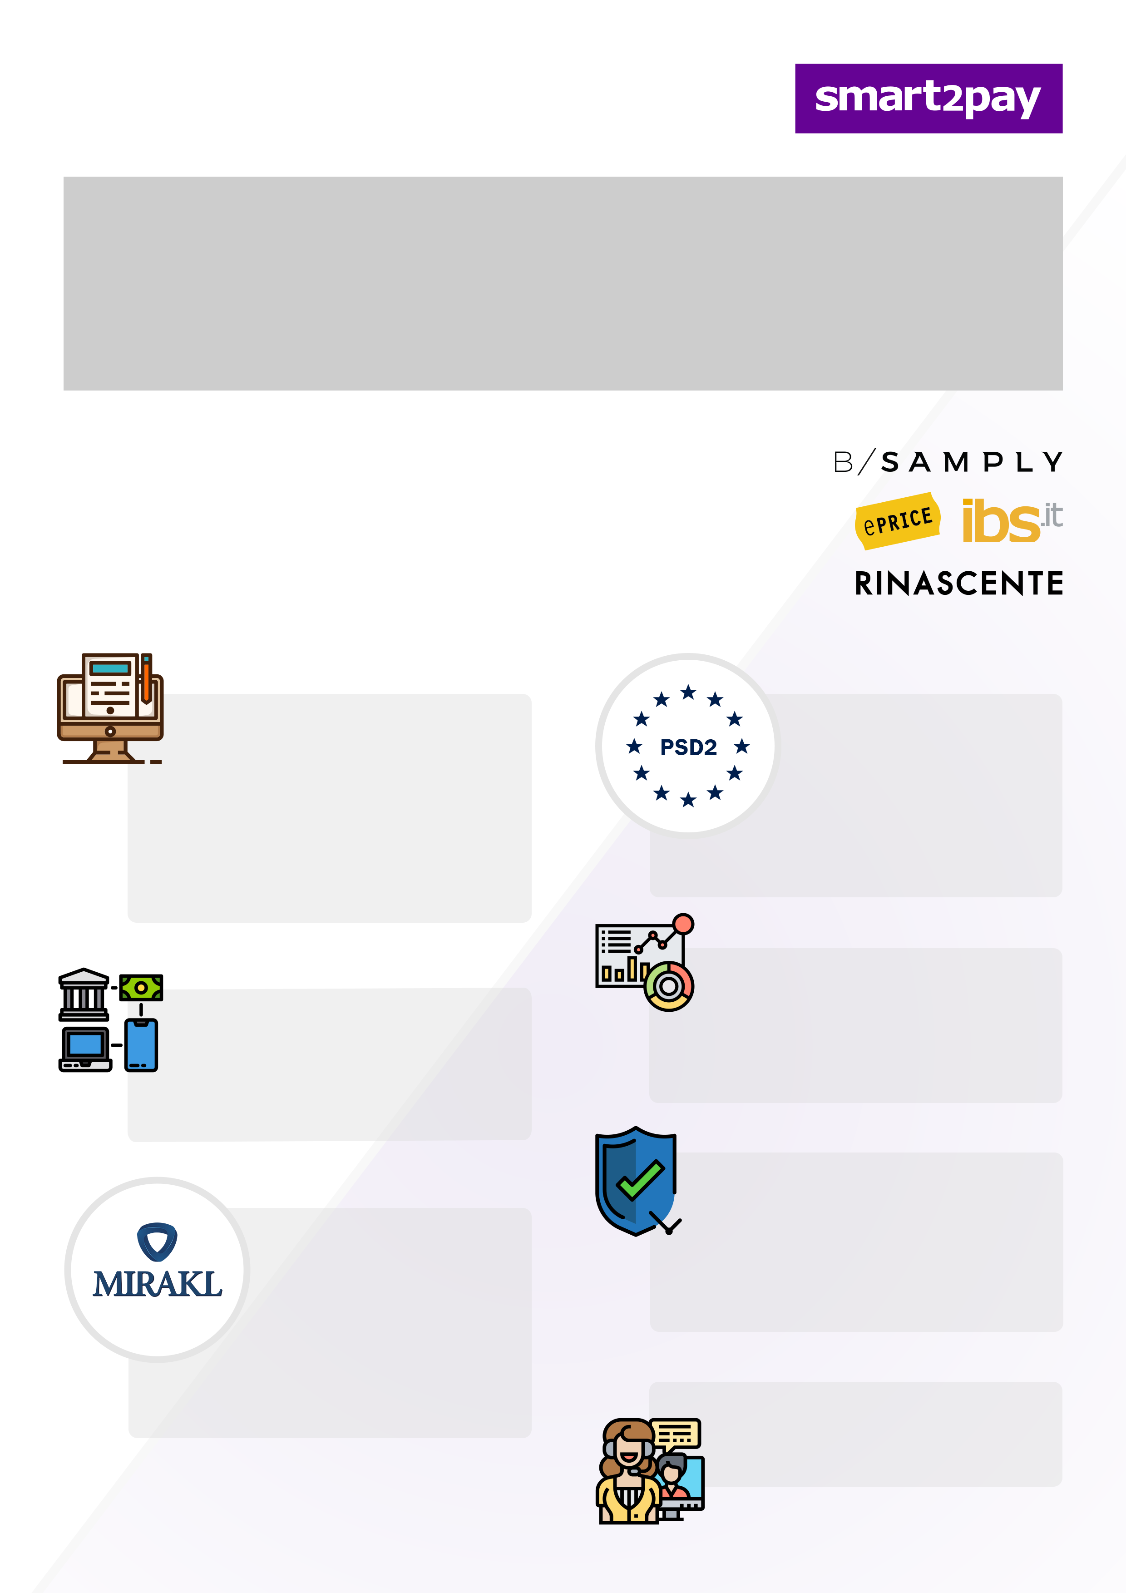

**Designed to seamlessly integrate with Mirakl’s e-marketplace products**

Not using Mirakl? No problem,   
we also offer Marketplace APIs to help you manage your marketplace payments.

Smart2Pay (founded 2002) is the preferred choice for marketplaces and merchants wishing to offer local payment methods (like Paypal, Wechat, Alipay) and international card schemes like Visa, Mastercard, UPI, Amex and JCB to its customers. With an impressive 200+ payment methods portfolio, swift integration and flexible funds management flow via API, Smart2Pay is the one stop shop for marketplaces. Eprice, Rinascente, IBS and Bsamply are some examples of marketplaces working with us.

**Fully PSD2 compliant solution**

We help marketplaces meeting the new PSD2 legal requirements in contracting / KYC of the shops and managing the collection of funds and split settlements.

**Fraud Management**

We provide you with a secure and reliable Fraud Management solution to protect you from any fraudulent activity and keep you and your customers safe.

**Reporting and reconciliation**

Reliable and secure transaction processing, prompt and flexible settlements, reconciliation to the penny and reporting.

**Support for marketplace operators and sellers**

More information here:

[**https://smart2pay.com/es/ForMarketplaces**](https://smart2pay.com/es/ForMarketplaces)

**Multiple payment methodsCards + 170 APMs worldwide**

We can handle credit cards and alternative payment methods simultaneously.

**Secure online onboarding via a Marketplace branded website (hosted by Smart2Pay) and KYC verification of sellers**We love to make things easy for our clients from the beginning to the end. This means that also onboarding is a seamless process with us. No hassle, just smooth processes.

**Wouldn’t it be great to have one partner to accept payments from customers via any payment method across the world and distribute funds to the Marketplace and its participating Shops? That’s precisely what we do.**

**Smart2Pay is the way to go for marketplaces.**