Lab 4: Finite automata and regular grammars for MiniWall
The statement asks for finite automata (FA) or regular grammars (RG) for the identifiers and constants of the language, and a program that turns an FA into an RG or the other way around. I defined the FAs and implemented the FA to RG direction. The code is in C and builds with gcc alone.
MiniWall has one identifier and three kinds of constants: numbers, strings and addresses. The protocol and verdict names (tcp, allow, …) are keywords, so they have no automaton here. The automata follow the lexical part of the Lab 2 grammar (firewall_dsl_bnf.txt), which did not change.

Files
File | What it has
automata/*.fa | the four automata: identifier, number, string, address
fa.c, fa.h | reads a .fa file, runs a word, prints the automaton and a graphviz version
rg.c, rg.h | the transformation FA to RG, printing, and a check of a word using only the grammar
main.c | the commands show, rg, check, test, dot
tests/ | one list of words per automaton, and even_a.fa for an extra case
out/ | the output of the program for every automaton, and the diagrams

The automata
Each automaton is deterministic, M = (Q, Σ, δ, q0, F), and is written in a small text file. A symbol of Σ can stand for a set of characters. letter is A-Z and a-z, the same way the BNF uses <letter> and <digit>. Without this the identifier automaton would need 52 transitions where one is enough. The sets of one automaton do not overlap, so every character belongs to one symbol and the automaton stays deterministic. The program checks that when it loads the file.
Identifier. A letter, then any letters, digits or underscores. Σ = {letter, digit, underscore}, Q = {Q0, Q1}, start Q0, F = {Q1}.
 | letter | digit | underscore
-> Q0 | Q1 | - | -
* Q1 | Q1 | Q1 | Q1
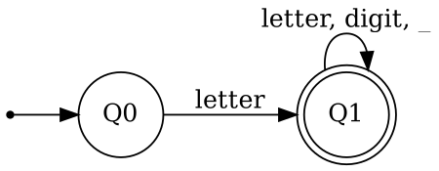
identifier
Number. Either 0 alone, or a digit from 1 to 9 followed by any digits. Σ = {zero, nonzero}, Q = {Q0, Q1, Q2}, start Q0, F = {Q1, Q2}. Q1 has no way out, which is why 007 is rejected.
 | zero | nonzero
-> Q0 | Q1 | Q2
* Q1 | - | -
* Q2 | Q2 | Q2
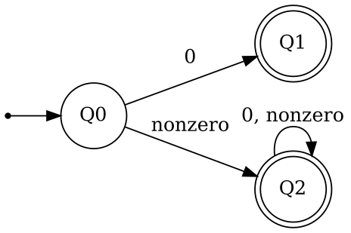
number
String. A double quote, any letters, digits or symbols, and a closing double quote. punct is the list from <symbol> in the BNF (space and . , : ; - _ / ! ? ( ) ' { } [ ] = < > + * % @ # & | $ ^ ~). The quote and the backslash are in no set, so they cannot be inside a string. Σ = {quote, letter, digit, punct}, Q = {Q0, Q1, Q2}, start Q0, F = {Q2}.
 | quote | letter | digit | punct
-> Q0 | Q1 | - | - | -
Q1 | Q2 | Q1 | Q1 | Q1
* Q2 | - | - | - | -
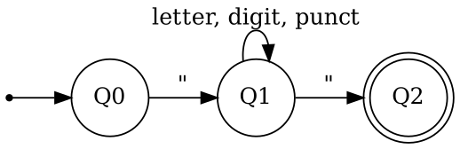
string
Address. Four octets of 1 to 3 digits separated by dots, then an optional / and 1 or 2 digits. Σ = {digit, dot, slash}, 19 states, start Q0, F = {Q13, Q14, Q15, Q17, Q18}. The diagram is cut in four pieces, the dashed arrow in each piece comes from the one before. The first three octets have the same shape: up to three digits and then a dot. Q13 to Q15 are the last octet, and Q17 and Q18 are the prefix. The full table is in out/address_show.txt.
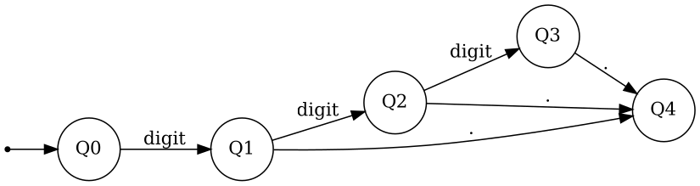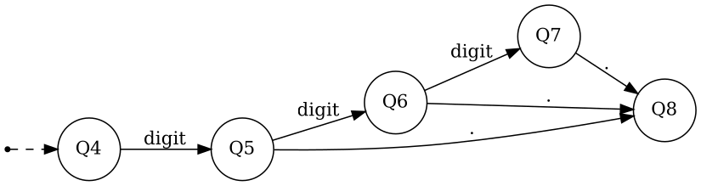
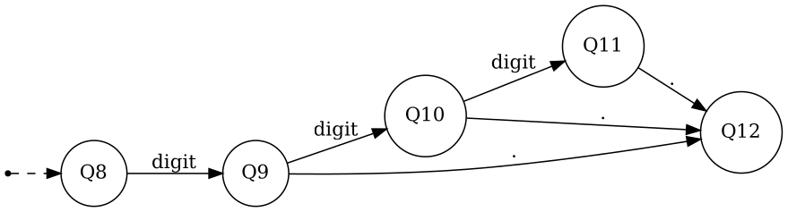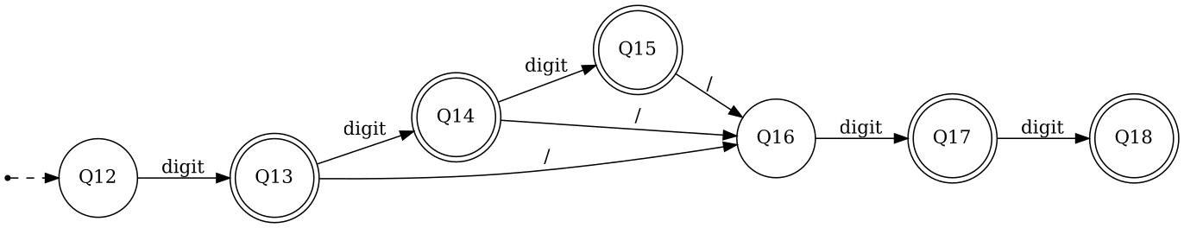
Octets up to 255 and prefixes up to 32 are not checked, as in the BNF. That is for the semantic phase.
The scanner of Lab 3 gets the same tokens from flex rules. The automata describe the same languages, with two differences. A keyword like rule is accepted by the identifier automaton, because the BNF does not exclude keywords, and the scanner checks keywords first. And the automaton judges one whole word, while the scanner takes the longest match inside a program.

From FA to RG
The program uses the usual rules for a transition p -a-> q:
- Every state becomes a nonterminal, and the start state becomes the start symbol.
- Every transition gives the production P -> a Q.
- If q is a final state, the transition also gives P -> a.
- If the start state is final, the grammar gets S -> epsilon. When some transition also goes back into the start state, a new start symbol S’ is made first. It gets a copy of the productions of the old start symbol plus epsilon, so that S’ is never on a right side.
Rule 4 does not happen in the four MiniWall automata, because none of them accepts the empty word. To test it I wrote tests/even_a.fa, words over a and b with an even number of a’s. Its start state is final and has transitions back into it.
The terminals are written like in the BNF, characters in quotes, and a symbol that stands for a set of characters by its name. The program prints what each name stands for. These are the grammars it produces (the full output is in out/*.rg):
identifier number
Q0 -> letter Q1 | letter Q0 -> "0" Q1 | "0" | nonzero Q2 | nonzero
Q1 -> letter Q1 | letter Q2 -> "0" Q2 | "0" | nonzero Q2 | nonzero
| digit Q1 | digit
| "_" Q1 | "_"
string
Q0 -> '"' Q1
Q1 -> letter Q1 | digit Q1 | punct Q1 | '"' Q2 | '"'
address
Q0 -> digit Q1 Q8 -> digit Q9
Q1 -> digit Q2 | "." Q4 Q9 -> digit Q10 | "." Q12
Q2 -> digit Q3 | "." Q4 Q10 -> digit Q11 | "." Q12
Q3 -> "." Q4 Q11 -> "." Q12
Q4 -> digit Q5 Q12 -> digit Q13 | digit
Q5 -> digit Q6 | "." Q8 Q13 -> digit Q14 | digit | "/" Q16
Q6 -> digit Q7 | "." Q8 Q14 -> digit Q15 | digit | "/" Q16
Q7 -> "." Q8 Q15 -> "/" Q16
Q16 -> digit Q17 | digit
Q17 -> digit Q18 | digit
even_a
S' -> "a" O | "b" E | "b" | epsilon
E -> "a" O | "b" E | "b"
O -> "a" E | "a" | "b" O
Some nonterminals have no productions: Q1 in number, Q2 in string, Q18 in address. They come from final states with no way out. Rules like Q0 -> "0" Q1 could be dropped, but I kept the textbook result.
The identifier grammar is close to the <identifier> rule of the BNF. That rule is already right linear, only it ends with epsilon where the RG ends with a terminal.

The program
gcc -Wall -Wextra -std=gnu99 -o fatool main.c fa.c rg.c
fatool show file.fa the automaton and its table
fatool rg file.fa the regular grammar made from it
fatool check file.fa word one word, with the states it goes through
fatool test file.fa cases.txt a file of words, + must be accepted and - rejected
fatool dot file.fa the automaton for graphviz
A .fa file has one line per item. Lines that start with # are comments, and \s is a space in a character list.
name identifier
symbol letter A-Z a-z
symbol digit 0-9
symbol underscore _
states Q0 Q1
start Q0
final Q1
Q0 letter Q1
Q1 letter Q1
Q1 digit Q1
Q1 underscore Q1
check runs the automaton and the grammar on the word and prints both answers:
$ ./fatool check automata/identifier.fa my_var1
Q0 -'m'-> Q1 -'y'-> Q1 -'_'-> Q1 -'v'-> Q1 -'a'-> Q1 -'r'-> Q1 -'1'-> Q1
FA: accepted
RG: accepted
$ ./fatool check automata/address.fa 1234.1.1.1
Q0 -'1'-> Q1 -'2'-> Q2 -'3'-> Q3
stops: no transition from Q3 on '4'
FA: rejected
RG: rejected
test does the same for a whole file and marks a line FAIL if the automaton or the grammar disagrees with the + or -. The exit code is 1 if any line fails. The last line of the run for addresses:
$ ./fatool test automata/address.fa tests/address.txt
...
address: 25 words, 25 ok, 0 failed
A file that is not a valid automaton (an unknown state, two transitions on the same symbol, a character in two symbols, no start state) is rejected with the line number and exit code 2.

How I checked it
What I tried | Result
Ran the word lists in tests/ (19 identifiers, 18 numbers, 19 strings, 25 addresses, 13 for even_a) | All ok, for the automaton and for the grammar
For each automaton I built a regular expression by hand from the BNF, then made words in three ways: random derivations of the BNF rule, those words with 1 to 3 characters changed, and every short word over a small alphabet. 421,615 words in total | The automaton and the grammar agree with the expression on every word. All words made from the BNF were accepted.
Ran the scanner of Lab 3 and the automata on 2,500 words per class (identifiers without the 27 keywords) | Same answer on all 10,000 words
Took the printed grammars as text and derived words from them: 50,000 random derivations each, and all the words of each length counted exactly (lengths 1 to 3 for identifier, 1 to 4 for number and string, 1 to 8 for address) | Every derived word is in the language, and the counts match the numbers computed by formula. For even_a the empty word is derived and the counts for lengths 0 to 10 are right.
Address sanitizer, undefined behaviour sanitizer and valgrind on all commands | No errors, no leaks
Bad .fa files (ten kinds), a missing file, a line over 511 characters, too many states, Windows line endings, a last line without a newline | Clear message with the line number and exit code 2 where it is an error, the rest work

