|  |  |
| --- | --- |
| **Project title** | **Hotel Reception during the pandemic** |
| **Author(s)** | **Bogdan Tamba and Andrei Nemes** |
| **Group** | **30424** |

# Task Description

The reception application is designed to combine all the information needed for a hotel in only one place. We think that for this app there are six types of users: the customer, the receptionist, the chief receptionist, the manager, the maid and the repairman. Now we will discuss about every user in details.

1. The Customer

We consider the customer as a user because this application could be installed on a kiosk, thus providing the option for the customer to perform the operations by himself. The operations that can be performed by the client are:

1. Create an user account
2. Login
3. Booking a room either on site or in advance
4. Canceling a booking
5. Self-Check-in, but for that he is required to pay for the reservation
6. Self-Check-out
7. The receptionist

The receptionist resembles the costumer, being able to perform almost all the operations that a customer can perform at a kiosk. The list of operations is:

1. Login
2. Verify if there are any available rooms
3. Check the advanced room status
4. Book a room
5. Check-in with payment
6. Check-out without payment
7. Chief Receptionist

This type of user can access information related financial aspect and all the operations from the standard receptionist.

1. Login
2. See financial information for a specific room(profit over a specified period of time)
3. The manager

This user is responsible with the account creation for the staff members.

1. Login
2. Create accounts for the staff
3. The maid

Can update the status from “in cleaning” to “done cleaning” and vice versa.

1. Login
2. Change the cleaning status
3. The repairman

This user can see if there is any problem in one of the rooms. After the repair is done, he can mark in the system.

1. Login
2. Change repair status

Now for each we will talk about each operation.

* Create a customer account – the customer creates an account for which he introduces the username, the password, the first name, the last name, the phone number, the email address, social security number and the credit card.
* Login – before the user can perform any operation, he must insert the username and password. After the combination is confirmed, he can access the operations available for that type of user.
* Verify available rooms – you insert the check-in and check-out date and verify the availability of rooms in that period.
* Book a room – if there are available rooms(of different types) in that period(we check using verify available rooms) the user can select a room and make a reservation for that type of room.
* Cancel a booking – depending on the cancelation date, the cancelation can be 20% of the fee for the first day (if they cancel one day ahead of the reservation period) and afterwards they must pay the full price for the first day.
* Self Check-in – at this point the user will be able to request the check-in for the booked rooms and they will have to pay the total reservation price.
* Self Check-out – at this point the user will be able to request a check-out from the booked room and they will not have to pay, as that was done at check-in
* Check the advanced room status – here the receptionist can see the full status for a specific room, the options for the status being: unoccupied, occupied, in cleaning, in repair, available for booking.
* Request repair-here the receptionist can select a specific room that is known to have a problem, and can request a repairman to look at the room, the status of the room becoming in repair.
* See financial information – the chief receptionist can see the profit for one specific room for a specified period of time.
* Create account for staff – the manager creates accounts for the staff members.
* Change the cleaning status – the maid can update the cleaned status for a room and the general status (if the room is being cleaned, the general status will be in cleaning).
* Change repair status – the repairman can change the general status for the room to in repair and after the repair is done change the status for the problem to repair done.

# Class Discovery

**https://tinyurl.com/y2kkw24k**

# Class Diagram

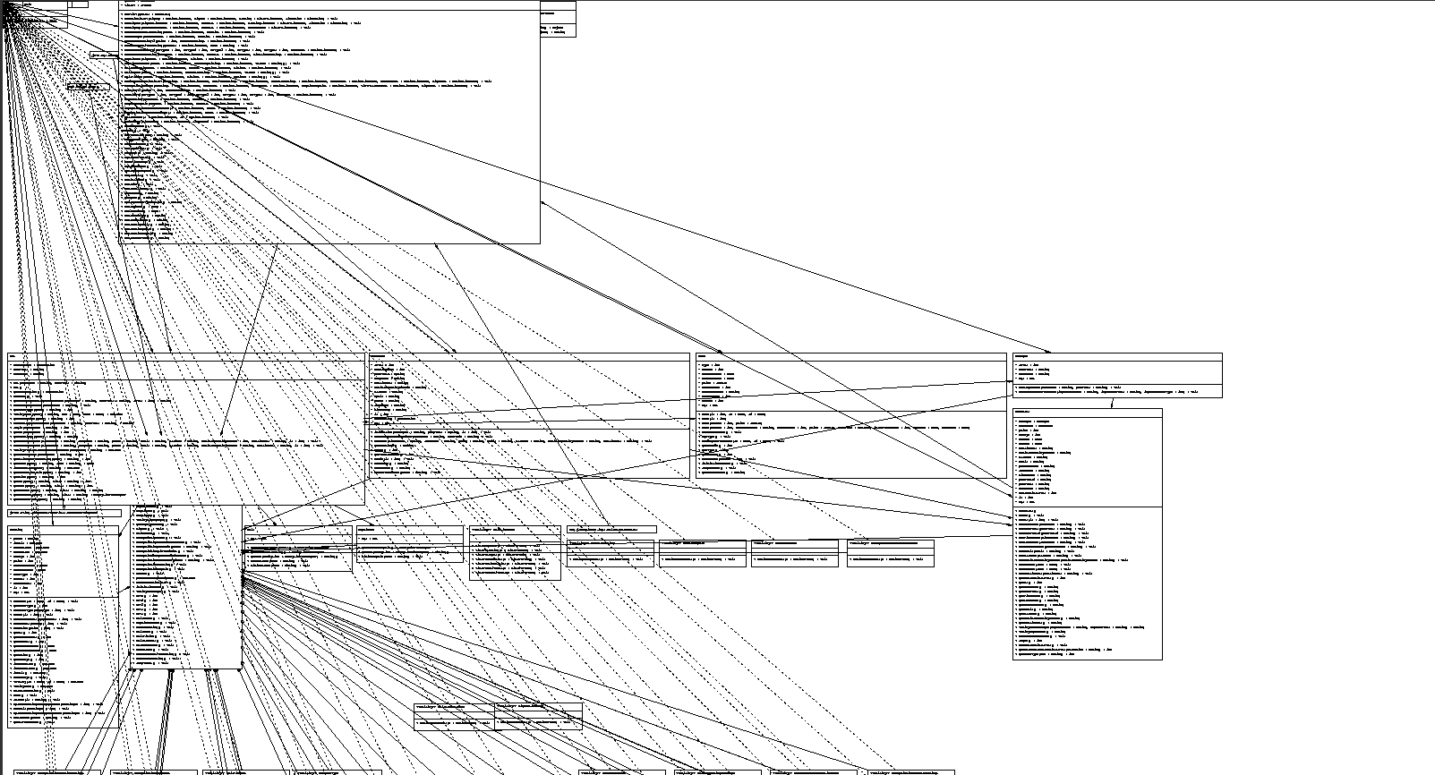

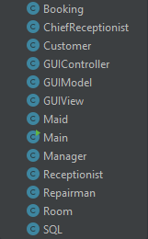

1. GUI designs

Login Page

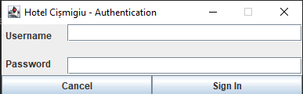

SignUp Page

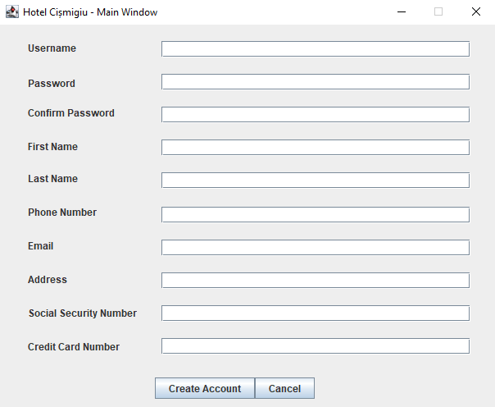

Manager Page

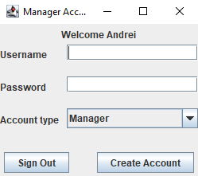

User Main Page

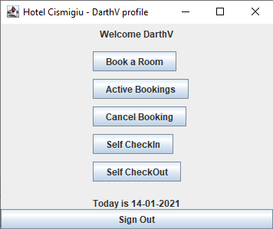

User Booking Page

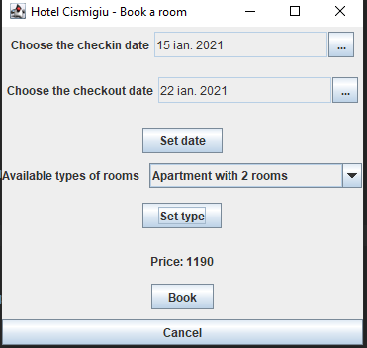

Repairman Repair Page

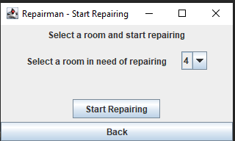

Maid Pages

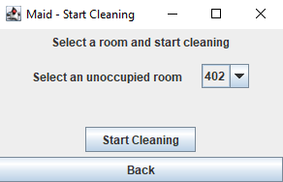

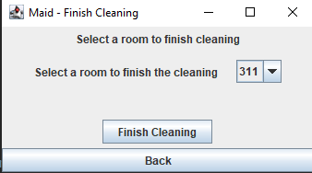

Status of Room Page

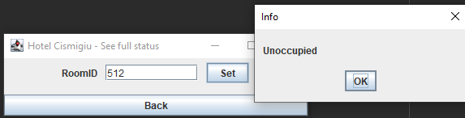

Earnings from a room Page

