Dascal Bogdan-Marius

Email: [b.moris_lion@yahoo.com](mailto:b.moris_lion@yahoo.com)

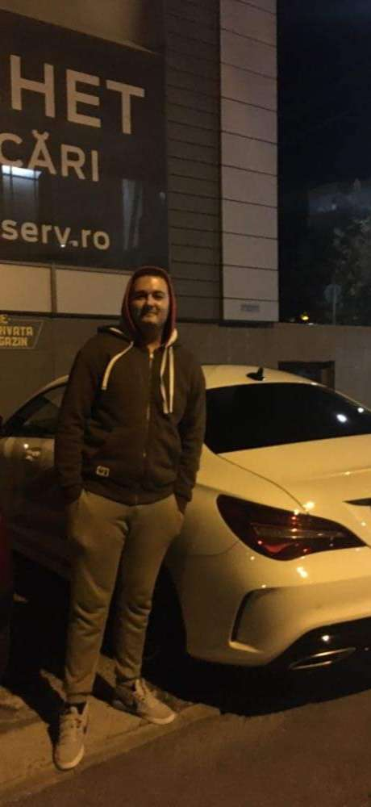

Citate: "Knowledge is power.", "The goal of education is the advancement of knowledge and the dissemination of truth."

Asteptarile mele: Sa invat cat mai multe din disciplinile studiate.

Analiza, fizica, ecuatii diferentiale

<https://etti.utcluj.ro/files/Acasa/Site/FiseDisciplina/EaRo/01b.pdf>

<https://etti.utcluj.ro/files/Acasa/Site/FiseDisciplina/EaRo/03b.pdf>

<https://etti.utcluj.ro/files/Acasa/Site/FiseDisciplina/EaRo/09b.pdf>

Muzica, jocuri video, dans, condus, arta