# Documentation - WebScrapper

**Application Overview**

This web application provides an interface for users to scrape articles from a given website. Post scraping, users can filter, search, and download the articles.

**API Endpoints**

**1. POST /scrape**

**Description**: Scrapes articles from a provided URL.

Request Body:



**Response**:

Returns a list of articles with the following structure:

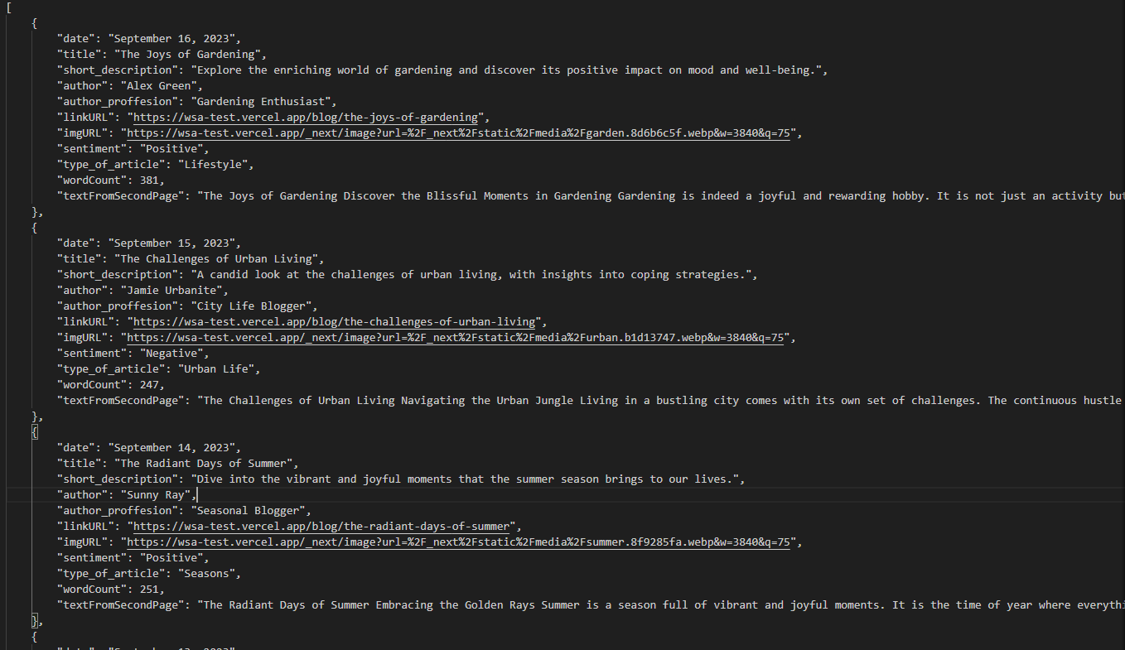

**2. GET /download**

**Description**: Allows users to download the scraped articles in JSON format.

**Response**: A .txt file containing the articles in JSON format.

**Frontend Interface**

The main UI consists of:

* An input field for the URL to scrape.
* A button to start scraping.
* Information about the articles in the blog
* A search field to filter articles based on keywords.
* A dropdown filter to select articles based on sentiment.
* A download button to get articles in JSON format.

**Explanation**

**Choices**:

Puppeteer & Cheerio: I chose these libraries because they provide a combination of real browser navigation (via Puppeteer) and DOM working capabilities (via Cheerio). This allows to effectively scrape and parse web pages.

Tailwind CSS: I chose this utility-first CSS framework for rapid interface design and also to work with something that I haven’t before in order to step out of my comfort zone. It's flexible and allows for easy customization without leaving the HTML.

**Standout Features**:

Sentiment Analysis: The main text of each article is scanned with my sentiment analysis algorithm, categorizing them into Positive, Neutral, or Negative sentiments. It’s a simple algorithm in order to follow the projects requirements however with some touchups like a vaster word base it could be a fast way to get the general sentiment of an article without analyzing the context.

Article Word Count: Alongside the basic details, the application also provides word count statistics for each article giving us an idea of the length of the article.

Search bar: Implemented a search bar in order for a user-friendly and quick way for users to find desired information from an article faster.

Sentiment filter: Implemented a filter for the user to filter out the sentiments and search for specific sentiment in articles.

Download JSON: A button to quickly get all the scrapped data in a JSON format directly in a file without issues.

**Learning Experience**:

**Complexity of Web Scraping**: The scrapping part was a difficult process at the beginning . I had to think of a very general way of getting all the data . Firstly I tough of getting the articles by their position on the website but then I checked and saw that the website is responsive so that wouldn’t work. Then I decided to get all the data needed from the <time> selector. Since on the website the time selector was used only once each time for each article I searched for that and then I got the other data that I needed in correlation with the <time> selector. For a bigger project I would think that first we could scan the page for its structure and then with AI(or a more general approach) get the data from each article we need . We could set some models for our data (for example we could now that the time of something is usually in a specific format or that the Title usually is bigger than the rest of the data on the page)

**Performance Concerns**: While Puppeteer gives me a real browser environment, it can be resource-intensive. However for this project was the right choice (I don’t think I would use this in a bigger project like yours) . Another thing was that sometimes puppeteer didn’t get the page ok , and I found out that it didn’t have enough time to get the page so I just added a timeout of half a second to make sure it has enough time. The same applies to the second time I had to access the link of each article to get the individual page of each article to get the entire content (added a timeout of 2 second there)

**Sentiment analysis** : The main issue was how would I design this algorithm . I didn’t really find a better way than just comparing each word of the content of the article with some positive and negative words provided by myself and then make a score for this. Another issue that I had to fix later was that in the neutral observation on modern art Article , there are the same number of positive words as negative but the word :bad has a “;” right after it , and when my first version of my algorithm checked on this didn’t find it well and returned that the article was positive . After this I modified the preprocess so that I get only letters in words and nothing else. And now it works fine ! ☺

**DOM**: Working with DOM and finding the structure of each article was an interesting process ☺. Also another issue was that I wanted to get only the content of the individual page and when I accessed that firstly I got as words the type of article and the ‘Back to Articles’ so I had to modify that so that it didn’t count as words or in the sentiment analysis.

**Tailwind CSS**: Finding the right class for each div , selector , input , span and , p was a real challenge however there were some useful videos on Youtube for that. (Getting everything to be well placed in the page and the page to be responsive was also a big deal)

The other implementations weren’t something that I had difficulties in.

**Improvements**

What I could see improved or added:

**Additional Filters**:

* Date Range: Allow users to filter articles based on a specific date range.
* Author: Allow filtering by the author's name.

**Database Integration**:

* Save Articles: Instead of saving articles to a file, I would consider using a database to store them, allowing more complex queries and persistent storage.
* User Accounts: With a database, I could also introduce user accounts where users can save favorite articles, set preferences, etc…

**Performance and Scalability**:

* Caching: I would implement caching to avoid scraping the same site repeatedly within a short period, reducing the load on both your server and the target website.