**Laboratory 10**

1. I implemented the Adding Matrices using divide-et-impera example as follows:

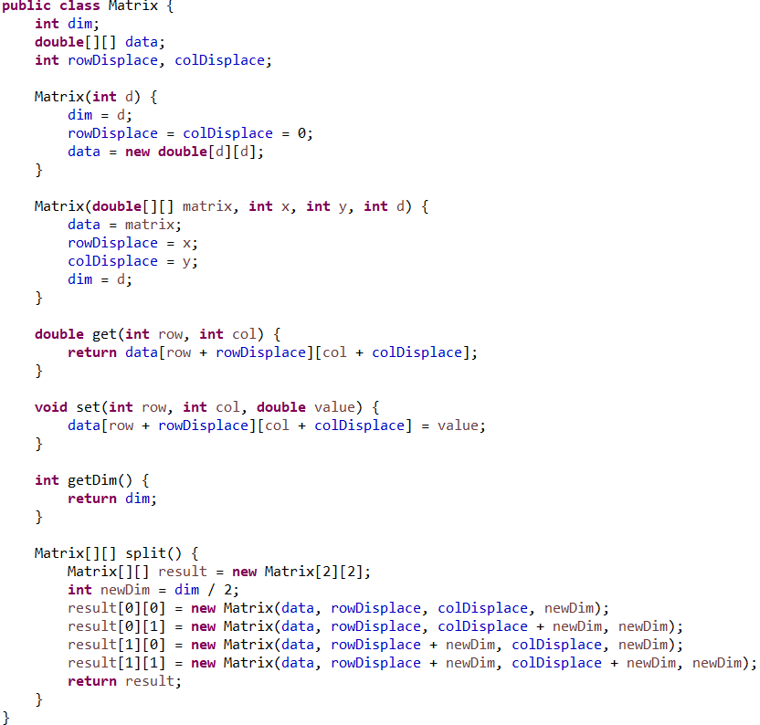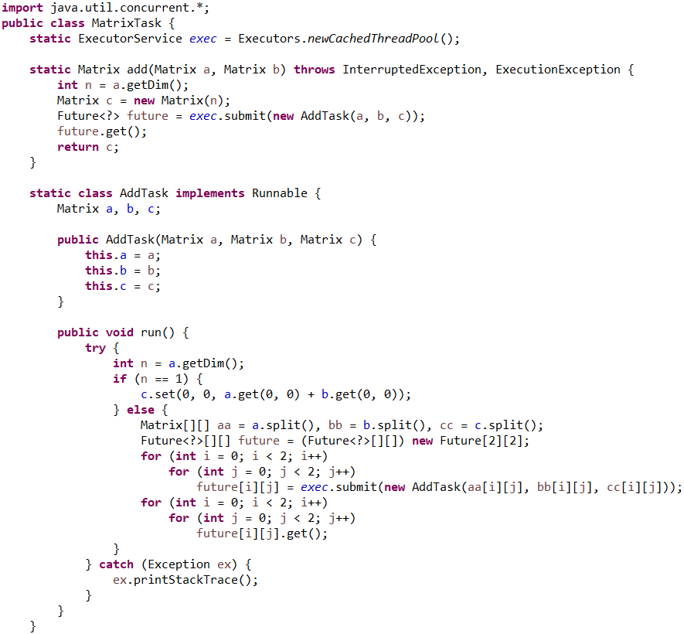

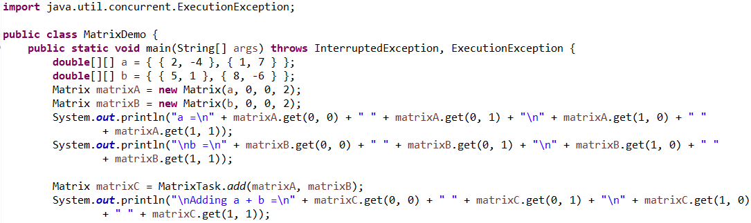

The result for running this code is:

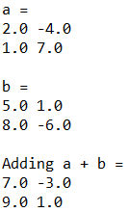

1. For the implementation of MulTask class I used and modified the code for AddTask.

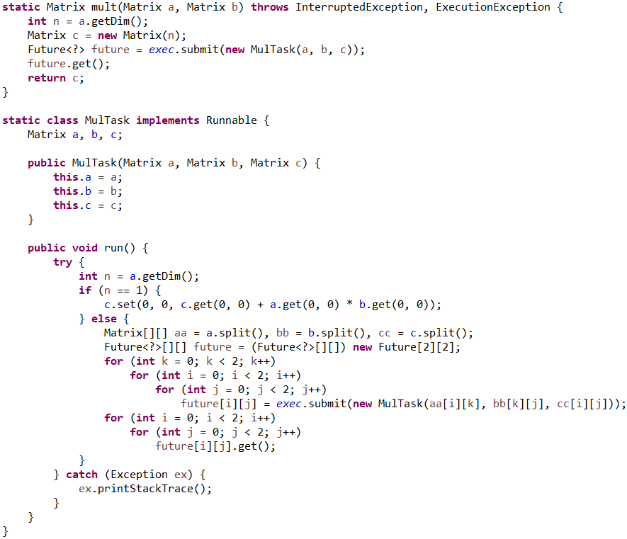

Also added in the main class the following code:



The result of running this code is:



For the multiplication, I added another for loop with the counting integer k, in order to add the result for each multiplication in its correspondent location.



Also changed the locations in the MulTask constructor so that it resembles the formula from the indication in the course chapter 9: $A_{ik}*B_{kj}$.



So that the result will be $A_{i0}*B_{0j}+A_{i1}*B_{1j}$, I changed the result in c to be the sum of all the multiplications.

