**Laboratory 12**

1. I implemented the UDP communication example as follows:

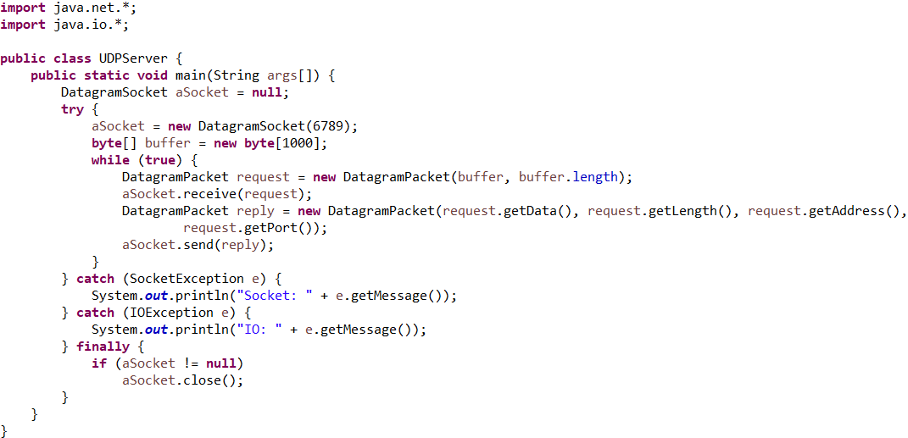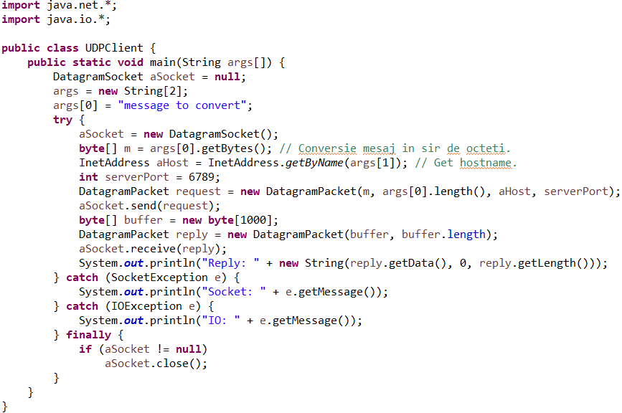

The result for running UDPServer and UDPClient is:



1. I implemented TCP communication example as follows:

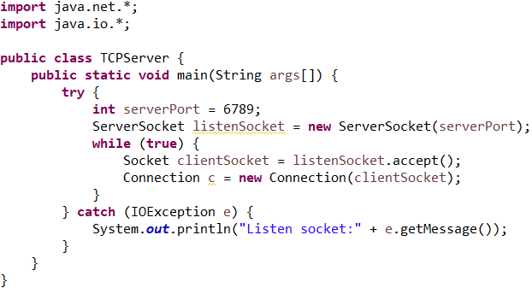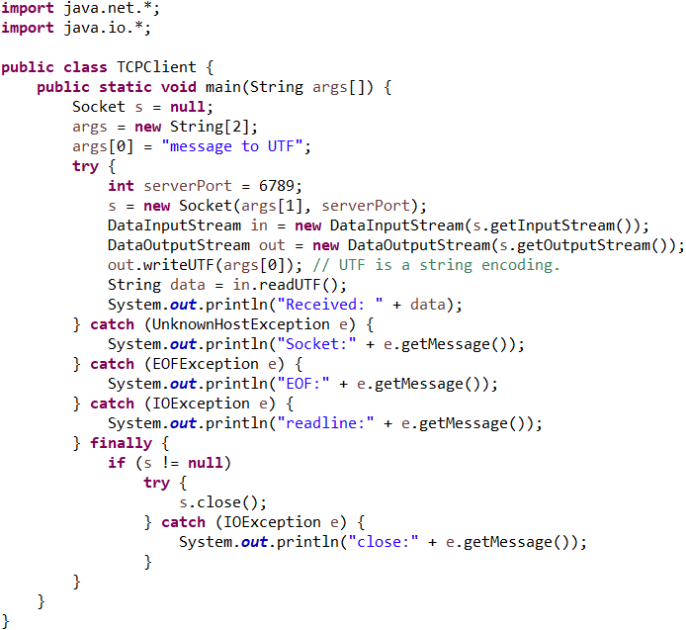

The result for running TCPClient first is:



The result for running TCPServer, and then TCPClient is:

