**Laboratory 4**

1. Implemented the Counter example and added some logging messages as it follows:

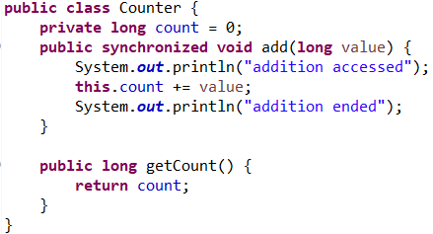

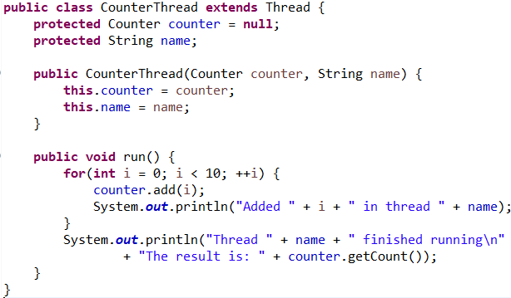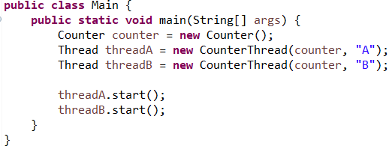

The result of running this code was:

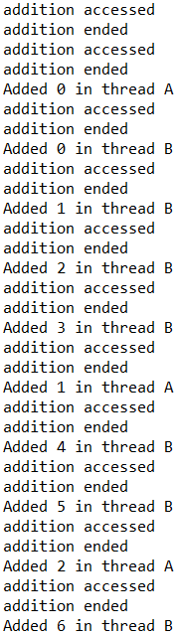 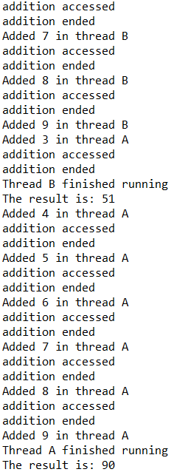

It is observed that addition method of an instance can only be accessed after the last call for it finished running. Therefore, the method can be accessed by only one thread at a time.

1. I created in the main class 2 different instances for the counter, each one of them being used for another thread.

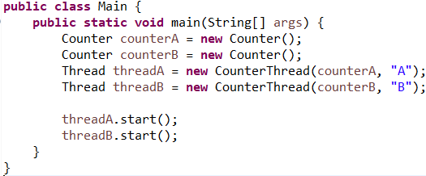

The result of running this code is:

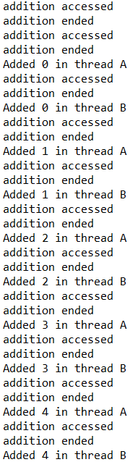 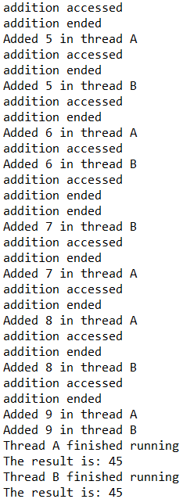

It is observed that because we have 2 different instances of Counter, each one of them can be accessed individually. The method add for each Counter instance can still be called by only one thread at a time, but because each one was assigned to a single thread, we will never be in the case where the method add from a Counter instance will be called by 2 threads at a time. This is easily noticed by looking in the results and seeing that the method add is accessed at the same time, by different instances. The result would have been the same as in the first code version if the method add was also static.