**Pipes**

I created the following C++ program:

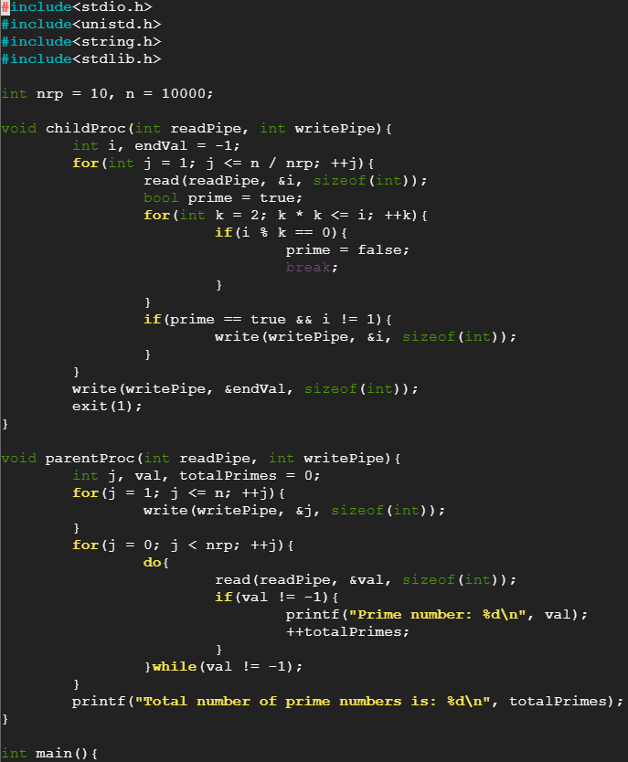

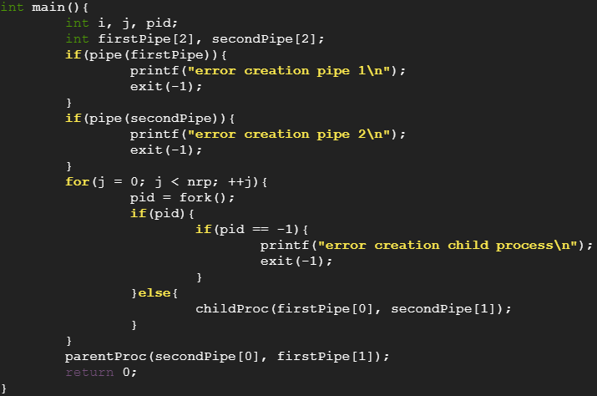

After compiling the program using the command g++ -o pipes -pipes.cpp , I executed the file pipes and obtained the following result:

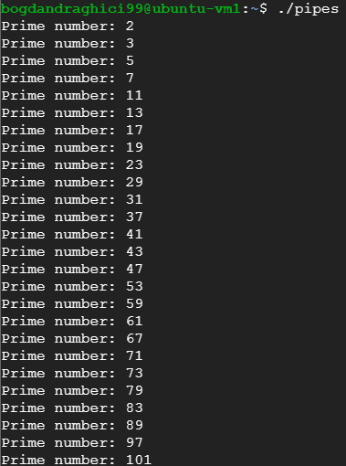

……………………………………………………………………….

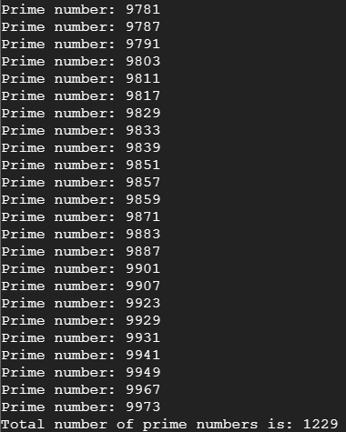

Moved the pipes.cpp file in the git repository, added it to stage, commit with the message “added pipes program”, then pushed it in the remote.

The link to the git repository is: <https://gitlab.ucv.ro/draghici.bogdan.h6u/hello-world>