**MADE by Европин Богдан aka MindAbuzer**

**All rights reserved and protected ©**

**Installation and set access rights to protect**

**and make regular activating**

**read to the end and do all by instruction**

1. **Running all files As Administrator**
2. Install python and add to the path in controlled users profile

python-3.10.0-amd64.exe

add to path and install for all users

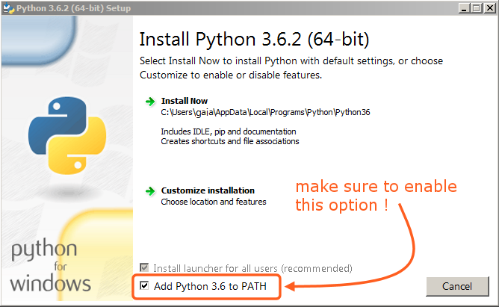

Reboot pc

1. Install pip by running:

install_pip.py

(use python to open file (type .py))

Wait till window close

1. Run install.cmd

Wait till end and check window for none red text and errors

Run install.cmd again, it will be like this:

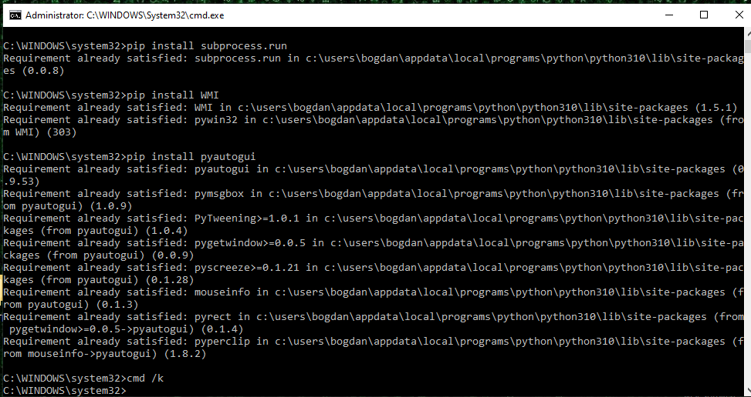

1. Create controller_exe_times.txt

If there is control_exe_times.txt write into apps you want to control, that consist name of app and time spited by “:”

example:

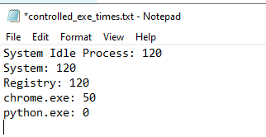

# block pc if open python, after 50 min of chrome and pc after 120 min anyway

# shutdown pc when today's time of using app from controlled_exe_times.txt is more than permitted  
  
# every minute apps_timer is checking current tasks (apps) and saving today's time of using this app  
# time of today's use writing in controlled_exe_times.txt by :  
# example  
  
System Idle Process: 120  
System: 120  
Registry: 120  
chrome.exe: 50  
python.exe: 0

Apps timers saves in apps folder

Names of apps that shutted-down user’s pc will saves in stopped_by folder

1. Urls will saves every 30 min in urls folder

Run all that files as administrator

1. Run make_rights_cmd.py
2. Run RIGHTS.cmd as Administrator
3. Run activator.py

If it creates files that ends \X_import_ERROR.cmd

(instead “X” can be any module name)