Design

# 1. Functional Requirements

|  |  |
| --- | --- |
| FR1.0 | Open trunk |
| FR1.1 | Close trunk |
| FR1.2 | Add item to the trunk |
| FR1.3 | Get all the items from the trunk |
| FR2.0 | Start the Engine |
| FR2.1 | Stop the Engine |
| FR3.0 | Accelerate |
| FR3.1 | Slow Down |

# 2. Actors

* The stone age people

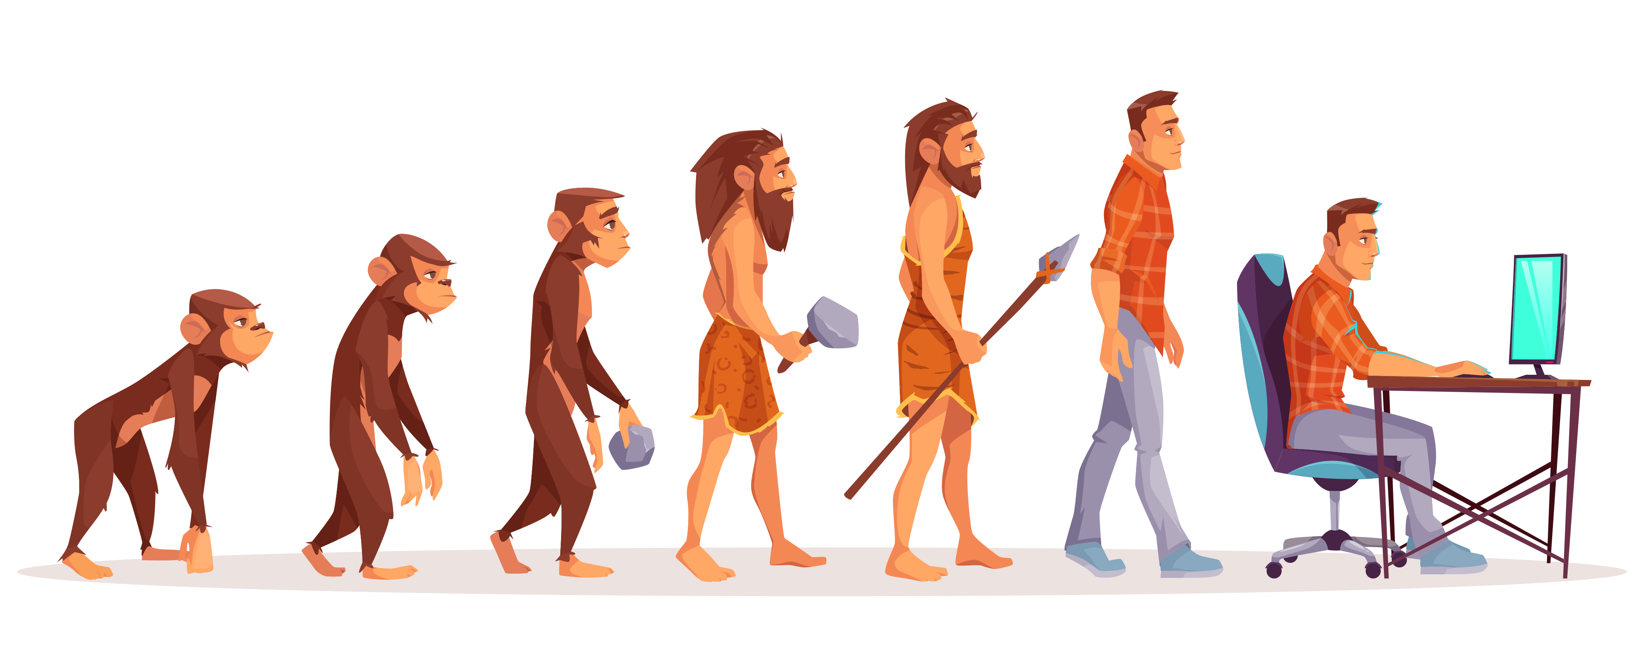

# 3. Use cases

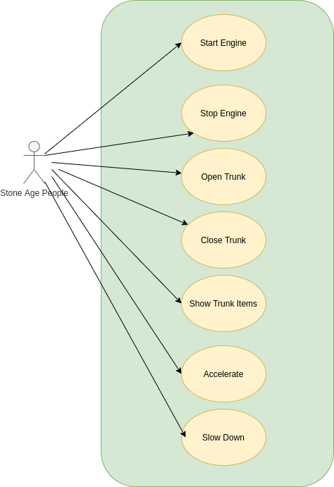

## 3.1 Open trunk

|  |  |
| --- | --- |
| **Actors** | Stone age people |
| **Description** | The stone age people open the trunk |
| **Preconditions** | The trunk is closed |
| **Postconditions** | The trunk is opened |

|  |  |
| --- | --- |
| **Action** | **System Response** |
| 1. Select the open trunk option from the menu |  |
|  | 1. Check if the trunk is closed and open it |
|  | 1. If the trunk is already opened, throw and exception to be displayed in the UI |

## 3.2 Close trunk

|  |  |
| --- | --- |
| **Actors** | Stone age people |
| **Description** | The stone age people close the trunk |
| **Preconditions** | The trunk is opened |
| **Postconditions** | The trunk is closed |

|  |  |
| --- | --- |
| **Action** | **System Response** |
| 1. Select the close trunk option from the menu |  |
|  | 1. Check if the trunk is opened and close it |
|  | 1. If the trunk is already closed, throw and exception to be displayed in the UI |

## 3.2 Add item in the trunk

|  |  |
| --- | --- |
| **Actors** | Stone age people |
| **Description** | Add a item in the trunk for storage |
| **Preconditions** | The trunk is opened |
| **Postconditions** | The item is stored in the trunk |

|  |  |
| --- | --- |
| **Action** | **System Response** |
| 1. Select the add item to the trunk option from the menu and input the required fields |  |
|  | 1. Perform the validations on the input items, check if the trunk is opened and add the item to the trunk |
|  | 1. If something is not ok, then we have a problem. #TODO good error handling |

# 4. Overview

The proposed architecture is MVC as we will be able to do an abstractization of all our processes and still benefit from the scalability that it comes with.



# 5. Class diagram

