Requirements

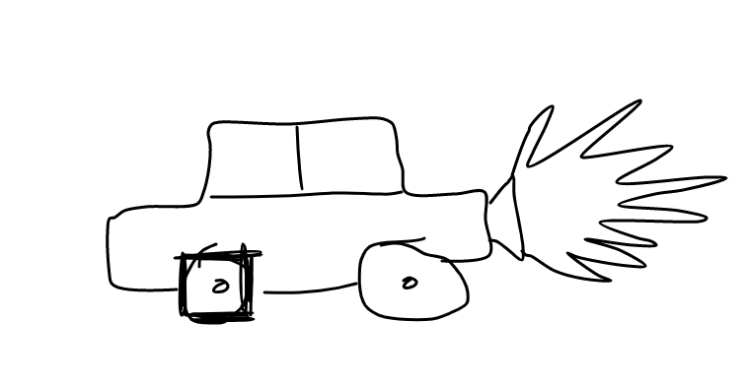

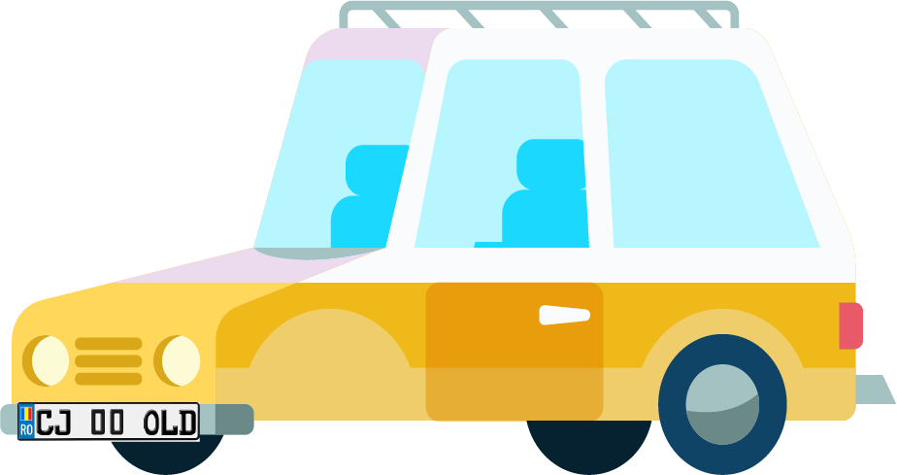

# Introduction

The application is designed for **the stone age** people to be able to **simulate the functionalities of a car**. It provides basic **transport** and **storage** functionalities that allow the user to waddle around the dangerous roads from the stone age with ease.

## 1.1 Purpose

The application allows the users to perform basic transport activities. The main purpose of the application is to mimic a car and offer the poor and vulnerable stone age people a reliable mean of transport to the stone factory.

## 1.2 Scope

The application can perform various activities like starting/stopping the vehicle, storing items in the trunk and to accelerate/slow down when the trunk is opened.

# Product description

The application can perform various activities like starting/stopping the vehicle, storing items in the trunk and to accelerate/slow down when the trunk is opened.

## 2.1 Product context

The product is independent and self-contained

## 2.2 User characteristics

The users that will be using this product are the stone age people that want to travel through the sky, like birds, and to transport their goods safely.

# Requirements

## 3.1 Functional Requirements

|  |  |
| --- | --- |
| FR1.0 | Open trunk |
| FR1.1 | Seal the trunk never to be opened again |
| FR1.2 | Add item in the trunk |
| FR1.3 | Get all the items from the trunk |
| FR2.0 | Stop the Engine |
| FR3.0 | Accelerate |
| FR3.1 | Slow down |

## 3.2 User interface requirement

The user should be represented by some sort of a menu.

## 3.3 Usability

* The user documentation should be comprehensive
* The system should be easy to learn

# User scenarios/ use cases

|  |  |
| --- | --- |
| In order to open the trunk | the trunk must be closed |
| In order to close the trunk | the trunk must be opened |
| In order to store items | the trunk must be opened |
| In order to see all the stored items | the trunk must be opened |
| In order to accelerate | the trunk must be closed and the engine started |
| In order to slow down | the vehicle must be already accelerated |