

Project Number 003185
Moonlight

W7100 and eLua based intelligent LED display with network connectivity
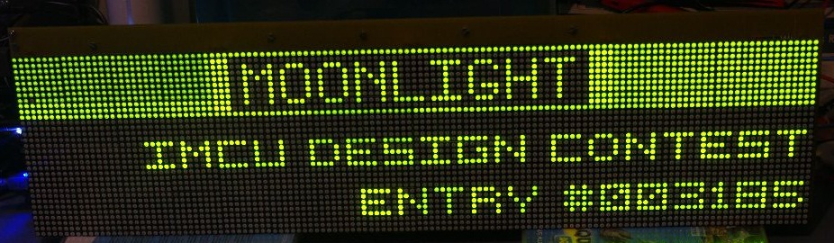
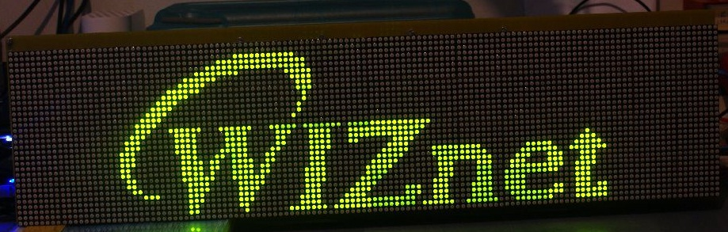

COMPLETE DOCUMENTATION

Table of Contents
1. Project description 2
1.1 Moonlight platform overview 5
1.2 Using Moonlight in demo mode 6
1.3 Using Moonlight in interactive mode 8
1.4 Building and programming the firmware 10
1.4.1 Building and programming the W7100 firmware 10
1.4.2 Building and programming the STM23 (eLua) firmware 11
1.4.3 Building the PC applications 12
1.5 The demo applications 12
1.5.1 Clock 12
1.5.2 Commercial (presentation) 13
1.5.3 PC monitor 14
1.5.4 Pachube client 16
1.5.5 ICMP network monitor 16
1.5.6 RSS reader 17
1.5.7 Tic-Tac-Toe game 18
1.5.8 Yahoo Weather client 19
1.5.9 WinAmp remote control and visualiser 19
1.6 Known bugs 21
1.7 An important note regarding the “originality” factor (please read) 22
2. Hardware design 23
2.1 The connector board 24
2.2 The controller board 26
2.3 The iMCU7100EVB board 27
2.4 The display board 29
3. Software design 30
3.1 RPC mechanism details 31
3.2 The W7100 firmware 34
3.2.1 The TFTP bootloader: stm32ld.c and tftp.c 34
3.2.2 The RPC server and the web configuration interface 35
3.2.3 The HTTP server: httpd.c 40
3.3 The STM32 (eLua) firmware 41
3.3.1 The RFS file system and the serial multiplexer 41
3.3.2 The network RPC client 45
3.3.3 The display driver 45
3.3.4 The remote control decoder 49
3.4 The Moonlight API 50
3.4.1 The networking API 50
3.4.2 The display API 57
3.4.3 The IR API 58
3.4.4 The sound API 59
4. Final thoughts and conclusions 60

Project description
In the microcontroller scene of today, the iMCU W7100 from WIZnet stands up as an interesting, very capable device. Besides implementing a complete network stack in hardware, it also exposes a MCU that is built around the industry standard 8052, which makes it compatible with a lot of tools, libraries and utilities available on the market. The extended amount of on-chip memory (64K of Flash and especially 64K of RAM, quite rare for an 8-bit MCU) makes it suitable for a lot of applications.
However, like any other chip, the W7100 has its shortcomings. Most of them stem from the same 8052 based core that gives it flexibility and extensive tool support: this is an old architecture, with lots of limitations which are clearly visible when enumerating the CPU peripherals. Besides the network controller and the standard GPIO ports, the W7100 CPU exposes only a single UART interface. This might not be enough for a real world application, that often needs other peripherals, such as I2C, SPI, ADCs and DACs, more U(S)ARTs and others. Also, being an 8-bit 8052 core, it might be slow for some applications, and even its quite generous 64k of Flash memory might prove insufficient for medium to high complexity applications.
Starting from the above assumptions, this project (Moonlight) aims to use the W7100 for what he knows to do best: networking. Although this is somewhat of an unusual approach, Moonlight uses the W7100 as a network coprocessor for a 32-bit microcontroller. This microcontroller (the STMicroelectronics STM32F103RE) is built around a modern ARM Cortex-M3 core, and it’s naturally much more powerful in terms of resources and processing power than the W7100. It’s powerful enough to run eLua (http://www.eluaproject.net), an open source project that aims to bring the Lua programming language (http://www.lua.org) to the embedded MCU world. However, it doesn’t “know” anything about networking, which is a serious constraint. This leads directly the idea behind Moonlight: let the 32-bit MCU run eLua (a task that is currently out of reach for any 8-bit CPU on the market) and let the W7100 run the network tasks. The two CPUs communicate through a simple, yet powerful RPC (Remote Procedure Call) mechanism. The STM32 CPU makes network requests to the W7100 using RPC, the W7100 executes them and sends the results back to the STM32.
While it can be argued that a 32 bit microcontroller with specialized Ethernet hardware might have been a better choice for this project, this isn’t necessarily true for a couple of reasons:

- the W7100 has a complete network stack in hardware, not just the hardware needed to inteface to an Ethernet network (not to mention that the W7100 can also do ADSL, although this isn’t used in Moonlight). In comparison, a 32 bit MCU that only has an Ethernet MAC (and maybe a PHY) still needs a software TCP/IP stack, and this can be very time consuming and expensive in terms of implementation time and maintenance.
- this solution is generic. The RPC layer is written 100% in ANSI C, and since it uses a serial port it can be adapted to a large number of different CPUs.

The actual application chosen to illustrate this concept is a large (638x176mm) LED display, programmable directly in Lua using eLua (which runs on the STM32) and with network connectivity (which is the task of the W7100). The project name comes from “Moon” (which is English for Portuguese “Lua”) and “light” (which is a reference to the LED display). The end result is a very versatile (because it can be programmed with Lua directly on the STM32) programmable display, with a huge range of connectivity options (because it uses the W7100). The whole system is controlled using a simple IR remote control (salvaged from an old Sony portable CD player), which can also reset the board. A number of applications (all of them written in Lua) are shown that demonstrate this functionality (almost all of them can be configured via a Web interface):

- a RSS reader
- a Yahoo! Weather client
- a clock that synchronizes the time with the network
- a remote Winamp visualiser and remote control
- a real-time PC monitor (which shows CPU load and memory consumption amongst other things)
- a configurable network monitor which pings (via ICMP) a number of hosts and show their status on the display
- a simple Tic-Tac-Toe (TTT) game (no network connectivity required)
- a simple presentation application which shows how the display can be used to display commercials or promotional material (no network connectivity required)
- a Pachube (http://www.pachube.com) client that effectively enables data from any Pachube compatible sensor to be displayed on Moonlight

The W7100 takes care of all the networking requirements of the application:
- RPC server for the STM32 board (for basic network functions like socket, send, recv, readfrom, recvfrom, but also for more complex services like lookup (DNS), ping (ICMP), HTTP client).
- HTTP server with basic authentication which can be used to configure the network (IP, netmask, gatway, DNS server) via a web interface
- Web configuration frontend for the applications running on the STM32
- DHCP client
- TFTP server. This is used to upload the firmware on the STM32 CPU (using its built-in serial bootloader over the same serial connection used for RPC) with a standard TFTP client running on the PC.
- STM32 firmware programmer (see 5 above).

Moonlight platform overview
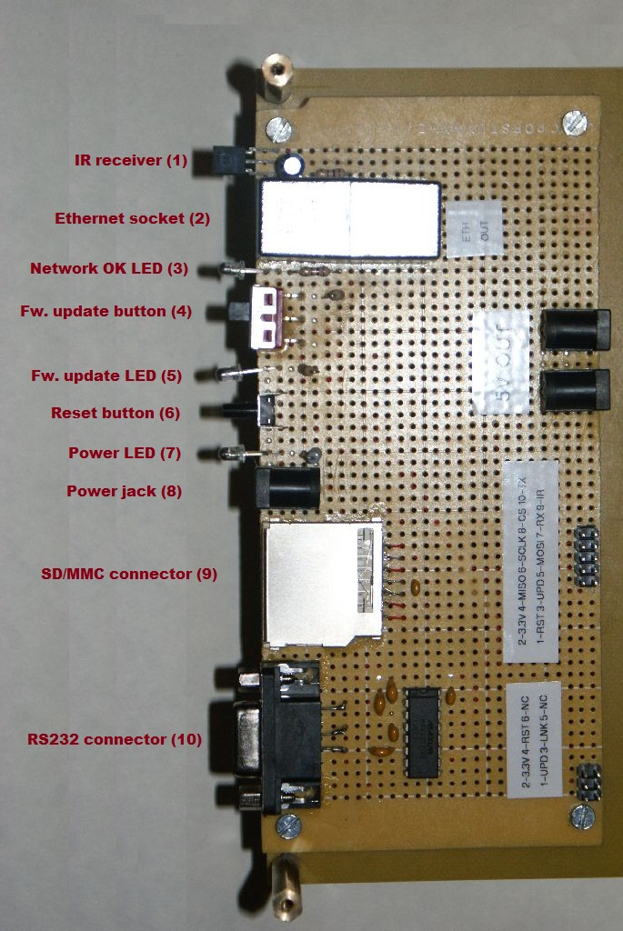
Figure 1 - Moonlight connectors

A detailed view of the moonlight connector board is presented below. The components are listed below:
- The IR receiver is used to control Moonlight using an IR remote control.
- The Ethernet socket connects Moonlight to the Ethernet network.
- The network OK LED (blue) lights when Moonlight establishes a connection to the local network.
- The firmware update button is used to put the board into firmware update mode (to update the firmware on the W7100 CPU)
- The firmware update LED (red) lights when the board is in firmware update mode (by changing the position of switch 4 above)
- The reset button is used to reset Moonlight
- The power LED (white) confirms the presence of power.
- The power jack is used to power all the Moonlight boards and displays
- The SD/MMC connector is used to add non volatile storage to the system
- The RS232 connector is used to connect Moonlight to a PC, in order to use it in interactive mode.

Using Moonlight in demo mode
Moonlight is ready to run out of the box. Just insert the power supply (5V@6A, centre-positive) jack in 8, the network cable in 2, and wait for the blue “network OK” LED 3 to light. If the LED doesn’t light, then Moonlight can’t establish a proper connection to the network. You can still use it in this mode, but without any network functions. By default Moonlight is configured with DHCP enabled and with HTTP authentication enabled (user: “admin”, password: “admin”). By accessing the web interface (http://moonlight.ip) the network configuration can be easily changed, as shown below:
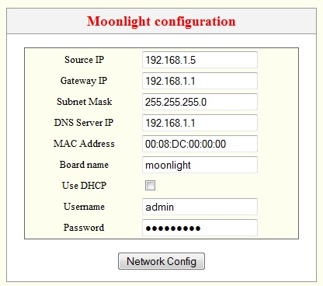
Figure 2 - Moonlight network configuration interace
Also, Moonlight will start in “demo mode” out of the box (but please also check section 1.3 below to get a feeling of the full capabilities of the system). The demo mode is a launcher for all the demos implemented as part of the. After the first screen (that shows information about the application) press any button on the supplied IR remote control, and you’ll be taken to the application selection screen (the launcher):
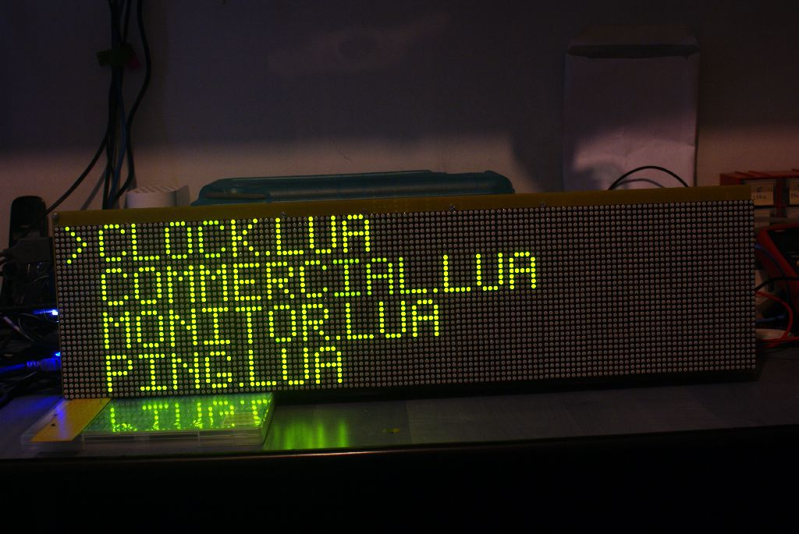
Figure 3 - Moonlight application launcher
Each application listed in the screen above is written in Lua, using eLua and the WIZnet board for network connectivity. Use “next track” and “previous track” buttons on the IR remote to select the demo, and press “play” to run the application. The application can be stopped using the “stop” key on the remote.
Most of the applications have a web configuration interface. While the application is running, point your browser to http://moonlight.ip and press on the link shown in the “Application base URL” field (if the field is empty, the application doesn’t have a web configuration interface). Configure your application as needed, then hit the “Update” button to commit the configuration. If the system stops working for whatever reason, hit the reset button 6 to restart it. Alternatively, you can restart the system by pressing the REPEAT button on the IR remote twice.

Using Moonlight in interactive mode
Probably the most interesting feature of Moonlight is its extensive interactive code development system. Being based on the open source project eLua (http://www.eluaproject.net), it brings the full power and flexibility of the project to Moonlight itself. The following is a quote from the eLua web page:

eLua stands for Embedded Lua and the project aims to offer the full implementation of the Lua Programming Language to the embedded world. [...]
The aim of the project is to have a fully functional Lua development environment on the microcontroller itself, without the need to install a specific development environment on the PC side, other than a serial or Ethernet console/terminal emulator.

What this means in practice is that you can write your programs directly in Lua, using only the microcontroller that runs eLua (in this case the STM32) and a serial connection to the PC. Once connected with a PC, one can run a Lua interpreter directly on the microcontroller and program his application directly from there. This makes the board extremely useful for fast prototyping and development, as the regular edit/compile/program/run development cycle is reduced to edit/run.
For more advanced usage, Moonlight allows the developer to edit the program on the PC (using one’s favourite text editor) and then run it directly from the PC HDD using a special file system called RFS (Remote File System). By simply issuing the command lua /rfs/program.lua at the eLua shell prompt, the program can be instantly tested. When the program is finalized, another file system can be used to store it on Moonlight. This is a standard FAT file system implementation that runs over a SD card. Copying the program to the SD card is a simple matter of running cp /rfs/progam.lua /mmc/program.lua at the eLua shell prompt. After that, the program can be run directly from SD by invoking lua /mmc/program.lua. The SD file system is also used for persistent data storage, for example the configuration of most of the applications that run in demo mode. There is yet another file system in eLua, the ROMFS (a read only file system which resides on the MCU Flash). It the case of Moonlight, it holds all the demo files, with the exception of the application configuration (which are stored on SD, as already specified). If you are interested to read more about the ROMFS, go to http://www.eluaproject.net/en_arch_romfs.html. The SD file system is documented at http://www.eluaproject.net/en_fatfs.html. The RFS file system isn’t officially documented yet, as it was mostly developed as part of Moonlight (for the WIZnet contest) and it isn’t part of the eLua source tree yet.
The RFS file system needs a server that runs on the PC and it also needs specialized software that can multiplex multiple data channels on a single physical RS232 port. This functionality is grouped in a single PC application with a GUI interface, named muxfe. It can be found in firmware/eLua/muxfe.exe, and a screenshot is given below:
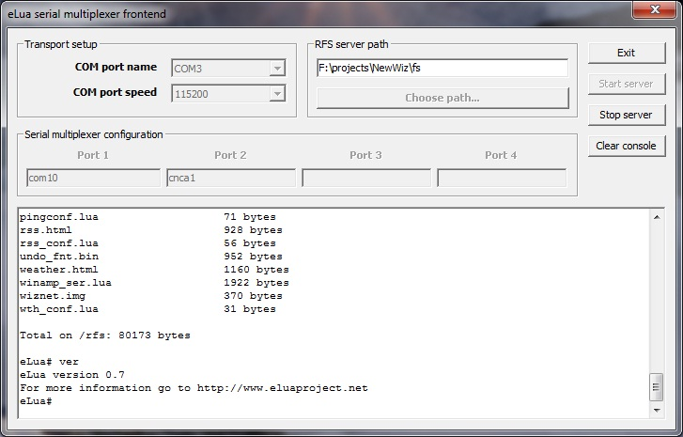
Figure 4 - muxfe screenshot
To use the interactive development mode with Moonlight, follow the steps below:

- connect Moonlight to a serial port on the PC interface on connector 10.
- run muxfe on the PC
- select the serial port that you’re using to connect to Moonlight and choose 115200 as the speed. Enter another valid COM port name in the “Port 1” field to enable the application (although you are not going to use this).
- select a directory to share with Moonlight (this directory’s content will be available to Moonlight via the /rfs file system).
- press the “Start server” button
- reset Moonlight, press a key on the remote to get over the intro screen, then press “stop” on the remote to exit the launcher application (or alternatively just start reset the board while the SD/MMC card is not plugged in). The eLua shell should appear in the lower part of the muxfe window. After that, follow the instructions at http://www.eluaproject.net/en_using.html#shell to use the eLua shell.

Building and programming the firmware
Since Moonlight is built around two MCUs (the W7100 and the STM32) one must build and program each of them separately in order to have a running system.

Building and programming the W7100 firmware
Building the W7100 firmware is easy. Just open the imcu_fw_tweed.uvproj file from firmware/w7100 and build it from the Keil environment. You’ll get a hex file that you can use to program the W7100. Regularly, you’d connect the iMCU7100EVB board to the PC and then use the software provided by WIZnet (WizISP) to program it in the MCU. However, in this case the iMCU7100EVB board is hidden inside Moonlight, and the only exposed serial port is the one that connects to the eLua board. Moreover, the eLua CPU (the STM32) already uses the serial port on the iMCU7100EVB to implement the network functions over RPC (see section 3.2.2 for details).
Moonlight uses a clever trick to solve this problem: the STM32 monitors the state of the firmware update switch 4. When the switch is active, the STM32 stops running the regular eLua firmware, executing instead a small piece of code that makes it behave like a “null-modem cable” between two of its internal UARTs: the one that connects to the iMCU7100EVB and the one that is normally used for the eLua console. In this way, one can program the iMCU7100EVB from the eLua console UART.
These are the actual steps one must follow in order to program the W7100 firmware:

- make sure that muxfe is NOT running.
- switch the firmware update switch 4 to ON (this will turn on the red LED 5; if the red LED doesn’t turn on, move the switch around a bit, it seems to have a mechanical problem at times).
- press the reset button
- run WizISP and specify the eLua console port and 115200 as the speed
- program your firmware in the usual way using WizISP
- switch the firmware update switch to OFF
- press the reset button

Your W7100 firmware should be up and running.
Please note that a compiled version of the firmware already exists in firmware/w7100.

Building and programming the STM23 (eLua) firmware
This is a bit more complex, as building eLua might be fairly involved. Full build instructions can be found at http://www.eluaproject.net/en_building_win.html. In short, the process can be reduced to this:

- if Python is not installed, download and install Python from http://www.activestate.com/activepython
- if scons is not installed, download and install scons from http://scons.org/download.php
- if the CodeSourcery toolchain is not installed, download and install from http://www.codesourcery.com/sgpp/lite/arm/portal/subscription?@template=lite (you need the EABI version)
- open a command prompt and cd to the firmware/eLua directory
- execute this from the command line
scons board=wiz toolchain=codesourcery prog

You’ll get a file named elua_lua_stm32f103re.bin in the current directory if the above sequence is successful, which is the STM32 firmware (note that a compiled version is already present as part of the Moonlight distribution). Fortunately, it’s very easy to program, using the TFTP server and the STM32 bootloader implemented in the W7100 firmware. To program it, you need a standard TFTP client. I use the small and free TFTPD32 software from http://tftpd32.jounin.net/, but any other client should do. Just send the .bin file to the IP of the Moonlight board and the firmware should be programmed automatically. The board will reset itself after the firmware is programmed.

Building the PC applications
The most important PC application is the ‘host application’ (muxfe) that allows Moonlight to run in interactive mode (see section 1.3 for details). The process of building muxfe, however, is extremely involved. It requires downloading and building a whole GUI interface (wxWidgets) and also having a functional gcc based build environment on the PC side, plus other dependencies (like the threading library). Because of this, the compilation of muxfe won’t be covered here. For your convenience, an already compiled version of muxfe, accompanied by (hopefully) all its dependencies is already include in firmware/eLua/muxfe.exe.
The other two PC side applications are a Windows service (for the PC monitor) and a WinAmp plugin (for the WinAmp remote application). Build instructions for them will be also provided in the next section (which presents the Moonlight demo applications), but compiled versions are already included in firmware/pc_apps.

The demo applications
This section gives a short overview of the applications written to demonstrate the functionality of Moonlight.

Clock
Location: firmware/eLua/romfs/d_clock.lua
This is a simple clock application, with a catch: it can synchronize with a network TIME server. The TIME protocol is an extremely simple protocol (check http://en.wikipedia.org/wiki/TIME_protocol for details), which is why it was chosen of NTP. The application updates its time every 5 minutes, which makes it an extremely precise clock. A screenshot can be seen below:
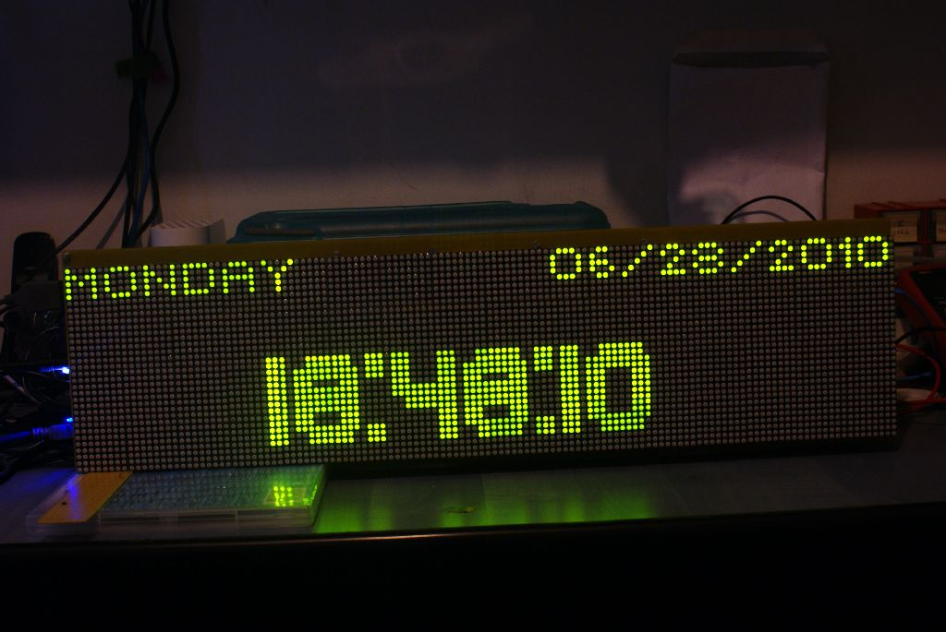
Figure 5 - The clock application
The clock application features a web configuration interface that can be seen below:
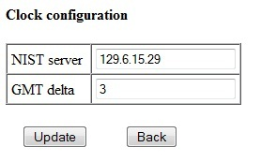
Figure 6 - The clock application web interface
Exit the application by pressing STOP on the remote control.

Commercial (presentation)
Location: firmware/eLua/romfs/d_commercial.lua
This is a simple demo that shows some of the animation capabilities of Moonlight. It proves that the platform can be used for commercial presentations. It doesn’t use any network functions, although it can be easily extended to read the presentation content from some remote location. Below is a picture of the first screen of the presentation:
Figure 7 - the first sceen of the 'commercial' application
Wait for the application to finish, it will exit automatically.

PC monitor
Location: firmware/eLua/romfs/d_monitor.lua
PC application location: firmware/pc_apps/pcmonitor.exe
This implements a real-time PC monitor that runs over a UDP connection. It requires special support on the PC side, in the form of a Windows service that monitors the system and sends all the required data to the board when needed.
You don’t need to build the PC monitor service, as it is already part of the Moonlight distribution. If you still want to build it, you need to have Python and scons installed (see 1.4.2 for details) and also Microsoft Visual Studio (the free edition is OK). Once everything is installed and in %PATH%:

- open a command prompt
- cd to firmware/pc_apps.
- execute this from the command line:
scons –f pcmonitor_udp.py

Even if you choose not to build the executable yourself, you still need to install it as a service on your PC. In order to do this, follow steps 1 and 2 above, then execute this command from the command line:

copy pcmonitor.exe c:\windows
sc.exe create “Moonlight PC service” binpath= c:\windows\pcmonitor.exe start= auto

A new service should appear in the list of system services. Make sure it’s started, then make sure that the PC monitor application interface (below) has the correct IP (it must be the IP of the computer on which the service is running):
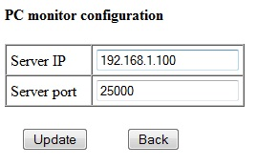
Figure 8 - PC monitor web interface
Use NEXT and PREV on the remote control to cycle through the application screens (there are 3 of them, with different data from the PC). Press STOP on the remote to exit.
If the application starts, but doesn’t show any data, or shows a lot of N/A (Not Available) lines, simply restarting it should fix the problem. Below is a picture of the first screen of the application.
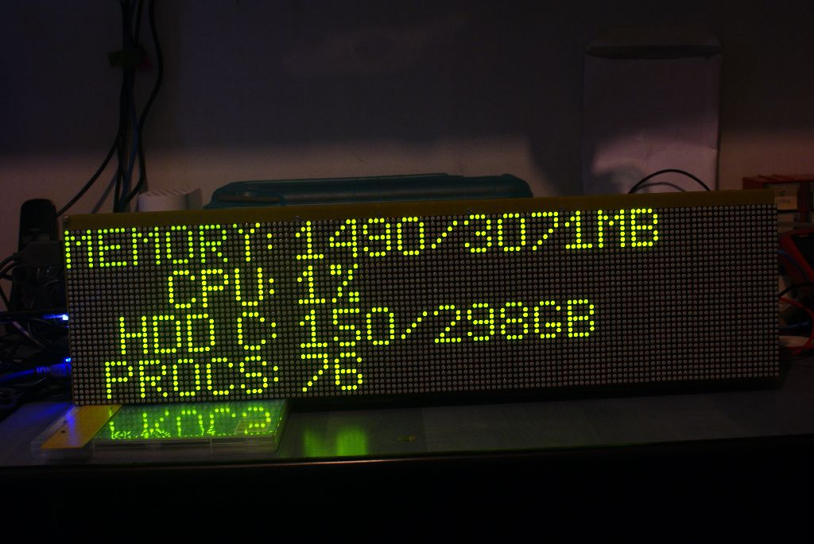
Figure 9 - The PC Monitor application (first screen)

Pachube client
Location: firmware/eLua/romfs/d_pachube.lua
Pachube (http://www.pachube.com) is a platform that allows for easy sharing of Internet enabled sensors (amongst other things). Moonlight implements a simple Pachube client that allows watching any Pachube feed (and specifying what data to display on the screen). Press STOP on the remote to exit. It comes with a web configuration interface that can be seen below:
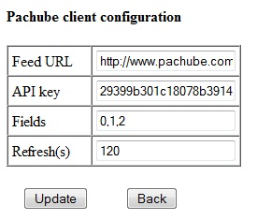
Figure 10 - Pachube web configuration interface

ICMP network monitor
Location: firmware/eLua/romfs/d_ping.lua
This is a simple network monitor that sends pings (ICMP ECHO) packets to a configurable list of hosts. For each ECHO packet sent it waits for a reply. It shows the percentage of replies received or ERR if the remote host can’t be contacted or if another network error occurred. A screenshot can be seen below:
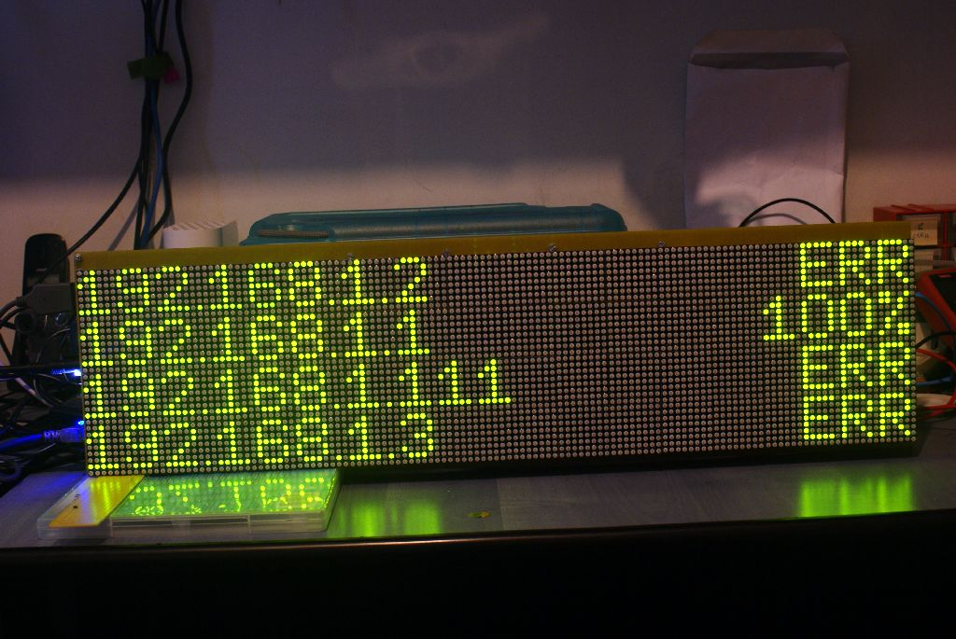
Figure 11 - The network monitor application
Press STOP on the remote to exit. The application has also a web interface:
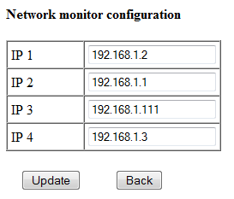
Figure 12- The network monitor configuration interface

RSS reader
Location: firmware/eLua/romfs/d_rss.lua
The RSS reader is a good way to read RSS feeds. It connects to a given RSS source, then parses the corresponding XML and shows the titles on the display. It also has a web configuration interface, shown below:
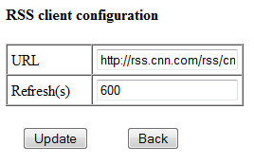
Figure 13 - The RSS client web configuration interface
A screenshot of the application itself is not available due to the rapid animation of the display lines which makes photography difficult. However, remember to take a look at the movie(s) in the media/ directory to see the application at work.
Press NEXT and PREV on the remote to cycle through the application screens. Press STOP to exit the application.

Tic-Tac-Toe game
Location: firmware/eLua/romfs/d_ttt.lua
This application doesn’t use any kind of network functions, but it was simply too fun to implement ☺ It implements a classic Tic-Tac-Toe game that can be played with the keys 1-9 on the remote (each key corresponds to a position in the grid).. A screenshot of this application is given below:
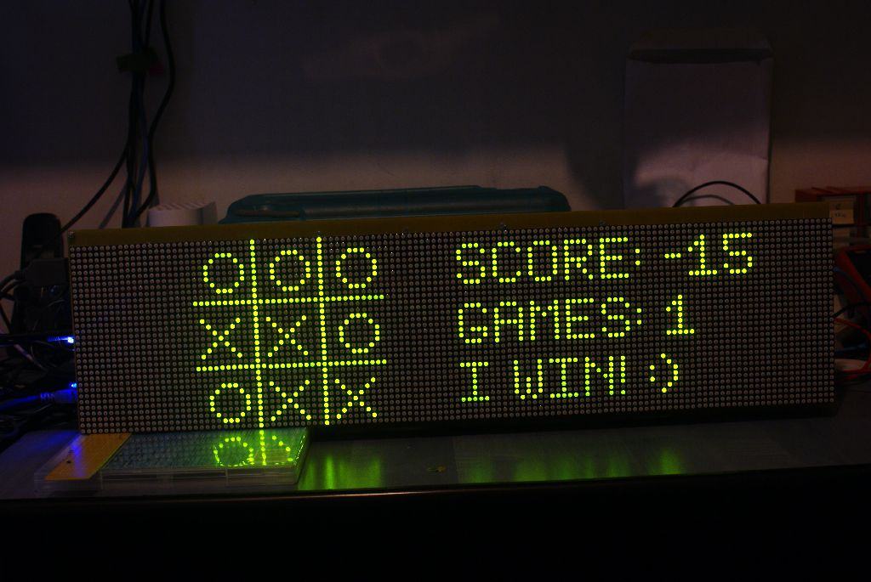
Figure 14 - The Tic-Tac-Toe game
This is also the only Moonlight application that uses the sound module (see section 3.4.4 for details).
Press STOP to exit this application.

Yahoo Weather client
Location: firmware/eLua/romfs/d_weather.lua
This is actually another example of a Moonlight RSS based application. It shows the current weather conditions for a given location, and also the forecast for the next two days using the Yahoo Weather API. It has a web configuration interface that can be seen below:
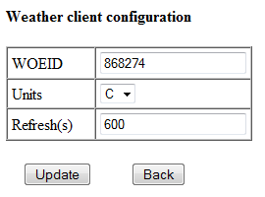
Figure 15 - The weather client web configuration interface
A screenshot of the application itself is not available due to the rapid animation of the display lines which makes photography difficult. However, remember to take a look at the movie(s) in the media/ directory to see the application at work.
Press STOP to exit this application.

WinAmp remote control and visualiser
Location: firmware/eLua/romfs/d_winamp.lua
This is probably the most spectacular application implemented in Moonlight. It uses a custom WinAmp plugin (firmware/pc_apps/plugin_udp) to display real time data from WinAmp: song title, current time, current position in playlist, and most importantly the real-time spectrum data, as received from WinAmp over a UDP connection. It is a very interesting application too, as it shows how well this works in practice: it can do 25fps without any problem, which is quite visible on the spectrum part of the display.
As already mentioned, this application requires support on the PC side. The plugin comes already built as part of the Moonlight distribution, you can find it in firmware/pc_apps/plugin.udp/gen_moonlight.dll. If you want to build it, you need a GCC based development environment (such a MinGW) installed. Follow the steps below to build:

- open a command prompt
- cd to firmware/pc_apps/plugin_udp
- execute the command below:
gcc -mdll -o gen_moonlight.dll -DWIN32_BUILD gen_moonlight.c -lwsock32

Even if you don’t compile the plugin, you still need to copy it to WinAmp’s plugin directory. First install WinAmp if it is not installed (version 5.56 was tested with Moonlight) then copy gen_moonlight.dll above in c:\Program Files\winamp\plugins). Then create a file named winamp.ini in the base directory of WinAmp with the following text (or add the following text to it if it already exists):
[moonlight]
ip=your.moonlight.board.ip
port=31000
A screenshot of the plugin is given below:
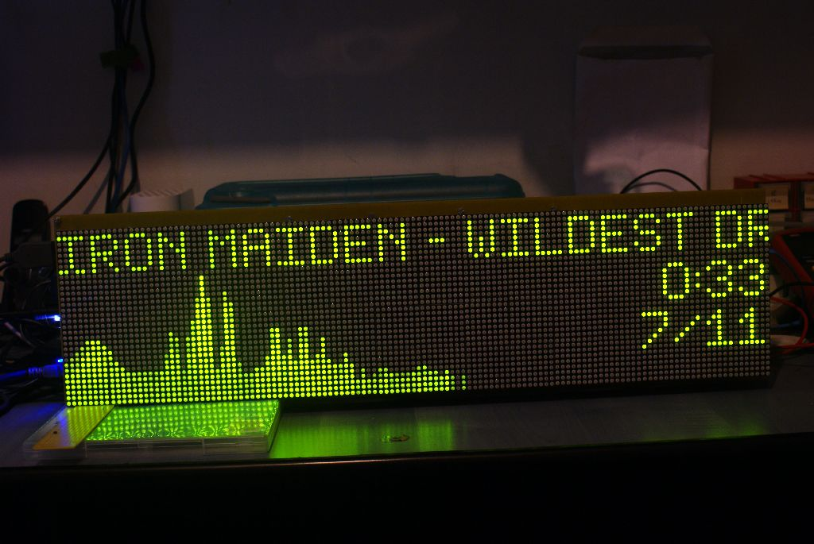
However, this is a static picture that makes it no justice. Make sure to watch the movie(s) in the media/ directory for a much more entertaining experience.
Also, this plugin has remote control capabilities. The NEXT, PREV, PLAY/PAUSE, STOP, VOLUME UP and VOLUME DOWN keys on the remote control can be used to control WinAmp via Moonlight. Press REPEAT once to exit this application.

Known bugs
The whole system is complex, and it has a number of bugs that couldn’t be fixed until now, mostly because of the lack of a hardware debugger for both CPUs, and also because they are quite sporadic in nature:

Symptom | Cause and solution
The SD/MMC card is not recognized by eLua, shows an empty file list when the “ls” command is used from eLua although there are files on the card, or gives I/O errors | This issue is most likely related to the SD initialization sequence. Reset the system (a few times if needed) and retry.
After configuring an application and pressing on “Update” on the web configuration page, the system freezes | Unknown cause, the bug is quite rare. Reset the system and retry.
The RFS file system gives I/O errors or “buffer overrun” errors are shown in the eLua console | The RFS server is in an inconsistent state. Restart “muxfe” and reset Moonlight.
A Moonlight application freezes suddenly. | Must likely a network error. Restart the system and retry.
The W7100 HTTP server suddenly stops working. | Unknown cause, the bug is quite rare. Reset the system and retry.
The TFTP session ends with an error before programming the whole firmware in the STM32. | Unknown cause, the bug is quite rare. Reset the system and retry.

An important note regarding the “originality” factor (please read)
This paragraph might seem strange to the reader of this document. If so, please accept my apologies, I assure you that this was not my intention. I made up my mind to write this paragraph by the simple fact that the originality factor counts for no less than 30% of the final note given to this project according to the contest rules, and maybe even more by subjective appreciation. The problem is that the reader of this document might get all too easy the impression that this project is nothing more than a simple integration of code from different open source projects and other various sources, with little or no innovation. Let me convince you that this is not the case by listing here the most important parts that were added to the eLua project specifically for this contest:

- the RFS (Remote File System) implementation, consisting both of the RFS server running on the PC side and the RFS firmware on the eLua MCU side (plus the serial multiplexer). Although the idea of the RFS came before the contest, the main design and implementation eventually became a large part of the overall contest entry development.
- the RPC mechanism that allows the STM32 CPU to execute network functions on the W7100.
- the STM32 bootloader running on the W7100.
- the TFTP server code running on the W7100.
- the HTTP server code running on the W7100.
- the intelligent display driver and the whole design and implementation of the display API (text output, graphic primitives, bitmap conversion and display, dirty rectangles, viewports, video memory write modes and others).
- the asynchronous IR receiver and decoder running on the STM32
- the network API (design and implementation)

All of these add up to some thousand lines of C code. And I’d also like to mention (with the hope that this will score some more points in the originality department), without any intention to reveal my actual identity (in accordance to the contest rules) that I’m one of the authors of the eLua project itself. Again, please accept my apologies if you feel that this pushes the limits of obeying the contest rules too far, or even breaks them. I’ve given this some thought, and I even consulted one of the contest administrators on the Circuit Cellar side, who advised me that I should mention this if I feel like it would help. And I do, as in my opinion creativity and innovation play a very important role in a competition like this.

Hardware design
NOTE: the complete schematics (both the Eagle 5.10.0 files and the corresponding high resolution PNG files) can be found in doc/schematics.
The hardware behind Moonlight is fairly small and easy to understand. The whole hardware subsystem consists of 3 boards:

- the connector board stays at the side of Moonlight, and contains connectors for power, Ethernet, RS232 and SD/MMC, as well as buttons for firmware update and reset, the IR sensor, connection headers and support circuits.
- the controller board is built around the ET-STM32 board from Futurlec (http://www.futurlec.com/ET-STM32_Stamp.shtml). It also contains the logic for driving the LED displays (plus the display connectors), a small speaker connected to a LM386 audio amplifier and a 3.3V LDO regulator.
- the iMCU7100EVB is the standard contest kit board, with the boot selection switch removed (as the switch sits now on the connector board) and a couple of connection headers.

The rest of the hardware consists of 16 pieces of 32x8 LED displays from Sure Electronics (http://www.sureelectronics.net/goods.php?id=903), connected as 4 lines of 4 pieces each.

The connector board
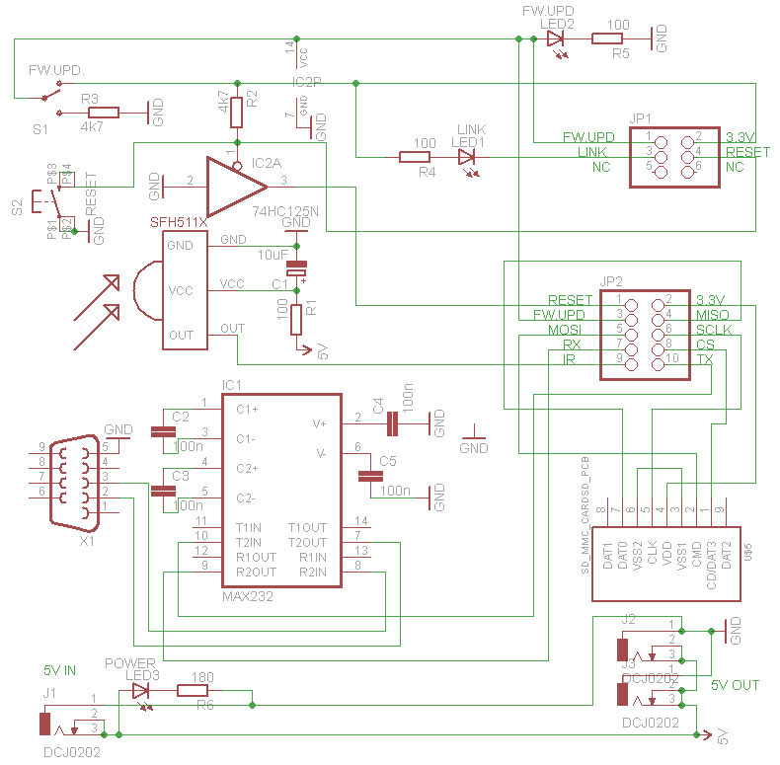
Figure 16 - connector board schematic
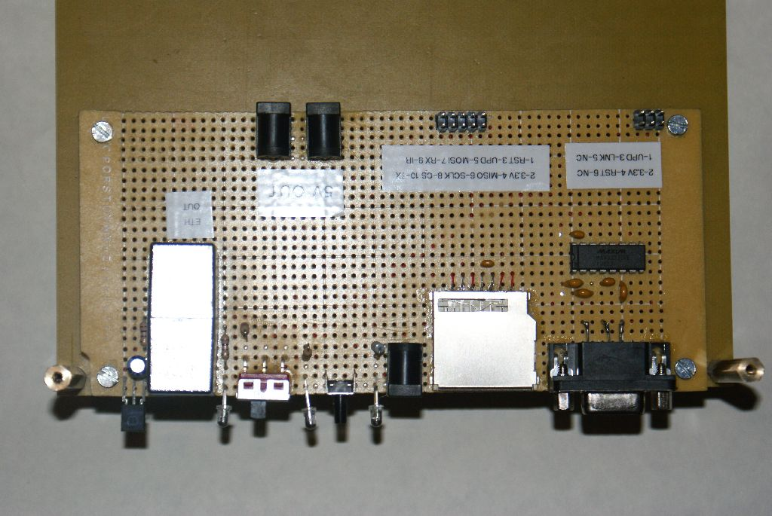
Figure 17 - The connector board
The schematic should be pretty clear. The serial interface (X1) uses a standard MAX3232 RS232 transceiver to convert RS232 voltage levels to 0-3.3V. A SFH5110-40 IR receiver is used to demodulate the signal from the IR remote. The SD card is connected directly to the STM32 CPU using a standard SD socket. The presence of power in the jack J1 is confirmed by LED3, and another two power jacks (J2 and J3) carry the power signals to the iMCU7100EVB board and the controller board. The switch S1 is used to put the iMCU7100EVB board in firmware update mode (LED2 lights up when this happens). JP1 is the header that connects the board to the iMCU7100EVB board, and JP2 is used to connect to the controller board.
The only thing that requires a bit more explanation is the 74HC125 three-state buffer. It is used to implement reset control in firmware update mode. Normally, the W7100 firmware is the one that controls the RESET line of the STM32 (it needs to do this in order to activate the STM32 bootloader and program the firmware via TFTP). However, when firmware update mode is selected, the W7100 firmware doesn’t run, but we need to reset the STM32 anyway, in order to activate the “null-modem cable” mode used for programming the W7100 firmware (see section 1.4.1 for details). The 74HC125 is powered directly from the firmware update line of the switch (thus it is powered only when the firmware update mode is active), and the RESET switch is used as an enable signal for one of the buffers inside the chip, which will send a logic 0 to the output of the buffer (connected to the RESET line of the STM32) when the reset switch is pressed. It doesn’t have any effect on the RESET line in “normal” (non firmware update) mode.

The controller board
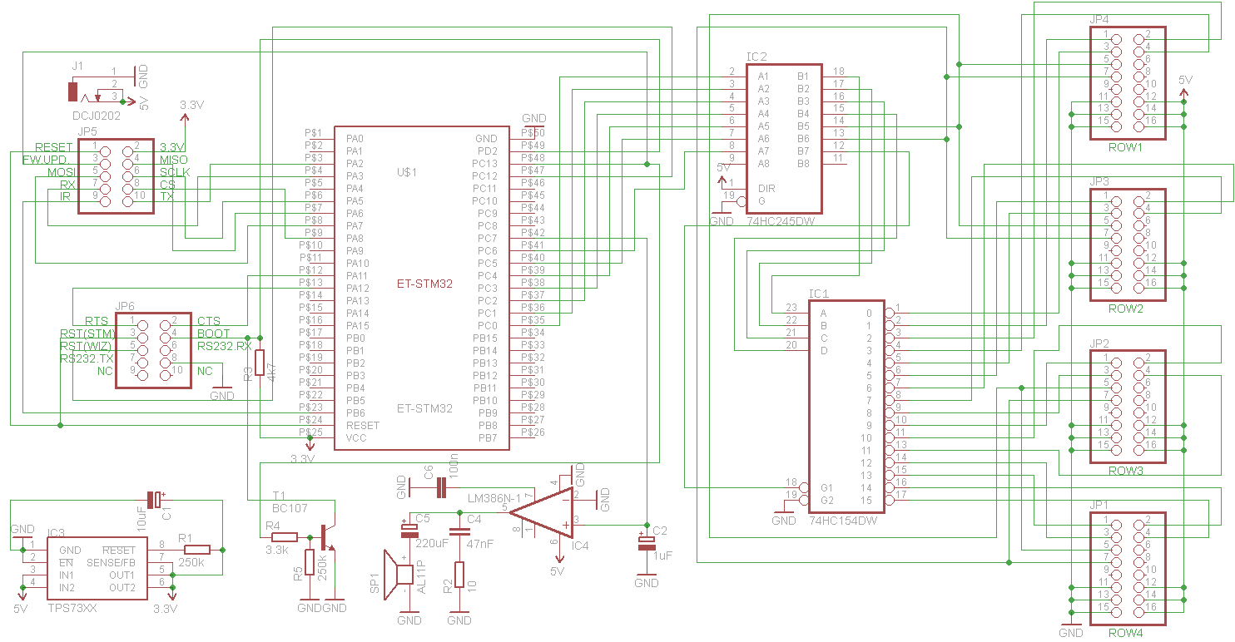
Figure 18 - controller board schematic
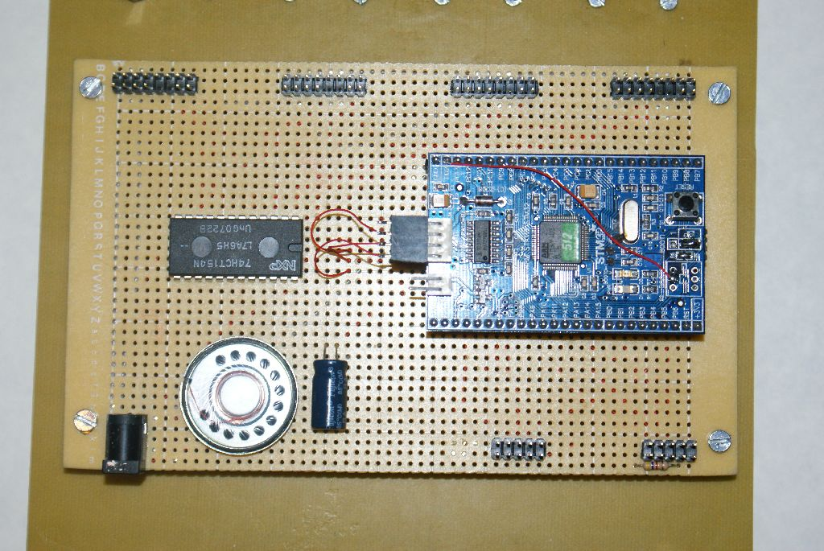
Figure 19 - The controller board
The controller board isn’t much more complex than the connector board. At the center of the controller is the ET-STM32 board from Futurlec. The JP1-JP4 headers are used to connect to the LED displays, using a simple glue logic layer which consists of a 74154 4-to-16 line decoder IC (used to activate the 16 chip select lines of the LED displays using only 4 microcontroller pins) and a 74245 octal bus transceiver IC (which buffers the 3.3V signals from the IC, transforming them into 5V signals (the LED displays use 5V logic), as some of them (the clock and data lines) have to travel a relatively long distance). A speaker is used to implement simple sound effects, and it’s driven directly by the STM32 by the means of a standard LM386 audio amplifier IC (plus its support circuitry). A TPS7333 LDO regulator converts the 5V input voltage to the 3.3V needed by the STM32 board. JP5 connects to the connector board (JP2 in Figure 16), and JP6 to the iMCU7100EVB board.
The BC107 transistor is here to make the CPU behave properly in the “null-modem cable” mode (see the previous paragraph for details). In regular mode, the W7100 controls the BOOT0 mode of the STM32, which selects between normal boot mode (logical 0) and bootloader mode (logical 1). In firmware update mode, the W7100 can’t control this line, so the BC107 takes over and forces the BOOT0 mode to 0, thus preventing the STM32 to enter bootloader mode.
The schematic of the STM32 board is in docs/schematics/STM32_SCH.pdf.

The iMCU7100EVB board
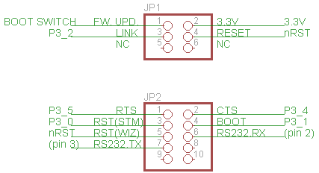
Figure 20 - iMCU7100EVB headers
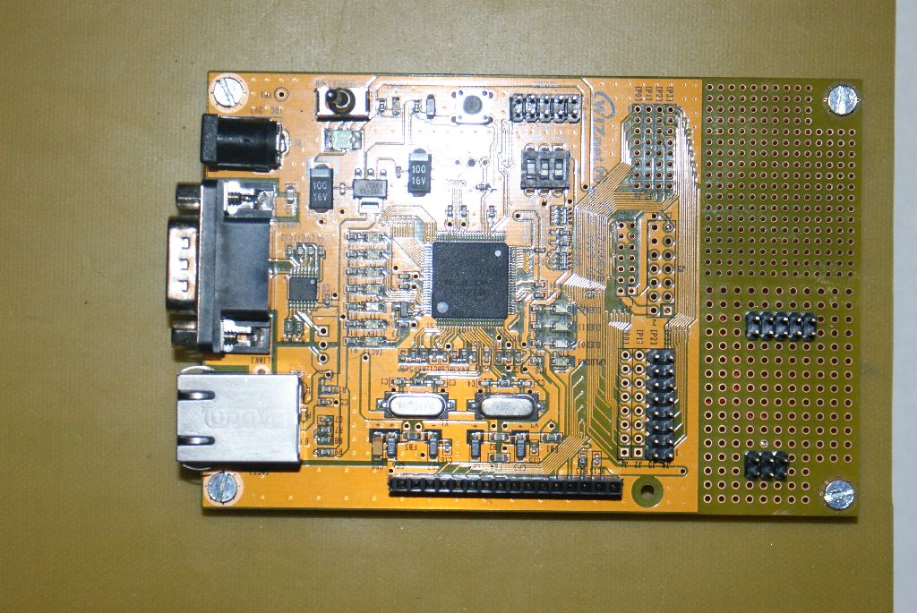
Figure 21 - The iMCU7100EVB
As already mentioned, Moonlight uses a standard iMCU7100EVB board with two modifications:
- The “boot” switch is removed from the board (it is replaced by the “firmware update” switch on the connector board)
- Two header connectors are soldered in the prototyping area of the iMCU7100EVB. Their connections are depicted above. JP1 connects to the connector board (JP1 in Figure 16), while JP2 connects to the controller board (JP6 in Figure 18). JP2 connects directly to the serial DB9 connector on the board, on pins 2 and 3 respectively.
More details about the actual meaning of the pins above will be given in the section dedicated to the software.
The schematic of the iMCU7100EVB is in doc/schematics/ iMCU7100EVB_SCH.pdf.

The display board
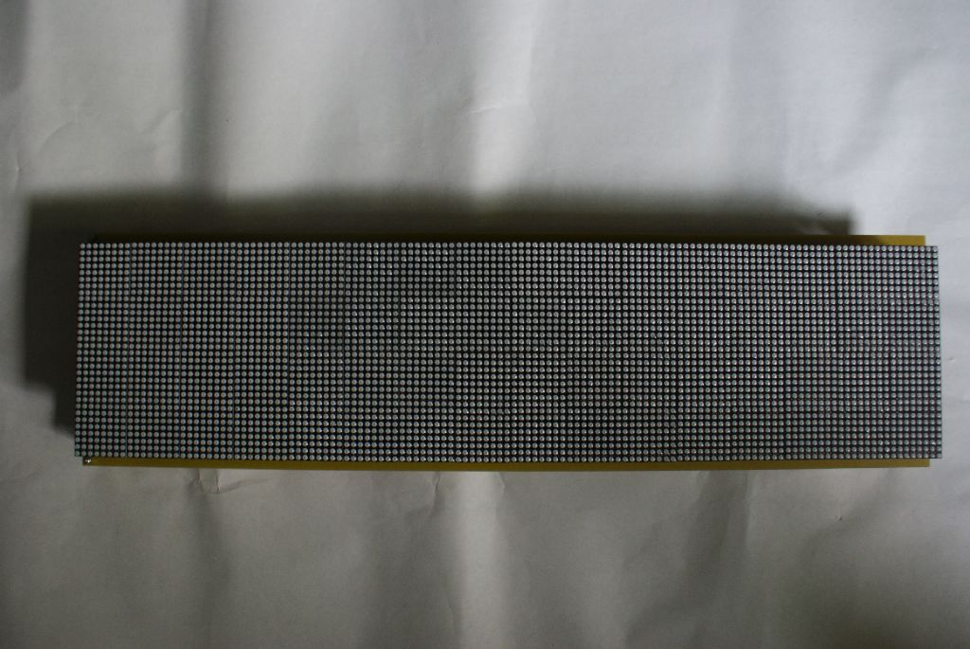
Figure 22 - The display board
The 128x32 LED display is made of 16 pieces of DP105 32x8 LED displays from Sure Electronics (http://www.sureelectronics.net/goods.php?id=903). These are intelligent displays, as each of them has a HT1632 LED matrix controller (http://www.holtek.com/chinese/docum/consumer/1632.htm), which makes driving these displays quite easy. However, while quite cost effective at $7.99 per piece, they do suffer from a lot of issues. One can easily notice visible differences in LED intensity from one display from another, and sometimes even on the same display. The effect is quite noticeable, although not too disturbing. Unfortunately this problem became apparent to me only after purchasing all the modules, otherwise I would’ve looked for different LED hardware. At the time of writing this document, Sure Electronics has a newer version of these displays, which might solve some of the issues mentioned here. However, Moonlight uses the previous version of the modules.
The datasheet of the DP105 module (doc/datasheet/dp105.pdf) includes a description of how 4 pieces of DP105 can be chained together by choosing the proper chip selects on the module back. Moonlight uses 4 lines of 4 modules chained together.
Also, the V-scores sides of the board are cut off to mount the displays next to each other, in order to get a continuous LED surface.

Software design
NOTE: the complete Moonlight firmware can be found in the firmware/ directory.
As already specified, Moonlight is a combination between two distinct firmwares: the W7100 firmware and the STM32 firmware. The overall software architecture is shown below.
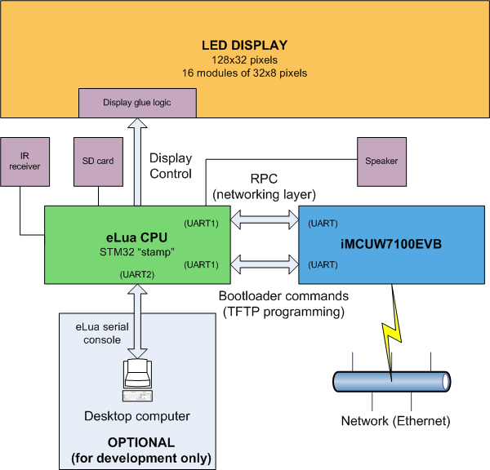
Figure 23 - Moonlight software architecture
The two CPU boards “talk” to each other via a single serial connection which has 3 distinct roles:
- In normal usage, the UART serves as a physical transport for the RPC mechanism that is used by the STM32 CPU to make network requests to the W7100 board (the full API will be presented in detail later). In this mode, the UART features hardware flow control (implemented in hardware on the STM32 side and emulated by software on the W7100 side).
- The UART is also used to program the firmware on the STM32. After starting the STM32 in bootloader mode (by manipulating its RESET and BOOT0 lines), the STM32 uses the UART to communicate with the STM32 bootloader. A simple TFTP programmer is all that’s needed to program the STM32.
- When updating the W7100 firmware (as described in 1.4.1), this UART is used to program the W7100. As it is already connected to the STM32, a small trick is used to make programming possible: the STM32 firmware has a special operation mode (a “null-modem cable” mode) that is activated when firmware update is requested via the dedicated switch (see 1.1). In this mode, the STM32’s only function is to connect two of its UARTs internally: the one that is connected to the W7100 (UART0) and the one that is exposed to the user, which is normally used to use Moonlight in interactive mode (UART1). In this way, it becomes possible to program the W7100 using the same UART as the one used for interactive mode.
The STM32 takes care of user interaction, peripheral control (LED displays, speaker, SD/MMC card, IR receiver) and runs the Lua programs written for Moonlight. In provides a separate UART that can be used to run Moonlight in interactive mode (see 1.3 for details).

RPC mechanism details
The RPC mechanism is in many aspects the “core” of Moonlight, as it enables two very different CPUs (an 8 bit network MCU and a much more powerful 32 bit general purpose MCU) to interface almost seamlessly. The STM32 calls functions that are implemented in the W7100 firmware as if they were local functions, which makes it very easy to implement networking functions through the application. As an added bonus, because the networking subsystem runs on the W7100, it can use the W7100 SRAM. Lua is a dynamic language, and it runs quite happily when there is enough RAM available. By moving most of the network buffers to the W7100 SRAM (which was mostly empty even after implementing all the firmware), we leave most of the STM32 SRAM to Lua and the applications, which is very helpful.
The idea behind the RPC implementation is quite simple: the client (the STM32 in this case) packs a function call into a “descriptor” that can be read at destination (the W7100 in this case), where a RPC server should run; the server will unpack it and run it at the destination, sending back any results needed by the client. While XML or other human readable format is preferred by desktop applications for RPC tasks, we’re dealing with embedded systems with very limited memory capabilities, so we pack and unpack everything binary.
The core of the RPC core is in firmware/eLua/src/eluarpc.c. Notably, because this file implements all the low level functions related to the RPC layer, it is included in both firmwares (W7100 and STM32), which is not a problem because it is written in a portable manner. It has functions that handle RPC packet encoding and decoding at the lowest (binary) level. It exports two variable arguments functions (printf-like) that can pack and unpack a RPC packet. Their signature is given below for reference:

// Generic write function
// Specifiers: o - operation
// r - response
// c - u8
// h - u16
// l - u32
// i - int
// L - s32
// p - ptr (given as ptr, len, len is an u32)
// P - ptr (given as ptr, len, len is an u16)
void eluarpc_gen_write( u8 *p, const char *fmt, ... );

// Generic read function
// Specifiers: o - operation
// r - response
// c - u8
// h - u16
// l - u32
// L - s32
// i - int
// p - ptr (returned as ptr, len, len is an u32)
// P - ptr (returned as ptr, len, len is an u16)
// Returns ELUARPC_OK or ELUARPC_ERR
int eluarpc_gen_read( const u8 *p, const char *fmt, ... )

Using these two functions, it becomes very easy to implement both RPC clients and servers. In this particular case, the source file that implements the actual RPC requests of network functions is in firmware/eLua/src/wiznet/wiznet.c. It implements all the network functions requests (and responses) used in the application. Consequently, it is also part of both firmware (STM32 and W7100). For each network function, it implements a function that sends a request, a function that reads a response (which are used only by client), a function that reads a request and a function that sends a response (which are used only by the server). For example, this is how the “sendto” function is handled in wiznet.c:

// *****************************************************************************
// Operation: sendto
// sendto: u16 sendto( u8 sockno, u32 dest, u16 port, const void *buf, u16 count, u16 timeout )

void wiznet_sendto_write_response( u8 *p, u16 result )
{
eluarpc_gen_write( p, "rh", ( int )WIZ_OP_SENDTO, result );
}

int wiznet_sendto_read_response( const u8 *p, u16 *presult )
{
return eluarpc_gen_read( p, "rh", ( int )WIZ_OP_SENDTO, presult );
}

void wiznet_sendto_write_request( u8 *p, u8 sockno, u32 dest, u16 port, const void *buf, u16 count, u16 timeout )
{
eluarpc_gen_write( p, "oclhPh", ( int )WIZ_OP_SENDTO, sockno, dest, port, buf, count, timeout );
}

int wiznet_sendto_read_request( const u8 *p, u8 *psockno, u32 *pdest, u16 *pport, const void **pbuf, u16 *pcount, u16 *ptimeout )
{
return eluarpc_gen_read( p, "oclhPh", ( int )WIZ_OP_SENDTO, psockno, pdest, pport, pbuf, pcount, ptimeout );
}

Note the use of eluarpc_gen_read and eluarpc_gen_write in all the four function. Any RPC function can be written like this very quickly.
Both the client and the server use a fixed size buffer to read and write RPC packets. For requests that are longer than the packet size (for example reads and writes), the request is repeated until all the data is read or written.
For more information about the RPC server, check section 3.2.2. The RPC client is presented in section 3.3.2.

The W7100 firmware
NOTE: the W7100 firmware can be found in the firmware/w7100 directory.
The W7100 uses the base code from Dave Tweed’s article on the W7100 chip published on Circuit Cellar (http://www.circuitcellar.com/archives/viewable/233-Tweed/2.html), as long as some application notes from WIZnet, plus a lot of code that implements RPC, STM32 boot loader, HTTP server with authentication and others. Some files from the source tree are briefly presented below, while the main components have dedicated sections:
- datamem.c: access to the W7100 data memory, in read/write mode.
- dhcp_app.c: adapted from WIZnet DHCP application note, with some modifications needed to make it functional (as the original application note implementation had some errors).
- dns.c: the DNS client, also adapted from the WIZnet DNS application note.
- ping.c: the ping client, adapted from the WIZnet ICMP application note.
- serial.c: an interrupt driven UART driver, with emulated parity mode (required to program the STM32, which serial bootloader needs even parity) and emulated hardware flow control. They are dedicated to difference
- settings.c: handles application settings (network and authentication data)
- vtmr.c: virtual timers implemented on top of the W7100 timer 0. They are used by different parts of the application (DHCP, network timeouts, UART timeouts), as the W7100 doesn’t have enough hardware timers for this application.
- main.c: firmware entry point. It initializes all the system components, then runs (in an infinite loop) the TFTP server, the RPC server and the HTTP server.

The TFTP bootloader: stm32ld.c and tftp.c
TFTP is quite a simple and popular protocol and an easy challenge for the W7100, thus it was chosen as the means to program the STM32. The TFTP server code (tftp.c) is implemented directly from the TFTP RFC (RFC 1350, http://www.faqs.org/rfcs/rfc1350.html). The challenge here was that the W7100 has only 64k of RAM, and the STM32 has a 512k Flash, so obviously it wasn’t possible to read the whole firmware from TFTP and then send it to the STM32. Fortunately, both protocols work in blocks: TFTP uses 512 byte data blocks, while the STM32 bootloader uses 256 byte data blocks. So, when the TFTP server receives a data block, it sends two write requests to the STM32 bootloader, and then acknowledges the data block. When the TFTP session is initiated, the W7100 puts the STM32 into bootloader mode (by pulling up the BOOT0 line and resetting the chip), then connects to the bootloader on the device. Once the updating process is complete, the W7100 resets itself using the watchdog, then resets the STM32 as part of its initialization sequence, so the STM32 starts with the new firmware. Please note that the TFTP server supports only writes, not reads (to protect the STM32 firmware).
The bootloader (stm32ld.c) is a very portable source code (it runs almost unmodified on the desktop) implemented from the ST application note that describes the bootloader UART protocol of STM32 (AN3155, http://www.st.com/stonline/products/literature/anp/17066.pdf).

The RPC server and the web configuration interface
The W7100 network RPC server is implemented in wizs.c. It exports the wizs_execute_request (called from main.c) which reads a request, executes it and then sends back the response:

// List of server request handlers
static const p_server_handler server_handlers[] =
{
server_socket, server_write, server_read, server_sendto,
server_recvfrom, server_lookup, server_ping, server_close,
server_connect, server_http_request, server_app_init,
server_app_set_page, server_app_set_arg, server_app_get_cgi,
server_app_end_page
};

void wizs_execute_request()
{
if( read_request_packet() )
if( server_execute_request() )
send_response_packet();
}

The server_execute_request function simply looks up the function in a table of server functions and then executes it:
All the functions exported by the server are declared in the server_handlers array. It contains basic network functions (socket, close, send, recv, sendto, recvfrom, connect) and more advanced operations (ping, lookup, and a HTTP client). An example is given below for the sendto function (all the server functions follow the same pattern):

static int server_sendto()
{
u8 sockno;
u32 dest;
const void *buf;
u16 count, port, timeout;
u8 ip[ 4 ];

// Validate request
if( wiznet_sendto_read_request( wiz_buffer, &sockno, &dest, &port, &buf, &count, &timeout ) == ELUARPC_ERR )
return 0;
sockno += WIZ_FIRST_APP_SOCKET;

// Execute request
server_u32_to_ip( dest, ip );
count = sendto( sockno, ( const uint8* )buf, count, ip, port, timeout );

// Send back response
wiznet_sendto_write_response( wiz_buffer, count );
return 1;
}

A somewhat uncommon API is used to handle the application web configuration interface. The idea behind this is that any Moonlight application (thus running on the STM32) can be configured via a web interface. First, the application presents its own configuration web page, by using server_app_init (called with the application name), then calling server_app_set_page until all the HTML page data (which is the application web interface) is sent to the W7100. The configuration web page is actually a template, which contains both valid HTTP code, but also placeholders for parameters (in the format $xx$ where xx is a parameter number) that are substituted by actual parameters. The client uses server_app_set_arg for each argument that must be substituted. For example, see below the HTML page of the clock application:

<html>
<head>
<meta http-equiv="content-type" content="text/html; charset=windows-1250">
<title>Network clock running on Moonlight</title>
</head>
<body>
<h4>Clock configuration</h4>
<form action="app.cgi" name="form1" method="post">
<table border = "1" cellpadding="4" cellspacing="0 width="200">
<tr>
<td width="80">NIST server</td>
<td width="120"><input name="server" type="text" size="20" value="$00$"></td>
</tr>
<tr>
<td>GMT delta</td>
<td><input name="delta" type="text" size="20" value="$01$"></td>
</tr>
</table><br />
<table border="0" cellpadding="1" cellspacing="1">
<tr>
<td width="100" align="center"><input type="submit" value="Update"></td>
<td width="100" align="center"><input type="button" value="Back" onClick="history.go(-1)"></td>
</tr>
</table>
</form>
</body>
</html>

Highlighted in red above are two parameters that need substitution: the NIST server IP is parameter 0 and the GMT delta is parameter 1. In this case, the STM32 needs to call server_app_set_arg with the server IP for the first time, and then with the GMT delta value.
Once the complete HTML page and all the parameters are sent, server_app_end_page must be called, which signals the W7100 that the application web interface setup is complete.
An interesting situation occurs after the application sets its configuration interface, then the user modifies the application parameters and then presses the “Update” button in the browser. At this point a CGI request is initiated, which is processed by the HTTP server running on the W7100 (see next section). However, this process is completely asynchronous. The W7100 doesn’t have any way to know about the state of the application running on the STM32, and thus no way to signal to it that new configuration data is available. The application could continuously poll the W7100 for the new configuration data, but this seems to be overkill for such a simple task, as the RPC mechanism obviously adds some processing overhead. Then again, the only way the W7100 has to communicate with the STM32 is via the serial interface, which is already assigned to handle RPC packets.
There are more possible solutions to this problem. The first one, which was originally implemented, was to signal the presence of CGI data to the STM32 using an I/O pin. However, this led to some hard to diagnose synchronization problems, so in the end another solution was chosen. The current solution uses character escaping: a “magic” character (WIZ_HAS_CGI_CHAR) is used to signal to the STM32 board that configuration data (which is CGI data, hence the symbolic name of the character) is available. When this character is part of the regular RPC data stream, it is escaped by another “magic” character (WIZ_ESC_CHAR). Sending a character is quite easy:

static void wiz_ser_write_byte( u8 d )
{
if( d == WIZ_ESC_CHAR || d == WIZ_HAS_CGI_CHAR )
{
ser_write_byte( WIZ_ESC_CHAR );
ser_write_byte( d ^ WIZ_ESC_MASK );
}
else
ser_write_byte( d );
}

Receiving a character is also easy (this code is from serial.c):

void serial_interrupt_handler() interrupt 4 using 2
{
// Check RX
if( RI )
{
RI = 0;
ser_c = SBUF;
ser_enqueue_char = 1;
if( ser_mode == SER_MODE_RPC )
{
if( ser_had_escape )
{
ser_had_escape = 0;
ser_c = ser_c ^ WIZ_ESC_MASK;
}
else if( ser_c == WIZ_ESC_CHAR )
{
ser_had_escape = 1;
ser_enqueue_char = 0;
}
else if( ser_c == WIZ_EREQ_CHAR )
{
ser_num_rpc_requests ++;
ser_enqueue_char = 0;
}
}
if( ser_enqueue_char )
{
ser_rx_buf[ ser_rx_w_idx ] = ser_c;
ser_rx_w_idx = ( ser_rx_w_idx + 1 ) & SER_RX_BUF_MASK;
}
}

if( TI )
{
TI = 0;
ser_tx_in_progress = 0;
}
}

(of course, this code is duplicated on the STM32 side, which must also handle character escaping over UART).
This solves two problems:
- The STM32 doesn’t have to poll the W7100 anymore. When the interrupt driver UART receive handler inside STM32 receives WIZ_HAS_CGI_CHAR, it sets an internal flag which is available to the application at any time. This is much more efficient.
- Everything (RPC and CGI data indication) goes over the same physical channel, which makes it self-synchronizing. As already specified, trying to send the CGI information over another channel (a PIO pin) led to some very hard to find synchronization problems.
Once the STM32 knows that it has CGI data, it can request the actual data by repeatedly calling server_app_get_cgi until no more CGI data is available.

The HTTP server: httpd.c
The W7100 runs a HTTP server that has two roles:
- web configuration interface. This is used to change the operation parameters of the W7100 (network configuration and authentication data).
- web application interface. This provides the means for any application running on Moonlight to expose a web configuration interface and to read back user data via a CGI mechanism. See the previous sections for details.
The HTTP server has the following capabilities:
- authentication support (basic HTTP authentication)
- GET and POST support for CGI support
- HTTP parameter substitution (see the previous section for details)
- CGI parameter parsing
The main function of the HTTP server is httpd_run, which implements a small state machine over the socket dedicated to the HTTP server. The actual processing happens inside httpd_read_parse, which reads the HTTP request (here, the fact that W7100 has generous amounts of RAM really helps) and then parses the header, line by line, looking at the GET line (to identify the actual request), then at the “Authorization: Basic” line (which contains BASE64 encoded authentication data), and also differentiating from GET and POST CGI requests. There are also functions for sending standard HTTP responses (OK, not found, authentication error, redirection), for CGI decoding, for HTTP parameter substitution (both for the application configuration interface and the Moonlight web interface itself). The code isn’t short, but it’s still quite easy to follow.

The STM32 (eLua) firmware
NOTE: the STM32 firmware can be found it the firmware/eLua directory.
As the STM32 firmware is based on eLua, a complete description is out of the scope of this document. There is an entire web page dedicated to eLua (http://www.eluaproject.net) that can be consulted to find out about eLua implementation details. In this section, only the parts that are relevant to Moonlight will be detailed.

The RFS file system and the serial multiplexer
The RFS (Remote File System) is a new feature of eLua, and an extremely important one, as it simplifies application development significantly. As already mentioned in section 1.7, the idea of RFS came before Moonlight, but the main design and actual implementation happened while developing Moonlight, so it can be regarded as a part of it. This is why it will be presented here.
Before RFS, there were a few ways to run and test applications on eLua:
- Write them directly at the prompt of the Lua interpreter built in eLua. This works fine, but the method doesn’t scale well for large applications. Plus, it is very hard or even impossible to save the code of the application once it is written, as the Lua interpreter doesn’t offer this feature.
- Write them on the PC, then made them a part of the eLua ROM file system. This requires reprogramming the eLua firmware anytime the application is modified, which makes it practically unusable.
- Write them on the PC, then send them to the eLua board using XMODEM. Much better than 2 above, but still quite inconvenient when it is repeated many times.
- Write them on a SD card, then put the SD card on the eLua SD socket and run them directly from the SD card. It suffers from the same problem as 3 above: it’s inconvenient to use for actual development, when the application will most likely require many changes before working properly, and moving the SD between the eLua board and the PC can easily become irritating.
RFS aims to change all this by implementing a simple “directory sharing” feature in eLua. A server application that runs on the PC (the RFS server) effectively makes a directory on the PC available directly to eLua. The code (both Lua and C) running on the eLua board can access a file from the PC just as it would access a local file, but the file is actually stored on the PC side. With this, the development scenario is extremely simplified:
- Write the code on the PC, making sure that the file with the source code is saved in the directory shared with the eLua board
- Test the code simply by running lua /rfs/progname.lua at the eLua shell prompt
- When the application code is finished, simply copy it to the SD card using the cp (copy) command built in eLua. The application is available on the SD persistent storage from now on, and can be executed directly from there.
After reading section 3.1, it should come as no surprise that the RFS implementation uses exactly the same RPC mechanism as the network layer. It was mentioned before that the RPC is flexible enough to easily implement any kind of remote application, and this is the best proof. The RFS code uses the same src/eluarpc.c code used by the network functions as the base RPC implementation. On top of it, src/remotefs/remotefs.c implements file I/O function requests. For example, this is how a read request looks like:

// *****************************************************************************
// Operation: read
// read: ssize_t read( int fd, void *buf, size_t count )

void remotefs_read_write_response( u8 *p, u32 readbytes )
{
eluarpc_gen_write( p, "rp", RFS_OP_READ, NULL, readbytes );
}

int remotefs_read_read_response( const u8 *p, const u8 **ppdata, u32 *preadbytes )
{
return eluarpc_gen_read( p, "rp", RFS_OP_READ, ppdata, preadbytes );
}

void remotefs_read_write_request( u8 *p, int fd, u32 count )
{
eluarpc_gen_write( p, "oil", RFS_OP_READ, fd, count );
}

int remotefs_read_read_request( const u8 *p, int *pfd, u32 *pcount )
{
return eluarpc_gen_read( p, "oil", RFS_OP_READ, pfd, pcount );
}

Once again, it can be easily observed that all these functions can be easily implemented in terms of eluarpc_gen_read and eluarpc_gen_write, just as it was the case with the network functions.
The RFS implementation on the eLua side also contains the RPC client, which is the piece of code (written using the functions exported by remotefs.c) that actually implements the I/O functions in terms of RPC packets. It builds a RPC request packet, asks the RPC layer to send the RPC request and read the RPC response, then decodes the RPC response packet. As an example, the implementation of read is given below:

s32 rfsc_read( int fd, void *buf, u32 count )
{
const u8 *resbuf;

// Make the request
remotefs_read_write_request( rfsc_buffer, fd, count );

// Send the request / get the response
if( rfsch_send_request_read_response() == CLIENT_ERR )
return -1;

// Interpret the response
if( remotefs_read_read_response( rfsc_buffer, &resbuf, &count ) == ELUARPC_ERR )
return -1;
memcpy( buf, resbuf, count );
return ( s32 )count;
}

All the functions from the RFS RPC client follow the same pattern.
The last piece of code used by RFS on the eLua board is src/remotefs/elua_rfs.c, which is used to integrate the RFS into the eLua device manager (src/newlib/devman.c). As this is part of the low-level eLua architecture, I won’t go into more details. In short, the device manager implements something similar to the Linux file system architecture (based on mount, but obviously much simplified) that can be used to “plug” any file system that exposes a number of basic functions (such as open, read, write, close, seek and others).
The other part of the RFS implementation is the RFS server. It resides in rfs_server/ and it is the part that runs on the PC, allowing for the actual directory sharing. It comes it two flavors: as a command line application and as a GUI interface. The GUI interface (muxfe.exe) is much easier to use, as it integrates another part of the eLua that was only briefly mentioned so far: the serial multiplexer (the sources are in mux/).
Developed as part of the RFS implementation, the serial multiplexer comes as a solution to the physical transport needs of the different components in eLua. eLua has parts that need to be connected to a desktop computer. The most obvious is the serial console, which connects to the PC using an UART. The RFS server also uses an UART as its physical transport. eLua RPC (another RPC mechanism present in eLua that works directly at Lua level and won’t be covered in this document) works over UART too. As eLua grows, it’s very likely that more and more components will require a PC connection. Obviously, it is extremely impractical to use 2 or more serial connections from an eLua board to the PC.
The solution to this problem is called “UART multiplexing” and the idea behind it is very simple: character escaping. The mechanism is similar to the one presented in section 3.2.2. It is based on escaping some “magic characters” that have special meaning in the serial stream. In short, both the PC and the eLua board know how to handle “virtual UARTs”, which are logical UART interfaces associated with a predefined range of numerical identifiers (IDs). When an UART based component (console or RFS server, for example) on either side wants to send data, it sends first the virtual UART ID as a “magic character”, and then the actual data. If another component needs to send data over another virtual UART, it sends the ID of its virtual UART, then the actual data, and so on. As long as both sides know how to handle virtual UARTs, this mechanism can be used to implement any number of virtual interfaces that share the same physical connection. They are obviously limited by the bandwidth of that unique physical connection, but in many practical situations this is perfectly fine.
The muxfe (MUltipleXer Front End) application mentioned earlier packs the serial multiplexer code and the RFS server code in a nice interface. You just need to start it, specify the directory you want to share, as well as the physical UART port and the speed (115200 in this case), and then hit “Start server”. You’ll have the RFS server running in background, and the eLua console will appear in the lower part of the muxfe window.

The network RPC client
In section 3.2.2, the RPC server part of the network layer was examined. Now it’s the time to meet its counterpart, the RPC client. Just like the RFS subsystem above, the RPC client implements the actual networking functions on the STM32 side in terms of RPC calls. Its implementation can be found in src/wiznet/wizc.c. The implementation of sendto is given below as an example:

s16 wizc_sendto( u8 sockno, u32 dest, u16 port, const void *buf, u16 count, u16 timeout )
{
// Make the request
wiznet_sendto_write_request( wizc_buffer, sockno, dest, port, buf, count, timeout );

// Send the request / get the response
if( wizch_send_request_read_response() == WIZC_ERR )
return -1;

// Interpret the response
if( wiznet_sendto_read_response( wizc_buffer, &count) == ELUARPC_ERR )
return -1;

return ( s16 )count;
}

It follows the same general pattern: make RPC request, send it and wait for the response, read and interpret the response.
The network RPC client (wizc.c) exports only a C interface. The programs written for Moonlight, however, are Lua programs, and they obviously need access to the network functions too. The connection between the C functions and Lua is implemented in a C module for Lua (modules/wiz.c). Its API will be discussed in details in the chapter dedicated to the Moonlight user API (section 3.4.1).

The display driver
Although the DP105 LED modules used by Moonlight already include a controller, implementing something that resembles a GUI API is a completely different story, especially for someone without practical experience in this area. Some features of the display driver:
- Different video memory write modes (regular, AND, OR, XOR)
- Viewport support
- “Dirty rectangle” based implementation that updates only the part of the display that needs to be updated (this is implemented at module level, not pixel level), thus increasing speed
- Text output with configurable fonts (fonts can also be loaded from a file)
- Bitmap output (bitmaps can be loaded from a file)
- Graphic primitives: put pixel, get pixel, line, rectangle, filled rectangle, circle
The low level driver, as well as the GUI functions and the Lua module that exposes the API to Lua code are implemented in src/platform/dp105.c. The first part of the file deals with low level interfacing LED module interfacing. The LED controller follows a simple protocol with a clock line and a data line (somewhat similar to SPI, but not compatible with SPI) which is fully described in the LED module datasheet (doc/datasheet/dp105.pdf). For convenience, the waveforms are also shown below:

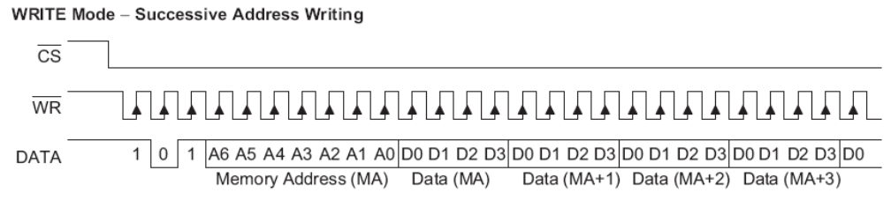
Figure 24 - Write mode waveforms for DP105
Sending bits is implemented via bit-banging in the low level part of the driver:

void drv_to_disp( u32 n, int bits )
{
for( ; bits; bits --, n >>= 1 )
{
BB_CLOCK = 0;
BB_DATA = n & 1;
BB_CLOCK = 1;
}
}

The function that sends actual data to the module is implemented according to the above diagram:

// Send data to display
static void drv_disp_send_data( int dispno )
{
unsigned i;
const u32* pdata = DISP_VMEM_PTR( vmem, dispno );

drv_disp_select( dispno, DISP_SELECT );
// Send "101b" (write command)
drv_to_disp( 5, 3 );
// Send address 0 (7 bits)
drv_to_disp( 0, 7 );
// Send all data
for( i = 0; i < VMEM_SIZE_PER_DISP; i ++ )
drv_to_disp( *pdata ++, 32 );
drv_disp_select( dispno, DISP_UNSELECT );
}

Other functions of the low level driver include initialization (drv_disp_setup), selection of a certain module (drv_disp_select) and setting the intensity of the LED light (currently this happens only for a whole line at a time).
Note that in order to improve the speed of the display driver, the video memory is mirrored locally in the driver (see the vmem variable). This way, read operations (needed for getpixel or various memory write modes) are much faster than issuing a “get pixel” command to the LED display. Also, write operations have vmem as the destination. The data in vmem is sent to the actual displays by the drv_disp_send_data function shown above.
The implementation of the GUI API comes right after the low level driver. The fundamental function here is disp_putpixel, which looks a bit too complex for a “put pixel” function. This happens because it has to take into account the currently defined viewport and the write mode:

// Put a pixel at the given location with the specified write mode
// (taking into account the viewport if one is specified)
static void disp_putpixel( int x, int y, int col, int mode )
{
if( x < 0 || x >= SIZEX || y < 0 || y >= SIZEY )
return;
if( disp_vp_mode != DISP_VP_NONE )
{
if( disp_vp_mode == DISP_VP_NORMAL && ( x < disp_vp_left || x > disp_vp_right || y < disp_vp_top || y > disp_vp_bottom ) )
return;
if( disp_vp_mode == DISP_VP_INVERTED && ( x >= disp_vp_left && x <= disp_vp_right && y >= disp_vp_top && y <= disp_vp_bottom ) )
return;
}
u32 idx, mask, prevv;
int disp_idx = SCR_XY_TO_DISP_VMEM_IDX( x, y );
u32 *localmem = DISP_VMEM_PTR( vmem, disp_idx );
int pcol;

x = SCR_X_TO_DISP_X( x );
y = SCR_Y_TO_DISP_Y( y );
idx = DISP_X_TO_ARR_IDX( x );
mask = 1 << DISP_XY_TO_MASK( x, y );
prevv = localmem[ idx ];
pcol = ( prevv & mask ) ? PIXEL_ON : PIXEL_OFF;
if( mode != DISP_WRITE_OVERWRITE )
{
switch( mode )
{
case DISP_WRITE_OR:
col = pcol | col;
break;
case DISP_WRITE_AND:
col = pcol & col;
break;
case DISP_WRITE_XOR:
col = pcol ^ col;
break;
}
}
if( pcol != col )
{
if( col == PIXEL_ON )
localmem[ idx ] = prevv | mask;
else
localmem[ idx ] = prevv & ~mask;
disp_mod_mask |= 1 << disp_idx;
}
}

As can be seen above, disp_putpixel also updates the disp_mod_mask global variable. This is a very simple implementation of the “dirty rectangle” concept in a GUI. All the graphical functions write video data locally, as previously explained. To send data to the display, one must explicitly call disp_draw:

// End draw
static void disp_draw()
{
unsigned i;

// Check for changes, update only the changed displays
for( i = 0; i < NUM_TOTAL_DISPLAYS; i ++ )
if( disp_mod_mask & ( 1 << i ) )
drv_disp_send_data( i );
disp_mod_mask = 0;
}

As can be seen above, disp_draw will only refresh the displays that have a 1 in the corresponding bit of disp_mod_mask. This is an important optimization, as most of the time only small parts of the display are changing.
The rest of the functions are quite easy to understand. There is a Bresenham line algorithm implementation (disp_line), a Bresenham circle implementation (disp_circle), a text output function that supports fonts in a proprietary format (disp_putstr) and a bitmap drawing function that uses bitmaps also in a proprietary format (disp_draw_bitmap), plus some utility functions.
The last part of the code implements the Lua display module. Its API will be presented in section 3.4.2.

The remote control decoder
The remote control decoder (src/platform/stm32/sircs.c) is a fairly simple piece of code, yet it is presented in a separate section as it is the only means of interacting with Moonlight. It uses one of the very powerful timers of the STM32 CPU in input capture mode and a PIO pin in interrupt-on-change mode, measuring the pulse lengths to differentiate between ones and zeroes received from the remote. The protocol itself is quite easy (http://www.sbprojects.com/knowledge/ir/sirc.htm), and the fact that the SFH5110-40 IR receiver is designed for the exact same modulation frequency as the one used by the SIRC protocol ensures a very good reception. The implementation is fully asynchronous, build around a simple state machine that mimics the IR protocol structure:
enum
{
DECODER_STATE_WAIT_START,
DECODER_STATE_IN_START_1,
DECODER_STATE_IN_START_0,
DECODER_STATE_DECODING,
DECODER_STATE_SPACE
};

Also, the decoder has a queue which is uses to save remote control codes as they are received, which ensures that no keys are lost in practical usage scenarios. As a special feature, it lets the user reset the system by pressing the REPEAT key on the remote control twice. As the decoder is completely asynchronous, it’s unlikely that it will be blocked even if the application code is stuck because of an exception condition (for example waiting for network data), so the user can simply reset the system by pressing REPEAT twice.
The IR module is mirrored by a Lua module which exposes the IR API to the application code. The API is presented in detail in section 3.4.3.

The Moonlight API
Moonlight is a platform for developing applications, so it needs a good API to do that. eLua’s own API (check “Reference manual” on http://www.eluaproject.net) is already a good start for that. This section will present only the APIs that were added especially to make Moonlight a versatile development platform.

The networking API
The network API (firmware/eLua/src/modules/wiz.c) is the central API of Moonlight, as it contains all the networking related functions. It has as “regular” API, as well as a special API that is optimized for devices with high resource constraints (which is the case for both the W7100 and the STM32).
The regular API is quite easy to follow, as it follows the well known conventions of the POSIX API. One very important addition is that all the calls that could be blocking have an optional timeout parameter, making it very easy to implement non-blocking code. The timeout can be wiz.NO_TIMEOUT (which means non-blocking operation), wiz.INF_TIMEOUT (which means blocking operation) or any number between 1 and 65535 which specifies an actual timeout (in milliseconds) for the operation. If not specified, the default value for the timeout parameter is wiz.INF_TIMETOUT (blocking operation). The API is summarized in the table below:

Function | Role
ip=wiz.ip(ip1,ip2,ip3,ip4) or  ip=wiz.ip(“ip1.ip2.ip3.ip4”) | Converts an IPv4 address (given as components or as a string) into an internal represenatation
ip1,ip2,ip3,ip4=wiz.unpackip(ip,“*n”) or  str=wiz.unpackip(ip, “*s”) | Converts the internal representation of an IPv4 address into separate components, or into a astring
s=wiz.socket(type, [port]) | Creates a socket of the given type (which can be either wiz.SOCK_TCP or wiz.SOCK_UDP) and returns its identifier. Optionally, it associates a port with the socket.
status=wiz.close(s) | Closes the given socket s, returns the operation status
sent=wiz.sendto(s, ip, port, arg, [to]) | Sends arg (which can be either a string or a number between 0 and 255) over the UDP socket s, using ip and port as the destination. to is an optional timeout argument. Returns the number of bytes actually sent.
recvd,host,port=wiz.recvfrom(s,size,[to]) | Receives at most size bytes from socket s. to is an optional timeout argument. Returns the number of bytes actually received, as well as the originating host IP and port.
res=wiz.connect(s,host,port) | Connects the TCP socket s to host/port. Returns the operation status.
recvd=wiz.recv(s,size,[to]) | Received up to size bytes from the connected TCP socket s. to is an optional timeout argument. Returns the number of bytes actually received.
sent=wiz.send(s,a1,[a2],…,[an]) | Sends the given argument(s) a1 to an (only a1 is required) over the connected TCP socket s. The arguments can be either strings or numbers between 0 and 255. Returns the number of bytes actually sent.

Besides the basic network API presented above, the module provides functions that acess higher level network services (note that these functions are also implemented on the W7100 and thus accessed with RPC, they are not implemented on the STM32):

Function | Role
ip=wiz.lookup(“hostname”, [to]) | Makes a DNS query for hostname, returning an internal representation of the host IP address. to is an optional timeout argument.
replies=wiz.ping(ip,count,[to]) | Sends ping (ICMP echo requests) to the given ip for count times, returning the number of times that the host sent back an ICMP reply. to is an optional timeout argument.
status=wiz.http_request(s,url,[to]) | Makes a HTTP request to the given URL. to is an optional timeout argument. Returns the operation status. Once the request was made, all the data (including the HTTP headers) can be obtained using simple wiz.recv calls. The HTTP client implementation can be found in firmware/W7100/wizs.c.

Another part of the network API has to do with the application web configuration interrface, which was described in section 3.2.2. The corresponding API is given below.

Function | Role
res=wiz.app_web_set(name,page,[args]) | Send the application web interface to the W7100. name is the name of the application, page is the actual HTML page template (given either as a string or as a Lua file). If the page needs argument substitution, args is a Lua array with the arguments that will be substituted. Returns the status of the operation.
res=wiz.app_web_unload() | Signals the W7100 that the application isn’t running anymore (thus the configuration interface must be unloaded). Returns the status of the operation.
res=wiz.app_has_cgi() | Returns true if the application has CGI (configuration) data that it can read from the web interface, false otherwise.
t=wiz.app_get_cgi() | Returns a table with all the CGI data of the application, or nil if no CGI data is available or another error has occurred.
Finally, we come to the part of the API that is highly optimized for devices with small constraints. The idea behind this API (which I call the “expect API”) is fairly simple: most of the time, when reading data from the network (for example from an web server) we are only interested in small parts of the data we receive. For example, when reading a HTML page, we’re rarely interested in the HTML document structure itself (tags, scripts and others), we care only about the content more often than not. Still, the usual approach is to read everything, then parse the document and keep only what’s needed. This might be perfectly fine for a desktop machine with at least 1G of RAM, but not as good for a MCU with 64k of memory.
To solve this issue, the expect API implements a pattern driven approach which assumes a prior knowledge of the logical structure of the data that is processed. If we know how the document looks like, we know what we need from it and what to get it. This is best understood by an example. The Yahoo weather client Moonlight application (firmware/eLua/romfs/d_weather.lua). The client receives a page from the Yahoo weather service, which looks like this:

<?xml version="1.0" encoding="UTF-8" standalone="yes" ?>
<rss version="2.0" xmlns:yweather="http://xml.weather.yahoo.com/ns/rss/1.0" xmlns:geo="http://www.w3.org/2003/01/geo/wgs84_pos#">
<channel>

<title>Yahoo! Weather - Sunnyvale, CA</title>
<link>http://us.rd.yahoo.com/dailynews/rss/weather/Sunnyvale__CA/*http://weather.yahoo.com/forecast/USCA1116_f.html</link>
<description>Yahoo! Weather for Sunnyvale, CA</description>
<language>en-us</language>
<lastBuildDate>Mon, 28 Jun 2010 2:56 am PDT</lastBuildDate>
<ttl>60</ttl>
<yweather:location city="Sunnyvale" region="CA" country="United States"/>
<yweather:units temperature="F" distance="mi" pressure="in" speed="mph"/>
<yweather:wind chill="64" direction="0" speed="0" />
<yweather:atmosphere humidity="75" visibility="10" pressure="29.74" rising="1" />
<yweather:astronomy sunrise="5:49 am" sunset="8:33 pm"/>
<image>
<title>Yahoo! Weather</title>
<width>142</width>
<height>18</height>
<link>http://weather.yahoo.com</link>
<url>http://l.yimg.com/a/i/us/nws/th/main_142b.gif</url>
</image>
<item>
<title>Conditions for Sunnyvale, CA at 2:56 am PDT</title>
<geo:lat>37.37</geo:lat>
<geo:long>-122.04</geo:long>
<link>http://us.rd.yahoo.com/dailynews/rss/weather/Sunnyvale__CA/*http://weather.yahoo.com/forecast/USCA1116_f.html</link>
<pubDate>Mon, 28 Jun 2010 2:56 am PDT</pubDate>
<yweather:condition text="Fair" code="33" temp="64" date="Mon, 28 Jun 2010 2:56 am PDT" />
<description><![CDATA[
<img src="http://l.yimg.com/a/i/us/we/52/33.gif"/><br />
<b>Current Conditions:</b><br />
Fair, 64 F<BR />
<BR /><b>Forecast:</b><BR />
Mon - Sunny. High: 84 Low: 61<br />
Tue - Sunny. High: 77 Low: 56<br />
<br />
<a href="http://us.rd.yahoo.com/dailynews/rss/weather/Sunnyvale__CA/*http://weather.yahoo.com/forecast/USCA1116_f.html">Full Forecast at Yahoo! Weather</a><BR/><BR/>
(provided by <a href="http://www.weather.com" >The Weather Channel</a>)<br/>
]]></description>
<yweather:forecast day="Mon" date="28 Jun 2010" low="61" high="84" text="Sunny" code="32" />
<yweather:forecast day="Tue" date="29 Jun 2010" low="56" high="77" text="Sunny" code="32" />
<guid isPermaLink="false">USCA1116_2010_06_28_2_56_PDT</guid>
</item>
</channel>
</rss><!-- api1.weather.ch1.yahoo.com compressed/chunked Mon Jun 28 03:51:05 PDT 2010 -->

One thing the client can count on is that the document will always have the same logical structure (as it is highly unlikely that Yahoo will change this format). The client also knows exactly what he wants to display, and thus he known how to get the information. The Moonlight weather application displays the location on the first line, the current conditions on the second line, and the two days forecast on the last two lines. In order to do this, it doesn’t need to read all the document. Merely, it needs to expect to find the <yweather:location tag and interpret what’s inside of it. It can ignore all that comes before that. After that, it will expect and parse the <yweather:condition tag, and then the two <yweather:forecast tags. It doesn’t need anything else, so it can ignore anything else.
The idea behind the expect API is probably pretty clear at this point. The API provides functions that expect to find certain text in the data stream, ignoring everything else up to that text (or storing everything else up to that text, as required by the application). The nice thing about this is that it can be implemented using a very small buffer, and in this particular case the buffer happens to be the exact same one used by the network RPC layer, thus no additional memory is required at all. This means, however, that one cannot freely mix the expect API with other network calls, as this would overwrite the RPC buffer and expect couldn’t work anymore. The expect API is presented in the table below.

Function | Role
wiz.expect_start() | Starts an expect “session”. The expect related functions can only be used after calling this function.
wes=wiz.expect(s,string,[to]) | Tries to find string by reading data from socket s (TCP or UDP). The data that comes before string is ignored. Returns true if found, false otherwise. to is an optional timeout argument.
s=wiz.expect_and_read(s,string,[to]) | As above, but instead of ignoring the data that comes before string, it accumulates and returns it. Returns nil if string wasn’t found or another error has occurred. to is an optional timeout argument.

And an example that shows how convenient this is in practice (also from the weather client) is given below:

-- Get location
wiz.expect( s, "<yweather:location ", timeout )
temp = wiz.expect_and_read( s, "/>", timeout )
if not temp then
errflag = true
break
end
dummy1, dummy2, temp1, temp2 = temp:find('city="(.-)".*country="(.-)"')
if not temp1 or not temp2 then
errflag = true
break
end
scr:settext( 1, string.format( "%s (%s)", temp1, temp2 ) )

-- Get units
wiz.expect( s, '<yweather:units temperature="', timeout )
units = wiz.expect_and_read( s, '"', timeout )
if not units then
errflag = true
break
end

-- Get current conditions
wiz.expect( s, '<yweather:condition ', timeout )
temp = wiz.expect_and_read( s, "/>", timeout )
if not temp then
errflag = true
break
end
dummy1, dummy2, temp1, temp2 = temp:find('text="(.-)".*temp="(.-)"')
scr:settext( 2, string.format( "%s (%s%s)", temp1, temp2, units ) )
if not temp1 or not temp2 then
errflag = true
break
end

-- Get conditions for the next day
for i = 1, 2 do
wiz.expect( s, '<yweather:forecast ', timeout )
temp = wiz.expect_and_read( s, "/>", timeout )
if not temp then
errflag = true
break
end
dummy1, dummy2, temp1, temp2, temp3, temp4 = temp:find('day="(.-)".*low="(.-)".*high="(.-)".*text="(.-)"')
scr:settext( 2 + i, string.format( "%s: %s (L: %s%s H: %s%s)", temp1, temp4, temp2, units, temp3, units ) )
if not temp1 or not temp2 or not temp3 or not temp4 then
errflag = true
break
end
end
if errflag then break end

This seemingly simple API (in combination with the http_request function) is so powerful that it is used to implement other 2 demos from the Moonlight distribution: the RSS client (firmware/eLua/romfs/d_rss.lua) and the Pachube client (firmware/eLua/romfs/d_pachube.lua). It can be used for all sorts of XML based services (including very popular ones, such as Twitter), or to parse HTML data instead of XML data, or in many other situations. It can even be used to parse binary data, not only text, which makes it usable even for binary-encoded protocols.

The display API
The display API is implemented in firmware/eLua/src/platform/stm32/dp105.c. Its functions are presented in the table below.
Note that most of the drawing function take an optional mode parameter which specifies the video memory write mode (and overwrites the default write mode):
- dp105.OVERWRITE (overwrite pixel)
- dp105.OR (bitwise OR the value of the pixel with the value in the video memory)
- dp105.AND (bitwise AND the value of the pixel with the value in the video memory)
- dp105.XOR (bitwise XOR the value of the pixel with the value in the video memory).
Another common arguments for the drawing functions is the color of the pixel (col), which can be 0 (pixel OFF) or 1 (pixel ON).
The string output functions have font support. There are 5 predefined fonts:
- dp105.FONT_5x7 (this is the default font)
- dp105.FONT_5x5_ROUND
- dp105.FONT_5x5_SQUARE
- dp105.FONT_3x5
- dp105.FONT_4x6
Other fonts can be loaded at any time using load_font and set_font.

Function | Role
dp105.draw() | Sends the contents of the current “dirty rectangle” to the display (refresh display operation).
dp105.putpixel(x,y, col,[mode]) | Write the pixel at the given coordinates in color col.
pixel=dp105.getpixel(x,y) | Returns the color of the pixel at the given coordinates.
dp105.set_write_mode(mode) | Set the default video memory write mode (see above for details).
dp105.set_viewport(left,top,right,bottom, type) | All the drawing happens relative to a viewport. This function is used to set the viewport and the viewport mode: dp105.NORMAL to forbid drawing outside the viewport or dp105.INVERTED to forbid drawing inside the viewport. Call this function with no arguments to reset the viewport to the whole display in normal mode.
dp105.clrscr(col) | Fills the entire screen with the given color.
dp105.putstr(x,y,str,[mode]) | Writes the given string at the given coordinates, using the current font.
dp105.set_row_intensity(row,intensity) | Sets the LED light intensity of the given row (0…3) to the given intensity (0 for none, 15 for full).
dp105.line(x1,y1,x2,y2,col,[mode]) | Draws a line from (x1,y1) to (x2,y2) in the given color.
dp105.rectangle(x1,y1,x2,y2,col,[mode]) | Draws a rectangle from (x1,y1) to (x2,y2) in the given color.
dp105.filled_rectangle(x1,y1,x2,y2,col,[mode]) | As above, but the rectangle is also filled with col.
w,h=dp105.get_text_extent(str) | Returns the text width and height of the representation of str with the current font.
dp105.set_font(font) | Sets the font. It can be one of the predefined values presented ealier, or a font loaded from a file via load_font.
font=dp105.load_font(filename) | Loads a font from a file.
bmp=dp105.load_bitmap(filename) | Loads a bitmap from a file.
dp105.draw_bitmap(x,y,bmp,[mode]) | Draws the given bitmap at the specified coordinates.
w,h=dp105.get_bitmap_size(bmp) | Returns the width and height of the given bitmap.
dp105.circle(xc,yc,r,col,[mode]) | Draws a circle with the center at (xc, yc) of radius r in color c.

The IR API
The IR API ((firmware/eLua/src/platform/stm32/sircs.c) is fairly simple, as it only has a few simple functions that query the IR decoder queue.

Function | Role
sircs.haskey() | Returns true if there is at least one key in the decoder queue, false otherwise.
sircs.getsize() | Returns the decoder queue size (the number of keys in the queue)
sircs.empty() | Empty the receiver queue
devid, keycode = sircs.getkey(blocking) | Returns a device id, key code pair (which are the result of SIRCS decoding). If blocking is set it waits for a key to be pressed, otherwise it looks in the queue and returns immediately if no key is found. Returns nil if no key is found.

The sound API
To call this an API is probably a bit of an overstatement. This is a very simple module (firmware/eLua/src/platform/stm32/snd.c) that was written to provide basic sound output capabilities to the platform. It’s currently used only by the Tic-Tac-Toe sample (firmware/eLua/src/romfs/d_ttt.lua) and it uses one of the STM32 timers in PWM output mode to provide simple waveforms which are then amplified by a LM386 and fed to a small speaker. It exposes a single function (play) which is best described by its comment block from the C sourc file:

// Plays a "string" that contains the song, as follows:
// Sounds:
// A - G : a "natural" note
// a, c, d, f, g: accidents
// p - a pause (no sound)
// 1, 2, 3, 4,... - change octave (a single digit) (3 by default)
// + - octave up
// - - octave down
// Durations:
// % - full note (default)
// * - 1/2
// ; - 1/4
// : - 1/8
// , - 1/6
// . - 1/32
// > - tempo up (1/4sec)
// < - tempo down (1/4sec)

Final thoughts and conclusions
I definitely had fun while developing this project, which in very important for me. Obviously, I hope it will receive some appreciation from the contest judges, as I invested a lot of time and effort in developing it (and I must say, without false modeststy, that I personally find it pretty cool ☺).
The whole development process included quite a bit of trial and error on the way. For example, there wasn’t an UART for interactive mode usage. Rather, evertyhing happened over Ethernet, with serial to Ethernet converters running on both PC and the W7100. However, this solution didn’t prove to be very feasible in the end. It slowed the network layer quite a bit (especially when RFS was in use) and it was showing noticeable delays in the eLua console. Eventually this was abandoned and was replaced with an actual UART interface. It adds another connector, but it provides a much better experience.
As always, there’s never enough time to do everything. I was planning to implement many other applications (like a Twitter client, IMAP4/POP3 clients, simple connections to other MCUs over UDP, a remote graphical interface for my RS232 enabled multi-meter and others. The possibilities of the platform are huge). I was also planning to add an “expansion connector” that could be used to add extension boards to Moonlight with different peripherals (sensors, memories, MPEG decoders, motors, radio transceivers), thus increasing its capabilities. A Flash based file system was also in the works (which would eliminate the need for a SD card altogether), but it wasn’t ready in time. Fortunately, this only means that I’ll have more cool stuff to add to eLua and to future versions of Moonlight.
My deepest grief with Moonlight, however, is related to the choice of the display hardware. As one can see easily in the media files attached to the documentation, the displays are quite bad, with large variations in LED intensity. Also, one of the LEDs (on the left side of the first line) has already died (it actually gives a very faint light, but it’s probably only a matter of time until it dies completely) without being subjected to any kind of abuse, electrical or otherwise. It’s quite annoying, unfortunately, since this is a display project and it is supposed to look good. I’ll definitely look for another source of displays if I ever do a similar project again.

