EBV Elektronik ST Design Contest 2011

Project Number 00138
STMBrain

STM32 based fully autonomous educational and automation computer

• The abstract is a publishable synopsis of the Application (approx. 500 words) in Microsoft Word or ASCII text, including a block diagram of the design, a project photograph, software code sample, and a schematic in a single document (the block diagram, project photograph, and schematic must also be supplied as separate fles in addition)

TODO: picture(s) here

ABSTRACT

NOTE TODO: check media/demo.mp4 for a demo of the project.

Project description
STMBrain is a fully autonomous educational/automation computer built around the STM3210E-EVAL board from ST and eLua (http://www.eluaproject.net) on the software side. It was designed from the very beginning around the idea of having a completely self-contained, accesible, open source development platform built on low cost hardware. STMBrain comes with its own input and output system (PS/2 keyboard and VGA interface) and allows the user to edit and run Lua programs like on a desktop machine. A PC is not needed in the process. Why would one choose to use STMBrain instead of a regular desktop PC which is obviously much more powerful? Check below for a list of (hopefully) compelling reasons:

- low cost: the STMBrain prototype comes as a "shield" over a STM3210E-EVAL board, but it can be produced on a dedicated PCB at low costs in large quantities, making it a compelling option for emerging economies and educational facilities in general.
- low power consumption: the STM32 along with its peripherals and the STMBrain additional hardware consumes much less power than a desktop PC or even a laptop.
- completely open source design: both the hardware and the software are open sourced, released under the very permissive MIT license which allows unrestricted use in both commercial and non-commercial projects.
- optimized for developing: based on the eLua project (http://www.eluaproject.net) that makes the popular Lua language (http://www.lua.org) suitable for running on MCUs, STMBrain is capable of running Lua source files directly on the STM32 CPU. Also, eLua is optimized for low memory devices, so it will make sure that the memory on the STM3210E-EVAL board is put to good use.
- built-in editor allows for very easy editing of source files.
- built-in interactive help browser makes programming a breeze. API help is available from the shell, from the editor or from the Lua interpreter. Whenever you forget the name, arguments or return result of a function that you need in your program, just ask the integrated help system.
- instant boot: forget about having to wait for an OS to load before being able to use your desktop. STMBrain boots in less than one second.
- access to a large number of peripherals directly from Lua: GPIOs, I2C, UART, SPI, timers, CAN and others.
- optimized TCP/IP stack lets network applications run on little memory.
- easy to interface with other hardware via the extension connector.
- multiple file systems for easy storage: FAT on SD/MMC card, ROM file system inside Flash, UDP-based network file system with automatic server detection.
- runs with cheap hardware: STMBrain needs a PS/2 keyboard and a standard VGA (640x480) monitor to run. These can be found at very low prices today. With a low cost VGA to PAL/NTSC adapter it can also use an old TV instead of a VGA monitor.
- comes with an extensive set of demos that covers a lot of topics (network connectivity, peripheral communication, algorithms, a Web server, radio controlled RGB lights and of course games) and can be a good starting point for future applications.
- good community support via the eLua communication channels (mailing list, IRC, wiki).

A list of the main hardware features is given below:

- built around the STM32F103ZET6 MCU from ST, an extremely powerful Cortex-M3 MCU with an impressive list of on-chip communication interfaces and peripherals.
- 1MB of external RAM memory allows very large, complex programs to run on the STMBrain.
- PS/2 connector for any PS/2 compatible AT keyboard.
- high speed VGA video interface: 80x30 characters (original DOS CP437 charset), 16 colors, built around a Propeller microcontroller.
- TCP/IP connectivity using the ENC28J60 Ethernet to SPI bridge.
- high speed, low power wireless interface (based on the nRF24L01 chip) for easy wireless communication with remote equipment.
- microSD storage for storing STMBrain programs and data.
- an extension connector for external daughter boards that allows connections to GPIO pins, ADC, SPI, I2C, UART, CAN, timer compare outputs and others.
- UART connector with standard RS232 logic levels.
- simple sound generation on a small speaker using PWM signals.

Being a generic development platform, STMBrain can be used in lots of practical applications, but it was design around two main usage scenarions:

- educational computer: STMBrain can be an excellent tool for students trying to learn about computer science and/or hardware design. Modern computer hardware is simply too hard to understand even for people with some computing knowledge, while most modern programming languages exhibit a growing trend of hiding as much about the hardware as possible. By contrast, STMBrain offers the full experience. Its hardware is quite easy to understand and it can be easily interfaced with other hardware (which might be a problem on a PC); at the same time, eLua offers APIs that can access the hardware at very low level. Learning about the software and hardware in parallel gives a student a much better idea about the software-hardware interactions, which in turn tends to develop better professionals. At the same time, learning about programming on a platform with relatively low resources forces the future programmers to consider resource allocation and optimization techniques which again leads to better programmers. All these make STMBrain a good tool for education in all markets (emerging or not).
- automation controller: STMBrain can act as a controller for a large number of automation tasks, ranging from home automation to industrial automation. Its main strenghts are the power of the STM32 CPU, the ability of being programmed on-the-fly, the built-in help system, the radio interface and the large number of peripherals available via its extension connector. It can replace a PC as an automation controller in the many cases where the full power of a PC isn't actually needed, but a better alternative is either not available or very expensive. Compared to a PC, it brings simplicity, reliability (a simpler system is almost always more reliable than a complex system), lower cost and lower power consumption.

On a more personal note, STMBrain is a dream come true for me (its author). I've been dreaming for quite a while to develop a fully independent computer around a microcontroller. Similar in concept with a Sinclair Spectrum (the computer that convinced me a long time ago that I really wanted to be a programmer), only much more powerful (in accordance with modern standards). After careful consideration, I've chosen the STM32 as the MCU for this project and didn't regret it for a second; the STM32F103ZE is the perfect MCU for this kind of medium-to-high complexity project as far as I'm concerned. Besides the above usage scenarios (in which I fully believe), I also consider STMBrain a very good demonstration about what can be done with today's micros. It was a lot of work, but at the same time tremendous fun and the final product looks a lot like what I've envisioned. Hopefully other people will find it appealing too.

Block diagram

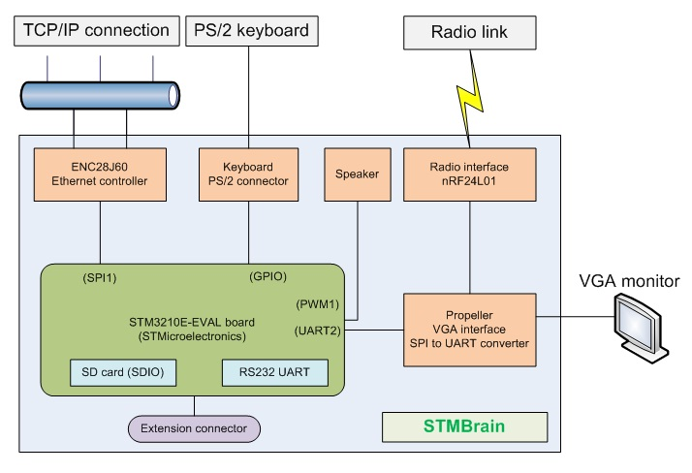
The overall structure of STMBrain can be seen above. It is built around a STM3210E-EVAL board from STMicroelectronics. The additional hardware (video controller, PS/2 connector, network controller, radio interface, speaker and glue logic) is implemented on a daughter board that connects to STM3210E-EVAL using its daughterboard extension connectors. STMBrain needs a VGA monitor and a PS/2 keyboard in order to function properly; the TCP/IP connection is optional, but probably desired. Users can interface other hardware with STMBrain (with a part of the MCU pins) using its extension connector. The micro SD socket on the STM3210E-EVAL board provides non-volatile storage capabilities. Also, the user can connect a serial capable with standard RS232 logic level to the UART1 DB9 socket on STM3210E-EVAL.

Schematics
The schematics of STMBrain are shown below (with the exception of the schematic for the STM3210E-EVAL board, in accordance with the contest rules). STMBrain uses two modules purchased from eBay: a radio interface module (based on the nRF24L01+ from Nordic Semiconductor) and a network interface module (based on the ENC28J60 chip from Microchip). Their schematics are include too, but please note that I’m not their author.

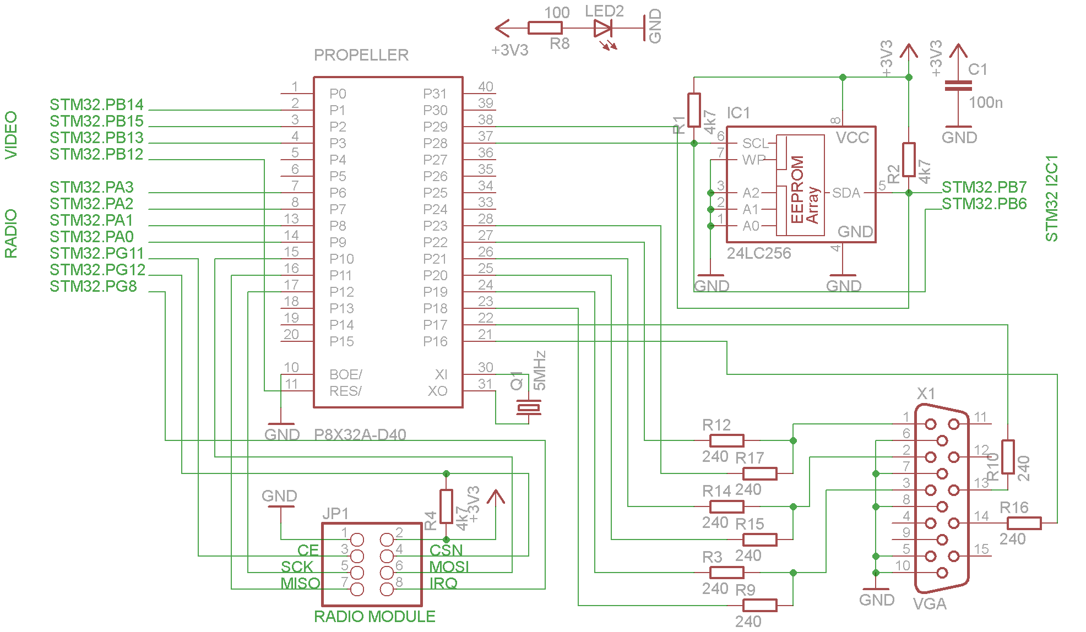
Figure 1 - The video controller and radio interface logic

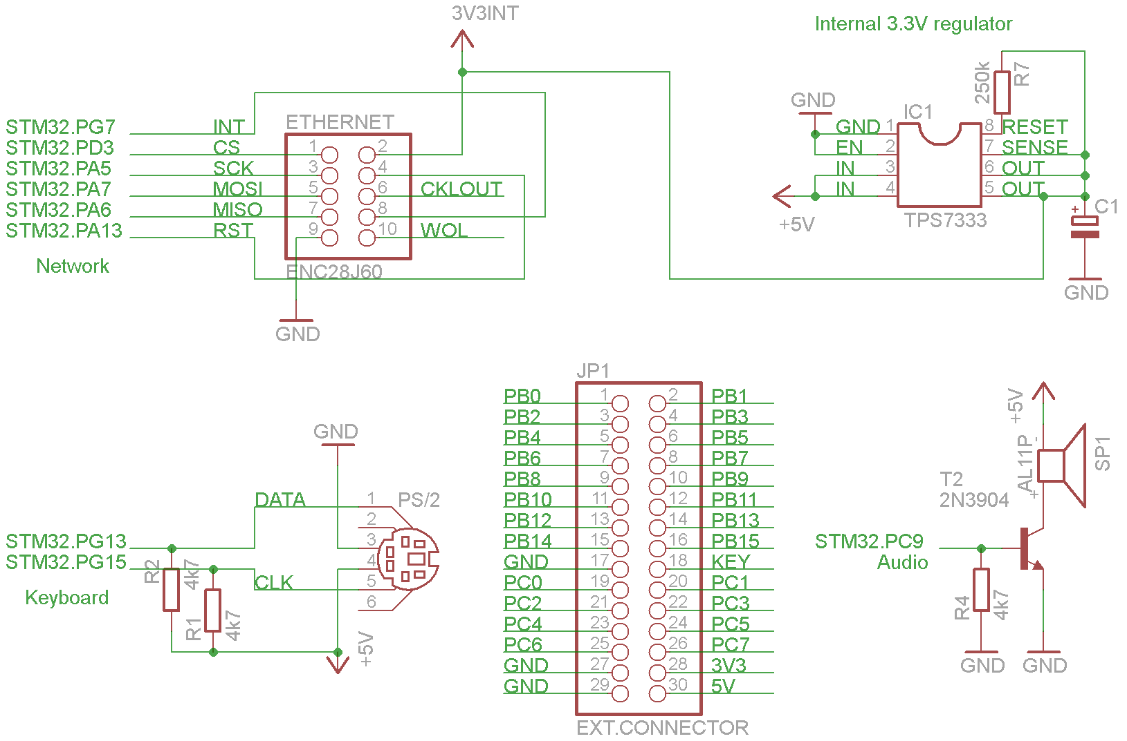
Figure 2 – Network, PS/2, speaker, extension connector

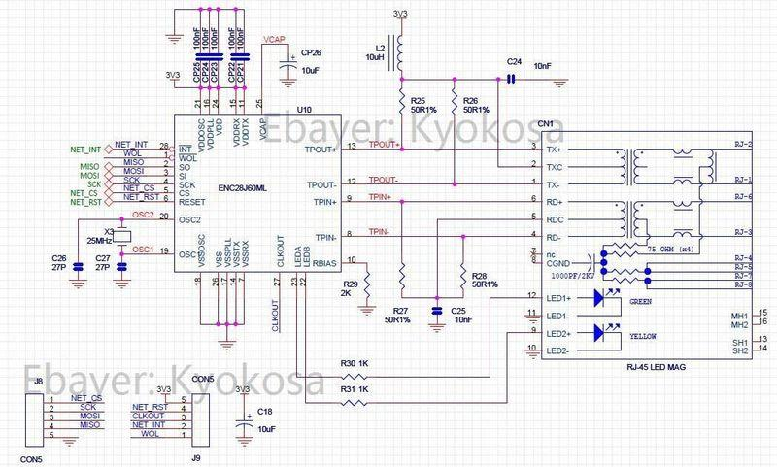
Figure 3 – ENC28J60 network module schematic
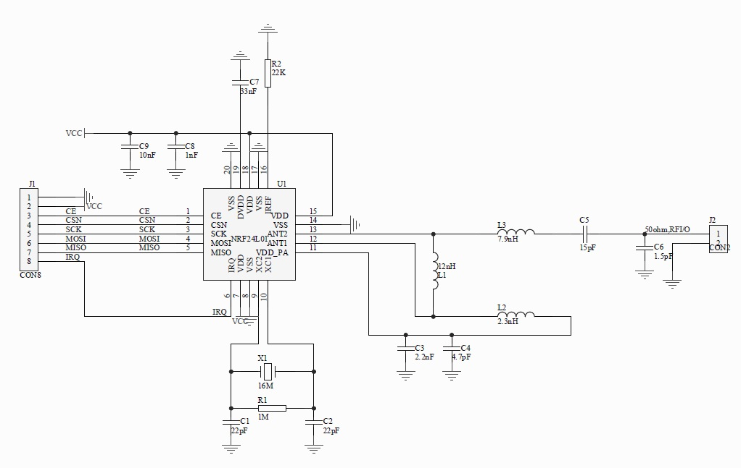
Figure 4 – Radio module schematic
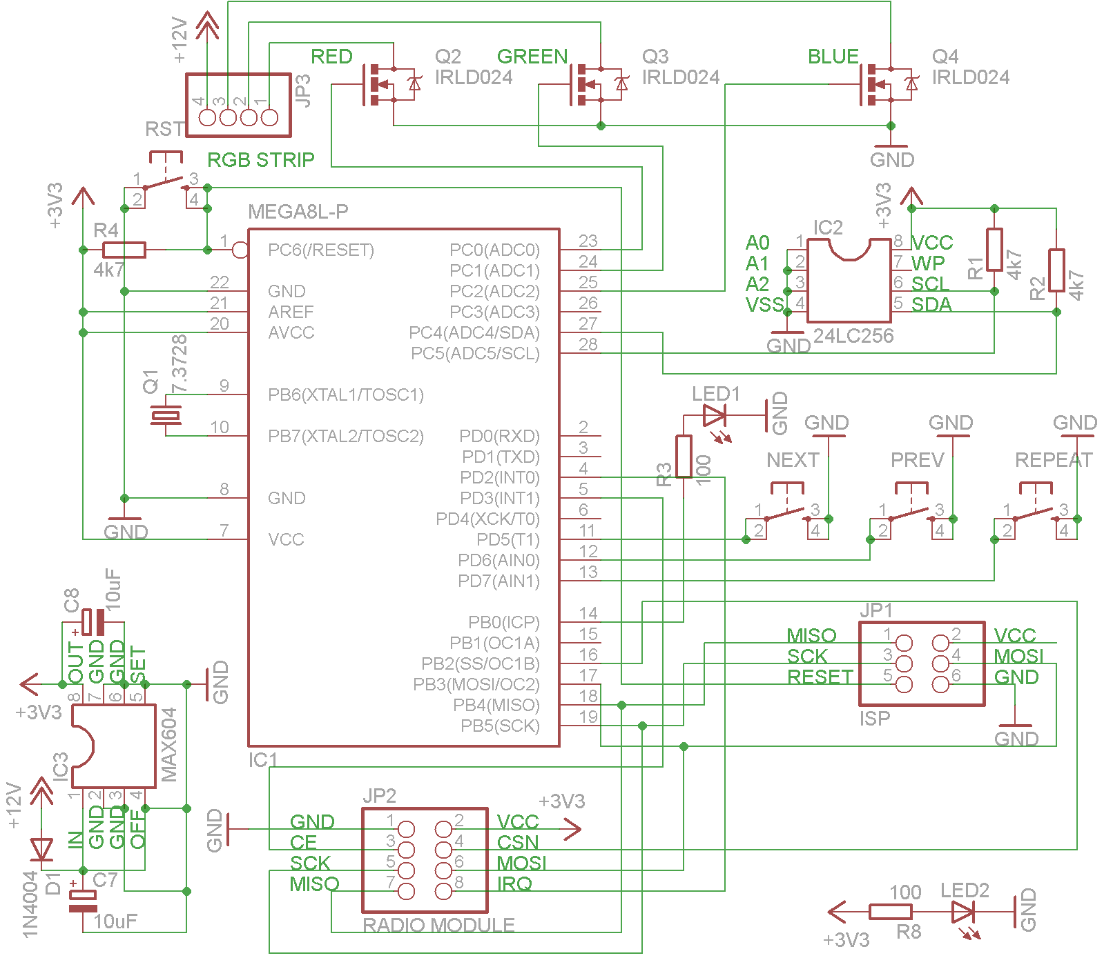
Figure 5 - Dynamic RGB light interface schematic

The last picture above is a schematic of a different board (not part of STMBrain) that was developed as a demonstration of its automation controller capabilities. It can program a RGB LED strip wirelessly using an ad-hoc language specifically designed for controlling RGB lights; this language is parsed and compiled by STMBrain itself.

Project pictures (board and applications)
TODO

Sample code
TODO

