**How to use menu**

To use menu, run menu.py in terminal using python3 command. Alternatively, you can create an instance of Menu and invoke its run method.

You’ll be prompted to enter number of vehicles and their numbers (this is needed for creating instance of LogisticSystem).

After that you’ll see the following in your terminal:

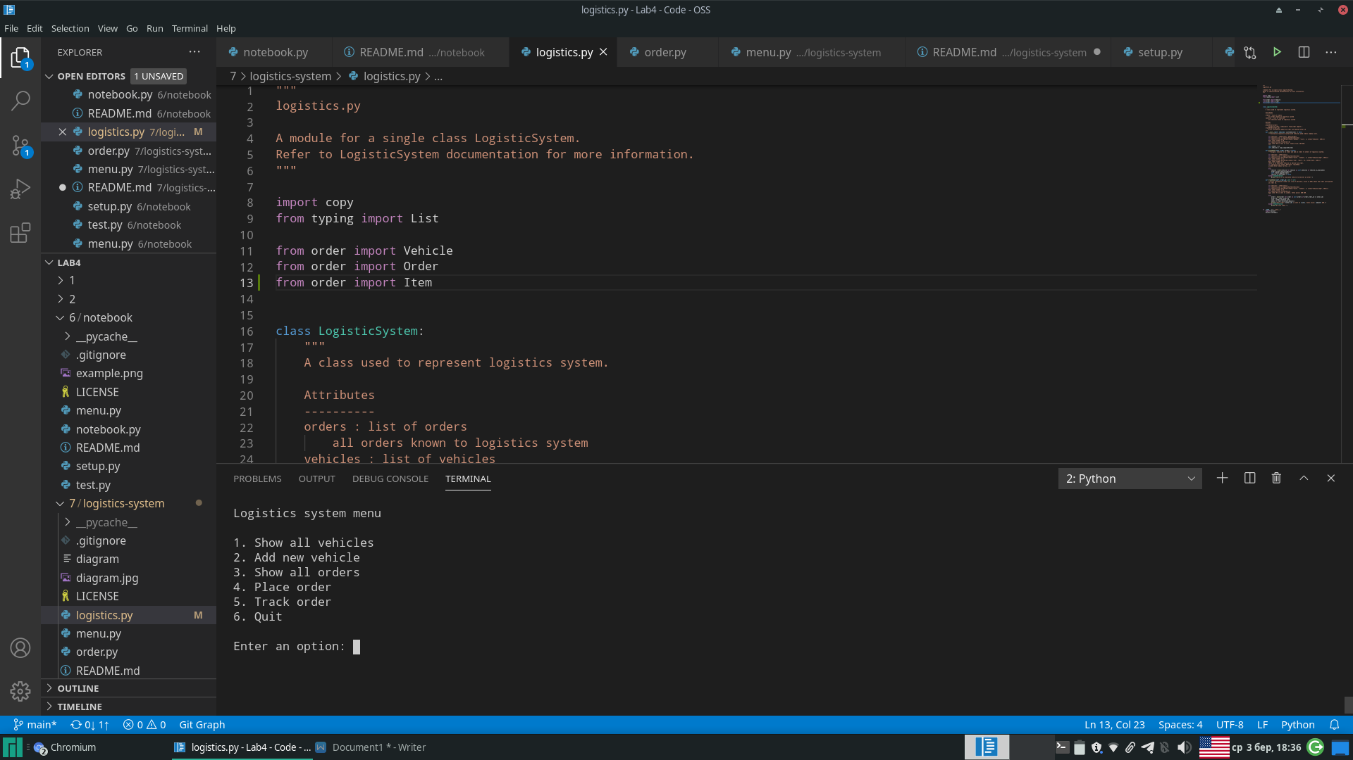

This is the menu. You are able to choose one of 6 options. You can choose one of them by typing the corresponding number and pressing Enter.

The description of each option:

1 - show all vehicles (vehicles attribute of LogisticSystem). Weather the vehicle is available or not is known from the column in which it is printed.

Example: 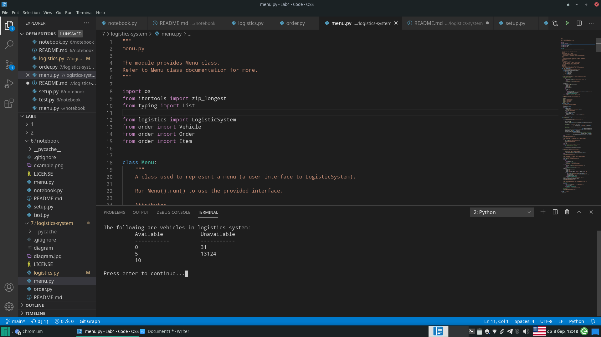

2 - ask user the number of new vehicle, create vehicle with specified number and add it to vehicles attribute of LogisticSystem.

Example: 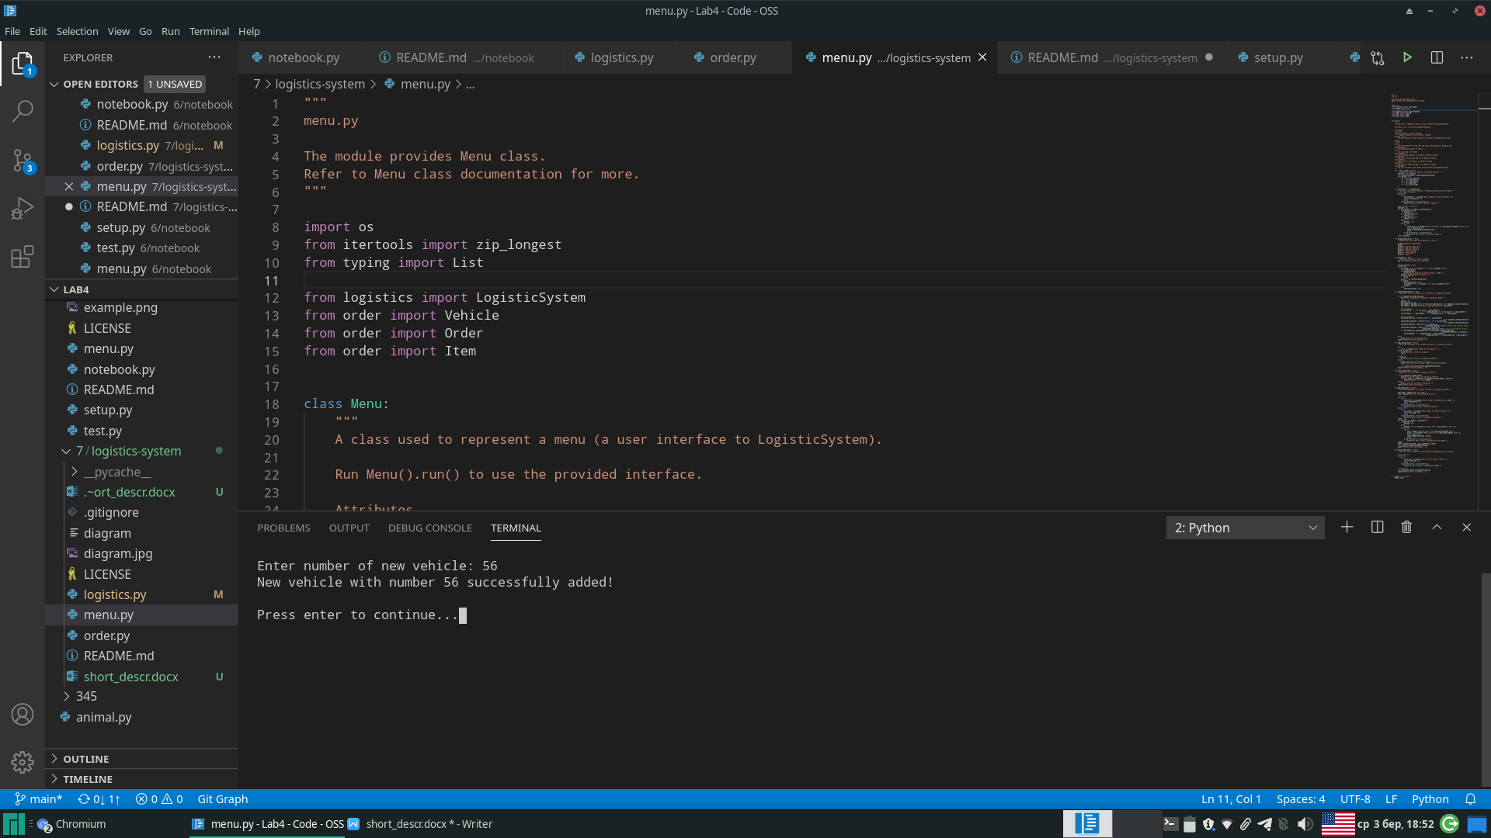

3 - print all orders of logistics system (orders attribute of LogisticSystem).

Example: 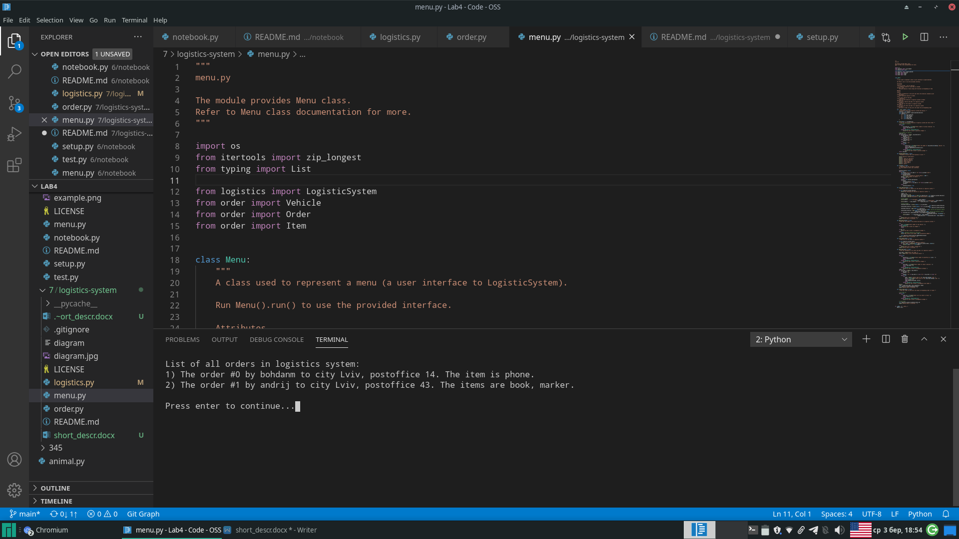

4 - create new order and add it to orders of logistics system. Uses placeOrder method of LogisticSystem.

Example: 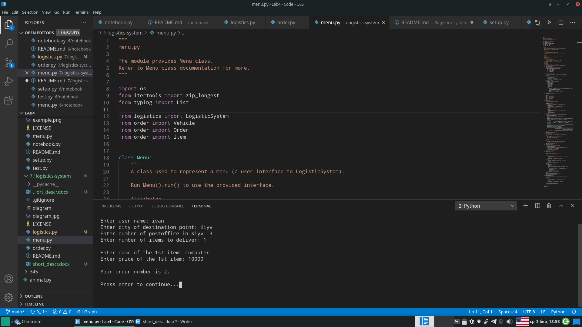

5 - ask user to enter ID of an order and print information about an order with specified ID. Uses trackOrder method of LogisticSystem.

Example: 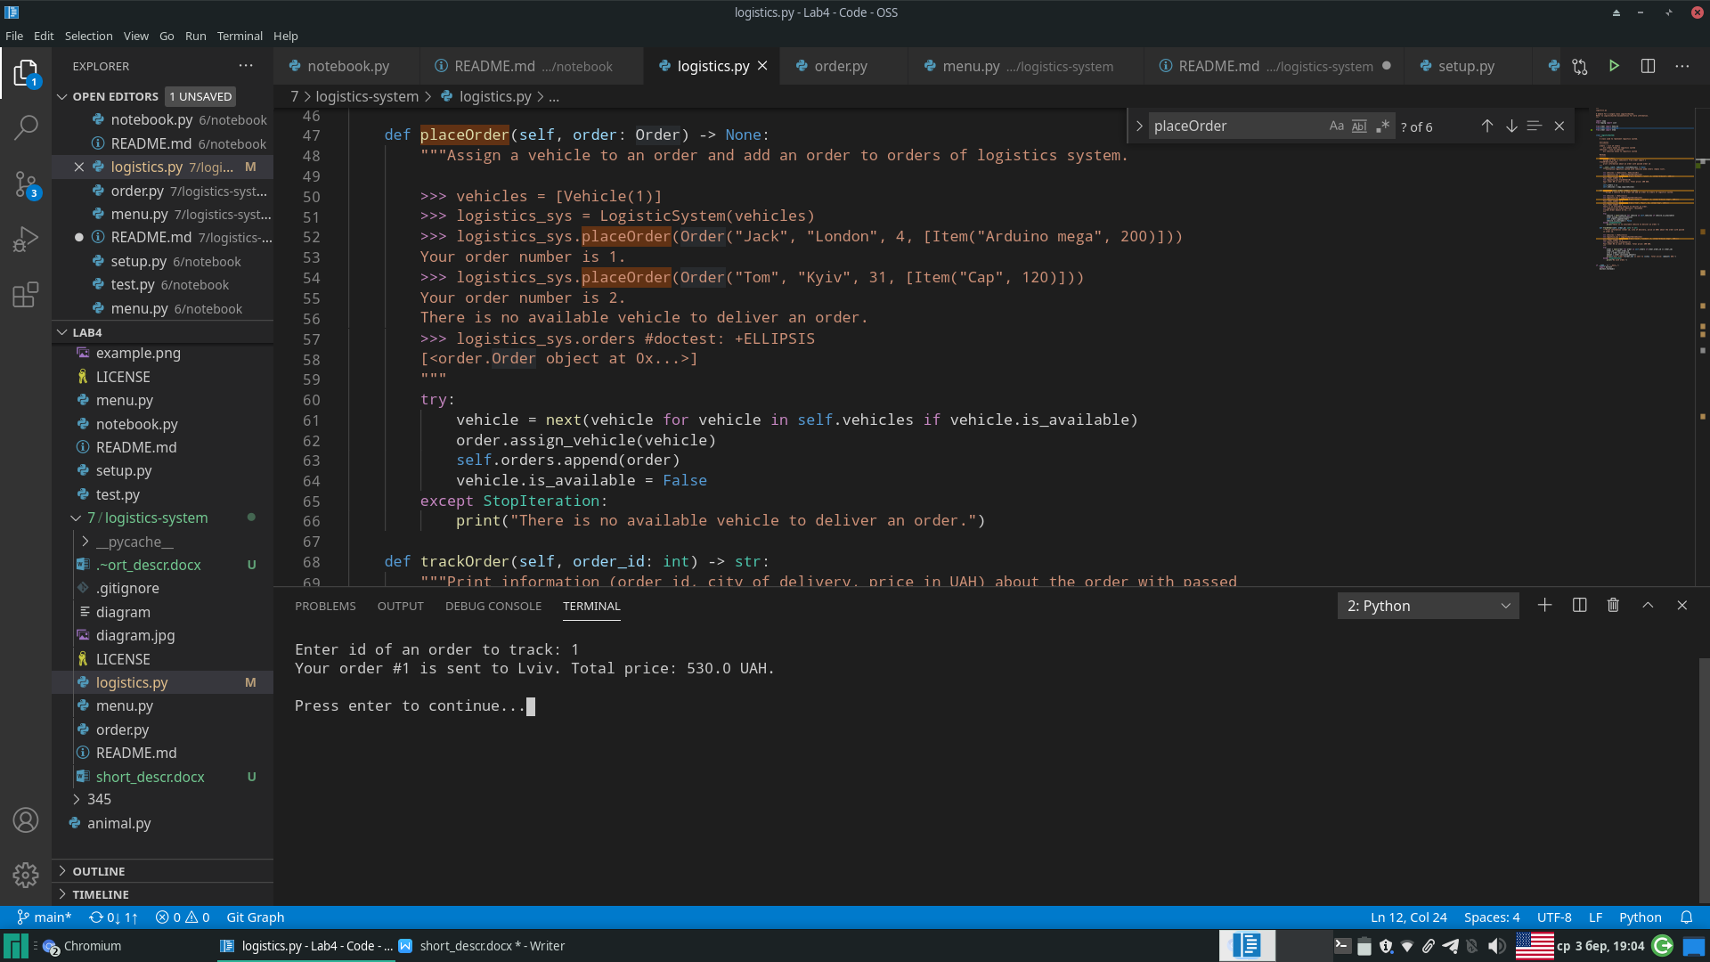

6 - exit menu. After selecting this option, the main loop ceases and the execution of run method is completed.