**UNIVERSITY “POLITEHNICA” OF BUCHAREST**

**FACULTY OF ENGINEERING IN FOREIGN LANGUAGES**

**Book Library**

**STUDENT:**

**Bogdan Matragociu**

**BUCHAREST**

**2014**

**Table of Contents**

**1.** **FEATURES. REQUIREMENTS**

**1.1** **Features**

**2.** **FILES. INSTALLATION AND EXECUTION**

**2.1** **Files**

**2.2** **Installation and Execution**

***2.2.1*** ***USING THE SOURCE FILES***

**3.** **DESIGN AND IMPLEMENTATION DETAILS**

**4.** **FUTURE WORK. POSSIBLE IMPROVEMENTS**

1. **Features. Requirements**

* 1. **Features**

The Book Library application version 1.0 is designed to allow librarians to manage books and clients.

It allows only the librarians to log in and then select clients, insert new clients and view their current books. The application does not use a database but has the ability to save the content on disk and load content form disk.

It was implemented and tested on Windows Operating System and it requires java JDK 1.5 or higher installed.

Additional features will be added in the next versions.

1. **Files. Installation and Execution**

* 1. **Files**

Here is the file hierarchy of the application.

* Book Library – packet structure :
  + 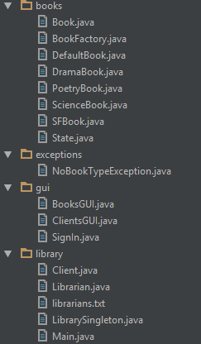

* 1. **Installation and Execution**

The application was implemented and tested on Windows Operating System and it requires java JDK 1.5 or higher installed.

* + 1. **Using the Source Files**

If you are interested in using the source file you will need to install IntelliJ IDEA 14.0 or any other Java IDE.

The entry point in the application is Main.java.

1. **Design and Implementation Details**

The application abstracts the object in a library and exposes them to the user using a graphical interface. The interface is built using Swing Java library.

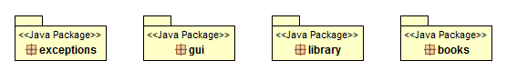

* books

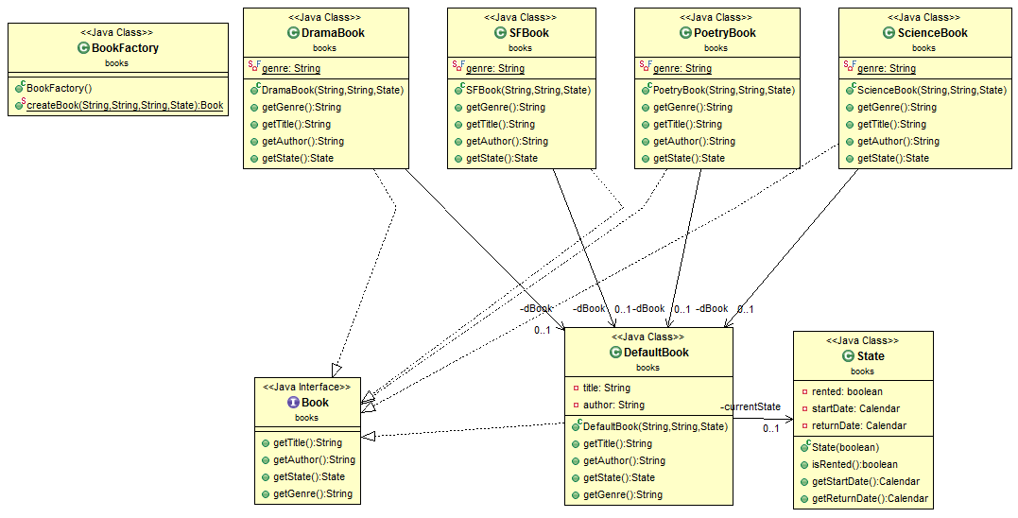

* gui

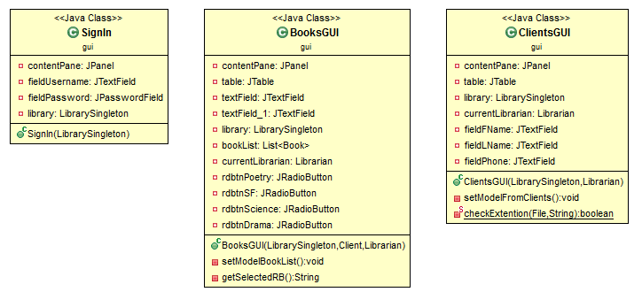

* library

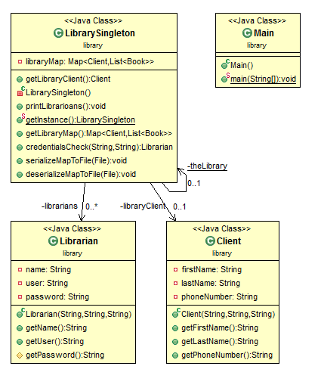

* exceptions

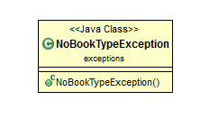

1. **Future Work. Possible Improvements**

As stated previously, current software version of the Book Library application is version number 1.0.

Future versions target the following features:

* Integrating a database.
* Performance enhancement
* E-mail notifications