SentAI: An Open-Source Dual-Camera Edge AI Runtime for Vision-Guided Drone Autonomy on Coral Micro
  - MDPI Drones DOCX Draft

Abstract
This paper presents SentAI, an open-source MicroPython environment for high-level autonomous flight control on a minimalist embedded AI board that integrates an EdgeTPU accelerator and extends it with two 5 Mpx cameras and an onboard IMU. The platform is designed as a compact sensing and decision layer for micro-aerial vehicles, combining scriptable mission logic, dynamic TensorFlow Lite model loading, continuous onboard inference, and real-time communication in a resource-constrained MCU system. Architecturally, the board is conceived to go beyond a single fixed sensor viewpoint: the two cameras can be mounted in parallel or perpendicular configurations, enabling either stereo-like directional redundancy or complementary views such as forward-looking navigation and downward-looking scene understanding.
A second major contribution of the work is a careful systems-level analysis of the complete real-time visual path, from photons captured by the image sensor to buffers in MCU RAM and further to the EdgeTPU input memory. The implementation studies and optimizes each stage of this chain, including sensor acquisition, DMA-backed frame delivery, hardware scaling and pixel conversion, tensor preparation, and inference scheduling inside the real-time operating system. To sustain high frame rates, these operations are organized as a pipelined parallel workflow, in which camera capture and image preparation execute concurrently with TPU inference through dedicated RTOS tasks and a double-buffered staging design. This transforms the platform from a proof-of-concept integration into an industrialized embedded vision stack, showing how techniques that are straightforward in theory require careful orchestration in practice once memory locality, transfer latency, buffer ownership, and accelerator access become hard hardware constraints.
The flight-control concept explicitly targets two complementary UAV platforms. The first is Bitcraze Crazyflie, chosen as an agile indoor research vehicle that is easy to instrument, safe to iterate on, and well suited for rapid experimental validation. The second is a professional PX4-based autopilot stack accessed through the MAVLink standard, representing the path toward more robust outdoor and field-deployable operation. SentAI exposes a common high-level control layer from MicroPython for both targets, allowing mission scripts to issue flight actions, consume telemetry, and couple perception outputs with guidance decisions while preserving a uniform developer workflow across the lightweight indoor platform and the professional-grade MAVLink ecosystem.
At the perception level, the main contribution is a dual-camera, multi-model runtime tailored for sensor-rich drone operation. The source code integrates camera initialization across both sensors, explicit runtime camera switching, per-camera geometric configuration, image rotation support, and a frame-sequencing mechanism that guarantees clean acquisition after a sensor change by waiting for fresh post-switch frames. This camera-switching concept is essential for aerial robotics because it allows the system to alternate between viewpoints according to mission phase: one camera can support obstacle awareness or pilot-centric navigation, while the other can support nadir inspection, target localization, or tracking relative to the ground plane. Over this visual substrate, SentAI adds continuous EdgeTPU detection, lightweight multi-object tracking, IMU-aware motion compensation, ground-plane projection, GPS-referenced localization, and dynamic model switching so that different neural networks can be invoked according to context, target type, or flight mode.
This optimization effort is especially important for YOLO-class detectors, whose input dimensions place strong pressure on the memory budget of an MCU-based platform. The work therefore addresses the practical problem of memory rearrangement and allocation across internal RAM and external SDRAM so that large model inputs, staging buffers, tracking structures, and MicroPython runtime data can coexist while minimizing unnecessary copies and other inefficient operations. The camera subsystem is directly coupled to the processor through a high-bandwidth embedded capture path, while the runtime adds a dedicated hardware-assisted stage for image conversion, resizing, and tensor preparation before inference. In this sense, the paper is not only about deploying models on embedded hardware, but about demonstrating how to make such deployments reliable, repeatable, and efficient under real hardware limits.
In addition to the embedded runtime, the work also provides a custom YOLO model trained on an open synthetic image dataset created specifically for drone-navigation scenarios in inhabited spaces. The dataset is designed as a reusable starting point for the community and contains aerial views captured both at nadir and at approximately 45 degrees, so that models can learn to generalize across the two most relevant operational perspectives for low-altitude UAV missions. This contribution is intended as a pre-training and adaptation basis for applications that must implement strict navigation and avoidance rules in populated environments, including use cases aligned with European drone operation constraints such as the A0-A3 and A2 categories. By combining an open embedded runtime, an open dataset, and a transferable detection model, the proposed framework aims to reduce the entry barrier for developing regulation-aware autonomous drone systems that couple onboard perception with high-level flight policies.
The result is an open-source embedded autonomy stack in which MicroPython orchestrates high-level drone behavior, high-fidelity sensors provide the situational context, and multi-model AI pipelines adapt the onboard perception strategy to the needs of the mission.

Introduction
Autonomous visual navigation for small drones sits at the intersection of several conflicting constraints: low mass, low power, real-time perception, onboard decision making, and enough software flexibility to support rapid iteration. In practice, many platforms solve only part of this problem. Very small aerial vehicles are easy to fly indoors and safe to test in tight environments, but they often lack the compute and memory budget required by modern object detection pipelines. At the opposite end, larger embedded AI platforms such as Coral Dev Board or NVIDIA Jetson-class systems provide significantly more resources, but they also bring higher current consumption, larger batteries, more weight, and a form factor that is difficult to justify for lightweight micro-UAV missions.
This work starts from an open-source platform with clear latent potential, namely Coral Micro, and treats it not as a finished product but as a promising technical base that can be pushed toward a much higher level of systems maturity. The research direction is therefore not limited to adding isolated features. Instead, it aims to move an accessible open hardware and open software project toward an industrialized embedded-AI stack with production-oriented performance characteristics, stronger runtime guarantees, richer sensing, and a more coherent control and telemetry model.
The starting point of this work was the need for a platform that remains physically lightweight and energy-efficient, while still exploiting as much as possible the inference capability of the EdgeTPU and the real-time performance of the MCU. The original minimalist EdgeTPU-based board configuration was attractive from the perspective of size and power, but its standard low-resolution camera workflow was not sufficient for the class of missions targeted here. In particular, a 320x240 sensing regime is too restrictive when the goal is to support richer object detection, stricter scene understanding, and higher-confidence flight decisions in inhabited or cluttered spaces. This became even more limiting when considering modern YOLO-style detectors, which benefit from larger spatial inputs and from a sensor pipeline capable of preserving more detail before resizing and quantization.
The objective of SentAI is therefore to define a new point in the design space: a board-level and software-level architecture that preserves the low-weight, low-power philosophy of minimalist embedded AI hardware, but extends it toward practical autonomous drone operation. The platform couples an MCU and an EdgeTPU with two 5 Mpx cameras and an onboard IMU, and exposes the whole sensing, inference, communication, and control stack through a MicroPython environment. This makes it possible to write high-level mission logic in Python while keeping timing-critical operations in the underlying real-time operating system and accelerator path. The result is not only a development framework, but also a systems study of how far one can push a compact embedded AI board toward real airborne autonomy and toward a level of robustness closer to production-grade embedded deployment.
The work explicitly targets two flight platforms. The first is Bitcraze Crazyflie, used as an indoor experimental platform because it is agile, lightweight, easy to maneuver, and well suited for repeated safety-conscious testing in the laboratory. The second is a PX4-based autopilot stack accessed through MAVLink, representing the path toward a more professional and transferable deployment model. The intention is to provide a common high-level autonomy layer across both targets, so that mission scripts, perception logic, and communication flows can be developed once and adapted across indoor research flights and more operational MAVLink-centered scenarios.
From a vision-systems perspective, the work is driven by the observation that model accuracy alone is not enough. Once YOLO-class detectors are pushed toward larger inputs, for example 640-class or even workflows derived from native 1280-wide camera imagery, the dominant issues become memory layout, transfer scheduling, tensor preparation cost, and buffer ownership between the camera subsystem, the MCU, and the EdgeTPU. For this reason, the contribution is as much about systems engineering as it is about AI. The implementation analyzes the full visual path from image acquisition at the sensor, through DMA-backed capture into RAM, through hardware pixel conversion and scaling, and finally into the EdgeTPU input memory. These stages are pipelined in parallel under the RTOS so that camera capture and image preparation can overlap with inference, thereby maximizing frame rate while minimizing idle time and unnecessary copies.
An important architectural extension is the addition of a dual-camera subsystem. Instead of treating perception as a single fixed viewpoint problem, SentAI supports two 5 Mpx sensors that may be mounted in parallel or perpendicular configurations. This enables distinct operational modes: forward-looking navigation together with nadir inspection, redundant views for indoor localization, or viewpoint switching according to the phase of the mission. The camera-switching mechanism is designed as a first-class runtime concept, not as an afterthought, and is supported by explicit per-camera geometry, frame sequencing, and clean post-switch acquisition logic. Together with IMU-aware tracking and ground-plane projection, this creates the basis for drone-centric perception that is aware of mounting geometry and flight context rather than only raw image content.
The work also extends beyond the runtime itself. In addition to dynamic model loading and multi-model switching, the project assumes the availability of a custom YOLO detector trained on an open synthetic dataset built for low-altitude drone navigation in inhabited spaces. The dataset contains views captured at nadir and at approximately 45 degrees, and is intended as a reusable pre-training or adaptation resource for future systems that must obey stricter navigation and avoidance logic in populated environments, including scenarios informed by European drone categories such as A0-A3 and A2. This dataset-and-model layer complements the embedded runtime by providing a path from open training assets to open onboard deployment.
In this sense, the present work should be read as an industrialization effort. Many of the underlying techniques are known in isolation: embedded Python, edge inference, object detection, MAVLink communication, or visual tracking. The novelty lies in bringing them together on a highly constrained airborne computing platform and resolving the practical bottlenecks that appear only during implementation. These include memory fragmentation, RAM placement between internal memory and external SDRAM, large tensor staging, synchronization between RTOS tasks, camera switching latency, and the challenge of sustaining high throughput without losing the low-power character of the platform. The broader contribution is thus to demonstrate how an open-source prototype platform can be evolved into a system with much stronger production-oriented behavior, where throughput, determinism, integration discipline, and operational usability become design targets in their own right.
The main contributions of the work can be summarized as follows:
- An open-source MicroPython runtime for a lightweight EdgeTPU-enabled MCU platform intended for high-level autonomous drone control.
- A dual-target flight-control concept spanning Bitcraze Crazyflie for indoor experimentation and PX4/MAVLink for professional autopilot integration.
- A dual-camera 5 Mpx sensing architecture with onboard IMU support, runtime camera switching, per-camera geometry, and viewpoint-aware operation.
- A real-time perception pipeline that studies and optimizes the end-to-end path from image sensor to MCU RAM to EdgeTPU memory, using parallel RTOS execution and double-buffered staging to maximize frame rate.
- A memory-aware deployment strategy for YOLO-class detectors and other larger vision models on an MCU-constrained platform.
- A multi-model workflow with dynamic model loading, context-dependent switching, tracking, projection to the ground plane, and telemetry integration.
- An open synthetic aerial dataset and a custom YOLO model intended as a starting point for regulation-aware drone navigation in inhabited environments.
The rest of the paper is organized as follows. The next section reviews related work in autonomous nano-UAV navigation, embedded deep learning, YOLO-based detection, MicroPython-enabled embedded control, and accelerator-centric edge AI. The following sections present the hardware and software architecture, the real-time memory and processing pipeline, the communication and flight-control abstractions, and the experimental perspective enabled by the platform.

Related Work

Autonomous visual navigation for nano-UAVs
An important reference point for this work is the line of research that demonstrates fully onboard visual autonomy on extremely small flying robots. A particularly relevant example is An Open Source and Open Hardware Deep Learning-powered Visual Navigation Engine for Autonomous Nano-UAVs, which shows that a nano-UAV can execute a closed-loop visual navigation pipeline onboard under severe power and mass constraints. That work is important not only because it proves feasibility, but because it frames the design problem correctly: perception, inference, control, and hardware architecture cannot be treated independently when the air vehicle is very small. SentAI inherits this systems-level viewpoint, but shifts the focus from a custom navigation engine toward a more general-purpose embedded AI runtime that combines high-level scripting, object detection, multi-view sensing, and compatibility with both experimental and professional drone-control ecosystems.
The broader nano-UAV literature also distinguishes between systems that are truly autonomous onboard and systems that depend on offboard computing, external localization infrastructure, or heavy companion computers. This distinction remains essential. For indoor research, offboard support is useful during development, but it does not solve the core embedded autonomy problem. SentAI therefore positions itself within the class of systems that aim to keep perception and high-level decision making onboard, even when this requires substantial engineering effort in memory organization, RTOS scheduling, and sensor integration.

Embedded AI accelerators and systolic-array inference
The use of an EdgeTPU-class accelerator places this work within the wider context of edge inference on specialized matrix-processing hardware. Systolic-array accelerators changed the practical landscape of embedded AI because they made it possible to execute neural inference at high throughput and low energy relative to CPU-only or even general GPU-centric approaches. In this broader context, the TPU family established a strong reference model for efficient tensor computation through structured dataflow and regular multiply-accumulate pipelines. SentAI is not a study of accelerator microarchitecture by itself, but it depends critically on the availability of this kind of accelerator model and on the practical challenge of feeding it efficiently from a constrained MCU environment.
This distinction matters. On larger boards, accelerator throughput is often discussed independently from sensor transfer and host memory layout, because the host has enough resources to hide inefficiencies. On small MCU-based systems, however, the effective performance of the accelerator is inseparable from the cost of moving images from the camera to RAM, rearranging tensors, and scheduling inference without starving the rest of the application. In that sense, this work contributes to the embedded AI literature by focusing on the host-side industrialization problem around the accelerator, not only on the accelerator itself.

YOLO-family object detectors and compact detection models
The object detection component of this work is aligned with the large body of literature around single-stage detectors and especially the YOLO family. YOLO-style architectures are attractive in airborne robotics because they offer a practical balance between accuracy, latency, and deployment simplicity. They are also natural candidates for quantized execution and edge deployment. At the same time, deploying YOLO-class models on resource-constrained embedded platforms introduces a very different set of concerns from those seen on desktop GPUs: input resolution becomes a memory-placement problem, post-processing cost becomes part of the frame budget, and intermediate copies become unacceptable at scale.
Within this design space, compact variants such as YOLO26-style models are especially relevant because they seek to preserve detection usefulness while reducing computational and memory pressure. This makes them well matched to embedded AI pipelines in which the native camera imagery may be relatively large, but the runtime still needs to fit within tight SRAM and SDRAM limits. SentAI positions itself precisely at this interface between compact model design and deployment-aware systems engineering. Rather than treating the detector as an isolated black box, it studies how detector choice interacts with camera resolution, quantization, memory layout, and real-time scheduling.

MicroPython and high-level programmability on embedded systems
MicroPython has long been valued in embedded systems for shortening the iteration cycle between algorithm design, hardware interaction, and system testing. In robotics, this is particularly attractive because state machines, mission logic, communication rules, and experimental procedures change quickly, often faster than low-level firmware can be safely recompiled and reflashed. However, the majority of MicroPython deployments emphasize convenience over hard real-time performance and are usually not coupled to a high-throughput edge-AI pipeline.
SentAI uses MicroPython differently: not as a replacement for the real-time system, but as a high-level orchestration layer placed above it. Time-critical operations such as frame capture, scaling, quantization, inference, and buffering remain implemented in compiled code under the RTOS, while Python exposes them as programmable mission primitives. This approach is relevant to previous work on embedded scripting because it shows how an interpreted environment can be integrated into an accelerator-centric, real-time drone application without turning the interpreter into the performance bottleneck.

Vision pipelines for drone perception and viewpoint-aware sensing
Most embedded drone-vision pipelines still assume a single active camera and a relatively static geometry. This is reasonable in many systems, but it limits mission flexibility. Drone operation frequently benefits from multiple sensing attitudes: forward views for obstacle awareness and navigation, nadir views for inspection and target localization, and oblique views that balance situational context with ground visibility. SentAI extends this discussion by treating dual-camera operation and runtime camera switching as core design elements. The system therefore aligns with research on viewpoint-aware aerial perception, but approaches the problem from the perspective of deployment on a compact embedded AI stack rather than from the perspective of large-scale perception benchmarks alone.
This also connects with work on projection-aware tracking and sensor fusion. Once IMU measurements, camera geometry, and ground-plane assumptions are available, detections can be represented not only in image coordinates but also in more operationally meaningful spatial coordinates. SentAI builds on this idea by combining tracking, IMU-aware motion compensation, per-camera geometry, and projection to the ground plane so that perception can be consumed more directly by flight logic and telemetry systems.

Open datasets, synthetic data, and regulation-aware navigation
Synthetic data has become increasingly important in aerial robotics because collecting and annotating large real-world datasets from drones is expensive, repetitive, and often constrained by safety or regulation. For applications involving inhabited spaces, this difficulty is even greater: the scenes are operationally sensitive, the failure modes are costly, and the data should ideally cover multiple viewing angles and flight contexts. An open synthetic dataset that explicitly contains nadir and oblique perspectives is therefore consistent with current trends in simulation-assisted pre-training and domain adaptation.
The relevance of this direction becomes stronger when drone navigation is discussed not only as a perception problem, but also as a compliance problem. European operation categories such as A0-A3 and A2 motivate systems that are more conservative, more aware of surrounding objects and persons, and easier to validate under explicit operational constraints. While regulation-aware autonomy is still an emerging topic, it provides an important framing device for this work: the detector and dataset are not meant only to improve benchmark accuracy, but to support future high-level navigation policies that must operate under stricter safety and legal constraints.

Positioning of this work
Relative to prior work, SentAI occupies a middle ground that is not addressed well by any single existing direction. It is lighter and more power-conscious than larger embedded AI computers, more programmable than fixed-function onboard vision stacks, more perception-rich than minimal MCU-only controllers, and more deployment-oriented than many standalone model papers. Its contribution is therefore not a new detector alone, not a new autopilot alone, and not a new board alone, but the integration of these concerns into a coherent embedded autonomy platform for small drones.
Indicative references to include in the final bibliography are the following:
- An Open Source and Open Hardware Deep Learning-powered Visual Navigation Engine for Autonomous Nano-UAVs.
- Core YOLO-family papers and the compact YOLO26 line relevant to efficient embedded detection.
- Foundational work on TPU and systolic-array-based neural accelerators.
- MicroPython project and related work on embedded scripting for robotics.
- Prior work on aerial perception, synthetic datasets for UAV vision, and regulation-aware autonomous flight.

Implementation
This chapter describes the implementation of SentAI as a research platform positioned at the intersection of embedded AI acceleration, real-time systems, and autonomous drone control. The central thesis of the implementation is that an EdgeTPU-class accelerator is simultaneously low-power and computationally powerful enough to justify a much tighter integration with an MCU than is common in larger companion-computer architectures. Rather than treating the accelerator as a peripheral attached to a heavy host, the design treats the MCU and EdgeTPU as a compact co-processing pair: the MCU handles sensing, scheduling, memory orchestration, communication, and high-level control, while the EdgeTPU is driven as the main execution substrate for neural inference.
An equally important framing point is that the implementation starts from an open-source platform with significant unrealized potential and deliberately pushes it toward industrialization. In other words, the work is not only about extending Coral Micro with additional capabilities, but about transforming an accessible open-source base into a system that exhibits more production-oriented behavior: higher sustained throughput, better control of memory and latency, richer sensor integration, clearer runtime abstractions, and a software structure that can support repeated deployment rather than isolated demonstrations.
The implementation presented in this work differs substantially from the initial fork baseline by transforming a board-oriented demo environment into a programmable autonomous-flight runtime. The main engineering question is not only whether inference can run onboard, but how to maximize accelerator utilization, sustain real-time responsiveness, and preserve a lightweight and low-power hardware profile suitable for micro-UAV operation. This leads to a design in which memory placement, transfer scheduling, camera integration, scripting boundaries, and telemetry abstractions become first-order implementation concerns. In this sense, the chapter documents a move from open-source proof-of-potential to an embedded system engineered with production-performance objectives in mind.
The chapter is organized into the following subchapters:
- implementation_01_system_architecture.md, which explains the hardware-software co-design and the motivation for pairing an MCU with an EdgeTPU on a lightweight drone-oriented board.
- implementation_02_runtime_and_memory.md, which analyzes the RTOS integration, linker-level memory layout, staging buffers, and the host-side logic required to keep the accelerator fed efficiently.
- implementation_03_vision_pipeline.md, which details the dual-camera subsystem, the real-time image path, tracking, projection, and the deployment of YOLO-class detectors.
- implementation_04_flight_and_telemetry.md, which presents the dual-target control strategy spanning Crazyflie and PX4/MAVLink, together with telemetry and backend integration.
- implementation_05_programming_model.md, which studies the MicroPython layer and uses the platform help system as evidence of how the embedded capabilities are exposed as a coherent experimental interface.
Taken together, these sections argue that the implementation is best understood as an exercise in practical embedded-AI industrialization: the work does not merely deploy neural inference on a small board, but systematically resolves the hardware and software bottlenecks that arise when such inference must coexist with flight control, camera switching, runtime programmability, and constrained memory resources. The overall contribution is therefore to show how an open-source platform can be matured toward a more production-capable embedded autonomy stack without abandoning its accessibility, compactness, or low-power design philosophy.

1. System Architecture and Design Rationale
The implementation of SentAI starts from a strong architectural hypothesis: for lightweight autonomous drones, the most useful computing arrangement is not a large companion computer with a small flight controller attached to it, but a tightly coupled MCU-plus-accelerator system in which the accelerator performs the dense tensor computation and the MCU orchestrates everything else. This view is consistent with broader trends in domain-specific architectures for neural networks, especially the systolic-array lineage popularized by TPU-style accelerators, where high arithmetic density and low energy per operation make specialized inference hardware much more attractive than general-purpose processing for continuously running perception tasks.
In this work, the EdgeTPU is treated as the primary neural execution engine and the MCU as the real-time systems controller that makes this engine usable in practice. The MCU is responsible for sensor bring-up, camera switching, image scaling and quantization setup, task scheduling under FreeRTOS, telemetry transport, filesystem access, and the high-level control hooks exposed to the drone. The choice of a real-time operating system, rather than a Linux-based software stack, is deliberate. For this class of airborne system, FreeRTOS offers lower software overhead, tighter control over scheduling and memory, faster boot behavior, simpler timing analysis, and a substantially smaller energy and storage footprint than a full operating-system distribution. This division of responsibility is central to the implementation strategy. It avoids the weight and current draw associated with larger embedded AI platforms while still enabling onboard deep-learning inference for navigation and scene understanding.
This design choice is particularly important in the drone context. Platforms such as Coral Dev Board or Jetson-class systems are powerful, but their mass, thermal requirements, battery burden, and system complexity make them difficult to justify for small indoor drones or for compact airframes where endurance and safety matter. Their software model is also usually tied to a Linux-class environment, which is convenient for development but less attractive when deterministic timing, reduced boot latency, and strict power discipline are required onboard a lightweight UAV. By contrast, a minimalist EdgeTPU-enabled board can remain lightweight and power-conscious, yet still sustain meaningful onboard perception if the software stack is built around the accelerator and an RTOS-controlled MCU rather than around the comfort assumptions of a desktop-like host. The implementation therefore argues that the EdgeTPU is not merely a convenient inference add-on, but a sufficiently strong low-power compute primitive to be integrated beside virtually any capable MCU, provided that memory and data movement are engineered with care.
The concrete system extends the minimal board profile with two 5 Mpx cameras and an onboard IMU. This is a deliberate departure from lower-resolution single-camera operating modes commonly found in embedded vision examples. The intent is to preserve more visual detail at the sensing stage, even when the final detector input is smaller, because high-resolution acquisition creates more room for strategic cropping, scaling, model switching, and camera-role specialization. In practical terms, this matters for YOLO-class detectors, which are sensitive to input detail and often benefit from larger or better-preserved spatial structure before quantization.
The two-camera design also reflects a broader systems argument. A single fixed camera is often enough for a benchmark, but not always enough for a drone mission. Indoor navigation, target localization, regulatory awareness, and scene understanding may require forward-looking and nadir-looking views, or rapid switching between complementary perspectives. The implementation supports this by treating the dual-camera subsystem as part of the platform architecture, not as an optional accessory. Camera identity, mount geometry, and active-view selection are propagated all the way to the tracking and projection layers.
At the software level, the architecture is also shaped by programmability. Rather than exposing the platform only through C++ firmware entry points, the system embeds a full MicroPython runtime and binds the major capabilities of the board into a structured sentai module. This follows the intuition that autonomous flight research evolves too quickly for every experimental change to require a full firmware rewrite. High-level mission logic, model orchestration, telemetry handling, and flight behaviors are therefore scripted, while the timing-critical path remains implemented in compiled code.
This leads to a deliberate split between two programming models. At the lower level, the firmware is task-oriented in C++: camera acquisition, preprocessing, communication, tracking, and control services are organized as explicit FreeRTOS tasks, queues, semaphores, and singleton runtime components with well-defined ownership over buffers and peripherals. At the upper level, the platform becomes script-oriented in MicroPython: the user composes these services through short scripts, REPL commands, and boot-time logic without needing to manage the underlying task graph directly. The purpose of this split is not only convenience, but architectural clarity. C++ remains responsible for determinism, concurrency, and performance-critical resource control, while MicroPython remains responsible for orchestration, experimentation, and rapid reconfiguration of behavior.
In this way, the implementation combines the rapid iteration benefits associated with embedded scripting with the deterministic execution required by real-time perception.
The resulting system should thus be understood as a co-designed stack with four tightly linked layers: hardware sensing and capture, real-time host orchestration on the MCU, neural inference on the EdgeTPU, and a high-level control and experimentation surface in MicroPython. This layered organization is what makes the platform useful as a research artifact rather than merely as a single-purpose demo.
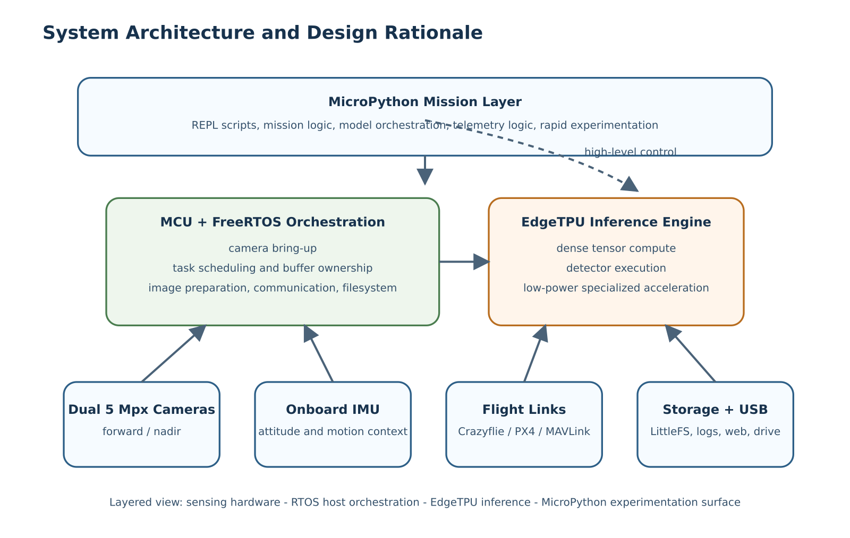

2. RTOS Integration, Memory Layout, and Accelerator Feeding
One of the main implementation claims of this work is that achieving strong onboard vision performance on a compact MCU-plus-EdgeTPU platform depends less on raw inference speed alone and more on how efficiently the host prepares, places, and transfers data. This is particularly visible in the code added relative to the initial fork, where the runtime evolves from a board example into a carefully staged real-time system.
The core execution environment is FreeRTOS. Rather than running perception as a single sequential loop, the implementation decomposes the workload into cooperating tasks with explicit ownership boundaries. The most relevant example is the continuous detection pipeline, where the code in detection_task.cc organizes the system around a preparation task and an inference task. The preparation task acquires the latest frame, scales and converts it through the hardware pixel pipeline, applies quantization when needed, and writes the result into a staging buffer. The inference task copies the prepared staging contents into the EdgeTPU input tensor, releases the staging buffer immediately, and then executes inference and post-processing while preparation for the next frame can already proceed. This design is not simply an optimization; it is the mechanism through which the implementation turns limited memory and compute resources into sustained throughput.
An important low-level detail is that the runtime does not feed the detector directly from the raw camera bus format. The active camera configuration captures native 1280x720 frames into 64-byte-aligned framebuffers with a 4-byte-per-pixel host representation. In practice, the software treats these buffers as XRGB8888-like surfaces because this layout is easier to move through CSI DMA, cache maintenance, and the RT1176 pixel pipeline than a tightly packed 3-byte RGB tensor. This is precisely where the PXP block becomes essential rather than optional: it converts the aligned capture surface into RGB888 output at the detector input size, eliminating expensive per-pixel software shuffles on the Cortex-M7.
This organization also clarifies the broader software split introduced in the architecture chapter. The lower implementation layer is task-oriented in C++, meaning that concurrency is expressed directly through FreeRTOS tasks, semaphores, queues, and explicit buffer handoff between producer and consumer stages. By contrast, the upper user layer remains script-oriented in MicroPython, where these same services are invoked as high-level operations without exposing the user to the internal synchronization structure. The runtime and memory subsystem is precisely where this separation becomes most meaningful: scripts can request model loading, camera capture, or continuous detection, but the correctness and performance of those operations depend on the task-oriented C++ layer maintaining deterministic ownership over memory, timing, and accelerator access.
The use of double-buffered staging is especially important because it enforces a clean ownership discipline between producer and consumer stages. The staging buffer is written by the preparation side and read by the inference side under semaphore-controlled handoff, while the TPU tensor is written only when the staging contents are ready. This minimizes race conditions, reduces needless synchronization complexity, and preserves the ability to overlap work. In a larger system with abundant memory, one could compensate for poor orchestration by brute force. In the present implementation, orchestration is the only realistic way to maintain high frame rate while preserving the low-power character of the platform.
The same section of code also shows why byte alignment becomes a first-order systems concern. The staging area in SDRAM is explicitly aligned to cache boundaries, while the PXP conversion path performs cache clean-and-invalidate operations before DMA writes and invalidation after completion so that stale boundary lines do not overwrite fresh image data. This is needed because the TFLite arena is not naturally aligned to the same cache-line granularity as the DMA engine. Without that discipline, a seemingly minor mismatch between 16-byte tensor allocation and 32-byte cache-line behavior would produce intermittent corruption exactly at the stage where the detector input is assembled.
The memory layout reflects the same philosophy. The linker script introduces a deliberate partitioning across internal memory, OCRAM, heap, SDRAM, and a dedicated region for camera-related traffic. MicroPython is placed explicitly in OCRAM rather than in the most latency-sensitive memory regions, while large buffers, tracker state, and staging areas are pushed into SDRAM where capacity matters more than absolute access latency. This is visible both in the custom linker script and in the pervasive use of explicit section placement such as .sdram_bss. The implementation thus accepts that not all memory is equal and uses the linker as part of the optimization strategy rather than as a passive build artifact.
This memory strategy also explains a design choice that would otherwise look surprising from a purely model-centric viewpoint: the system first tolerates a larger, alignment-friendly framebuffer representation and only later collapses it into the compact RGB tensor expected by the model. In other words, the runtime pays for structure before it pays for compactness. That tradeoff is justified because aligned DMA and deterministic hardware conversion are cheaper on this platform than repeatedly manipulating tightly packed pixels in software.
This issue becomes more acute once YOLO-class detectors are considered. Larger detector inputs significantly increase the pressure on staging buffers, copied tensors, post-processing data, and runtime metadata. In a conventional desktop pipeline this is almost invisible. On an MCU platform it becomes decisive. The code therefore embodies a memory-rearrangement strategy aimed at fitting the MicroPython runtime, the real-time tasks, the tracker structures, and the camera-to-TPU pipeline into a workable whole while minimizing inefficient copies. This is one of the places where the implementation differs most strongly from a conceptual prototype: the problem is no longer simply to run a model, but to run it without collapsing the rest of the system.
The same logic informs the build system. The custom CMake configuration aggregates a full embedded MicroPython build, nanopb-generated protocol code, additional audio and communication components, and the custom runtime sources into a single executable with a purpose-built linker script. This makes the firmware itself part of the experimental method. The implementation is not a loose collection of demos, but a custom-built runtime whose compilation model, memory map, and dependencies are aligned with the targeted deployment conditions.
From a research perspective, this subsection supports a broader claim: on compact embedded AI platforms, the practical efficiency of a specialized accelerator depends on the host system’s ability to keep the accelerator supplied with valid input at the right pace. The implementation therefore treats memory organization and RTOS scheduling as intrinsic parts of accelerator utilization rather than as secondary engineering details.
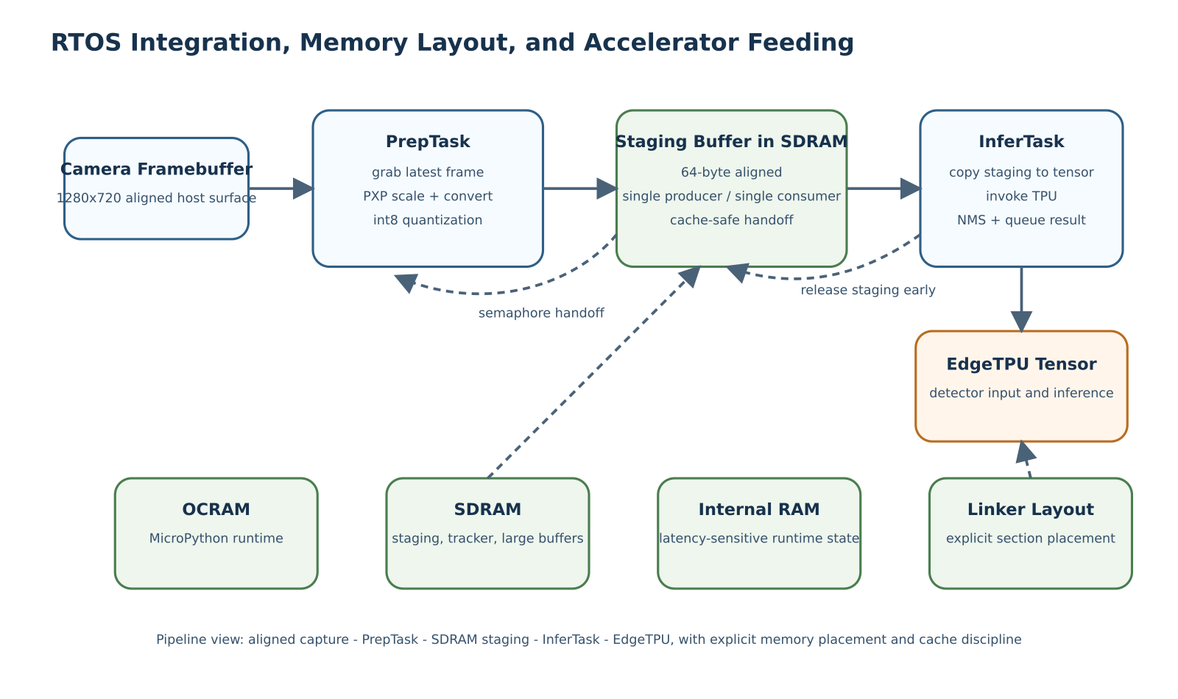

3. Dual-Camera Vision Pipeline and Perception Stack
The perception implementation is built around the idea that high-quality airborne vision is constrained as much by sensing geometry and data movement as by the neural model itself. For this reason, the codebase extends the original single-board camera model into a dual-camera system with explicit support for runtime switching, per-camera geometry, and high-resolution acquisition.
At the capture level, the cameras are integrated through the processor camera subsystem and the MIPI CSI-2 path. This is an important architectural choice because it prevents the image path from becoming dominated by the kind of software-managed peripheral transfer overhead that would be unacceptable for sustained real-time inference. The camera stack is designed so that CSI and MIPI remain active even during switching, which reduces disruption and helps preserve throughput. In practical terms, the runtime exposes sentai.camera.switch(id) while internally snapshotting the frame sequence and waiting until enough fresh frames have arrived from the newly selected sensor to guarantee a clean image. This is a small but important example of the thesis that real embedded autonomy depends on disciplined treatment of edge cases that benchmark-oriented prototypes often ignore.
The OV5640 integration itself is more substantial than a generic sensor bring-up. Register control is handled over SCCB through the board I2C interfaces, including model-ID verification, reset and power-down sequencing, per-camera mirror and rotation adjustments, and sensor-specific initialization on each side of the camera multiplexer. On the video side, the datasheet-level interface still matters to the architecture: the sensor family supports compact formats such as 8-bit RGB565, but the host capture path on the RT1176 is engineered around aligned 32-bit framebuffers and DMA-friendly pitches. As a result, the implementation deliberately separates transport format concerns from model-input format concerns instead of assuming that the detector can consume the capture representation directly.
The implementation also recognizes that switching cameras is not useful unless geometry travels with the switch. The perception pipeline therefore maintains per-camera configuration for field of view, mount pitch, mount roll, mount yaw, and ground-reference mode. This allows the same runtime to support parallel cameras, perpendicular camera placement, nadir sensing, or oblique views without hard-coding assumptions about the sensor pose. In aerial robotics this is essential because the operational meaning of a detection depends on how the camera is mounted, not only on where the pixels appear.
The neural perception path itself is intentionally deployment-aware. Frames are captured at the sensor side, then scaled and converted through the hardware pixel pipeline before being prepared for the model input tensor. This means the system can begin from richer camera imagery, including workflows derived from native 1280-wide sensing, while still feeding smaller quantized tensors to the detector. Such a path is crucial for compact YOLO-family models, which often live in tension between the need for more spatial detail and the strict memory limits of MCU deployment.
One fine but important engineering point is that the PXP stage is not used only for resizing. The camera receiver exposes raw host buffers whose layout is convenient for aligned capture, cache maintenance, and bus transfer, but not for direct detector input. The runtime therefore uses PXP to transform XRGB-style capture surfaces into packed RGB output with the exact detector dimensions, and then quantizes in place if the TPU model expects int8 input. This avoids repeated software byte shuffling, avoids ambiguities caused by aligned scanline storage, and turns pixel-format conversion into a deterministic hardware stage of the pipeline.
Above the detector, the implementation adds a custom tracking layer referred to in code as SentAI-SORT. The design borrows the logic of modern tracking-by-detection systems while adapting it to the realities of a Cortex-M7-class host. The tracker combines an 8-state Kalman formulation, a ByteTrack-style two-stage association process, and compact HSV histogram features. Instead of relying on expensive feature-based motion compensation, it uses IMU-informed compensation derived from camera motion. This substitution is not only computationally cheaper, but also better aligned with the sensing resources already present on the platform.
The tracker is further extended with ground-plane projection and optional GPS-referenced localization. Once altitude, heading, IMU attitude, and camera geometry are known, detections can be mapped beyond image coordinates into a spatial frame meaningful for the drone and for downstream consumers. This is particularly important when the runtime is used not only to detect objects, but also to generate position-aware telemetry or to feed higher-level navigation policies.
The implementation therefore supports a wider claim than simple onboard detection. It demonstrates that a small embedded AI platform can host a complete airborne perception chain: dual high-resolution sensing, viewpoint switching, quantized detection, lightweight tracking, motion compensation, and spatial projection. In combination with model switching, this also creates the conditions for multi-model operation in which different detectors or visual policies can be applied according to mission phase, camera viewpoint, or scene constraints.
Finally, the perception stack is complemented conceptually by the custom YOLO model and the synthetic open dataset discussed elsewhere in the paper. Although those assets are external to the code implementation, they are consistent with the implementation logic described here: the runtime is engineered so that compact detection models trained for nadir and oblique drone views can be loaded dynamically and used as part of a practical onboard autonomy workflow.
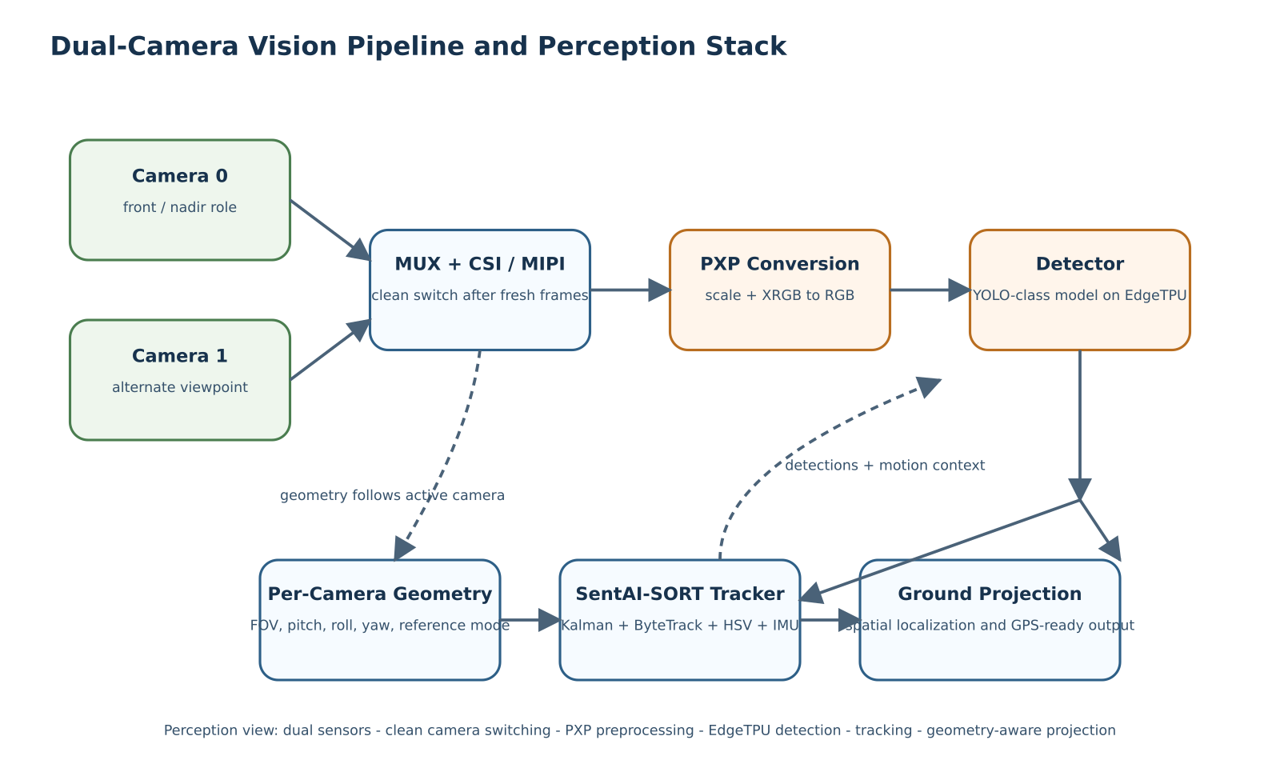

4. Flight Control, Telemetry, and External Integration
The implementation does not stop at perception. A central design goal is to make perception actionable in flight-relevant terms, and this is why the runtime introduces two distinct but complementary control paths: one centered on Bitcraze Crazyflie for indoor experimentation and one centered on PX4-compatible communication through MAVLink for a more standard professional autopilot ecosystem.
The Crazyflie path is valuable because it gives the research platform an immediately usable indoor drone target that is lightweight, inexpensive, and safe to iterate on in constrained spaces. In implementation terms, the runtime exposes high-level flight functions for arming, takeoff, landing, attitude control, hover-like motion, waypoint movement, and basic link validation. The significance of this layer is less in the underlying protocol details and more in the abstraction boundary it creates: the experimental logic written in MicroPython can command a real flying platform without descending into firmware-specific implementation code for every new experiment.
The MAVLink path plays a different role. It positions the same perception and scripting environment toward a standard autopilot workflow, enabling connection to ground-control software and to a PX4-style vehicle architecture. In the implementation, the MAVLink bridge is built around the official message library and a dedicated receive task, with queue-based delivery of decoded telemetry into the runtime. This allows the platform to consume motion, position, and status telemetry while also publishing onboard detections and system messages back to the wider vehicle ecosystem. The result is a credible bridge between a compact onboard perception unit and a more conventional autopilot stack.
This bridge is not limited to a single control primitive. The runtime exposes both transmission and reception semantics at the scripting layer, including reception of autopilot telemetry and chunked transmission of vision payloads that would not fit cleanly into a single small embedded message. That detail matters because it shows the design is meant for sustained exchange between perception and flight software rather than for one-shot demo messages.
This dual-target approach is important conceptually. Many embedded AI demonstrators either remain tied to a single experimental robot or aim immediately at a professional stack without a low-risk iteration platform. Here, the implementation supports both modes. Crazyflie serves as a rapid prototyping platform for indoor validation, while MAVLink provides compatibility with broader drone workflows. From a research standpoint, this strengthens the portability of the proposed autonomy layer.
The communication stack extends further through mesh and backend services. The firmware side includes a compact binary vision message protocol and bridges for wireless dissemination, while the repository also adds backend proxy services that relay, aggregate, and expose telemetry through ground-side interfaces such as MQTT. This is significant because it shows that the implementation is intended to operate as part of a distributed autonomy pipeline rather than as an isolated board demo. Detections are not merely computed; they are structured, transported, and made available to external systems.
In implementation terms, the control and communication layers provide the missing operational dimension of embedded perception. A detector running locally is useful only to a point. A detector that can feed a Crazyflie experiment, inform a MAVLink autopilot context, publish compact messages to external services, and remain scriptable from a high-level runtime becomes much more valuable as a research instrument. This is the level at which the runtime begins to resemble a true onboard autonomy substrate rather than a perception benchmark harness.
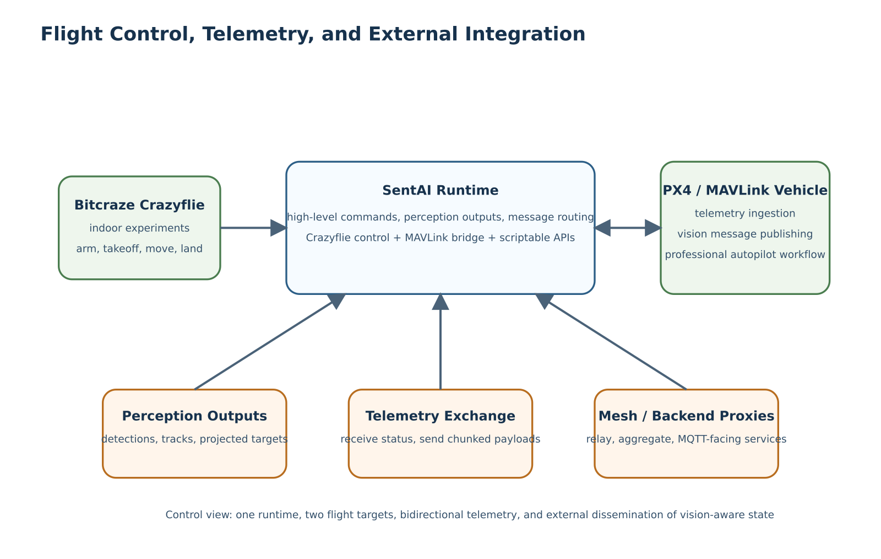

5. Programming Model and User-Facing Runtime Surface
An implementation of this kind must be evaluated not only by its internal efficiency but also by how coherently it exposes its capabilities to the user. This is especially important on MCU-based platforms, where debugging is often more difficult than on Linux-class systems because the developer has less runtime introspection, fewer interactive tools, and a much narrower margin for trial-and-error when something goes wrong during boot or during a real-time task interaction. For this reason, SentAI does not expose a single debugging path, but a small set of complementary connection modes over USB that make the board significantly easier to inspect and operate in practice.
The first mode is an interactive MicroPython REPL available over the serial interface, which allows a researcher or operator to connect directly to the board, inspect the runtime state, execute commands live, load scripts, and request contextual help from within the system itself. This is a consequential design choice: the platform is not only flashed and executed as a fixed firmware image, but can also be interrogated and steered interactively during development and testing. In practice, the REPL becomes the primary entry point for experimentation, rapid diagnosis, and iterative mission design.
The second mode is USB networking over IP, through which the firmware exposes an onboard web server and file-browser interface. This gives the board a lightweight service surface that can be reached directly from the host, making it possible to inspect and transfer artifacts without depending exclusively on the serial console. The third mode is USB mass storage, in which the LittleFS user partition is exposed as a mounted drive so that images, scripts, and models can be uploaded or downloaded directly from the host machine. Taken together, these three USB-facing paths, namely serial REPL, IP connectivity with web access, and mounted LittleFS storage, form a practical answer to the usual debugging and deployment friction of MCU-based systems.
The built-in help interface available from the REPL makes this programming model discoverable without forcing the user to leave the target system. This matters because the runtime is relatively rich: it does not expose a single detector call or a single flight command, but a full namespace of platform primitives intended to support sensing, inference, telemetry, storage, and high-level control from one embedded environment. The same environment also supports script-driven startup through /main.py, which is automatically executed at boot before the interactive session begins. This gives the platform an important dual character: it can behave as an interactive research instrument during development, but it can also behave as a self-starting embedded application once the desired mission logic has been written.
This startup behavior is complemented by a boot logging mechanism implemented directly in the runtime. During initialization, console and driver output are captured into /log/boot.log, while the previous boot log is rotated to /log/boot_old.log. This is an important practical feature for embedded debugging, because many failures on an MCU platform occur before a user can attach interactively to the REPL. By preserving the initialization trace on LittleFS, the system allows the user to inspect the outcome of FreeRTOS bring-up, early peripheral initialization, and startup script execution even after the board has already moved past the failing point.
The sentai namespace organizes the platform into functional modules such as io, rtos, tpu, fs, camera, imu, usb, link, crazy, and pipeline, alongside several other utility interfaces. This structure is significant because it reveals the intended user abstraction: the operator is not expected to manipulate a collection of unrelated firmware endpoints, but to work with a coherent runtime in which device functions are grouped by task and by experimental purpose. The platform can query RTOS state, inspect heap usage, load models, capture or switch cameras, read inertial measurements, start a continuous detector, track objects, communicate over MAVLink, or command a drone, all through a single embedded language environment.
This helps explain why MicroPython is a central implementation choice rather than a peripheral convenience. The interpreter does not replace the lower-level real-time system; instead, it defines a stable experimentation layer above it. The help text demonstrates this duality clearly. On one hand, users access simple operations such as sentai.camera.to_tensor() or sentai.tpu.invoke(). On the other hand, the same interface reaches into advanced platform features such as tracking events, per-camera geometry, ground-plane projection, and MAVLink message exchange. The implementation thereby condenses a complex firmware system into a form that is operable from concise Python scripts.
Several modules are especially important for understanding the research value of the platform. The rtos module exposes runtime observability primitives such as task inspection, CPU statistics, and heap information, which are essential when the system is tuned for sustained real-time throughput. The tpu module provides the basic inference control plane: model loading, tensor access, invocation, quantization metadata, and detector-oriented post-processing. The camera module complements it by managing capture, JPEG export, transfer to the tensor path, runtime camera switching, and frame sequencing. The imu module supplies the inertial measurements needed by viewpoint-aware tracking and projection. The fs and usb modules support a practical workflow in which models, scripts, captured outputs, and debugging artifacts can be transferred to and from the device without rebuilding the firmware for every iteration.
The help surface also shows that these capabilities were designed to be exercised directly from the target rather than only through host-side tooling. Typical examples include immediate tensor feeding from the camera, live detector startup, autopilot connection, or direct Crazyflie flight commands, for example:
sentai.camera.to_tensor()
sentai.tpu.invoke()
print(sentai.tpu.detect())
sentai.link.init(57600)
sentai.pipeline.start(0.3, 0.45, 50, True)
while True:
msg = sentai.link.receive()
if msg:
print(msg)
sentai.crazy.init()
sentai.crazy.arm()
sentai.crazy.fly(0.3, 3000)
sentai.crazy.fly_stop()
At the control and autonomy layer, link, crazy, and pipeline form the most distinctive part of the namespace. The link module exposes MAVLink communication as a first-class runtime capability, allowing the board to exchange telemetry and structured messages with an autopilot or a ground-control system. The crazy module does the same for the indoor Crazyflie target, exposing high-level flight functions directly to Python. The pipeline module unifies the continuous detector, tracker, event stream, per-camera geometry, and pose-aware projection logic into a single interface. Together, these modules reveal the real ambition of the implementation: the embedded AI platform is not only an inference endpoint, but a scriptable autonomy substrate in which perception, communication, and high-level flight behavior can be composed interactively.
The pipeline module is especially illustrative. According to the documented runtime surface, it exposes continuous detection, statistics, tracker snapshots, event streams, configurable association parameters, pose setting, and per-camera geometry. This is not a trivial wrapper around a detector. It is the public face of the deeper implementation presented in the previous subsections: the parallel camera-to-TPU pipeline, the tracking-by-detection logic, and the geometry-aware projection model all become accessible through a minimal but expressive Python API. The same can be said for the link and crazy modules, which reveal that flight and telemetry functions are not separate applications but first-class capabilities of the runtime itself.
From a research-methodology perspective, this matters because it changes the pace and style of experimentation. A researcher can move from firmware bring-up to mission logic, data capture, tracking inspection, and communication testing without leaving the same runtime environment. This reduces iteration cost and makes the platform more suitable for exploratory autonomy research, where control policies, perception thresholds, and communication strategies change frequently.
The built-in help surface also provides indirect evidence of implementation maturity. A platform that documents precise operational behaviors, module boundaries, argument conventions, and example workflows has generally progressed beyond proof-of-concept code. In SentAI, the fact that these capabilities can be explored directly from the serial REPL supports the claim that the implementation has been organized as a reusable experimental environment rather than as a collection of hidden firmware entry points.
The programming model therefore completes the overall argument of the chapter. The EdgeTPU provides the inference power, the MCU and RTOS provide the orchestration, the cameras and IMU provide the sensing context, and MicroPython makes the whole system operable as a research platform. The implementation succeeds not only when it runs efficiently, but when it turns that efficiency into a usable and extensible interface for autonomous drone experimentation.
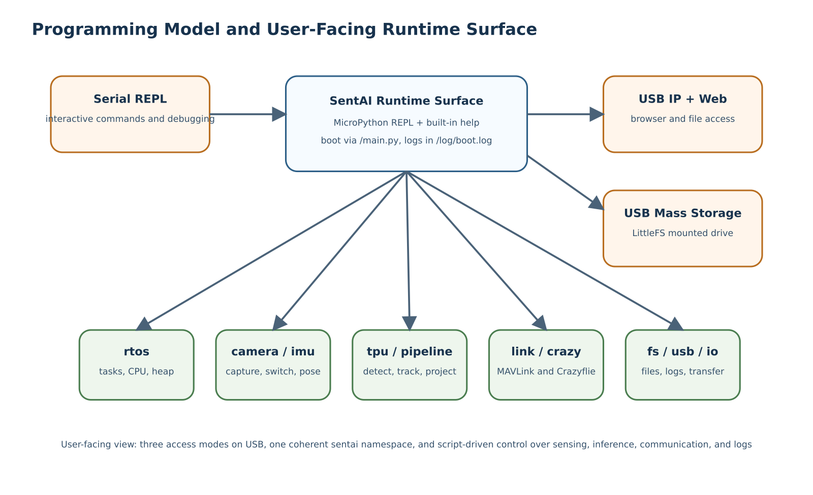

Conclusion
This work presented SentAI as an attempt to push a lightweight open-source embedded AI platform from proof-of-potential toward a more industrialized and production-oriented autonomy stack for drones. The central thesis has been that an EdgeTPU-class accelerator is both energy-efficient and computationally strong enough to justify a tight coupling with an MCU, provided that the surrounding software architecture is designed to keep the accelerator continuously useful rather than intermittently accessible. The resulting system is not a Linux-class companion computer and does not attempt to compete with heavier edge platforms on raw general-purpose flexibility. Instead, it demonstrates that a much lighter board can still support meaningful onboard autonomy when sensing, memory layout, task scheduling, telemetry, and programmability are treated as a single co-design problem.
The implementation extends the original open-source Coral Micro base with a number of capabilities required for practical autonomous drone research: a full MicroPython runtime, dual 5 Mpx cameras, onboard IMU integration, a parallel camera-to-EdgeTPU perception pipeline, lightweight tracking and projection, runtime camera and model switching, interactive debugging and deployment paths, and dual-target control support spanning both Bitcraze Crazyflie and PX4/MAVLink-style workflows. Taken together, these additions transform the platform from a collection of board-level features into a coherent embedded autonomy environment.
One of the strongest conclusions of the work is that the decisive bottlenecks in compact airborne AI systems often appear outside the neural model itself. The main implementation effort was not limited to running inference on the EdgeTPU, but to ensuring that images could be acquired, transferred, staged, quantized, and scheduled in real time without breaking the low-power and low-mass profile of the system. In this sense, the work confirms that production-capable embedded AI depends as much on host-side systems engineering as on the accelerator. Memory placement, ownership discipline, boot-time observability, and developer-facing programmability were all necessary to make the final platform usable.
The platform also contributes a broader methodological point. By combining a task-oriented C++ runtime with a script-oriented MicroPython layer, the system shows that it is possible to preserve real-time discipline while still exposing an experimental interface suitable for rapid research iteration. This is particularly valuable in drone autonomy, where sensing configuration, communication policies, and flight behaviors are rarely fixed early in development. The ability to move fluidly between low-level performance engineering and high-level behavioral scripting is one of the main reasons the resulting system is useful as a research artifact.
Finally, the work suggests that lightweight open-source embedded AI boards should not be viewed only as educational or prototyping tools. With enough attention to integration quality, memory engineering, and runtime design, they can become credible foundations for more demanding autonomous systems. SentAI therefore stands as both a concrete implementation and an argument: there is substantial unexploited value in taking accessible open-source platforms seriously and carrying them further toward robust, production-like embedded autonomy.

Future Work
Several directions follow naturally from the present implementation. A first line of future work concerns completing the symmetry between the two flight targets. Although the platform already exposes both Crazyflie-oriented and MAVLink-oriented control paths, a fuller unification of mission abstractions, telemetry semantics, and safety behaviors across both environments would strengthen the claim of a truly portable high-level autonomy layer. This includes deeper integration with PX4 control modes, more explicit offboard control patterns, and a cleaner common contract between indoor experimental flights and more operational autopilot-driven deployments.
On the perception side, future work should extend the current multi-camera and multi-model logic toward tighter cross-camera continuity. The present system supports runtime camera switching, per-camera geometry, and viewpoint-aware projection, but does not yet provide full track handoff across cameras. A next step would therefore be to reproject existing track hypotheses across viewpoints and preserve track identity when a target moves from one sensor to the other. This would make the dual-camera architecture more than a switching mechanism and turn it into a more integrated multi-view perception system.
A second major direction concerns model deployment. The current work argues for compact YOLO-style detectors and open synthetic pre-training assets, but there remains significant room for improvement in model adaptation, quantization robustness, and scene-specific specialization. Future work could evaluate alternative compact detectors, mixed-model cascades, task-specific switching policies, and better domain adaptation between synthetic and real aerial imagery. In particular, the regulation-aware navigation framing introduced in this work would benefit from models trained not only for general detection, but also for explicit recognition of flight-relevant constraints in inhabited spaces.
Another important direction is deeper optimization of the memory and dataflow path. The current implementation already uses task parallelism, staging buffers, and explicit SDRAM placement, but more aggressive zero-copy strategies, richer DMA-assisted transfer patterns, or compiler-assisted layout optimization may further improve throughput and energy efficiency. The same is true for the host-side interaction with the EdgeTPU: a richer study of tensor residency, batching patterns, or asynchronous execution opportunities could reveal additional performance margins on this class of embedded platform.
The developer experience can also be extended. The current system already provides a serial REPL, IP-based access with a web interface, mounted LittleFS transfer, boot logging, and boot-time execution through main.py. Future work could unify these into a more formal device-management workflow with remote script deployment, structured runtime tracing, automated collection of telemetry and images, and reproducible experiment packaging. Such tooling would be especially useful if the platform is to be used by multiple researchers or integrated into longer experimental campaigns.
At the system level, the project also opens a path toward broader hardware generalization. One of the arguments made throughout this work is that the EdgeTPU is a sufficiently capable low-power inference primitive to justify close integration with an MCU. A natural next step is therefore to explore how much of the present design can be ported to other MCU families, other camera configurations, or future open-source boards with similar accelerator-centric architectures. If successful, this would strengthen the broader claim that lightweight accelerator-plus-MCU designs are a viable class of embedded autonomy platform rather than a single-board exception.
Taken together, these directions suggest that the present work is less an endpoint than a foundation. The current implementation establishes the runtime, sensing, memory, and control abstractions needed for a compact embedded autonomy stack. Future work can now build on this base to improve viewpoint continuity, flight-platform symmetry, regulation-aware perception, deployment tooling, and cross-platform generalization.

Section Source Map
This appendix maps each chapter and implementation subchapter to source material that describes the concepts used in the manuscript. It is intended as a reusable citation-planning artifact for the final MDPI Drones submission.

Abstract
- Embedded accelerator-backed inference on constrained hosts: [@Jouppi2017; @TensorFlowLite2024; @TFLM2024].
- Lightweight onboard UAV autonomy and fully onboard visual navigation: [@Palossi2019; @PX4Docs2024].
- Flight-control interoperability and drone messaging workflows: [@MAVLinkDocs2024; @CrazyflieDocs2024].
- Operational and regulatory framing for inhabited-space drone use: [@EASA2024].

Introduction
- Tradeoffs between low-mass UAV autonomy, onboard perception, and compute budget: [@Palossi2019; @CrazyflieDocs2024].
- Accelerator-centric embedded AI deployment and host-side orchestration: [@Jouppi2017; @TensorFlowLite2024; @TFLM2024].
- PX4-oriented autopilot integration and interoperable telemetry/control links: [@PX4Docs2024; @MAVLinkDocs2024].
- Regulatory framing for low-altitude operations in populated areas: [@EASA2024].

Related Work

Autonomous visual navigation for nano-UAVs
- Onboard autonomy under severe mass and power limits: [@Palossi2019; @CrazyflieDocs2024].

Embedded AI accelerators and systolic-array inference
- TPU-style accelerator design and its deployment implications: [@Jouppi2017; @TensorFlowLite2024; @TFLM2024].

YOLO-family object detectors and compact detection models
- Single-stage real-time detection and later YOLO refinements: [@Redmon2016; @Redmon2018; @Bochkovskiy2020].

MicroPython and high-level programmability on embedded systems
- Embedded scripting for rapid iteration over resource-constrained systems: [@MicroPythonDocs2024; @FreeRTOS2024].

Vision pipelines for drone perception and viewpoint-aware sensing
- Camera interface and embedded image-path concepts: [@MIPI2024; @NXPIMXRT1170RM2024].
- Lightweight tracking-by-detection baselines and embedded-friendly association logic: [@Bewley2016; @Zhang2022].

Open datasets, synthetic data, and regulation-aware navigation
- Operational constraints that motivate regulation-aware perception: [@EASA2024].
- Embedded aerial autonomy context for onboard sensing and decision-making: [@Palossi2019].

Implementation
- Co-design of MCU orchestration, accelerator inference, and developer-facing runtime layers: [@Jouppi2017; @FreeRTOS2024; @MicroPythonDocs2024; @TFLM2024].

1. System Architecture and Design Rationale
- Accelerator-plus-MCU architectures for edge inference: [@Jouppi2017; @TensorFlowLite2024; @TFLM2024].
- RTOS-backed embedded control and task partitioning: [@FreeRTOS2024].
- Scriptable embedded user environments for robotics experimentation: [@MicroPythonDocs2024].

2. RTOS Integration, Memory Layout, and Accelerator Feeding
- FreeRTOS task decomposition, queues, and synchronization primitives: [@FreeRTOS2024].
- Host-side tensor preparation and microcontroller-oriented inference runtime constraints: [@TFLM2024; @TensorFlowLite2024].
- RT1170 memory, DMA, cache, CSI, and PXP concepts: [@NXPIMXRT1170RM2024].

3. Dual-Camera Vision Pipeline and Perception Stack
- MIPI CSI-2 capture and embedded camera-interface fundamentals: [@MIPI2024; @NXPIMXRT1170RM2024].
- Detection and tracking baselines used as conceptual anchors: [@Redmon2016; @Redmon2018; @Bochkovskiy2020; @Bewley2016; @Zhang2022].
- Edge deployment path from captured image to quantized tensor: [@TensorFlowLite2024; @TFLM2024].

4. Flight Control, Telemetry, and External Integration
- Crazyflie as an indoor experimental UAV platform: [@CrazyflieDocs2024].
- PX4 autopilot concepts and vehicle-integration model: [@PX4Docs2024].
- MAVLink messaging and telemetry transport semantics: [@MAVLinkDocs2024].

5. Programming Model and User-Facing Runtime Surface
- Interactive embedded scripting and REPL-oriented workflows: [@MicroPythonDocs2024].
- RTOS observability and runtime diagnostics on embedded targets: [@FreeRTOS2024].
- Filesystem-backed deployment and data persistence on MCU devices: [@LittleFS2024].

Conclusion
- Evidence base for compact onboard autonomy and integrated perception/control: [@Palossi2019; @Jouppi2017; @PX4Docs2024; @MAVLinkDocs2024].

Future Work
- Portability across flight stacks and autopilot ecosystems: [@PX4Docs2024; @MAVLinkDocs2024; @CrazyflieDocs2024].
- Further optimization of dataflow and inference pipelines on MCU-class targets: [@TFLM2024; @TensorFlowLite2024; @NXPIMXRT1170RM2024].
- Regulation-aware autonomy and operational constraints in inhabited spaces: [@EASA2024].

