# Project specifications

Debate Web Application

Bogdan Stupariu

Group: 30441

Table of Contents

Project specifications 1

1. General project description 2

2. User roles 2

2.1. Guest 2

2.2. Regular user 2

2.3. Administrator 2

3. Project functional requirements 3

3.1. Registration 3

3.2. Debates 3

3.3. Opinions 3

4. Project non-functional requirements 4

# 1. General project description

Implement a web application for online debates. The web application should have three types of users: visitor (not registered on the website), regular user (registered on the website) and administrator.

The main concept behind are the debates. What makes them different from a forum, are the following aspects: Each debate is help by exactly two users, under a specific format (Three statements for each user, alternatively), with time limitations (for each statement/written speech/part, there is a limit of time to submit). Other users (regulars or guests) judge the debate.

The idea comes from the similar American website debate.org and should have, as future developments, all the other functionalities.

# 2. User roles

## 2.1. Guest

The guest can perform the following operations:

* Register on the website
* Search for debate themes and access their content: search made after other users, debate theme category, debate subject
* Search for opinions
* Interact with other user’s debates: Vote the result of debates made by other users.
* Vote for opinions pro or con

## 2.2. Regular user

The regular user can perform the following operations:

* Interact with other user’s debates: Vote the result of debates made by other users, add comments, suggestions, and arguments on ended debates (under comment form).
* Open a debate: Propose a debate subject and wait for other user to join in the debate. After a user joins (accepts the challenge) and start the rounds in the debate.
* Join a debate: Enter in an already proposed debate and start the debate round.
* Open a new opinion: propose a theme to be under discussion with arguments
* Vote for opinion: vote pro or con on an opinion, add arguments for one side

## 2.3. Administrator

The administrator user can perform the following operations:

* CRUD on user accounts
* CRUD on debates
* Accept or reject debate or opinion subjects: each subject has to be under this action, in order not to allow racist, xenophobic etc. subjects to be proposed.
* Delete and censor unappropriated content on website

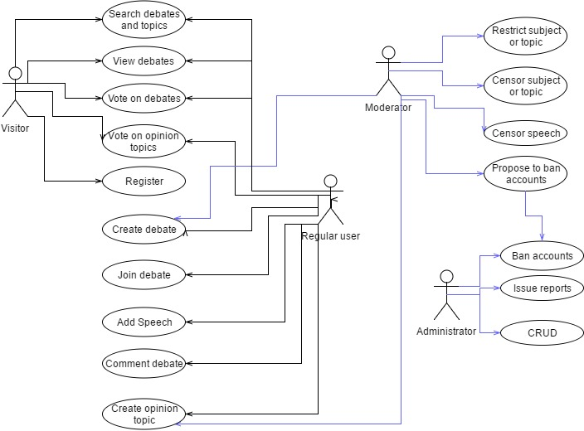

# 3. Project functional requirements

## 3.1. Registration

* Should provide registration and authentication services
* Should provide verification for email authenticity – send confirmation email and verify it by code/link

## 3.2. Debates

* Should have 3 states: waiting for player, running and closed (done).
* Running state should be on timer -> automatically pass from one state to another
* Should send mail to users when they have to post a speech
* Should provide a wysiwyg text editor -> users should have the possibility of editing text format when posting a speech
* Should count votes for pro or con and determine the winner

## 3.3. Opinions

* Should compute the percentage of votes for and con an opinion
* Should permit to be added pro or con arguments for an opinion

# 4. Project non-functional requirements

* Response time should be under 3 seconds at first load and under 0.5 second when changing between pages (having a decent network connection)
* Should provide strong security for authentication
* Should run on any browser
* Should be UI responsive – adapt to phone/tablet
* Access security – Backend calls should be secured against direct unauthorized HTTP calls
* Confidentiality – Should only give access to database content to administrator
* Usability – Should offer guideline for main functionalities