Extranet
Rulehearing

System for external reviewing
of
DNV GL Rule Proposals

Design Specification and

System Documentation

Version 2.2

MApp ID 2977
DocuLive ID 38708/OSLA

Det Norske Veritas
February 2015

0 What's new 4
0.1 Version 2.0, July 2005 4
1 List of application items & configuration items 5
2 Requirements specification 7
2.1 General requirements 7
2.2 System specification 7
2.3 Availability and support requirements 8
3 System documentation 9
3.1 Application location (March 2015) 9
3.2 Database (March 2015) 9
3.3 Access control 9
3.4 Error handling 9
3.5 Safe document storage 10
3.6 Document upload - Upload_Files_Without_COM_v3.zip 10
4 Test & verification reports 11
5 User guide 12
6 'Rulehearing' Database 13
6.1 Tables 13
7 User interface 14
7.1 Reviewer screens - for regular members 14
7.2 Document administration screens 17
7.3 User administration screens 20
8 Maintenance issues 22
8.1 Adding a member to a hearing body – UsersInsProc 22
8.2 Users table - passwords 22
8.3 HearingBodies table 22
8.4 global.asa 22
8.5 include/globals.inc 22
8.6 include/dbConnection.asp 22
8.7 include/Functions.inc 22

Document history

Ver. | Changes | Applies to | Author | Date
1.0 | Document created | Whole document | Bo Johanson | Sept. 2004
2.0 |  |  | Bo Johanson | July 2005
2.1 | 8.1 UsersInsProc |  | Bo Johanson | May 2013
2.2 | New servers for web and database |  | Bo Johanson | February 2015

MApp ID 2977
DocuLive ID 38708/OSLA
Development records are located at
\\Osl028\dfs\OrgUnits\Mstno231\Rules Secretariat\HOTI approval documentation\E_HOTI

What's new

Version 2.0, July 2005

Archive of hearing documents
Functionality for viewing archived hearing documents together with their comments and post-hearing annexes (e.g., minutes of design review).
- Consequences for the database are a new table RPAnnex and a new column DateArchived in the table RuleProps.
- For the user category reader/reviewer, the consequences are the new page AnnexList.asp plus minor changes to ruledocs.asp, review.asp.
- For the user category administrator (i.e., the Rules Secretariat), the consequences include
- new pages in the DocAdm folder:
  - ArchiveRP.asp
  - AddRPAnnex.asp - AddRPAnnexAction.asp
  - UpdateRPAnnex.asp - UpdateRPAnnexAction.asp
- modified pages in the DocAdm folder:
  - UpdateOrRemoveRuleDocs.asp
  - UpdateRuleDoc.asp - UpdateRuleDocAction.asp
  - RemoveDocAction.asp

Database normalisation
"Repeated groups" have been eliminated in three tables, i.e. columns with value lists have been replaced by indexing tables and foreign keys. The eliminated colums and their replacement tables are:
Table/eliminated column | New indexing table
Users/HearingBodiesMembership | HB_Membership
RuleProps/ToHearingBodies | RestrictedRuleProps
Comments/HearingBodies | RestrictedComments
Virtually all ASP files have been modified to accommodate these changes to the database .

Minor issues related to security and integrity
Minor code changes have been made to reduce vulnerability to "cross site scripting" and "SQL injection". The changes affect several ASP files.

List of application items & configuration items
This document describes DNV GL's Extranet application Rulehearing. The application is used by invited members of DNV GL's Technical Committees and other hearing bodies, to review and comment DNV GL's rule proposals and other Rules related documents subject to external hearing.
Extranet Rulehearing is derived from the internal intranet application with the same name. The user interface is very similar to the intranet application

The application is built on the Active Server Pages (ASP) platform and coded in VBscript and the occasional Javascript. The application items include:
- Web site (production)
- http://rules.dnvgl.com/rulehearing/
- Web site (development and maintenance)
- http://rules-test.dnvgl.com/rulehearing/

- Essential subfolders and files:
Folder | Files | Description
(root) | default.asp | Redirects to ct/default.asp, switching to https:
(root) | global.asa | empties the "document buffer" at application start
ct/ | default.asp | Sign-in (login) screen
ct/ | ruledocs.asp | Menu of Rule Proposals (RPs)
ct/ | review.asp | Shows a Rule Proposal with its comments  Contains the form to submit comments.
ct/ | comments.asp | Comments to a Rule Proposal - frame of review.asp
ct/ | addComment.asp | Submit comment to RP - frame of review.asp
ct/ | AnnexList.asp | List of annexes to archived RP - frame of review.asp
ct/ | AdminMenu.asp | Tools menu for application administrators
ct/ | SelectAudiences.asp | Specify target Hearing Bodies for RP or comment
DocAdm/ | AddRuleDoc.asp | Upload an RP document and enter document info
DocAdm/ | AddRuleDocAction.asp | --"--
DocAdm/ | AddRPAnnex.asp | Upload an annex to an RP document
DocAdm/ | AddRPAnnexAction.asp | --"--
DocAdm/ | ArchiveRP.asp | Archive/Un-archive an RP document
DocAdm/ | cls*.asp | Server side support for file upload. See chapter 3.6.
DocAdm/ | RemoveDocAction.asp | Delete an RP along with its comments
DocAdm/ | UpdateOrRemoveRuleDocs.asp Menu of RPs to update or delete
DocAdm/ | UpdateRuleDoc.asp | Update info on RP; upload revised document
DocAdm/ | UpdateRuleDocAction.asp | --"--
DocAdm/ | UpdateRPAnnex.asp | Update info on RP annex; upload revised annex
DocAdm/ | UpdateRPAnnexAction.asp | --"--
UserAdm/ | AddUser.asp | Add new userID
UserAdm/ | AddUserAction.asp | --"--
UserAdm/ | UpdateOrRemoveUser.asp | Modify or delete existing userID
UserAdm/ | RemoveUserAction.asp | Delete existing userID
UserAdm/ | UpdateUser.asp | Modify existing userID
UserAdm/ | UpdateUserAction.asp | --"--
include/ | dbConnection.asp | ADO connection string
include/ | Functions.inc | Common server ASP code
include/ | Globals.inc | Global declarations and varables
include/ | main.css | Common style sheet
include/ | md5_PAJ.js | The MD5 algorithm to encrypt users' passwords
include/ | popup.asp | "Pops up" a confirmation dialog box
include/ | SelectAudiences.inc | Common code for the "Select Audience" function
include/ | topright.asp | Common elements to (almost) all ASP pages
docbuf/ | temporary copies of RP documents | Buffer area for RP documents - see 3.5 "Safe document storage"
"RP doc repository" | RP documents | Logically separate storage folder - see 3.5 "Safe document storage"

Requirements specification

General requirements
The main objective of the Extranet Rulehearing is to replace the e-mail and paper based hearing process by a common "review centre" on the internet.

Functional requirements
- Provide a closed review centre for hearing documents. Invited members only.
- Register members' comments to hearing documents
- Present submitted comments to other members
- Provide archive of hearing documents with minutes from design reviews
- Administration tools for adding, modifying and deleting hearing documents and comments by Rules Secretariat staff
- Administration tools for adding, modifying and deleting application userIDs, passwords and other user particulars
- Moderate level of protection against "hacking", particularly
- unauthorized access to documents, comments and user particulars
- database intrusion, particularly SQL injection techniques
- cross-site scripting

Responsibilities
See also Ver-IT approval checklist.
- DNV GL's Rules Secretariat owns this application. In 2015, that's MCCNO831. Sille Grjotheim represents the owner.
- Main re-developer of the application in 2004 was Bo Johanson, Web Service Centre at UCTNO933 (2004), building on the intranet version originally built in 2002 by Torgeir Punnerud and Fredrik Mæhlum (CGE&Y) on behalf of the Rules Secretariat.

System specification
The application is located on rules.dnvgl.com - a DNV GL internet/extranet host running on Microsoft's Internet Information Server (IIS). Rulehearing uses a custom built system for login and access control, and uses encrypted communications between server and web browser under the SSL protocol (Secure Sockets Layer - https:).
On the server side, the application is built on the Active Server Pages (ASP) platform and coded in VBscript and the occasional Javascript. The application was developed and implemented on IIS v.6. No extra server components are required.
Rulehearing's database resides in a Microsoft SQL Server. The database contains Rule Proposals metainformation, comments to the hearing documents and the user database for access control. The application uses the standard Windows ADO interface to the database.
A reasonably modern, standard web browser is required to use the application. Rule Proposal documents are provided in the PDF file format, so Adobe Acrobat (Reader) is required. Some client javascripting is used. Cookies must be enabled. Rulehearing has been tested with Internet Explorer v.6, Mozilla v1.7 and Mozilla Firefox v.1.0.

Availability and support requirements
Rulehearing is not a production critical application. The availability requirements are moderate/uncritical. Høvik office hours are sufficient for 2. line support. DNV GL's regular IT support model and channels are used.

System documentation

Application location (February 2015)
Production:
URL: | http://rules.dnvgl.com/rulehearing
Windows share: | \\osl2347.external.dnv.com\rulehearing$. UserID on domain "external"  \\osl2347.external.dnv.com\Site01 (temporary). For external\admbgj
File system path | \\osl2347.external.dnv.com\Site01\Rulehearing
RP document repository | osl2347 - D:\RulehearingDocs
Development, maintenance:
URL: | http://rules-test.dnvgl.com/rulehearing
Windows share: | \\osl2348.externaltest1.dnv.com\Site01 (temporary). For externaltest1\admbgj
File system path | \\osl2348.externaltest1.dnv.com\Site01\Rulehearing
RP document repository | osl2348 - D:\RulehearingDocs

Database (February 2015)
Production:
Database Name: | Rulehearing | The application specific database
Database server: | osl1768.verit.dnv.com, SQL Server 2012 (v11)  verit\admbgj is dbo | Running on Win Server
UserID: | srvrulehearing
Password: | refer to include/dbConnection.asp
Development, maintenance:
Database Name: | Rulehearing | The application specific database
Database server:
UserID: | srvrulehearing
Password: | refer to include/dbConnection.asp

Access control
A custom logon and access control system has been built, storing user credentials in the applications "Users" database table. Passwords are encrypted with the industry standard MD5 hashing algorithm. The web server and web browser communicate by the encrypted standard SSL protocol (https:).
Users are forced to change their initial password at first logon. The password must then be changed at regular intervals, initially set to maximum 1 year.
Users are assigned membership in various groups according to which "hearing bodies" they are members of. DNV GL's Technical Committees are the main hearing bodies. There are two special user groups for system administration and document administration. These admin groups have tools and privileges to add and delete Rule Proposal documents along with their comments and metadata. The admin groups also have tools and privileges to maintain the user database.

Error handling
Upon any serverside error (including database access errors), the user is taken back to the initial sign on screen. To prevent "hacker analysis" of the application and its database, no error details are disclosed to the user.

Safe document storage
Rule Proposal documents are restricted, and measures have been taken to prevent unauthorized individuals from accessing them by simply guessing at an internet address (URL). When uploading a Rule Proposal document, the document gets stored in a "document repository"- a file folder logically separate from the web application, inaccessible by means of a URL (internet address). The path to this document repository folder must be declared in the file include/globals.inc, assigned to the variable strDocRepository.
When a legitimate user wishes to review a document, it is copied by the application to a temporary buffer area which is "visible" via a URL and sent to the web browser from there. The temporary document buffer area is periodically deleted.

Document upload - Upload_Files_Without_COM_v3.zip
The 3rd party package "Upload_Files_Without_COM_v3.zip" is used for uploading Rule Proposal documents to the document repository, Source code and documentation for the package has been included in the application's DocuLive archive. The package was available in 2004 at the author's web site http://www.lewismoten.com. See http://www.lewismoten.com/LewiesCodeLibrary/Details.htm?folder=ASP/UploadFilesWithoutCOMv3.

Test & verification reports
Testing has been done by Mike Dyer, MSTNO231.

User guide
The application is believed to be self-explaining, so no user guide has been provided..

'Rulehearing' Database
The application uses a SQL Server database, named Rulehearing. It holds Rule Proposal metadata, reviewers' comments to the Proposal documents, and user/access control data. The actual Rule Proposal documents are not stored in the database, but on a file server location separate from the application web site.
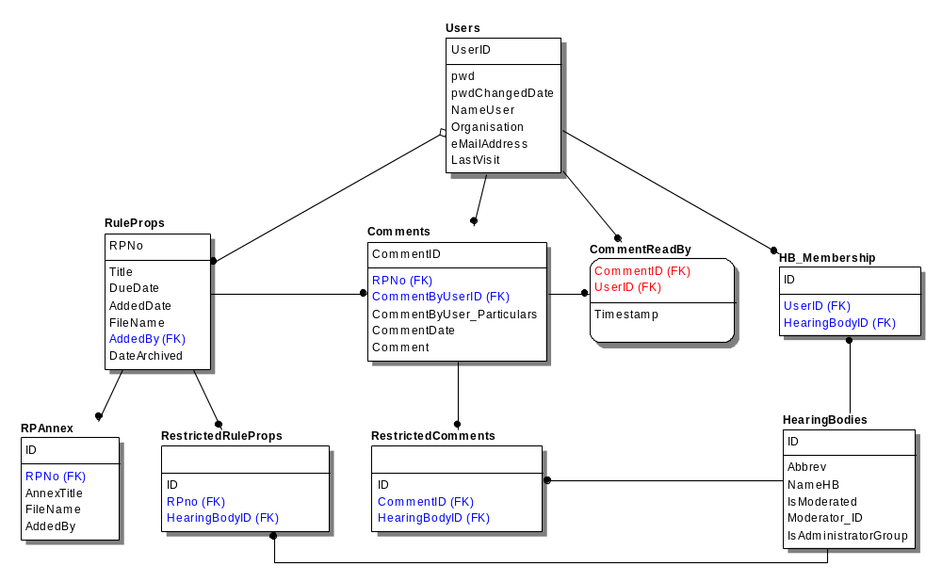
Figure ‎6-1 Data model

Tables
Table | ID field | purpose
Users | UserID | Members, allowed to sign in
HearingBodies | ID | Tech. Committees, sysadmins and other user groups
RuleProps | RPNo | Rule Proposals
Comments | CommentID | Reviewers' comments to Rule Proposals
CommentReadBy | – | What comments was read by which users

User interface
Only invited members may use the application. DNV GL's Rules Secretariat maintains the user database.

Reviewer screens - for regular members
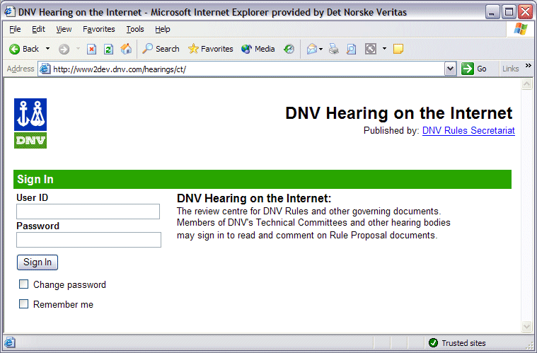
Figure ‎7-2 Sign in - ct/default.asp
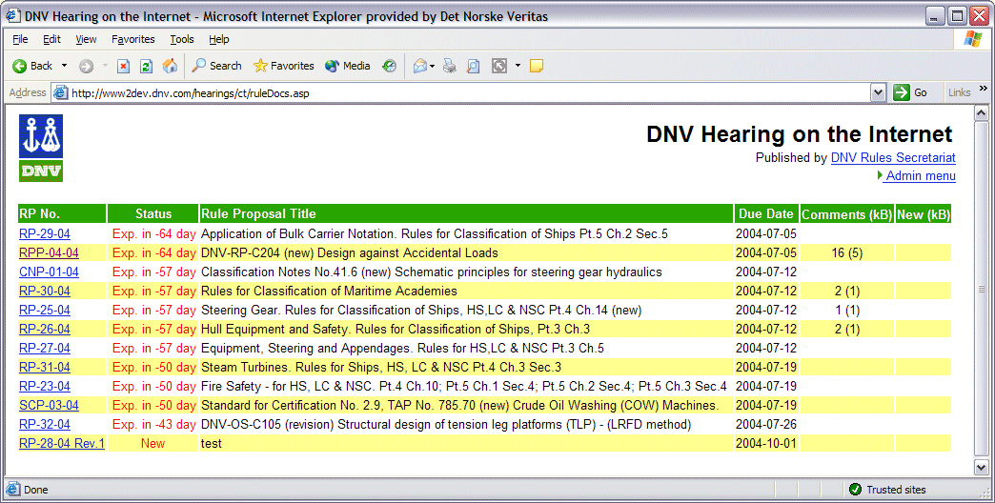
Figure ‎7-3 RuleDocs.asp - List of Hearing Documents
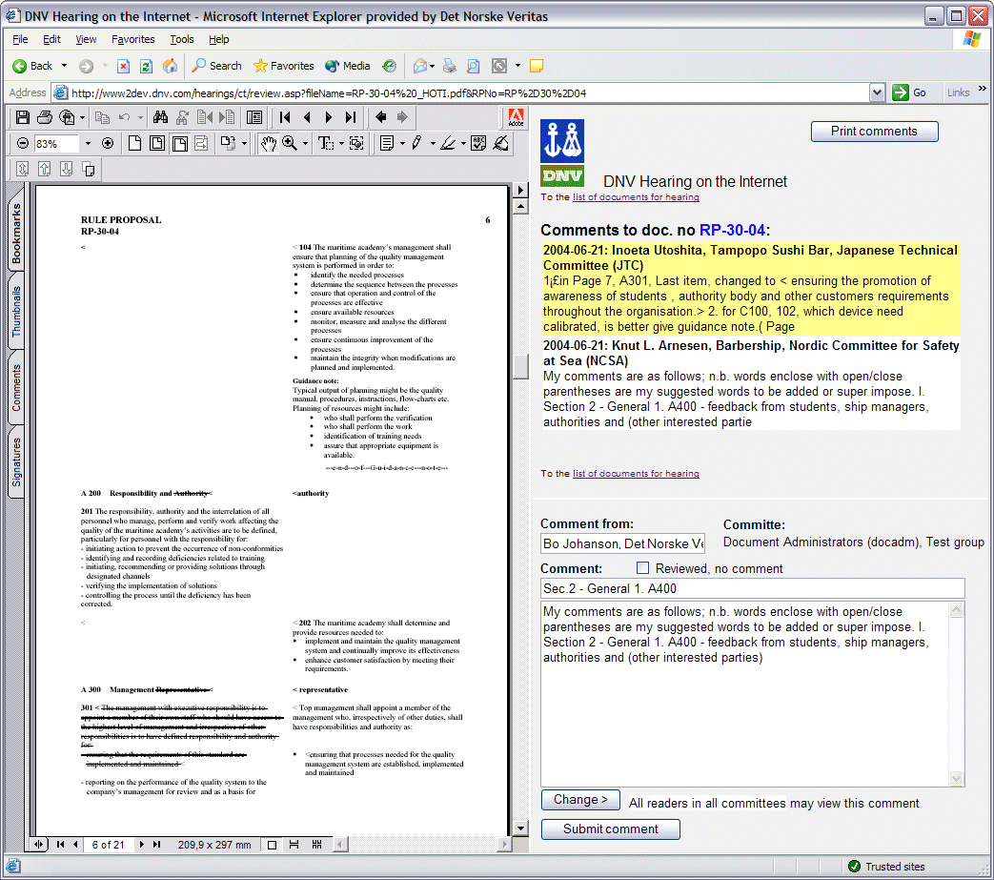
Figure ‎7-4 Review.asp - Reviewing Screen
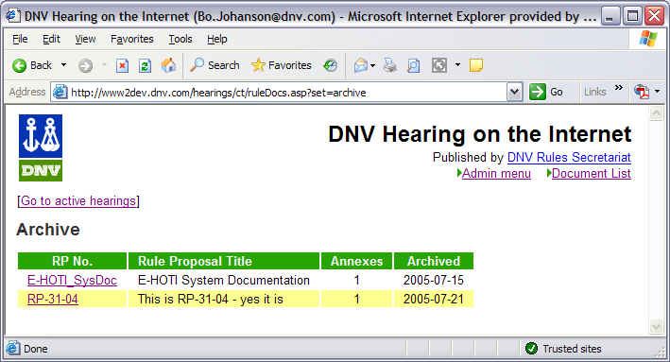
Figure ‎7-5 RuleDocs.asp (archive) - List of Archived Hearing Documents
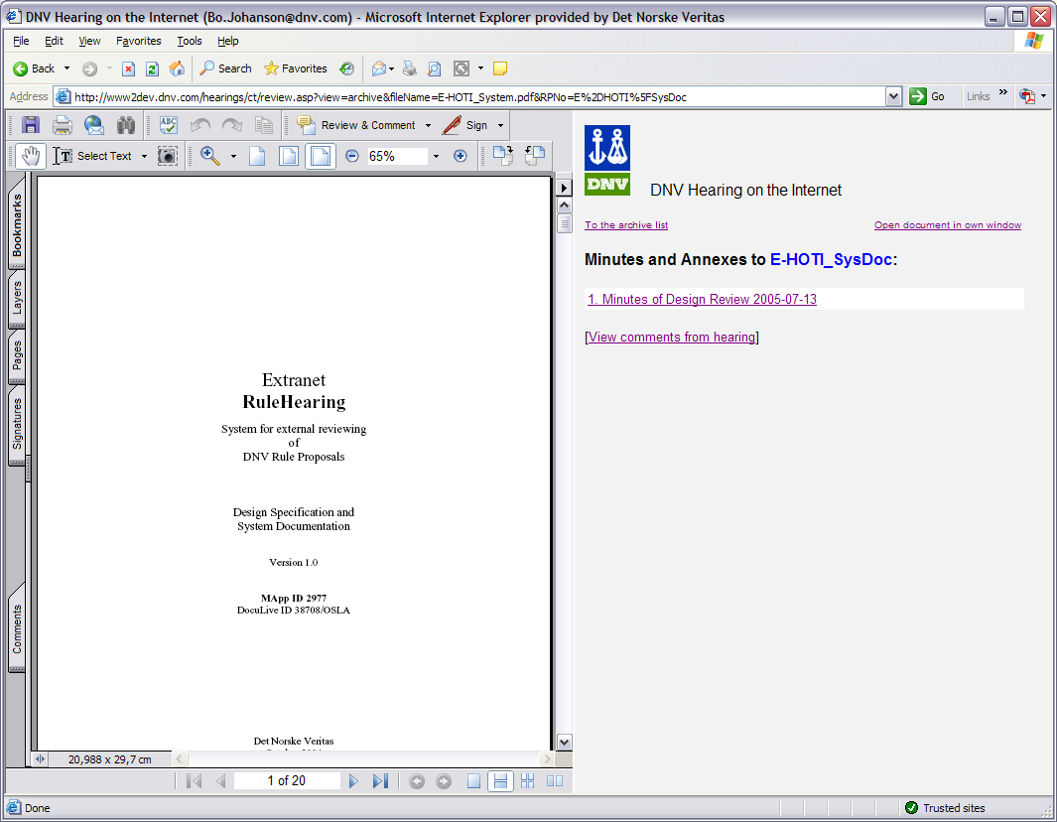
Figure ‎7-6 Review.asp (archive) - Reviewing Screen for Archived Hearing Documents

Document administration screens
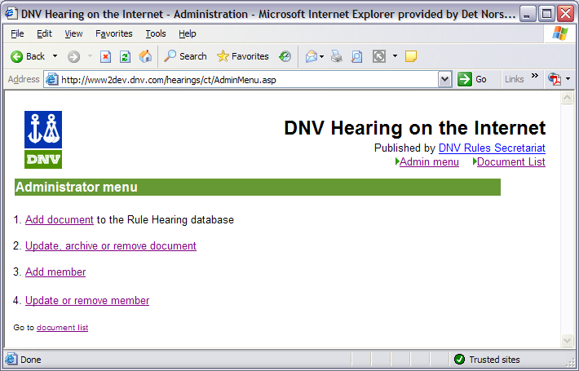
Figure ‎7-7 AdminMenu.asp - Administration Tools
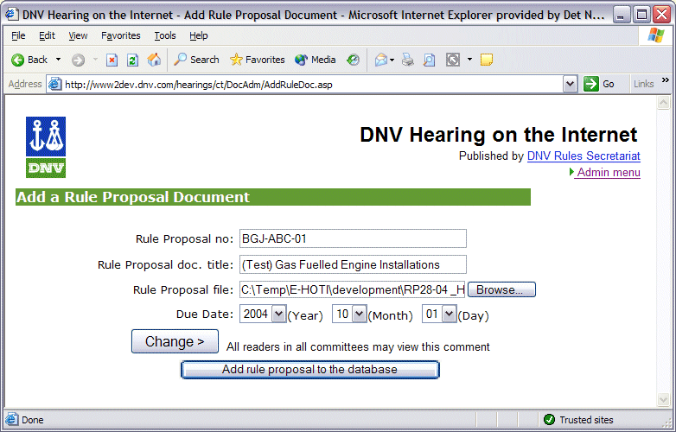
Figure ‎7-8 AddRuleDoc.asp - Add Rule Proposal document
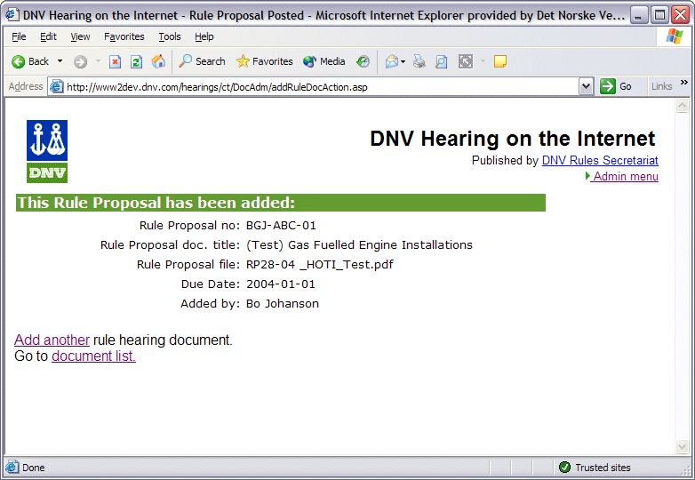
Figure ‎7-9 AddRuleDocAction.asp - Receipt
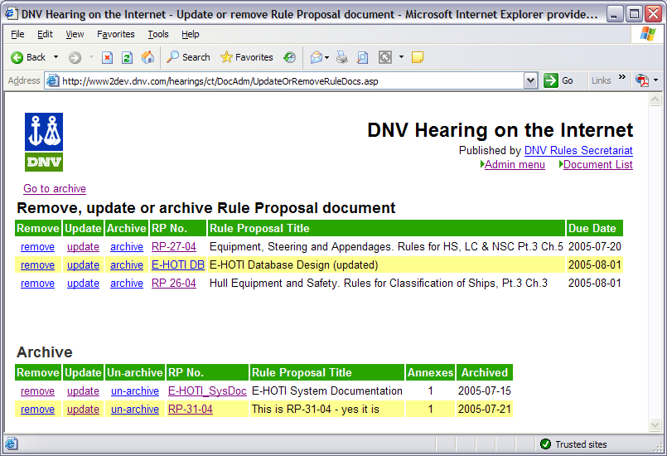
Figure ‎7-10 UpdateOrRemoveRuleDocs.asp - Menu of RPs for Update, Archive or Delete
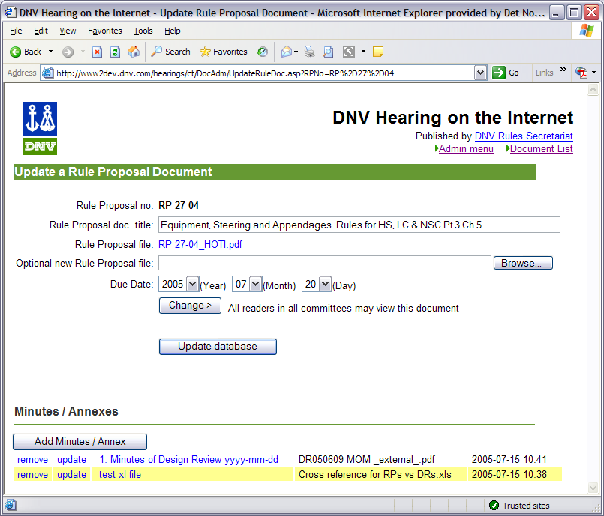
Figure ‎7-11 UpdateRuleDoc.asp - Modify Rule Proposal info, Manage Annexes
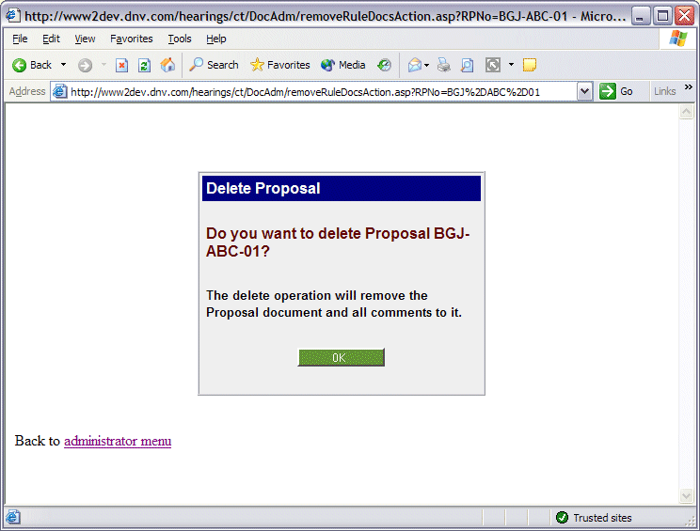
Figure ‎7-12 RemoveRuleDocAction. asp - Delete RP

User administration screens
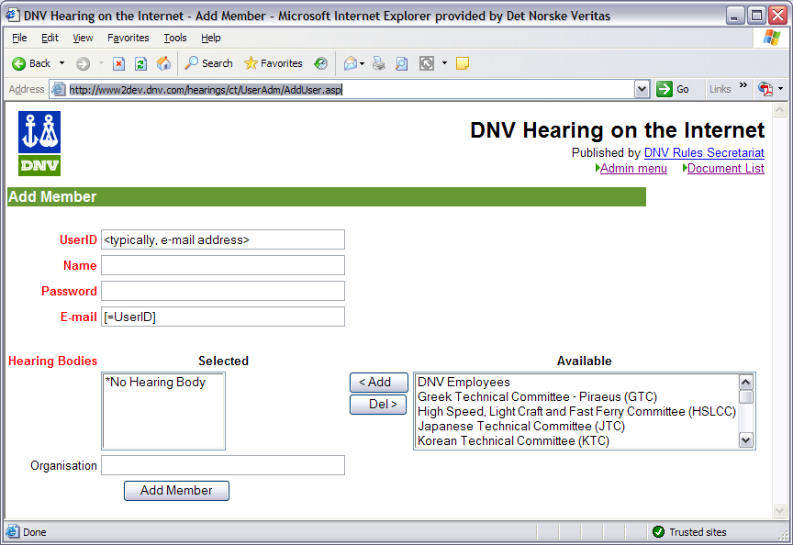
Figure ‎7-13 AddUser.asp - Add user
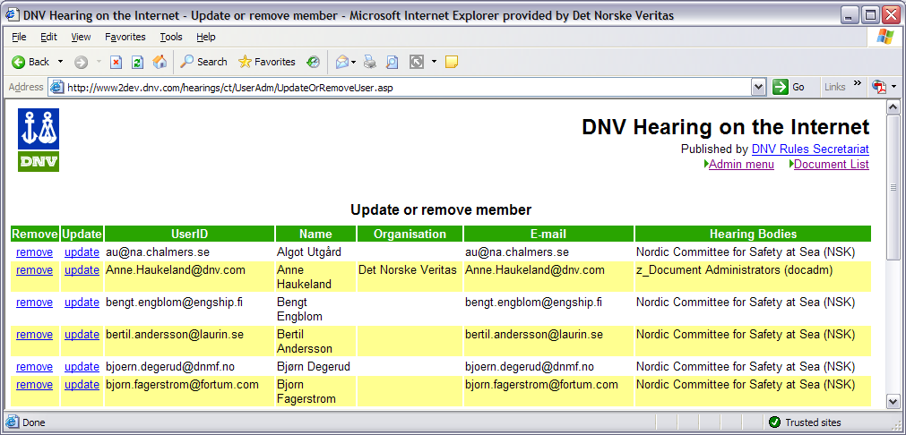
Figure ‎7-14 UpdateOrRemoveUser.asp - Remove userID, or Go Update User Information
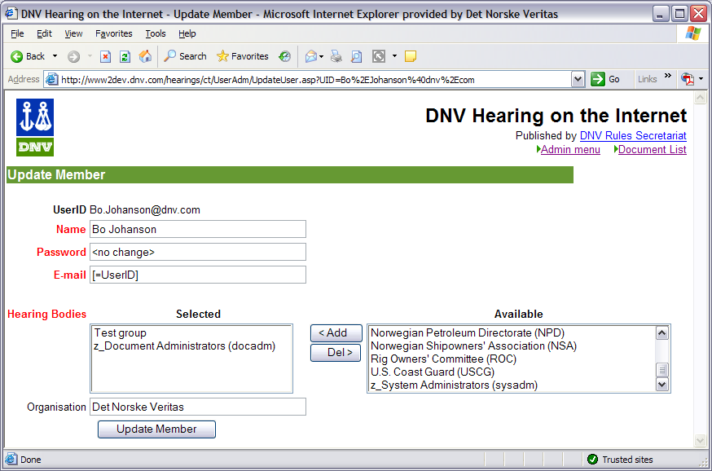
Figure ‎7-15 UpdateUser.asp - Update User Information

Maintenance issues
- "Collective userIDs" must have IDs beginning with "Member_". Application code for distinguishing collective IDs depend on that presumtion.
- Collective userIDs are not subject to automatically enforced change of passwords. Nor are they allowed to change passwords.
- Establish "document repository" folder where original documents are to be uploaded.
- sysadm and docadm must have "list, create, modify and delete" privileges on doc. repository folder
- docbuf folder: anonymous must have "modify" files privileges - (which include "create" and "delete")
- Initial password: DnV140RS
Encrypted with the MD5 algorithm, this initial password is stored in the database as: f3c37c7fc7285334fedac0fad00cbda1

Adding a member to a hearing body – UsersInsProc
EXEC UsersInsProc <user name>, <user organisation>, <user email address>, <hearing body ID>
user name: | the member's full name: surname family name, e.g., 'Svein Solbakken'
user organisation: | the organisation/company that the user represents, e.g., 'Kongsberg Maritime AS'
hearing body ID: | the ID field (an integer) of E-HOTI's "HearingBodies" table, for the corresponding hearing body. E.g., "DNV Pipeline Committee" (DPC) has ID = 27
Example:
EXEC UsersInsProc 'Svein Solbakken ', 'Kongsberg Maritime AS', 'svein.solbakken@kongsberg.com', '27'

Users table - passwords
The stored passwords are encrypted ("hashed") with the MD5 algorithm. To manually change a password in the database, the password must be MD5-encrypted. There are several MD5-encrypters on the internet that may be used, i.a. at http://pajhome.org.uk/crypt/md5. Rule Hearing's MD5 program code was downloaded from that web site.

HearingBodies table
How to maintain the HearingBodies table, including cleaning HB_Membership, RestrictedRuleProps and RestrictedComments.

global.asa
Update file system path for "strDocBuffer" - the temporary document buffer area.

include/globals.inc
Update file system path for "strDocRepository" - the RP document repository. See 3.5 - "Safe document storage"

include/dbConnection.asp
Update data connection specification and credentials

include/Functions.inc

