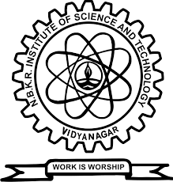 | NBKR INSTITUTE OF SCIENCE AND TECHNOLOGY  (AUTONOMOUS)  Accredited by NAAC with ‘A’ Grade, Accredited by NBA  Approved by AICTE & Recognized by UGC, New Delhi  Affiliated to JNTUA, Ananthapuramu  Vidyanagar, Kota Mandal,  S.P.S.R. Nellore District, Andhra Pradesh – India: 524413  Website: www.nbkrist.org / E-mail: ist@nbkrist.org  Phone: +91-8985382247, +91-8985159547

Date: April 18, 2026
BONAFIDE CERTIFICATE

This is to certify that the student detailed below is a bonafide student of our institution, NBKR INSTITUTE OF SCIENCE AND TECHNOLOGY.
Name of the Student | : BOGGAVARAPU MANOJ KUMAR
Reg. No. | : 25KB5A0528
Degree | : _Bachelor of Technology ______________
Branch | : Computer Science and Engineering
Period of Study | : From MM/YYYY 08/25 to 05/28 MM/YYYY
Present Academic Year | : 2nd Year_4TH _Semester
CGPA (or) % of marks | : 7.90 out of 10
Issued for the purpose of | : ___Internship__ _
Requested duration | : 1 Months 16 Days

He is permitted to apply for and undertake the above-mentioned purpose. His character and conduct have been found to be good.
[Signature Placeholder Space]

Signature of HoD

Name: Prof Hari BABU Mutchakala

(Institution Seal)

