Medicinereminder2 Version 1.0.0
Documentation

Medicinereminder2 is a simple application to help keep track of your medication / pills , so you don’t forget taking them, or forget that you took them , then take them again , which is not good.

This application is completely anonymous , it does not track you nor does it store data beyond your pills setup and daily progress information, in it’s current setting, it will remember this information for 2 days , then automatically forget them.

Medicinereminder2’s source code can be found at https://github.com/bogi99/medicinereminder2
you can check the source code or have your programmer friend check it for you. Also, you can install it on your own web server and run a private self hosted instance in your home basement or a vps you can rent. I have it running at https://medicinereminder.ca/ you can also use that.

This documentation is for the end user, not for installing and hosting your own instance , that will be provided in another document.

Medicinereminder2 can be accessed using a browser, any browser really , each browser , on your desktop , laptop , phone , smartwatch is an independent entity, and they won’t sync, since they don’t know who you are. Medicinereminder2 upon contact doles out a unique id to your browser that made the contact only, so your first view would look like this. Note I use dark mode, so the color scheme on your device may look different.

As you may see, you will need to create a pill schedule , there ar 2 ways to do that, but since this is the first time , and you have an empty session , you will need to click on the Setup menu, or the setup link to start setting up your medication schedule. So let’s go the the setup page. | 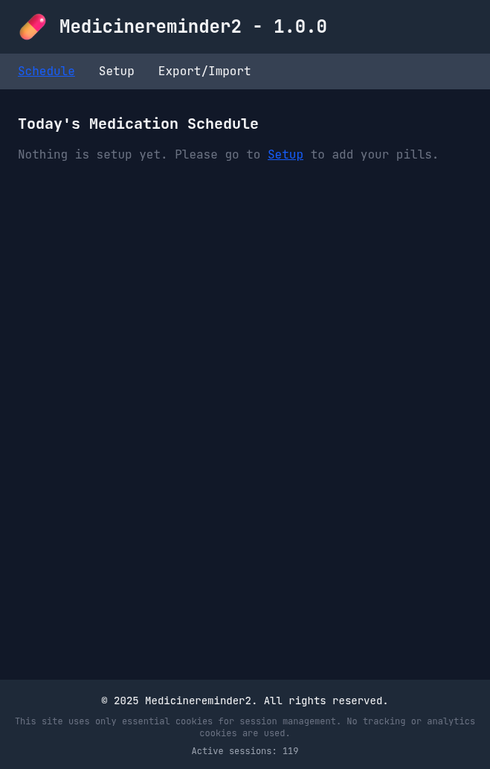
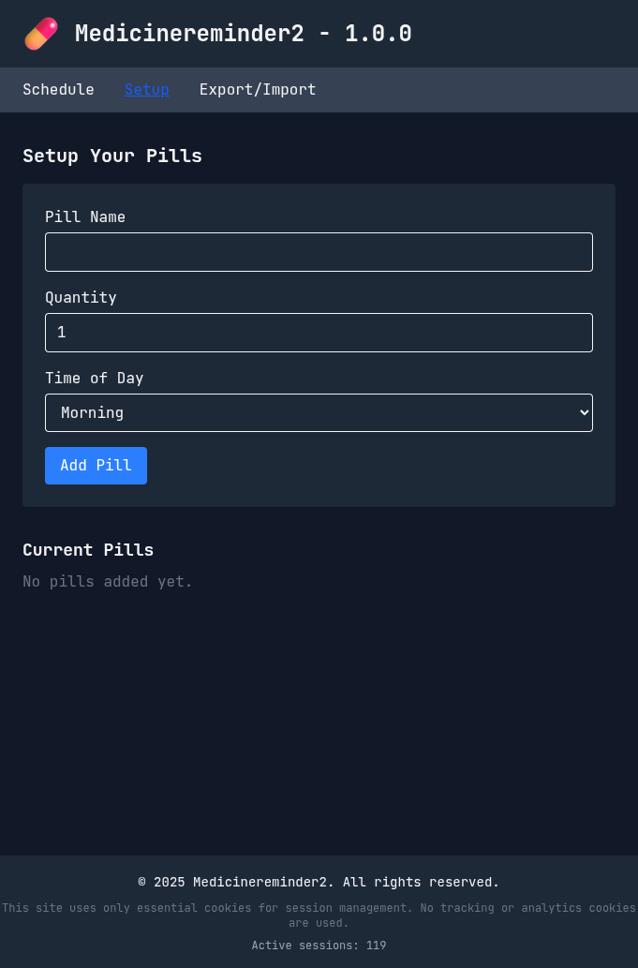 | This is your setup page, you can type in the name of your pill or indeed an action , like do 30 pushups for pill name, set the quantity , default is one obviously, then use the dropdown to set which time of the day this action needs to happen.  When ready, click on the Add Pill button, this will add your pill to your daily schedule.  We can move to the next slide.
Great, you have added your fist, maybe your only pill of the day and you can see it listed on the bottom of the page. You may repeat the previous step to add another pill or action, but also, you may delete that pill from the schedule or edit it, to change the quantity or maybe you had a typo in the name, or designated the wrong time of day.  Next we should take a look at the edit slide. | 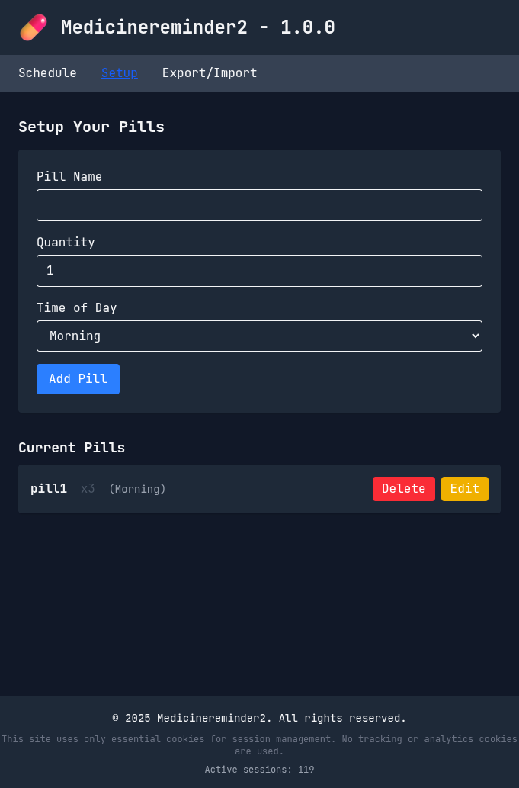
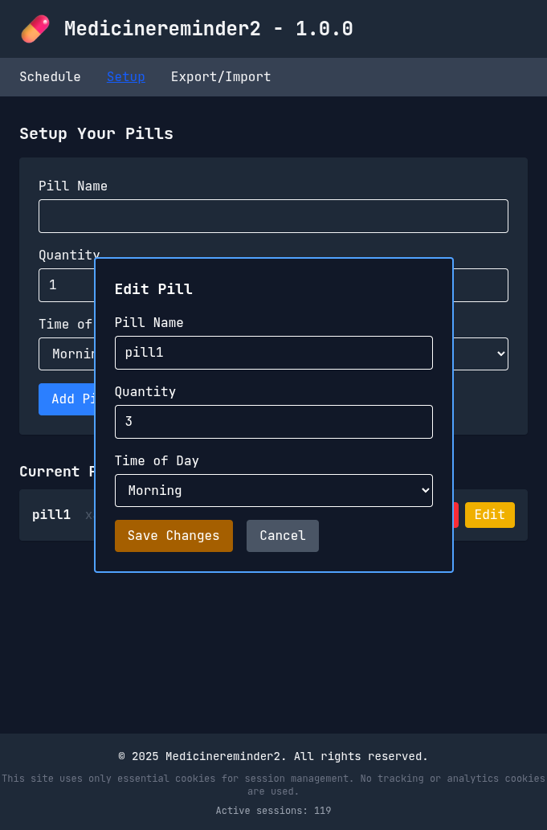 | This is your edit screen, you can change the parameters and name of the pill you selected for editing , when satisfied, you can click save changes button , or leave it unchanged by clicking cancel.
Now you can go back to the very first page, and it is not empty anymore, you have created your schedule and now you can commence following it, note the gorgeous progress bar at the top informing you at a glance of your progress taking your daily pills.  Initially the progress bar will be at 0% and the button next to your pill will say Take not Taken it will also be blue not green. More easy to follow visual cues to check your progress.  Once you finished your day, you can press the Reset Day red button, this will restart your day and you can commence following the daily routine from the beginning, a new day, a new set of pills to take. | 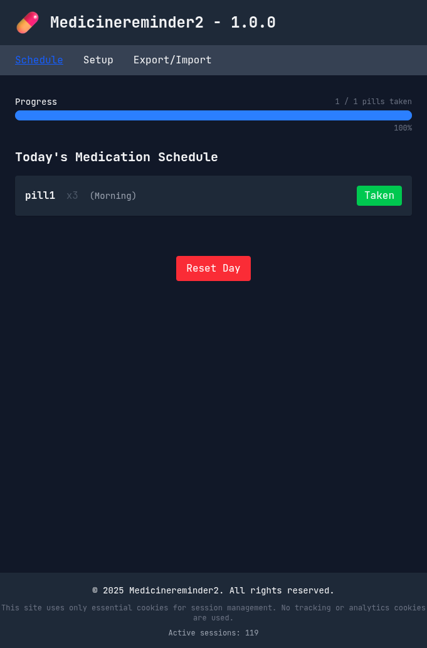
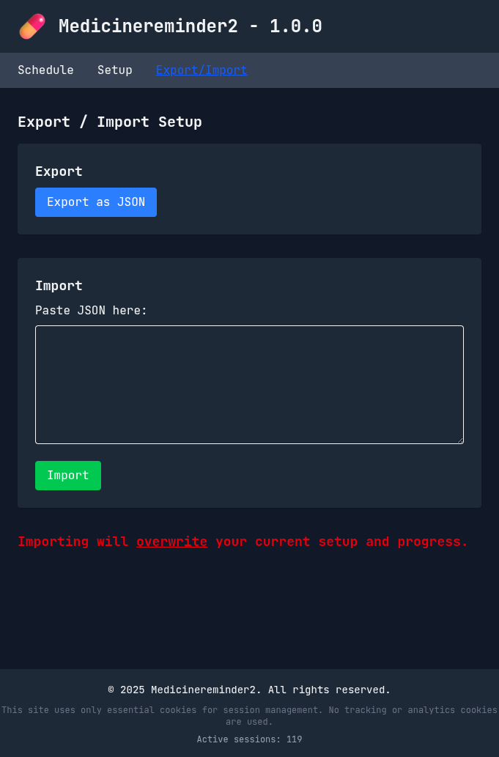 | And this brings us to the last slide of this document, the Export/Import menu, once you set up your schedule, you should export it by pressing the Export as JSON button, this will allow your browser to download a small text file and save it on your system, usually your Downloads folder. This file contains your pill setup information, and any progress you may have done during the day, go ahead open it, with any text editor and take a look.  If you want to take your schedule and put it on another browser or device , like your phone for example , this is the file you will need to open in a text editor , copy and paste in the field labeled as Paste JSON here: if you done the copy paste correctly , and pressed the Import button, your prescribed schedule will appear on your schedule page, do note that JSON files always start and end with {} curly braces, so make sure you copy them carefully.

* note, your doctor or healthcare provider can build a schedule for you and send it to you via e-mail, in case your schedule needs to adjusted or changed.

* if you stop using the app for more than 48 hours, it will forget your settings , so saving it locally is actually a great idea , apart from enabling you to set up multiple devices / browsers in seconds.
* as the very stark and red warning is presented at the bottom of the import / export page. Importing will overwrite your current setup and progress.

* I wrote this software as is, for my own benefit, I use it myself to help me not forget to take my pills and to prevent me from double taking them because I forget I took them … hopefully you may find it useful too.

* this document and other information can be found at the github repository mentioned above.

