SONG ARRANGEMENT LICENSE LETTER

Name: Abednego Bogi Christian
Role: Arranger
Title of Arrangement: {{Title_Scores}}
I, the undersigned, Abednego Bogi Christian, hereby confirm that I am the arranger of the musical arrangement titled {{Title_Scores}}.
I grant {{Licensed_To}} permission to use, rehearse, perform, and present my arrangement of {{Title_Scores}} for artistic, educational, and performance purposes, including concerts, competitions, rehearsals, and related non-commercial promotional activities.
This license is granted specifically to {{Licensed_To}} and does not automatically apply to any other choir or ensemble. Use of this arrangement by another choir or ensemble requires separate written permission and, where applicable, a separate licensing fee.
This permission does not transfer ownership of the arrangement. All rights in my arrangement remain with me as the arranger.
This letter serves as an official written authorization for the permitted use stated above.

Issued at: Jakarta
Date: {{Date_Issued}}
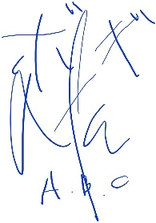
Sincerely,

Abednego Bogi Christian
Arranger – {{Title_Scores}}
Email: abednegobogichristian@gmail.com

