A

MINI

PROJECT REPORT ON

***MS TRAVELS***

*A project report submitted in partial fulfilment of requirement for award of degree of*

BACHELOR OF ENGINEERING

IN

COMPUTER ENGINEERING

*(PUNE UNIVERSITY)*

**Submitted by**

**SAURABH KUMAR MARPADGE MAYANK BHASKAR**

**MANOJ KOTWAL MAYURI LOKARE**

**SWAPNIL MANE**

**Under the Guidance of**

**.........................**



***DEPARTMENT OF COMPUTER ENGINEERING***

**ACKNOWLEDGEMENT**

I would like to take this opportunity to thank all the people who were part

Of this Project in numerous ways, people who gave un-ending support right from

The initial stage. In particular, I wish to Thank NEERAJ KADAM.

**M**y internal project guide who gave his co-operation timely and precious guidance without which this project would not have been a success. I thank him for reviewing the entire project with painstaking efforts .And more of him, unbanning ability to spot the mistakes.

I would like to thank our H.O.D **Prof B. B. Gate** for his continuous

encouragement and support and guidance at each and every stage of

development of this project.

And last but not the least I would like to thank all my friends who were

Associated with me and helped me in preparing my project. The Project named

**MS TRAVELS**  would not have been possible without the

extensive support of people who were directly or indirectly involved in its successful Execution.

**SAURABH KUMAR MARPADGE**

**MAYURI LOKARE**

**SWAPNIL MANE**

**MAYANK BHASKAR**

**MANOJ KOTWAL**

**CONTENTS**

**1.Abstract**

**2. Introduction.**

**3.SYSTEM STUDY**

**3.1 Proposed System.**

**3.2 Scope Of System.**

**3.3 Working Of System.**

**3.4 Feasibility Technique.**

**3.5 Hardware & Software Requirement.**

**4.STRUCTURED ANALYSIS**

**4.1 Entity Relatioship Diagram.**

**4.2 Content Level Diagram.**

**4.3 Data Flow Diagram.**

**5.SYSTEM DESIGN**

**5.1 Table Design.**

**5.2 Input Screen.**

**5.3 Reports.**

**6.TESTING.**

**7. CONCLUSION.**

**1.ABSTRACT**

“ MS TRAVELS ” is an idea to computerize the various functionality of management in customer service . The main objective Of this project was to avoid Broker or Mediator and and book tickets dirictly .

This software deals with overall functionality of hotel management including booking hotels, flights .We have tried our best to bring best and economical hotels in different cities across India .It also generates the respective reports.

The main challenge was to make the system work without any error so that all the booking of hotels and flights were generated accurately.

**2.INTRODUCTION**

“ MS TRAVELS “ is a online booking system that replaces the manual working mode of a technical institute by a more convenient, user-friendly, efficient and user-oriented working enviroment.

It resolves the problem of booking hotels and flights online, without standing in a queue to book your tickets. if you don’t have rupees in your wallet then you can book your tickets by your debit or credit card whenever you want.

The system is divided into two Modules:

1. Master Module.
2. Booking Module.

**Master Module :**

This Module provides forms to sing up or sing in along with user name and password.

**Booking Module:**

This Module validates the data filled in forms provided to the user, authenticates it and stores in the database.

**3. System Study**

**3.1 PROPOSED SYSTEM :**

The system provides a user friendly interface which saves time and cost of paper work.

The main Motto Of this system is to computerize the whole record keeping Protocol of booking hotels with minimum human efforts and in least possible time and most importantly without errors.

The system also provides accurate, quick and meaningful information based on the booking processed. It also provides quick and accurate reports relating to the Booking management.

The System makes sure that the booking records are complete, accurate and readily available. It provides Standard for Data sharing and analysis keeping in mind the standards for privileges and Data security.

There is Login Form for authenticating Users for gaining authorised access to the system and restrict invalid access to the system by unauthorised users.

**3.2 Scope Of System :**

The System helps to Access real time information. It has an effective use of well Laid-out Graphical User Interface.

The System provides Validation and Error Handling. The system provides automatic generation and validation

of Reports according the User. It also have powerful booking management and routine data processing capabilities. The system enables a strong controlled environment.

Thoughtful and Timely changes are made to keep place with advances in both Technology and Business. An effective governance and Administrative structure is created and maintained to support the management with network or improved functionality, fixes and service releases.

**3.3 Working Of System :**

**3.4 Feasibility Study :**

The main objective of feasibility study is to do hotel booking along with the flights, test Technical, Operational and Economical extensibility for developing computerised system. This is done by investigating and generating idea about a new system.

Feasibility study helps to obtain an successful booking overview and get rough assessment of whether feasible solution exists. There are three types of

feasibility studies in order to understand whether the proposed system would be feasible if implemented.

They are as follows:

* Technical Feasibility
* Economical Feasibility
* Operational Feasibility

**1.Technical Feasibility :**

Technical Feasibility will need to consider the possibilities of using machines available and the nature of hardware being used in the system. Its always better to select the best package that will be flexible with other programmers or outside developers and as possible for the user.

We are using MongoDB to develop this application MongoDB is the feasible technology due to its strong desktop development Architecture.

**2.Operational Feasibility :**

The system is user friendly and it is accesible to user, and much easier to operate because the interface of the system and screen display is quite clear. The system must operate in proper cyclic frequency of booking management. There are navigation bars by which the users and administrator both can lead to system operations.

**3.Economical Feasibility :**

Proposed or developed system is been justified by the cost and analysis benefits to ensure that efforts are concentrated on the project that will give best returns at the earliest opportunity. The cost of operation of the proposed system is minimal, since there is no need of installing hardware, training etc as computers are already installed and users are well trained.

**3.5 HARDWARE AND SOFTWARE REQUIREMENTS**

**HARDWARE REQUIREMENTS :**

**Processor-:2.2 Ghz**

**Hard Disk-:80GB**

**RAM-: 2 GB**

**Mouse-: Any Make**

**Keyboard-:Any Make**

**Printer-:Any Make**

**Moitor-:Any CRT or LCD**

**SOFTWARE REQUIRED :**

**Operating System-: Windows10, Windows8.1**

**Front End -: Visual Studios**

**Back End -: mySQL**

**4.STRUCTURED ANALYSIS :**

**4.1 Entity Relationship Diagram.**

***CUSTOMER***

ROOM

Has

Contacts

Has

Has

CustomerFlight

***TRAVELLING AGENCY***

***HOTELS***

***FLIGHTS***

**Billing Details**

**5.SYSTEM DESIGN :**

**5.1 Table Design**

**Tables in travel**

captcha

customer

flightbk

flightdb

hotelbk

hoteldb

**Captcha**

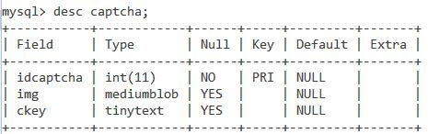

**Customer**

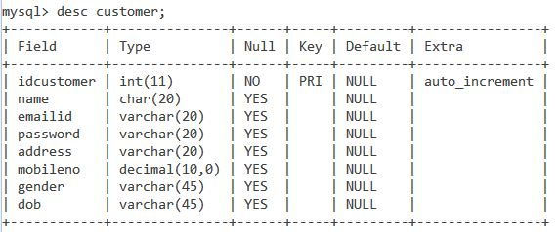

***Flightbk***

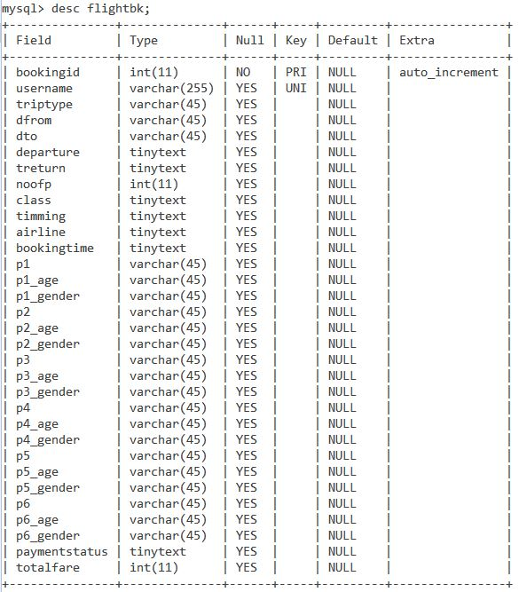

***Hotelbk***

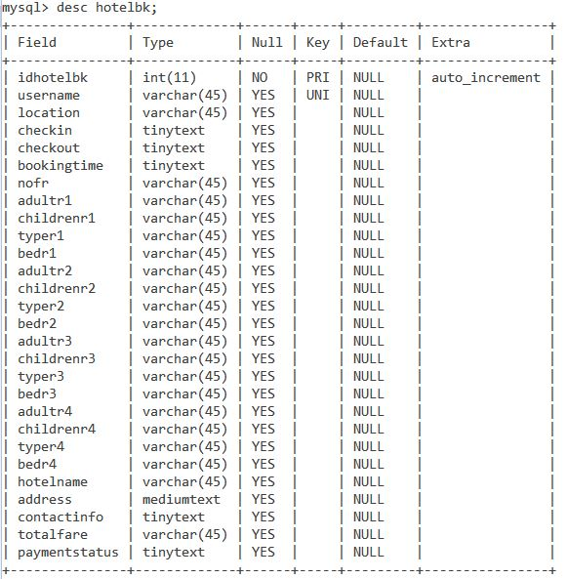

***Flightdb***

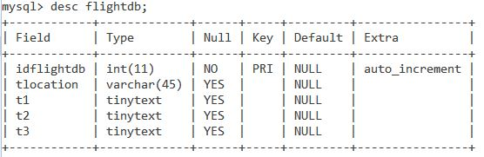

***Hoteldb***

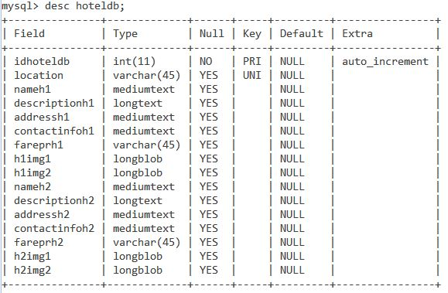

**5.2 Input screen(Screen Shots)**

**Sign In Page**

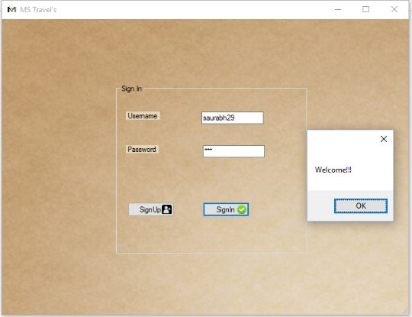

**Sign Up**

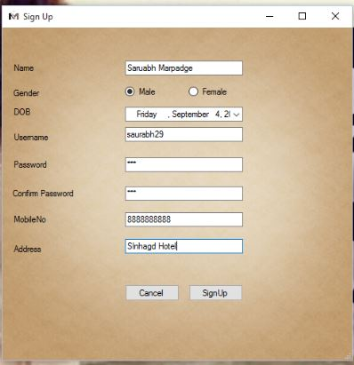

**Home Page**

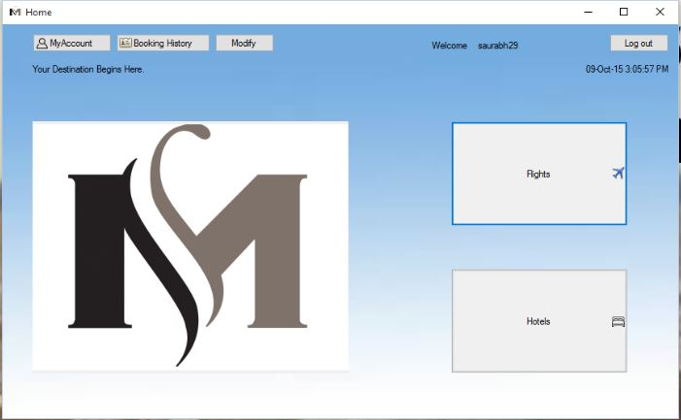

**My Account Page**

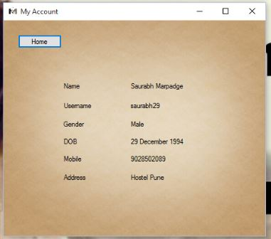

**Hotel Modification Page**

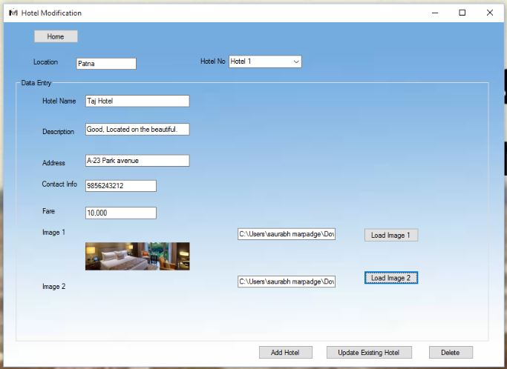

**Flight Booking Page**

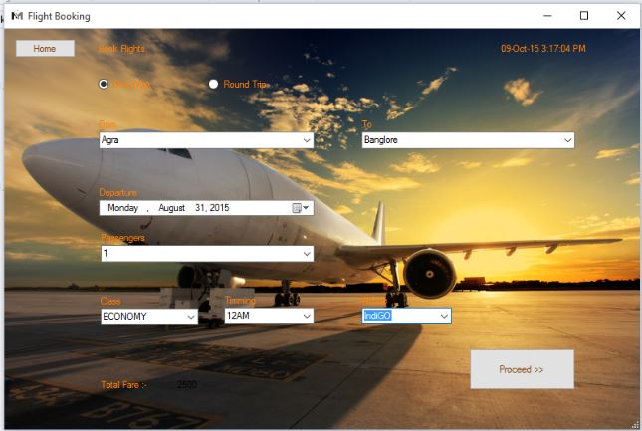

**Flight Passenger Details Page**

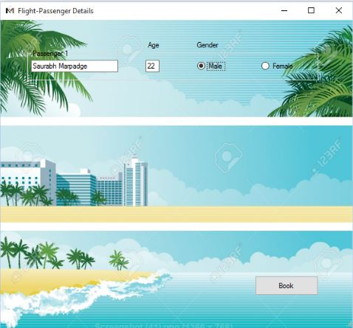

**Hotel Booking Page**

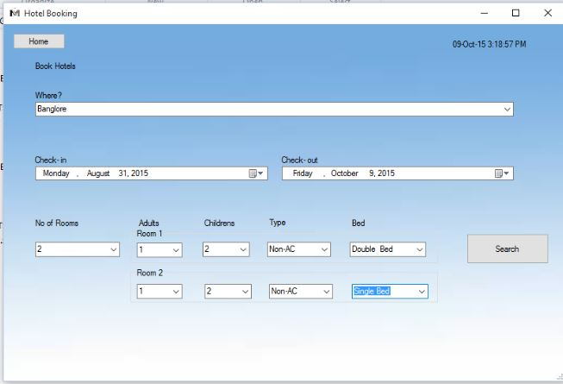

**Hotels Page**

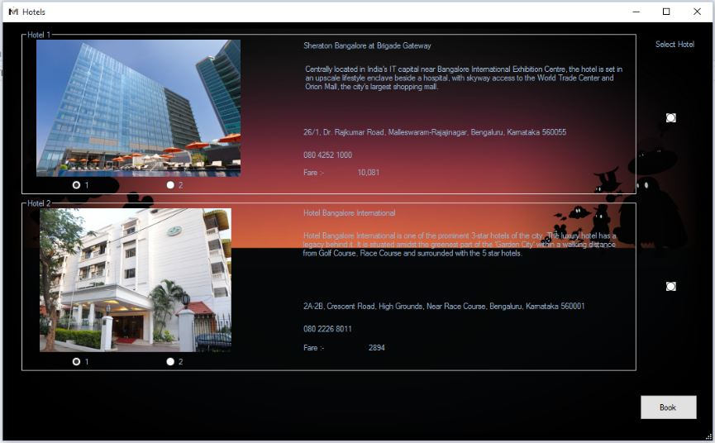

**Booking History Page**

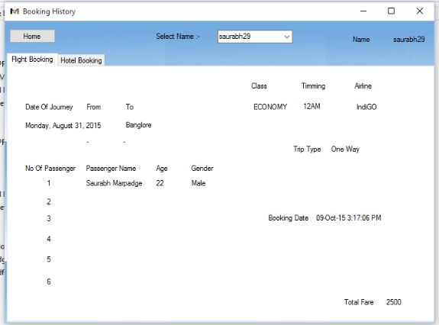

**Hotel Booking History Page**

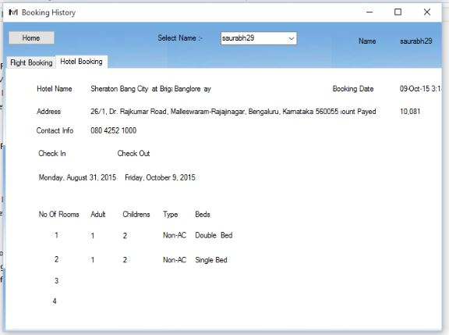

**Payment Page**

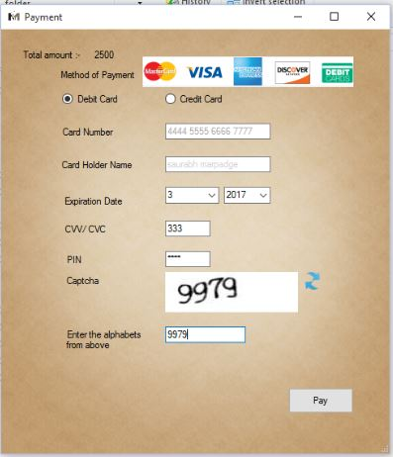

**6.TESTING.**

Testing is one of the important step to be performed to ensure

Successful implementation of the system. The basic idea of carrying out testing is to

ensure no error exits in the functionality and operability of the program. Therefore

the most useful and practical approach is with intension of finding errors .This is the

phase where the system is intentionally made to fail so as to make the system full

proof and error free up to the limit possible.

Initially test data is prepared to check the software. During this phase

the system is used experimentally to ensure that the software does not

fail. Special test data are inputs for processing and the result is examined.

It is very essential for increasing its effectiveness and accuracy.

The testing of system is necessary to ensure the following issues:

* Completeness
* Correctness
* Reliability

In general the system was thoroughly checked at each level, right

From the beginning. System was checked at different levels.

* Testing of data entry procedures is done.
* Testing of data validations id done.
* Entering data via different screens (forms) is done.
* Recharge procedure is done.

**7. CONCLUSION.**

This system also provides reports to each level of hierarchy.

The system carries it work from the point of view of administrator

As well as the point of other users.

The valid inputs are required which can yield the best results.

Unauthorised user will not be able to access the system.

Thus the system gives its result properly.

1. The system was found feasible and operational.
2. The User found the system to be interesting and very easy to handle, apart from the fact that it’s accurate and efficient.
3. The system maintained the required information with all the validations and

Thus implements data consistency throughout.

1. All the tedious reports were generated automatically, hence was tedious work of removing the necessary data for report generation was done away, saving time, energy and resources.