1. Google sheets: The spread sheet makes the data obvious to be manipulated. Creating charts is simply select the desired columns and then insert graphs. Among the “tools”, this one has the advantage of directly edit the data, which provide more flexibility among the “tools” in order to graph something that are not directly from the data.
2. Infogram: I make three charts through their website. It’s amazing that when uploading the data, the graphs would automatically show up. The problem is, they fix the columns as the categories when building pie charts, but I want the rows as the categories. Later, I changed the original data in order to fit in their style of the chart.
3. Tableau: data visualization first comes as a full-size software. I think tableau makes clear definition on dimension and measure. In that way, it’s easier to distinguish which column would be used as in the axis and which would be used as the data in the graph. It also categorizes the dimensions in the graph by let the user choosing the color, the size, or the angle if it’s a pie chart.
4. D3.js: D3 is the most heavily coding one, but, at the same time, it gives you more control on the visualization. In another way of saying that, it would take more time to build a lovely and interactive graph compare to other applications. It has built in function to load data which would help when the data is too large to manually enter.
5. Highcharts: It’s more automatic compared to D3.js. The color, interaction, and things like labels are all encapsulated in a json-like variable. Loading data is also very convenience with the data module, which just signify the file path into the json-like structure then everything will be done automatically. When switching to bar chart from line chart, just change the type to “column” then it’s done.

Compare these tools and codes:

Tools: google sheets, Infogram, tableau.

The advantage for these tools compare to the “code” is that it’s very user friendly even for beginners. As a beginner for javascript, I spend lots of time just for figuring out how to code in the style of javascript and understanding the demo I googled. These tools are much more convenient if we just want to draw some simple charts.

Individually, Google sheets would be more advantageous if we need any fix directly on the data, while it’s hard for the other two to change the data. Infogram would be more appropriate if we need a really quick graph. Building a visualization in Infogram would take the least time among these tools. Due to some prior knowledge for Tableau, Tableau would have more benefit when apply to real business cases. Since It could update the data, users won’t need to upload new data every time, Tableau would be fitted to those industrious level demand on data visualization. There won’t be any significant cons for these applications rather than less customizable features than coding.

Json configuration: Highcharts

Configuration style is in the middle of tools and codings. It has more customizability compare to tools, and more ease for beginner to use compare to code. Because of its mediocre position among the toolkits, my direct feelings of using Highcharts are both harder to use and harder to customize. I had a hard time figuring out how to load the local csv file and also how to alter the data for series section in order to create an appropriate line chart.

Code: D3.js

The impression for D3.js is it could be customized from top to bottom. User would have direct control from even axes’ color, or tick marks size to how interactive the graph would be. Because of the full customizability, the learning cost for coding style of data visualization would be much longer compare to using tools. I spent the most amount of time in drawing the 3 charts in D3.js. Most of the time is trying to understand how javascript works.

Charts:

I created three types of charts for all the applications.

First would be a pie chart showing 2018’s enrollment comparison for men and women.

Second would be a line chart for the trends of admission for all the years

Third would be a bar chart of the same thing as the line chart.

Google Sheets:

Pie chart

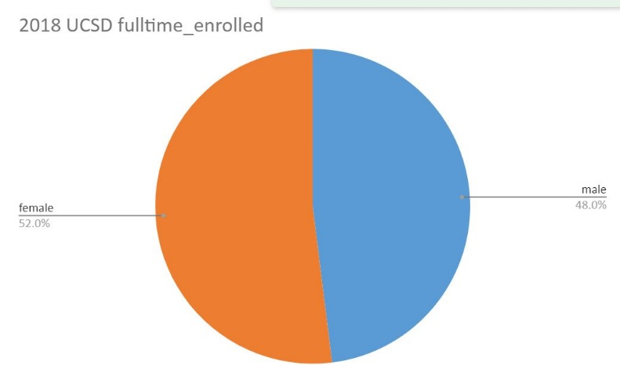

Line chart

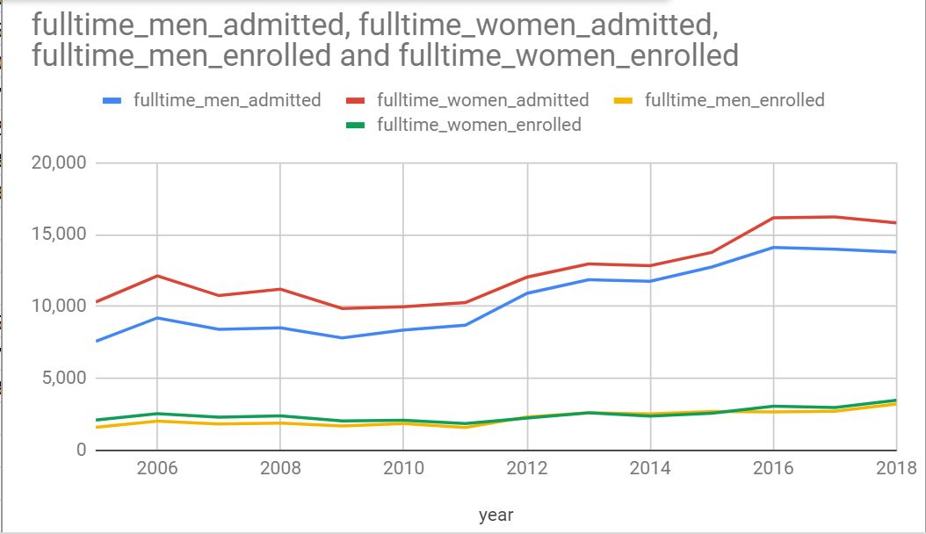

Bar chart

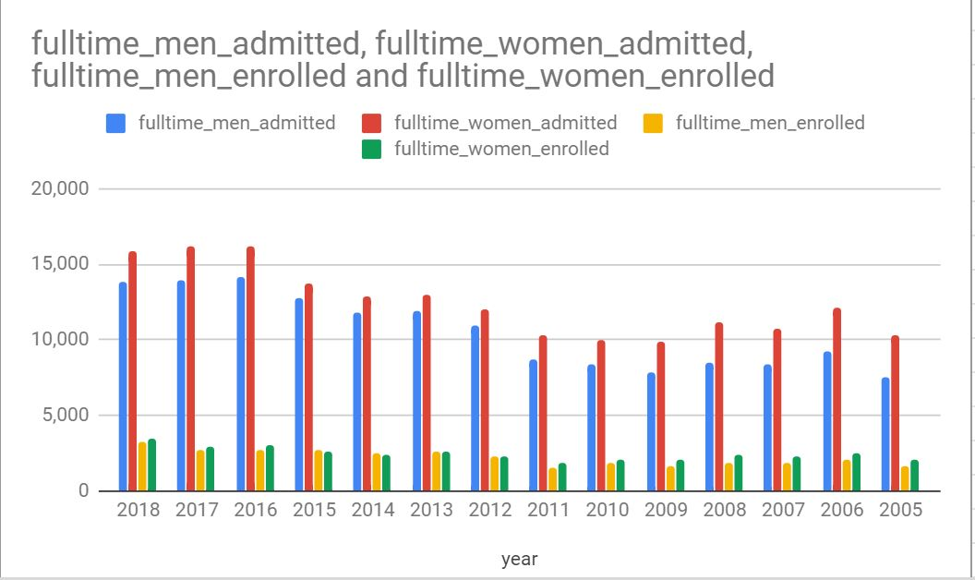

Infogram:

Pie chart

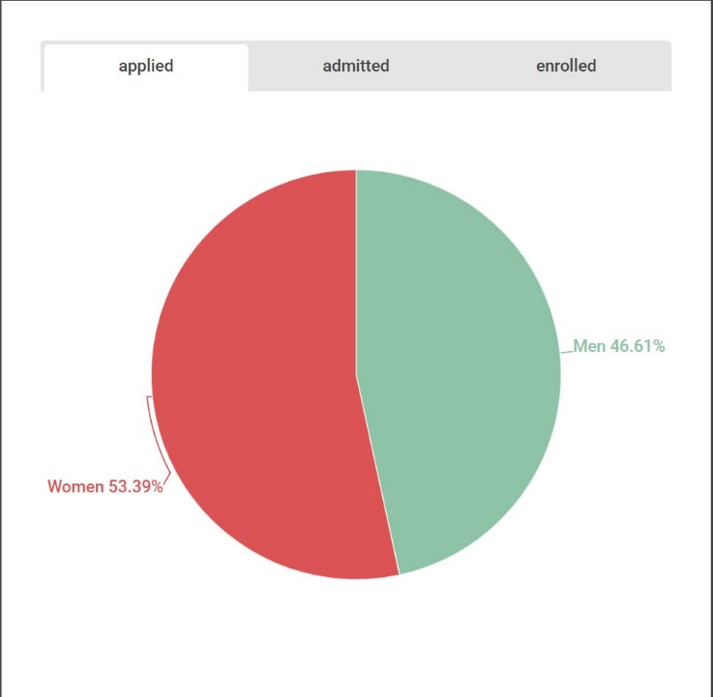

Line chart

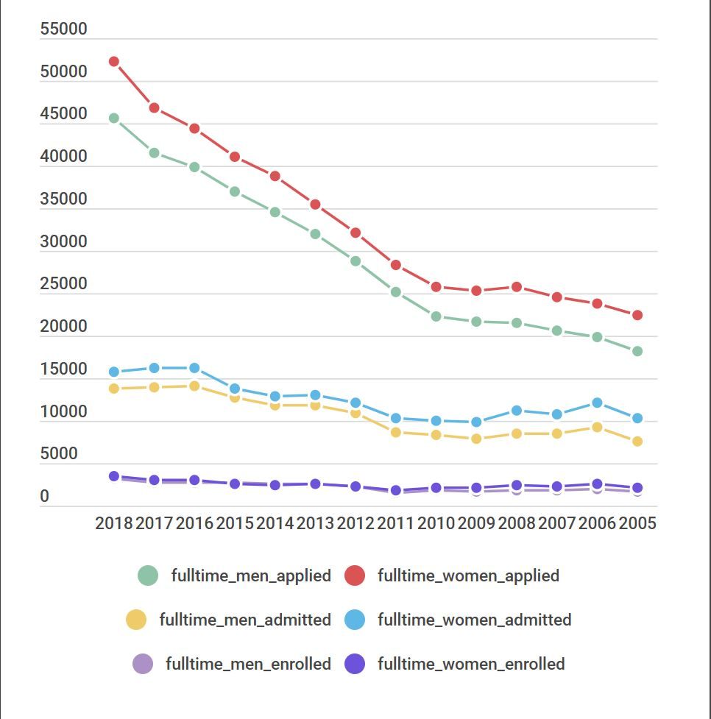

Bar chart

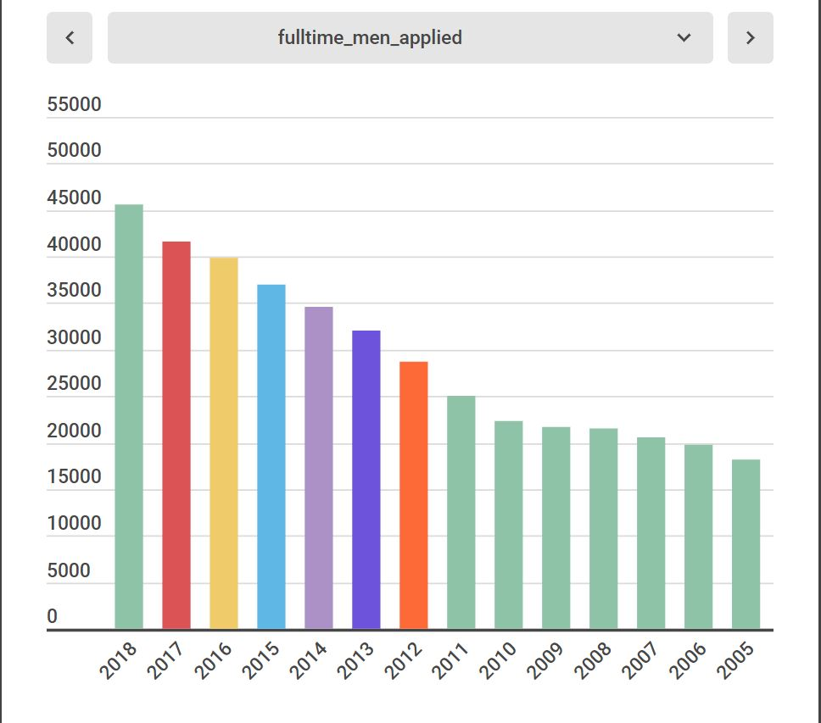

Tableau:

Pie chart

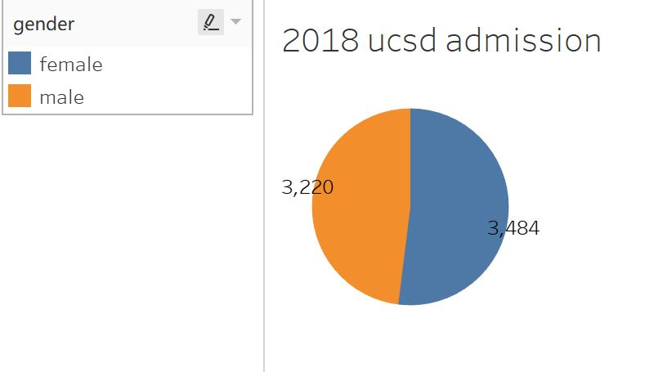

Line chart

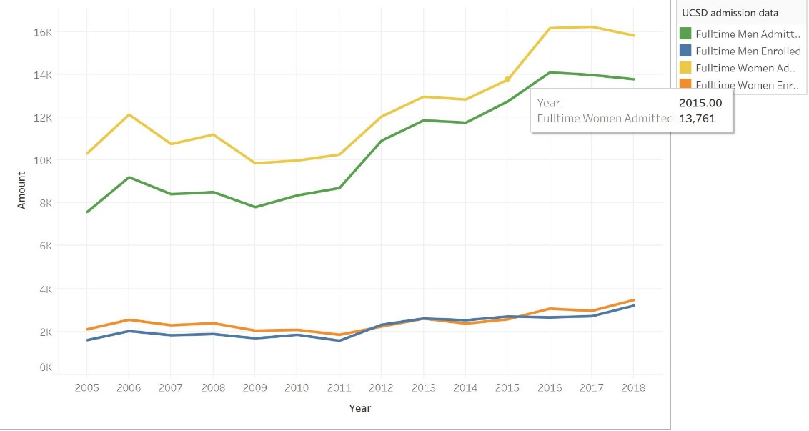

Bar chart

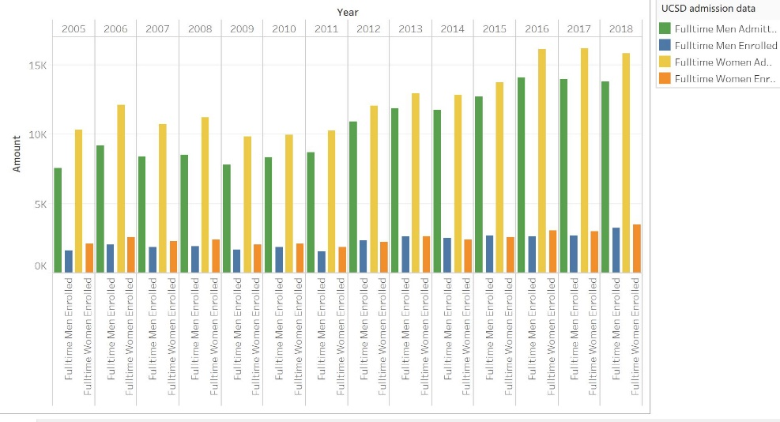

D3.js:

Pie chart

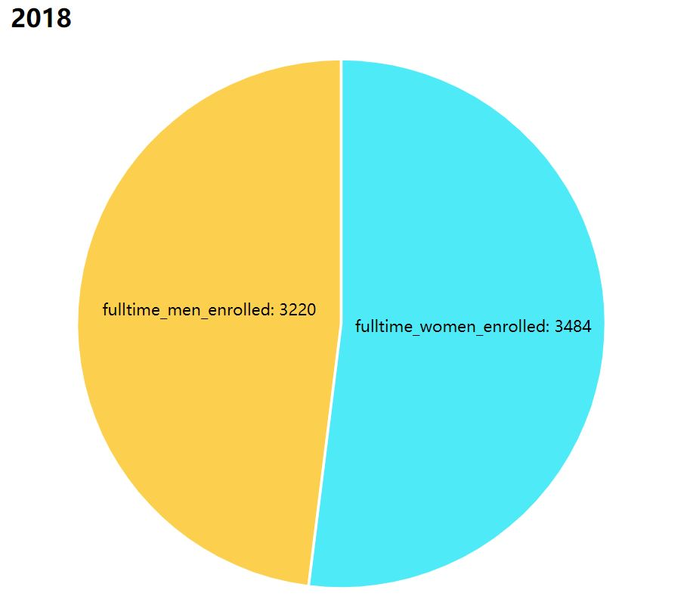

Line chart

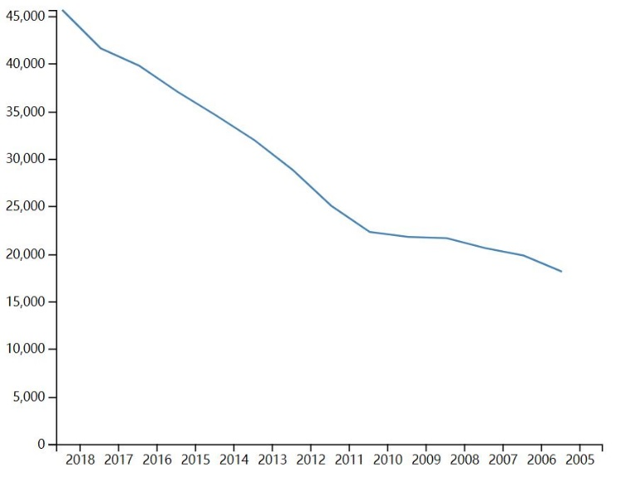

Bar chart

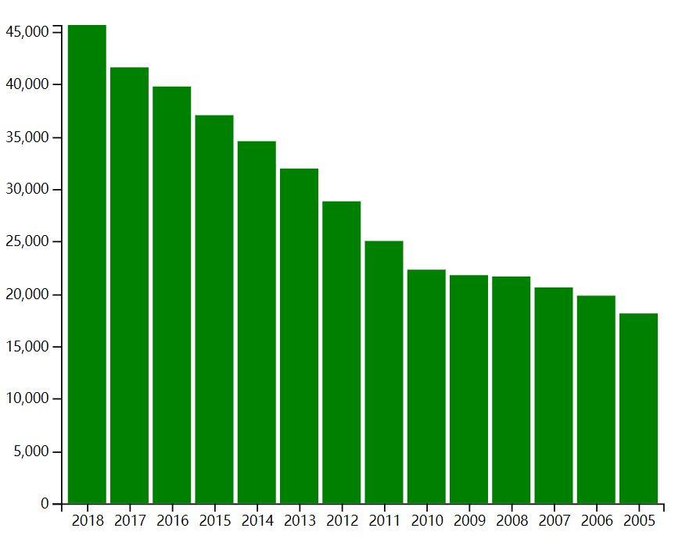

Highcharts:

Pie chart

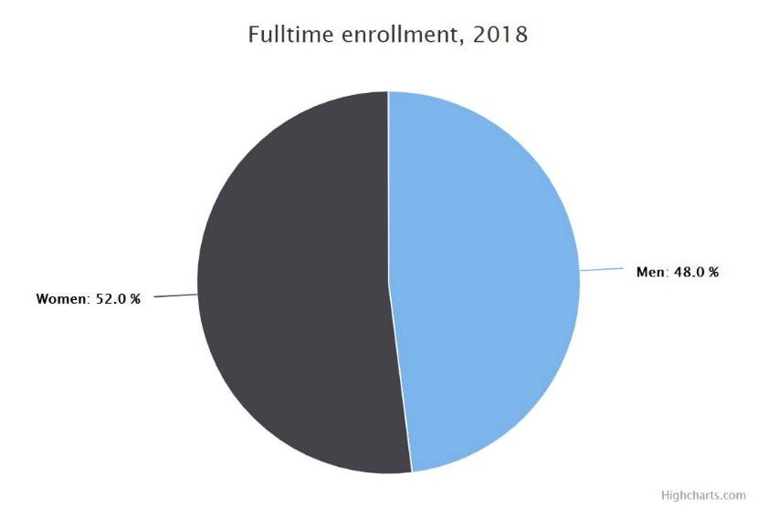

Line chart

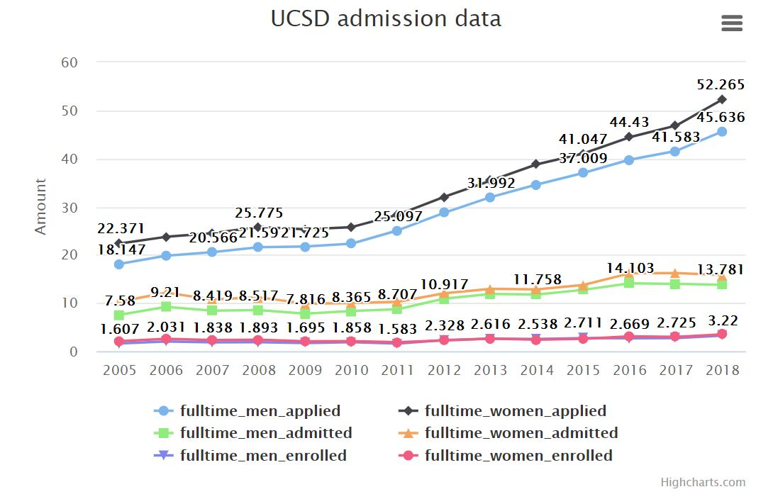

Bar chart

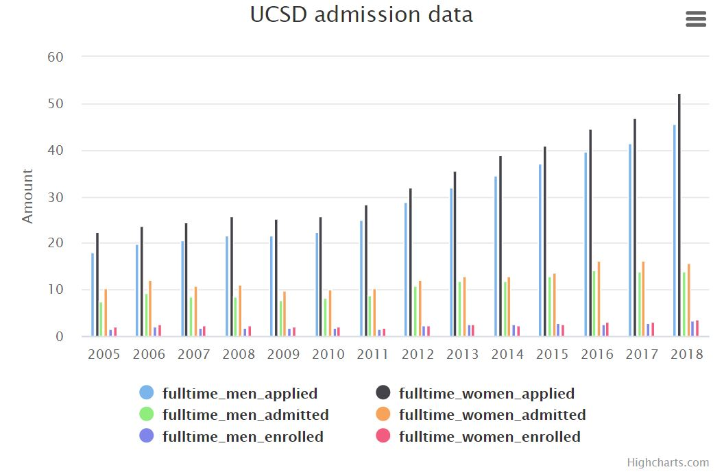

GitHub Repository: <https://github.com/boh016/dsc106>