Part A: Answering the Questions
- Which models got it right?
- The Sentence Transformer and both OpenAI models (Small & Large) nailed it every single time. They correctly realized the topic was Flowers even in the complex sentence test. In the sentiment tests ("The movie was upsetting" and "This is terrible"), they can also correctly identified the vibe as Negative.
- Why did some fail?
GloVe (50d) falled all three tests. It is probably because GloVe uses simple math and just takes the values of every word in the sentence and averages them together. In the first test, the sentence had three color words ("red", "blue", "grey") but only one flower word ("Roses"). The "color" words overpowered the "flower" word, making the model think the category was colors.
For the negative sentences, GloVe failed to catch the bad mood. It classified "The movie was upsetting" and "This is terrible" as positive with very high confidence. This happens because common words like "The", "movie", or "is" might slightly lean positive in the vector space, and the simple average washed out the meaning of "terrible" or "upsetting."

- What does this reveal about word order?
This shows that GloVe is oblivious to word order. It just mixes all the words up and doesn't care if "Roses" comes first or last.
On the other hand, the Transformer and OpenAI models can actually "read" the sentence. They pay attention to context and order. They understood that even though there are colors mentioned, they are just describing the main subject.
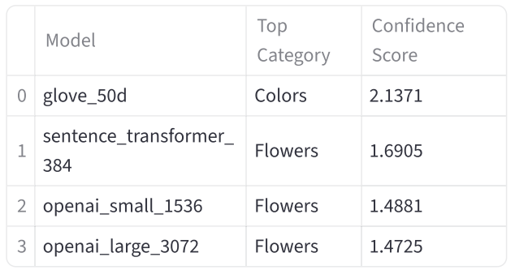
Figure 1: Context Awareness Test.
This screenshot shows Transformers correctly identifying the topic as "Flowers" despite the presence of multiple color words, whereas GloVe fails and selects "Colors" due to simple word averaging.

Part B: Model Comparison
- Accuracy on Test Cases
- GloVe (50d): It scored 0% accuracy. It failed the "Roses" poem and both negative sentiment tests.
- Sentence Transformer & OpenAI: They scored 100% accuracy. All three of these models correctly identified the "Roses" poem as Flowers and correctly flagged the negative sentences as Negative.
- Dimensionality vs. Performance
- GloVe (50d): This was the smallest model, and its performance was terrible. 50 dimensions just aren't enough to capture complex meanings or feelings.
- Sentence Transformer (384d): Even though it is smaller than OpenAI, it performed perfectly. This shows that a smart design can beat raw size.
- OpenAI (1536d & 3072d): These are massive models. They performed perfectly, but for these specific tasks, they didn't really offer a noticeable advantage over the small one or the local transformer.
- Speed / Response Time
- GloVe: It is the fastest since it just simply averages all the numbers.
- Sentence Transformer: It is fast, but it runs on local machine, which may defer to different setups.
- OpenAI: It is the slowest, since it has to send data over the internet to OpenAI's servers and wait for a reply.
- Word Order Sensitivity
- GloVe: It has no sensitivity. If we switch the words, GloVe would likely give the exact same result because the average doesn't change.
- Transformers (Sentence Transformer & OpenAI): They are highly sensitive. They read the sentence from start to finish and this ability to understand structure is why they perform better.
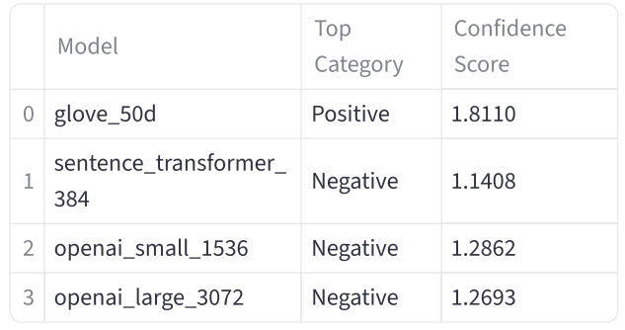
Figure 2: Sentiment Test (Upsetting).
This image demonstrates that GloVe incorrectly classifies the negative sentence as "Positive" with high confidence, while Transformers correctly identify it as "Negative".
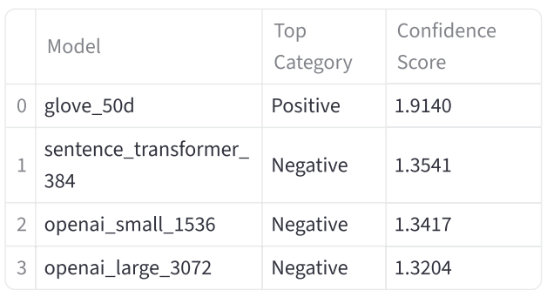
Figure 3: Sentiment Test (Terrible).
This screenshot shows GloVe failing to capture the strong negative sentiment of the word "terrible", classifying it as "Positive", unlike the Transformer models which correctly flag it as "Negative".

Part C: Real-World Applications
Group 1: The "Seattle Hot Dog" Paradox
Sentences:
- A: "I saw a Seattle hot dog."
- B: "I saw a Seattle dog hot."
Observations:
- GloVe: Incorrectly classified both as Food with high confidence, failing to distinguish between the food and the animal.
- Transformers: Correctly identified A as Food and shifted B to Animal, successfully detecting the change in meaning.
Brief Explanation: Sentence A uses the compound noun "hot dog" (Food). Sentence B breaks the compound, making "dog" the head noun modified by the adjective "hot" (Animal). GloVe sums vectors identically regardless of order, while Transformers analyze syntactic dependencies to identify the true subject.

Group 2: The "Butterfly" Effect
Sentences:
- A: "There is a butterfly in the kitchen."
- B: "There is a fly butter in the kitchen."
Observations:
- GloVe: Failed completely, classifying both as Magic (likely due to low-dimensional noise).
- Transformers: Correctly identified A as Insect. Most models successfully shifted B to Cooking (identifying "butter").
Brief Explanation: "Butterfly" is a distinct concept (Insect). Splitting it into "fly butter" changes the head noun to "butter" (Cooking). Transformers recognized "butter" as the primary object, whereas GloVe's averaged vectors failed to capture the individual concepts.

Group 3: The "Will Smith" Inception
Sentences:
- A: "Will Will Smith smith that gold?"
- B: "Smith will smith Will with gold."
Observations:
- GloVe: Classified both as Celebrity, fixating entirely on the name "Will Smith."
- Transformers: Classified both as Blacksmith, correctly recognizing the action.
Brief Explanation: These sentences test the polysemy of "Smith" (name vs. verb). GloVe is biased by the high-frequency celebrity association. Transformers parsed the Subject-Verb-Object structure, correctly identifying "smith" as an action verb (to forge) rather than a proper noun.
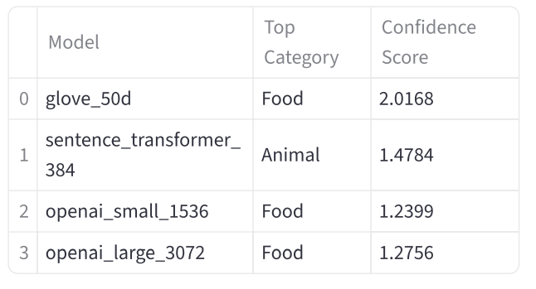 | 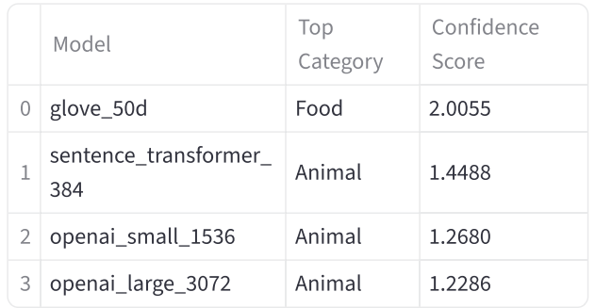
Figure 4 & 5: Compound Noun Structure Test.
The images compare "Seattle hot dog" (Food) vs. "Seattle dog hot" (Animal). It shows that Transformers successfully detect the semantic shift from food to an animal when the compound noun is broken, whereas GloVe treats both as Food.
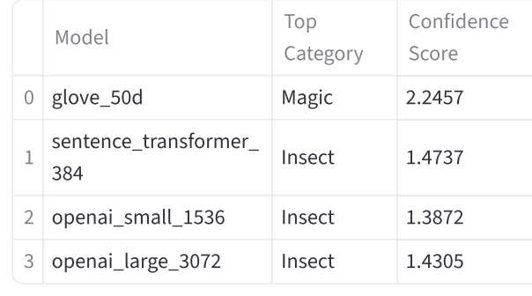 | 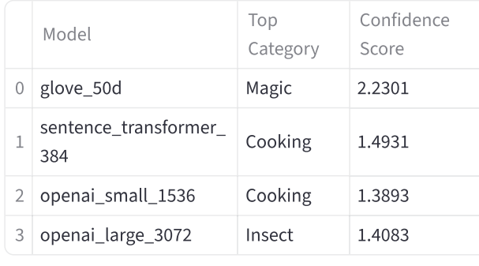
Figure 6 & 7: Compound Word Split Test.
The screenshots contrast "butterfly" (Insect) with "fly butter" (Cooking). It demonstrates the Transformers' ability to identify the head noun "butter" in the second sentence, while GloVe fails to distinguish the concepts.
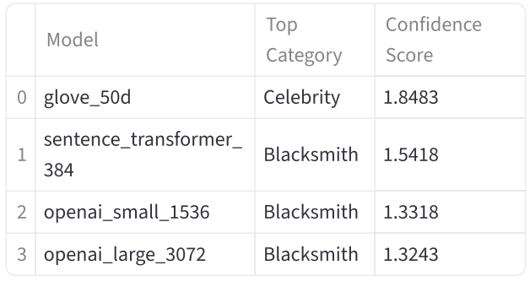 | 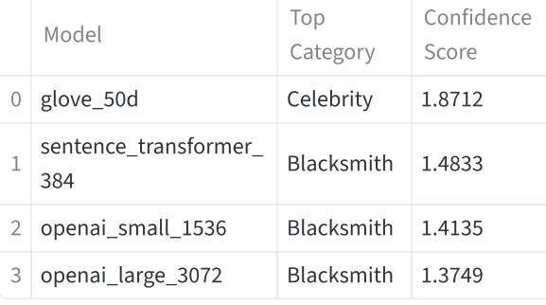
Figure 8 & 9: Polysemy and POS Tagging Test.
The images show the models analyzing complex sentences using "Will" and "Smith". It highlights that Transformers correctly identify the verb "smith" (Blacksmith) in both structures based on syntax, while GloVe relies solely on the celebrity name association.

