Two-stage Pipeline ARM Processor Core in TSMC 65nm Technology

Ruiheng Wang, Ali Najafi, Bohan Wang
EE 477 VLSI II, Capstone
Abstract
This project is proposed as the capstone of UW EE capstone design for VLSI concentration. It consists of processor core with datapath and controller, instruction memory, data memory and a linear voltage regulator. Both memories are modeled in Verilog, and the core is built by both custom design and Auto Placing and Routing flow. Datapath consists of an ALU, shifter, register file and MUXs for controlling data flow, and is fully customized in Cadence Virtuoso. Controller includes instruction decoder, program counter, and special registers that stores flag values, linked values and stack pointer, and it is synthesized in Verilog. For verification, the group both devised test vectors for each component in each phase and use provided test files for timing tests and functionality tests. Both instruction memory and data memory are ideal and assumed zero latency. The regulator is incorporated as part of the enhanced module that regulates supply voltage from 0.8 to 1.2V,
Introduction
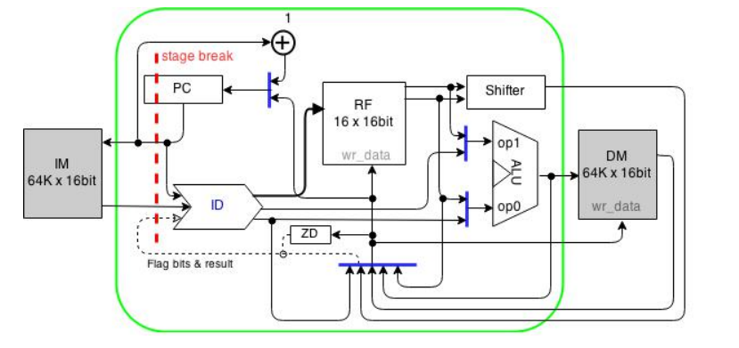
Fig 1. Overview
This project is a two-stage pipelined ARM-based processor that supports twenty-six instructions. It can be roughly divided into three main components: datapath, memories and controller. Datapath includes an ALU, a shifter, a register file and MUXs for controlling data flow. ALU is able to perform addition, subtraction, AND, XOR, NOT and OR logic. The shifter is able to perform logic shift, arithmetic shift and rotation. MUXs in the ALU will select the appropriate operation based on codes from controller. The controller is able to store binary instructions, decode them the control the operation and data flow between datapath and memory.
Both data memory and instruction memory are modeled in Verilog which store data and instructions in text files. Both Verilog code are compiled and synthesized in Synopsys VCS.

Implementation

Register File
The 16bits register file is implemented as the key component of the CPU, and supports both read and write operations. There are two reading ports and one writing port, and the size is 13 entries with word length of 16 bit. Notice the separation of master latches and slave latches, and the reason is to save area and power by sharing master latches across all addresses. The following section will discuss write and read separately.

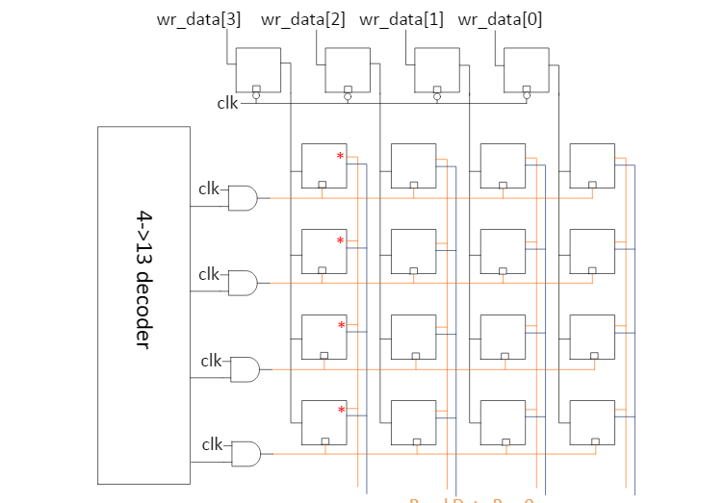
Fig. 2 Register file conceptual diagram
Write operation
When writing to the register file, decoder determines the correct address in the register file. Master latches will be transparent to allow wr_data<15:0> to be stored. Timing is of essence, and the “clk” signal in the above diagram is the AND of wr_en and global clk. This is to ensure master latches are enabled by wr_en, and data are written on the rising edge of the clock signal.
Read operation
Two 4-bit read ports will index 13 register file entries and read corresponding data. Based on ARM ISA, two ports are required for logic, arithmetic operations as well as memory instructions. Two transmission gates controlled by read address ports are connected to slave latches to choose the correct port.
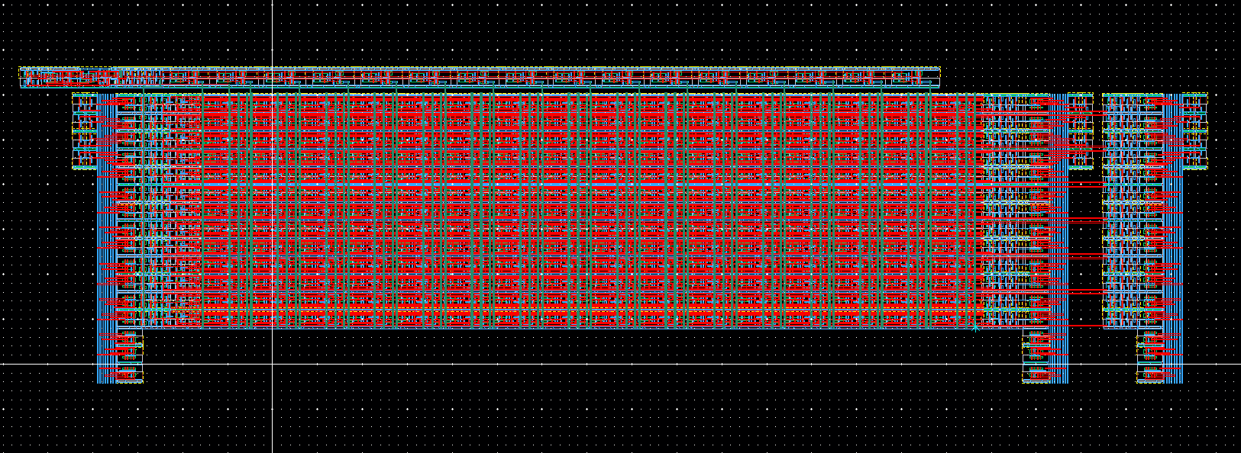
Fig 3. Register File layout

ALU
The arithmetic logic unit (ALU) in this processor design supports the following instructions ADD, SUB, OR, NOT, XOR, and AND. Four flags stored in the special register are carry overflow flag, negative flag, carry out, and comparison flag. The core of the ALU is the 16-bit adder, with additional logic gates to implement standalone functions.

Adder
In all forms of adders, tree adders are the fastest due to parallel carry generation and propagation. Some examples of fast adders are variants of carry lookahead adders, including Brent-Kung adders, Sklansky tree, Kogge-Stone adders and Ling adder. The group originally intended to implement two blocks of 8-bit Kogge Stone tree and created two carry-skip blocks. Although each blocks propagate carry efficiently, in practice Kogge-Stone does not demonstrate significant superiority due to very few stages with smaller data size( < 16 bits) and large parasitic capacitance from dense wiring. This design is essential a two block ripple carry with each block implemented as Kogge-Stone tree, and no “skip” occurs during carry propagation. The advantage of adder is to quickly calculate final carry-out signal of each block given log2N complexity of N-bit input, yet unnecessary carry skip(analysis)
(Need to Kogge Stone schematic)
MUX codes
Three bits selection signals are employed to control ALU operations.
Flags
Negative, carry-out, comparison and overflow flags will be determined at ALU based on ARM architecture. Flags are defined as follows:
N | Negative | MSB of ALU output
C | Carry out | Set to 1 if indicate unsigned overflow
Z | Zero | Set to 1 when ALU SUB result is zero
V | overflow | Set to 1 if signed overflow
Table. Flags

Shifter
Fig 4. Shifter overview

Fig 5. Shifter Masking logic
16-bit logarithmic barrel shifter is implemented and supports both arithmetic shifts and logical shift. The shifter consists of rotation mux arrays, control signals and masking logic for shifting operation.
A simple 4-bit barrel shifter capable of both right and left rotation/shift schematic can be seen below. It shows the first stage of MUX array is to “preshift” to right by one since left rotation is equivalent to rotate right by the amount of opposite of k, which is controlled by four-bit shift amount signal. When performing shift, masking logic is required to kill bits that are rotated off, depending on either logical shift or arithmetic shift.
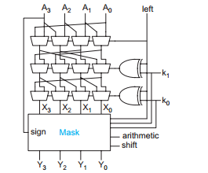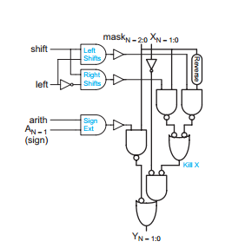
(From Weste Harris)
Physical layout of shifter requires wrapping wire in MUX arrays. The group should make compromise by routing metal trunks outside standard cell since restricted cell height does not provide enough horizontal wiring tracks. In this case area is not optimized, and masking logic is not aligned well with MUXs. Bit slice consistency is also broken from other datapath components.
Datapath Overview
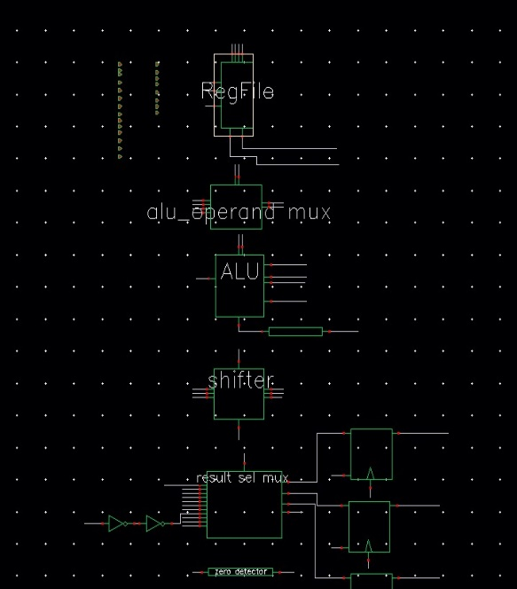
Fig6 . Datapath schematics

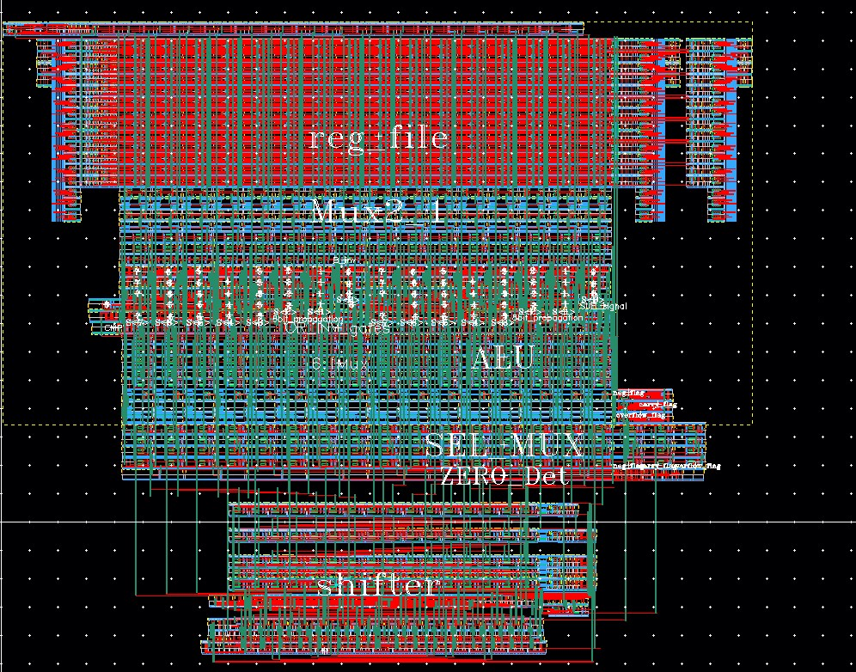
Fig 7. Datapath Layout
Layout attempts to align bit-slice, except shifter at the bottom, and all components are labeled.
Processor controller
Some of datapath control signals, decoded by MUXs, are integrated in the above custom-design modules, such as ALU operation code and shift amount. Instruction decoder is coded in behavioral Verilog, and synthesized, placed and routed in Synopsys Design Compiler and IC Compiler respectively. In addition, program counter is also coded in Verilog.
Final integration
Datapath components are assembled by bit slice defined in register file. In addition, instruction decoder and program counter are coded, synthesized, placed and routed. Layout of these blocks are imported in gdsii format to Virtuoso environment. Both data memory and instruction memory are modeled in Verilog, so they are ideal and don’t account for any delay and power consumption in reality.
Due to limited time, global routing is done manually. When memories, instruction decoder and program counter layout are imported and placed in Cadence, pin placement is accomplished via Python script by floorplanning.
From the top-level layout below, processor controller is placed on top of datapath. Pins are pre-planned to match datapath and to reduce route congestions.
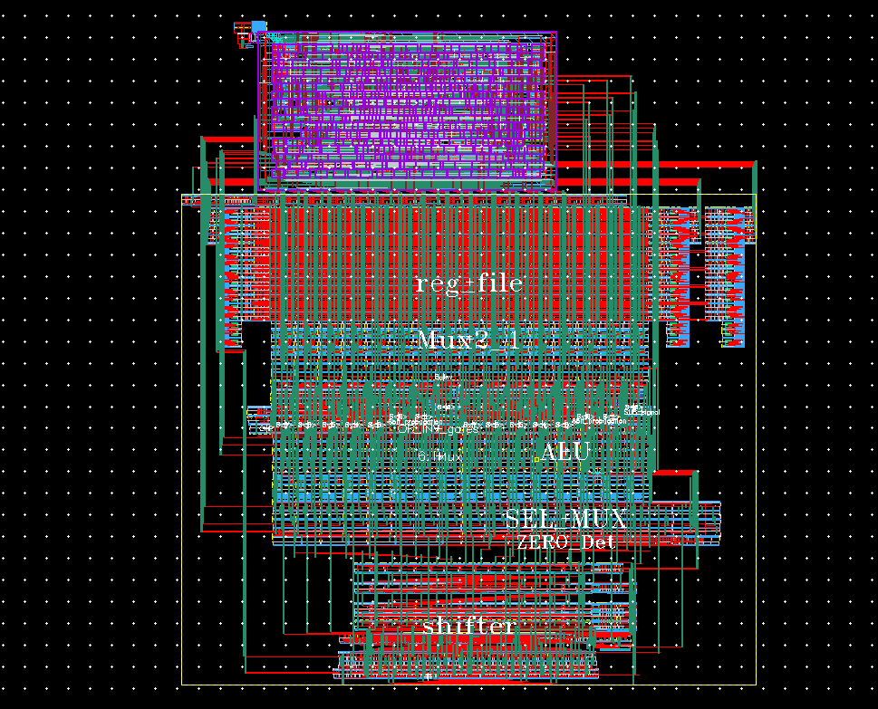
Fig 8. Top-level Layout of processor core without Memories
Measurement/Performance
For simulation, both SPICE and Verilog simulations are used for performance analysis. Post layout simulation perforamcne and layout metrics are described below:
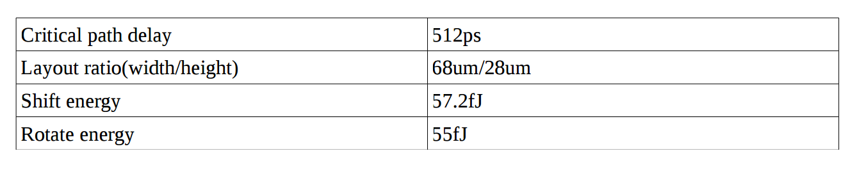
Table1. Shifter performance
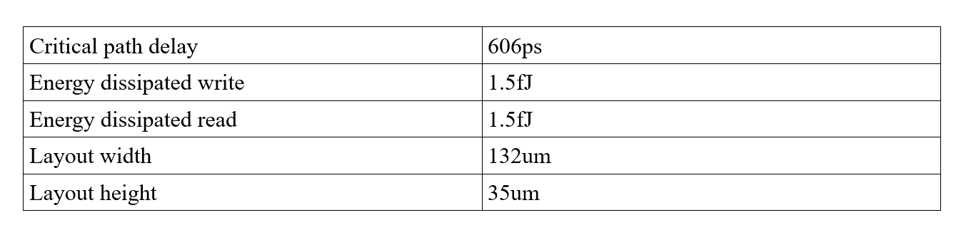
Table2. Register file Performance Post Layout
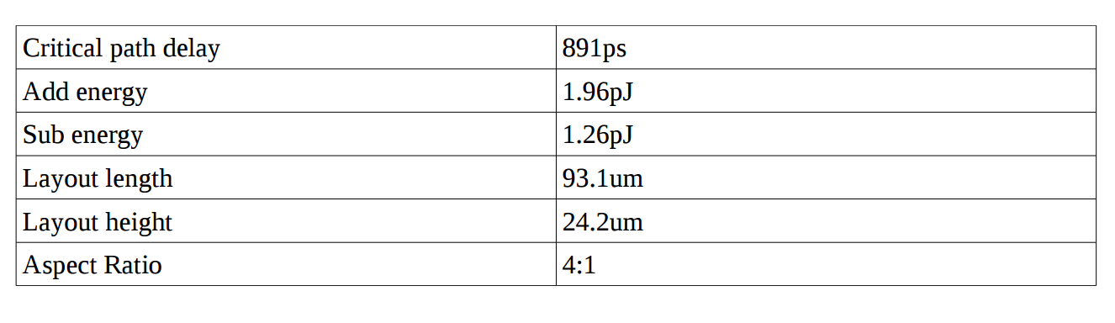
Table 3. ALU Performance Post-Layout
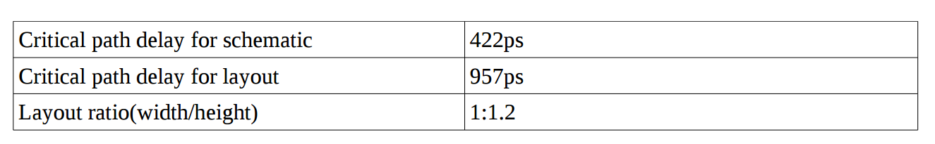
Table 4. Datapath Performance
Since memory is ideal and no delay is employed, performance is better measured by datapath delay. The critical path is based on the one from ALU, from LSB of rf_data_1<0> to the MSB of datapath when doing subtraction and data is written back to register file in a cycle.
Test and Verification
Mixed use of HSPICE and Verilog simulations intend to test different blocks of the circuit. For datapath blocks the group code HSPICE test vectors to examine the rise/fall propagation delay and power consumption, especially for critical path.
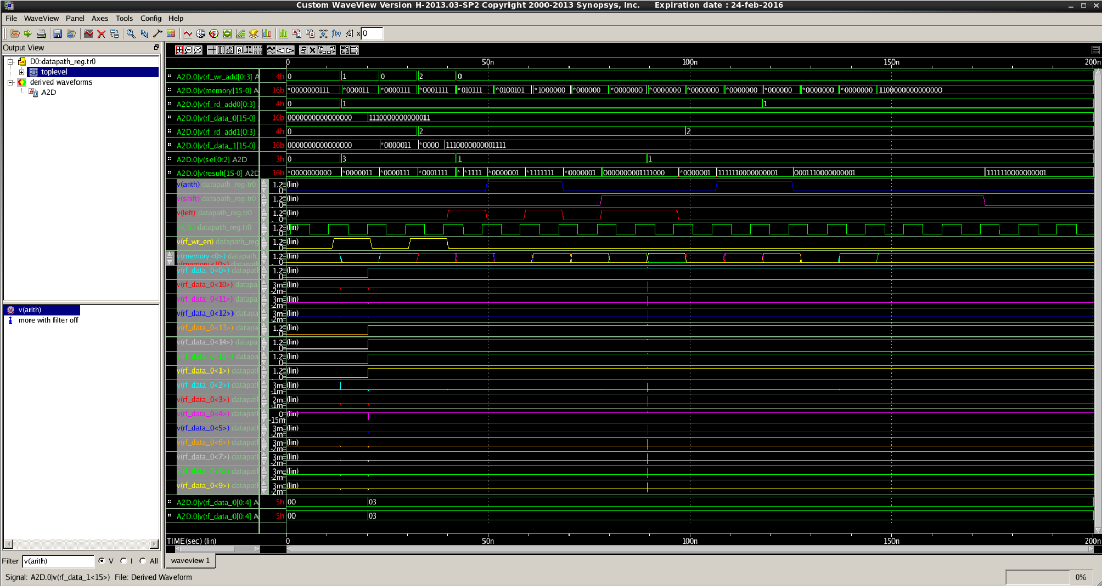
Fig 9. HSPICE simulation waveform for datapath

Fig 10. HSPICE wavrform showcasing shifter operations
Instruction decoder is done in RTL style. Synopsys VCS is used to build, synthesize and simulate Verilog code. After integration, ARM instruction assembler is used to assemble assembly program such as factorial and Fibonacci number computation and test the processor core.
Limitation
This design does not reflect the full processor design flow. Bit slice in datapath is not maintained so that extra delay, energy consumption on metal are not optimized, and area is not optimal as well. Additional delay factors such as pad resistance and clock tree routing are not considered due to limited time. From system’s viewFinal integration does not exploit CAD tool capability and is done manually, thus wiring delay, area efficiency are not thoroughly considered in physical design.
Conclusion
The group is able to design, implement, integrate and test a functional ARM processor core using both custom-design flow and ASIC flow. Use of industry-standard design/simulation tool from Cadence and Synopsys expose real VLSI design flow and methodology to the group. However many factors in physical design are not implemented thoroughly due to time limit. Clock tree which is critical in digital design is not optimized. Floorplanning and integration is done manually. Additionally, latches are created in logic synthesis. Padding is ignored when creating the processor core.

