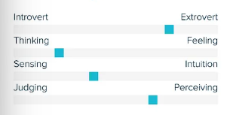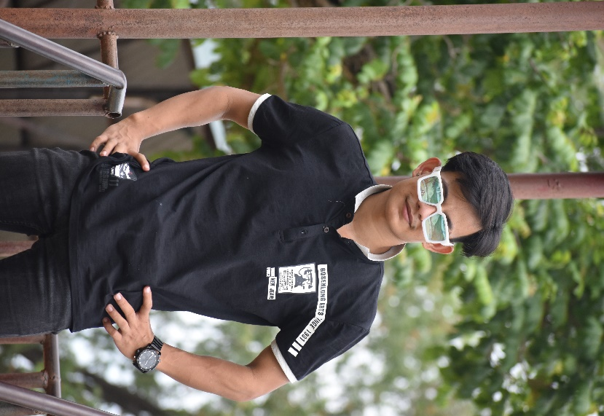of

**PRAKASH BOHARA**

**Bio**

Mr. Bohara is a passionate home cook and a student at the University of Roehampton. He loves learning and sharing recipes from different cultures, believing that food is more than just nourishment—it’s a gateway to understanding diverse traditions, histories, and ways of life.

For him, exchanging recipes is not just about cooking; it’s about storytelling and preserving cultural heritage. He sees food as a powerful way to build connections among people from different religious, cultural, and regional backgrounds. Through this platform, he hopes to foster a sense of community, where students can share their culinary traditions, discover new flavors, and celebrate diversity through the universal language of food.

**Frustrations**

❌ **Ingredient Accessibility** – Some traditional ingredients are hard to find in the local area.  
❌ **Authenticity Concerns** – Prefers traditional recipes over Westernized versions.  
❌ **Time Constraints** – Juggling university life makes it hard to cook elaborate meals.

**Goals**

✅ **Share & Explore Recipes** – Wants to share traditional family recipes and learn new ones from different cultures.  
✅ **Cultural Connection** – Interested in understanding the cultural significance behind different dishes.  
✅ **Cooking Confidence** – Hopes to improve his cooking skills by trying authentic recipes with proper guidance.  
✅ **Community Engagement** – Seeks an inclusive platform where students interact and exchange ideas beyond just food.

**Personality**

Age: 21

University: Roehampton University

Major: Computer Science

Background: white-Asian passionate about cultural diversity and food

**Tech Comfort Level:** Moderate (familiar with social media, willing to explore new platforms)

Location: London, UK

Educated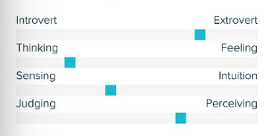

Friendly

Ambitious

Committed

I enjoy exchanging varieties of recipes