Project Report

ClassSense
Web-App for Classroom Climate and Focus Awareness

submitted to
Department of Informatics at the University of Fribourg

User Centered Design

Prof. Dr. Denis Lalanne

submitted by
Bohdan Potuzhnyi
Matriculation Number: 23-477-839
Vlada Svirsh
Matriculation Number: 23-477-961
Samuel Schaffhauser
Matriculation Number: 99-731-218

Semester A2025

Fribourg, December 13, 2025

Table of Contents
1 Introduction 1
1.1 Background 1
1.2 Problem 1
1.3 Goals of the Project 2
1.4 Methodological Approach 2
2 Materials and Methods 3
2.1 Exploratory Study 3
2.1.1 Participants 3
2.1.2 Instruments and Procedure 3
2.1.3 Data Analysis 3
2.1.4 From Requirements to Core System Elements 3
2.2 Prototype Development 4
2.2.1 Teacher prototype 4
2.2.2 Student prototype 5
2.2.3 Physical prototype 6
2.3 Controlled Experiment 7
2.3.1 Theoretical Basis 7
2.3.2 Hypotheses 7
2.3.3 Experimental Design 8
3 Results 10
3.1 Exploratory Study 10
3.1.1 Teacher Survey and Interviews 10
3.1.2 Student Survey and Interviews 11
3.1.3 Qualitative Style Guidance from Interviews 12
3.1.4 Summary of Design Consequences 12
3.2 Personas and Scenarios 12
3.2.1 Teacher Personas 12
3.2.2 Student Personas 13
3.2.3 Scenarios 14
3.3 Controlled Experiment 15
3.3.1 Students 15
3.3.2 Teachers 17
4 Discussion 19
4.1 Findings and Implications 19
4.2 Limitations and Suggestions for Further Research 19
4.3 Retrospective “What we could do differently” 20
List of Figures 21
List of Tables 21
5 References 22

Introduction

Background
Swiss high schools (Gymnasien) are undergoing a significant transformation through the reform “Weiterentwicklung der gymnasialen Maturität” (WEGM). The reform emphasizes digital competence, media literacy, and self-regulated learning. As digital devices become integral to everyday teaching, teachers face new challenges: maintaining attention, managing distractions, and supporting students’ emotional and cognitive well-being. ClassSense aims to address these needs with a user-centered web application that enables both teachers and students to monitor and co-regulate classroom climate in real time, respecting privacy and autonomy.

The “Weiterentwicklung der gymnasialen Maturität” (WEGM) reform modernizes Switzerland’s high school system to prepare students for the 21st century.
WEGM emphasizes five areas of change:
- Digitalization and digital competence: promoting critical and creative use of technology.
- Media literacy: strengthening media literacy as a transversal competence.
- Interdisciplinary skills: fostering self-regulation, teamwork, and reflective thinking.
- Teacher role evolution: from information delivery to facilitation and emotional guidance.
- Mobility and exchange: enhancing intercantonal and international collaboration.

These priorities align with broader trends in Swiss education policy, which emphasize wellbeing, autonomy, and sustainable learning environments. ClassSense supports these priorities by providing a digital solution that encourages focus, emotional balance, and reflective technology use.

Problem
As more and more Swiss high schools integrate laptops, tablets, and other electronic tools into the curriculum, classrooms are more lively but also more distracted. While digitalization releases creativity and the potential of information, it simultaneously makes it harder for teachers to get the class coordinated in concentration, interest, and emotional self-regulation.

Available evidence suggests that emotional classroom climate is a strong predictor of pupil engagement and performance (Brackett et al., 2011; Wang et al., 2020). Yet most schools still rely on the teacher's unassisted intuition to sense when attention is getting smaller. The WEGM approach, which requires greater self-regulation and media literacy (Schweizerische Konferenz der kantonalen Erziehungsdirektoren (EDK), 2024), underscores the necessity of providing teachers with light, privacy-respecting feedback instruments rather than invasive monitoring instruments.

Despite progress made in online learning, there remains a chasm connecting technology application, emotional sensitivity, and ethical classroom management. Teachers and students both need a simple-to-use, privacy-respecting instrument for monitoring, understanding, and jointly modulating classroom mood and focus in real time.

Goals of the Project
The development of ClassSense was driven by a set of functional and ethical design goals, with the objective of ensuring its suitability for everyday school use. The system was developed for the purpose of providing teachers with a real-time overview of the classroom climate by displaying an anonymous, aggregated distribution of student states (e.g., understood, confused, overloaded, tired). Feedback is refreshed within a few seconds, thereby enabling timely pedagogical decisions and supporting the link between emotional climate and engagement (Reyes et al., 2012; Brackett et al., 2011).

To encourage frequent use, student interaction kept as short as possible. Students can send feedback without any form of login or identification, so the system stays fully anonymous. One-tap reporting has been demonstrated to reduce interaction effort, therefore increases the likelihood students will use it in class (Fitts, 1954). The teacher view is designed to support quick adjustments (e.g., slowing down, briefly re-explaining a step, or taking a short break). In that sense, the dashboard is not only descriptive (e.g., “90% tired, 5% OK”) but also intended to be actionable by linking the signals to plausible responses (e.g., a short pause or an additional explanation).

Privacy-by-design is a core architectural principle of ClassSense. The system is designed to work without collection/storage any personal identifiers. Student inputs are collected only as a state (e.g., ok, confused, overloaded, tired) with a timestamp inside a per-lesson session. System does not build any individual histories. The session is deleted automatically at the end of the lesson. To support transparency, the project is done under the AGPL license. This means data handling can be inspected. Any modified deployments must disclose their source code to users of the service. Teachers can optionally download an anonymous lesson retrospective for reflection.

Moreover, the additional workload for teachers must remain minimal. The system must be “off-the-shelf” so that configuration and usage can be completed within a matter of minutes. Interactions during teaching should require only minimal effort from both teachers and students. Finally, ClassSense is aligned with the WEGM curriculum goals, promoting digital competence, metacognitive awareness, and responsible use of technology in learning environments (Movetia, 2024; EDK, 2024).

Methodological Approach
To ensure that ClassSense fits real classroom needs, we followed the Design Process Model showcased during User-Centered Design (UCD) led by D. Lalanne at the University of Fribourg. The project was structured around four iterative phases: Articulate, Brainstorm, Refine, Complete. In the “Articulate” phase, questionnaires and follow-up interviews with teachers and students at St. Klemens Gymnasium were used to identify the main constraints: anonymity, low interaction effort, and non-disruptive classroom use. In “Brainstorm”, we translated these requirements into early concepts and low-fidelity prototypes (sketches) for both: the teacher dashboard and the student input. During “Refine”, sketches were turned into Figma prototypes (later to the web-based prototype). Adjustments were made to layout, wording, and visual style based on usability and readability feedback. As part of this phase evaluation of the key interface variants was conducted in a controlled within-subject experiment in a realistic classroom setting. Finally, in “Complete”, we finished a functional web-based prototype based on the results of a controlled experiment (including an optional sensor-based setup).

Materials and Methods

Exploratory Study
Prior to the implementation of the interactive prototypes, an exploratory user study was conducted to understand the needs and concerns regarding classroom climate monitoring in BYOD settings. This phase followed the "Articulate" and "Brainstorm" stages of the user-centred design process and laid the foundation for the ClassSense concept.

Participants
The sample comprised ten practising teachers and forty-five students from a Swiss Gymnasium (Gymnasium St. Klemens in Ebikon LU). All participants regularly work with laptops or tablets in class. A subset of three teachers and three students participated in follow-up interviews to further explore the survey findings.

Instruments and Procedure
Two online questionnaires (one for teachers, one for students) were developed. Microsoft Forms was used for the questionnaires. The survey of teachers concentrated on the perceived difficulty of evaluating engagement in BYOD lessons, the openness to real-time feedback from students, the preferred visualisations of class climate, attitudes towards environmental sensors, and data-protection concerns.

The student survey addressed willingness to report mood or focus during lessons, preferred input modalities, acceptable frequencies of feedback, and attitudes toward anonymity, and usage of sensors, app tracking or web-camera emotions tracking. Both surveys contained a mix of closed questions (Likert scales and multiple choice) and open questions.

Based on the survey responses, six semi-structured interviews were conducted. Teacher interviews explored classroom management strategies, indicators used to infer engagement, and expectations towards a supportive tool. Student interviews examined how lesson format and teacher behaviour affect motivation, when digital distraction becomes problematic, and what a “safe” feedback channel would look and feel like. Interviews lasted approximately 20 minutes and were audio-recorded and transcribed using Sonix.ai.

Data Analysis
Survey data were analysed descriptively. Open responses and interview transcripts were subjected to thematic coding. Codes were iteratively clustered into higher-level themes such as “visibility of engagement”, “anonymity and trust”, “interaction effort”, and “style and tone of the interface”. From these themes, functional requirements and stylistic guidelines for ClassSense were derived.

From Requirements to Core System Elements
Based on the converging teacher and student themes, the system was specified around the following core elements:

- an anonymous one-tap student input with four central states (OK/continue, too fast/ confused, overloaded/need break, low energy/tired),
- an aggregated class-climate bar on the teacher side, showing the current distribution of these states without individual identities,
- a real-time teacher dashboard that remains visible in peripheral vision, either as a narrow browser sidebar or on an external screen,
- optional environment indicators (noise, temperature, CO₂) shown only at room level;
- strict privacy guarantees (no logins, no individual histories, no export to admin systems),
- a closed feedback loop, where teachers are encouraged to react briefly to the signals (e.g., pause, clarify, ventilate), so that students experience their input as meaningful.

Prototype Development
The analysis of the initial questionnaires and interviews yielded two core design priorities: the necessity of a rapid and anonymous process for student feedback, and the requirement for teachers to maintain continuous awareness of the class climate without visual distraction. In order to explore these requirements, low-fidelity prototypes were created before implementation.

Teacher prototype
In response to the provided teacher feedback, two distinct dashboard layouts were conceptualised with the objective of facilitating different workflows.

- The full-screen dashboard (external display) is a visual interface that provides a comprehensive overview of system metrics and status. The apparatus has been designed to facilitate continuous peripheral visibility, thereby enabling educators to monitor pupils' focus and emotional state whilst continuing to deliver instruction.
- The compact status bar represents an integrated view. The display is characterised by its narrow horizontal configuration, which is intended to ensure its visibility on the primary teaching device without obscuring the educational material.

Initial layouts were manually sketched as paper prototypes (Figure 1) to explore visual hierarchy, data arrangement, and alert metaphors. These sketches were then transformed into interactive Figma prototypes (Figure 2), thereby enabling teachers to assess readability, colour coding, and information density in a more realistic manner. Following evaluations which indicated the potential for visual overload, the compact version underwent a series of reductions.

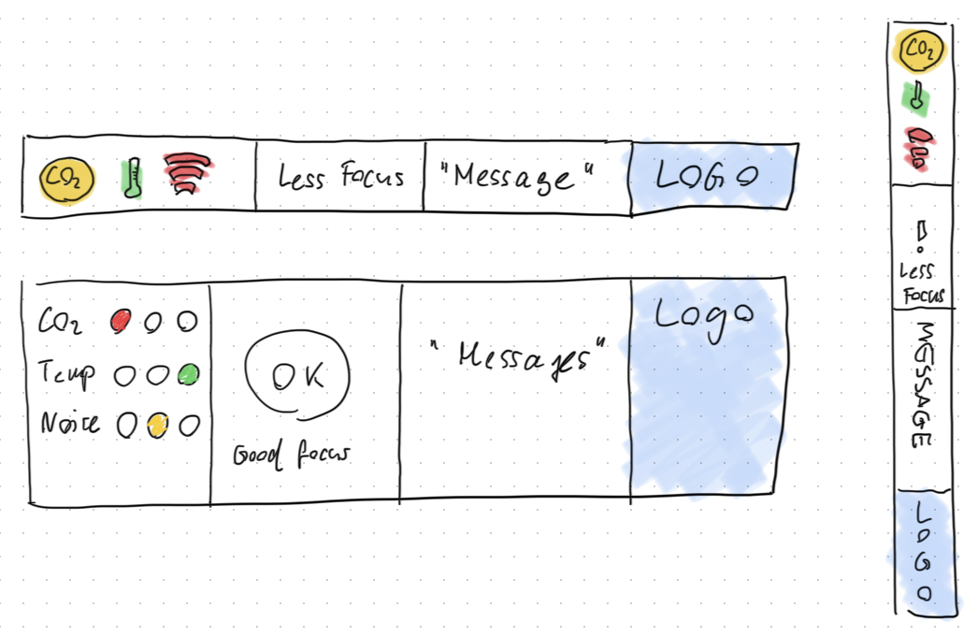

Figure 1 Paper prototype of the teacher UI (top: horizontal stripe / right: vertical stripe / bottom: dashboard with details)

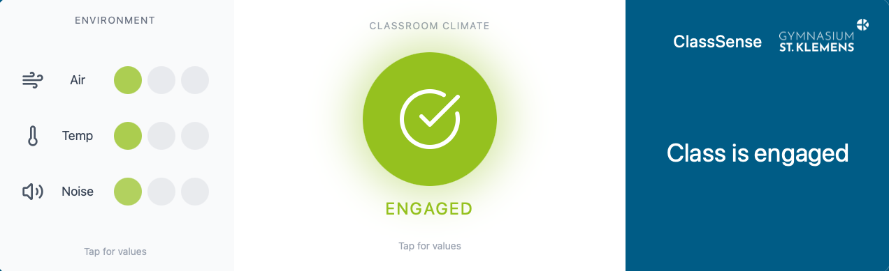

Figure 2 Figma prototype of the teacher UI (top: horizontal stripe / bottom: dashboard with details)

Student prototype
The exploration of two interaction concepts was conducted for the students:

- The device incorporates a one-tap button interface. Four states (OK, confused, overloaded, tired) derived from the earlier survey were designed for effortless input and clear semantic interpretation.
- Slider interface: Whilst the continuous scale facilitates more nuanced expression, it does require greater precision and attention during use.

As with the teacher dashboard, student interfaces were sketched on paper (Figure 3) to refine the widget placement (bottom-corner activation) and tap flows. The subsequent modelling of these components in Figma (Figure 4) involved a thorough evaluation of the animations and tap areas for accessibility and minimal disruption.

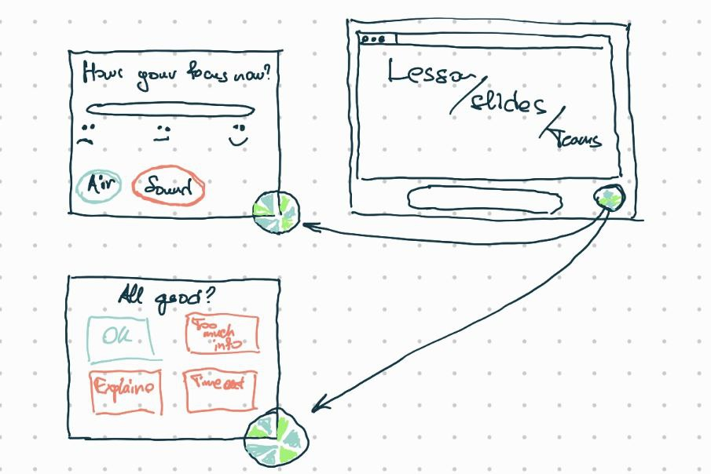

Figure 3 Paper prototype of the student UI (upper left: slider / bottom left: buttons)
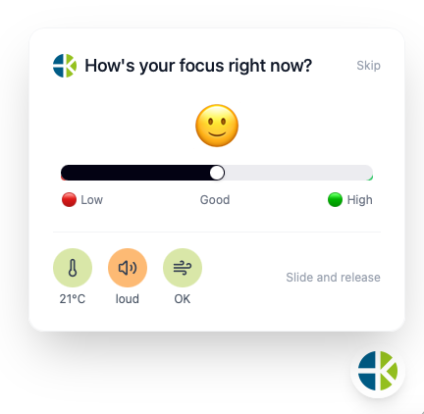 | 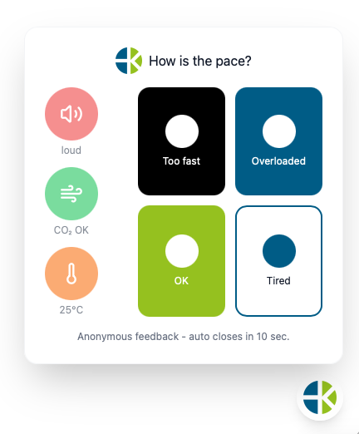
Figure 4 Figma prototype of the student UI (left: sliders / right: buttons)

Physical prototype
In order to assess technical feasibility in realistic conditions, a first physical prototype was implemented. The system architecture (Figure 5) comprised a Raspberry Pi 5 (4 GB RAM) equipped with an Enviro+ sensor board and an SGP30 VOC/eCO₂ module for environmental monitoring (temperature, humidity, CO₂-equivalent, noise, light). A Python script running on Raspberry Pi OS Trixie was configured to capture sensor data and transmit it in JSON format via HTTPS to a central web server. Subsequently, the data stream was synchronously distributed to both teacher dashboard variants and the student UI.

Concurrently, student feedback interactions were captured directly in the browser and forwarded through the same streaming interface. This configuration enabled the aggregation of real-time feedback from the classroom environment and the conditions in which the activities were being conducted. It facilitated the evaluation of responsiveness, stability, and usability.

Figure 5 System architecture of the ClassSense functional prototype.

Controlled Experiment

Theoretical Basis
Systems that provide feedback on emotions and engagement through technology should be designed to be as smooth as possible to avoid getting in the way of the learning process. Established HCI research shows that the difficulty of pointing and selecting directly increases with the distance and precision required (Fitts, 1954). In other words, the more effort a user must invest to complete an interaction, the less often they will do it. In our study, we asked 45 students about their thoughts on providing feedback. The students said they would only give feedback if it was anonymous, quick and not distracting. One-tap buttons are easier to use than sliders, which require more precise and focused motor control.

For teachers, it is very important to be aware of the situation in the classroom. Interfaces that require switching between windows (e.g. browser dashboards) can be more difficult to use and distract from the instructions. Teachers said that a display which is always on and can be seen by everyone would help them to see what the class is like without being stopped. This idea is supported by research on attention and how people interact with displays. Studies show that having dashboards on other screens can make it easier to switch between tasks and improve the feel of how they fit together (Czerwinski, Horvitz, & Wilhite, 2004).

Hypotheses
In order to evaluate the different design approaches for classroom engagement tools, two user interface variants were developed for each of the main user groups: students and teachers. Students tested a version with discrete buttons, allowing very fast one-tap feedback, and a version with a continuous slider, enabling more nuanced input but requiring more precision. Teachers tested two versions of a classroom dashboard: one version was shown directly in the browser on the teacher's laptop, and the other was on a dedicated external display to support continuous peripheral awareness without window switching.

Working Hypothesis (H1-Students)
“A button-based UI will be rated higher in terms of usability, be less disruptive, and be more readily adopted than a slider UI.”

The rationale behind this is that one-tap interactions facilitate rapid, effortless feedback and align more closely with students' preference for simplicity.

Null Hypothesis (H0-Students)
“There is no discernible difference between button and slider UIs with regard to usability, disruptiveness, or user willingness to engage with them.”

Table 1 Variables
Dependent variables:  • Perceived usability  • Perceived disruptiveness of class flow  • Willingness to use | Independent variable:  • Input type (buttons vs. slider)

Working Hypothesis (H1-Teachers)
“A dashboard on a separate external screen will be rated as more practical, easier to integrate into teaching, and more desirable to adopt, compared to a browser-only dashboard.”

The rationale behind this is threefold: firstly, it reduces the need to switch tasks, secondly, it maintains attention on the task at hand, and thirdly, it lowers cognitive load.

Null Hypothesis (H0-Teachers)
“The placement of the dashboard had no discernible impact on the perceived practicality, ease of use, or intention to use it.”

Table 2 Variables
Dependent variables:  • Practicality / workflow fit  • Perceived usability  • Adoption intention | Independent variable:  • Dashboard location (WebApp in Browser vs. WebApp on external screen)

Experimental Design
A within-subject controlled experiment was conducted to directly compare two interaction variants for students (buttons vs. sliders) and two teacher dashboard configurations (browser vs. external screen). Each participant tested both interface versions, thereby reducing inter-individual variability, such as differences in technical affinity, confidence, or motor skills. In order to mitigate the potential impact of order on the results, the sequence of conditions was counterbalanced. This entailed the allocation of half of the participants to begin with Version A and subsequently transition to Version B, while the remaining half completed the conditions in the reverse order.

Participants
The study involved two secondary school classes (n = 26 students) and a group of practising teachers (n = 7). All participants used a Bring-Your-Own-Device setting typical for their everyday school environment. Only one hardware prototype was available, as result all trials were run with this single shared setup: one sensor device and one external screen showing the teacher dashboard.

Procedure – Students
The student experiment took approximately 15 minutes and consisted of the following stages:

- Introduction (1 min): Clarification that the goal was to compare user interfaces.
- Condition 1 (5 min): Students used the first variant (buttons or slider), triggered by 3–5 feedback prompts during an authentic learning sequence.
- Questionnaire 1 (2 min): Immediate evaluation of usability, disruptiveness, and willingness to use.
- Condition 2 (5 min): Students switched to the alternative version using the same interaction prompts.
- Questionnaire 2 (2 min): Evaluation of the second version followed by a forced-choice preference question.

Procedure – Teachers
The teacher experiment lasted approximately 15 minutes:

- Introduction (1 min): Short explanation of the dashboard indicators and intended support.
- Condition 1 (5 min): Teachers conducted a short instructional task while using the first dashboard configuration.
- Questionnaire 1 (2 min): Immediate subjective evaluation.
- Condition 2 (5 min): The same task was repeated with the alternative dashboard setup.
- Questionnaire 2 (2 min): Second evaluation and final preference question.

Measurements
All subjective measures were collected via Microsoft Forms questionnaires using 5-point Likert scales (1 = strongly disagree, 5 = strongly agree).
Three dependent variables were recorded for each interface condition:

- Perceived usability (ease of understanding and interaction speed)
- Perceived disruptiveness/practicality in a classroom context
- Adoption intention (likelihood of future use)

Each participant additionally selected a final preference between the two variants and had a chance to provide a qualitative justification.

To complement subjective judgments with behavioural data, reaction time was also recorded for all student interactions. The UI prototypes logged the exact timestamp between the feedback prompt and the start of student’s input. This measure served as an indicator of interaction effort and potential distraction during learning.

Results

Exploratory Study

Teacher Survey and Interviews
The teacher survey confirmed that assessing engagement in BYOD lessons is challenging. Sixty percent of teachers reported that it is at least sometimes difficult to judge the class mood and concentration when students work behind laptops (Figure 6). Teachers described relying on indirect cues such as participation, eye contact, screen posture and general noise level, and emphasised that these cues are less reliable when devices are open.

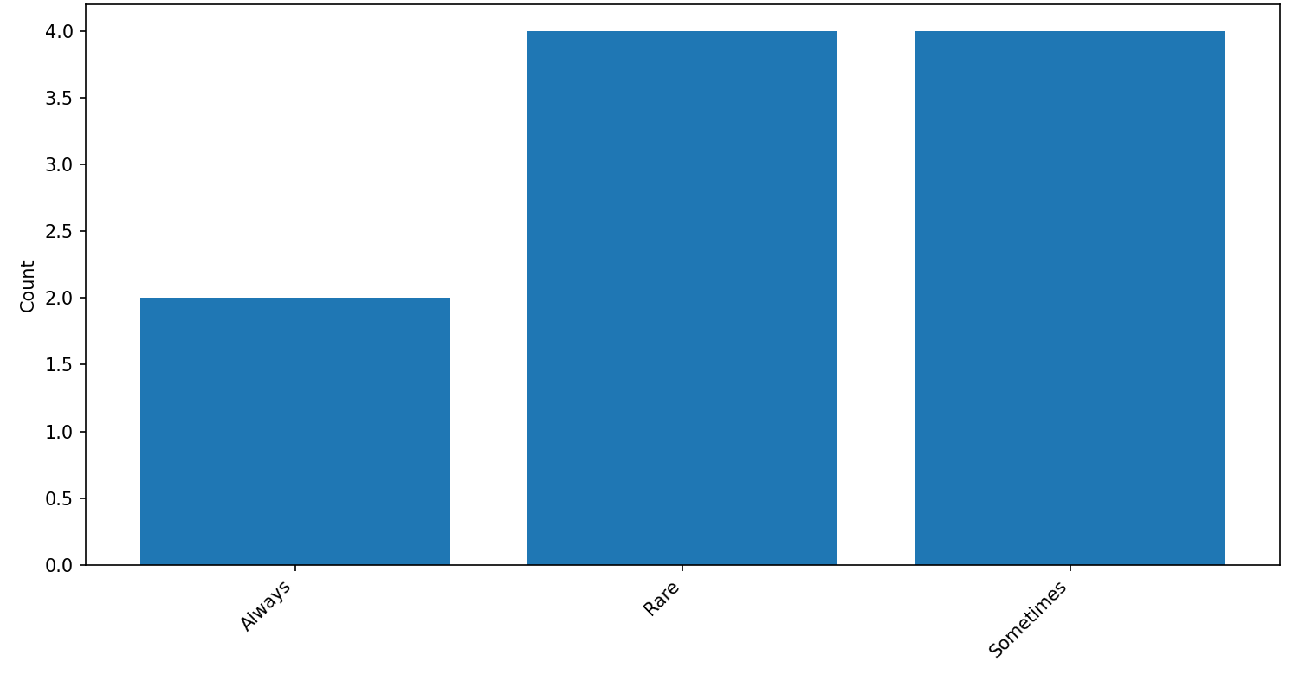
Figure 6 Difficulty in judging engagement

A clear majority indicated that real-time feedback from students (e.g., “verwirrt”, “gelangweilt”, “konzentriert”) would be helpful, provided that it is anonymous and easy to interpret. Most teachers wanted to see such feedback during the lesson rather than only in an after-class report; they were interested in “regulation support” instead of retrospective analytics. In terms of representation, respondents consistently favoured an aggregated class view, such as a simple bar or percentage distribution (“40 % overloaded, 30 % OK, 30 % tired”), and explicitly rejected lists of individual students (Figure 7).
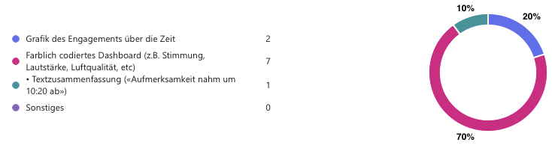
Figure 7 Preferred visualization features by teachers.

Qualitative answers highlighted a wish for information that goes beyond a single “engagement score”. Teachers wanted to understand how cognitive load, emotional energy and environmental factors interact: whether learners are confused or under-challenged, when energy drops in the course of a double period, and how air quality or noise might contribute. The interviews showed that teachers would be willing to participate in a pilot only if the tool is framed as a supportive assistant rather than a monitoring system.

These findings led to the decision that the teacher dashboard would display only group-level percentages of the four core states, supplemented by a very small set of environmental indicators and optional post-lesson summaries.

Student Survey and Interviews
The student survey revealed that most learners are willing to share their state sometimes, particularly when they feel lost, overloaded or tired; only a small minority wished to report in every lesson or never at all (Figure 8).

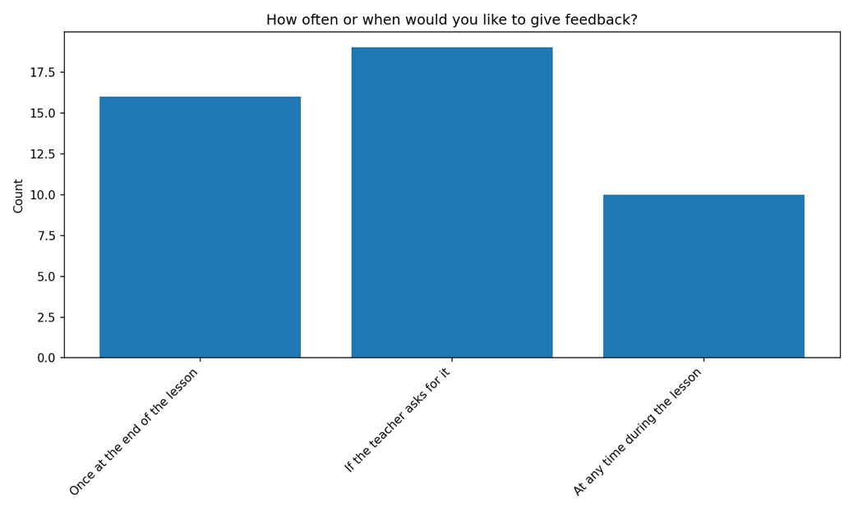
Figure 8 Preferred timing for student feedback during lessons.

Anonymity emerged as a non-negotiable prerequisite. Many students were comfortable with the idea that teachers see an anonymous class summary, but rejected individual tracking, app-use monitoring, and especially camera-based observation.

Regarding interaction style, students clearly preferred very fast, minimal input in the form of tapping an emoji or button. They did not want to type or navigate long menus while the teacher is speaking. Open responses and interviews stressed that the interface should stay in the background, appear only at selected moments or on demand, and never dominate the screen. Small pop-up notifications in a corner, similar to operating-system alerts, were perceived as appropriate; full-screen overlays were seen as disruptive (Figure 9).
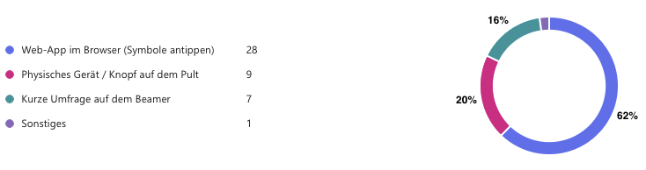
Figure 9 Preferred interaction style by students.

Students also linked their willingness to use such a tool to visible teacher reactions. They were prepared to provide feedback if they could see that the teacher slowed down, clarified a step, or inserted a short activity as a consequence. Without these reactions, they expected motivation to contribute to decline quickly.

Qualitative Style Guidance from Interviews
The interview material provided important guidance for the tone and style of ClassSense. Teachers reported that they already manage attention through subtle, non-verbal strategies such as walking through the room, eye contact and short pauses. They therefore asked that any digital tool should “blend” into existing routines instead of competing with them. This led to the design of a dashboard that can sit quietly at the edge of a screen or on a small external display and uses a restrained, traffic-light-inspired colour scheme rather than dominant animations. Students emphasised that their ideal tool would feel “small, calm and optional”. They associated motivational value primarily with varied teaching methods — games, group work, creative tasks — rather than with technology itself. Consequently, ClassSense is positioned as a light communication layer rather than as a central teaching platform: feedback windows are intentionally compact, and all texts are short, neutral, and free of judgmental wording.

Summary of Design Consequences
Taken together, the exploratory study provided a detailed picture of how digital lessons drift out of sync and how a technical system can support co-regulation without violating trust. Both groups described the same core problem, loss of shared focus that often remains invisible, and formulated similar expectations: a safe channel to surface this drift, an anonymous aggregated view of class climate, possibilities for quick instructional adjustments, and strict avoidance of surveillance optics.

These results defined the core functionality and stylistic principles implemented in the ClassSense prototypes that were later evaluated in the controlled experiment.

Personas and Scenarios
Based on the exploratory questionary and interview results, we have defined 3 teacher personas, 4 student personas and 3 scenarios. These objects will provide the ideas, that will be later used in the prototype development.

Teacher Personas
- Mr. Müller, 42 years old, teaches History and English, BYOD class.
Pain points:
- Cannot read the class once everyone looks at laptops.
- Asks “Is the pace ok?” and gets silence.
- Feels tired managing constant micro-adjustments.
Motivations:
- Wants to act early before the group drifts.
- Wants feedback that does not expose individual students.
- Wants a tool that runs quietly in the background.

Design implications:
- Teacher view must be simple, aggregated, and readable at a glance.
- Needs immediate hints for action (“slow down,” “pause”).
- Privacy guarantee visible on first screen.

- Mrs. Brinkmann, teacher of Mathematics and Physics, 28 years old.
Pain points:
- Knows students multitask on screens.
- Wants empirical feedback, not only intuition.

Motivations:
- Wants to measure engagement across lesson phases.
- Wants aggregated data after class to improve slides or pacing.

Design implications:
- Add optional end-of-lesson summary.
- Allow export of anonymous “lesson heatmap.”
- Keep real-time view simple enough for in-lesson use.

- Mr. Zemp, teacher of Languages, 58 years old.
Pain points:
- Feels saturated with new tools.
- Fears student misuse or extra workload.
Motivations:
- Willing to try if privacy and simplicity are guaranteed.

Design implications:
- Onboarding must take under 3 minutes.
- Use neutral visual design and clear labels.
- Highlight “no extra admin work.”

Student Personas
- Melanie, 17 years old, organised, cares about grades.
Pain points:
- Gets frustrated when the class slows down.
- Does not want others’ disengagement to waste time.
Motivations:
- Wants efficient pacing and clarity.

Design implications:
- Needs “OK / continue” option to express readiness.
- System must show that feedback from all sides balances the group.

- Tim, 16 years old, introverted, good comprehension but slow processing.
Pain points:
- Feels anxious when teacher moves on too fast.
- Avoids asking publicly for help.
Motivations:
- Wants a safe way to signal “too fast” or “overloaded.”

Design implications:
- One-tap anonymous input required.
- System must confirm receipt (“Your input counted”).

- Jasmin, 17 years old, average grades, avoids attention.
Pain points:
- Feels invisible; sees teacher unaware of general tiredness.
Motivations:
- Wants collective expression (“many of us are tired”).

Design implications:
- Aggregated results must be visible to teacher only.
- No personal trace of participation.

- Phil, 16 years old, digitally fluent, constantly switches tabs.
Pain points:
- Bored quickly; task repetition triggers distraction.
Motivations:
- Wants variety and quick feedback loops.

Design implications:
- Short check-ins maintain re-engagement.
- Interface should feel modern but minimal.

Scenarios
- Scenario 1 – Live regulation
- During a maths lesson, students tap icons:
- 30 percent “too fast,” 50 percent “OK,” 20 percent “tired.”
- Teacher view flashes amber: “Overload rising.”
- Teacher pauses 2 minutes, repeats key step.
- Next pulse shows 70 percent “OK.”
Outcome: Teacher prevents frustration; students see reaction; trust reinforced.

- Scenario 2 – Energy monitor in double period
- After 45 minutes, many students signal “tired.”
- Teacher adds micro-break and short pair task.
- Energy score returns to green zone.
Outcome: Maintains attention without disciplinary interventions.

- Scenario 3 – Post-lesson review
- ClassSense shows teacher anonymous timeline: first 20 min = OK, middle = overload, last = fatigue.
- Teacher adjusts next lesson by reducing input length and adding examples.
Outcome: Supports reflection without tracking individuals.

Controlled Experiment

Students

Usability
Students rated the usability of both variants on a 5-point scale. A paired-samples t-test showed no significant difference between the button interface (M = 3.95, SD = 0.79) and the slider interface (M = 3.72, SD = 0.83), t(25) = 1.49, p = 0.148 (Figure 10).
Both variants were perceived as similarly usable.
Mean
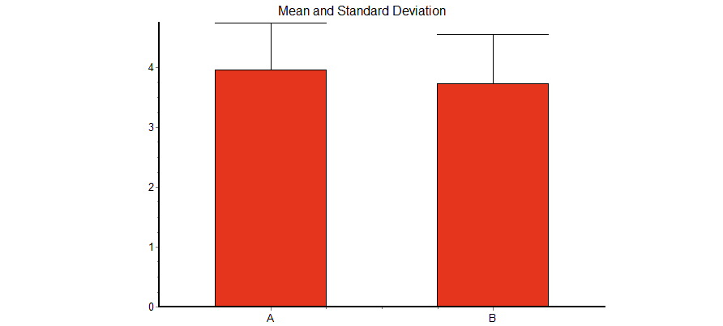
Figure 10 Mean and STD for usability (Condition A = Buttons, Condition B = Sliders)

Disruption during class
Because disruption ratings were not normally distributed, a Wilcoxon matched-pairs signed-rank test was applied. Results showed no significant difference between the button version (M = 3.6, SD = 1.02) and the slider version (M = 3.23, SD = 1.21), p = 0.152 (Figure 11). Neither interface was considered disruptive to the class.
Mean
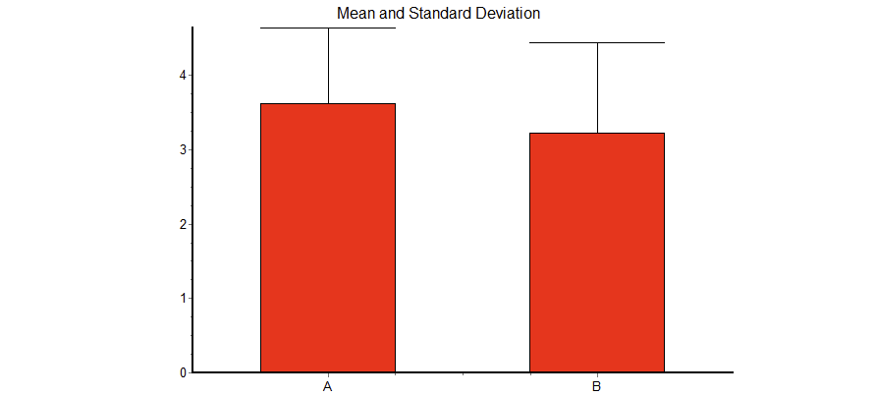
Figure 11 Mean and STD for disruption (Condition A = Buttons, Condition B = Sliders)

Adoption Intention
Intention to use the tool frequently in real lessons was also analysed using the Wilcoxon test due to non-normal distributions. No significant difference emerged between the button interface (M = 3.69, SD = 1.03) and the slider interface (M = 3.54, SD = 0.98), p = 0.34 (Figure 12). Students showed similar willingness to adopt both variants.
Mean
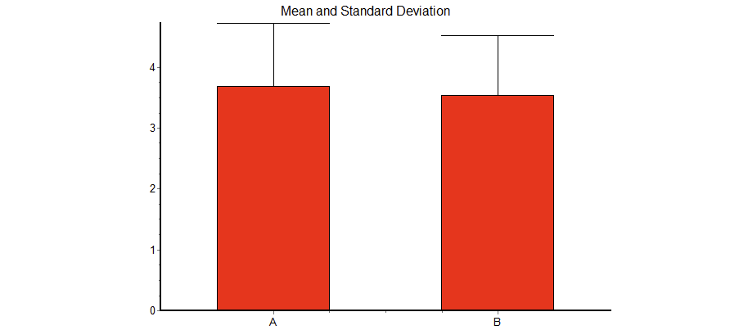
Figure 12 Mean and STD for adoption (Condition A = Buttons, Condition B = Sliders)

Preference
Despite comparable rating scores, students showed a clear preference when required to choose one variant for real classroom use.
Out of 26 students, 19 preferred the button interface, while 7 preferred the slider interface.
A binomial test confirmed this deviation from chance (50%), p = .040.
Students favouring the button variant argued that it was faster, simpler, and less distracting (“nur ein Knopfdruck”, “lenkt weniger vom Inhalt ab”), while slider supporters emphasized precision and expressiveness (“präziser ausdrücken”, “tieferer Bedeutung”).

Reaction Time
Reaction-time data were analysed to evaluate the efficiency of student input. Because distributions deviated strongly from normality and the number of observations differed between conditions (buttons: n = 516 vs. sliders: n = 89), a Mann–Whitney U test was applied.
Students reacted significantly faster using the button interface (Mdn = 80 ms) than when using the slider interface (Mdn = 514 ms), U = 11576, p < 0.0001 (Figure 13).
This supports the assumption that one-tap feedback enables quicker responses with lower cognitive effort during class activities.
Mean

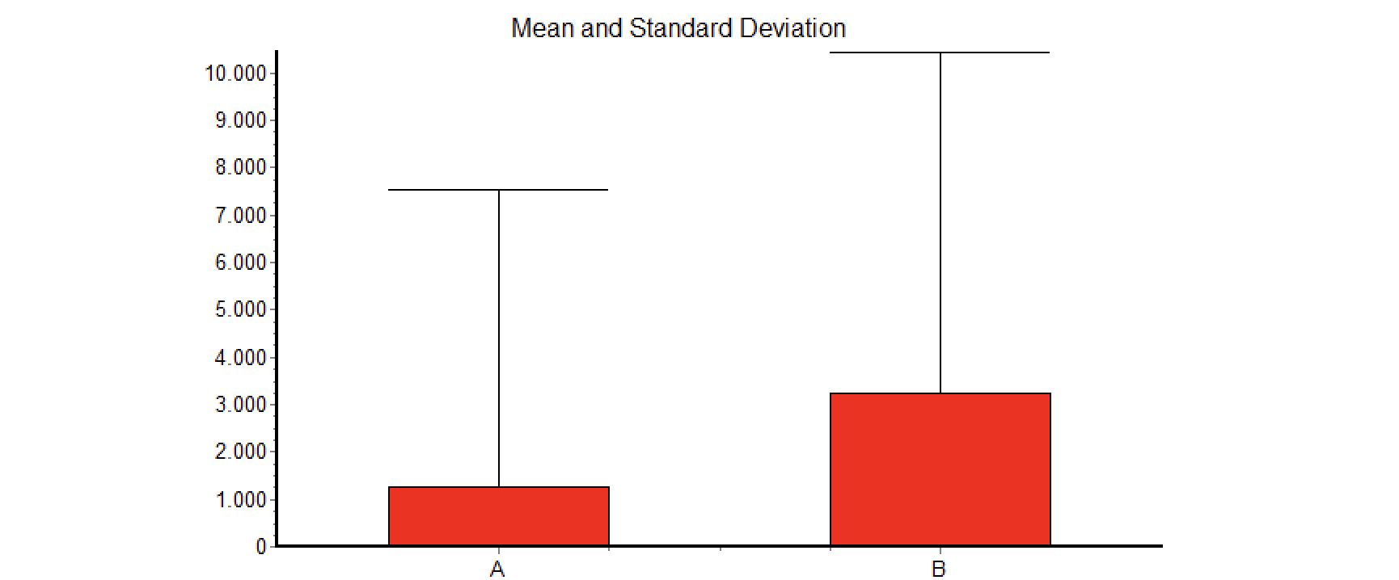
Figure 13 Mean and STD for reaction time for feedback input (Condition A = Buttons, Condition B = Sliders).

Teachers

Usability
Teachers evaluated how easy it was to access the classroom state on each dashboard. A paired-samples t-test indicated no significant difference between the browser dashboard (M = 4.21, SD = 0.86) and the external-screen dashboard (M = 4.64, SD = 0.38), t(6) = 1.35, p = 0.225 (Figure 14). Both versions were perceived as easy to use in practice.

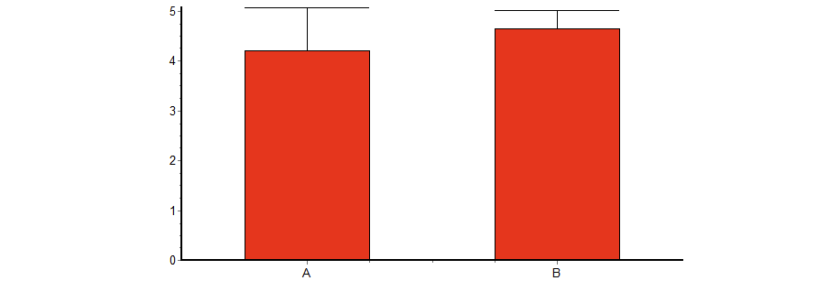
Mean
Figure 14 Mean and STD of usability (Condition A = WebApp in Browser, Condition B = WebApp on external Screen)

Practicality / Disruption
Because the data did not meet normality assumptions, a Wilcoxon matched-pairs signed-rank test was conducted. No significant difference was found between the browser version (M = 3.71, SD = 0.76) and the external-screen version (M = 4.43, SD = 0.53), p = 0.25 (Figure 15). Teachers indicated that both variants integrate smoothly into classroom flow.

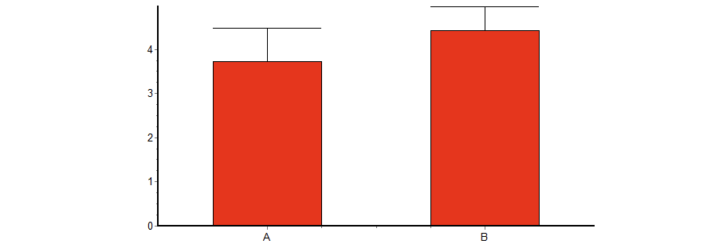
Mean
Figure 15 Mean and STD for disruption (Condition A = WebApp in Browser, Condition B = WebApp on external Screen)

Adoption Intention
Adoption intention was likewise analysed using the Wilcoxon test due to non-normal distribution. Results showed no significant difference between the browser dashboard (M = 3.86, SD = 0.63) and the external-screen version (M = 4.36, SD = 0.48), p = 0.25 (Figure 16).
However, scores for the external display trended higher, suggesting a more favourable perception in real teaching scenarios.

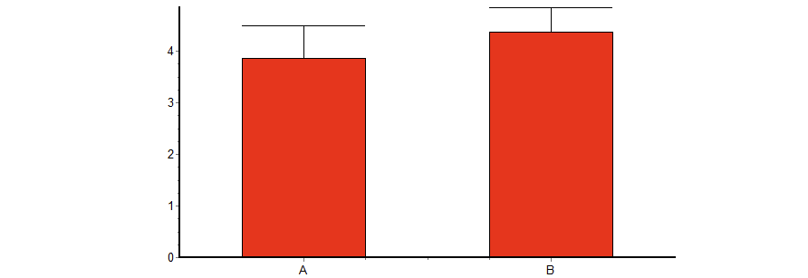
Mean
Figure 16 Mean and STD for adoption (Condition A = WebApp in Browser, Condition B = WebApp on external Screen)

Preference
Unlike the questionnaire ratings, the forced-choice question revealed a strong preference. Six out of seven teachers chose the external-screen dashboard over the browser version.
Teachers explained that an additional screen:

• avoids switching windows during instruction
• keeps teaching materials visible on their primary device
• supports continuous peripheral awareness of the class state
• reduces cognitive interruption

Example comments included:
“Es ist die ganze Zeit präsent.”
“Keine weitere Ablenkung auf dem Hauptbildschirm.”

The single teacher who preferred the browser version cited reduced hardware needs.

Discussion

Findings and Implications
The main finding from our work is that classroom climate tools such as ClassSense are desirable and feasible in a BYOD secondary school environment. However, these tools must still respect strict constraints regarding anonymity, interaction effort and classroom disruption.

Firstly, the exploratory study confirmed our initial hypothesis that both teachers and students face the same problem: once devices are switched on, the emotional and attentional state of the class becomes harder to read. Teachers reported that they struggle to judge engagement based on indirect cues alone. They expressed an interest in real-time feedback, provided that the system is simple to use, requires no setup, and does not create an additional workload or distractions during teaching. Students also raised concerns about class time being used inefficiently. However, their main concern was anonymity. They strongly rejected individual tracking ideas such as app monitoring or camera-based emotion tracking. These perspectives resulted in the basic design direction for ClassSense: the tool should be (1) lightweight, (2) anonymous, and (3) straightforward to use.

Secondly, both the qualitative feedback and the controlled experiment highlighted that interaction effort is one of the critical factors in the classroom. Students preferred minimal input, such as tapping an icon. They did not want to use a slider, which requires more time and precision. Although questionnaire ratings for usability, disruption and adoption did not show significant differences between the two student variants, the preference and reaction time results still point in the same direction: one-tap input is more suited to real lesson conditions. This suggests that, for classroom tools, small differences in effort can matter a lot, even if Likert ratings appear similar.

Thirdly, in the controlled experiment, teachers once more indirectly chose the option that required minimal manual input from them. While both dashboard conditions were rated positively, most teachers preferred the external screen over the browser version. They gave practical reasons for this preference: less window switching, teaching materials stay visible on the main device and the class state is always present in peripheral vision. This implies that the external screen configuration may support smoother integration into real teaching process, even if the basic usability scores remain similar.

Overall, our findings suggest that the value of ClassSense is not in complex analytics, but in providing a calm, privacy-respecting feedback loop that enables teachers to react early and makes students feel that their state is important. For future classroom climate tools, the most important design priority should remain trust and low effort, not more detailed individual data.

Limitations and Suggestions for Further Research
This project has several limitations. Firstly, the controlled experiment was conducted with a relatively small sample size (n = 26 students, n = 7 teachers). While this is sufficient to generate statistically significant findings, it limits the generalisability of the results. Secondly, participants only tested the system for a short time in a controlled setup. Therefore, we cannot fully predict long-term adoption, habituation effects or the impact of repeated use across many lessons.

Another limitation is that we mainly evaluated the teacher dashboard on one prototype setup and in one school context. Different classroom environments, subject types and school cultures may result in different preferences and adaptations. Additionally, while the physical prototype included environmental sensors, the evaluation mostly focused on interface comparisons. Future work could examine more deeply whether sensor-based indicators meaningfully improve teaching decisions, or whether they should remain optional.

For further research, we recommend deploying the tool for longer periods of time, such as several weeks or months, during which real lessons will be observed. This would provide a better understanding of how teachers adapt the tool into their routine practices and whether students continue to use it when novelty fades. Future iterations should also address user accessibility in more detail. beyond colour choices, which was already accessed in this prototype, for example with icon clarity, text alternatives, bearing in mind how such a prototype can be made to work sustainably for people with different disabilities.

Retrospective “What we could do differently”
Looking back at the project, we have agreed on the following points that could have been done differently, which might have helped us to cover more topics or achieve different results in the final evaluation.

Firstly, in the early phase, we considered approaches such as app usage tracking and camera-based emotion detection. However, these ideas were strongly rejected by students in the exploratory study. However, through informal communication outside of the scope of the official data in this report, we discovered an important point: when students answered the first questionnaire, some of them had in mind a completely different type of app. This may have influenced their responses. Because of that, we could have framed these questions more carefully to avoid creating the impression of surveillance from the first contact, as this was the main concern. The original intention of this idea was privacy-driven, and it would not collect more data than what students already share when they tap a button. However, this was not made clear enough in our introduction.

Secondly, the interview phase could have been extended to include multiple rounds. Only one round of follow-up interviews was conducted with a small subset of participants. If there had been more time, an additional round of interviews after the first prototype refinement would have helped to validate whether the early design interpretations (e.g., the four core states, the calm visual style, and the additional teacher view) truly matched real classroom expectations, before moving on to the controlled experiment.

Thirdly, the technical architecture was designed to be functional and lightweight within the course timeline. With more development time, the backend and data pipeline could have been improved for more stable classroom use.

Overall, these points do not change the general direction of the project. However, we present them to show where the process could be strengthened for other agents that might be interested in such a project. Despite the time and scope limitations, the UCD approach still helped to shape ClassSense around the key constraints that mattered most in this context: anonymity, low-effort student input and a teacher view that does not disrupt the lesson.

List of Figures

Figure 1 Paper prototype of the teacher UI (top: horizontal stripe / right: vertical stripe / bottom: dashboard with details) 4
Figure 2 Figma prototype of the teacher UI (top: horizontal stripe / bottom: dashboard with details) 5
Figure 3 Paper prototype of the student UI (upper left: slider / bottom left: buttons) 5
Figure 4 Figma prototype of the student UI (left: sliders / reight: buttons) 6
Figure 5 System architecture of the ClassSense functional prototype. 6
Figure 6 Difficulty in judging engagement 10
Figure 7 Preferred visualization features by teachers. 10
Figure 8 Preferred timing for student feedback during lessons. 11
Figure 9 Preferred interaction style by students. 11
Figure 10 Mean and STD for usability (Condition A = Buttons, Condition B = Sliders) 15
Figure 11 Mean and STD for disruption (Condition A = Buttons, Condition B = Sliders) 15
Figure 12 Mean and STD for adoption (Condition A = Buttons, Condition B = Sliders) 16
Figure 13 Mean and STD for reaction time for feedback input (Condition A = Buttons, Condition B = Sliders). 16
Figure 14 Mean and STD of usability (Condition A = WebApp in Browser, Condition B = WebApp on external Screen) 17
Figure 15 Mean and STD for disruption (Condition A = WebApp in Browser, Condition B = WebApp on external Screen) 17
Figure 16 Mean and STD for adoption (Condition A = WebApp in Browser, Condition B = WebApp on external Screen) 18

List of Tables

Table 1 Variables 7
Table 2 Variables 8

References
Brackett, M. A., Reyes, M. R., Rivers, S. E., Elbertson, N. A., & Salovey, P. (2011). Classroom Emotional Climate, Teacher Affiliation, and Student Conduct. The Journal of Classroom Interaction, 46(1), pp. 27-36.
Czerwinski, M., Horvitz, E., & Wilhite, S. (2004). A diary study of task switching and interruptions. In ACM (Ed.), Proceedings of CHI 2004, (pp. 175–182).
Fitts, P. M. (1954). The information capacity of the human motor system in controlling the amplitude of movement. Journal of Experimental Psychology, 47(6), pp. 381–391.
Movetia. (2024). Weiterentwicklung der gymnasialen Maturität (WEGM). Retrieved October 2025, from https://www.movetia.ch
Reyes, M. R., Brackett, M. A., Rivers, S. E., White, M., & Salovey, P. (2012). The role of classroom emotional climate in promoting student engagement. Journal of Educational Psychology, 104(3), pp. 700-712.
Schweizerische Konferenz der kantonalen Erziehungsdirektoren (EDK). (2024). Retrieved October 2025, from Rahmenlehrplan für die gymnasiale Maturität (RLP 2024): https://www.edk.ch
Wang, M. T., Degol, J. L., Amemiya, J., Parr, A., & Guo, J. (2020). Classroom climate and children’s academic and psychological adjustment: A meta-analytic review. Educational Psychology Review, 32(2), pp. 337-376.

