1) Create virtual machines connection according to figure 1. VM2 has one interface (internal), VM1 has 2 interfaces (NAT and internal). Configure all network interfaces in order to make VM2 has an access to the Internet (iptables, forward, masquerade).
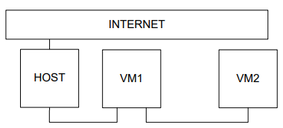
Settings for VM1
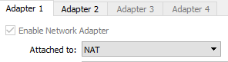 | 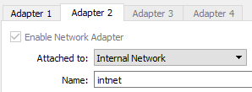

root@CsnKhai:~# cat /etc/network/interfaces

# The loopback network interface
auto lo
iface lo inet loopback

# 1-NAT
auto eth0
iface eth0 inet dhcp

#internal
auto eth1
iface eth1 inet static
address 10.10.10.1
netmask 255.255.255.0
broadcast 10.10.10.255

root@CsnKhai:~# mcedit /etc/sysctl.con

iptables -t nat -A POSTROUTING -o eth0 -j MASQUERADE
iptables-save > /etc/iptables.rules
mcedit /etc/rc.local

Settings for VM2
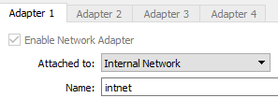
# The loopback network interface
auto lo
iface lo inet loopback

# The primary network interface
auto eth0
iface eth0 inet static
address 10.10.10.2
netmask 255.255.255.0
broadcast 10.10.10.255
gateway 10.10.10.1

3) Check the route from VM2 to Host.
traceroute to 192.168.56.1 (192.168.56.1), 30 hops max, 60 byte packets
1 10.10.10.1 (10.10.10.1) 0.000 ms 0.000 ms 0.000 ms
2 10.0.2.2 (10.0.2.2) 0.000 ms 0.000 ms 0.000 ms
3 10.0.2.2 (10.0.2.2) 0.000 ms 0.000 ms 0.000 ms

4) Check the access to the Internet, (just ping, for example, 8.8.8.8).
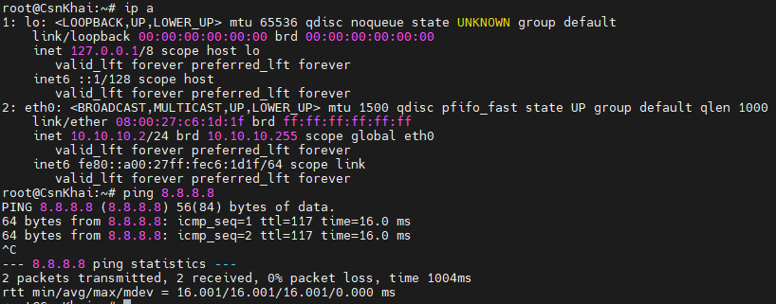
5) Determine, which resource has an IP address 8.8.8.8.
root@CsnKhai:~# nslookup 8.8.8.8
Server: 127.0.0.1
Address: 127.0.0.1#53

Non-authoritative answer:
8.8.8.8.in-addr.arpa name = dns.google.

Authoritative answers can be found from:
8.8.8.in-addr.arpa nameserver = ns3.google.com.
8.8.8.in-addr.arpa nameserver = ns2.google.com.
8.8.8.in-addr.arpa nameserver = ns1.google.com.
8.8.8.in-addr.arpa nameserver = ns4.google.com.
ns1.google.com internet address = 216.239.32.10
ns1.google.com has AAAA address 2001:4860:4802:32::a
ns2.google.com internet address = 216.239.34.10
ns2.google.com has AAAA address 2001:4860:4802:34::a
ns3.google.com internet address = 216.239.36.10
ns3.google.com has AAAA address 2001:4860:4802:36::a
ns4.google.com internet address = 216.239.38.10
ns4.google.com has AAAA address 2001:4860:4802:38::a

6) Determine, which IP address belongs to resource epam.com
root@CsnKhai:~# dig epam.com

; <<>> DiG 9.9.5-3ubuntu0.19-Ubuntu <<>> epam.com
;; global options: +cmd
;; Got answer:
;; ->>HEADER<<- opcode: QUERY, status: NOERROR, id: 64950
;; flags: qr rd ra; QUERY: 1, ANSWER: 1, AUTHORITY: 6, ADDITIONAL: 8

;; OPT PSEUDOSECTION:
; EDNS: version: 0, flags:; udp: 1220
;; QUESTION SECTION:
;epam.com. IN A

;; ANSWER SECTION:
epam.com. 2695 IN A 3.214.134.159

;; AUTHORITY SECTION:
epam.com. 2118 IN NS a7-64.akam.net.
epam.com. 2118 IN NS a11-65.akam.net.
epam.com. 2118 IN NS a10-64.akam.net.
epam.com. 2118 IN NS a20-67.akam.net.
epam.com. 2118 IN NS a14-66.akam.net.
epam.com. 2118 IN NS a1-195.akam.net.

;; ADDITIONAL SECTION:
a7-64.akam.net. 260 IN A 23.61.199.64
a1-195.akam.net. 2118 IN A 193.108.91.195
a10-64.akam.net. 2224 IN A 96.7.50.64
a11-65.akam.net. 1385 IN A 84.53.139.65
a14-66.akam.net. 367 IN A 184.26.161.66
a20-67.akam.net. 2118 IN A 95.100.175.67
a20-67.akam.net. 360 IN AAAA 2a02:26f0:67::43

;; Query time: 4 msec
;; SERVER: 127.0.0.1#53(127.0.0.1)
;; WHEN: Sat Dec 25 07:03:34 UTC 2021
;; MSG SIZE rcvd: 310

7) Determine the default gateway for your HOST and display routing table.
root@CsnKhai:~# route
Kernel IP routing table
Destination Gateway Genmask Flags Metric Ref Use Iface
default 10.0.2.2 0.0.0.0 UG 0 0 0 eth0
10.0.2.0 * 255.255.255.0 U 0 0 0 eth0
10.10.10.0 * 255.255.255.0 U 0 0 0 eth1вш

8) Trace the route to google.com
dig google.com
;; ANSWER SECTION:
google.com. 64 IN A 216.58.215.78

root@CsnKhai:~# mtr 216.58.215.78
