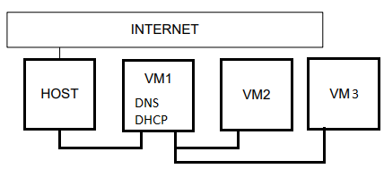
2. Install and configure DHCP server on VM1.
DNSMASQ
mcedit /etc/network/interfaces
# 1-NAT
auto eth0
iface eth0 inet dhcp
#internal
auto eth1
Iface eth1 inet static
address 10.10.10.1
netmask 255.255.255.0
broadcast 10.10.10.255
mcedit /etc/dnsmasq.conf
interface=eth1
dhcp-range=10.10.10.10,10.10.10.20,12h
mcedit /etc/dhcp/dhclient.conf
prepend domain-name-servers 127.0.0.1;
#request subnet-mask……….
mcedit /etc/resolv.conf
nameserver 127.0.0.1
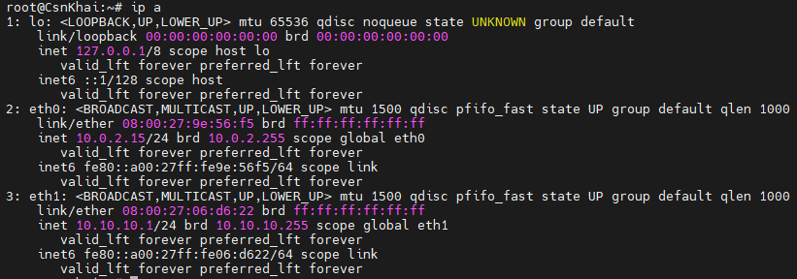
3. Check VM2 and VM3 for obtaining network addresses from DHCP server.
VM2
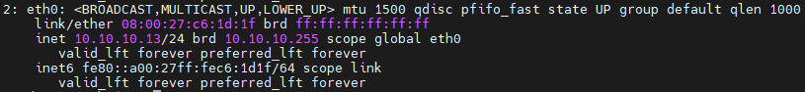
VM3
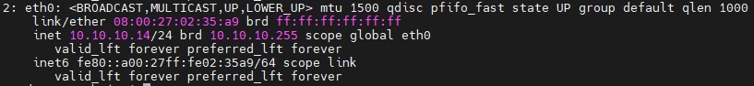
4. Using existed network for three VMs (from p.1) install and configure DNS server on VM1. (You can use DNSMASQ, BIND9 or something else).
DNSMASQ
mcedit /etc/resolv.conf
nameserver 127.0.0.1
mcedit /etc/dhcp/dhclient.conf
prepend domain-name-servers 127.0.0.1;
#request subnet-mask……….

5. Check VM2 and VM3 for gaining access to DNS server (naming services).
VM2
VM3
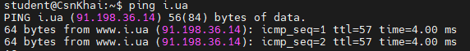

2. Install and configure DHCP server on VM1.
ISC-DHCP-SERVER

mcedit /etc/default/isc-dhcp-server
INTERFACES="eth1"

/etc/network/interfaces
# 1-NAT
auto eth0
iface eth0 inet dhcp

#internal
auto eth1
iface eth1 inet static
address 10.10.10.1
netmask 255.255.255.0
broadcast 10.10.10.255

mcedit /etc/dhcp/dhcpd.conf
subnet 10.10.10.0 netmask 255.255.255.0 {
range 10.10.10.10 10.10.10.25;
option domain-name-servers 10.10.10.1;
option domain-name "workgroup";
option routers 10.10.10.1;
option broadcast-address 10.10.10.255;
default-lease-time 604800;
max-lease-time 604800;
}

service isc-dhcp-server restart

Установил bind9 с параметрами по умолчанию, для работы DNS

