2) Use the passwd command to change the password. Examine the basic parameters of the command. What system file does it change *?
student@CsnKhai:~$ sudo su -
[sudo] password for student:
root@CsnKhai:~# passwd
Enter new UNIX password:
Retype new UNIX password:
passwd: password updated successfully

3) Determine the users registered in the system, as well as what commands they execute. What additional information can be gleaned from the command execution?
root@CsnKhai:~# w
18:53:00 up 16 min, 2 users, load average: 0.00, 0.01, 0.01
USER TTY FROM LOGIN@ IDLE JCPU PCPU WHAT
student tty1 18:46 6:26 0.05s 0.02s -bash
student pts/0 192.168.56.1 18:47 0.00s 0.03s 0.02s sshd: student [priv]
root@CsnKhai:~# who
student tty1 2021-12-21 18:46
student pts/0 2021-12-21 18:47 (192.168.56.1)
root@CsnKhai:~# whoami
root

4) Change personal information about yourself.
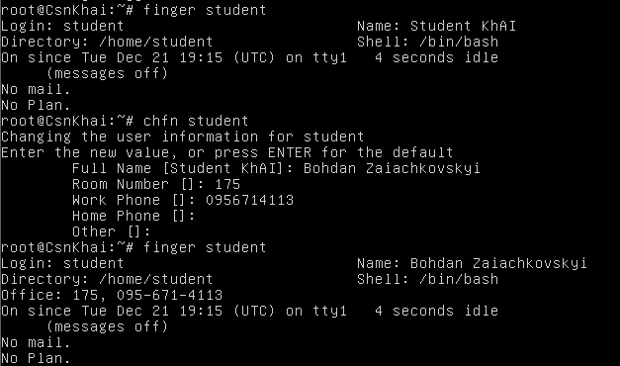
5) Become familiar with the Linux help system and the man and info commands. Get help on the previously discussed commands, define and describe any two keys for these commands. Give examples.
man sudo
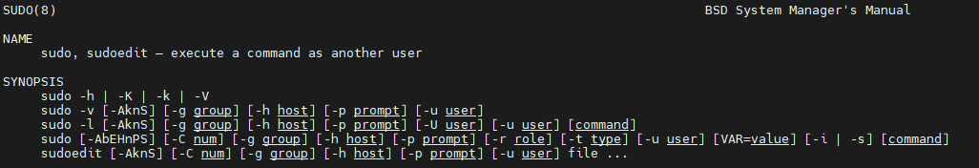

info sudo
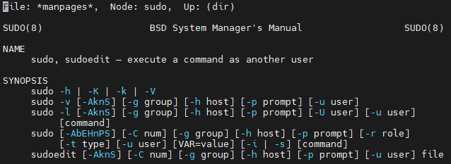
6) Explore the more and less commands using the help system. View the contents of files .bash* using commands.
cat .bashrc | less
cat .bashrc | more
More - старая и основная терминальная команда, которая используется при открытии файла для интерактивного чтения. Если содержимое файла слишком велико, чтобы помещаться на одном экране, оно отображает содержимое страницы за страницей. Вы можете прокручивать содержимое файла, нажимая клавиши ENTER или SPACE. Но одно ограничение – вы можете прокручивать только вперед, а не назад. Это означает, что вы можете прокручивать вниз, но не можете подняться.
Less - Позволяет прокрутку вперед и назад,
- Поиск в прямом и обратном направлениях,
- Немедленный переход к концу и началу файл,
- Открытие данного файла в редакторе.

7) Describe in plans that you are working on laboratory work 1. Tip: You should read the documentation for the finger command.
student@CsnKhai:~$ echo "I'm going to be good DevOps!" > .plan
student@CsnKhai:~$ finger -l
Login: student Name: Bohdan Zaiachkovskyi
Directory: /home/student Shell: /bin/bash
Office: 175, 095-671-4113
On since Tue Dec 21 19:34 (UTC) on tty1 11 minutes 39 seconds idle
(messages off)
On since Tue Dec 21 19:36 (UTC) on pts/0 from 192.168.56.1
1 second idle
No mail.
Plan:
I'm going to be good DevOps!

8) List the contents of the home directory using the ls command, define its files and directories. Hint: Use the help system to familiarize yourself with the ls command
student@CsnKhai:~$ ls -ial
total 40
476 drwxr-xr-x 4 student student 4096 Dec 21 19:49 .
8203 drwxr-xr-x 3 root root 4096 Sep 15 2015 ..
5479 -rw------- 1 student student 113 Dec 21 19:31 .bash_history
54346 -rw-r--r-- 1 student student 220 Sep 15 2015 .bash_logout
60613 -rw-r--r-- 1 student student 3637 Sep 15 2015 .bashrc
60631 drwx------ 2 student student 4096 Sep 15 2015 .cache
1115 -rw-rw-r-- 1 student student 29 Dec 21 19:47 .plan
57151 -rw-r--r-- 1 student student 675 Sep 15 2015 .profile
57810 drwxrwxr-x 2 student student 4096 Dec 21 19:49 test_directory
1641 -rw------- 1 student student 53 Dec 21 19:36 .Xauthority

PART 2

1) Examine the tree command. Master the technique of applying a template, for example, display all files that contain a character c, or files that contain a specific sequence of characters. List subdirectories of the root directory up to and including the second nesting level.
student@CsnKhai:~$ tree -a
.
├── .bash_history
├── .bash_logout
├── .bashrc
├── .cache
│ ├── mc
│ │ └── Tree
│ └── motd.legal-displayed
├── .config
│ └── mc
│ └── ini
├── .local
│ └── share
│ └── mc
│ └── history
├── .plan
├── .profile
├── test_directory
└── .Xauthority

student@CsnKhai:~$ tree -a -P "*bas*"  .  ├── .bash_history  ├── .bash_logout  ├── .bashrc  ├── .cache  │ └── mc  ├── .config  │ └── mc  ├── .local  │ └── share  │ └── mc  └── test_directory | 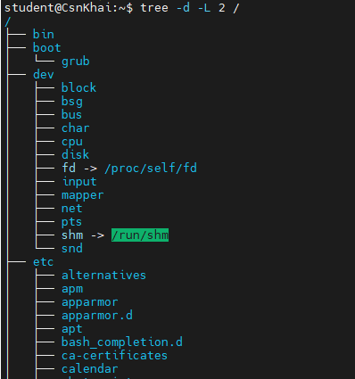

2) What command can be used to determine the type of file (for example, text or binary)? Give an example.
root@CsnKhai:/usr/bin# cd /usr/bin
root@CsnKhai:/usr/bin# file bas*
base64: ELF 32-bit LSB executable, Intel 80386, version 1 (SYSV), dynamically linked (uses shared libs), for GNU/Linux 2.6.24, BuildID[sha1]=de7bb3b2db9f027d941fa55196e94b86d509be9e, stripped
basename: ELF 32-bit LSB executable, Intel 80386, version 1 (SYSV), dynamically linked (uses shared libs), for GNU/Linux 2.6.24, BuildID[sha1]=6c72b04138d654c1cd424a674784175cfad3f5bc, stripped
bashbug: POSIX shell script, ASCII text executable, with very long lines

3) Master the skills of navigating the file system using relative and absolute paths. How can you go back to your home directory from anywhere in the filesystem?
student@CsnKhai:~$ cd ~
student@CsnKhai:~$ pwd
/home/student
student@CsnKhai:~$ cd /
student@CsnKhai:/$ pwd
/
student@CsnKhai:/$ cd $HOME
student@CsnKhai:~$ pwd
/home/student
student@CsnKhai:~$

4)Become familiar with the various options for the ls command. Give examples of listing directories using different keys. Explain the information displayed on the terminal using the -l and -a switches.
student@CsnKhai:~$ ls -l
total 4
drwxrwxr-x 2 student student 4096 Dec 21 19:49 test_directory
student@CsnKhai:~$ ls -a
. .bash_history .bashrc .config .plan test_directory
.. .bash_logout .cache .local .profile .Xauthority
student@CsnKhai:~$ ls -hli
total 4.0K
57810 drwxrwxr-x 2 student student 4.0K Dec 21 19:49 test_directory

5)Perform the following sequence of operations: - create a subdirectory in the home directory; - in this subdirectory create a file containing information about directories located in the root directory (using I/O redirection operations); - view the created file; - copy the created file to your home directory using relative and absolute addressing. - delete the previously created subdirectory with the file requesting removal; - delete the file copied to the home directory.
student@CsnKhai:~$ mkdir dir_with_files
student@CsnKhai:~$ ls -ali / > ~/dir_with_files/dir_list.txt
student@CsnKhai:~$ cd dir_with_files/
student@CsnKhai:~/dir_with_files$ cat dir_list.txt
total 88
2 drwxr-xr-x 21 root root 4096 Sep 15 2015 .
2 drwxr-xr-x 21 root root 4096 Sep 15 2015 ..
8207 drwxr-xr-x 2 root root 4096 Dec 21 19:21 bin
8199 drwxr-xr-x 3 root root 4096 Dec 21 19:22 boot
1025 drwxr-xr-x 14 root root 4000 Dec 22 07:26 dev
12 drwxr-xr-x 84 root root 4096 Dec 22 07:26 etc
8203 drwxr-xr-x 3 root root 4096 Sep 15 2015 home
19853 lrwxrwxrwx 1 root root 33 Sep 15 2015 initrd.img -> boot/initrd.img-3.13.0-63-generic
8200 drwxr-xr-x 22 root root 4096 Dec 21 19:20 lib
11 drwx------ 2 root root 16384 Sep 15 2015 lost+found
8193 drwxr-xr-x 2 root root 4096 Sep 15 2015 media
8205 drwxr-xr-x 2 root root 4096 Apr 10 2014 mnt
8209 drwxr-xr-x 2 root root 4096 Sep 15 2015 opt
1 dr-xr-xr-x 97 root root 0 Dec 22 07:26 proc
8201 drwx------ 5 root root 4096 Sep 15 2015 root
7636 drwxr-xr-x 16 root root 540 Dec 22 07:27 run
8206 drwxr-xr-x 2 root root 12288 Dec 21 19:21 sbin
8208 drwxr-xr-x 2 root root 4096 Sep 15 2015 srv
1 dr-xr-xr-x 13 root root 0 Dec 22 07:26 sys
8202 drwxrwxrwt 3 root root 4096 Dec 22 08:01 tmp
8195 drwxr-xr-x 10 root root 4096 Sep 15 2015 usr
16385 drwxr-xr-x 11 root root 4096 Sep 15 2015 var
19854 lrwxrwxrwx 1 root root 30 Sep 15 2015 vmlinuz -> boot/vmlinuz-3.13.0-63-generic
student@CsnKhai:~/dir_with_files$ cp dir_list.txt ~
student@CsnKhai:~/dir_with_files$ cd ..
student@CsnKhai:~$ ls -a
. .bash_history .bashrc .config dir_with_files .plan test_directory
.. .bash_logout .cache dir_list.txt .local .profile .Xauthority
student@CsnKhai:~$ rm dir_list.txt
student@CsnKhai:~$ cp /home/student/dir_with_files/dir_list.txt /home/student/
student@CsnKhai:~$ ls -a
. .bash_history .bashrc .config dir_with_files .plan test_directory
.. .bash_logout .cache dir_list.txt .local .profile .Xauthority
student@CsnKhai:~$ rm -ri dir_with_files/
rm: descend into directory ‘dir_with_files/’? y
rm: remove regular file ‘dir_with_files/dir_list.txt’? y
rm: remove directory ‘dir_with_files/’? Y
student@CsnKhai:~$ rm dir_list.txt
student@CsnKhai:~$ ls -a
. .bash_history .bashrc .config .plan test_directory
.. .bash_logout .cache .local .profile .Xauthority

6)Perform the following sequence of operations: - create a subdirectory test in the home directory; - copy the .bash_history file to this directory while changing its name to labwork2; - create a hard and soft link to the labwork2 file in the test subdirectory; - how to define soft and hard link, what do these concepts; - change the data by opening a symbolic link. What changes will happen and why - rename the hard link file to hard_lnk_labwork2; - rename the soft link file to symb_lnk_labwork2 file; - then delete the labwork2. What changes have occurred and why?
student@CsnKhai:~$ cp .bash_history test/labwork2
student@CsnKhai:~$ ls -a test/
. .. labwork2
student@CsnKhai:~$ ln -s test/labwork2 soft_labwork2
student@CsnKhai:~$ ls -a
. .bash_history .bashrc .config .plan soft_labwork2 test_directory
.. .bash_logout .cache .local .profile test .Xauthority
student@CsnKhai:~$ mcedit soft_labwork2

student@CsnKhai:~$ mcedit soft_labwork2

student@CsnKhai:~$ ln test/labwork2 hard_labwork2
student@CsnKhai:~$ ls -a
. .bash_history .bashrc .config .local .profile test .Xauthority
.. .bash_logout .cache hard_labwork2 .plan soft_labwork2 test_directory
student@CsnKhai:~$ mcedit hard_labwork2

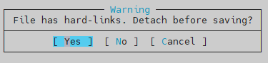
student@CsnKhai:~$ mv hard_labwork2 hard_lnk_lab2
student@CsnKhai:~$ mv soft_labwork2 symb_lnk_lab2
student@CsnKhai:~$ ls -al
total 56
drwxr-xr-x 7 student student 4096 Dec 22 08:42 .
drwxr-xr-x 3 root root 4096 Sep 15 2015 ..
-rw------- 1 student student 512 Dec 22 07:46 .bash_history
-rw-r--r-- 1 student student 220 Sep 15 2015 .bash_logout
-rw-r--r-- 1 student student 3637 Sep 15 2015 .bashrc
drwx------ 3 student student 4096 Dec 21 19:58 .cache
drwx------ 3 student student 4096 Dec 21 19:58 .config
-rw------- 2 student student 525 Dec 22 08:30 hard_lnk_lab2
drwx------ 3 student student 4096 Dec 21 19:58 .local
-rw-rw-r-- 1 student student 29 Dec 21 19:47 .plan
-rw-r--r-- 1 student student 675 Sep 15 2015 .profile
lrwxrwxrwx 1 student student 13 Dec 22 08:22 symb_lnk_lab2 -> test/labwork2
drwxrwxr-x 2 student student 4096 Dec 22 08:16 test
drwxrwxr-x 2 student student 4096 Dec 21 19:49 test_directory
-rw------- 1 student student 53 Dec 22 07:27 .Xauthority
student@CsnKhai:~$ cd test
student@CsnKhai:~/test$ ls -i
2746 labwork2
student@CsnKhai:~/test$ rm labwork2
student@CsnKhai:~/test$ cd ..
student@CsnKhai:~$ ls -i
2746 hard_lnk_lab2 4742 symb_lnk_lab2 59198 test 57810 test_directory
student@CsnKhai:~$ ls -ila
total 56
476 drwxr-xr-x 7 student student 4096 Dec 22 08:42 .
8203 drwxr-xr-x 3 root root 4096 Sep 15 2015 ..
5479 -rw------- 1 student student 512 Dec 22 07:46 .bash_history
54346 -rw-r--r-- 1 student student 220 Sep 15 2015 .bash_logout
60613 -rw-r--r-- 1 student student 3637 Sep 15 2015 .bashrc
60631 drwx------ 3 student student 4096 Dec 21 19:58 .cache
59026 drwx------ 3 student student 4096 Dec 21 19:58 .config
2746 -rw------- 1 student student 525 Dec 22 08:30 hard_lnk_lab2
59110 drwx------ 3 student student 4096 Dec 21 19:58 .local
1115 -rw-rw-r-- 1 student student 29 Dec 21 19:47 .plan
57151 -rw-r--r-- 1 student student 675 Sep 15 2015 .profile
4742 lrwxrwxrwx 1 student student 13 Dec 22 08:22 symb_lnk_lab2 -> test/labwork2
59198 drwxrwxr-x 2 student student 4096 Dec 22 08:44 test
57810 drwxrwxr-x 2 student student 4096 Dec 21 19:49 test_directory
4250 -rw------- 1 student student 53 Dec 22 07:27 .Xauthority
student@CsnKhai:~$ mcedit hard_lnk_lab2 (по хард линку удаленный файл открывается)

7) Using the locate utility, find all files that contain the squid and traceroute sequence. student@CsnKhai:~$ sudo updatedb
[sudo] password for student:
student@CsnKhai:~$ locate squid traceroute
/etc/alternatives/tcptraceroute
/etc/alternatives/tcptraceroute.8.gz
/etc/alternatives/traceroute
/etc/alternatives/traceroute.1.gz
/etc/alternatives/traceroute.sbin
/etc/alternatives/traceroute6
/etc/alternatives/traceroute6.8.gz
/lib/modules/3.13.0-63-generic/kernel/drivers/tty/n_tracerouter.ko
/usr/bin/traceroute
/usr/bin/traceroute-nanog
/usr/bin/traceroute.db
/usr/bin/traceroute6
/usr/bin/traceroute6.db
/usr/bin/traceroute6.iputils
/usr/sbin/tcptraceroute
/usr/sbin/tcptraceroute.db
/usr/sbin/traceroute
/usr/share/doc/traceroute
/usr/share/doc/traceroute/CREDITS
/usr/share/doc/traceroute/README
/usr/share/doc/traceroute/TODO
/usr/share/doc/traceroute/changelog.Debian.gz
/usr/share/doc/traceroute/copyright
/usr/share/man/man1/traceroute-nanog.1.gz
/usr/share/man/man1/traceroute.1.gz
/usr/share/man/man1/traceroute.db.1.gz
/usr/share/man/man1/traceroute6.db.1.gz
/usr/share/man/man8/tcptraceroute.8.gz
/usr/share/man/man8/tcptraceroute.db.8.gz
/usr/share/man/man8/traceroute6.8.gz
/usr/share/man/man8/traceroute6.iputils.8.gz
/var/cache/apt/archives/traceroute_1%3a2.0.20-0ubuntu0.1_i386.deb
/var/lib/dpkg/alternatives/tcptraceroute
/var/lib/dpkg/alternatives/traceroute
/var/lib/dpkg/alternatives/traceroute6
/var/lib/dpkg/info/traceroute.list
/var/lib/dpkg/info/traceroute.md5sums
/var/lib/dpkg/info/traceroute.postinst
/var/lib/dpkg/info/traceroute.prerm

8) Determine which partitions are mounted in the system, as well as the types of these partitions. root@CsnKhai:/home/student# fdisk -l

Disk /dev/sda: 1610 MB, 1610612736 bytes
175 heads, 43 sectors/track, 418 cylinders, total 3145728 sectors
Units = sectors of 1 * 512 = 512 bytes
Sector size (logical/physical): 512 bytes / 512 bytes
I/O size (minimum/optimal): 512 bytes / 512 bytes
Disk identifier: 0x0006c3c4

Device Boot Start End Blocks Id System
/dev/sda1 * 2048 3143679 1570816 83 Linux

9) Count the number of lines containing a given sequence of characters in a given file. student@CsnKhai:~/test$ ll / > ~/test/file1.txt
student@CsnKhai:~/test$ wc file1.txt
24 213 1204 file1.txt
student@CsnKhai:~/test$ wc -l file1.txt
24 file1.txt

10) Using the find command, find all files in the /etc directory containing the host character sequence.
student@CsnKhai:~/test$ sudo !!
sudo find /etc -name '*host*'
/etc/hosts
/etc/hosts.allow
/etc/ssh/ssh_host_ed25519_key.pub
/etc/ssh/ssh_host_ecdsa_key.pub
/etc/ssh/ssh_host_rsa_key
/etc/ssh/ssh_host_rsa_key.pub
/etc/ssh/ssh_host_ecdsa_key
/etc/ssh/ssh_host_dsa_key.pub
/etc/ssh/ssh_host_dsa_key
/etc/ssh/ssh_host_ed25519_key
/etc/init/hostname.conf
/etc/hostname
/etc/hosts.deny
/etc/host.conf
/etc/dbus-1/system.d/org.freedesktop.hostname1.conf

11) List all objects in /etc that contain the ss character sequence. How can I duplicate a similar command using a bunch of grep?
sudo find /etc -name '*ss*'
ls -al | grep "ss"
tree /etc | grep "ss"

12) Organize a screen-by-screen print of the contents of the /etc directory. Hint: You must use stream redirection operation
ll /etc | less

13) What are the types of devices and how to determine the type of device? Give examples.
Символьные (байт-ориентированные) устройства читают и записывают данные в виде потока байтов. Сюда входят последовательные и параллельные порты, накопители на магнитной ленте, терминалы и звуковые платы.
Блочные (блок-ориентированные) устройства читают и записывают данные блоками фиксированного размера. В отличие от символьных устройств блочные устройства предоставляют произвольный доступ к своим данным. В качестве примера можно назвать жесткий диск.
14) How to determine the type of file in the system, what types of files are there? Файлы, каталоги, блочные файлы, cимвольные файлы , симв.ссылки, туннели, сокеты

15) List the first 5 directory files that were recently accessed in the /etc directory student@CsnKhai:~/test$ sudo find /etc - atime | head -n 6
/etc
/etc/apt
/etc/apt/sources.list
/etc/apt/trusted.gpg.d
/etc/apt/sources.list.d
/etc/apt/auth.conf.d

