Name: Aniketh Tharmatt

UID: 21MCI1014

Phone: 9149653096

Website Name: Mobile4U

URL: <https://aniketh1.000webhostapp.com/>

GitHub: <https://github.com/boheldo/Mobile4u_Website>

Screen Shots

Login Page

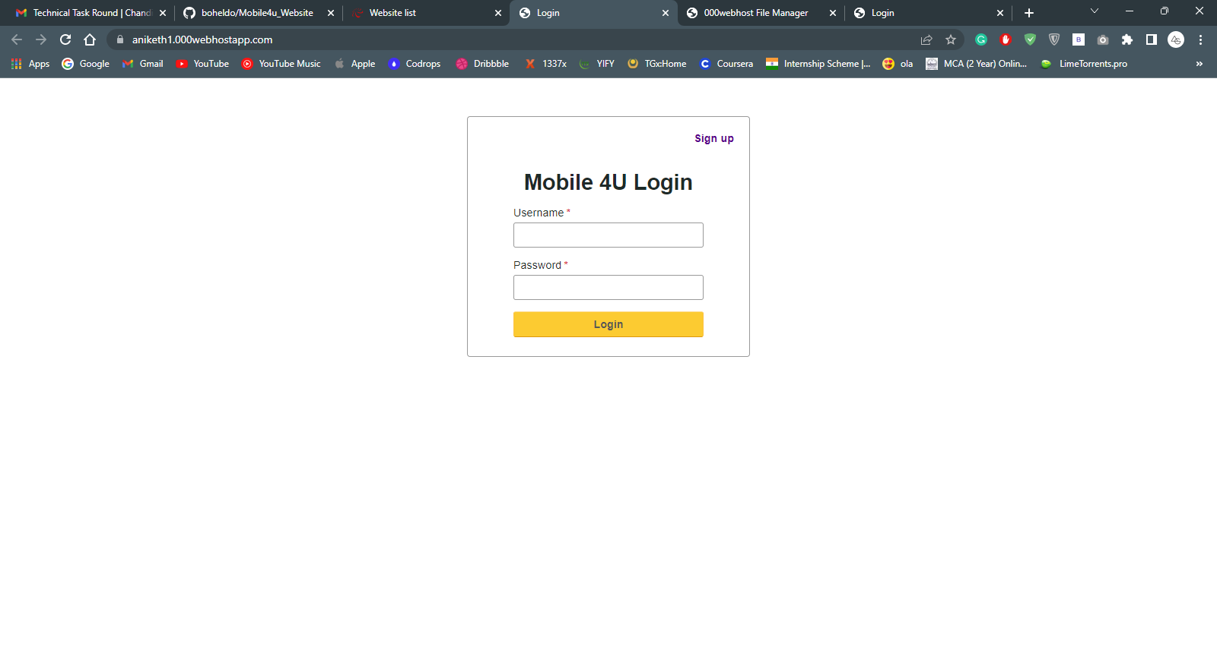

Signup page

A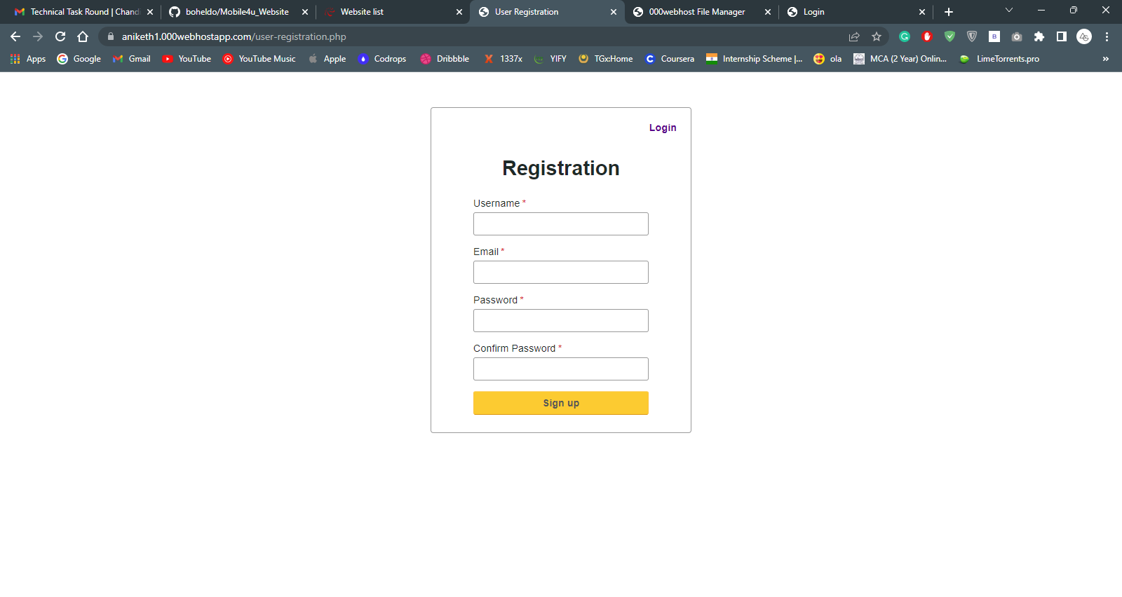

After Sucessful Login Landing Page

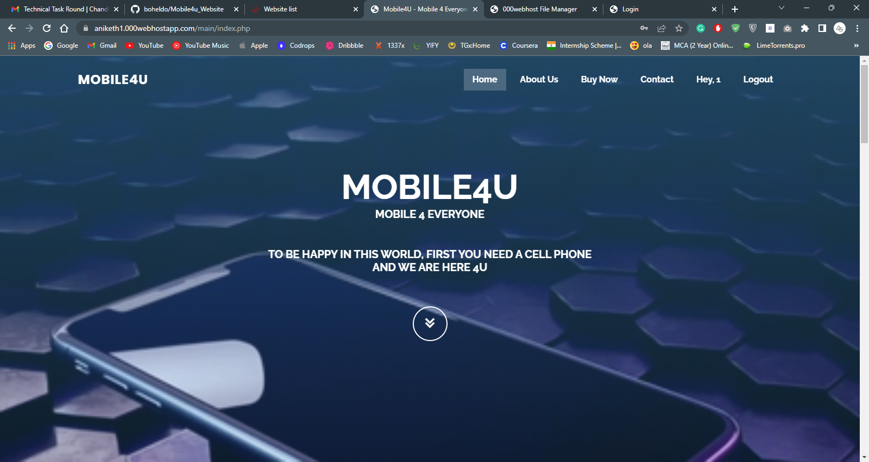

About Us

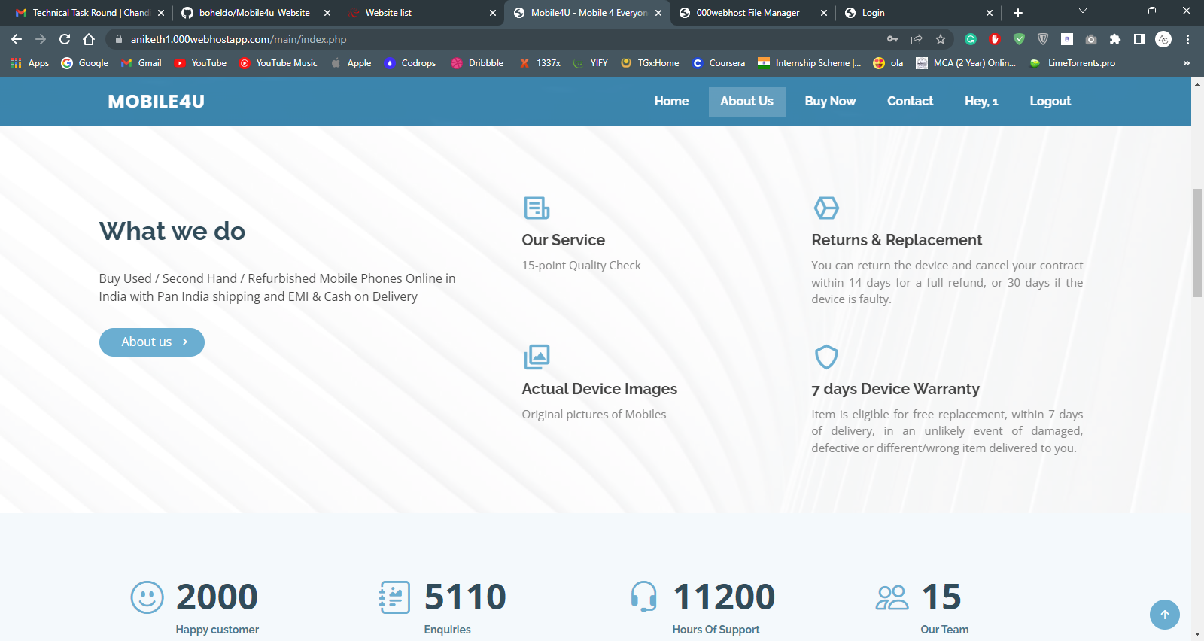

Our Products You can buy

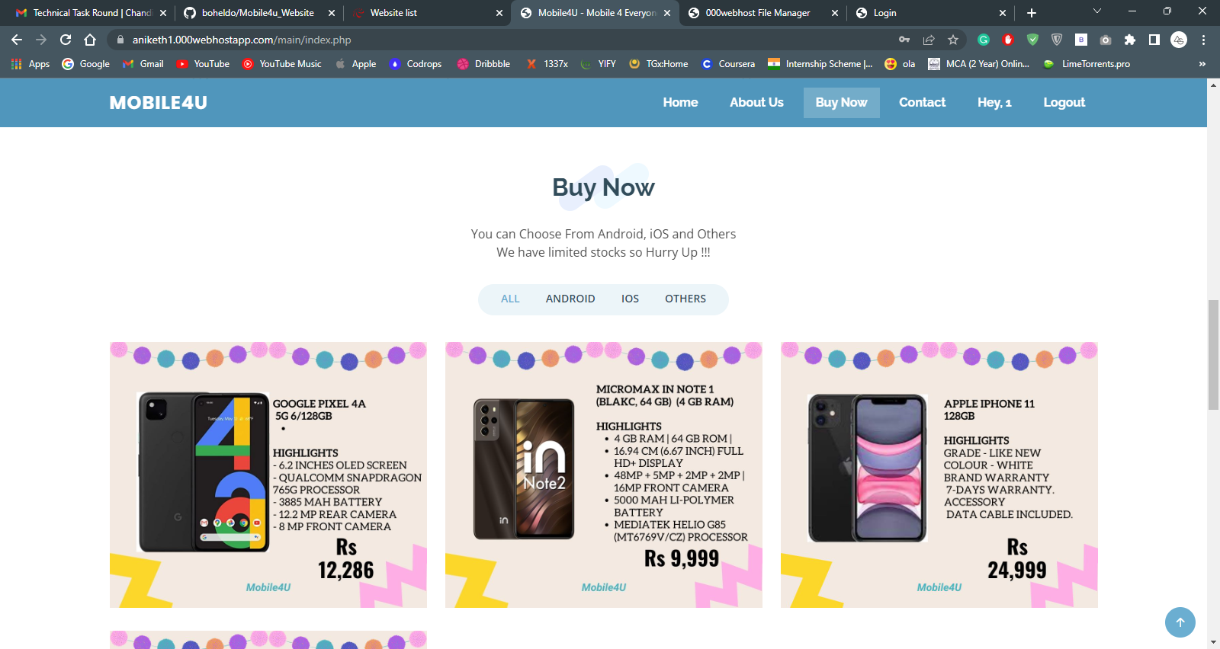

You can select from iOS android and others

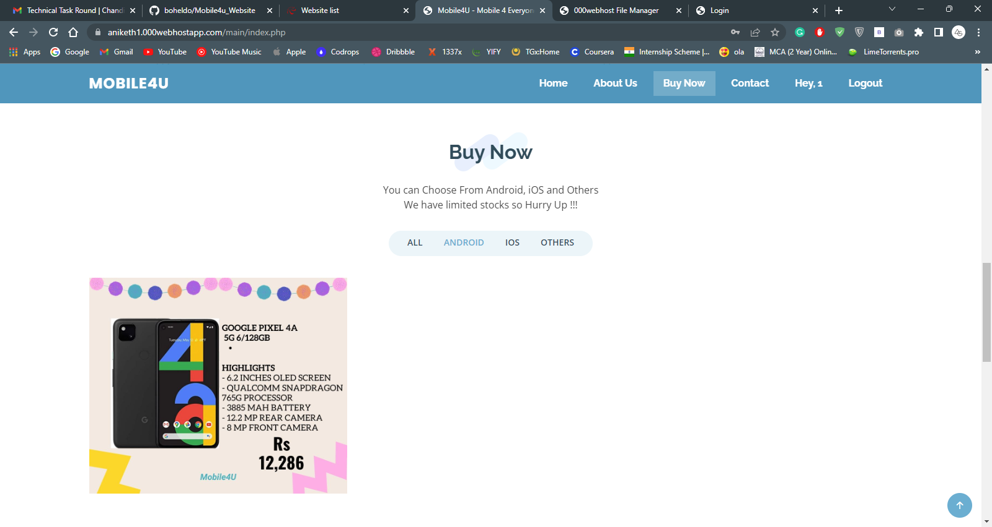

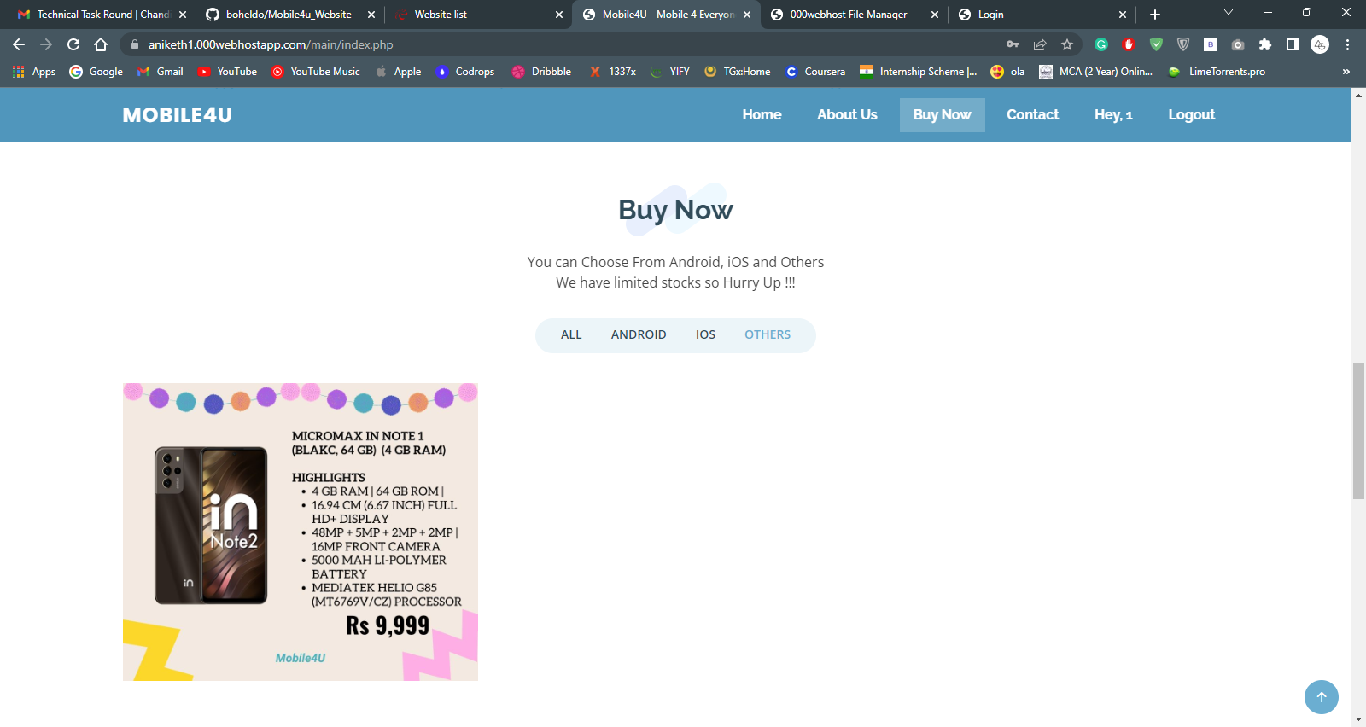

You can Choose any phone you want to buy

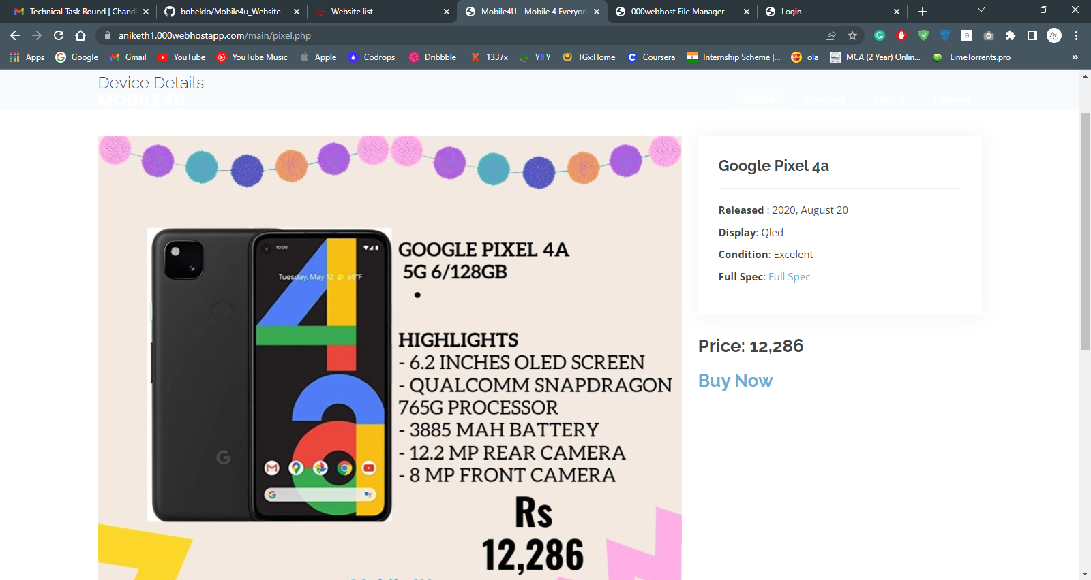

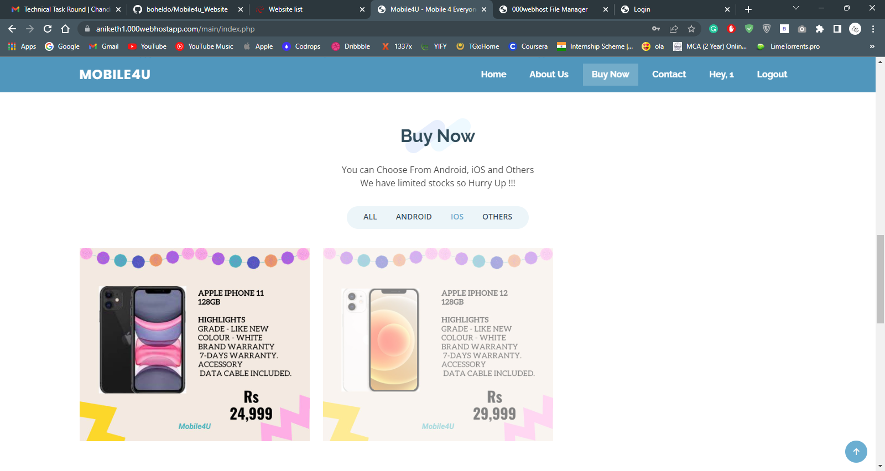

Testimonials page

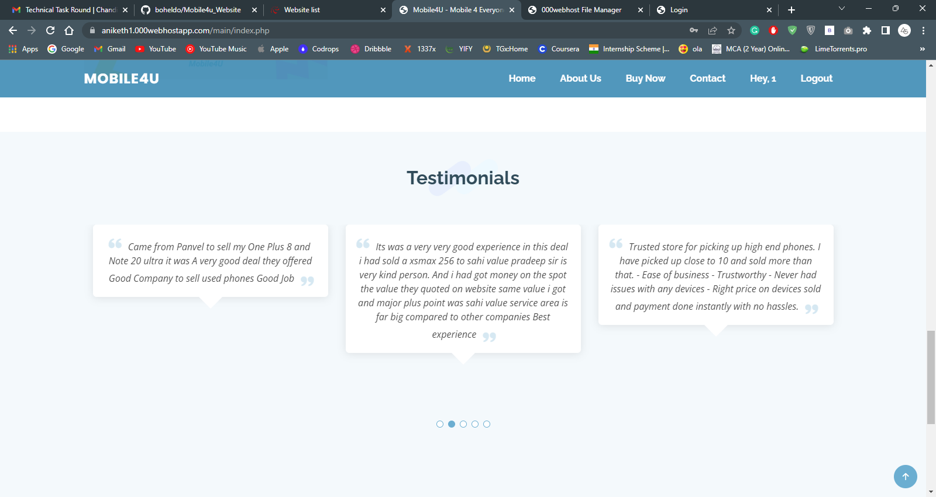

Contact us page

