Kazakh-British Technical University
Data collection and preparation

STUDENTS' INDEPENDENT STUDY (SIS) №1
Mental Health and Seasonality:
Daylight, Temperature and Well-being Across Cities

Team members:
Full Name: Imangali Kaisar ID: 23B031318
Full Name: Kairzhan Tomiris ID: 23B031507
Full Name: Mubarakova Danelya ID: 23B031372

30.10.2026
Almaty

1. Introduction and Research Question
The project applies the full data collection and preparation pipeline to the question: how do seasonal factors (daylight duration, sunshine, temperature) relate to a population-level mental health indicator across cities? We tested three hypotheses: (H1) cities with a stronger seasonal swing in daylight have different suicide rates; (H2) within a city, monthly temperature follows monthly daylight (a data sanity check); (H3) sunshine hours from the API agree with sunshine hours from Wikipedia.

2. Approach
- API (Open-Meteo Historical Weather): for 28 cities from Singapore (1.35°) to Reykjavik (64.15°) we requested daily temperature_2m_mean, daylight_duration and sunshine_duration for 2019 to 2023 with requests; status 429 was handled with a retry. Result: 51,128 rows.
- Web scraping (Wikipedia, requests + BeautifulSoup): after checking robots.txt (both pages allowed), we scraped List of countries by suicide rate (column All, used as a proxy for population mental health, since no SAD prevalence table exists) and List of cities by sunshine duration. Helper functions expanded merged cells (rowspan/colspan) and removed footnote markers. Raw HTML was cached for reproducibility.
- Cleaning: columns renamed, datatypes fixed (datetime, float), seconds converted to hours, missing values and duplicates checked (0 in the weather data), the aggregate World row removed, numbers parsed from text, implausible values filtered. Result: 185 countries and 439 cities with sunshine values.
- Merging and features: daily data was averaged to 12 monthly means per city, giving temp_mean, temp_range, daylight_min, daylight_range (seasonal swing in daylight, the main measure) and annual_sunshine_api. Weather was joined to the suicide rate by country and to Wikipedia sunshine by city using normalised names and a left join; all 28 cities were matched.
- Analysis: descriptive statistics, Pearson and Spearman correlations with Bonferroni correction (six features tested), Welch t-test and Mann-Whitney test, five plots with Matplotlib/Seaborn.

3. Results
H2 – confirmed. Within each city, monthly temperature follows monthly daylight (mean r = 0.83, min 0.54). The daylight swing grows with latitude from 0.15 h (Nairobi, Singapore) to 16.39 h (Reykjavik), so the API data is consistent.
H3 – partly confirmed. The two sources rank cities almost identically (Pearson r = 0.91, Spearman ρ = 0.92, p < 0.001), but the absolute values differ: the API gives 3,272 hours per year on average versus 2,260 on Wikipedia, i.e. 1.12 to 1.92 times more (1.49 on average; paired t-test t = 21.53, p < 0.001). Open-Meteo sunshine is a model estimate, while Wikipedia uses station data. A high correlation does not mean the values are equal.
H1 – not supported. No seasonal feature is significantly related to the suicide rate (Table 1). High-latitude cities (≥ 50°, n = 7) have a mean rate of 10.66 versus 11.30 for the rest (n = 21); Welch p = 0.67, Mann-Whitney p = 0.73. The weak negative link with sunshine and temperature depends on Cairo and Dubai (rates 0.8 and 2.8); without them it disappears (ρ ≈ −0.07, p > 0.7). The highest rates are in Seoul (23.4), Nairobi (19.1) and Almaty (18.2), cities with very different climates.
Table 1. Correlation of seasonal features with the suicide rate (n = 28)
Feature | Pearson r | Spearman ρ | Spearman p | Bonferroni p
Annual sunshine (API) | −0.25 | −0.25 | 0.21 | 1.00
Mean temperature | −0.34 | −0.24 | 0.22 | 1.00
Temperature range | 0.17 | 0.17 | 0.38 | 1.00
Absolute latitude | −0.01 | 0.02 | 0.91 | 1.00
Daylight swing | 0.01 | 0.02 | 0.91 | 1.00
Shortest daylight | −0.01 | −0.02 | 0.91 | 1.00
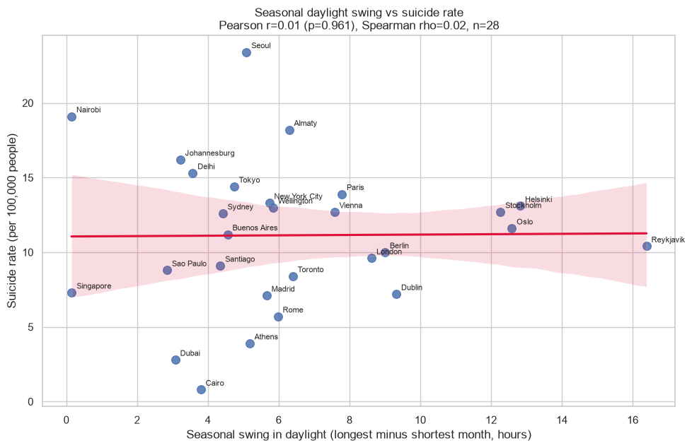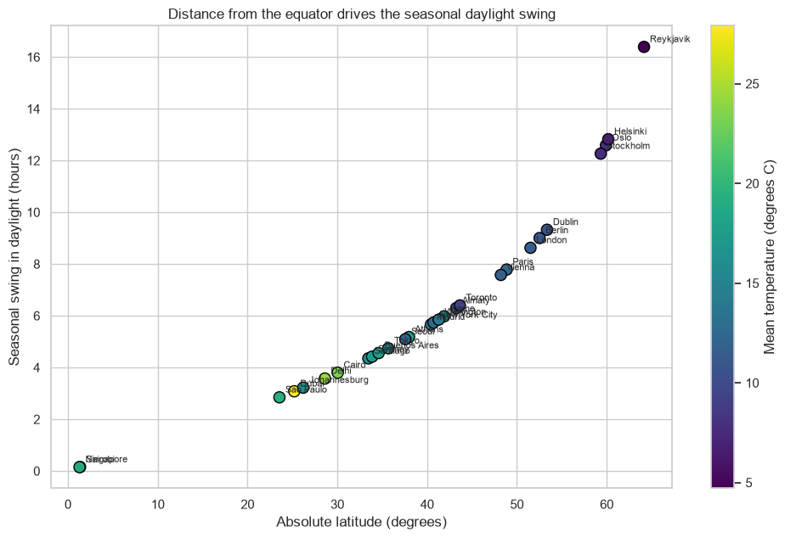
Figure 1. Daylight swing vs suicide rate: flat trend (left). Figure 2. Latitude determines the daylight swing (right).

4. Key Insights and Limitations
- In our sample there is no evidence that daylight, seasonal swing, sunshine or temperature are related to the national suicide rate; national social and economic factors are likely more important.
- The result is sensitive to the data: an older version of the Wikipedia table gave a weak association with latitude (ρ ≈ 0.39, p ≈ 0.04) that disappeared after the page was updated.
- Limitations: the suicide rate is only a proxy for SAD and well-being; the indicator is national while weather is city-level; only 28 cities; confounders (income, healthcare, culture, reporting quality, e.g. very low rates in Cairo and Dubai) and the ecological fallacy; different time frames of the sources.
- Future work: more cities, a city-level well-being measure, and control variables such as GDP per capita from the World Bank API.
GitHub repository: [https://github.com/bohemia998/datacollection26]

