**Functional Specification**

**3-D Markerless Motion Capture System for Active Shooter Response Training**

**Project Manager: Bo Heyse**

**Matthew Healea, Karina Paz**

**Faculty Advisor: Dr. Stan McClellan**

**Texas State University**

**Ingram School of Engineering**

**Texas State University**

**602 University Dr.**

**San Marcos, TX 78666**

**Date: September 23, 2019**



|  |  |  |  |
| --- | --- | --- | --- |
| **Revision History** | | | |
| **Version** | **Date** | **Description** | **Author** |
| 0.1 | 03/11/2019 | Initial Draft for Advisor Review | Authors Named |
| 1.0 | 03/13/2019 | Submitted Version | Authors Named |
| 1.1 | 04/03/2019 | Updated for Initial Design Review | Authors Named |
| 1.2 | 09/20/2019 | Updated for Progress Presentations | Authors Named |
| 1.3 | 11/13/2019 | Updated for Final Design Review | Authors Named |

Table of Contents

1 Introduction 3

1.1 Summary 3

1.2 Customer Requirements 3

1.3 Existing System 4

1.4 Terminology 4

2 Functional Description 6

2.1 User Attributes and Use Cases 7

2.2 Administration Functions 8

2.3 Error Handling 9

2.4 Safety and Security 11

2.5 Help and User Documentation 11

2.6 Interfaces 11

2.6.1 User 12

2.6.2 Software 12

2.6.3 Hardware 12

2.7 Boundary Conditions and Constraints 13

2.8 Performance 15

2.9 Software Platforms 19

2.10 Service, Support, & Maintenance 19

2.11 Expandability or Customization 19

3 Project Alignment Matrix 20

4 References 21

5 Approvals 22

# **Introduction**

Bo Heyse:

This project is based around first response training in active shooter scenarios as developed by the Texas State University ALERRT Center [1]. Our project will utilize a wireless sensor and communication system made up of motion tracking sensors called inertial measurement units (IMU) to record a responder’s three-dimensional (3D) motion relative to time. The recorded data can be implemented into a virtual or augmented reality simulation. The data this project will provide can generate a golden standard simulation for municipalities in need of proper training.

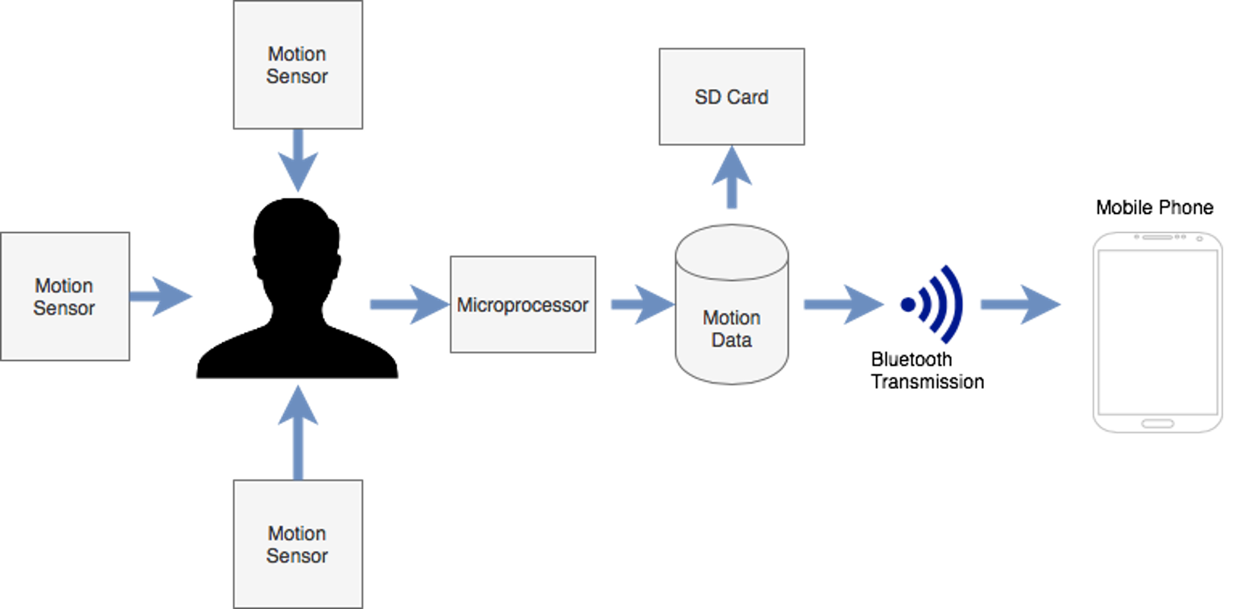

*Figure 1: A general diagram laying out the project’s structure.*

## Summary

Karina Paz:

Our project will develop a markerless three-dimensional motion capture system. A single unit will be prototyped, which includes sensors for head wear, center mass, and a weapon. These sensors will record motion data as seen in Figure 1. The unit intakes analog motion data, processes and writes digital data in the form of an X, Y, Z coordinate system to local storage. Post recording, the unit will transmit data to a mobile device and then push the data to a centralized cloud location for data repository. This data will be used, in the future, to power a virtual or augmented reality simulation. The integrated simulation will provide a technology-enhanced approach to training for police departments, or any first responder at an affordable cost. This product will require minimal participant interaction to the extent of simply putting on the unit, clicking start and clicking stop. Figure 2 displays the projects over all goal. Motion tracking sensors are placed on the user to intake motion data. The sensors will then wirelessly transmit the data to a mobile device which then transmits the data to a central device. Once sensor fusion is completed, the data can then be taken to create the VR simulation.

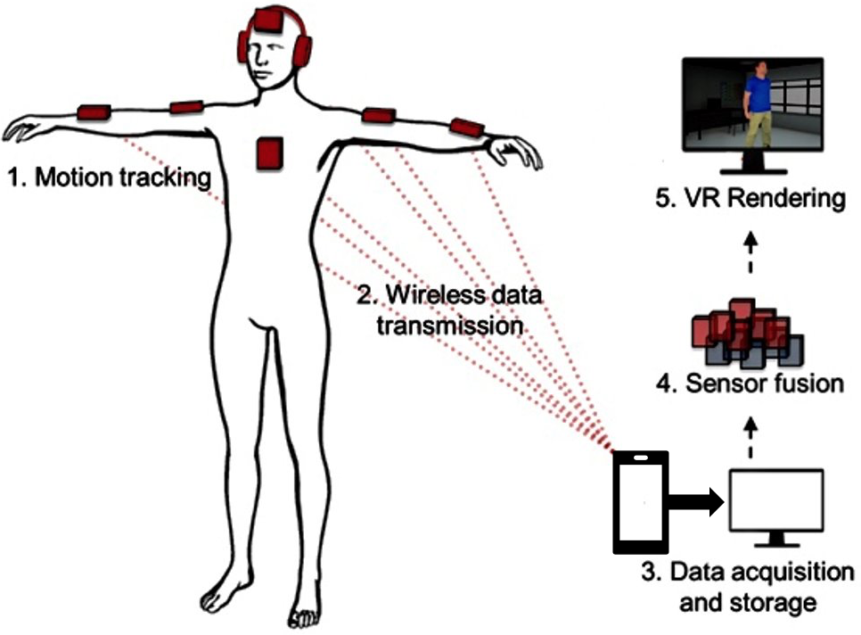

*Figure 2: A diagram laying out the project’s overall structural goal.*

## Customer Requirements

Matthew Healea:

The following are requirements from the sponsor:

* Record motion and trajectory of the body, gun, and head of a wearer

A participant of the active shooter simulation is to wear the motion/trajectory units to accurately record their location within a meter. As well as record their trajectory within 25 centimeters of accuracy during the simulation. Noise abatement, sample rates, and smoothing via software filtering will ensure boundary conditions are met.

* Minimally intrusive equipment

Each motion tracking unit must be nonintrusive to the user, gear provided, and environment during the simulation as well providing an enclosure to protect the hardware.

* Simple user interface

An interface to start/stop recording data will be provided.

* Minimum battery life of 2 hours

The maximum simulation time that is performed at the ALERRT Center is twenty minutes, thus the device needs to be able to record the simulation in its entirety. The ALERRT Center runs 6 simulations therefore creating the need of 2 hours minimum for all the total trainings.

## Existing System

Bo Heyse:

The standard for motion capture and positioning systems in the current market is a mixed video camera and sensor system, often referred to as a marker system, because the video camera and sensor combination overlay data to mark an object’s movement and orientation in space. While these systems produce precise measurements, the cost can exceed $75,000 [2], often limiting motion capture to movie sets, video game studios and other high budget arenas. Other constraints that come with these systems include the environment and equipment that must be used. Marker systems require confined areas where cameras can be set around a perimeter as well as wearing equipment which can be intrusive and even limit movement.

Unfortunately, the constraints of the marker systems cannot be overcome for our project due to cost, intrusion on the wearer, and the dynamic environment the project will be deployed in. Thus, the standard motion capture system will not work for this particular application. Instead, the type of system we propose is a markerless system which is minimally intrusive to the wearer, is not constrained by environment with regards to a cameras line of sight, and is able to track the distance covered by the wearer.

Currently, there is much research and development in the field of markerless motion capture as it is considered the top tier of motion capture and position tracking. The weakness with markerless technology is the precision with which it can capture movement without the aid of other sensor systems. This lack of precision occurs due to slight calibration changes during instances of quick rotation and acceleration because there is no reference point to orient back to. This issue can be solved or at the very least minimized with recalibration through additional hardware components and software algorithms.

Markerless motion capture systems are available although they are cost prohibitive custom solutions. Our project will address the issue of being completely customized and integrated with the ALERRT Center’s provided equipment.

## Terminology

Bo Heyse:

Provided below is a table of common terminology associated with the current project.

|  |  |
| --- | --- |
| Term | Definition |
| IMU | An acronym used for Inertial Measurement Unit, an electronic device which combines a Gyroscope, Magnetometer, and Accelerometer to measure motion |
| Markerless | Motion capture that is free of video cameras for orientation |
| Marker | Motion capture that uses a sensor and video camera system to orient and track the user |
| Gyroscope | A sensor used for measuring orientation and angular velocity, will be used to find orientation of sensor in space |
| Accelerometer | A sensor which measures the acceleration, rate of change in velocity, of an object – Allows for distance to be measured as well. |
| Magnetometer | A sensor that measures magnetic flux density, will be used in calibration. |
| Pitch – Roll – Yaw | Names which represents the three dimensions in which an object can rotate – representative of the X, Y, Z axes, respectively |
| Python | A popular, general purpose programming language used heavily in data processing and data visualization, also used for simple user interface design applications. |
| MATLAB | A high-performance programming language for technical computing. |
| Memory card | A non-volatile memory device which is used to store data in portable devices |
| Transceiver | An electronic component which can both transmit and receive signals |

# **Functional Description**

Matthew Healea:

Each section description is as follows and will be explained in greater detail in the appropriate preceding sections:

1. User Attributes and Use Cases – Who will be using the product, what skills must they require in order to operate the system and how these interactions will achieve goals.
2. Administration Functions – This section characterizes the interactions between the administrator and user roles as well as their access to each part of the system.
3. Error Handling – How to identify and logically categorize error occurrence in the system, as well as error resolution procedure.
4. Safety and Security – How the system will control access to data and to whom access is granted.
5. Help and User Documentation – User information documentation including a user manual and overview of the system.
6. Interfaces – How the system is divided into the User, Software, Hardware and Mechanical sections as well as how they interact among each other.
7. Boundary Conditions and Constraints – Description of testing limitations and product constraints that will define product performance.
8. Performance – Detailed description of each portion of the project, including performance characterization.
9. Software Platforms – List software platforms supported by the system as well as appropriate version of each.
10. Service, Support, and Maintenance – Description of any functions or devices that will make maintenance or support easier to service.
11. Expandability and Customization – Description of how the system could be expanded upon or customized.

## User Attributes and Use Cases

Karina Paz:

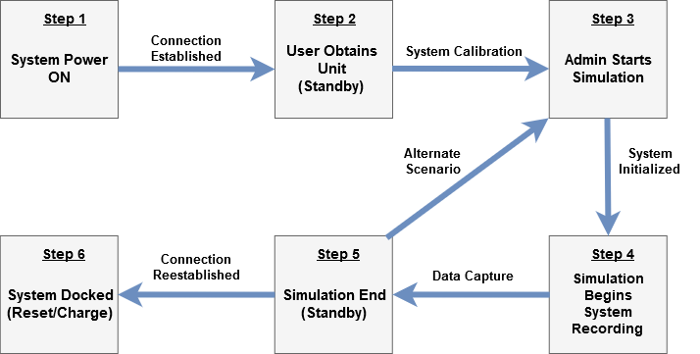

*Figure 3: User and admin interaction with system flowchart diagram. Shows the admin’s interaction and settings occurring during motion and positioning capture.*

Motion Capture System

**Step 1:** Administrator powers on system and issues it to user, wireless connection between unit and mobile device is established after a connect button is pressed on mobile phone.

**Step 2:** User obtains system hardware and the sensors perform calibration.

**Step 3:** Administrator issues a synchronized system start, user clicks start button. Sensor begins recording (rate to be determined).

**Step 4:** Motion data is being captured while user moves freely throughout environment.

**Step 5:** Administrator issues a system wide stop upon simulation completion, user accesses app and pushes stop, standby mode is entered.

**Step 6**: User clicks “Upload Data”, connection is established with a main computer system, unit data is downloaded.

## Administration Functions

Karina Paz:

The system will require one administrator (admin). The admin will be a Texas State University engineer and their function will be initiating and terminating the system via a series of user interface buttons. Admin and unit interaction can be seen in Figure 4.

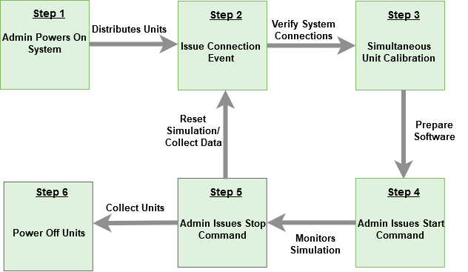

*Figure 4: Administrator interaction with the system.*

**Step 1:** Administrator powers on the system and distributes the unit to the users.

**Step 2:** Admin issues a connection event to ensure mobile units communicate properly with mobile unit and verifies controls.

**Step 3:** A simultaneous calibration will be issued to ensure proper data capture for the simulation.

**Step 4:** Admin issues a start command which the user will begin by pressing the start button. The time stamp is placed on the file for the sensors, triggering simultaneous start time.

**Step 5:** Admin issues a stop command which the user will issue by pressing the stop button. This places a time stamp on the end of data collection.

**Step 6**: Equipment is collected, recharged, and stored.

## Error Handling

Bo Heyse:

In the current design of the system we have identified several potential error vectors. The design of our error handling system is to be as self-contained as possible because if an error occurs it needs to be handled in a way that the ongoing simulation will not be disturbed. Errors will be handled within a connection event and with a calibration event issued by the admin. The connection event will be used to establish connection to the units, and calibration event will be used to check storage connection and battery status.

Figure 5 details the error handling that will occur in establishing a wireless connection. Establishing this connection is crucial for the calibration and capture events to occur. Once a capture event occurs wireless connection is not required due to all data being recorded locally. There are two potential sources of error here, the two systems are out of range from each other, thus wireless connection ceases or there is a transceiver malfunction that occurs and stops wireless communication.

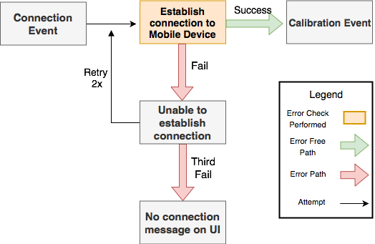

*Figure 5: Error sequence for wireless connection and error path*

Figure 6 details the potential errors that can occur during calibration of the system. In our design, the system will be powered on and proceed to initialization. Two steps have a potential for error, recognizing a memory card connection and if that passes, opening a file on the memory card. If either of these two errors occur, a signal will be sent to the mobile device, notifying the user that the system is not recording data because it either doesn’t recognize the memory card or it can’t open a file on the memory card, respectively. The initialization process will then occur two additional times. If no connection is established or a file can’t be opened, then the unit will be switched offline.

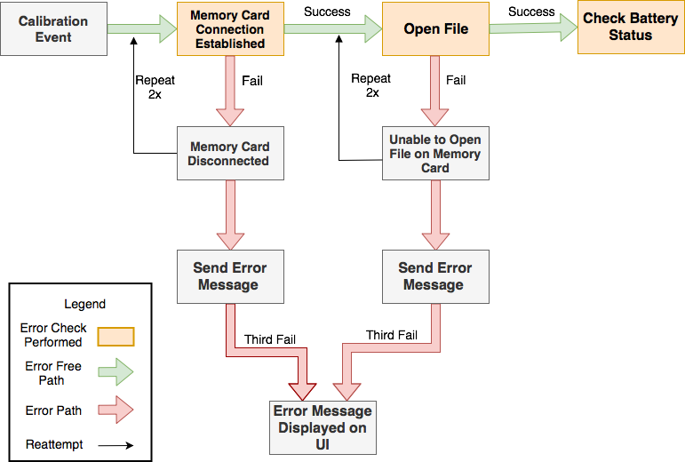

*Figure 6: Error sequence for memory card and error path*

The data capture system depends on a battery to power the onboard microprocessor and sensor, the first issue that may occur is a low battery life. Figure 7 details the battery status error handling in our design. We plan to use a software battery check to poll the life of the battery. A low battery will be considered anything less than 20 percent battery capacity. A battery capacity warning will be sent as a notification to the mobile device.

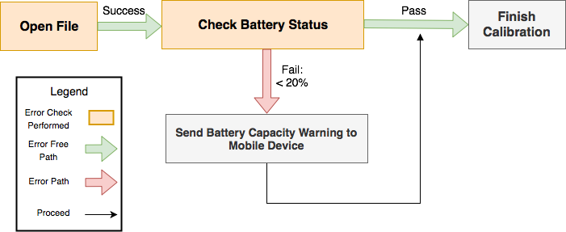

*Figure 7: Battery error sequence and error path*

## Safety and Security

Matthew Healea:

The security of the system is outside the scope of this project since data is to be collected and submitted only to law enforcement and faculty involved with the sponsor. There are no software or user risks for the data since they are isolated to sponsor use only. This project does not contain significant security considerations.

## Help and User Documentation

Matthew Healea:

A step by step system tutorial generated via appropriate means will be included in the documentation for future engineering teams. The documentation will include wiring diagrams of each subsection of the system as well as connections to the microprocessor and personal computer. Among the tutorial in user documentation, there will be a user manual for the completed portion of the system which will incorporate set up instructions for the sensor recording unit. Also included will be archived software and documentation through the Texas State University GitHub page.

## Interfaces

Bo Heyse:

Figure 8 displays a flow chart of the hardware and software interfaces that will be used in our project. Hardware will provide the communication interface and data production while software will be the proverbial “gas” that makes the machine run. Software will control aspects such as sensor frequency, filtering, data visualization and Graphical User Interface controls.

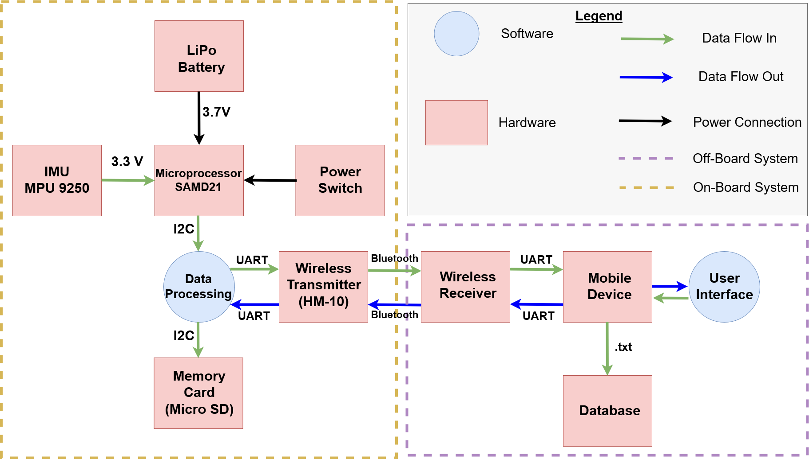

*Figure 8: Depicts the interactions between hardware and software interfaces of the system*

### User

Bo Heyse:

The user interaction with this system is minimal and is designed to involve two parties, the administrator and the mobile unit. To make the system as minimally invasive as possible, the mobile unit will have no interaction with the system beyond wearing the necessary equipment, pushing the connect, start and stop buttons. The administrator will be responsible for powering the system on and then the user will interact with the system through a user interface. The user interface will have three different commands, Connection, Start, Stop. Each command will perform a different event as defined in previous sections. Each of the commands will allow the user to enter the next state and control the state of the mobile unit. Figure 9 outlines the connection between admin and user interaction within the system.

The start button will be the signal required by the mobile microprocessor to begin recording data. The signal will contain a time stamp which will synchronize the unit with all other sensors. When the start signal is received by the mobile unit it will begin recording sensor data locally. A stop button via the user interface will be pushed to cease data recording and allow the mobile unit to enter a debrief state which is where data downloading will occur.

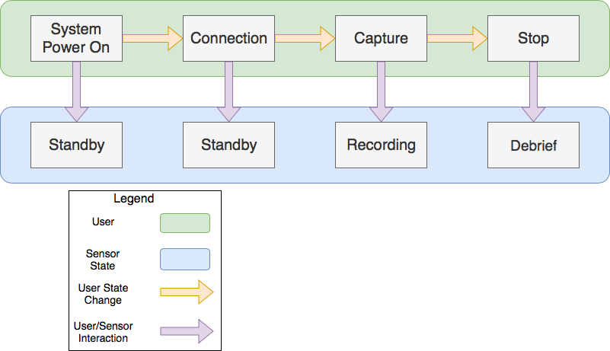

*Figure 9: Depicts the interactions between the admin and user states in our system*

### Software

Bo Heyse:

We have leveraged the iOS development environment to create an application that functions to start and stop our sensors via a Bluetooth connection. The application accepts and sorts data into a file structure where the user can view according to the specified recording session and body part that the sensor was being used to record data.

We have leveraged the Arduino integrated development environment (IDE) version 1.8.8 and several packages native to the IDE in order to program our IMU sensors. We have used open source software that integrates with our sensor and extended its functionality. The software now functions to start and stop when receiving a specific signal from the mobile device, save data to an SD card, transfer that data via Bluetooth to the mobile app, error report and manage the power consumption of the sensor.

As a stretch goal, we’d like to implement a backend that will automate the processing of all data received during motion capture and visualize all data in a virtual environment using one script. MATLAB can be utilized for visualization of data and is anticipated being used extensively. Unity is a data visualization software suite used extensively in virtual reality design and will be used if we are able to attain our stretch goals to implement a simplistic AR/VR recreation of the data.

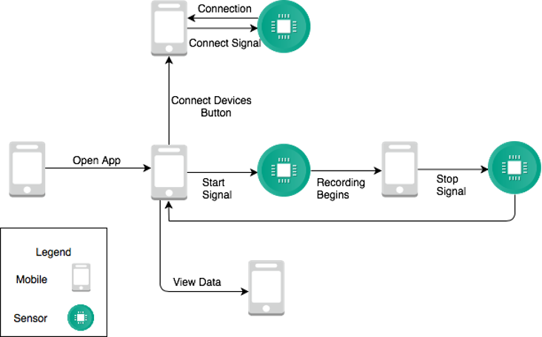

*Figure 10: Depicts the interactions between the mobile device and sensor software within our system*

### Hardware

Karina Paz:

The ALERRT Center system will be composed of several different existing hardware components. The ALERRT Center supplies a standard 9mm gun, reflective vest, protective helmet, and goggles. We will implement our technology into their equipment using an IMU providing an accelerometer, gyroscope, and a magnetometer all in three-dimensional data. Upon research, the current industry standard in markerless motion capture is the IMU M0 chip and is heavily supported by software libraries among meeting all requirements for motion recording. It also provides an optimal size and an onboard microprocessor.

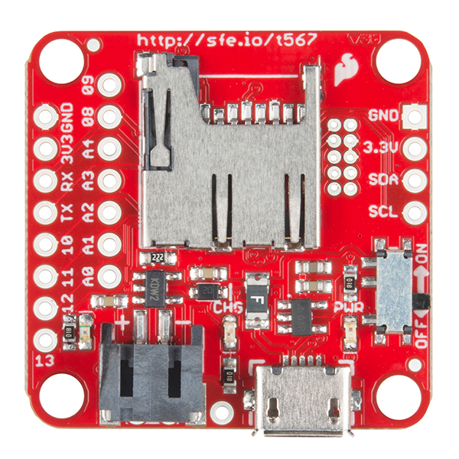 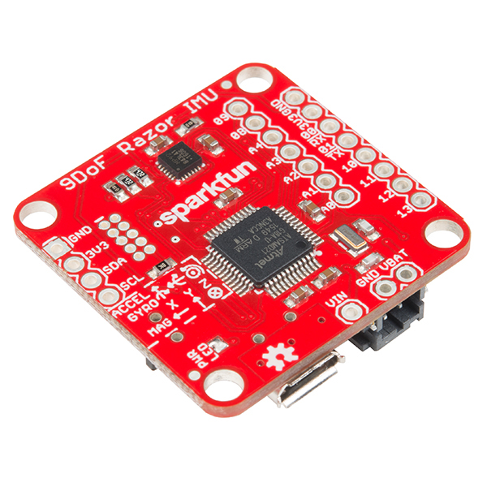

*Figure 11: SparkFun 9DoF IMU M0. These are images, front and back, of the sensor containing the required accelerometer, gyroscope, and magnetometer with an onboard SD card attachment and microprocessor.*

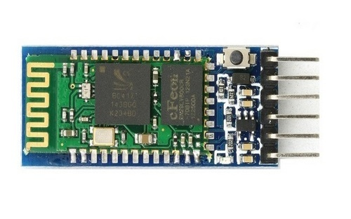

*Figure 12: HM-10. This is an image of the Bluetooth module used for the IMU unit.*

All hardware components will be powered by a battery that has a capacity of 400 mAh. With that capacity, our sensors will be able to record and transmit data at max capacity (300 mAh) for over an hour or just record data for over 3.5 hours. The actual output of the system will fall somewhere in the middle. Easily allowing us to achieve a 2-hour battery life. Due to the availability of battery options the battery is also easily upgradeable to an 800 mAh battery. The final decision will be selected in accordance with the known power consumption of the mobile system after testing. The battery chosen will be required to provide a minimum of 108 mAh (discussed in power budget).

## Boundary Conditions and Constraints

Matthew Healea:

|  |  |
| --- | --- |
| **Condition/Constraint** | **Description** |
| Power | The current IMU for testing requires between 10 mA and 15 mA, while the present Bluetooth module requires between 30 mA and 50 mA depending on the transmission status. The easiest method will be to supply the IMU board with a battery of at minimum 108 mAh to operate the mobile microprocessor unit for duration of the maximum expected simulation timeframe. |
| Wireless Transmission | The anticipated method for wireless transmission is a Bluetooth transmitter. The transmission range requirement is 10 m at most considering this will only be used to download data post simulation. |
| Temperature | Boundary conditions for this product are from –18°C to 48.8°C which are well within the constraints of the electronics.  Transmitter: -40°C to 85°C  IMU: -40°C to 85°C  Microprocessor: -40°C to 85°C |
| Administrative Controls | The system is designed to be passed on to another engineering student(s) as the administrator during the simulation sequence. Even with this in mind, the administration controls are kept nearly as simple as the push of a button(s). |
| Battery Life | This system must be mobile which requires power from a battery pack. The minimum lifespan of the battery is to be at least 2 hours to ensure capture of the entire simulations. |

## 2.8 Performance

Karina Paz:

|  |  |  |  |  |  |
| --- | --- | --- | --- | --- | --- |
| ***Hardware Performance Parameters*** | | | | | |
| ***Parameter*** | ***Test Conditions*** | ***Min*** | ***Max*** | ***Units*** | ***How Tested*** |
| *Sensor Accuracy* | *Heading at varying orientation* | *0* | *360* | *Degrees* | Tested displacement of X-Y-Z axes by starting each axis at 0 and comparing reported pitch yaw and roll via a protracted circle. We require the sensor being within 25% of the angle being measured. |
| *Sample Rate (frequency)* | *Movement across measured plane* | *20* |  | *Hz* | *The current industry minimum for motion capture of human movement with an IMU is 20 Hz. We will test a variety of sample rates from 20 Hz to 200 Hz (automotive industry standard) to determine a rate that gives the desired accuracy. This will go hand in hand with the above testing.* |
| *Transmission Range* | *Enclosed building* |  | *10* | *Meters* | Attempt wireless data transfer at incremented measured distances ranging from 1 meter until a transmission is incomplete |
| *Battery life* | *38°F*  *115°F* | *2* |  | *Hours* | *Connect all the hardware components and simulate data collection until battery dies. Components will be placed in a temperature-controlled environment. (max power draw is 315.01 mW)* |
| *Storage capacity* | *I2C protocol* | *1.51* |  | *MB* | *Storage Capacity will be determined by collecting sensor data at a to be determined maximum sample rate for an action event for 20 min from 4 input sensors to a text file. We have a known byte depth of 252 bytes/sample using the I2C protocol. The minimum was determined by calculating system storage requirement at 20 Hz sample rate (minimum standard for motion capture)* |

|  |  |  |
| --- | --- | --- |
| **Software Performance Parameters** | | |
| **Function** | **Description** | **How Tested** |
| User interface | Loads in 5 seconds or less in order to stop a recording session | Instrument the software timer to analyze load time |
| Latency | <1 second “Capture” to sensor recording data | Use software-based time stamps on hardware to check latency time by comparing time stamps |
| Error Reporting Screen | Display a notification to mobile app that an error has occurred | Perform a ground truth connection trial where known errors occur and see if screen reports them. |

**Power Budget**

|  |  |  |  |  |  |
| --- | --- | --- | --- | --- | --- |
| *Part Name* | *Quantity* | *Supply Current* *(mA)* | *Supply Voltage*  *(V)* | *Power Subtotal*  *(per unit)*  *(mW)* | *Total Power Consumption*  *(mW)* |
| *MPU-M0 (IMU)* | *1* | *4.1* | *2.4 - 3.6* | *9.84 - 14.8* | *9.84 - 14.8* |
| *HM-10 Bluetooth* | *1* | *30 - 50* | *3.6 - 6* | *108 - 300* | *108 - 300* |
| *Voltage Divider* | *1* | *0.02 - 0.05* | *3.3 - 4.2* | *0.066 - 0.21* | *0.066 - 0.21* |

The power budget displays researched components which temporarily fit the initial design requirements in order to get a ballpark range of total power consumption and most importantly mobile unit power consumption. The MPU-M0 was selected as the initial IMU for its specifications that are anticipated to perform well within our bounds, as well as due to its onboard microprocessor and storage capabilities. The HM-10 Bluetooth module is compatible with the onboard microprocessor protocols contained on the MPU-M0 board. Since battery life is crucial to this project, the minimum battery requirement for the above components is rated at 108 mAh. This is based off the mobile unit power consumption which uses a maximum current draw of 54.1 mA. Batteries are typically rated in mAh capacity. Since simulations last a maximum of 20 minutes each, our system requires a battery with 6 times of the max current draw. 54.1 mA x 2 hours (given there are 6 simulations) gives around 108 mAh.

Power Total (mW) = 117.84 – 314.8

(Calculated from best case to worst case)

Mobile Unit Power Consumption Total (mW) = 117.84 - 314.8

(Calculated from best case to worst case)

Sources

<https://cdn.sparkfun.com/assets/learn_tutorials/5/5/0/MPU9250REV1.0.pdf>

<https://www.sparkfun.com/datasheets/Components/SMD/nRF24L01Pluss_Preliminary_Product_Specification_v1_0.pdf>

[https://store.microprocessor.cc/usa/microprocessor-nano](https://store.arduino.cc/usa/arduino-nano)

<http://datalogger.pbworks.com/w/file/fetch/89507207/Datalogger%20-%20SD%20Memory%20Reader%20Datasheet.pdf>

<https://static.raspberrypi.org/files/product-briefs/Raspberry-Pi-Model-Bplus-Product-Brief.pdf>

## 2.9 Software Platforms

Bo Heyse:

Our software suite for this system will run on Arduino IDE and iOS devices with support up until iOS 9.2. We do not foresee this as an issue as we have tested the ability of our system to run on an iPhone 5s, which are also the first iPhones to have BLE capabilities, which we have seen no issues with control. At the current time, Android is not supported but can be planned for future groups to extend. In terms of cost, iPhones can be purchased for as low as $10 [6], 1/3 the price of the IMU sensor.

## 2.10 Service, Support, & Maintenance

Matthew Healea:

The system can be considered as two main modules, the mobile unit which is comprised of the IMU sensors, a transceiver, a microprocessor and battery; and the administrator unit which is made up of a transceiver, and a personal computer. As for the mobile unit, the microprocessor will be attached to a vest with an access point that allows for manipulation of the battery, SD card, and wiring. The administrator unit will be a standalone feature and will not have an accessibility issue or need of battery maintenance as it will be supplied via a hardwired power supply.

Support for the physical units will be implemented in terms of error handling. These errors will be outlined the *Error Handling* section of this document as well as in the user manual provided in the system documentation. Software support will feature error codes to a user interface indicating the area in need of attention. Error checking is done in software for both units to ensure signals are properly transmitted and received. Calibration of the system is carried out by a couple simple body motions that will take place just before the beginning of each simulation.

## 2.11 Expandability or Customization

Bo Heyse:

Modularity and scalable will remian key functions of this project even for the oncoming teams and design groups who will continue to develop this product. While we will be developing a single stand-alone prototype, this product requires a design which can be expanded to up to 30 first responders training at once at the ALERRT training center. Keeping that in mind, wireless data transmission needs to be designed in a way in which the hardware can handle this load, making the solution a software update rather than a system redesign.

All source code and design plans will be made open source to allow for software changes and potential hardware tweaks. The documents will be well documented as outlined in *Service, Support & Maintenance*.

# **Project Alignment Matrix**

**TABLE 1: Knowledge Alignment Matrix**

|  |  |  |
| --- | --- | --- |
| **Course No.** | **Core knowledge** | **Specific knowledge incorporated by team** |
| EE 3350 (Electronics I) | Design and analysis of active devices and equivalent circuits | Power budget analysis and consideration |
| EE 3370 (Signals and Systems) | Frequency domain representation of signals and frequency response, transfer functions | Signal analysis and noise compensation techniques |
| EE 3420 (Microprocessors) | Principles of operation and applications of microprocessors | I2C and SPI communication protocols, logic level matching, and micro controller selection |
| EE 4352 (Introduction to VLSI Design) | Analysis and design of CMOS integrated circuits | Sensor function and selection for compatibility with system |
| EE 4370 (Communications Systems) | Transmission of signals through linear systems, analog and digital modulation, and noise | No team member has taken the course, but we are utilizing specific wireless communication transfer protocols within system |

**TABLE 2: Constraint Alignment Matrix (and applicable standards)**

ABET Criterion 3 (c): “an ability to design a system, component, or process to meet desired needs within realistic constraints such as economic, environmental, social, political, ethical, health and safety, manufacturability, and sustainability.”

|  |  |
| --- | --- |
| **Constraint Type** | **Specific Project Constraint** |
| Economic | Is the project cost effective for an already overpriced market? |
| Environmental | Limitations on communication frequencies available |
| Health and safety | Units integrated to mechanical equipment should be well insulated in order to prevent electrical shock |
| Social/Ethical | Ensure data is for ALERRT Center faculty only |
| Applicable Standards | |  |  |  | | --- | --- | --- | | Protocol | Version | Characteristics | | SPI - Serial Peripheral Interface | NA | * High speed, uninterrupted data flow  * No error detection | | I2C -  Inter-Integrated Circuit | NA | * Addressing system  * Slowest transfer rate | | UART - Universal Asynchronous Receiver-Transmitter | NA | * Parity bit (Error Checking)  * No addressing | | Bluetooth - Wireless protocol | 4.0 | * Wide availability, ease of use  * Limited range | |

# **References**

[1] “Advanced Law Enforcement Rapid Response Training.” ALERRT Center

<https://alerrt.org/>

[2] “Motion Capture Cost”. Optitrack. <https://optitrack.com/systems/#virtual-reality>

[3] “MPU-9250 Product Specification.” *InvenSense Inc.*, 2014, [cdn.sparkfun.com/assets/learn_tutorials/5/5/0/MPU9250REV1.0.pdf.](http://cdn.sparkfun.com/assets/learn_tutorials/5/5/0/MPU9250REV1.0.pdf.)

[4] “Microprocessor Nano (V2.3) User Manual.” *Microprocessor*, 2008,

[www.microprocessor.cc/en/uploads/Main/MicroprocessorNanoManual23.pdf](http://www.microprocessor.cc/en/uploads/Main/MicroprocessorNanoManual23.pdf)

[5] “Single Chip 2.4 GHz Transceiver - nRF24L01.” *SparkFun*, Nordic Semiconductor ASA, 2006, [www.sparkfun.com/datasheets/Components/nRF24L01_prelim_prod_spec_1_2.pdf](http://www.sparkfun.com/datasheets/Components/nRF24L01_prelim_prod_spec_1_2.pdf).

[6] “Price of an iPhone on ebay” <https://www.ebay.com/sch/i.html?_from=R40&_nkw=iphone++5&_sacat=0&LH_TitleDesc=0&_sop=15>

# **Approvals**

The signatures of the people below indicate an understanding in the purpose and content of this document by those signing it. By signing this document you indicate that you approve of the proposed project outlined in this Functional Specification and that the next steps may be taken to proceed with the project.

|  |  |  |  |
| --- | --- | --- | --- |
| **Approver Name** | **Title** | **Signature** | **Date** |
|  | Project Manager |  |  |
|  | D2 Project Manager |  |  |
|  | Faculty Sponsor |  |  |
|  | Sponsor |  |  |
|  | Instructor |  |  |